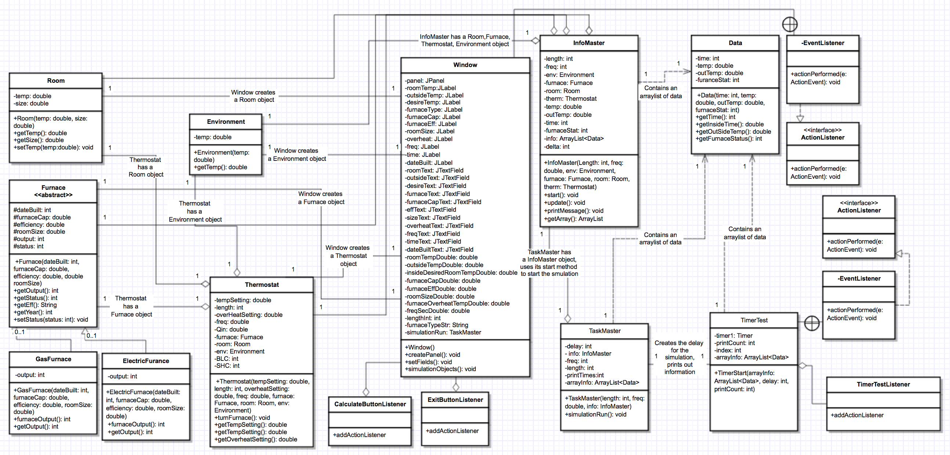

Gas Furnace capacity = 50000 Efficiency = 90.0% Pilot on = true heating = False

Room: Year Built: 1996 Temperature = 20.0 Area (Sq ft) = 2000.0 SHC = 4.0 BLC = 1.0

Environment: Temperature = 10.0

Thermostat: Setting = 22.0 Overheat = 2.0

Starting simulation: Display frequency(seconds) = 5 Runtime(seconds): 7200

0 20 10.0 Off

300 20.31 10.0 On

600 20.62 10.0 On

900 20.92 10.0 On

1200 21.21 10.0 On

1500 21.5 10.0 On

1800 21.78 10.0 On

2100 22.06 10.0 On

2400 22.33 10.0 On

2700 22.59 10.0 On

3000 22.85 10.0 On

3300 23.1 10.0 On

3600 23.35 10.0 On

3900 23.59 10.0 On

4200 23.83 10.0 On

4500 24.06 10.0 On

4800 23.77 10.0 Off

5100 23.48 10.0 Off

5400 23.2 10.0 Off

5700 22.93 10.0 Off

6000 22.66 10.0 Off

6300 22.39 10.0 Off

6600 22.14 10.0 Off

6900 21.88 10.0 Off

7200 22.16 10.0 On

Gas Furnace capacity = 65000 Efficiency = 90.0% Pilot on = true heating = False

Room: Year Built: 1700 Temperature = 30.0 Area (Sq ft) = 2000.0 SHC = 4.0 BLC = 1.0

Environment: Temperature = 10.0

Thermostat: Setting = 20.0 Overheat = 3.0

Starting simulation: Display frequency(seconds) = 1 Runtime(seconds): 6000

0 30 10.0 Off

60 29.92 10.0 Off

120 29.83 10.0 Off

180 29.75 10.0 Off

240 29.67 10.0 Off

300 29.59 10.0 Off

360 29.51 10.0 Off

420 29.42 10.0 Off

480 29.34 10.0 Off

540 29.26 10.0 Off

600 29.18 10.0 Off

660 29.1 10.0 Off

720 29.02 10.0 Off

780 28.94 10.0 Off

840 28.86 10.0 Off

900 28.79 10.0 Off

960 28.71 10.0 Off

1020 28.63 10.0 Off

1080 28.55 10.0 Off

1140 28.47 10.0 Off

1200 28.4 10.0 Off

1260 28.32 10.0 Off

1320 28.24 10.0 Off

1380 28.17 10.0 Off

1440 28.09 10.0 Off

1500 28.02 10.0 Off

1560 27.94 10.0 Off

1620 27.87 10.0 Off

1680 27.79 10.0 Off

1740 27.72 10.0 Off

1800 27.65 10.0 Off

1860 27.57 10.0 Off

1920 27.5 10.0 Off

1980 27.43 10.0 Off

2040 27.35 10.0 Off

2100 27.28 10.0 Off

2160 27.21 10.0 Off

2220 27.14 10.0 Off

2280 27.07 10.0 Off

2340 26.99 10.0 Off

2400 26.92 10.0 Off

2460 26.85 10.0 Off

2520 26.78 10.0 Off

2580 26.71 10.0 Off

2640 26.64 10.0 Off

2700 26.57 10.0 Off

2760 26.51 10.0 Off

2820 26.44 10.0 Off

2880 26.37 10.0 Off

2940 26.3 10.0 Off

3000 26.23 10.0 Off

3060 26.16 10.0 Off

3120 26.1 10.0 Off

3180 26.03 10.0 Off

3240 25.96 10.0 Off

3300 25.9 10.0 Off

3360 25.83 10.0 Off

3420 25.76 10.0 Off

3480 25.7 10.0 Off

3540 25.63 10.0 Off

3600 25.57 10.0 Off

3660 25.5 10.0 Off

3720 25.44 10.0 Off

3780 25.37 10.0 Off

3840 25.31 10.0 Off

3900 25.25 10.0 Off

3960 25.18 10.0 Off

4020 25.12 10.0 Off

4080 25.06 10.0 Off

4140 24.99 10.0 Off

4200 24.93 10.0 Off

4260 24.87 10.0 Off

4320 24.81 10.0 Off

4380 24.75 10.0 Off

4440 24.68 10.0 Off

4500 24.62 10.0 Off

4560 24.56 10.0 Off

4620 24.5 10.0 Off

4680 24.44 10.0 Off

4740 24.38 10.0 Off

4800 24.32 10.0 Off

4860 24.26 10.0 Off

4920 24.2 10.0 Off

4980 24.14 10.0 Off

5040 24.08 10.0 Off

5100 24.02 10.0 Off

5160 23.97 10.0 Off

5220 23.91 10.0 Off

5280 23.85 10.0 Off

5340 23.79 10.0 Off

5400 23.74 10.0 Off

5460 23.68 10.0 Off

5520 23.62 10.0 Off

5580 23.56 10.0 Off

5640 23.51 10.0 Off

5700 23.45 10.0 Off

5760 23.4 10.0 Off

5820 23.34 10.0 Off

5880 23.28 10.0 Off

5940 23.23 10.0 Off

6000 23.17 10.0 Off

Gas Furnace capacity = 50000 Efficiency = 90.0% Pilot on = true heating = False

Room: Year Built: 1997 Temperature = 17.0 Area (Sq ft) = 2000.0 SHC = 4.0 BLC = 1.0

Environment: Temperature = 10.0

Thermostat: Setting = 17.0 Overheat = 2.0

Starting simulation: Display frequency(seconds) = 2 Runtime(seconds): 2000

Gas Furnace capacity = 50000 Efficiency = 90.0% Pilot on = true heating = False

Room: Year Built: 2006 Temperature = 17.0 Area (Sq ft) = 2000.0 SHC = 4.0 BLC = 1.0

Environment: Temperature = 10.0

Thermostat: Setting = 17.0 Overheat = 3.0

Starting simulation: Display frequency(seconds) = 2 Runtime(seconds): 7000

0 17 10.0 Off

120 16.94 10.0 Off

240 17.09 10.0 On

360 17.24 10.0 On

480 17.39 10.0 On

600 17.54 10.0 On

720 17.68 10.0 On

840 17.83 10.0 On

960 17.97 10.0 On

1080 18.11 10.0 On

1200 18.25 10.0 On

1320 18.39 10.0 On

1440 18.53 10.0 On

1560 18.67 10.0 On

1680 18.8 10.0 On

1800 18.94 10.0 On

1920 19.07 10.0 On

2040 19.2 10.0 On

2160 19.34 10.0 On

2280 19.47 10.0 On

2400 19.6 10.0 On

2520 19.72 10.0 On

2640 19.85 10.0 On

2760 19.98 10.0 On

2880 20.1 10.0 On

3000 20.02 10.0 Off

3120 19.94 10.0 Off

3240 19.85 10.0 Off

3360 19.77 10.0 Off

3480 19.69 10.0 Off

3600 19.61 10.0 Off

3720 19.53 10.0 Off

3840 19.45 10.0 Off

3960 19.37 10.0 Off

4080 19.29 10.0 Off

4200 19.21 10.0 Off

4320 19.14 10.0 Off

4440 19.06 10.0 Off

4560 18.99 10.0 Off

4680 18.91 10.0 Off

4800 18.84 10.0 Off

4920 18.76 10.0 Off

5040 18.69 10.0 Off

5160 18.62 10.0 Off

5280 18.55 10.0 Off

5400 18.48 10.0 Off

5520 18.4 10.0 Off

5640 18.33 10.0 Off

5760 18.26 10.0 Off

5880 18.2 10.0 Off

6000 18.13 10.0 Off

6120 18.06 10.0 Off

6240 17.99 10.0 Off

6360 17.93 10.0 Off

6480 17.86 10.0 Off

6600 17.79 10.0 Off

6720 17.73 10.0 Off

6840 17.67 10.0 Off

6960 17.6 10.0 Off