For the following issues, please refer to data.csv to see the post parameters for each iteration (test case).

1. **Error message incorrect for account number when country is US**



The error message is incorrect for account_number when bank_country_code is ‘US’. In this case the correct length is between 1 and 17, not 7 and 11. See line 17 of data.csv

1. **Incorrect account number validation for CN and AU**

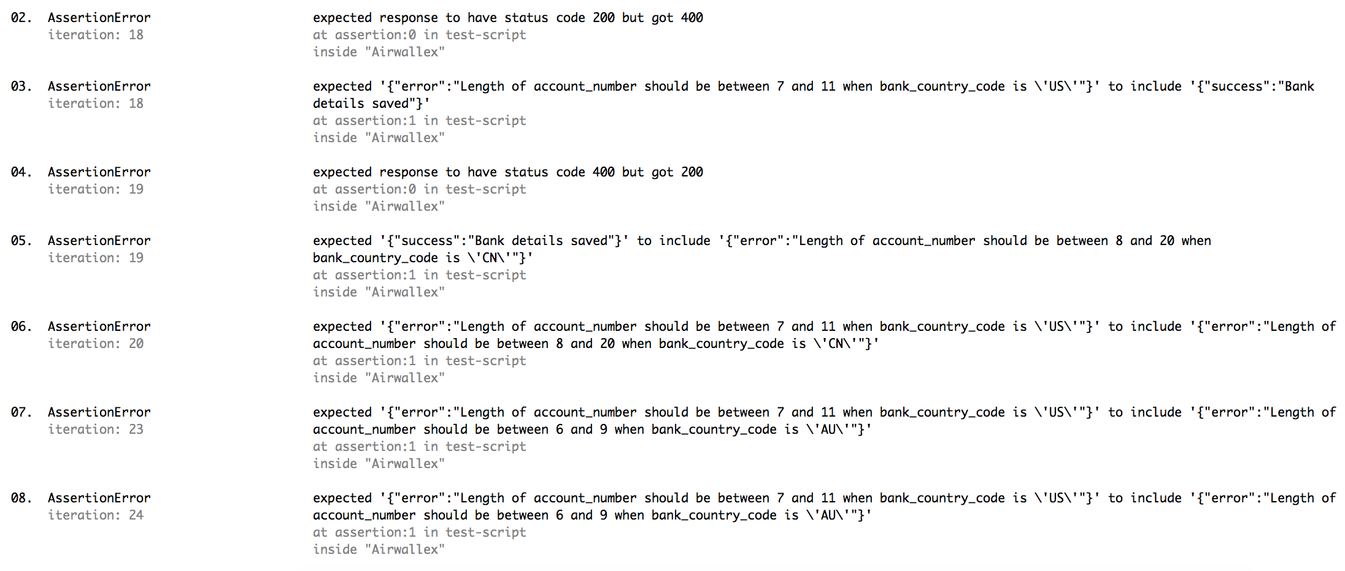

Incorrect validation for account_number length when the country code is CN or AU. For CN, the length should be between 8-20 characters and for AU the length should be between 6-9 characters. See lines 19, 20, 21, 24 and 25 of data.csv

1. **Swift code length should only be 8 or 11**

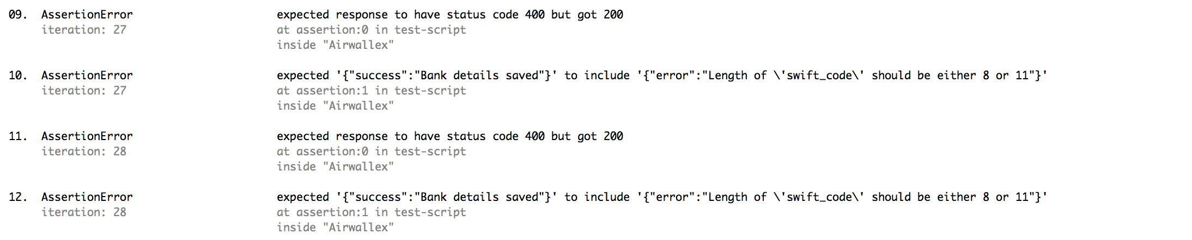

Swift codes with lengths of 9 and 10 are currently being allowed, whereas these should only be 8 or 11 characters long. See lines 28 and 29 of data.csv

1. **Aba should be mandatory for US**



When the bank_country_code is US, the aba value should be mandatory – currently it isn’t. See line 38 of data.csv