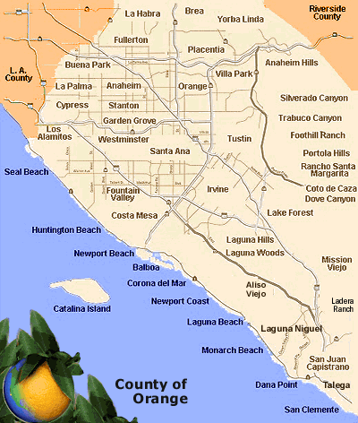

<https://www.orangecounty.net/html/cities.html>

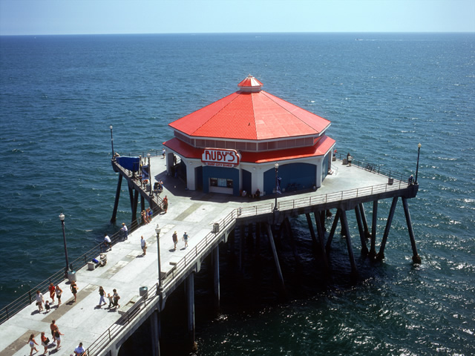

<https://www.californiabeaches.com/restaurant/rubys-diner/>



<https://www.ocregister.com/2018/02/28/best-thing-i-ate-this-spicy-noodle-soup-in-irvine-is-worth-standing-in-line-for/>



<https://www.ocregister.com/2019/01/11/cauldron-ice-cream-brings-its-puffle-cone-fluffypuff-sandwich-to-new-irvine-shop/>

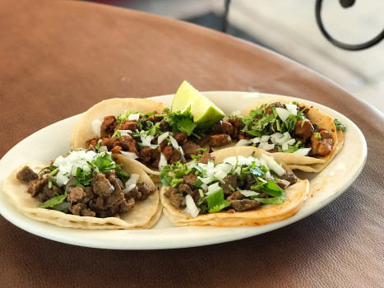

<https://www.ocregister.com/2019/01/15/taco-tuesday-mi-casa-in-orange-is-like-a-food-truck-with-walls/>



<https://disneyland.disney.go.com/destinations/disneyland/>

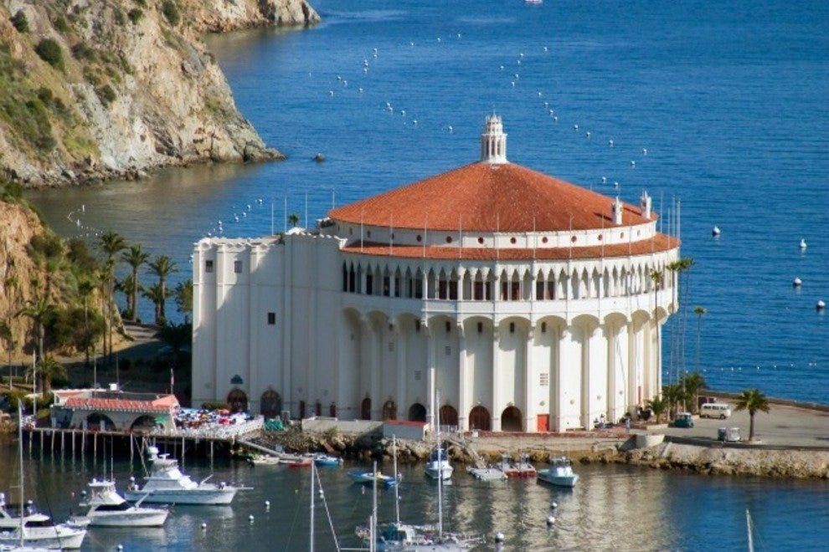

<https://www.10best.com/destinations/california/orange-county/attractions/>



<https://www.foapom.com/>

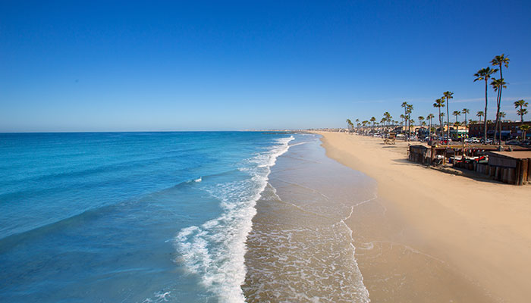

<https://www.visitnewportbeach.com/hotels/newport-beach-timeshare-rentals/>

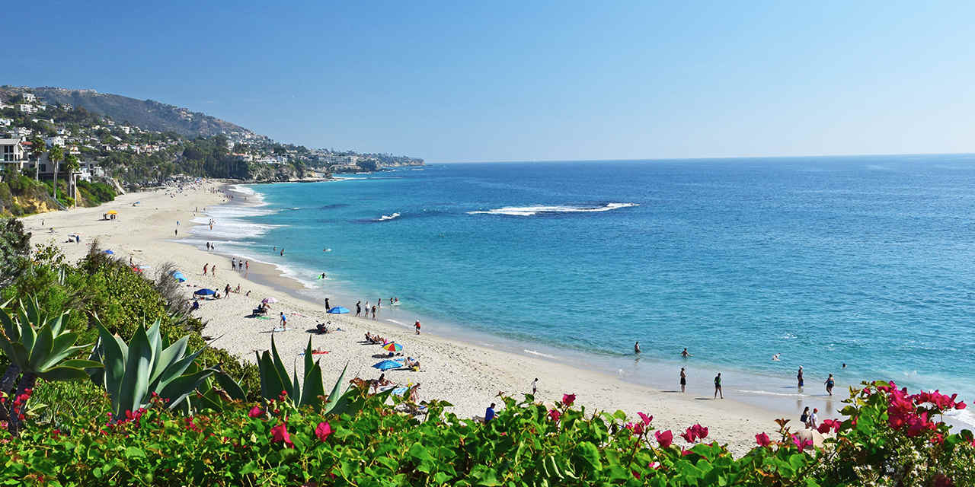

<https://www.visitcalifornia.com/au/attraction/laguna-beach>

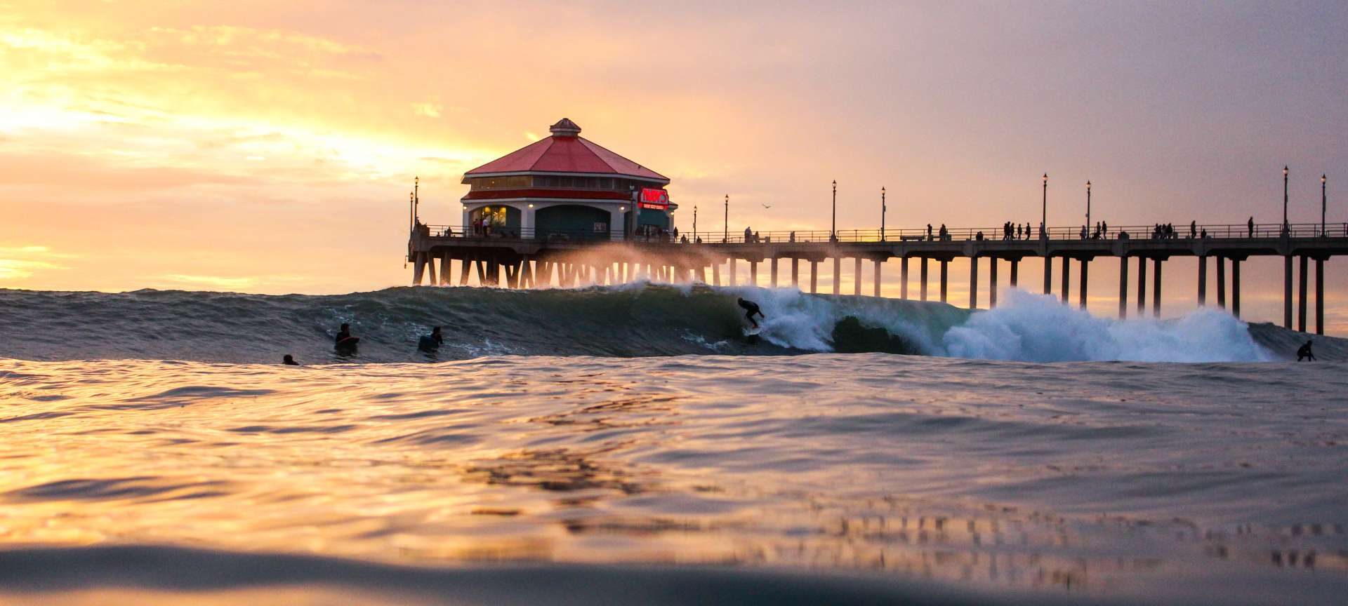

<https://www.surfcityusa.com/about-huntington-beach/>

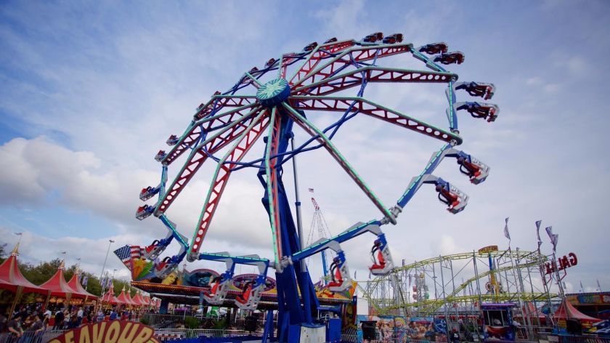

<https://www.latimes.com/socal/daily-pilot/news/tn-dpt-me-of-fair-advance-20170707-story.html>

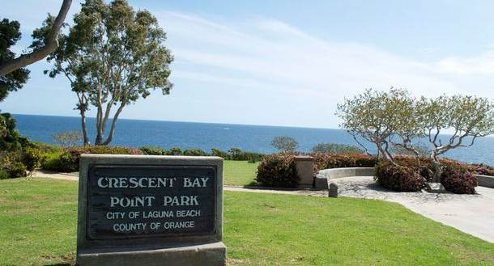

<https://www.visitlagunabeach.com/directory/crescent-bay-point-park/>



<https://fullertonarboretum.org/>



<https://www.visitlagunabeach.com/blog/lagunas-hidden-history-the-victoria-beach-pirate-tower/>