ZERAKI ACHIEVERS’ EXAMINATION
END OF TERM 1 ASSESMENT
FORM THREE EXAM
BIOLOGY PAPER 2 MARKING SCHEME
1. (a) (i) Cell membrane;
(ii) Tracheole system/Tracheoles; ( 2mks)
(b) (i) A. – (Gill) filament, rej. Filaments
B. – (Gill) bar;
C. – (Gill) racker; Rej: rakers
(ii) Prevent solid particles from harming/injuring gill filaments;
(iii) – Thin membrane for fast diffusion of gases;
- Supplied with blood capillaries to transport gases; ( any 2)
- Spread singly in water to increase surface area for gaseous exchange;
Rej: moist (2mks)
2. (a) A – Cortex
B – Pith
(b) C – Transport soluble manufactured food/translocation from leaves the other parts of plant;
D – Leads to secondary growth/manufacture xylem/phloem;
E – Transport water and mineral ions from root to other parts of the plant; (3 mks)
(c) Stem Root section
Has pith Lacks pith;
Has cambium ring Lacks cambium ring;
Vascular bundles are Xylem is star-shaped and at the centre with phloem
in cambium ring in between the arms of xylem;
Lacks root hairs Has root hairs ; ( any 3) (3 mks)
3. (a) (i) To find out the products formed when food is burnt/oxidized; (1mk)
(ii) Water vapour accumulates on the walls of test tube; while lime water in test tube B forms white
precipitate; (2 mks)
(iii)When burnt /oxidized, food substances produce water and carbon (IV) oxide; (1mark)
(b) (i) To investigate anaerobic respiration in yeast cells/fermentation.
(ii) To avoid destroying/killing yeast cells and to remove oxygen; rej air (1mk)
(iii) To avoid denaturing enzymes in yeast cells; (1mk)
(iv) Prevent re-entry of air into yeast solution; (1mk)

4. (a) (i) Osmotic extraction of water from the tissues which may lead to dehydration/excessive loss of
water; (1mk)
(ii) Osmotic influx of water in the tissues which may cause dilution of protoplasm/bursting of cells;
(1mk)
(b) (i) High glomerular filtration rate;
Numerous and large glomeruli;
Excrete large amounts of hypotonic urine; ( any 2)
Excrete nitrogenous waste inform of ammonia which require a lot of water for removal;
Chloride excretory cells in gills take up salt actively; (Any two ( 2mks)
(ii) Low filtration rate;
Fewer and smaller glomeruli;
Excrete small amount of hypotonic urine; ( any 2)
Excrete nitrogenous waste in a less toxic form/ trimethylamine oxide which require less water;
chloride secretory cells exclude salts. (Any two 2 mks)
(c) At a low temperature metabolic activities/respiration is high; producing more water/metabolic wastes
hence more urine than when hot;
At a low temperature less sweat is produced hence more water retained in the blood therefore more
water is filtered out by the kidney tubules leading to production of more urine; (max 2)
5. (a) (i) Distilled water is hypotonic /less concentrated than cell sap; cells absorb water by osmosis; hence turgor pressure increased leading to curling; cortical cells curl more because they absorb water more than epidermal cells; ( 3marks)

ii) salt solution is hypertonic to cell sap/ more concentrated than cell sap; water move from the cells by osmosis; and becomes plasmolysed/ turgor pressure/turgidity is lost; hence straighten out; (3 mks)
(b) Cortical cells have a higher turgor pressure than epidermal cells; hence curve outwards; (2mks)

6.(a) Graph
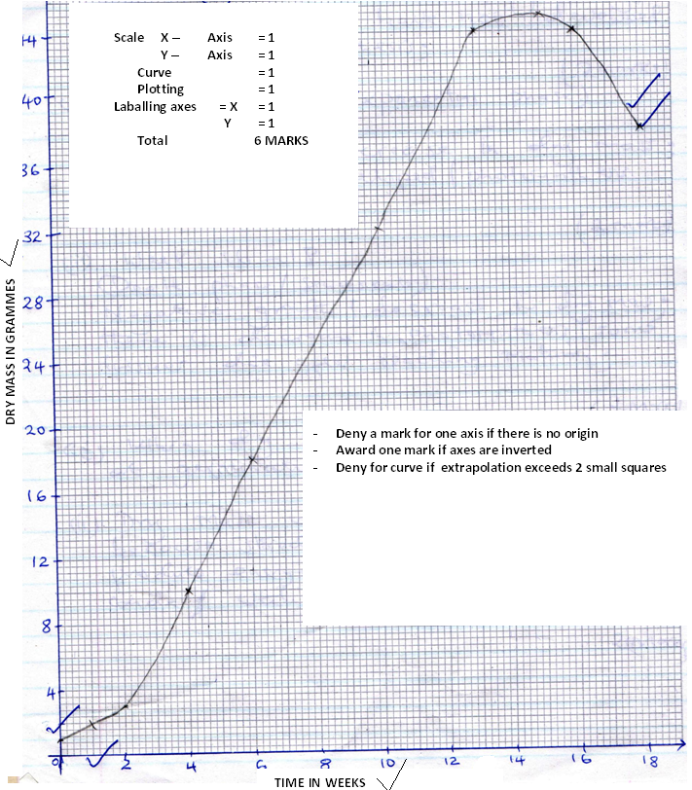

(b) (i) 0 – 2 weeks (Lag phase)
Dry mass increased slowly/gradually; because the plants have not developed leaves for photosynthesis; (2 mks)

(ii) 5 – 13 weeks (Exponential phase)
Rapid growth/increase in dry mass; Leaves have developed/photosynthesis is taking place;
(iii) 16 – 18
(Death phase/senescence)
Negative growth/decrease in dry mass;
There is decrease in photosynthesis/some tissues die after reaching maturity;
(2 mks)
(c) (i) When dry mass was first recorded at germination; (1 mk)
(ii) Dry mass would decrease first; because stored food is oxidized to produce energy, water and
carbon IV oxide/utilized in respiration; ( 2 mks)
(d) (i) Harvest every week an equal number of seedlings ; dry in an oven to a constant dry mass; calculate
the average mass for one seedling; and record results;
(ii) Advantage:
Dry mass is not affected by environmental conditions. (1mk)
Disadvantage
Fresh weight is dependent on the amount of water in the plant which fluctuate with environmental
factors affecting transpiration rate.
7. (a) Red blood cells; transport oxygen from the lungs to body tissue; (in the form of oxyhaemoglobin)
Transport carbon IV oxide; from body tissue to the lungs; (in the form of bicarbonate)
Plasma; Transport dissolved food nutrients/glucose/amino acids; from the small intestines to the liver and other body tissues; transport hormones/enzymes; from secretory glands to tissues where required; transport urea; from tissues to the kidneys for excretion; distribute heat; (12mks)
(b) White blood cells; engulf; and destroy bacteria/pathogens by producing antibodies; which destroy
them/produce antitoxins which neutralize bacteria toxins;
Blood platelets; cause blood clotting; on fresh wounds preventing entry of bacteria/pathogens into
tissues; prevents loss of excess blood, water and mineral salts;
(8 marks)
8. Wind dispersal;
Small and light; to float in air/blown by air; Have wings; to increase buoyancy;
Have hairs/parachute shaped; to increase buoyancy in air.
Animal dispersal;
Are succulent; to attract animals;
Scented; to attract animals.
Have small and hard seeds resistant to digestive enzymes; to prevent digestion once swallowed; Have
hooks; to attach to fur/hair of animals;
Brightly coloured; to attract animals;
Water dispersal;
Water proof epicarp; to prevent entry of water or soaking;
Fibrous mesocarp; with air spaces to increase buoyancy in water;
Self-explosive mechanism;
Have lines of weakness; where they break to release seeds;
Have rings of pores; through which seeds are released;
25 marks
Max 20marks

