**Wine Tracker: UI Design**

Course Code: COMP 3097

Submitted To: Przemyslaw Pawluk

Created By:

Samuel Benoit – 101007189

Thomas Del Rosario – 101017215

Introduction:

Wine Tracker is the topic myself and Thomas chose for our project. While creating a layout for our wine tracker. Thomas and I chose to create a design that is user friendly and light weight. The user interface design is neat and well organized. Buttons are evenly spaced and intuitively ordered so users may easily perform CRUD operations on their persistently store wines. With a small hint a color to add life.

Wine List

The conceptual design below presents the layout wine list. The list displays the name of each wine saved on the IOS device. Users may use this list to delete a wine entity in the list by swiping a wine cell to the right.

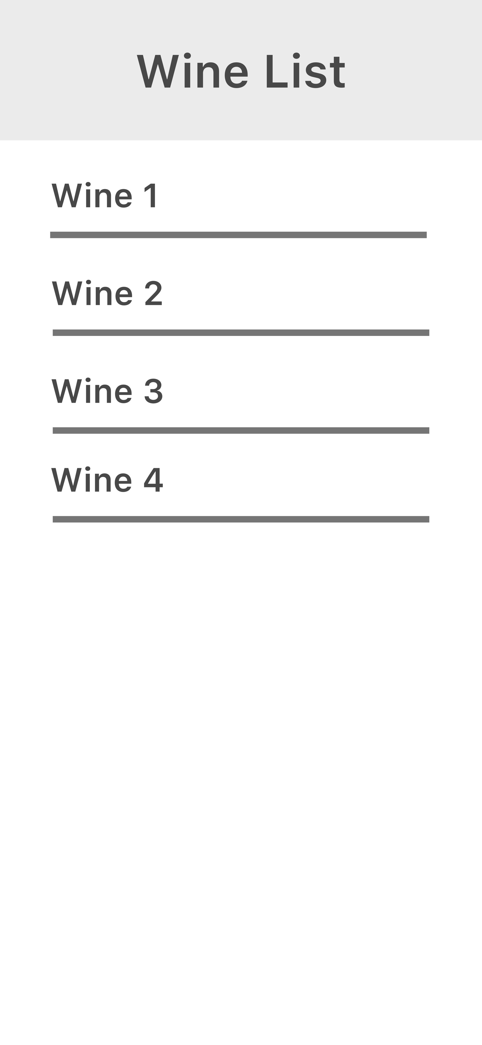

Wine Form

The conceptual design below presents the layout wine form. This form is used to create and update a wine entity.

