**National Citizens Record Unification Project (NCRUP)**

The project uses a web application to simulate and provide a framework for unifying citizen records from NIMC, FRSC, INEC, and Immigration, while making sure that each agency has access to only information that pertains to them from the unified citizen’s record.

The program displays a representation of the various agency databases and a unified (central) database, it uses a unique identification number called the UCR number (UCR means unified citizen records) as a unique identification number for each citizen for the unification and harmonization of citizen records across the agencies.

**The following are the steps to run the web application:**

1. Install XAMPP: Download and install the latest version of XAMPP from the Apache Friends website (<https://www.apachefriends.org/index.html>.
2. Start XAMPP: Launch the XAMPP control panel. Start the Apache and MySQL services by clicking the "Start" button next to each of them. Ensure that both services are running, indicated by green status indicators.
3. For the Database: Access phpMyAdmin by clicking on the "Admin" button next to MySQL. Create a new database named “ncrup”, select it, click on the "Import" tab, choose the SQL file “ncrup.sql” in the project folder (NCRUP), and click "Go" to import the database. -Ensure that your database credentials are set to default, i.e. servername = "localhost"; username = "root"; password = "";
4. Locate the htdocs folder: The htdocs folder is the default directory where you can place your web app files. By default, it is in the XAMPP installation folder. You can access it by navigating to the following path:

-For Windows: C:\xampp\htdocs\

-For macOS: /Applications/XAMPP/xamppfiles/htdocs/

-For Linux: /opt/lampp/htdocs/

1. Copy the Project Folder (NCRUP): Inside the htdocs folder, copy and paste the project folder. This will serve as the root folder for the web app.
2. Access the web app: Open your web browser and enter "localhost/ NCRUP /index.php" in the address bar. If everything is set up correctly, the web app should load.
3. The Webapp consists majorly of five buttons, one for each agency database representation, and the unified citizen records display. The buttons lead to a login page for the respective agencies and unified citizen records, which when logged in leads to a PHP CRUD display of their respective agency database tables, in the cmp212ucr database.

* In the agency webpages, there are options to:

-Add new citizen: This leads to a form for filling in relevant citizen information and adding it to the agency table as well as the unified records table in the database.

Note: The UCR number is a primary key, meaning, if a citizen is added (registered) in one agency, the same UCR number is to be used for that citizen’s registration across other agencies, to ensure the harmonization of the citizen data.

-Update: This leads to a form for updating/editing an added(registered) citizen’s information and updates it in the agency tables as well as the unified records table in the database.

-Search: This consists of an input bar where the UCR number of the Citizen is required for the search.

-Delete: This deletes an entire citizen’s record from the agency tables as well relevant records from the unified records table in the database.

Note: Triggers are set up in the agency tables to automatically update the unified citizen records table whenever any operations such as insertions, updates, or deletions occur. These triggers ensure that changes made to the agency tables are reflected in the unified records, maintaining data synchronization across all agencies.

-Access Unified Records: This leads to a login page, which then leads to a PHP CRUD display of only agency relevant data from the unified records tables.

* In the Unified Citizen Records webpage, there is a PHP CRUD display of the unified citizen records from the unified records table synchronized from across the four agency tables of each citizen using a unique identification number (UCR Number).

**Visual Guide to WebApp Functionality**

1. **Homepage**: In the Web app’s home page(index.php), users can access different sections of the application by clicking their respective buttons. These sections are the CRUD display for the database tables related to NIMC, INEC, FRSC and Immigration.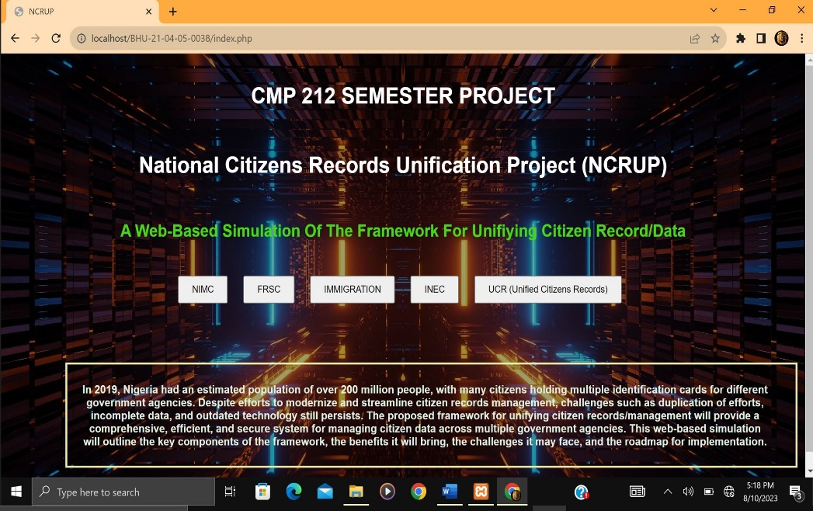
2. **NIMC Section:** (Username and password are pre-filled);

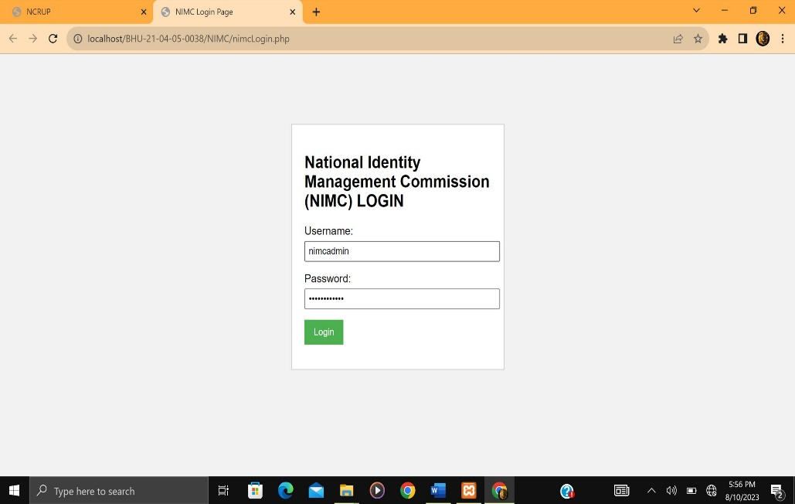

Upon successful login the NIMC section of the web app displays:

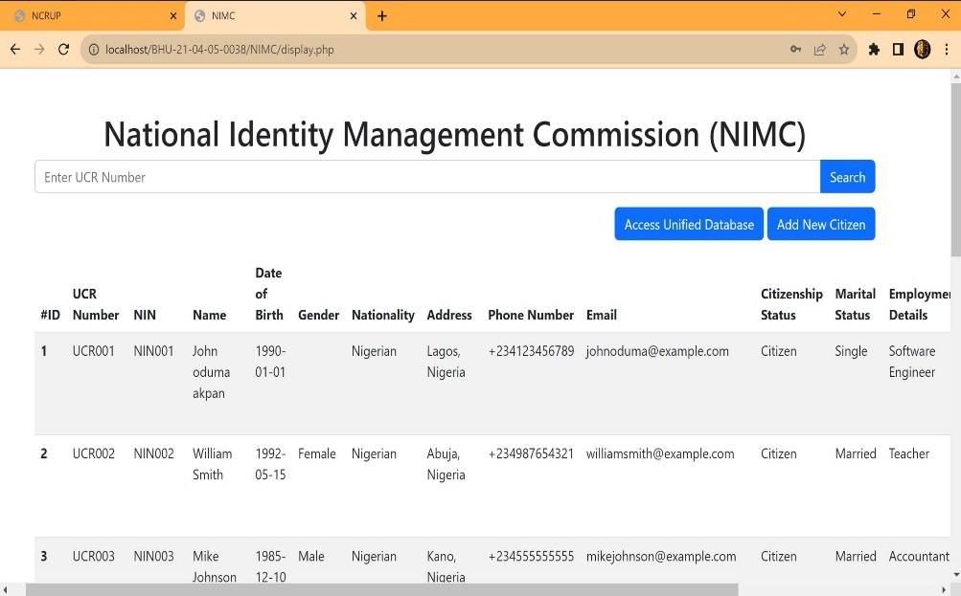

Above is a CRUD display of the NIMC table in the database, with options to add, update, search, and delete citizen records, as well as an option to access unified citizen records with information pertaining only to NIMC.

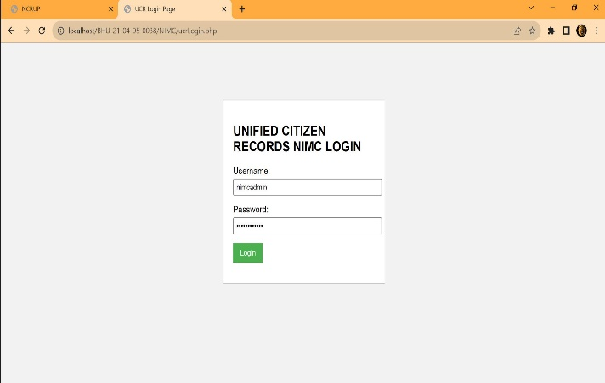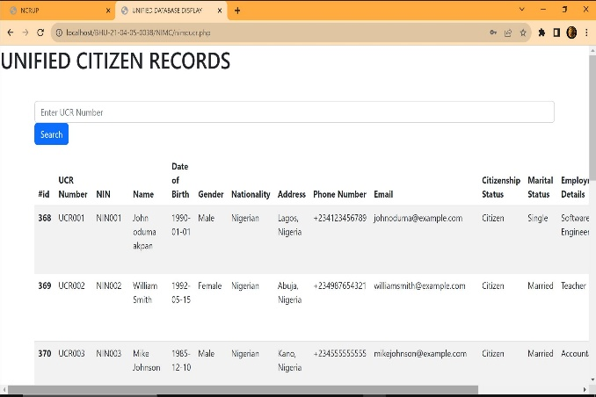

Above is the login page proceeding to the section of the CRUD display of unified citizens record from the unified citizens record database table with information pertaining only to the NIMC.

1. **FRSC Section:** (Username and password are pre-filled);

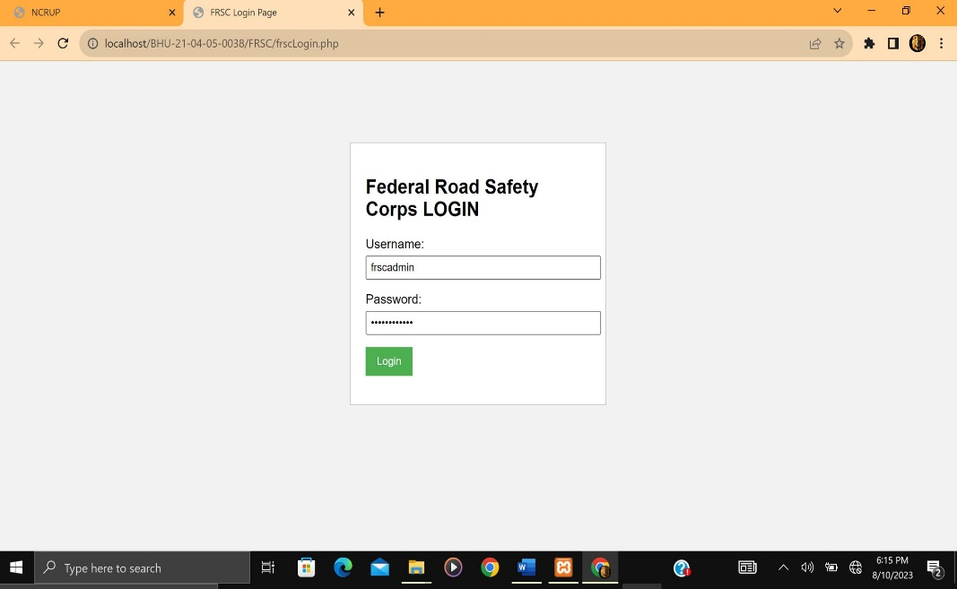

Upon successful login the FRSC section of the web app displays:

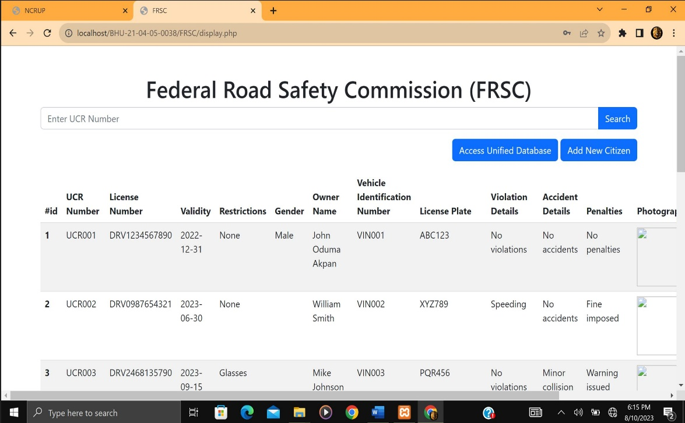

Above is a CRUD display of the FRSC table in the database, with options to add, update, search, and delete citizen records, as well as an option to access unified citizen records with information pertaining only to FRSC.

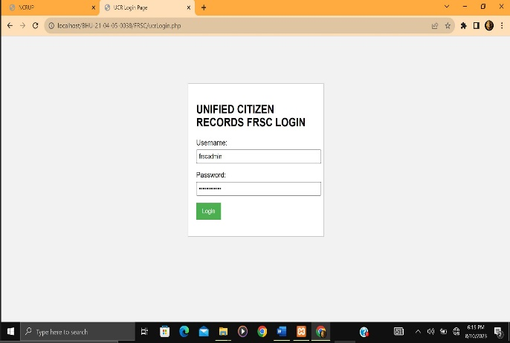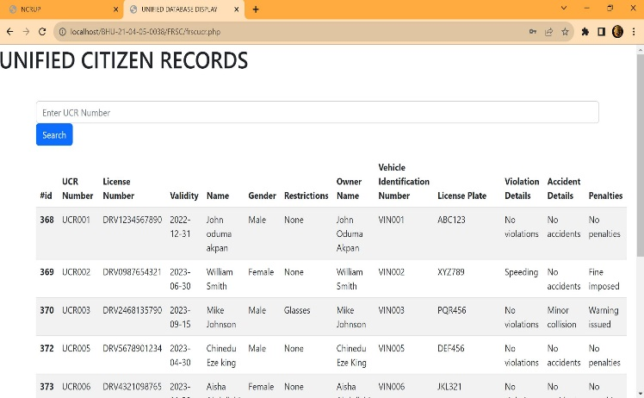

Above is the login page proceeding to the section of the CRUD display of unified citizens record from the unified citizens record database table with information pertaining only to the FRSC.

1. **Immigration Section**: (Username and password are pre-filled);

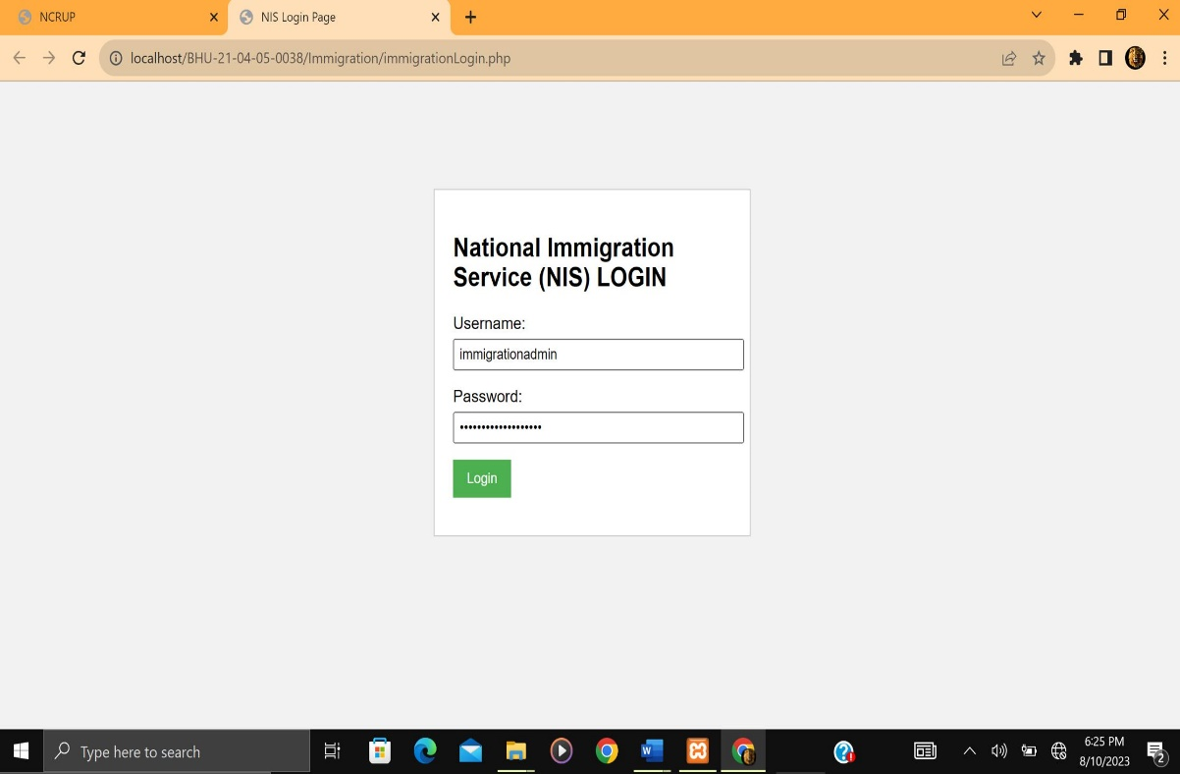

Upon successful login the Immigration section of the web app displays:

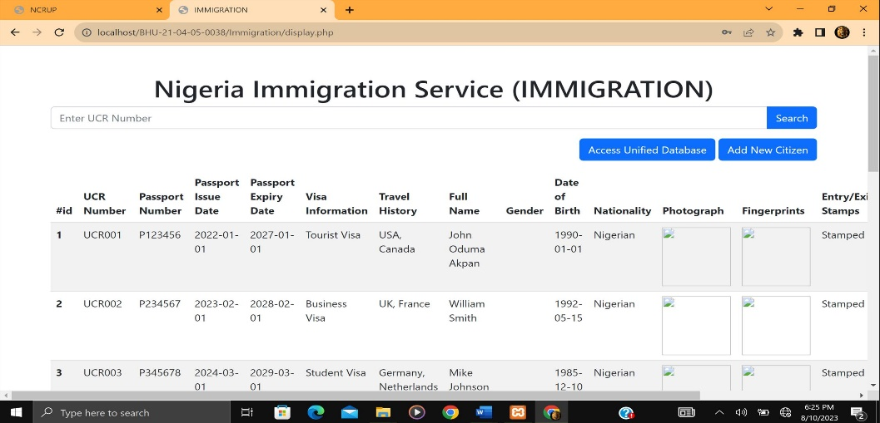

Above is a CRUD display of the Immigration table in the database, with options to add, update, search, and delete citizen records, as well as an option to access unified citizen records with information pertaining only to Immigration.

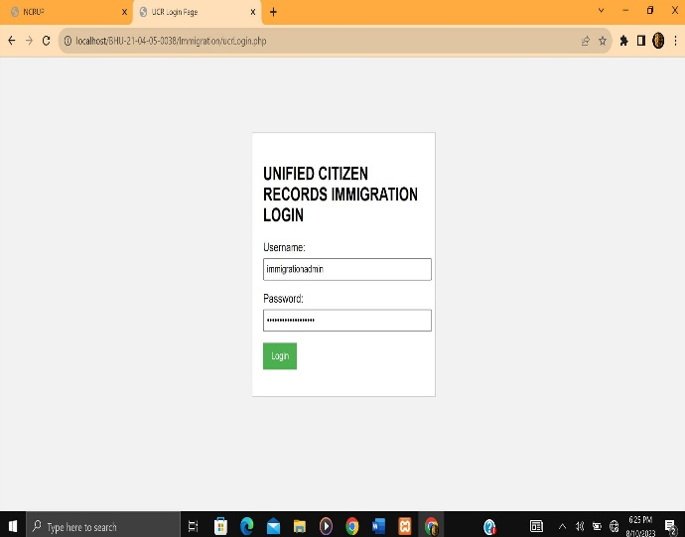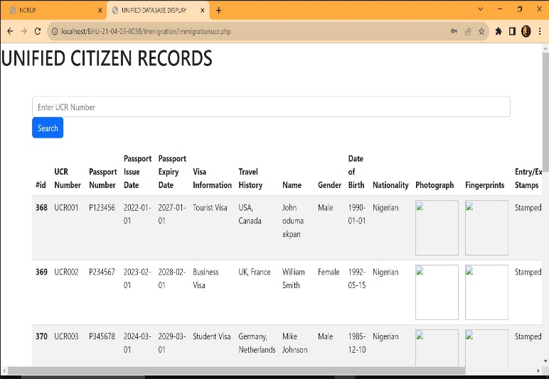

Above is the login page proceeding to the section of the CRUD display of unified citizens record from the unified citizens record database table with information pertaining only to Immigration.

1. **INEC Section:** (Username and password are pre-filled);

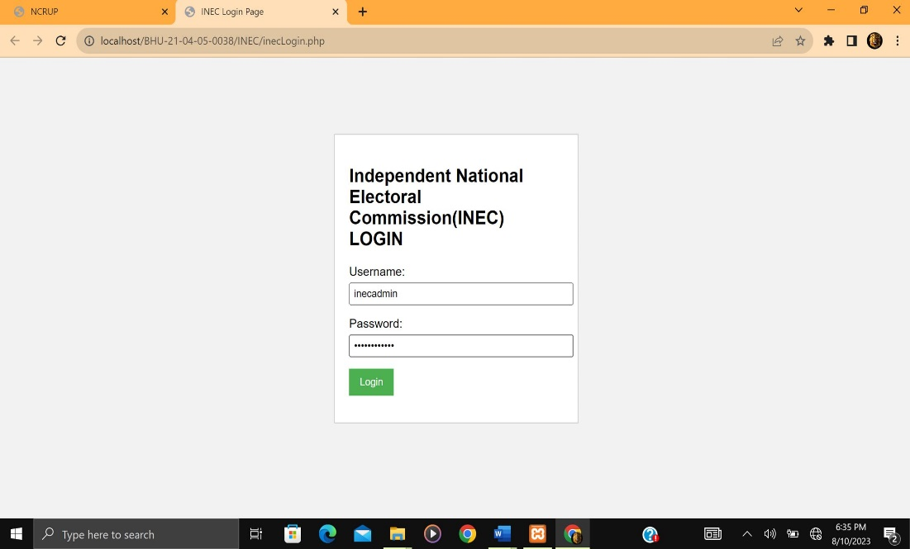

Upon successful login the INEC section of the web app displays:

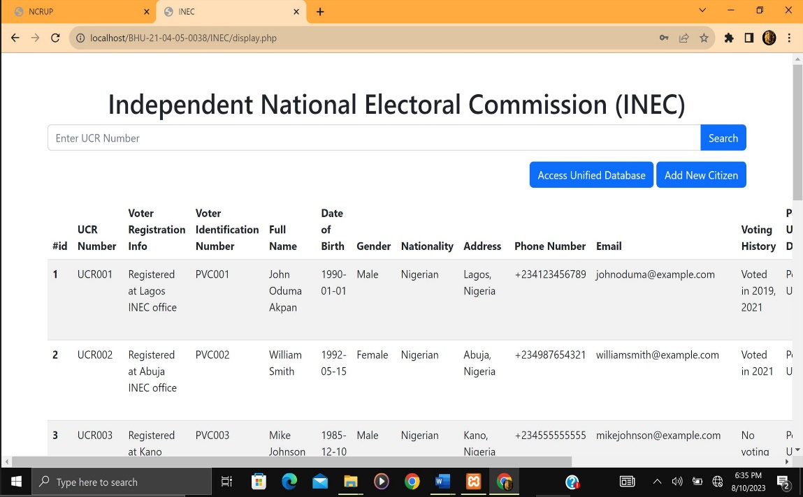

Above is a CRUD display of the INEC table in the database, with options to add, update, search, and delete citizen records, as well as an option to access unified citizen records with information pertaining only to INEC.

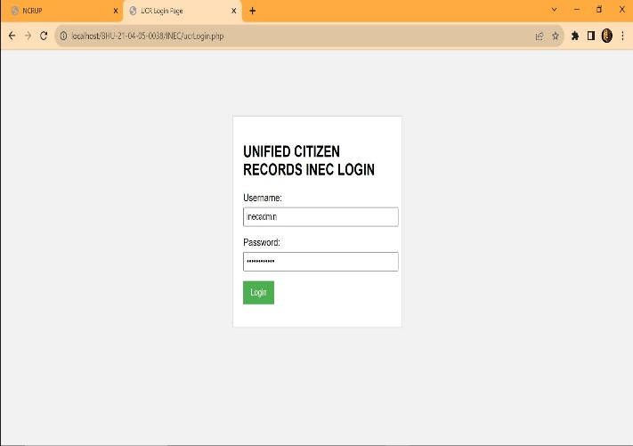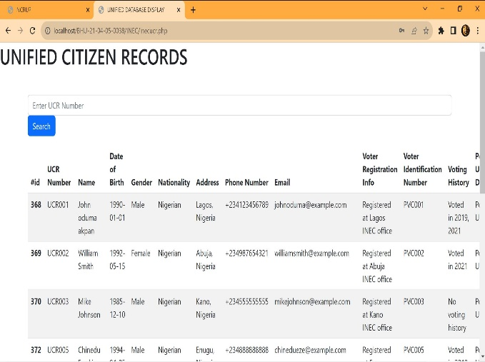

Above is the login page proceeding to the section of the CRUD display of unified citizens record from the unified citizens record database table with information pertaining only to the INEC.

1. **Unified Citizens Records (UCR) Section**: (Username and password are pre-filled);

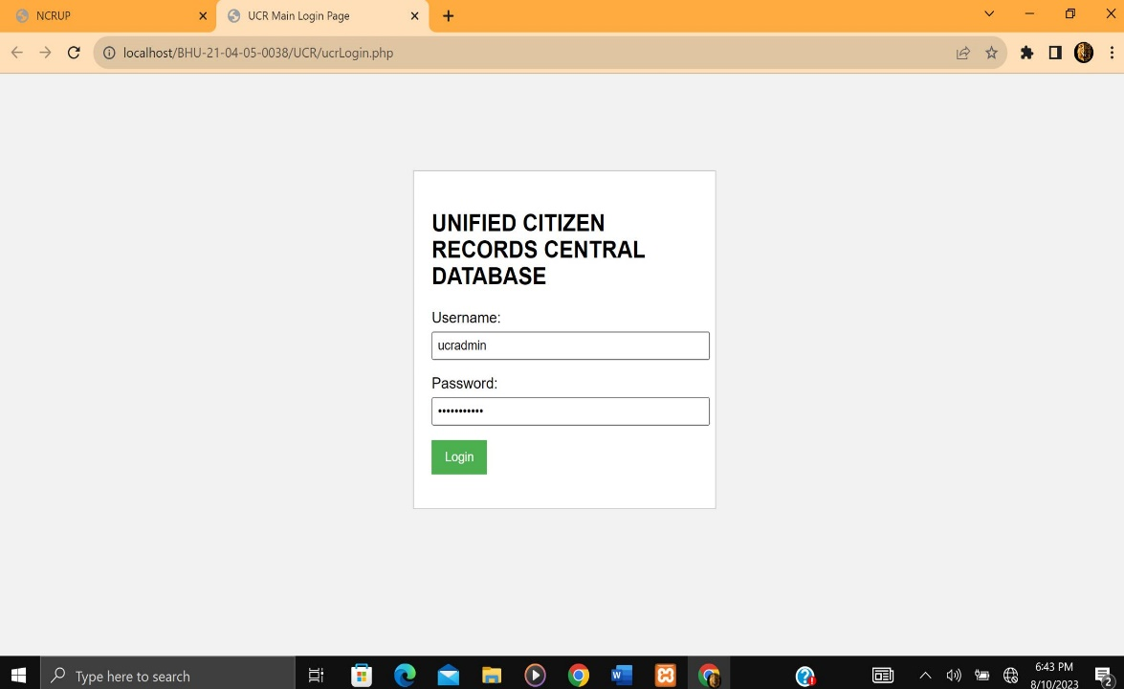

Upon successful login the Unified Citizens Records (UCR) section of the web app displays:

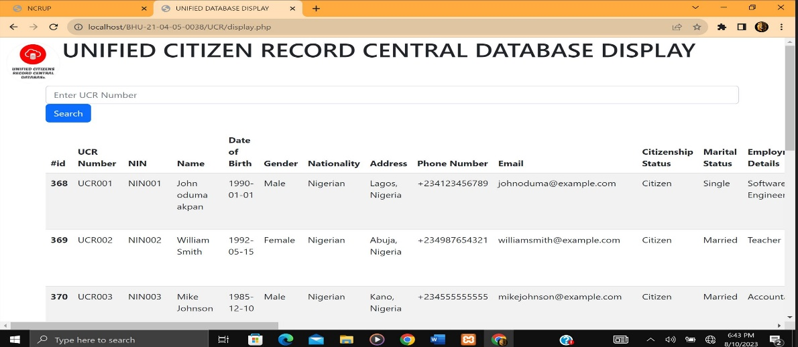

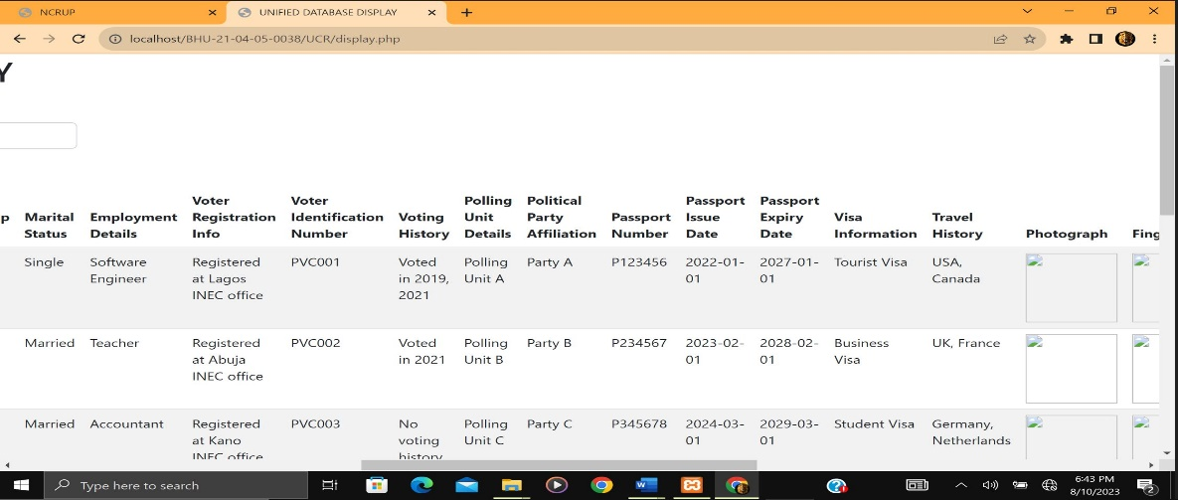

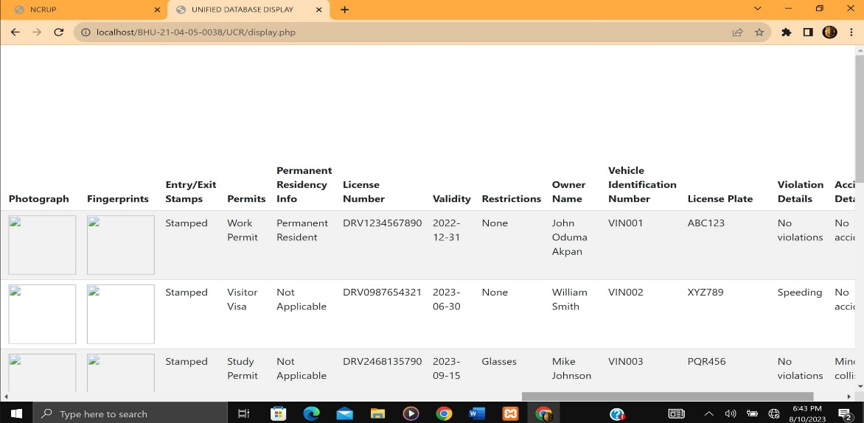

Above is a CRUD display of the Unified Records table in the database, containing the unified records of citizens across all four agencies tables using a unique identification number (UCR number).

**Overview of How the Web App Achieves the Framework for the Unification of Citizen Records Across the Four Agencies (NIMC, FRSC, INEC, and Immigration).**

* + Folder Structure: The project's folder structure organizes the codebase into separate folders for each agency (NIMC, FRSC, INEC, and Immigration) and a folder for unified citizen records (UCR). Each agency folder contains PHP files responsible for CRUD operations on their respective agency databases. The UCR folder has PHP files for connecting to the database and displaying unified data.
  + Agency Databases: Within the database, there is a separate table for each agency (NIMC, FRSC, INEC, Immigration). These tables store the relevant citizen data specific to each agency, allowing for agency-specific operations and maintenance of their individual records. The agency tables primary key is the UCR number, providing a unique identifier for each citizen record.
  + Unified Citizen Records (UCR) Table: In addition to the agency tables, there is a unified citizen records table. This table serves as a centralized repository for citizen data across the four agencies. It contains records that are common to all agencies, enabling data integration and ensuring consistency across the system. The UCR table's primary key is the UCR number, providing a unique identifier for each citizen record.
  + Triggers: Triggers are set up in the agency tables to automatically update the unified citizen records table whenever any operations such as insertions, updates, or deletions occur. These triggers ensure that changes made to the agency tables are reflected in the unified records, maintaining data synchronization across all agencies. Whenever an agency's table is modified, the corresponding trigger initiates the necessary updates in the UCR table, ensuring the unified view of citizen records remains up to date.
  + Web Interface: The index.php file serves as the main entry point for the web application. It contains an HTML and CSS web page with buttons representing the four agencies. By clicking on a button, users can access the respective agency's database, where they can perform CRUD operations on the specific agency's citizen data.
  + UCR Display: The UCR folder's display.php file is responsible for presenting the unified citizen records in a consolidated view. It connects to the UCR table in the database and retrieves the data, providing users with a comprehensive display of citizen records across all agencies.
* By employing this web app framework, I have created a system that brings together citizen records from multiple agencies, enabling efficient data management, synchronization, and access across the four agencies involved. Users can interact with individual agency databases while also having access to a unified view of citizen records, ensuring consistency, and facilitating the unified management of citizen data. The use of triggers ensures that changes made in the agency tables are automatically propagated to the unified records, simplifying the maintenance of a synchronized and up-to-date database. Having the UCR number as the primary key in the agency tables allows for efficient retrieval, updating, and referencing of individual citizen records within each agency's database. It ensures that each agency has a consistent and unique identification system for its citizen records.

The proposed framework for unifying citizen records across multiple agencies has several advantages, but it also comes with its own set of challenges. Let's discuss the advantages, disadvantages, processes, and the implementation considerations for this framework:

Advantages:

* + Centralized Data Management: The framework centralizes citizen records into a unified database, allowing for easier management, integration, and retrieval of data across agencies. It eliminates the need for maintaining separate databases for each agency, reducing redundancy, and improving data consistency.
  + Data Synchronization: The use of triggers ensures that any changes made in the agency-specific tables are automatically reflected in the unified citizen records. This ensures data synchronization and minimizes the risk of inconsistencies across databases.
  + Enhanced Data Access and Analysis: With a unified database, authorized users can access citizen records from multiple agencies simultaneously, facilitating comprehensive data analysis and generating insights that may not be possible when data is siloed.
  + Streamlined Processes: The framework provides a standardized approach to CRUD operations, ensuring consistency in data management processes across agencies. It simplifies the development and maintenance of web applications by reusing common components for database connections, CRUD operations, and data display.

Disadvantages and Challenges:

* Data Security and Privacy: Unifying citizen records raises concerns regarding data security and privacy. Special attention must be given to access control, data encryption, and compliance with privacy regulations to protect sensitive information.
* Complex Integration: Integrating existing agency databases into a unified system can be a complex process, involving data mapping, data transformation, and database schema modifications. Careful planning and coordination are required to ensure a smooth transition.
* Agency Cooperation: The framework's success relies on the cooperation and willingness of the participating agencies to share data and collaborate on system integration efforts. Inter-agency communication and agreement on data standards and protocols are essential.

Implementation Considerations:

* Planning and Requirements: Clearly define the objectives, requirements, and scope of the unified system. Identify key stakeholders, data sources, integration points, and establish a detailed implementation plan.
* Data Mapping and Transformation: Analyze the existing agency databases and identify common fields and data structures to facilitate data mapping and transformation. Develop strategies to handle data inconsistencies, duplicates, and conflicts.
* Database Design and Schema: Design a robust and scalable database schema that accommodates the data requirements of all agencies and the unified records. Consider performance optimization techniques, such as indexing and normalization, to ensure efficient data retrieval.
* Integration and Testing: Implement the necessary code and scripts to integrate the agency databases into the unified system. Conduct thorough testing to validate data accuracy, system functionality, and performance under various scenarios.
* Security and Privacy Measures: Implement stringent security measures to protect citizen data, including access controls, encryption, secure data transmission, and compliance with relevant privacy regulations such as GDPR or HIPAA.
* User Training and Change Management: Provide training and support to end-users on the new system, ensuring their smooth transition and adoption. Implement change management strategies to address resistance to change and promote user acceptance.
* Overall, the proposed framework offers significant benefits in terms of centralized data management, synchronization, and streamlined processes. However, it also requires careful planning, addressing security and privacy concerns, effective integration strategies, and cooperation among participating agencies for successful implementation.