***Executive Summary***

The objective is to utilise voting patterns of UK MPs in order to predict their corresponding political affiliations and the 2016 UK referendum outcome in the respective MPs’ constituency. By employing techniques from data mining to generate such predictions using the votes cast in the two rounds of indicative votes on 27th March and 1st April 2019, it was found that MPs’ political affiliations can be predicted with more than 95% accuracy, whereas predicting their constituencies’ 2016 referendum result is more challenging. This suggests that MPs voted similarly to their fellow party members, even though the parties allowed these to be “free votes”1.

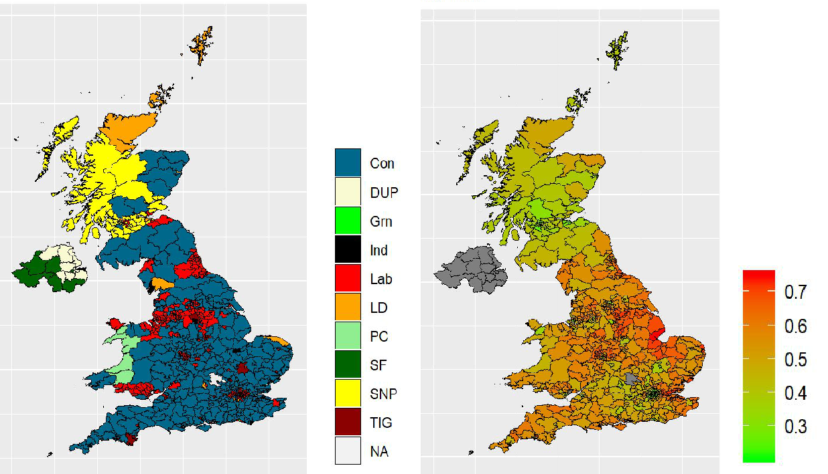

Figure 1 - Left: Constituencies by parties shown across the UK. Right: Percentage of leave vote in the 2016 referendum (0 is 0% Leave and 1 is 100% Leave). Generated from our dataset.

From the models built, it was also evident that some votes were more central in aiding the prediction process. This implies that following this machine-learning based analysis process one could extract knowledge from voting patterns beyond what is visible in basic analyses, and so could be utilised further to provide insights into future voting patterns. This approach is able to uncover patterns which may be able to inform the public in their future choices, and increase transparency of the democratic process.



* Article regarding free votes:

<https://www.ft.com/content/e242335a-5099-11e9-9c76-bf4a0ce37d49>

***Methods***

For the analysis, we have fit nine computationally intensive machine learning models per prediction objective, and the best model was chosen based on the accuracy in the predictions it provided. Despite the complexity of the best models, the most important votes were extracted to allow further interpretation.

***Findings and results***

Out of the variations we obtained, the best model for predicting the party membership of MPs performed at 95% accuracy. As a matter of fact, the underlying pattern was so clear that several models were able to perform at such a high level of accuracy. Even a very simple model based off whether or not an MP voted ‘For’ Votes 3 and 5 was able to predict party allegiance with >90% accuracy. Moreover, our best model has been chosen to provide a fair trade off among interpretability, complexity, and performance. The interpretability of this model allows us to see that the third vote of the first round (Labour's plan for a close economic relationship with the EU) is the most influential, and the eighth vote of the first round ( EEA/Efta without customs union Remain within the EEA and rejoin Efta but outside a customs union with the EU) is second most decisive in determining which party the MP belongs to. This is shown in the chart below.

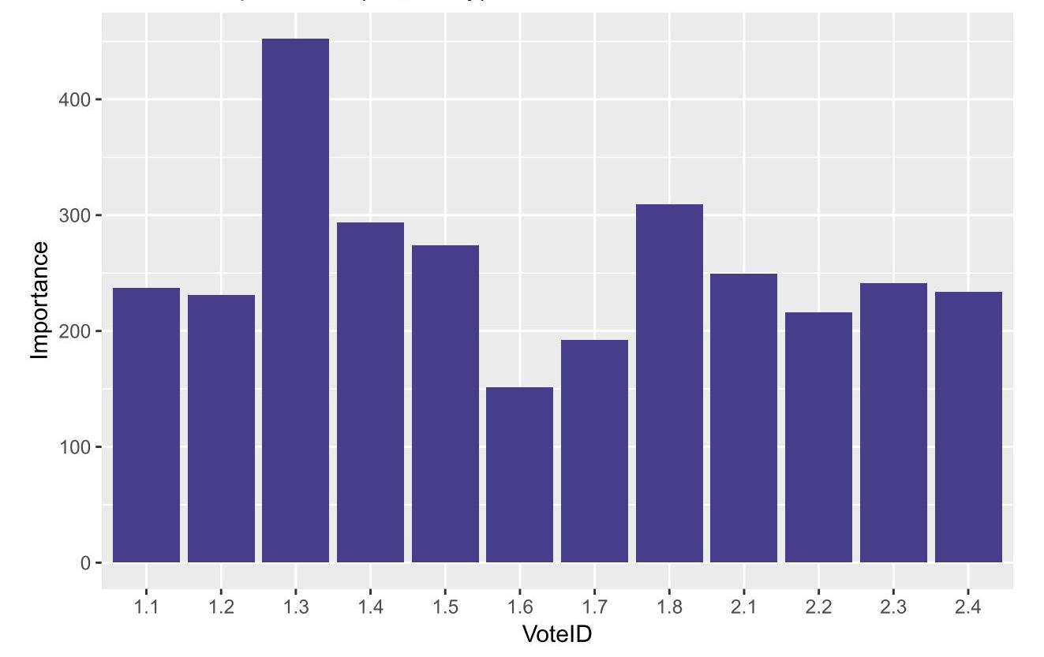

Figure 2 - Vote importance for predicting party affiliation which clearly shows the most important votes identified by our evaluation.

The second objective, predicting constituencies 2016 referendum outcomes, was a more challenging aim. When measuring the agreement between our numeric predictions and those we know to be the original measures, we can easily see that the agreement of the model fit was poor. This indicates that it is much more difficult to predict these from our recent parliamentary votes. In the search for better accuracy regarding the referendum result, we also built models to simply predict whether the constituency voted for Leave or Remain. The best of these models obtained an accuracy of 75%, which outperforms random predictions significantly. This means

that there is some relationship between the MPs indicative votes and their constituents’ referendum wish almost 3 years previously, as this has been picked up by the models. From these models we can again extract the importance of votes in predicting the referendum results.

It can be seen that the fifth vote in the first round (on the matter of revoking Article 50 two days before Britain would leave the EU without a deal) is the most influential factor and also that the fourth vote in the second round (let parliament decide the way forward and to extend Article 50) came second. It is not surprising in light of the fact that these two votes were similar in context. The rest of the votes were of lesser importance. This is illustrated in the chart below.

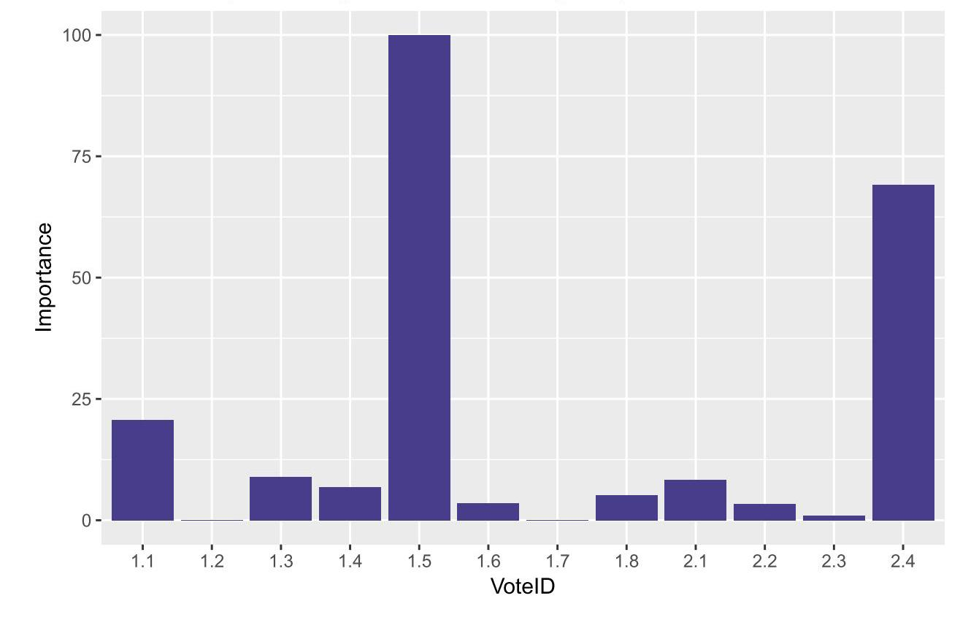

Figure 3 - Vote importance for predicting constituency vote which clearly shows the most important votes identified by our evaluation.

***Conclusion***

In this report, we have successfully constructed models using the indicative votes to capture more than 95% accuracy for MPs’ political affiliations and more than 75% accuracy for the constituencies referendum result in our prediction, in spite of the time latency between the Brexit referendum in 2016 and the indicative votes in 2019. Consequently, the analysis process used in this project can be employed in the future to provide insight into voting patterns in Parliament in a systematic manner, highlighting which votes matter the most through the analysis of votes’ importances. This may include further studies that could be performed on MPs’ past voting patterns, related to past general elections and referenda, to possibly provide insight into future referendum results or general elections from their current voting patterns. As it stands, however, the patterns uncovered in this analysis of the indicative votes can make more transparent the inner workings of party allegiance within the democratic system, and can inform the general public of these.

Finally, as our models are able to predict party affiliations and constituencies’ referendum results, they are able to produce a prediction for any set of votes cast for the indicative votes questions. This means that any individual may submit their 12 votes and our models, treating their votes as legitimate votes cast by a fictional MP, can present them with their likely party affiliation and the 2016 referendum result of their fictional constituency. This could be implemented as an interactive online tool to engage the public in the proceedings of the Parliament.

***Github Repository***

For more details about the code used for this analysis please visit the Github repository using the link provided below:

[***https://github.com/samomidi/MPs_vote***](https://github.com/samomidi/MPs_vote)