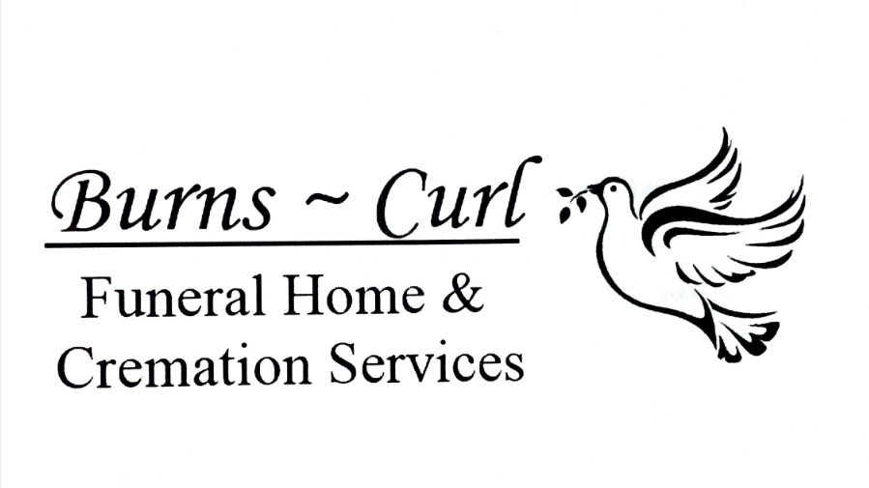

**RELEASE AUTHORIZATION**

THE UNDERSIGNED HEREBY AUTHORIZE

________________________________________________________

NAME OF INSTITUTION

TO RELEASE THE BODY AND PERSONAL EFFECTS OF:

________________________________________________________

NAME OF DECEASED

TO BURNS-CURL FUNERAL HOME & CREMATION SERVICES OR TO

BURNS-CURL CREMATION & FUNERAL SERVICES AND OR ITS AGENTS.

I HEREBY REPRESENT THAT I AM OF THE SAME AND NEAREST DEGREE OF RELATIONSHIP TO THE DECEASED AND / OR ARE LEGALLY AUTHORIZED OR CHARGED WITH THE RESPONSIBILITY FOR BURIAL AND / OR DISPOSITION OF THE DECEASED.

_____________________________ __________________________________

NAME RELATIONSHIP TO DECEASED

_____________________________ __________________________________

SIGNITURE DATE

Burns-Curl Funeral Home & Cremation Services

1-303-562-8613 Burns.Curl.Cremation.Funeral@Gmail.Com