Release Control System

------File feature and deployment

1. File feature

* Modify file path to adapt release directory.

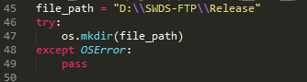

* Inherit fileadmin to define user permission

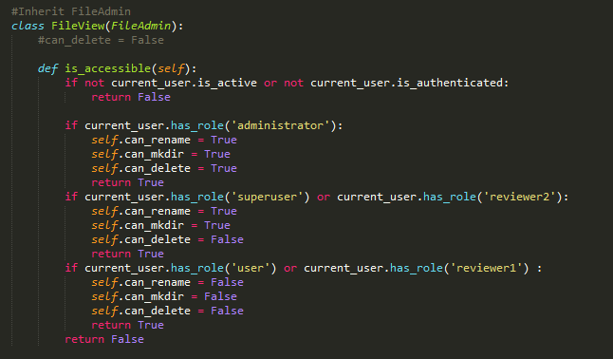

* Add file view

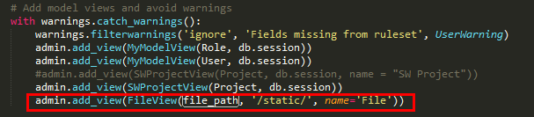

The above should be **admin.add_view(FileView(file_path, name='File'))**

Otherwise there will be an error when downloading the file since wrong path.

1. Deployment

* Install the needed package

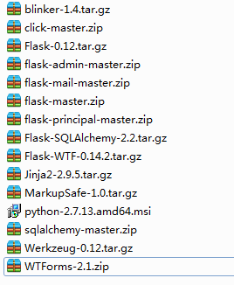

* Listen on every available network interface



* Change app.py to no console python file

Just rename app.py to app.pyw and double-click it to start.