Co-Authorship in AHRD Journals

Chad (Chungil Chae)

June 20, 2014

AHRD 저널들의 Co-authorshi 네트워크와 관련하여 시행순서에 대해 명시합니다.

Co-authorship의 네트워크 분석에 대한 순서입니다. - 1. 데이터 추출 - 2. 데이터 변환 - 3. 네트워크분석 - 4. 시각화

summary(cars)

## speed dist   
## Min. : 4.0 Min. : 2   
## 1st Qu.:12.0 1st Qu.: 26   
## Median :15.0 Median : 36   
## Mean :15.4 Mean : 43   
## 3rd Qu.:19.0 3rd Qu.: 56   
## Max. :25.0 Max. :120

You can also embed plots, for example:

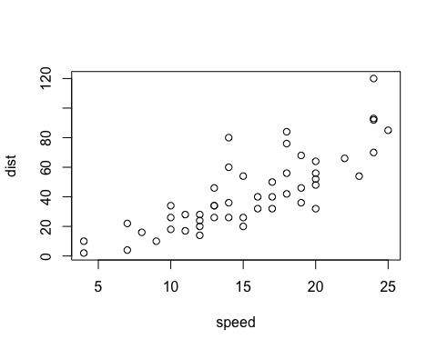

Note that the echo = FALSE parameter was added to the code chunk to prevent printing of the R code that generated the plot.