Lab 1 Report Samuel Proulx

Part 1.1
For the iterative approach, a simple loop with no subroutine was enough to execute the program.
The program thus consists of a setup section where some constants are moved into argument registers and the loop section that computes the Fibonacci. The loop first adjusts the argument register A3, then adds the content of A1, which corresponds to the result of the previous iteration of the loop, or fib(n-1), with the content of A2, which corresponds to the result of the second previous operation, or fib(n-2).

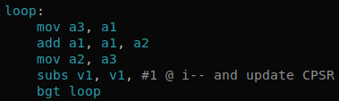
A mistake I did early on was to not reduce the number of iterations the loop has to do by 1. If the input n is not reduced by 1, the program will compute the next Fibonacci in the sequence.
In terms of improvements, I found no clear improvements that could be made to the logic of the program since the algorithm is already as simple as it can get. An improvement could be made to the structure of the program to make it more flexible, or in other words, make it so that it could run with other programs using some registers, would be to make the loop a subroutine. That would most likely be slower since a subroutine needs to push and pop values from the stack in memory. This is a marginal improvement to the program in terms of structure. It would also not improve the code readability as the simple loop shown above is very short and concise.

Part 1.2
For the recursive approach, a subroutine had to be used. Like part 1.1, I used register A1 (R0) as the one that would contain the answer and used registers A2 for fib(n-1) and A3 for fib(n-2). This assures the positions of the arguments is known in every call of the subroutine. The subroutine is responsible for adding the two previous results in A1 then updating the two other arguments in what resembles a queue (A2 is next in line and A3 comes after). The subroutine also needs to keep track of how many iterations it has done and stop when it has done the required amount. This is done by decrementing a counter initialized at the given input. It works similarly to a static variable in a high-level programming language.
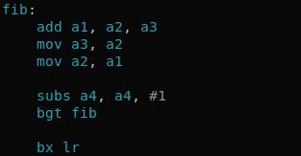
Planning the subroutine and how to handle argument registers so that we know where previous results are located was challenging. As mentioned previously, I used the idea of a queue where items are shifted towards R0 where they are added.

Potential improvements??

Part 2
The program initially declares the 2D array fx as a very large 1D array. The same goes for kx. A space for 400 bytes is allocated to the result array gx since its size is 10x10 in a 4-byte word architecture. I translated every loop in a subroutine. Every loop obviously incremented an index analogous to the ones found in the C program but also had to reset the one immediately nested into it. The y, x, and i loops are all very similar with the exception that the x_loop initializes the variable sum at 0.
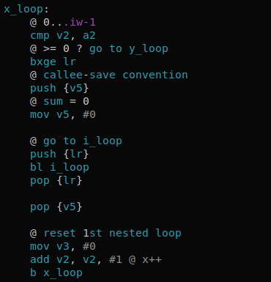

The j loop is more complex in that it works like the other loops, but also has to compute the convolution.

Part 3
For this part, I used a similar approach to that of part 2. Each loop was implemented using a subroutine.

