# Chapter 1: Abstract

Blood transfusion safety is a relevant and significant public health issue in the Sultanate of Oman. Since most blood banks are still in paper-based system, various disadvantages are

experienced by various stakeholders, which endanger the lives of patients and deter the

healthcare system. As such, the researchers aimed to design, develop, and implement an online blood bank management system (OBBMS). This web-based application allows hospitals in Oman to make inventories of their blood bags online, subsequently, allowing each hospital to check the availability of blood bags anytime. The researchers designed and administered a questionnaire that assesses the perceptions of various stakeholders in both manual-based and OBBMS. Based on the findings and results, it was found out that these stakeholders perceived online blood bank management system is much better than the manual system. Therefore, with the use of online blood bank management system, blood transfusion process is safe and secured. Threats on improper blood donor documentation or misplaced records will be totally eradicated. Also, processes involving recording about blood donors, blood bag collection, storage, and inventory will be systematized and organized, hence, improving the healthcare management for blood banks.

# Chapter 1: Introduction

**1.1 BACKGROUND**

For hospitals, a blood bank known as blood collection center, also is an area in which

collected blood bags are stored and preserved for future use in blood transfusion services.

Blood transfusion is a medical operation where a patient requires blood or blood products as a

life saving measure. . In an article1 published in Times of Oman in 2014, it was reported by

Ministry of Health (MoH) that the total amount of blood donated annually in Muscat is approximately 25,084 units. MoH further reported that its Department of Blood Services is

functioning at full capacity to meet the demands in the Sultanate. Most blood banks are still running manual system in its processes. As such, there is a lack of efficiency because it is still paper-based in collecting information about donors, inventories of blood bags, and blood transfusion services. The lack of proper documentation may endanger patients’ health due to the possibility of having contaminate blood bags. Contamination happened when there is an incomplete donors’ medical history record and the blood bags’ shelf life is not monitored properly. Hence, a web-based blood bank management system might be needed to address these issues and problems encountered to ensure blood transfusion safety.

* 1. **OBJECTIVES and SCOPE**

This applied research aims to design, develop and implement online blood bank

management system. This web-based application provides:

• To ensure good supply or inventories of blood bags.

• To check the availability of blood bags anytime.

• To manage the information of its blood donor.

• To allow good documentation about the donor and its blood donation activities.

•Support fast searching to find match blood bags for the right person.

**CHAPTER 2**

**DATABASEDESIGN**

* 1. **Description of the database**

**tbladmin:**

ID (Primary Key)

AdminName

UserName

MobileNumber

Email

Password

AdminRegdate

**tblblooddonars:**

id (Primary Key)

FullName

MobileNumber

EmailId

Gender

Age

BloodGroup (Foreign Key referencing tblbloodgroup)

Address

Message

PostingDate

status

Password

**tblbloodgroup:**

id (Primary Key)

BloodGroup

PostingDate

**tblbloodrequirer:**

ID (Primary Key)

BloodDonarID (Foreign Key referencing tblblooddonars)

name

EmailId

ContactNumber

BloodRequirefor

Message

ApplyDate

**tblcontactusinfo:**

id (Primary Key)

Address

EmailId

ContactNo

**tblcontactusquery:**

id (Primary Key)

name

EmailId

ContactNumber

Message

PostingDate

status

**tblpages:**

id (Primary Key)

PageName

type

detail

* 1. ERdiagram

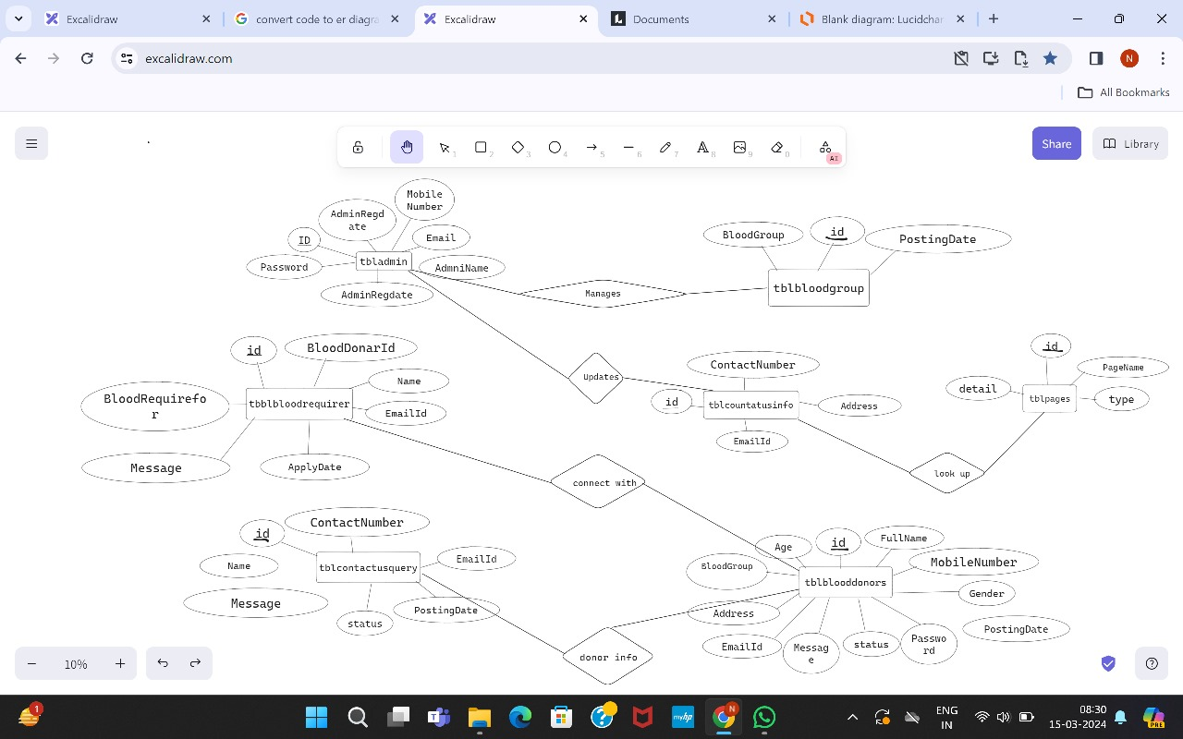

**CHAPTER4**

**IMPLEMENTATION:**

Implementing a blood bank management system using HTML, CSS, JavaScript, XAMPP, Bootstrap, PHP, and SQL involves several steps. Here's a general overview of the implementation process:

Database Design: Design the database schema based on the requirements of the blood bank management system. This includes creating tables for admins, blood donors, blood groups, blood requesters, contact information, contact queries, and pages.

Backend Development with PHP: Write PHP scripts to handle server-side operations such as user authentication, database interactions (CRUD operations), and processing form submissions.

Frontend Development with HTML, CSS, and JavaScript:

HTML: Create the structure of web pages, including forms for user input and displaying information retrieved from the backend.

CSS: Apply styles to make the UI visually appealing and user-friendly.

JavaScript: Enhance interactivity by adding client-side validation, dynamic content loading, and AJAX requests for seamless data retrieval.

Database Integration with SQL: Use SQL queries to interact with the MySQL/MariaDB database. Perform operations such as inserting new records, fetching data, updating records, and deleting records based on user actions.

Testing: Thoroughly test the application to ensure that it functions as expected. Test for both frontend and backend functionalities, including user registration, login/logout, blood donation requests, contact queries, etc.

Deployment: Once the application is tested and debugged, deploy it on a web server. XAMPP can be used for local development and testing, but for production deployment, you may need to configure a hosting server with PHP and a MySQL/MariaDB database.

Here's how these technologies fit into the implementation process:

HTML: Provides the structure and layout of web pages.

CSS: Styles the HTML elements to enhance the visual presentation and user experience.

JavaScript: Adds interactivity to the web pages, validates user input, and makes asynchronous requests to the server for dynamic content.

Bootstrap: A front-end framework that provides pre-designed UI components and responsive layouts, speeding up the development process and ensuring consistency across different devices.

PHP: A server-side scripting language used for backend development. PHP scripts handle user authentication, database interactions, and business logic.

MySQL/MariaDB: A relational database management system used to store and manage data for the blood bank management system.

XAMPP: A software package that includes Apache (web server), MySQL/MariaDB (database), PHP. It provides an easy way to set up a local development environment for testing PHP applications.

By integrating these technologies effectively, you can develop a robust blood bank management system with a user-friendly interface, seamless data management, and secure user authentication.

**CHAPTER 5**

**RESULT**

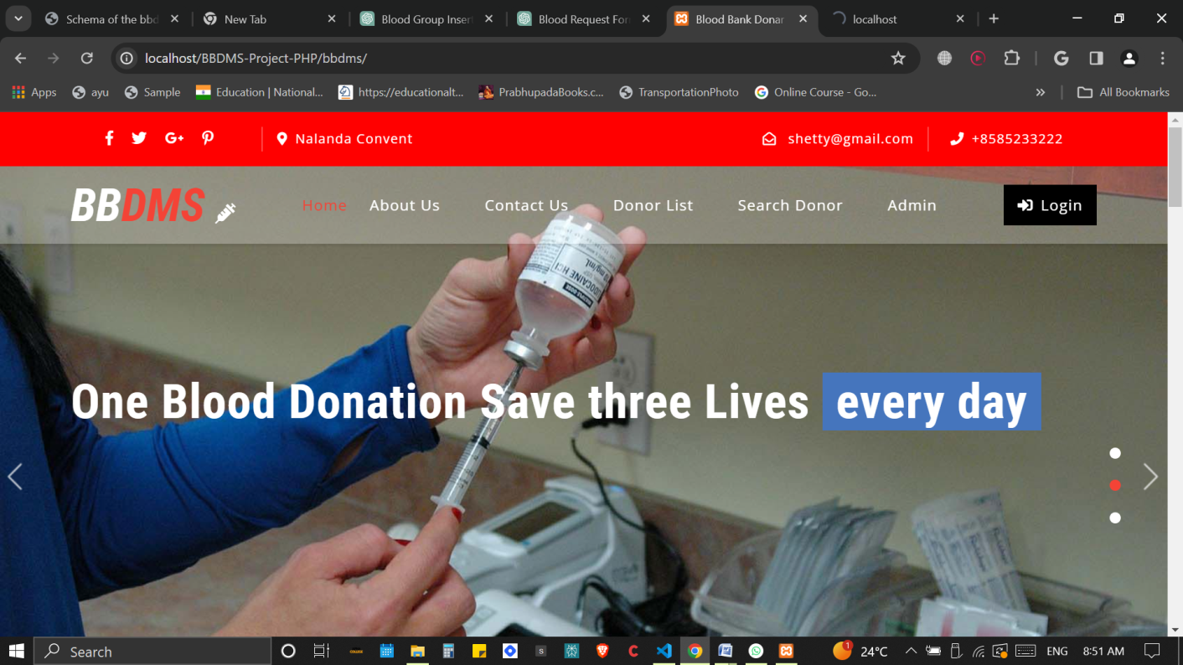

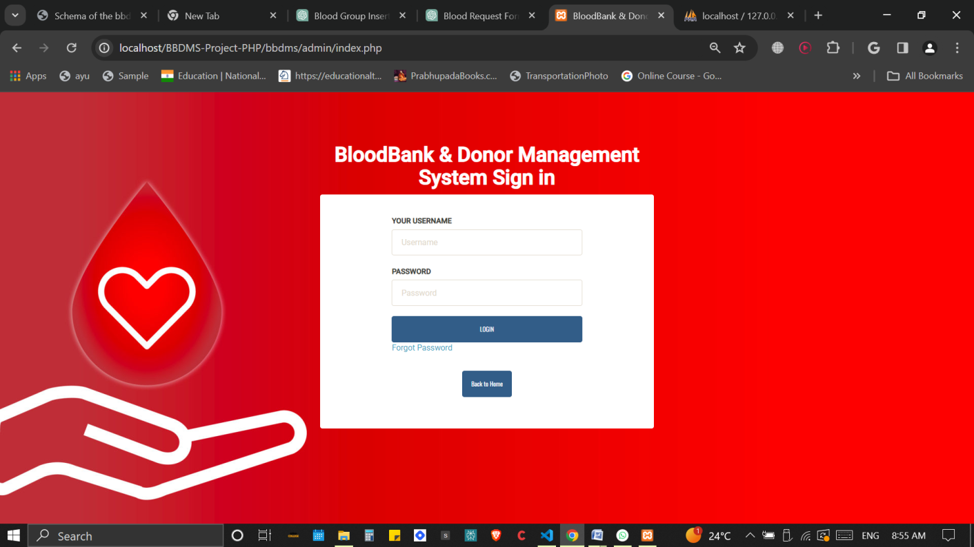

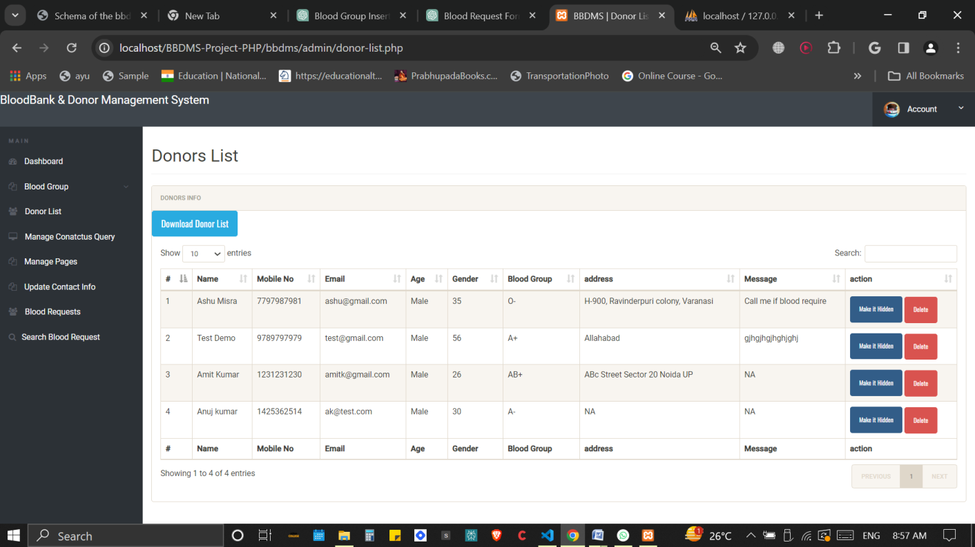

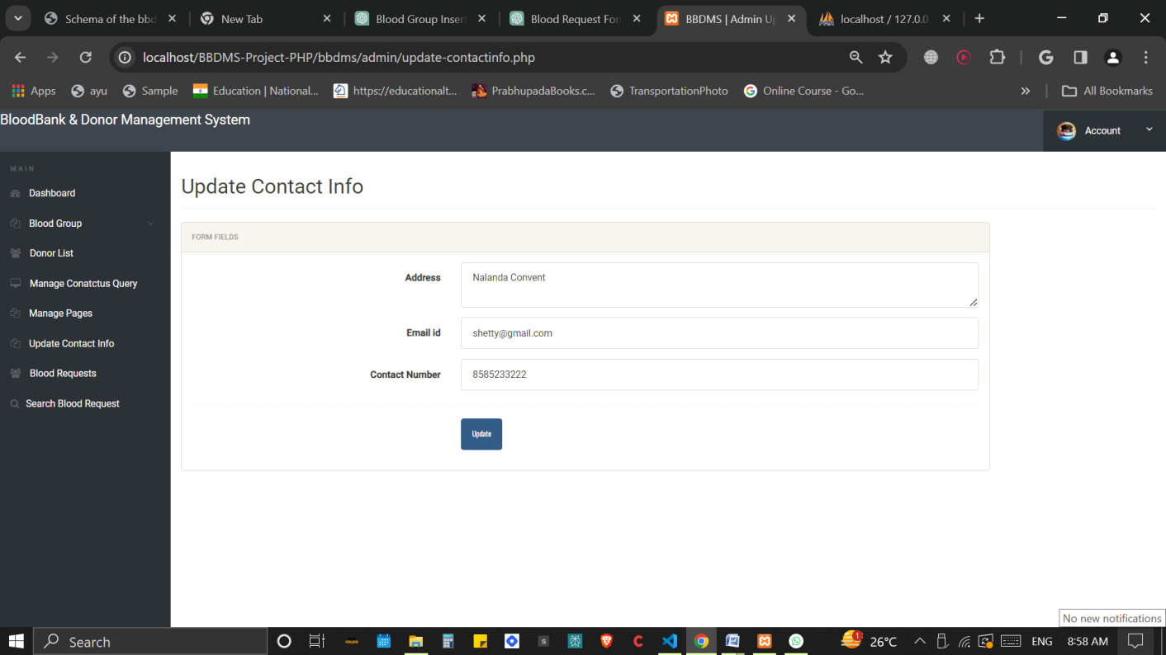

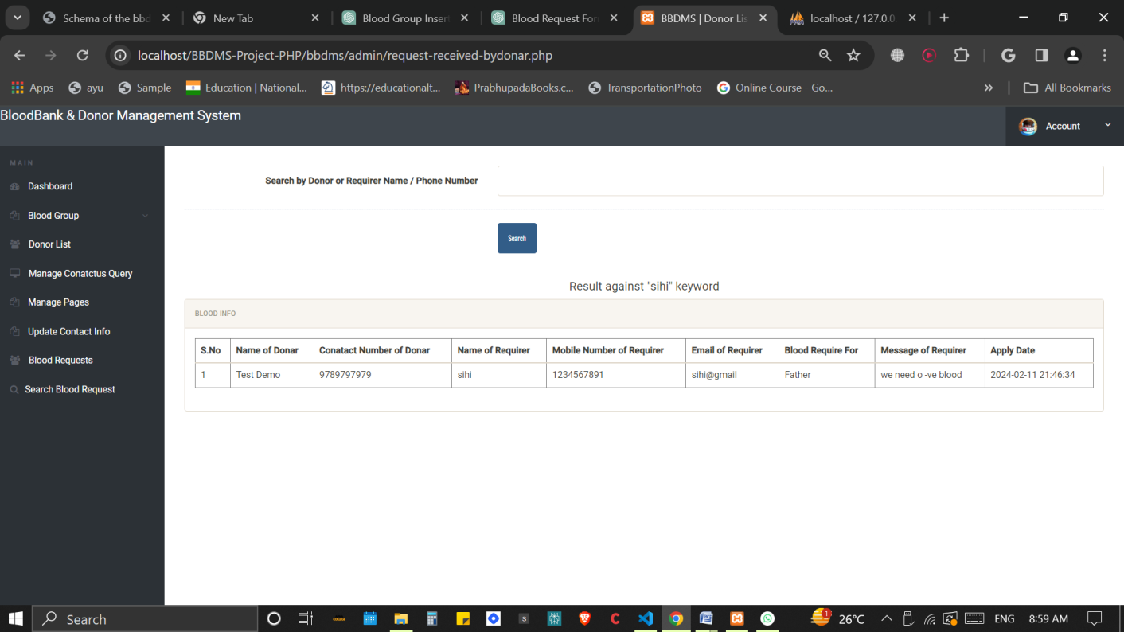

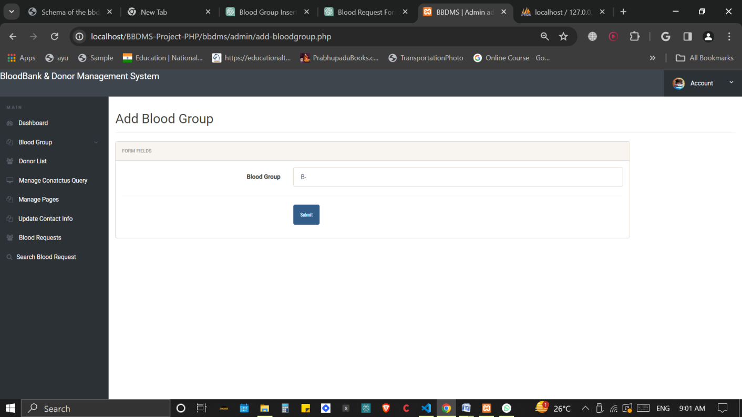

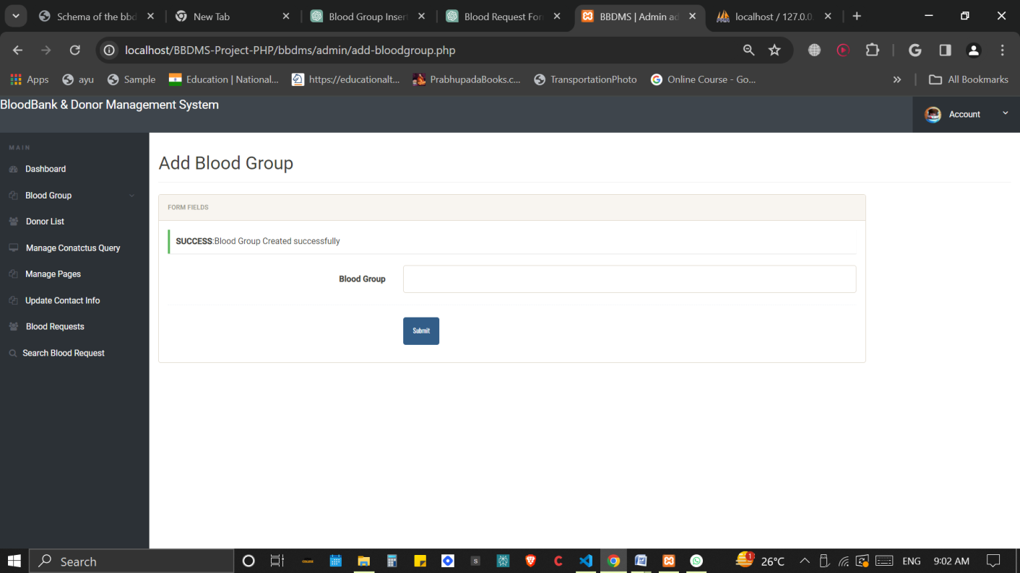

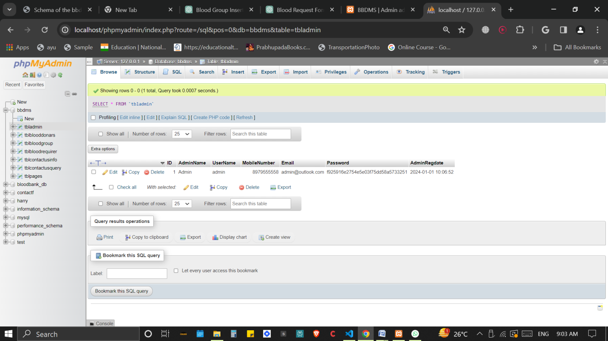

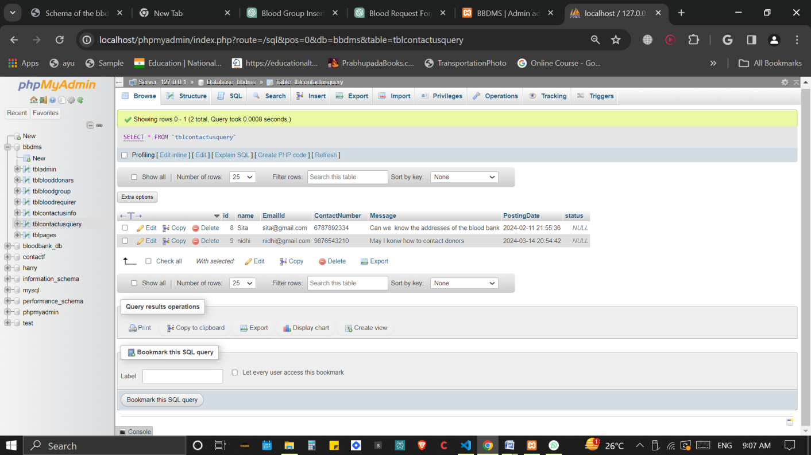

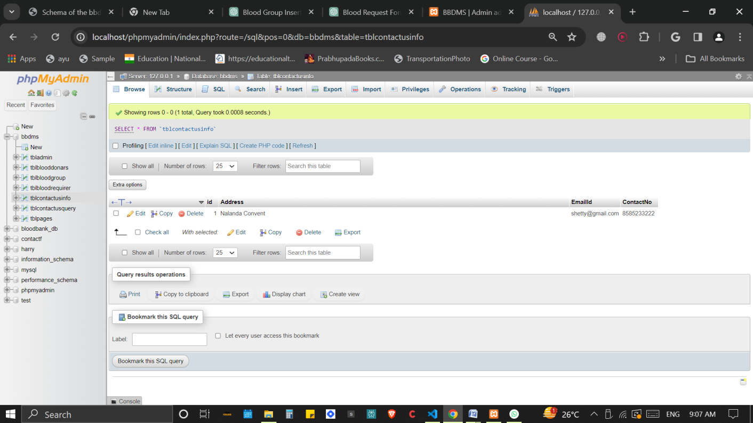

**CHAPTER 6**

**CONCLUSION**

In conclusion, the implementation of a blood bank management system using HTML, CSS, JavaScript, XAMPP, Bootstrap, PHP, and SQL offers a comprehensive solution for managing blood donation processes, donor information, blood group inventory, and contact queries efficiently.

By leveraging HTML for structuring web pages, CSS for styling, and JavaScript for interactivity, the frontend interface can be designed to be visually appealing, intuitive, and user-friendly. Bootstrap further enhances the frontend development process by providing a library of pre-designed components and responsive layouts, ensuring a consistent experience across different devices.

On the backend, PHP scripts handle server-side operations such as user authentication, database interactions, and form submissions. SQL queries facilitate seamless communication with the MySQL/MariaDB database, enabling CRUD operations to manage data effectively.

XAMPP serves as a valuable tool for local development and testing, providing a complete environment with Apache, MySQL/MariaDB, PHP, and Perl. This setup streamlines the development process and allows developers to debug and iterate on their code in a controlled environment before deploying to a production server.

Overall, the integration of these technologies enables the creation of a robust blood bank management system that meets the needs of donors, recipients, and administrators alike. With its intuitive interface, efficient data management capabilities, and secure authentication mechanisms, the system can play a vital role in facilitating blood donation processes and saving lives