**Screenshots**

1. **Load data and create a Spark data frame**

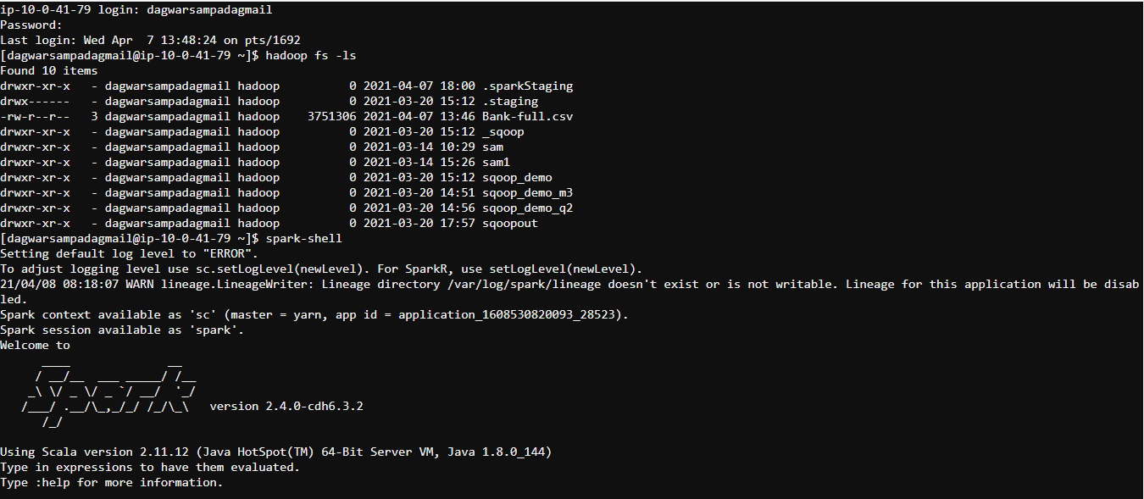

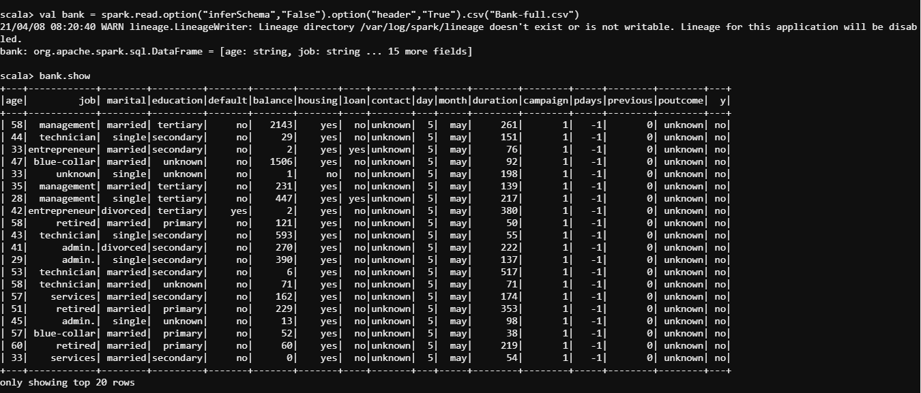

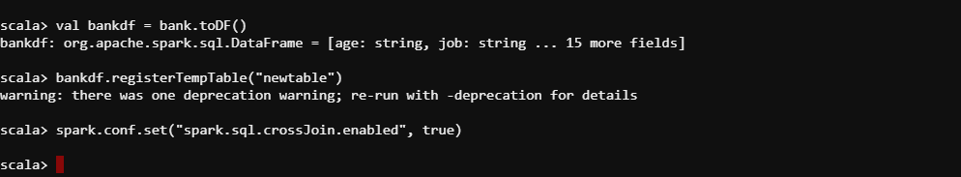

1. **Give marketing success rate (No. of people subscribed / total no. of entries)**

* **Give marketing failure rate**

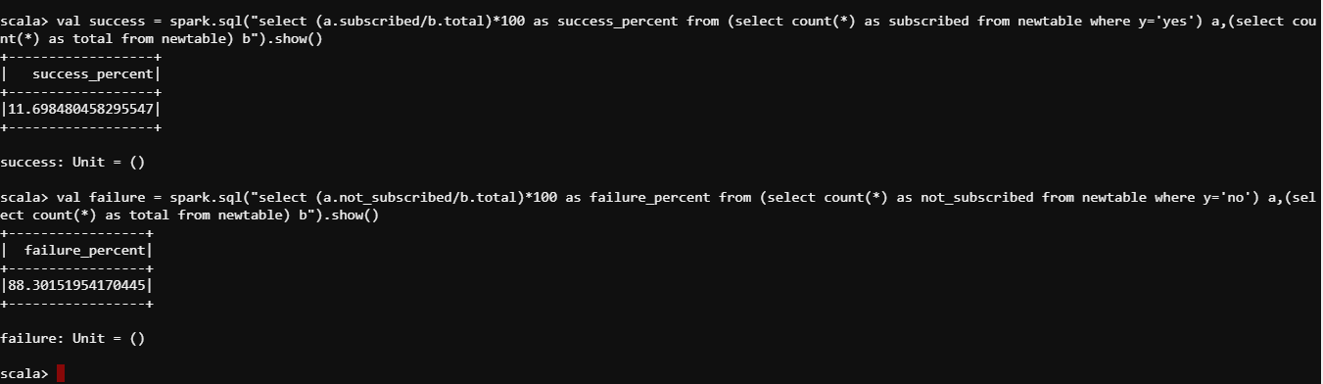

**2.1 Give the maximum, mean, and minimum age of the average targeted customer**

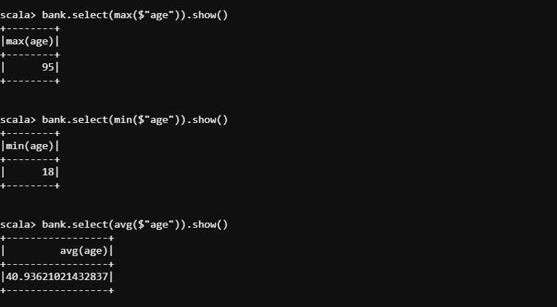

* 1. **Check the quality of customers by checking average balance, median balance of customers**

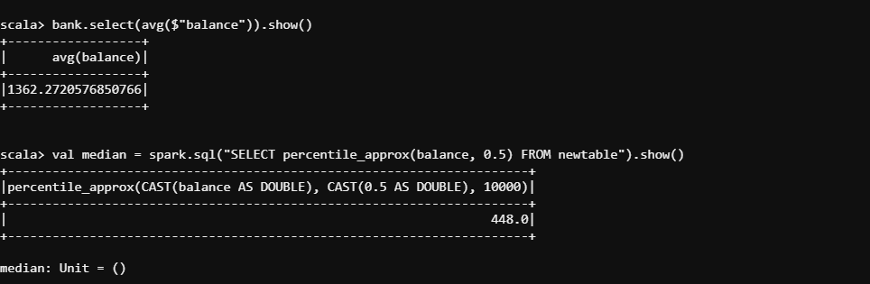

* 1. **Check if age matters in marketing subscription for deposit**

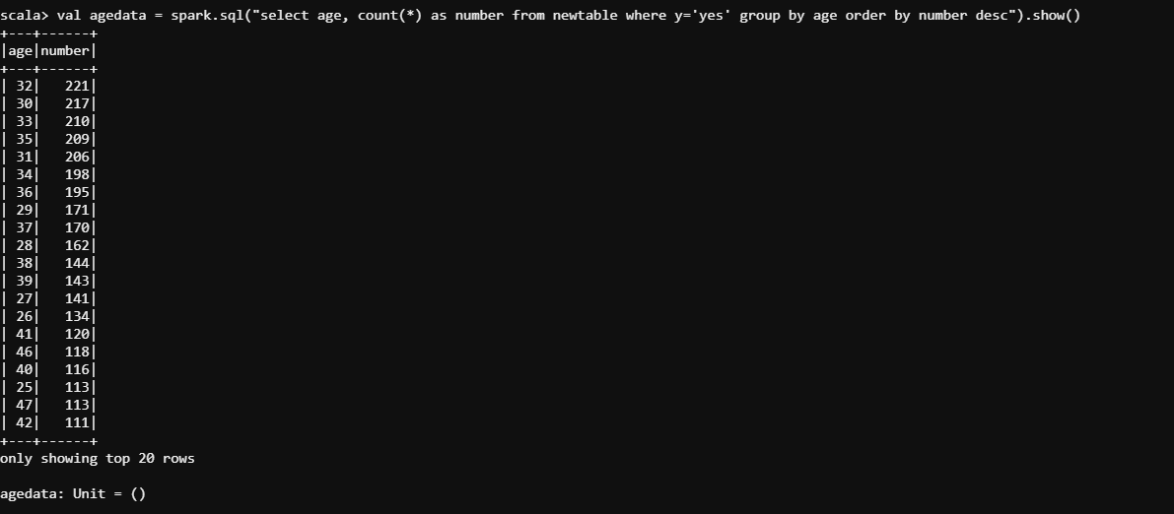

* 1. **Check if marital status mattered for a subscription to deposit**

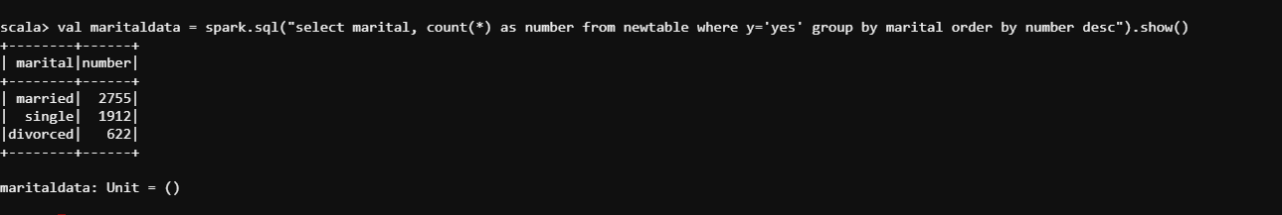

* 1. **Check if age and marital status together mattered for a subscription to deposit scheme**

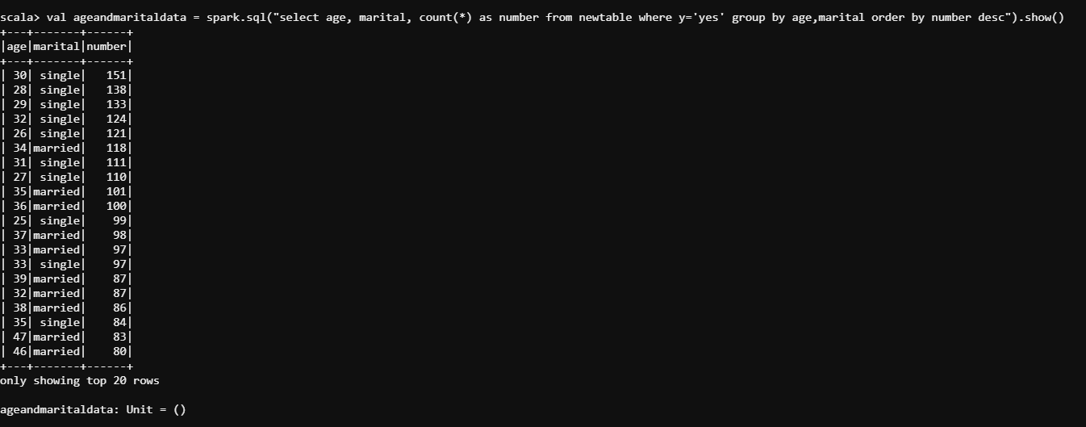

* 1. **Do feature engineering for the bank and find the right age effect on the campaign.**

