Decoupling Agent charts with Portfolio agent
Problem – Every time the portfolio agent is run, the agent charts auto update for all where it finds KPI data
Agent charts can be run in isolation, but a report always triggers it
Idea is to use the agent as a tracker of KPI data, flag missing fields and share a weekly report (for 4/6 weeks after the quarter end) to the users
Portfolio Agent
- Runs – automated or manual trigger
- Weekly emailers
- Trigger reminders for companies that have not uploaded KPIs
Navigation
- To run – under support agents, trigger from agent page
- To view dashboard - Stakeholders – Actions – Portfolio Company Agent Dashboard ( to replace completed and failed)
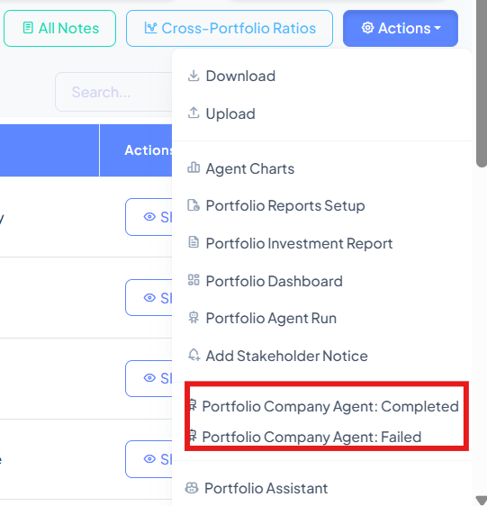
Agent charts
- Runs – automated or manual trigger (this is already enabled)
- Remove also updates when portfolio agent run is triggered
Navigation
- To run - Stakeholders – Actions – Agent charts – go inside the chart and select generate for all or generate for selected(this is already there)
Agent charts are used on dashboard or to export as an image

