CapHive MCP Server — Admin Setup & Claude.ai Connection Guide
A step-by-step guide for CapHive admins and entity admins to enable MCP access and connect Claude.ai.

What is This?
The CapHive MCP Server lets users query fund management data from CapHive using Claude.ai. Users authenticate via OAuth, and Claude can then call 23 read-only tools covering funds, capital activity, portfolios, cap tables, documents, and commitments.
MCP URL: https://dev.altconnects.com/mcp

How It Works
Connecting Claude.ai to CapHive is a simple process:
- A CapHive admin enables MCP for the entity (one-time)
- An entity admin configures MCP settings — roles, allowed clients (one-time)
- The fund manager pastes the MCP URL into Claude.ai → logs in → connected
No OAuth Client ID or Secret is needed. Claude registers itself automatically via Dynamic Client Registration (RFC 7591).

Step 1: Enable MCP Permission (CapHive Admin)
This step is required before the entity can see or use MCP at all. Only CapHive admins (super/support role) can do this.
- Log in as a CapHive admin
- Go to /admin/entities (Administrate panel)
- Find the entity and click Edit
- Under Permissions, check enable_mcp
- Save
This is the billing/licensing gate — it controls whether the entity has purchased MCP access. Without this, the “AI Client Integration” section won’t appear on the entity’s edit page.
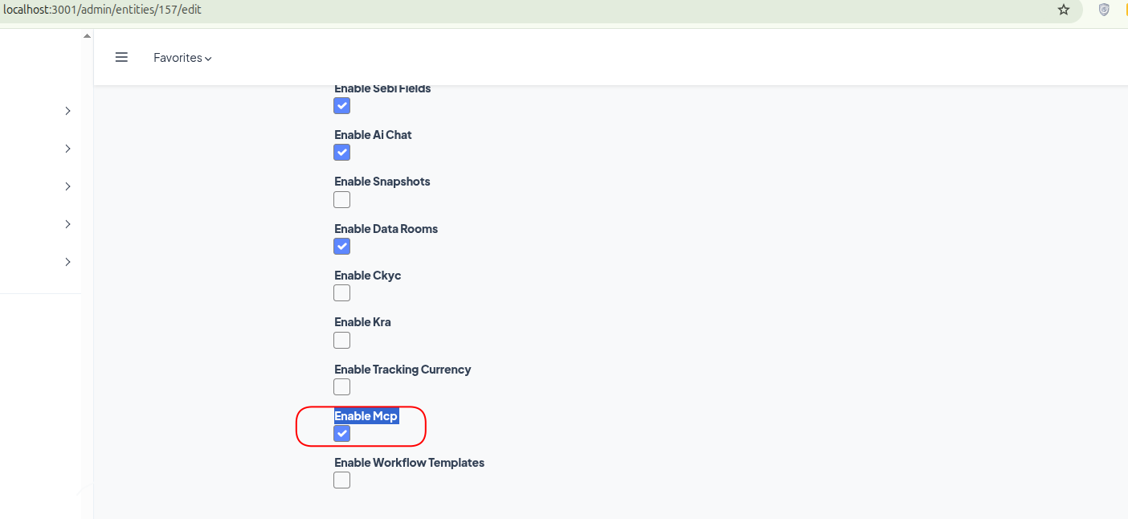

Step 2: Configure MCP Settings (Entity Admin)
Once the CapHive admin has enabled the enable_mcp permission, the entity’s own admin can configure it:
- Log in as an entity admin (company_admin role)
- Go to Entity Settings → Edit your entity
- Scroll to the “AI Client Integration (MCP)” section
- Check “Enable AI Client Integration”
- Under Allowed Roles, check the roles that should have MCP access:
  - Fund Managers (employee role)
  - Investors / LPs (investor role)
- Under Allowed AI Clients, you can either:
  - Leave all unchecked → allows all AI clients
  - Check “Claude” → restricts to Claude only
- Save

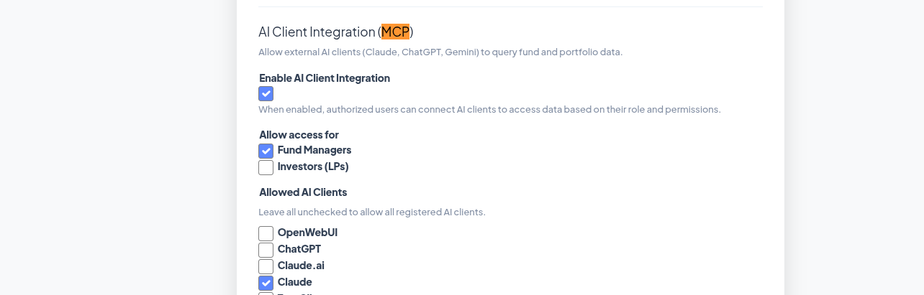
Important: The allowed client name is “Claude” (not “Claude.ai”). This is the name Claude registers itself with during the automatic registration process.

Step 3: Connect Claude.ai
This is what the fund manager (or any authorized user) does:

Add the CapHive Connector
- Go to claude.ai (desktop browser only — mobile is not supported)
- Click Settings (gear icon) → Integrations → Add More
- Enter the following:
  - Name: CapHive (or any name you prefer)
  - URL: https://dev.altconnects.com/mcp
  - No Client ID or Secret needed — Claude auto-registers automatically
- Click Add
Screenshot: [TODO: Screenshot of Claude.ai Integrations page with "Add" dialog showing Name and URL fields]

Connect and Authorize
- Click on the newly added CapHive connector
- Click the “Connect” button
- A browser popup opens with the CapHive login page
- Log in with your credentials
- You’ll see an authorization prompt — click “Authorize”
- The popup closes and you’re connected

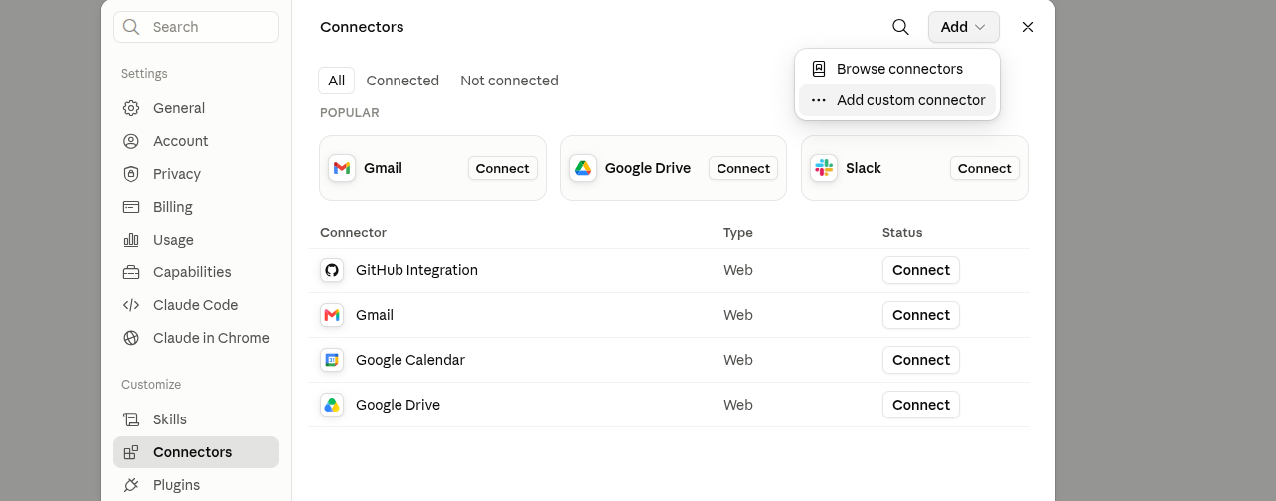
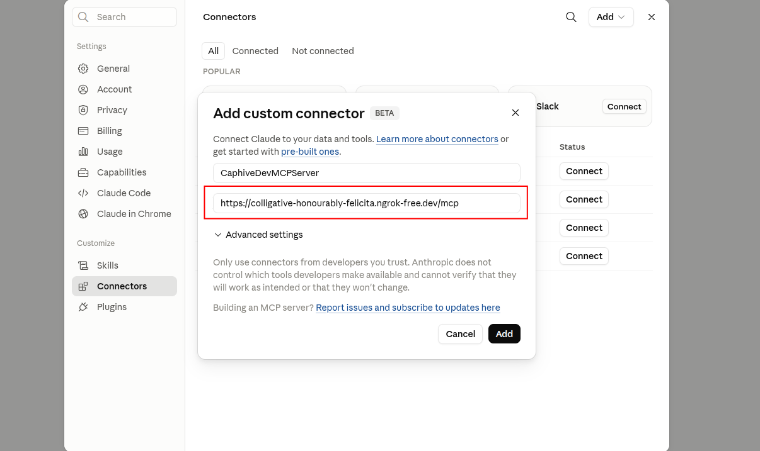

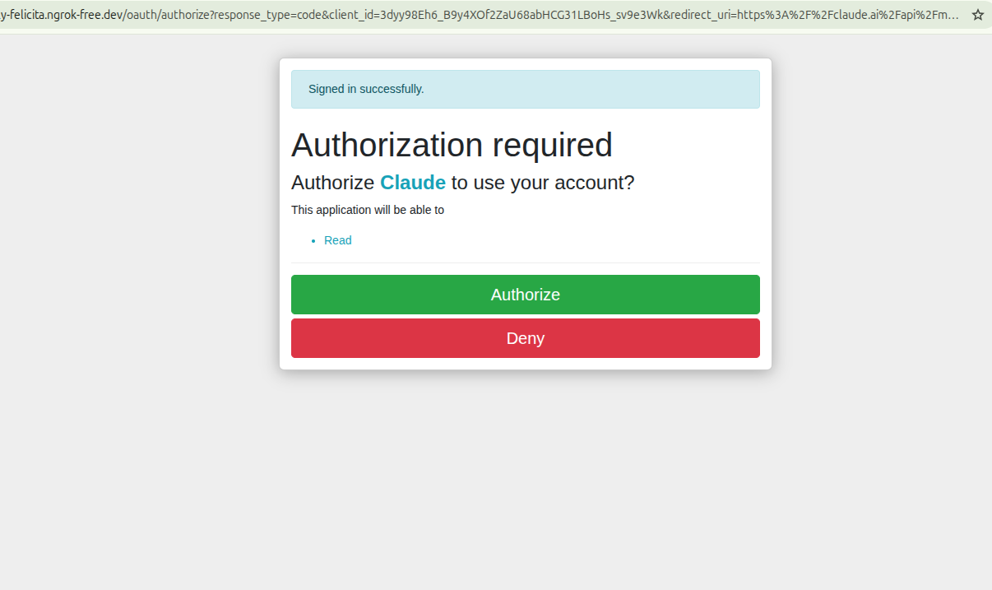

Test It
Start a new conversation on Claude.ai and try these queries:
- “List all my funds”
- “Show me capital calls for [fund name]”
- “What are the portfolio companies in my fund?”
- “Show me the cap table for [company name]”
- “What are the TVPI and IRR ratios for my funds?”

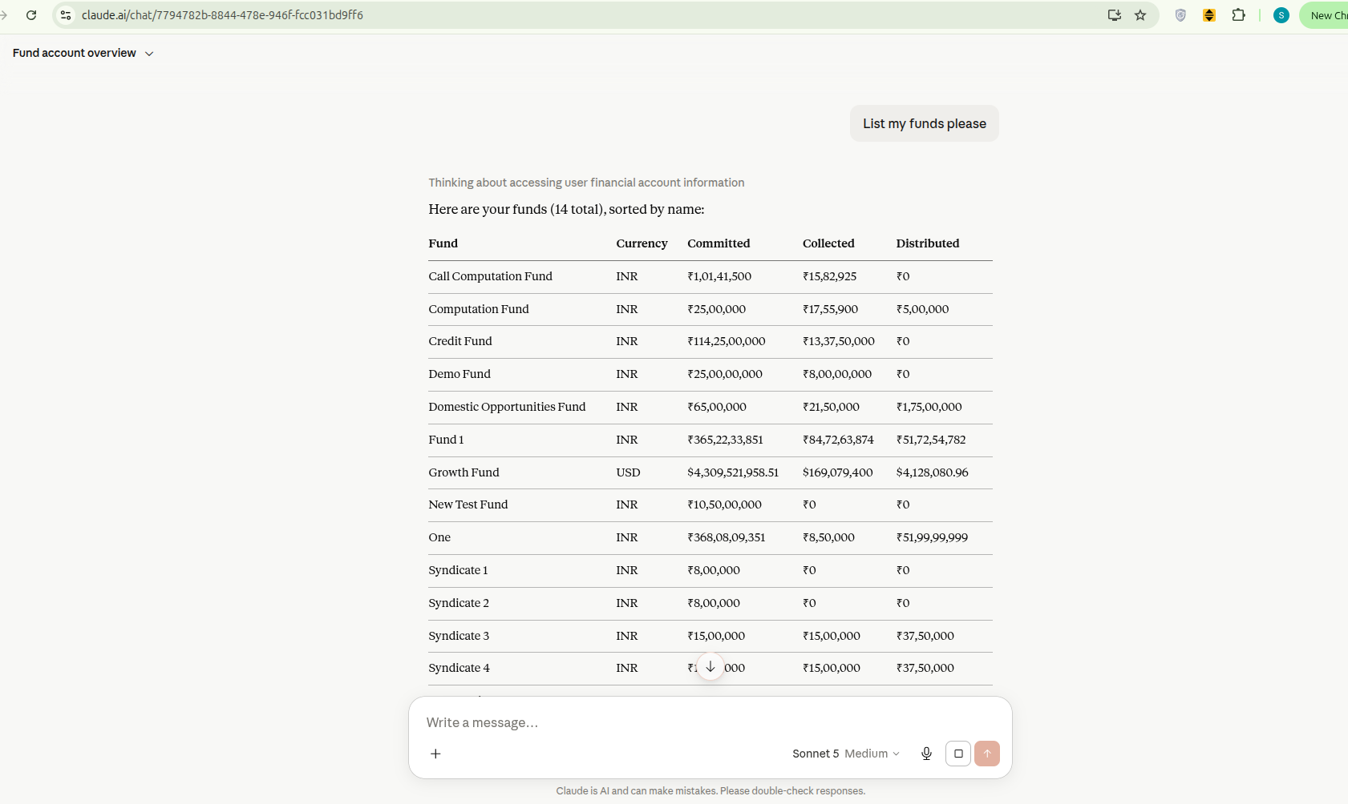

Available Tools (23)
Once connected, Claude can call these tools:
Domain | Tools
Funds | list_funds, get_fund_details, list_fund_ratios
Capital Activity | list_capital_calls, list_capital_commitments, list_capital_distributions, list_capital_remittances, list_capital_remittance_payments, list_capital_distribution_payments
Portfolio | list_portfolio_companies, get_portfolio_company_details, get_portfolio_company_snapshot, list_portfolio_investments, list_portfolio_kpis, list_valuations
Cap Table | get_cap_table, get_investments_in_cap_table
Documents | list_documents, get_document
Commitments | get_commitment_details, list_fund_units, list_account_entries
All tools are read-only — no data can be created, modified, or deleted through MCP.

Troubleshooting

“MCP is not available for this organization”
Cause: CapHive admin has not enabled enable_mcp for this entity. Fix: Go to /admin/entities → Edit → check enable_mcp → Save.

“MCP is not enabled for this organization”
Cause: Entity admin has not toggled MCP on. Fix: Entity Settings → Edit → Enable “AI Client Integration” → Save.

“Your role does not have MCP access”
Cause: User’s role is not in the allowed roles list. Fix: Entity admin → Edit entity → check the user’s role under “Allowed Roles”.

“This AI client is not authorized for your organization”
Cause: Entity has restricted allowed AI clients, and “Claude” is not checked. Fix: Entity admin → Edit entity → either uncheck all clients (allow all) or check “Claude”.

“Missing token” or “Invalid or expired token”
Cause: OAuth flow not completed, or token expired (tokens last 30 days). Fix: Disconnect and reconnect the connector in Claude.ai.

Connection works but no data returned
Cause: User account may not have fund data. Fix: Verify the user has funds/portfolios assigned in CapHive.

Security
- Two-level governance: CapHive admin controls which entities have MCP access (billing gate). Entity admin configures roles and client restrictions (self-serve).
- Read-only: No create, update, or delete operations are possible through MCP.
- User-scoped: Every query returns only data the authenticated user is authorized to see. No cross-tenant data is ever exposed.
- Automatic registration: Claude registers itself as a public OAuth client using PKCE — no shared secrets.
- Token lifetime: Access tokens expire after 30 days with automatic refresh. Users can revoke access by disconnecting in Claude.ai.
- Audit trail: Every MCP tool call is logged for audit purposes.
- OAuth admin panel (/oauth/applications) is restricted to super/support roles only.

