**9. Print any pattern with entered number.**

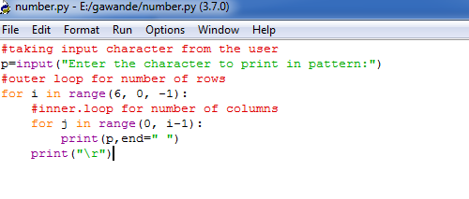

\*\*\***OUTPUT**\*\*\*

