**OPENSTACK**

* WHAT IS OPENSTACK ?
* OpenStack is a set of software tools for building and managing cloud computing platforms for public and private clouds. Backed by some of the biggest companies in software development and hosting, as well as thousands of individual community members, many think that OpenStack is the future of cloud computing. OpenStack is managed by the OpenStack Foundation, a non-profit that oversees both development and community-building around the project
* OpenStack is a cloud operating system that controls large pools of compute, storage, and networking resources throughout a datacenter, all managed through a dashboard that gives administrators control while empowering their users to provision resources through a web interface.

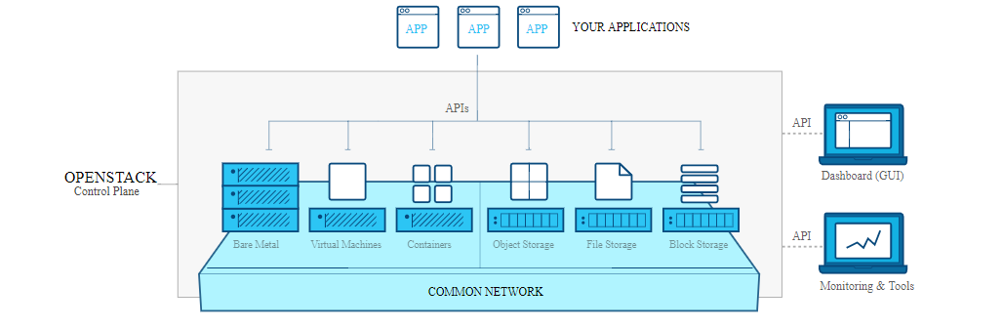

* INTRODUCTION TO OPENSTACK
* OpenStack lets users deploy virtual machines and other instances that handle different tasks for managing a cloud environment on the fly. It makes horizontal scaling easy, which means that tasks that benefit from running concurrently can easily serve more or fewer users on the fly by just spinning up more instances. For example, a mobile application that needs to communicate with a remote server might be able to divide the work of communicating with each user across many different instances, all communicating with one another but scaling quickly and easily as the application gains more users.
* OpenStack is open source software, which means that anyone who chooses to can access the source code, make any changes or modifications they need, and freely share these changes back out to the community at large. It also means that OpenStack has the benefit of thousands of developers all over the world working in tandem to develop the strongest, most robust, and most secure product that they can.
* HOW IS OPENSTACK USED IN A CLOUD ENVIRONMENT?
* The cloud is all about providing computing for end users in a remote environment, where the actual software runs as a service on reliable and scalable servers rather than on each end-user's computer.
* Cloud computing can refer to a lot of different things, but typically the industry talks about running different items "as a service"—software, platforms, and infrastructure. OpenStack falls into the latter category and is considered Infrastructure as a Service (IaaS).
* Providing infrastructure means that OpenStack makes it easy for users to quickly add new instance, upon which other cloud components can run. The infrastructure then runs a "platform" upon which a developer can create software applications that are delivered to the end users.
* COMPONENTS OF OPENSTACK
* OpenStack is made up of many different moving parts. Because of its open nature, anyone can add additional components to OpenStack to help it to meet their needs. But the OpenStack community has collaboratively identified nine key components that are a part of the "core" of OpenStack, which are distributed as a part of any OpenStack system and officially maintained by the OpenStack community.

1. Nova is the primary computing engine behind OpenStack. It is used for deploying and managing large numbers of virtual machines and other instances to handle computing tasks.
2. Swift is a storage system for objects and files. Rather than the traditional idea of a referring to files by their location on a disk drive, developers can instead refer to a unique identifier referring to the file or piece of information and let OpenStack decide where to store this information. This makes scaling easy, as developers don’t have the worry about the capacity on a single system behind the software. It also allows the system, rather than the developer, to worry about how best to make sure that data is backed up in case of the failure of a machine or network connection.
3. Cinder is a block storage component, which is more analogous to the traditional notion of a computer being able to access specific locations on a disk drive. This more traditional way of accessing files might be important in scenarios in which data access speed is the most important consideration.
4. Neutron provides the networking capability for OpenStack. It helps to ensure that each of the components of an OpenStack deployment can communicate with one another quickly and efficiently.
5. Horizon is the dashboard behind OpenStack. It is the only graphical interface to OpenStack, so for users wanting to give OpenStack a try, this may be the first component they actually “see.” Developers can access all of the components of OpenStack individually through an application programming interface (API), but the dashboard provides system administrators a look at what is going on in the cloud, and to manage it as needed.
6. Keystone provides identity services for OpenStack. It is essentially a central list of all of the users of the OpenStack cloud, mapped against all of the services provided by the cloud, which they have permission to use. It provides multiple means of access, meaning developers can easily map their existing user access methods against Keystone.
7. Glance provides image services to OpenStack. In this case, "images" refers to images (or virtual copies) of hard disks. Glance allows these images to be used as templates when deploying new virtual machine instances.
8. Ceilometer provides telemetry services, which allow the cloud to provide billing services to individual users of the cloud. It also keeps a verifiable count of each user’s system usage of each of the various components of an OpenStack cloud. Think metering and usage reporting.
9. Heat is the orchestration component of OpenStack, which allows developers to store the requirements of a cloud application in a file that defines what resources are necessary for that application. In this way, it helps to manage the infrastructure needed for a cloud service to run.
10. Sahara is a component to easily and rapidly provision Hadoop clusters. Users will specify several parameters like the Hadoop version number, the cluster topology type, node flavor details (defining disk space, CPU and RAM settings), and others. After a user provides all of the parameters, Sahara deploys the cluster in a few minutes. Sahara also provides means to scale a preexisting Hadoop cluster by adding and removing worker nodes on demand

* MASSIVE INDUSTRY SUPPORT
* OpenStack was originally formed by Rackspace and NASA in 2010 as a platform for allowing organizations to provide cloud computing services running on standard commodity hardware. It is free and open source software managed by the OpenStack Foundation. Since its creation, an enormous number of key industry players have pledged support, including IBM, Intel, Red Hat, AMD, HP, and Canonical. Because of this strong level of investment, development moves very quickly and OpenStack has some of the most innovative companies in the world as contributors.
* AWS COMPATIBILITY
* OpenStack’s APIs are designed to be compatible with Amazon Web Services, the most popular public cloud platform. For businesses, that means the process of porting IaaS client applications from AWS to OpenStack-based IaaS providers requires minimal effort.
* SECURITY
* Openstack has very robust role-based access controls. Access and resource utilization can be controlled at the level of users, roles, and projects. The Keystone Identity Service provides multiple forms of authentication including username / password and token-based authentication.
* A POWERFUL DASHBOARD
* OpenStack makes it very easy for IaaS providers to monitor and manage their cloud services. The dashboard is a web app that provides an intuitive interface for managing compute, storage, and networking resources, allowing users and administrators to have a clear overview for the management of resource usage, currently active VM instances, and users.
* Allows restriction and management of large networks of virtual machines
* Offers an infrastructure as a service (Iaas) to create own policies/services
* IT departments can provide cloud services to business units and teams
* Processes large data with tools like Hadoop
* Accommodates to the demand of web resources or applications
* Processes diverse and intensive workloads (High Performance Computing)
* ADVANTAGES

1. Option of having private or public clouds
2. Available anytime at any computer or location through a web browser
3. Low costs per megabyte of storage and customers pay for what they use
4. Simple to integrate (any organization can offer cloud computing services using their standard hardware e.g. amazon)
5. Can be upgraded easily (scalable)
6. Provides an infrastructure as a server (Iaas) for managing large groups of public or private clouds
7. Has “Dashboard” for letting users organize and access data/resources
8. Unlimited storage
9. Built in storage management tools
10. Can limit storage access to users
11. Protects drive failures by preventing and controlling data corruption

* DISADVANTAGES

1. Servers are not always reliable and issues could dissatisfy customers
2. Technical support is offered ONLY through email and chat
3. Uploads are time consuming
4. Software still being produced
5. Software is constantly changing and the user must keep up with up to date with changes
6. Is not compatible with multi-languages or multi-currency
7. Does not have billing and monitoring systems
8. Lack of development compared to other software

* THE FUTURE OF OPENSTACK
* The main barriers of adoption for this software are the disadvantages of the product and deciding whether the technology suits the system of the company. A user must also consider the products competitors
* e.g. Eucalyptus, Apache Cloud Stack and Flexiant (the former leader of OpenStack Brian Garvey switched to Flexiant due to better services provided).
* OpenStack is still being developed (according to InfoWorld) and investing in underdeveloped software could be a risk.