ข้อ 1

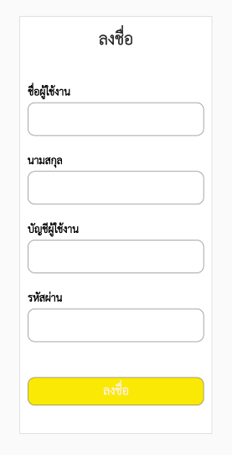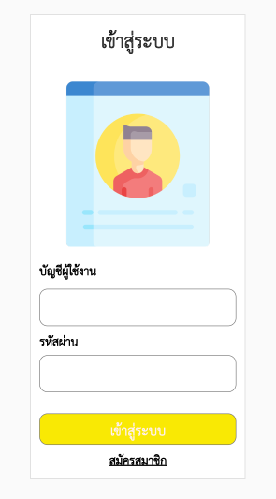

ข้อ 2

//This is an example code to understand TextInput//

import React from 'react';

//import react in our code.

import {TextInput, View, StyleSheet, Text, Button, Image} from 'react-native';

//import all the components we are going to use.

export default class App extends React.Component {

onPressLearnMore() {

alert('เข้าสู่ระบบสำเร็จ');

}

constructor(props) {

super(props);

this.state = {username: '', password: ''};

this.state = {valx: 0, valy: 100000000};

setInterval(() => {

this.setState({valx: this.state.valx + 1});

this.setState({valy: this.state.valy - 1});

}, 1000);

}

render() {

return (

<View style={styles.container}>

<Text style={{color: 'cyan'}}>{this.state.username}</Text>

<Image

source={require('./login.png')}

style={{width: 250, height: 250}}

/>

<Text style={styles.title}>

{'\n'}

{'\n'} เข้าสู่ระบบ {'\n'}

</Text>

<TextInput

value={this.state.username}

onChangeText={(username) => this.setState({username})}

placeholder={'Username'}

style={styles.input}

/>

<TextInput

value={this.state.password}

onChangeText={(password) => this.setState({password})}

placeholder={'password'}

style={styles.input}

/>

<Button

onPress={this.onPressLearnMore}

title="เข้าสู่ระบบ"

color="#FFFF00"

/>

<Text>

{'\n'}

{'เวลาที่เข้าใช้ระบบ ' + this.state.valx}

</Text>

<Text>

{'\n'}

{'เวลาที่เหลืออีก ' + this.state.valy}

</Text>

</View>

);

}

}

const styles = StyleSheet.create({

container: {

flex: 1,

alignItems: 'center',

justifyContent: 'center',

backgroundColor: '#ffffff',

paddingTop: 50,

},

input: {

width: 250,

height: 44,

padding: 10,

marginBottom: 10,

backgroundColor: '#ecf0f1',

},

stretch: {

width: 50,

height: 200,

resizeMode: 'stretch',

},

title: {

fontSize: 25,

alignItems: 'center',

fontWeight: 'bold',

color: 'red',

},

});

การแสดงผล