Changes Made to wikipedia home page

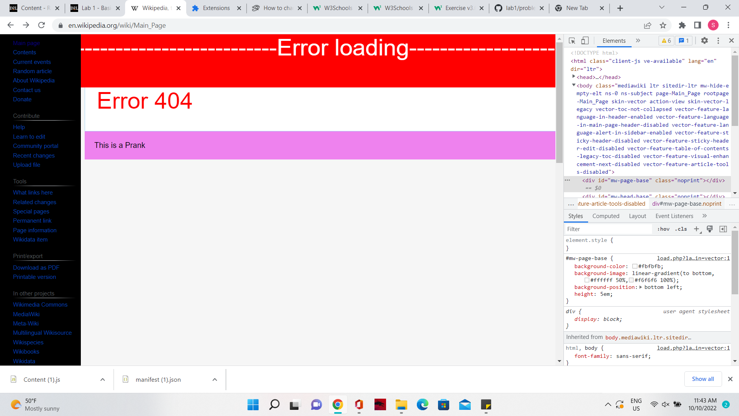

head_base.style.backgroundColor="Red";

head_base.innerHTML='------------------------------------Error loading-----------------------------';

head_base.style.fontSize ="xxx-Large"

head_base.style.color="White";

-> changed the head base

const bodyContent = document.getElementById("bodyContent");

bodyContent.innerHTML='Error 404';

bodyContent.style.fontSize="xxx-Large";

bodyContent.style.color="red";

-> changed the body of the content to "ERROR 404"

document.getElementById("mw-panel").style.backgroundColor="black";

->changed the left panels background to black

document.getElementById("footer").style.backgroundColor="violet";

document.getElementById("footer").innerHTML='This is a Prank ';

->Changed the content and the background color

const logo = document.getElementById("p-logo");

logo.style.display="None";

->removed the logo