Lab 4 – ReactJS

D18124115

Sampanna Pathak

Question 1. Explain using code examples what is meant by props and state in React JS?

Props is a common keyword in React, which is short for property. They are to React components what arguments are to functions.

  class DummyComponent extends React.Component {

      render() {

        return <div>Hello {this.props.name}</div>;

      }

    }

    // using the component

    <DummyComponent name="abc" />

    <DummyComponent name="zxy" />

State is the local state of the component which cannot be accessed and modified outside of the component. It's equivalent to local variables in a function.

    class DummyComponent extends React.Component {

      state = {

        name: 'abc'

      }

      render() {

        return <div>Hello {this.state.name}</div>;

      }

Question 2. In functional programming, what does the term functor mean? Can you give an example in JavaScript?

A functor is an object which implements a method to transform or map its properties into another functor while preserving its data structure.

const Functor = (v) => ({

  value: v,

  map: (f) => Functor(f(v))

});

var s =  Functor(2)

  .map(x=>x*x)

  .map(x=>x.toString());

console.log(s.value);

Question 3. We have looked at three kinds of asynchronous programming mechanisms,

namely callbacks, promises and streams. Mention one advantage and one

disadvantage of each type

|  |  |  |
| --- | --- | --- |
|  | Advantage | Disadvantage |
| Callback | It helps develop asynchronous JavaScript code. | Callback Hell is essentially nested callbacks where each callback is dependent on previous callback. |
| Promise | An object to decide the action that needs to be taken after the async task completes. This gives more manageable code and avoids callback hell | Cannot return multiple arguments. |
| Streams | Streams allow a lot of control of data buffering. | Stream can only be used once |

Question 4. With the aid of a diagram and example code, describe the Cascading Style

Sheets (CSS) Box Model and show how it can be used to space DOM

Elements?

A CSS box model is a compartment that includes numerous assets, such as edge, border, padding and material. It is used to develop the design and structure of a web page.

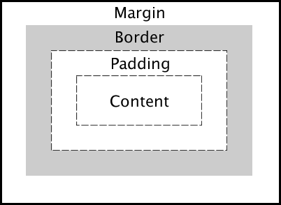

    <!DOCTYPE html>

    <html>

    <head>

    <style>

    div {

      width: 320px;

      padding: 10px;

      border: 5px solid gray;

      margin: 0;

    }

    </style>

    </head>

    <body>

    <img src="red.jpg" width="350" height="263" alt="red">

    <div>The picture above is 350px wide. The total width of this element is also 350px.</div>

    </body>

    </html>

Question 5. Detail how the browser loads and bootstraps a rich web application from an

initial URL.

Bootstrap is a collection of HTML, CSS and Java script codes that are reusable. Bootstrap includes HTML and CSS based design templates for typography, forms, buttons, tables, navigation, modals, image carousels and many other, as well as optional JavaScript plugins.