Readme.txt
Deployment process

"dependencies": {
"cookie-parser": "^1.4.4",
"express": "^4.16.3",
"express-session": "^1.15.6",
"mysql": "^2.16.0",
"nodemailer": "^6.1.1",
"nunjucks": "^3.1.3",
"uuid": "^3.3.2"

}
}

- Dependencies
Make a new project and start installing following dependencies
Npm I node (if you have not installed node js)
Npm install cookie-parse
Npm install express
Npm install mysql
Npm install nodemailer
Npm install nodemon
- SQL
Run the queries from the sql file inside cinema folder nodelogin.sql.
- Directory will look like this.
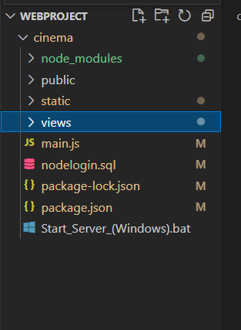

- After that open up the batch file inside the cinema folder
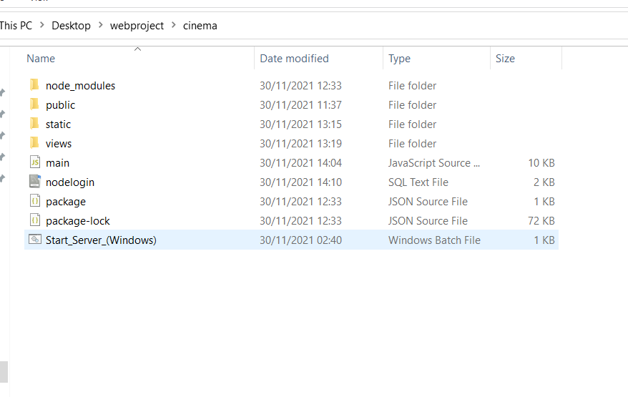

- After running the server got to localhost://3000/ in one of your web browser
