**Container diagram:**



Make API Call

[HTTP/JSON]

API Services

[Container: Java, Spring framework]

Single Page Application

[Container: ReactJs, JS, HTML5, CSS]

View website

HTTP/HTML

Data Read, write

[JDC Driver call]

Azure

[Software system]

Uses

[HTTPS/SDK]

Database

[Container: Yugabyte]

**User Interface Component diagram:**



View website

HTTP/HTML

User Login

Single Page Application

[Container: ReactJs, JS, HTML5, CSS]

Pronunciation

Playback

Pronunciation

recording

Uses

[React/HTML]

User Lookup

Uses

[React/HTML]

Name

Pronunciation

User Interface

**Application Services (APIs) component diagram:**

Uses

[HTTPS/SDK]

Data Read, write

[JDC Driver call]

Make API Call

[HTTP/JSON]

Database

[Container: Yugabyte]

Azure

[Software system]

API Services

[Container: Java, Spring framework]



Single Page Application

[Container: ReactJs, JS, HTML5, CSS]

View website

HTTP/HTML

Make API Call

[HTTP/JSON]

User Login

User Lookup

Pronunciation

recording

(PR)

Pronunciation

Playback

(PP)

API Services

[Container: Java, Spring framework]

Uses  
[RestControllers]

Azure

[Software system]

Uses

[HTTPS/SDK]

Application services

Data Read, write

[JDC Driver call]

Database

[Container: Yugabyte]

**Current Runtime Representation:**

Azure Cloud

Single Page Application

[Container: ReactJs, JS, HTML5, CSS]

NodeJs

VM/Container

User

Browser



Azure Storage Services

Azure Logging

Database

[Container: Yugabyte]

Azure Cognitive Services

Tomcat

VM/Container

API Services

[Container: Java, Spring framework]

**Admin/Employee - User Login Sequence diagram [Post registration/Account creation]:**

API

Azure

Database

Authentication API

Browser



Query

Enter Emp Id/password

Authenticate

JWT Token

Result

GetEmployeeInfo

Query

Result

EmployeeInfo

**Admin/Employee – Standard name pronunciation sequence diagram [Post Login]:**

PP

Azure

Database

Browser



Click Play icon in user profile

pronounceName

text2Speech

pronunciation

pronunciation

playPronunciation

write

savePronunciation

Result

Response

**Admin/Employee - Record custom name pronunciation sequence diagram [Post Login]:**

PR

Azure

Database

Browser



Click Record icon in user profile

processRecording

processSpeech

processedSpeech

processRecording

playRecording

write

saveRecording

Result

Response

**Admin/Employee - User Lookup Sequence diagram [Post Login]:**

UserLookup API

Database

Azure

Browser



Result

Query

Enter Emp Id/name

GetUserInfo

UserInfo

**Admin/Employee - User Lookup & Custom Name pronunciation playback Sequence [Post Login]:**

PP

UserLookup API

Browser

Azure

Database



Query

GetUserInfo

Enter Emp Id/name

Result

UserInfo

Query

GetRecording

Result

Recording

**Admin/Employee - User Lookup & Standard Name Pronunciation sequence diagram [Post Login]:**

Azure

PP

UserLookup API

Browser

Database



Query

GetUserInfo

Enter Emp Id/name

Result

UserInfo

GetRecording

Text2Speech

pronunciation

Recording

**Admin/Employee – Reset recorded pronunciation sequence diagram [Post Login]:**

Azure

API

Database

Browser



resetPronunciation

delete

Click reset in user profile

Reset status

Result

**Swagger Details**

**URL:** **https://name-pronunciation-service.azurewebsites.net/swagger-ui/index.html**

1. **Service Details**

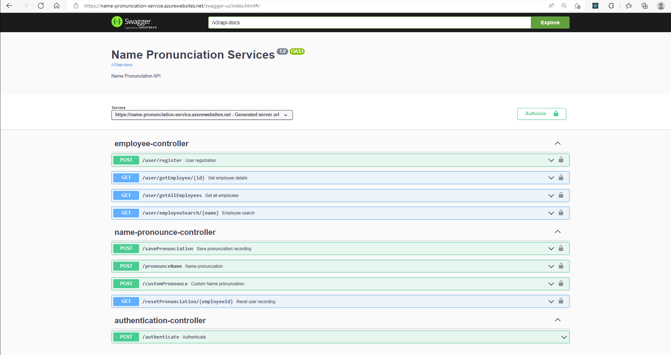

1. **Schema Details**

