# E-commerce SQL Analysis

We have been provided with the sales, product and customer data . Following are the common questions that the stakeholders will be interested in. It gives us some important KPIs to have a look upon

We have used SQL (Big Query) here to do the analysis.

The dataset can be found here :[Dataset](https://drive.google.com/drive/folders/1AXsgQUD8gMRp0zHIF88hizhWMfwJ9ivr?usp=sharing)

Data Description -[PR2-Data-Dictionary- SQL Analysis](https://docs.google.com/document/d/1V8IoRnJipw8EWmyWesc9CRWiSgODyC6vORRvAI0vAEg/edit?usp=sharing)

**I. Basic Metrics from the Data**

* **Total Orders, Number of Customers, Total Sales, Count of Stores**

**Query:**

SELECT COUNT(DISTINCT BASKET_ID) as Total_Orders

FROM ecommerce_sql.transaction_data;

SELECT COUNT(DISTINCT PRODUCT_ID) as Total_Products_Sold

FROM ecommerce_sql.transaction_data;

SELECT COUNT(DISTINCT household_key) as Total_Customers

FROM ecommerce_sql.transaction_data;

SELECT COUNT(DISTINCT STORE_ID) as Num_of_Stores

FROM ecommerce_sql.transaction_data;

SELECT ROUND(SUM(SALES_VALUE),2) as Total_Sales_Value

FROM ecommerce_sql.transaction_data;

SELECT SUM(QUANTITY)/COUNT (DISTINCT BASKET_ID) as Average_basket_Size

FROM ecommerce_sql.transaction_data;

**Result:**

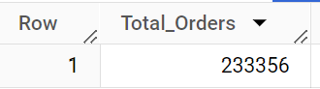 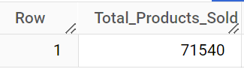 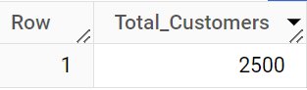

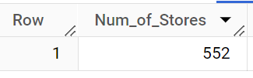 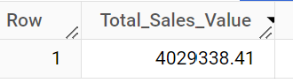

**II. Is there a growing trend in the no. of orders placed over the weeks?**

**Query:**

select week_no,count(distinct basket_id) as Total_Orders

from ecommerce_sql.transaction_data

group by 1

order by 1;

**Result:**

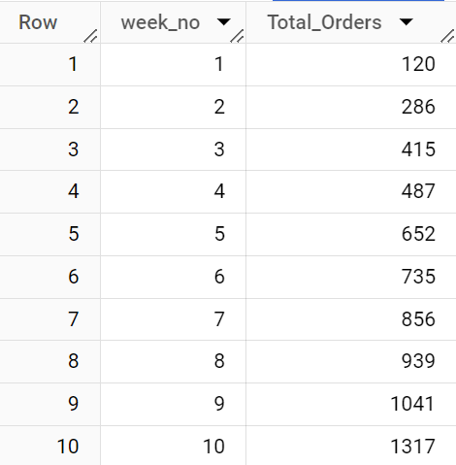

**Insights:**

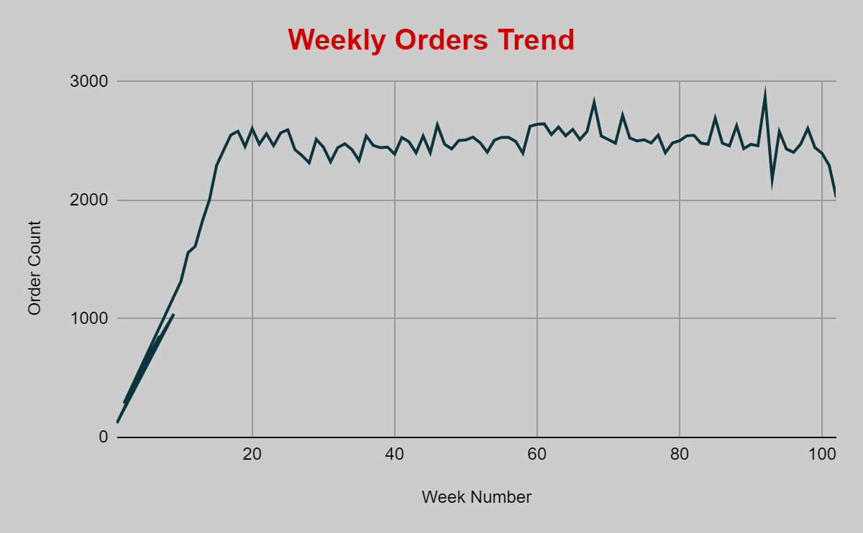

* There is a steady increase in orders till week 20.
* From there with few ups and downs the order trend has been almost same.

**Recommendations:**

* Offer seasonal discounts on the products specific to a particular season to boost the sales.
* Implement new marketing strategies to attract untapped customer base.

**B.** During what time of the day, do the customers mostly place their orders? (Dawn, Morning, Afternoon or Night)

● 0-6 hrs: Dawn ● 7-12 hrs: Mornings ● 13-18 hrs: Afternoon ● 19-23 hrs: Night

**Query:**

select

  case

    when trans_time between 0000 and 0600 then 'Dawn'

    when trans_time between 0601 and 1200 then 'Morning'

    when trans_time between 1201 and 1800 then 'Afternoon'

    when trans_time between 1801 and 2359 then 'Night'

    end as Duration_Of_Day,

  count(distinct basket_id) as Total_Orders

from ecommerce_sql.transaction_data

group by 1

order by 2 desc;

**Result:**

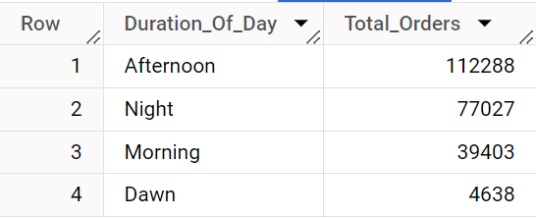

**Insights:**

* Most of the orders from customers are placing the orders during Afternoon.
* During Morning & Night good number of orders being placed.
* Least number of orders are being placed during Dawn.

**Recommendations:** Since most of the orders are being placed during afternoon, business can run more discounted sales or promotional offers during this time to increase the number of sales.

**III. Top 5 Selling Products by Volume and Revenue**

**Query:**

SELECT PRODUCT_ID, SUM(QUANTITY) AS Total_Quantity_Sold

FROM ecommerce_sql.transaction_data

GROUP BY PRODUCT_ID

ORDER BY Total_Quantity_Sold DESC

LIMIT 5;

SELECT PRODUCT_ID, ROUND(SUM(SALES_VALUE),2) AS Total_Revenue

FROM ecommerce_sql.transaction_data

GROUP BY PRODUCT_ID

ORDER BY Total_Quantity_Sold DESC

LIMIT 5;

**Result:**

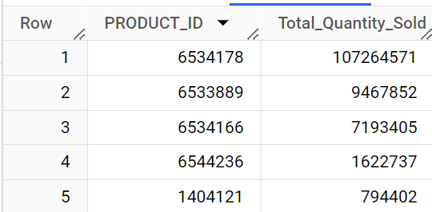 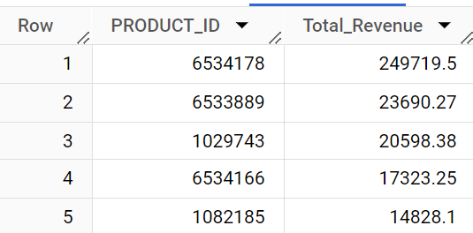

**IV. Top Stores by Revenue**

**Query:**

SELECT STORE_ID,

    COUNT(DISTINCT BASKET_ID) AS Total_Orders,

    ROUND(SUM(SALES_VALUE),2) AS Total_Revenue,

    ROUND(SUM(SALES_VALUE)/COUNT(DISTINCT BASKET_ID),2)AS Average_Order_Value,

FROM ecommerce_sql.transaction_data

GROUP BY STORE_ID

ORDER BY Total_Revenue Desc;

**Result:**

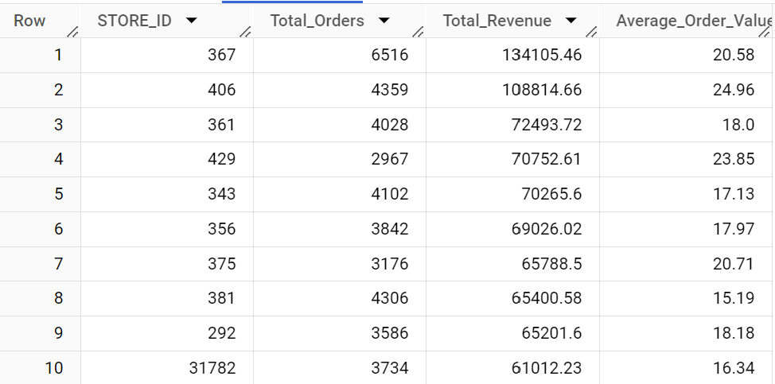

**V. Purchasing Behaviour based on Demographics**

**Query:**

SELECT

    d.AGE_DESC,

    d.INCOME_DESC,

    COUNT(DISTINCT t.BASKET_ID) AS Total_Orders,

    ROUND(SUM(t.SALES_VALUE), 2) AS Total_Revenue

FROM ecommerce_sql.transaction_data t

JOIN ecommerce_sql.demographic d ON t.household_key = d.household_key

GROUP BY 1,2

ORDER BY 4 DESC;

**Result:**

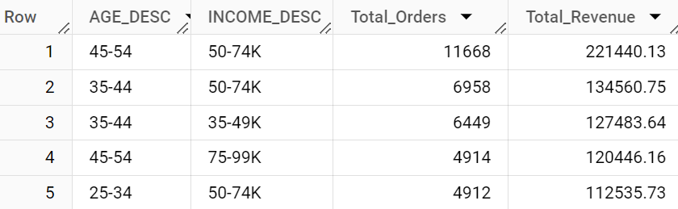

**Insights:**

* Customers between age group 45-54 with income 50-74K are the ones generating highest revenue

**Recommendations:** Customer outreach program might help with retaining them like loyalty points etc.

**VI. Find the number of orders that have small, medium or large order value (small:0-10 dollars, medium:10-20 dollars, large:20+)**

**Query:**

WITH sales_category AS

(

    SELECT basket_id, ROUND(SUM(sales_value), 2) AS Sales

    FROM ecommerce_sql.transaction_data

    GROUP BY 1

)

SELECT

    CASE

        WHEN Sales BETWEEN 0 AND 10 THEN 'Small'

        WHEN Sales > 10 AND Sales <= 20 THEN 'Medium'

        WHEN Sales > 20 THEN 'Large'

    END AS Order_Category,

    COUNT(basket_id) AS Total_Orders

FROM sales_category

GROUP BY 1

ORDER BY 2 DESC;

**Result:**

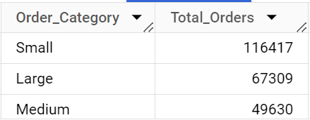

**Insights:**

* Almost 50% orders are from Small Order Category.
* Have good proportion of orders with Large Category as well

**Recommendations:** Attract customers with less order value to make them increase in order size so that the Average order value increases in turn increases the profits

**VII. Find top 3 stores with highest foot traffic for each week (Foot traffic: number of customers transacting)**

**Query:**

WITH store_traffic AS (

    SELECT WEEK_NO, STORE_ID, COUNT(DISTINCT household_key) AS foot_traffic

    FROM ecommerce_sql.transaction_data

    GROUP BY 1,2

),

rank_traffic AS (

    SELECT WEEK_NO, STORE_ID, foot_traffic,

           RANK() OVER (PARTITION BY WEEK_NO ORDER BY foot_traffic DESC) AS pos

    FROM store_traffic

)

SELECT WEEK_NO, STORE_ID, foot_traffic

FROM rank_traffic

WHERE pos <= 3

ORDER BY 1,3 DESC,2;

**Result:**

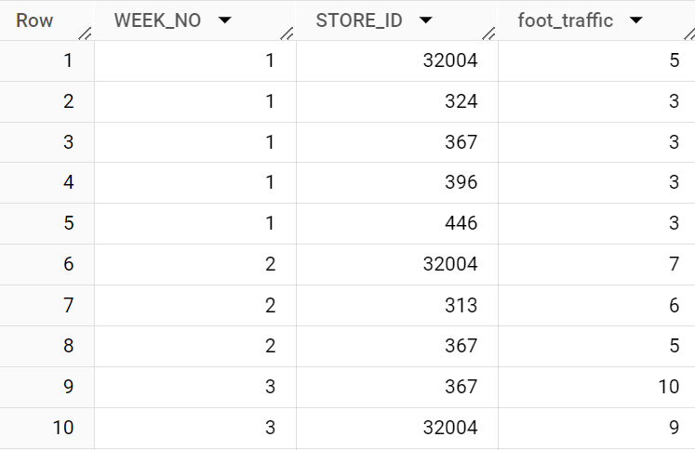

**VIII. Create a basic customer profiling with first, last visit, number of visits, average money spent per visit and total money spent order by highest avg money**

**Query:**

SELECT

    household_key,

    MIN(DAY) AS first_visit,

    MAX(DAY) AS last_visit,

    COUNT(DISTINCT BASKET_ID) AS num_visits,

    round(SUM(SALES_VALUE)/COUNT(DISTINCT BASKET_ID),2) AS avg_money_spent_per_visit,

    round(SUM(SALES_VALUE),2) AS total_money_spent

FROM ecommerce_sql.transaction_data

GROUP BY household_key

ORDER BY avg_money_spent_per_visit DESC;

**Result:**

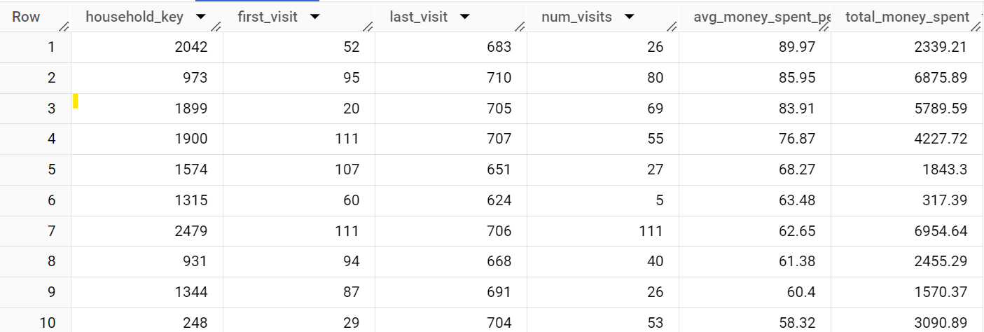

**IX. Do a single customer analysis selecting most spending customer for whom we have demographic information(because not all customers in transaction data are present in demographic table)(show the demographic as well as total spent)**

**Query:**

WITH high_spending AS (

    SELECT household_key, ROUND(SUM(sales_value),2) AS total_spent

    FROM ecommerce_sql.transaction_data

    GROUP BY 1

    ORDER BY 2 DESC

)

SELECT d.*, hs.total_spent

FROM ecommerce_sql.demographic d

JOIN high_spending hs ON d.household_key = hs.household_key

ORDER BY hs.total_spent desc

LIMIT 1;

**Result:**



**X. Find products (product table: SUB_COMMODITY_DESC) which are most frequently bought together and the count of each combination bought together. do not print a combination twice (A-B / B-A)**

**Query:**

WITH cte1 AS (

    SELECT td.BASKET_ID, p.SUB_COMMODITY_DESC AS product_desc

    FROM ecommerce_sql.transaction_data td

    JOIN ecommerce_sql.product p

      ON td.PRODUCT_ID = p.PRODUCT_ID

),

product_combinations AS (

    SELECT bp1.BASKET_ID, bp1.product_desc AS product_A, bp2.product_desc AS product_B

    FROM cte1 bp1

    JOIN cte1 bp2

        ON bp1.BASKET_ID = bp2.BASKET_ID

        AND bp1.product_desc < bp2.product_desc

)

SELECT product_A, product_B, COUNT(*) AS frequency

FROM product_combinations

GROUP BY product_A, product_B

ORDER BY frequency DESC

LIMIT 10;

**Result:**

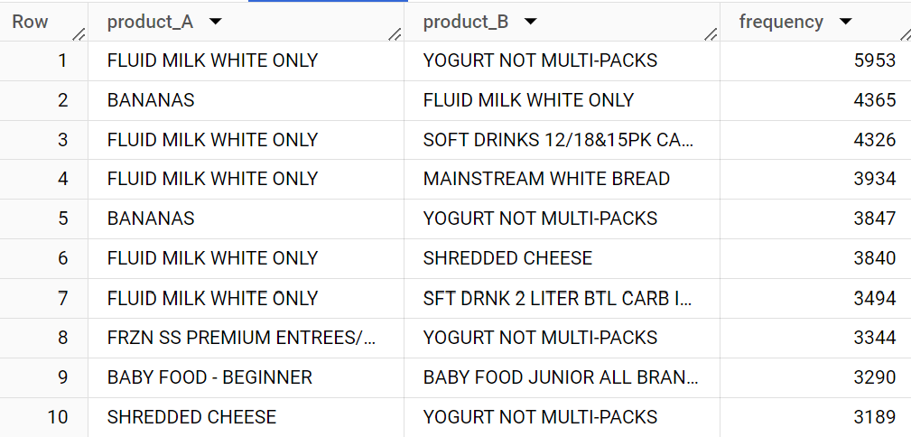

**Insights:**

* Fluid White Milk is the product that was brought together with other products well

**Recommendations:**

* Optimise the search Engine/ place the products that are frequently brought together to increase the sales
* Product placement of top selling products to be done so that they can catch the customer’s eye

**XI. Find the weekly change in Revenue Per Account (RPA) (difference in spending by each customer compared to last week)(use lag function)**

**Query:**

WITH weekly_rev AS (

    SELECT household_key, WEEK_NO, ROUND(SUM(SALES_VALUE),2) AS weekly_spend

    FROM ecommerce_sql.transaction_data

    GROUP BY 1,2

),

weekly_rpa AS (

    SELECT household_key, week_no, weekly_spend,

           LAG(weekly_spend) OVER (PARTITION BY household_key ORDER BY WEEK_NO) AS previous_week_spend

    FROM weekly_rev

)

SELECT household_key, week_no, previous_week_spend,weekly_spend,

       ROUND(weekly_spend - previous_week_spend,2) AS rpa_change

FROM weekly_rpa

ORDER BY 1;

**Result:**

