**Report for Sorting algorithms:**

* We invoked the program for 10 times to get the average time.
* Random number generator is used for values: 0, 10000, 20000, 30000, 40000, 50000, 60000, 70000, 80000, 90000, 100000.
* To get the runtime accurately we used time functions to get the accurate percent of the start and end time. We used CLOCKS_PER_SEC function to divide the runtime value.

**Analysis:**

* In the given sorting algorithms quick sort have faster execution time and continued with randomized quick sort and next merge sort take the more time.
* Using the range 0-100000 quick sort still perform more faster when compared with merge sort.
* We show the complexity of the graph in different random numbers and show runtime for each sort function.

**Randomized Dataset: 20000**

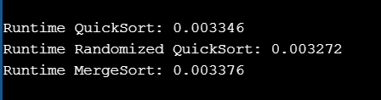

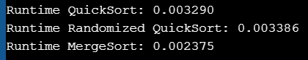

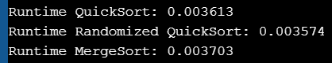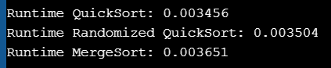

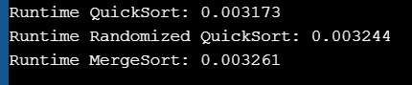

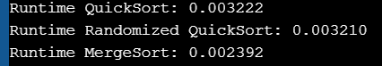

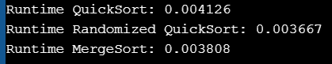

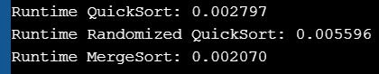

**Randomized Dataset: 30000**

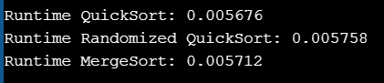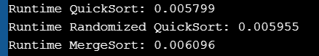

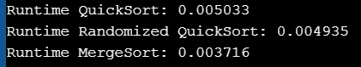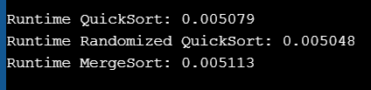

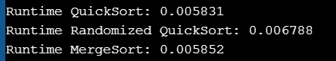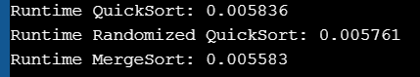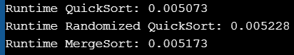

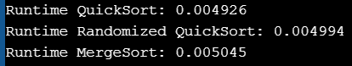

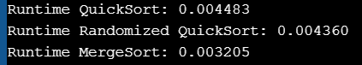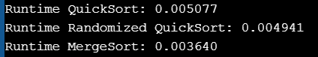

**Randomized Dataset: 40000**

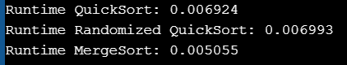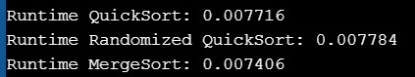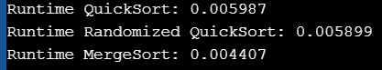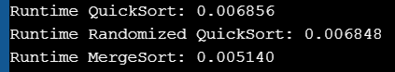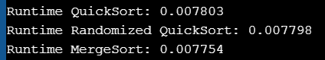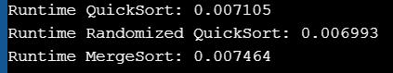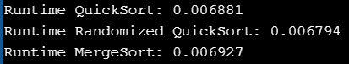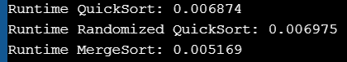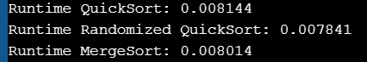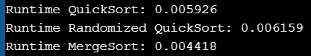

**Randomized Dataset: 50000**

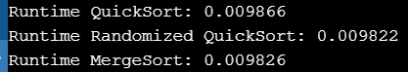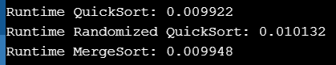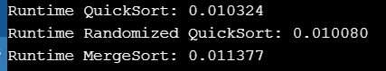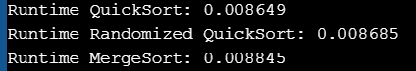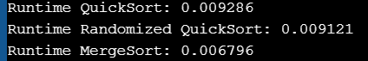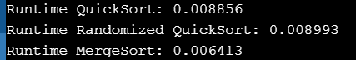



**Randomized Dataset: 60000**

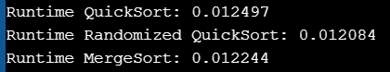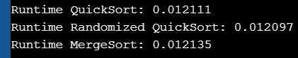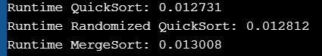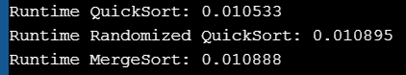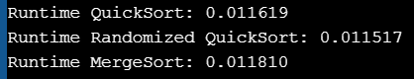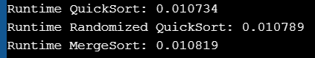

**Randomized Dataset: 70000**

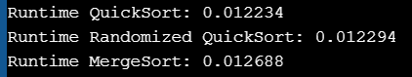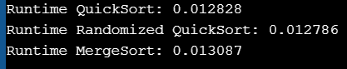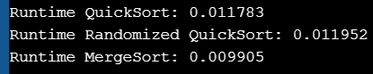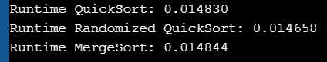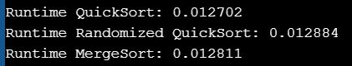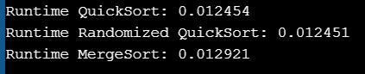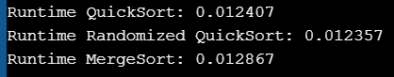

**Randomized Dataset: 80000**

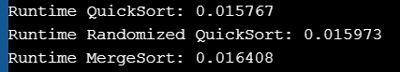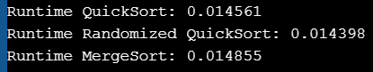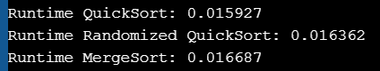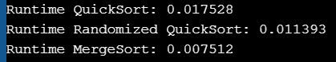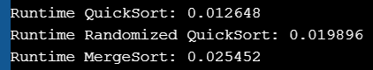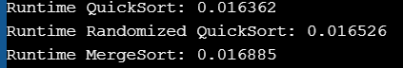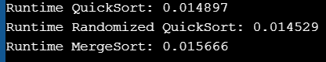

**Randomized Dataset: 90000**

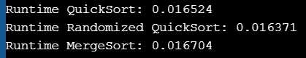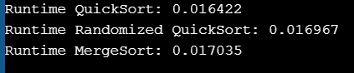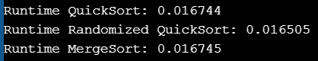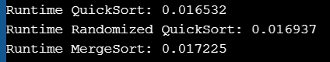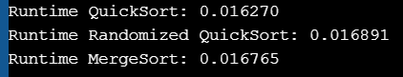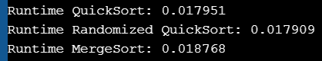

**Randomized Dataset: 100000**

