CIS6300: Business Data Management

Assignment 2 [date: 9/16/2019]

**SAMPATH TALLURI**

This assignment is similar in nature to HW1 as it also requires you to design a conceptual data model. However, this assignment is different in way the problem is presented. In HW1, you had to develop a conceptual data model based on a case, whereas in this assignment, you will have to develop a conceptual data model based on an application, specifically, a User Interface (UI). In Assignment1, work processes, tasks, business rules and constraints were provided in the case. In this assignment, however, only user interfaces are provided.

Based on the data displayed on the UI, you need to come up with ER Diagrams using reverse engineering approach. In other words, you need to develop an ER diagram from a UI. Suggested steps are listed below:

1. Start with the first UI.
2. Write down all attributes [data elements] on a piece of paper as if all attributes belong in one big table.
3. Identify any business rules, constraints, additional attributes which will be required to support Form.
4. Create a dependency diagram. Once dependency diagram is formed, you will have an idea regarding entities and their related attributes.
5. Apply your knowledge of Determinants and dependencies to divide this big entity [table] into smaller entities [tables].
6. Relate newly created smaller entities [tables] by identifying Primary Keys (PKs) & Foreign Keys (FKs).
7. Develop a complete ER diagrams for the UI. Make sure that final ER diagram is up to 3rd Normal Form compliance.

# **Figure 1:** User Interface-Lakefront Homes Lease

|  |  |
| --- | --- |
| Lakefront Homes Lease | |
| Client Number: ______CL55___    Client Name: ____Mark Ownby___ | Property Number: ____PR39_________    Property Address:  Street: 233 W. Main Street  City: Kalamazoo  State: MI  ZIP: 49008 |
| Monthly Rent: ____$ 550______    Rent Start: ____01/01/18_____    Rent Finish: __12/31/19______ | Owner Number: ___OW50__  Full Name: __Lisa Ray Address:  Street: 1212 Blueberry Road City: Portage  State: MI  ZIP: 49024 |

Create an appropriate Conceptual Model (ERD) for the ‘**Lakefront Homes**’.

1. Identify the functional dependencies based on the data shown in the form and also any new attribute that may be required. Draw a dependency diagram.
2. Identify the attributes, primary, and foreign keys in final relations.
3. Draw Entity-Relationship diagrams (ERDs). Make sure that final ER diagram is up to 3rd Normal Form compliance.
4. Provide a list of relations [entities] with attributes, primary, and foreign keys.

Turn in a **copy** of the word document on eLearning. The document must include the following:

1. A cover page with the Course ID, assignment number, student name and submission date.
2. Answers to questions a) – d) with appropriate diagrams.

**Solutions**

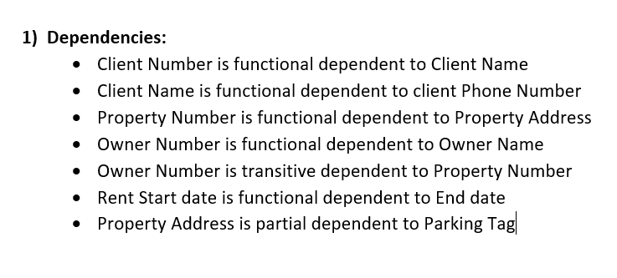

|  |  |  |
| --- | --- | --- |
| Client Number | Client Name | Phone Number |

**CLIENT**

|  |  |  |  |  |  |
| --- | --- | --- | --- | --- | --- |
| Property Number | Property Address | Rent | Parking Tag | Owner Number | Owner Name |

**PROPERTY**

|  |  |  |  |  |  |
| --- | --- | --- | --- | --- | --- |
| Owner Number | Owner Address | Owner Name | Owner Mobile number | Property Number | Property Address |

**OWNER**

|  |  |  |  |
| --- | --- | --- | --- |
| Client Number | Property Number | Rent Start | Rent End |

**RENTAL RELATION**

|  |  |  |  |  |
| --- | --- | --- | --- | --- |
| Property Number | Property Address | Rent | Owner Name | Owner Number |

**PROPERTY FOR RENTAL RELATION**

|  |  |  |  |  |
| --- | --- | --- | --- | --- |
| Payment Method | Client Name | Property Number | Property Address | Amount |

**PAYMENT**

1. Identify the attributes, primary, and foreign keys in final relations

**Entity:** CLIENT

**Attributes:** Client Number, Client Name, Phone Number

**Primary Key:** Client Number, Client Name

**Foreign Key:** None

**Entity:** PROPERTY

**Attributes:** Property Number, Property Address, Parking Tag, Rent, Owner Number, Owner Name

**Primary Key**: Property Number Property Address, Rent

**Foreign Key:** Owner Number, Owner Name

**Entity:** OWNER

**Attributes:** Owner Number, Owner Name, Owner Address, Owner Mobile Number, Property Number, Property Address

**Primary Key:** Owner Number, Owner Name

**Foreign Key:** Property Number, Property Address

**Entity:** RENTAL RELATION

**Attributes:** Client Number, Property Number, Rent Start, Rent End

**Primary Key:** None

**Foreign Key:** Client Number, Property Number

**Entity:** PROPERTY FOR RENTAL RELATION

**Attributes:** Property Number, Property Address, Rent, Owner Number, Owner Name

**Primary Key:** None

**Foreign Key:** Property Number, Property Address, Rent, Owner Name, Owner Name

**Entity:** PAYMENT

**Attributes:** Payment Method, Client Name, Property Name, Property Address, Amount

**Primary Key:** None

**Foreign Key:**  Client Name, Property Name, Property Address

1. ER Diagram

PAYMENT

RENTAL RELATION

PROPERTY

PROPERTY FOR RENTAL RELATION

OWNER

CLIENT