**CIS6300- Business Data Management**

**Assignment-4**

**Name:** SAMPATH TALLURI



1. Display Job ID and Job description of jobs that are not associated with any employee.

select job_id, job_desc from jobs where not exists (select * from employee where jobs.job_id = employee.job_id);

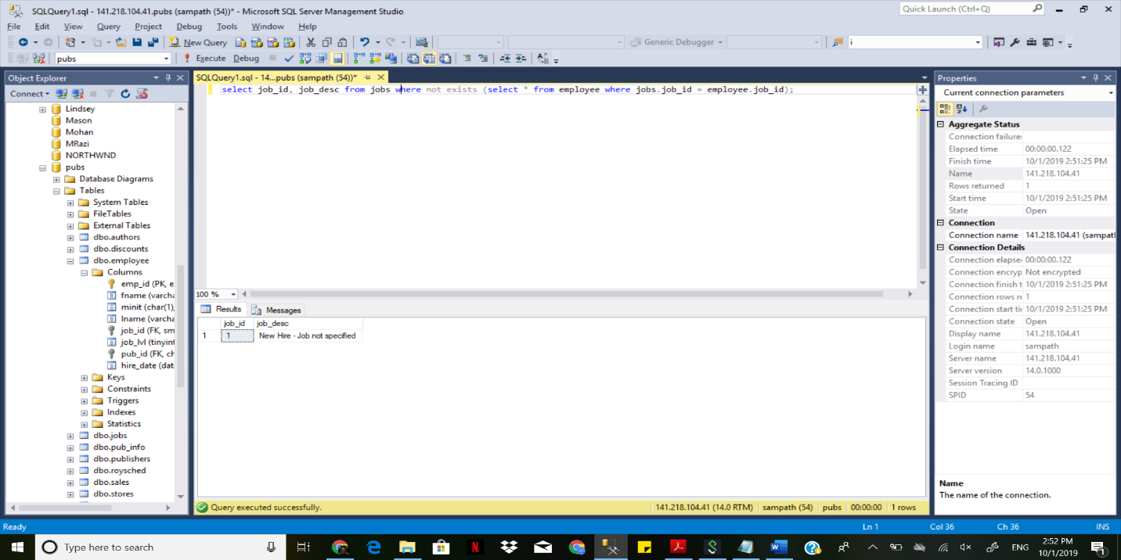

1. Display Title ID, Title and Royalty of Books where Royalty is NULL.

select title_id, title, royalty from titles where royalty is null;

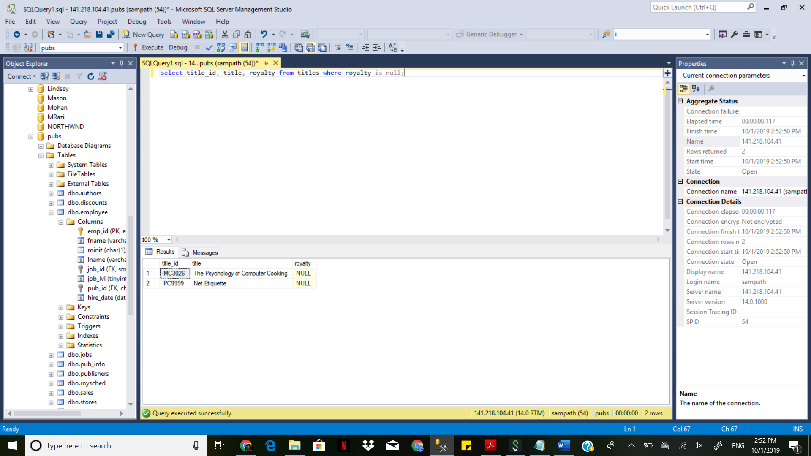

1. Display Store ID and Store name where Store name contains the word Book.

SELECT stor_id, stor_name FROM stores WHERE stor_name LIKE '%book%';

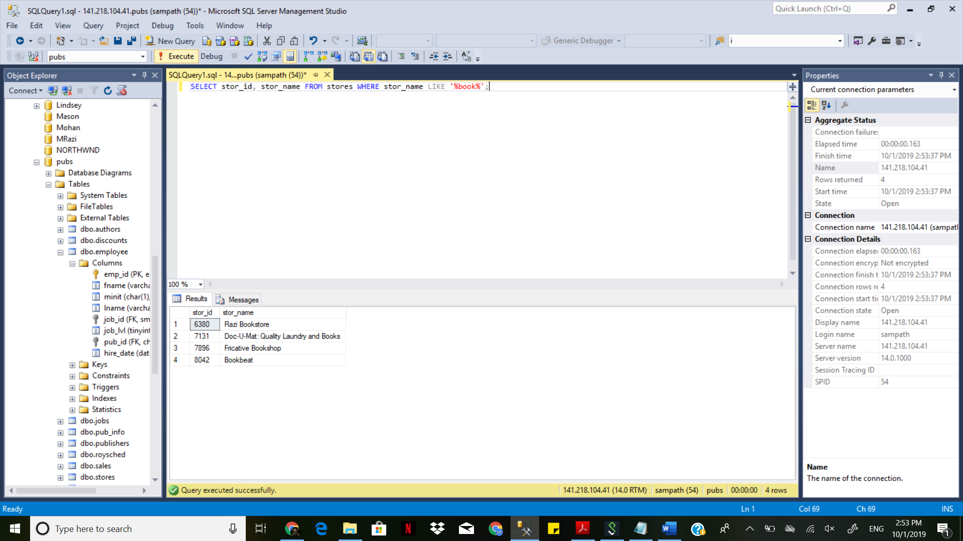

1. Display City and State from Authors table. Make sure to list a city and state combination once only (no repetition).

select distinct city, state from authors;

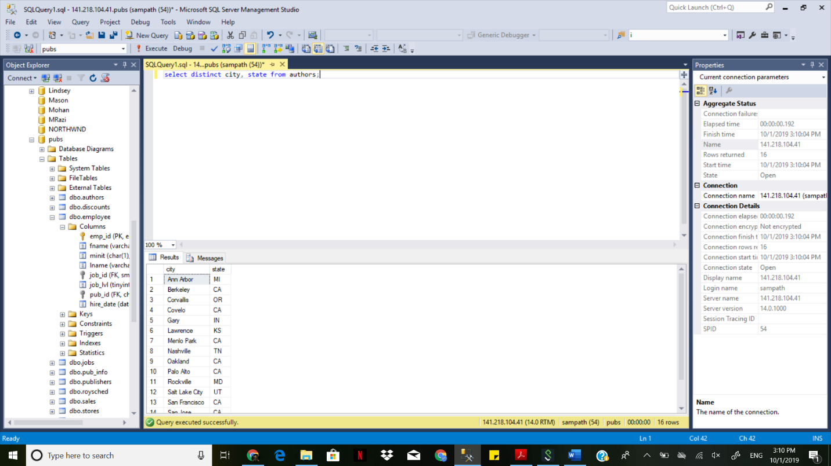

1. Display First Name, Last name of Authors and Store name where the ZIP code for Authors and Stores match.

SELECT authors.au_lname, authors.au_fname, stores.stor_name from authors, stores where authors.zip=stores.zip;

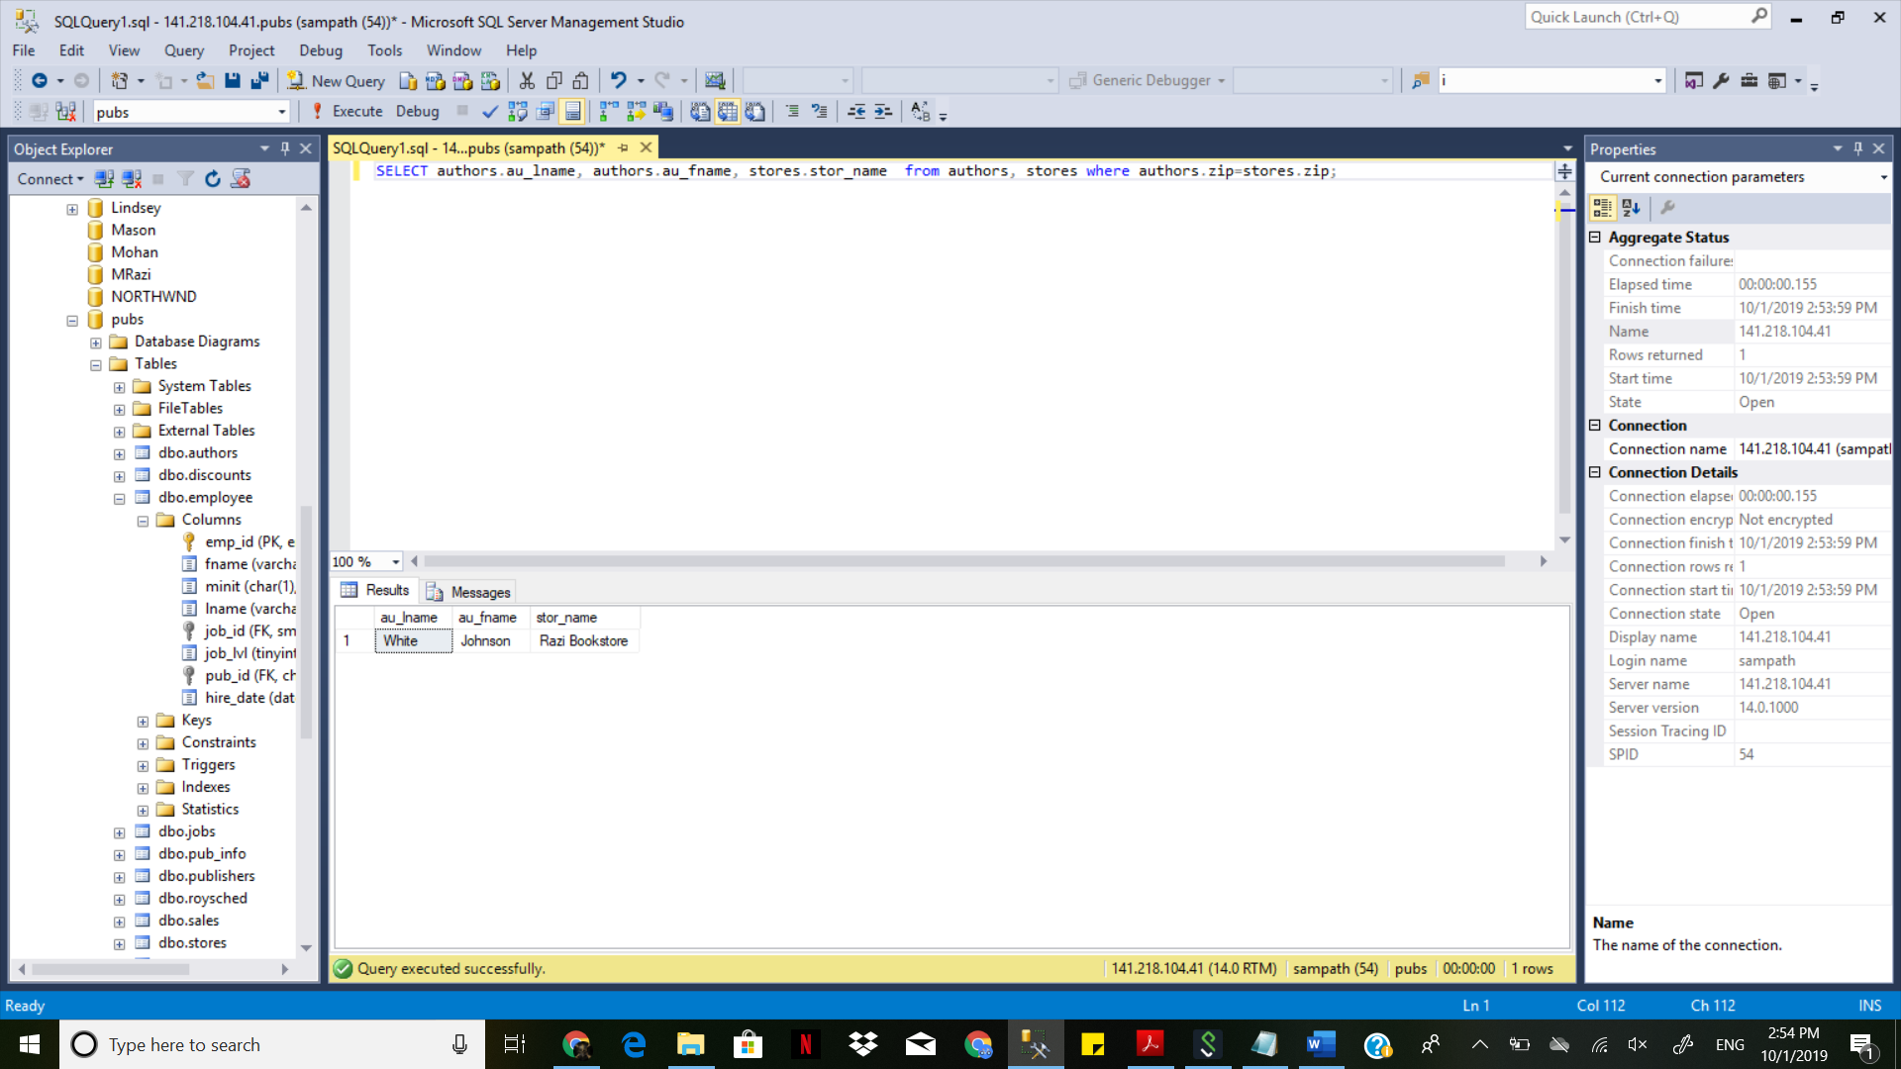

1. Display Store ID, Store name and Discount for each store. Only display stores with discounts (do not display if a store does not offer discount).

select stores.stor_id, stores.stor_name from stores, Discounts where discounts.stor_id = stores.stor_id;

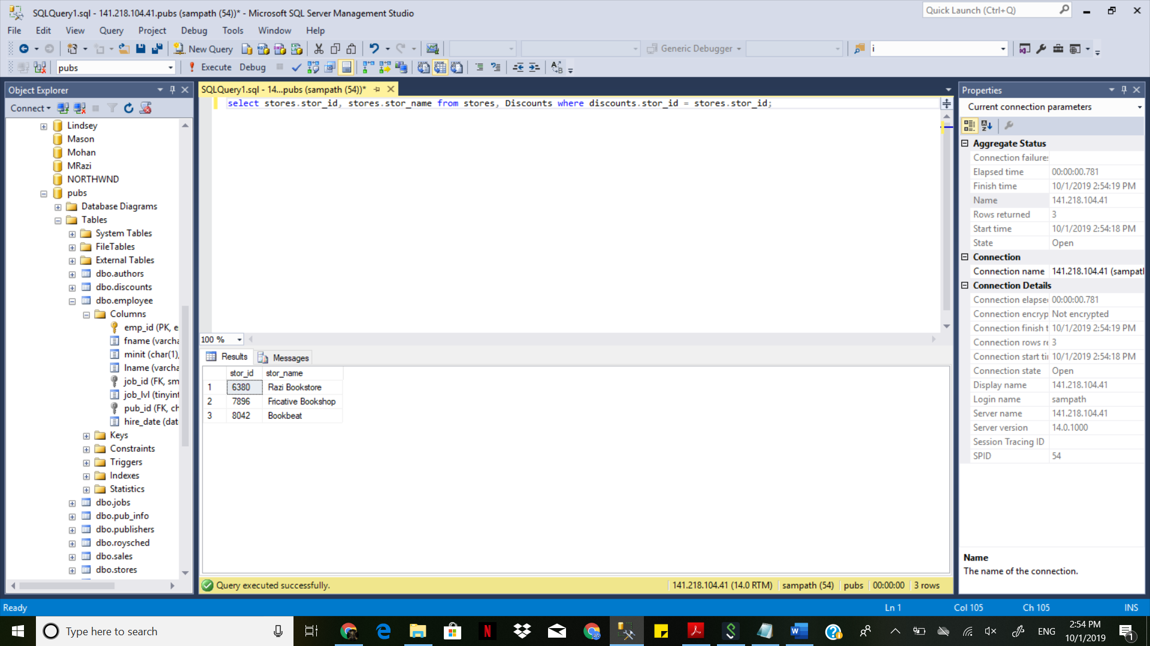

1. Display Store ID and Store name for each store that does not offer any discount.
2. Display Publisher ID, Publisher Name and Total Number of employees for each publisher. Order the records by the descending order (highest to lowest) of Total Number of employees.

select publishers.pub_id, publishers.pub_name, count(*) as count

from employee inner join publishers on employee.pub_id = publishers.pub_id

group by publishers.pub_id, publishers.pub_name;

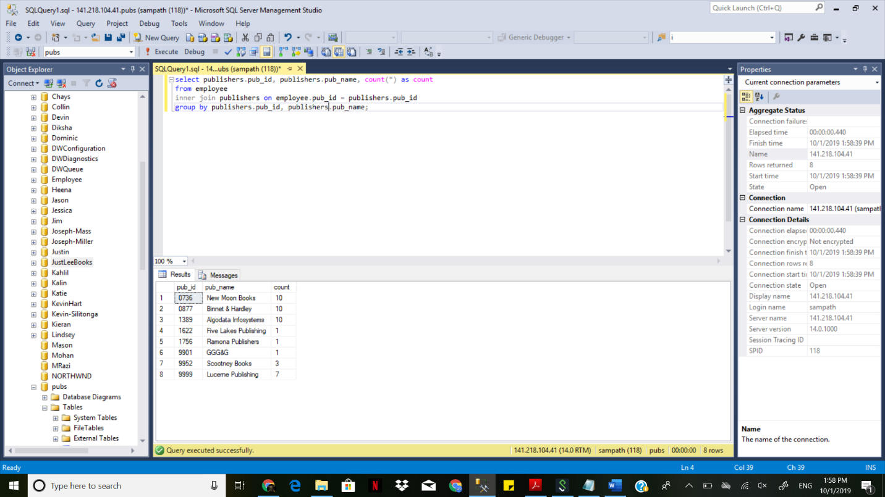

1. Determine how many orders have been placed by each customer in the CUSTOMER table. [Hint: Use Group By].

select custID, count(*) from orders

group by custID;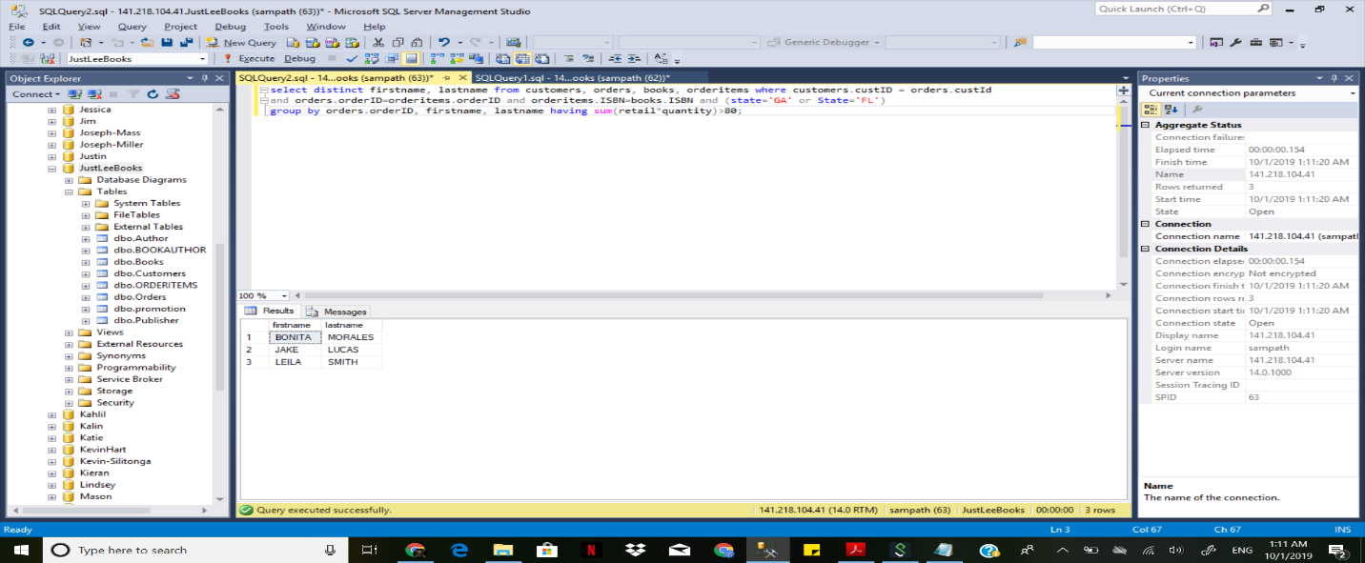

10. List the customers living in Georgia or Florida who have recently placed an

order totaling more than $80. [Hint: Use Group By & Having clauses].

select distinct firstname, lastname from customers, orders, books, orderitems where customers.custID = orders.custId

and orders.orderID=orderitems.orderID and orderitems.ISBN=books.ISBN and (state='GA' or State='FL')

group by orders.orderID, firstname, lastname having sum(retail*quantity)>80;