1. Develop an SQL that will list PID, Name, Unit_Cost of products that have more than 50 units in the Inventory.

select distinct PID, Name, Unit_cost from PRODUCT where PID in (select PID from INVENTORY where Qty > 50)

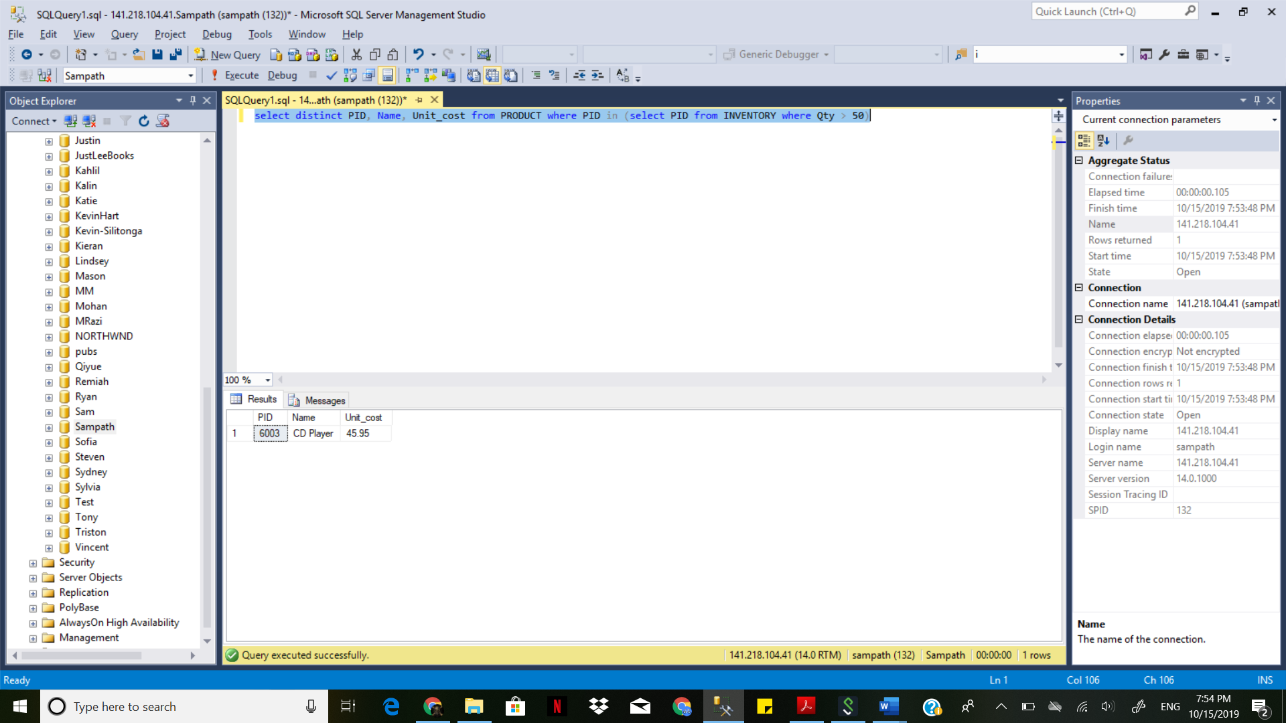

1. Develop an SQL that will list all PID, Name, Unit_Cost for products related to warehouse 2 OR in-transit for warehouse 2 [Hint: UNION].

select PID, Name, Unit_cost from product where pid in

(select pid from lineitem where InvNo in (select InvNo from SHIPMENT where WID=2));

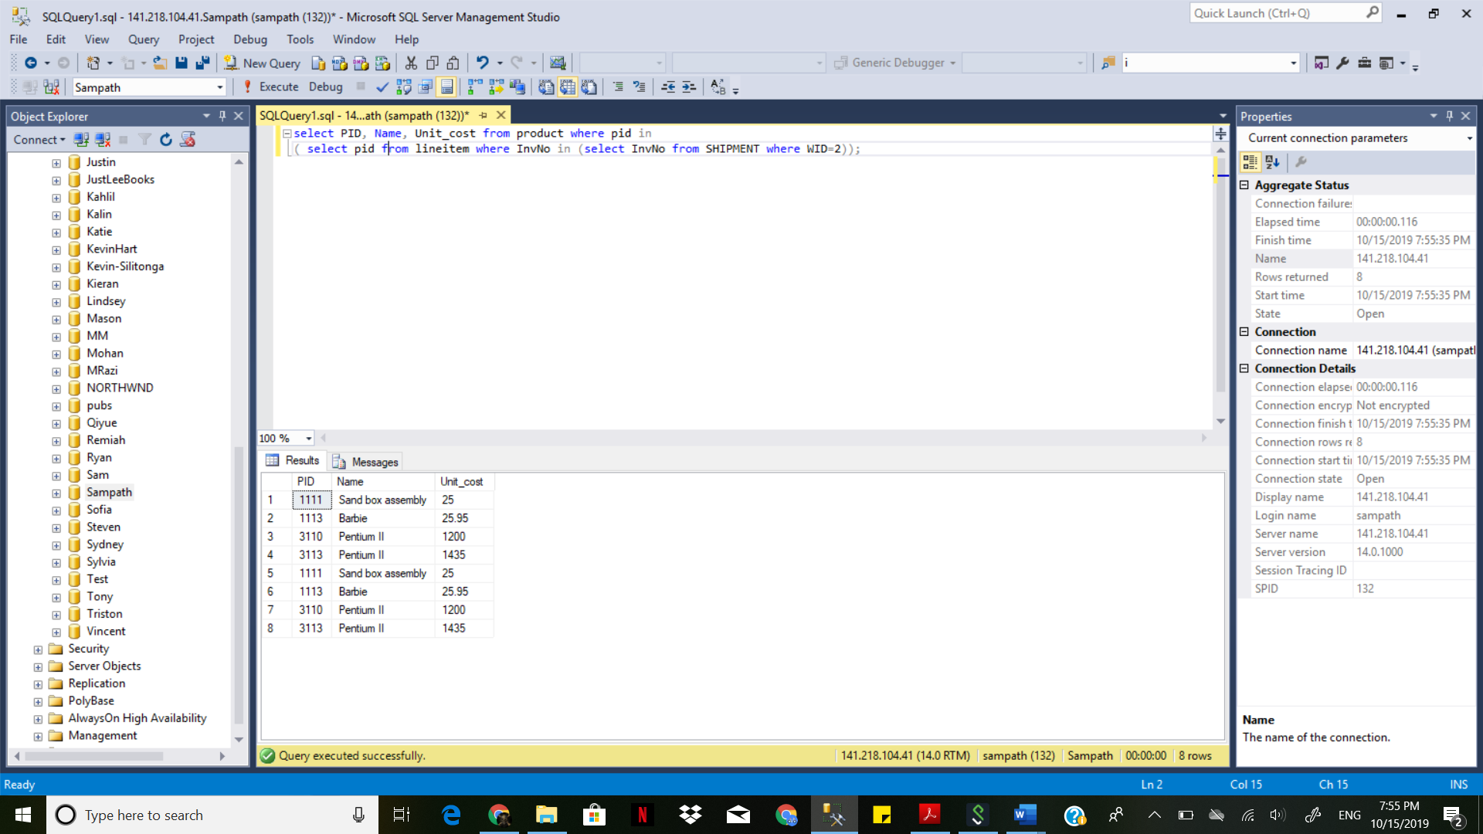

1. Develop an SQL that will list Division Name and the Name of the Manager for the Main Division.

select DISTINCT employee.name, division.name from employee, division

where division.MainDivision > 0 and employee.Mgr_EID<>0 and employee.Mgr_EID = division.Mgr_EID;  
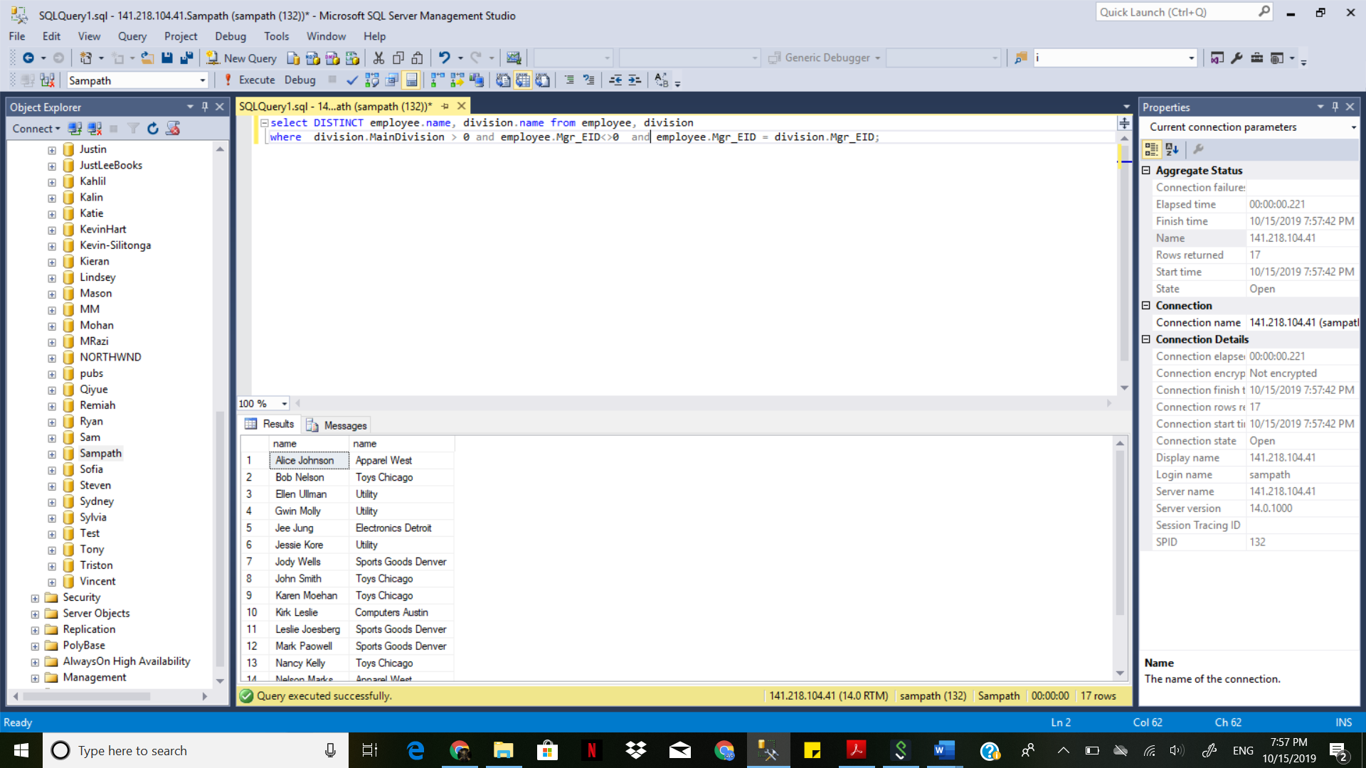

1. Develop an SQL that will list WID, Street_No, City, and State for all warehouses that have multiple shipment records.

select DISTINCT WAREHOUSE.WID, WAREHOUSE.Street_No, WAREHOUSE.City, WAREHOUSE.state from Warehouse,shipment where (select count(*) from SHIPMENT where shipment.WID=warehouse.wid) > 1 order by WAREHOUSE.WID;

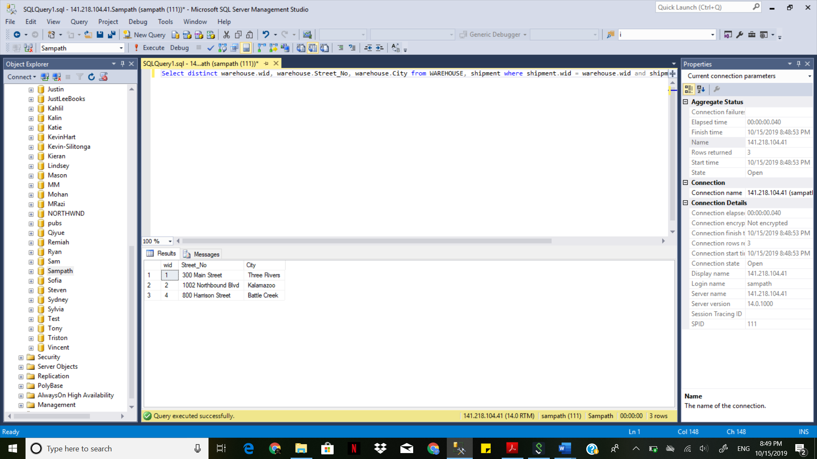

1. Develop an SQL that will list EID and Name of Employees who are managers but do not manage any department. Please note that Employees who are managers their Mgr_EID <> 0.

select DISTINCT employee.EID, employee.NAME FROM EMPLOYEE, DIVISION

WHERE division.did<>employee.did and Employee.Mgr_EID=0 and division.Mgr_EID!=employee.Mgr_EID;

