6

select stores.stor_id, stores.stor_name from stores, Discounts where discounts.stor_id = stores.stor_id;

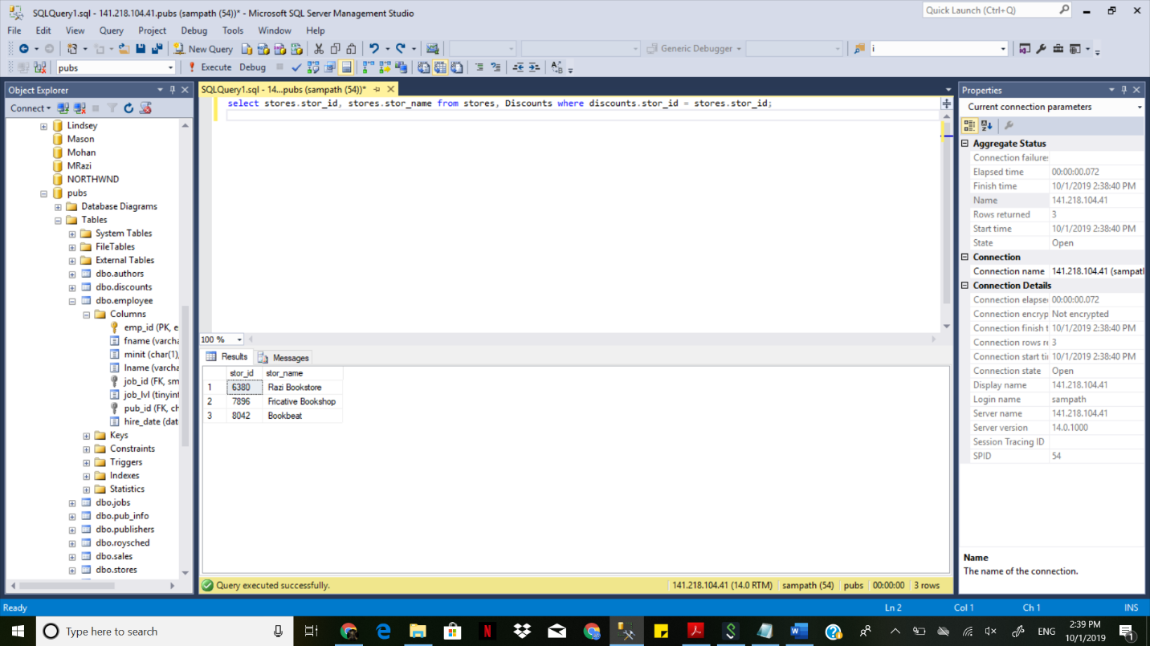

7

8

select publishers.pub_id, publishers.pub_name, count(*) as count

from employee

inner join publishers on employee.pub_id = publishers.pub_id

group by publishers.pub_id, publishers.pub_name;

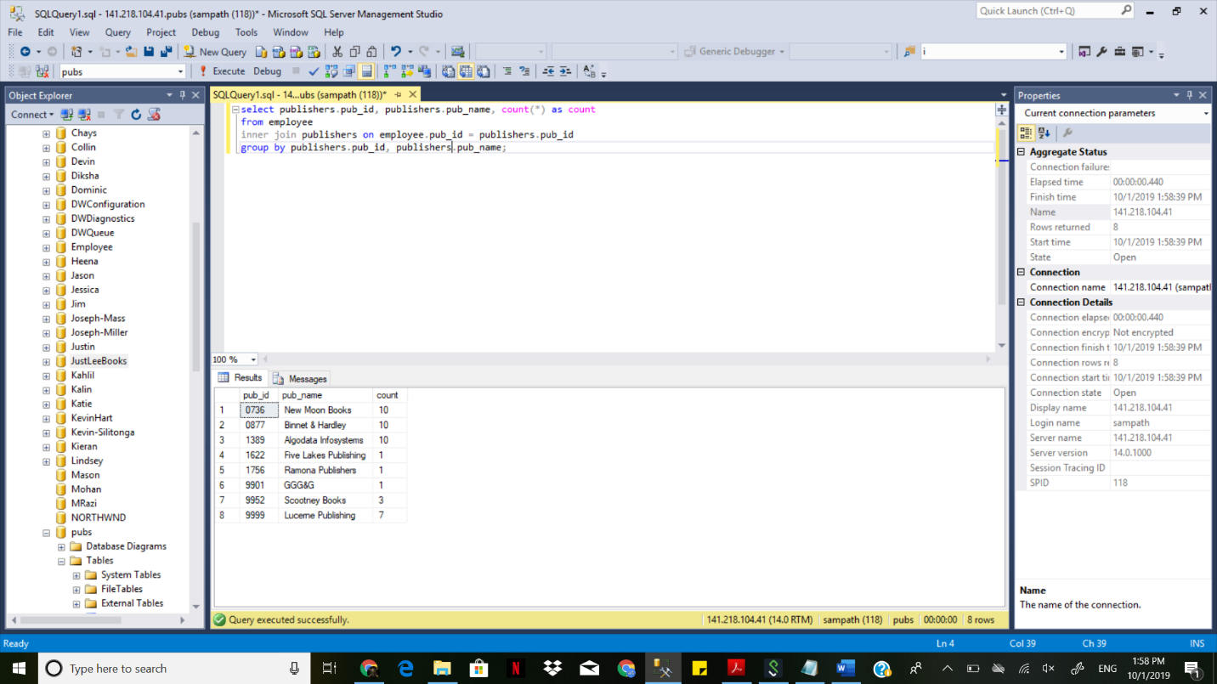

9

select custID, count(*)

from orders

group by custID;

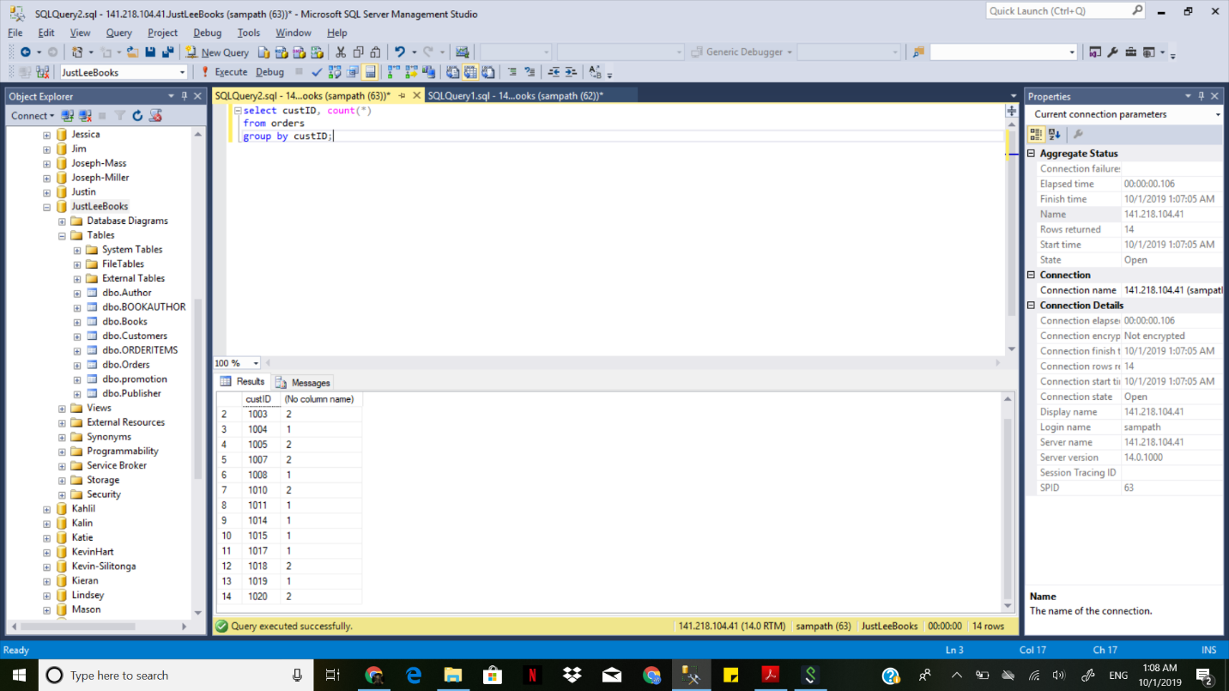

10

select distinct firstname, lastname from customers, orders, books, orderitems where customers.custID = orders.custId

and orders.orderID=orderitems.orderID and orderitems.ISBN=books.ISBN and (state='GA' or State='FL')

group by orders.orderID, firstname, lastname having sum(retail*quantity)>80;

