Project Title
Deadlock Detection and Recovery Simulator: Work/Finish Detection and Process-Termination Recovery in C
Project Report submitted for the partial fulfilment of grade for the course

Operating Systems and Systems Programming (25CS2104E)
in

A.Y. 2026-2027

Submitted by
M Sampath (2520090005)
M Susheel Rao (2520080064)

Team Number: 15
Section: 11

Under the guidance of

[Faculty Name]

Assistant Professor, Department of CSIT
Hyderabad-500090, Telangana, India.

K L (Deemed to be) University
DEPARTMENT OF COMPUTER SCIENCE AND INFORMATION TECHNOLOGY



DECLARATION

The Mini Project Report entitled “Deadlock Detection and Recovery Simulator” is a record of Bonafide work of M Sampath – 2520090005; M Susheel Rao – 2520080064 submitted in partial fulfillment for the award of B. Tech in Computer Science and Information Technology to the K L University. The results embodied in this report have not been copied from any other departments/University/Institute.

M Sampath – 2520090005
M Susheel Rao – 2520080064

K L (Deemed to be) University
DEPARTMENT OF COMPUTER SCIENCE AND INFORMATION TECHNOLOGY
CERTIFICATE

This is to certify that the mini project based report entitled “Deadlock Detection and Recovery Simulator” is a bonafide work done and submitted by M Sampath – 2520090005; M Susheel Rao – 2520080064 in partial fulfillment of the requirements for the award of the degree of BACHELOR OF TECHNOLOGY in Department of Computer Science and Information Technology, K L (Deemed to be University), during the academic year 2026-2027.

Signature of the Supervisor

Signature of the HOD Signature of the External Examiner

ACKNOWLEDGEMENT

The success in this project would not have been possible but for the timely help and guidance rendered by many people. Our wish to express my sincere thanks to all those who has assisted us in one way or the other for the completion of my project.

Our greatest appreciation to our guide, [Faculty Name], Assistant Professor, Department of Computer Science and Information Technology, which cannot be expressed in words for her tremendous support, encouragement and guidance for this project.

We express our gratitude to Dr. Khaja Shareef, Head of the Department of Computer Science and Information Technology, for providing us with adequate facilities, ways and means by which we are able to complete this project-based Lab.

We thank all the members of teaching and non-teaching staff members, and also who have assisted me directly or indirectly for successful completion of this project. Finally, I sincerely thank my parents, friends and classmates for their kind help and cooperation during my work.

M Sampath – 2520090005
M Susheel Rao – 2520080064

TABLE OF CONTENTS

S.No. | Contents | Page no.
1. | Abstract | 6
2. | Introduction | 7
3. | Literature survey | 8
4. | Problem Statement and Objectives | 10
5. | Hardware and Software requirements | 11
6. | Implementation | 13
7. | Results & Discussion | 17
8. | Conclusion & Future Scope | 23
9. | References | 24
1.ABSTRACT

Modern operating systems run many processes at once, and each process may need shared resources such as memory, files and I/O devices. When every process in a group holds a resource while waiting for one held by another, none of them can proceed and the system is deadlocked. This project presents the Deadlock Detection and Recovery Simulator, a command-line program written in standard C (C11) that lets a user define processes and resource types with several instances each, enter the Allocation and Request matrices, and see what the operating system’s detection algorithm concludes. The system state is held in Total, Available, Allocation and Request structures. Detection uses the Work/Finish method for multiple-instance resources: it works on local copies, repeatedly finds a process whose outstanding request can be met, simulates its completion and reclaims its resources, and reports every process left unfinished as deadlocked. Recovery is simulated by process termination, either one chosen deadlocked process or all deadlocked processes; the simulator releases the victim’s resources, rebuilds Available and runs detection again so that the outcome is verified rather than assumed. Input is validated strictly (letters, negative numbers, over-allocation and short rows are rejected and data entry is all-or-nothing). The program compiles with GCC on Linux under -Wall -Wextra -Wpedantic without warnings, runs cleanly under AddressSanitizer and UndefinedBehaviorSanitizer, and was exercised with twelve test scenarios covering deadlock, deadlock-free execution, boundary cases, invalid input and successful and partial recovery. The result is a working tool that makes the four deadlock conditions, the detection algorithm and the recovery trade-offs visible.
Team Name: Team 15 (Section 11)
Team Logo (if any): Not applicable
Team Members:
1. M Sampath, 2520090005
2. M Susheel Rao, 2520080064
Under the guidance of: [Faculty Name], Department of Computer Science and Information Technology
- INTRODUCTION

In a multiprogrammed system, processes compete for a finite set of shared resources. This is safe until a group of processes each hold something that another member of the group is waiting for. Then no process in the group can ever continue, and the resources they hold stay locked. This is a deadlock.
Deadlocks are hard to study on a real machine because they depend on timing and on the order of requests. As a result, the four necessary conditions (mutual exclusion, hold and wait, no preemption and circular wait) and the detection algorithms are usually met only as theory. This project makes them runnable: the user describes a system, and the simulator decides whether it is deadlocked, names the stuck processes and lets the user try to repair it.
The Deadlock Detection and Recovery Simulator is a single C program with a menu-driven command-line interface. A user configures the number of processes and resource types and the number of instances of each type, enters what each process currently holds (Allocation) and is still waiting for (Request), and then displays the state, runs detection, performs recovery, or runs the complete workflow in one step. No real Linux process is touched; terminating a victim only changes the simulated state.
The course angle. The project applies the deadlock-handling part of Operating Systems and Systems Programming (25CS2104E): the resource-allocation model, deadlock characterisation, detection with multiple instances per resource type, and recovery by process termination. It is plain C with only the standard library, which also exercises the systems-programming side of the course: static data structures, strict string-to-integer conversion with strtol and errno, bounded input with fgets, and compilation and debugging with GCC and sanitizers on Linux.
Scope. The simulator handles up to 20 processes, 20 resource types and 1,000 instances per type, with detection and two termination-based recovery strategies. Preemption, file input and cost-based victim selection are left for future scope.
The rest of this report reviews related work (Section 3), states the problem and objectives (4), lists requirements (5), explains the implementation (6), presents test results (7) and concludes with limitations and future scope (8).
- LITERATURE SURVEY

Deadlock handling is one of the oldest and best-documented topics in operating systems. The books, papers and tools below were reviewed to understand what already exists and where this project fits. Reference numbers point to the References section.
1. Operating System Concepts (Silberschatz, Galvin and Gagne) [1]. The standard textbook treatment defines the resource-allocation model, the four necessary conditions, detection for single and multiple instances, and recovery by termination or preemption. Its multiple-instance detection algorithm, with Work and Finish vectors, is the algorithm implemented here, and its Allocation, Request and Available notation is used throughout the code.
2. Modern Operating Systems (Tanenbaum and Bos) [2]. This text presents deadlock as a choice between ignoring it, detecting and recovering, avoiding it dynamically and preventing it structurally. It discusses recovery by preemption, rollback and killing processes, and notes that killing is the simplest and the most commonly used. This supports our choice of process termination as the recovery mechanism and our decision to re-check the system after each kill.
3. System Deadlocks (Coffman, Elphick and Shoshani, 1971) [3]. The paper that stated the four conditions required for deadlock and represented the system as a resource graph. The simulator’s test cases are built directly from these conditions: a circular wait with single instances (T2, T3), multiple instances, and states where the conditions do not all hold (T1, T6).
4. Some Deadlock Properties of Computer Systems (Holt, 1972) [4]. Holt models processes and resources as a directed graph and shows how reduction of the graph decides whether a deadlock exists. The Work/Finish loop is the matrix form of that reduction: a process whose request can be met is removed from the graph and its resources are returned.
5. Cooperating Sequential Processes (Dijkstra, 1965) [5]. Dijkstra introduced the banker’s algorithm and the idea of a safe state, which is used for deadlock avoidance. Avoidance grants a request only if the system stays safe, whereas this project detects and repairs deadlocks after they occur. The same Work-style scan appears in both, so the simulator is a good base for adding avoidance later.
6. Prevention of System Deadlocks (Habermann, 1969) [6]. Habermann generalised the banker’s algorithm to several resource types with several units each. It is the multiple-instance setting that our data model uses: Total, Available, Allocation and Request are all vectors or matrices over m resource types.
7. Deadlock Detection in Distributed Databases (Knapp, 1987) [7]. Knapp’s survey classifies detection methods for distributed systems (path pushing, edge chasing, diffusion and global-state approaches) built on the wait-for graph. This project works on a single machine with the full state in one place, so a central matrix algorithm is sufficient, but the survey shows how the same idea scales to distributed settings.
8. Linux kernel lock validator (lockdep) [8]. The Linux kernel records the order in which lock classes are taken and reports possible circular dependencies at run time, before an actual hang. It shows that deadlock detection is a working part of a real operating system, but it targets lock ordering inside the kernel rather than teaching the general resource model.
9. Valgrind Helgrind [9]. Helgrind is a thread-error detector that reports inconsistent lock acquisition order in POSIX-thread programs. Like lockdep it finds potential deadlocks in real code; it is not meant for experimenting with arbitrary allocation and request states, which is what the simulator provides.
Research gap. Textbooks explain the algorithm on paper with fixed examples, and tools such as lockdep and Helgrind analyse real locking code. Neither lets a learner build an arbitrary state, change one number and watch the result. This project fills that gap with a small, readable C program that accepts any valid state, identifies exactly which processes are deadlocked, shows the order in which the others could finish, applies a recovery strategy and then verifies the outcome with a second detection run.
- Problem Statement and Objectives

Problem Statement: To build a command-line simulator in C that models processes and shared resources, detects deadlock from the Allocation, Request and Available data, identifies the deadlocked processes, and applies recovery strategies to restore normal execution.
Problem Description: Deadlocks depend on timing and on the order of requests, so they are difficult to observe and reason about on a real system. Students therefore learn the four necessary conditions and the detection algorithm as theory only. A hands-on tool is needed to create deadlock and deadlock-free scenarios, run the detection algorithm on the resulting state, see which processes are stuck, and compare recovery choices.
Objectives:
Purpose of the project. A learner or instructor should be able to describe a resource state, ask whether it is deadlocked and receive a precise, explained answer. The objectives that follow from this purpose are:
- Model processes, resource types and instances using Total, Available, Allocation and Request data structures, with a command-line interface for entering and modifying the system state.
- Implement the Work/Finish deadlock detection algorithm for multiple-instance resources and report the completion sequence and the set of deadlocked processes for any state.
- Implement recovery by process termination (one selected process or all deadlocked processes), show the system state before and after recovery, and verify the result by running detection again.
- Validate all input strictly so that letters, negative values, over-allocation, empty and incomplete input can never corrupt the simulation state.
- Test the simulator against deadlock, deadlock-free, boundary, invalid-input and recovery scenarios, and document the algorithms and their results.
- HARDWARE AND SOFTWARE REQUIREMENTS

Hardware Requirements:
- Processor: any x86-64 or ARM processor that can run a current Linux distribution (a normal student laptop is enough).
- Memory: 1 GB RAM is sufficient; the simulation state is a few kilobytes of static arrays (at most 20 × 20 integers per matrix) and no dynamic memory is used.
- Storage: under 50 MB of free disk space for the source file, the compiler output and test inputs.
- Display: any terminal window of 80 columns or more; no GPU, graphics or network connection is needed.
Software Requirements:
- Operating system: Linux (Ubuntu); also runs under WSL on Windows. Developed and tested on Ubuntu.
- Language and compiler: C11, compiled with GCC using -std=c11 -Wall -Wextra -Wpedantic -O2; the build produces no warnings.
- Libraries: none beyond the C standard library (stdio.h, stdlib.h, string.h, ctype.h, errno.h).
- Build and debugging: Make for build automation, GDB for debugging, and Valgrind or the GCC AddressSanitizer and UndefinedBehaviorSanitizer for memory-error checking. The final test run used the sanitizers.
- Version control: Git and GitHub (repository link in Section 6.6).
- Editor: any text editor or IDE, for example VS Code or vim.
Operating Systems Concepts and Linux APIs Used:
OS concept / Linux API / system call | Purpose in the project
Deadlock conditions (mutual exclusion, hold and wait, no preemption, circular wait) | Basis for building the deadlock and deadlock-free scenarios in the simulator.
Resource-allocation and request model (Total, Allocation, Request, Available) | Represents the system state that the detection algorithm reads.
Deadlock detection algorithm (Work / Finish vectors) | Identifies which processes are deadlocked and the order in which the rest can finish.
Recovery by process termination | Breaks the deadlock by removing a victim, releasing its resources and removing its request.
C standard I/O (fgets, printf, strtol, errno) | Command-line interface, bounded line input and strict integer validation.
Static memory layout (fixed-size arrays and structs) | Stores the whole system state without dynamic allocation, so there are no leaks or invalid frees.
Table 1 Operating-system concepts and C library calls used, and their purpose
- IMPLEMENTATION

The simulator is one C source file of about 1,500 lines, deadlock_simulator.c. A menu in main() calls functions for configuration, data entry, display, detection, recovery, a complete one-step simulation and reset. The state lives in one SystemState structure; detection works on local copies of the data and never modifies it, while recovery is the only code that changes the Allocation and Request matrices. Table 2 maps the main functions to their tasks, and the core modules are then shown with their code.
6.1 Project structure
Function(s) | Task | Concept
main, display_main_menu | Menu loop with seven options and exit; ends cleanly on end-of-input | CLI design
read_line, validate_input, read_int_in_range, ask_yes_no, parse_row | Bounded input with fgets, strict integer parsing with strtol and errno, range checks, row parsing | Safe input handling
configure_system, reset_simulation, clear_matrix_data | Set processes, resource types and instances; reset or clear state | System model
enter_allocation_data, enter_request_data, enter_data_menu | Row-by-row matrix entry; each value is bounded so over-allocation is impossible; all-or-nothing commit | Allocation and Request matrices
calculate_available_resources, validate_configuration | Available = Total − sum of Allocation; consistency check before detection | Resource accounting
detect_deadlock | Work/Finish detection on local copies; records completion sequence, idle and deadlocked processes | Deadlock detection
terminate_process, recover_by_terminating_process, recover_by_terminating_all_deadlocked, recovery_session | Simulated kill of one or all deadlocked processes, release of resources, re-detection and verification | Recovery
display_system_state, display_detection_result, print_final_summary | Show matrices, status, detection result and recovery history | Presentation
run_complete_simulation | Detect, recover and summarise in one guided run | Workflow
Table 2 Main functions of deadlock_simulator.c and their tasks
6.2 Data model: system state (SystemState, DetectionResult)
The system state is stored in two structures. SystemState holds the dimensions, Total, Available, Allocation, Request, a terminated flag per process and the recovery history; DetectionResult holds the output of one detection run. All sizes are fixed by constants, so the whole state is static and no memory is allocated at run time. The code below is abridged from the source.
#define MAX_PROCESSES 20
#define MAX_RESOURCES 20
#define MAX_INSTANCES 1000

typedef struct { /* output of one detection run */
int valid, deadlock_found;
int sequence[MAX_PROCESSES]; int sequence_length; /* completion order */
int deadlocked[MAX_PROCESSES]; int deadlocked_count;
int idle[MAX_PROCESSES]; int idle_count; /* hold nothing */
int work_final[MAX_RESOURCES];
} DetectionResult;

typedef struct { /* complete simulation state */
int num_processes, num_resources;
int total[MAX_RESOURCES];
int available[MAX_RESOURCES];
int allocation[MAX_PROCESSES][MAX_RESOURCES]; /* HELD now */
int request[MAX_PROCESSES][MAX_RESOURCES]; /* additionally WAIT */
int terminated[MAX_PROCESSES];
DetectionResult last_detection;
/* ... names, flags and recovery history ... */
} SystemState;

6.3 Module 1: Input handling and validation (validate_input, parse_row)
Every number typed by the user passes through validate_input. It skips leading spaces, converts with strtol, and rejects empty text, letters, trailing garbage, overflow (ERANGE) and values outside the allowed range. Nothing is written to the result on failure. Matrix rows are parsed the same way by parse_row, and each Allocation value is limited to the instances still unallocated, so over-allocation cannot be entered at all. Entry of the whole data set is all-or-nothing: if input ends or a check fails, nothing is stored.
static int validate_input(const char *text, long min, long max, long *value)
{
const char *p = text;
while (*p != '\0' && isspace((unsigned char)*p)) p++;
if (*p == '\0') return INPUT_EMPTY;

char *end = NULL;
errno = 0;
long parsed = strtol(p, &end, 10);

if (end == p) return INPUT_NOT_INTEGER;
if (errno == ERANGE) return INPUT_OUT_OF_RANGE;
while (*end != '\0' && isspace((unsigned char)*end)) end++;
if (*end != '\0') return INPUT_NOT_INTEGER;
if (parsed < min || parsed > max) return INPUT_OUT_OF_RANGE;

*value = parsed; /* written only when the whole text is valid */
return INPUT_OK;
}

6.4 Module 2: Deadlock detection (detect_deadlock)
Detection follows the standard algorithm for several instances per resource type. Work starts as a copy of Available. A process is marked finished at the start if it has been terminated or holds nothing, because it cannot be part of a deadlock (processes that hold nothing are listed separately as idle). The main loop then repeatedly looks for an unfinished process whose Request is less than or equal to Work for every resource type; it adds that process’s Allocation to Work (the process is assumed to run to completion and release what it holds) and records it in the completion sequence. When no further process can be found, every process still unfinished is deadlocked. In the worst case the loop scans n processes up to n times, each scan comparing m resource types, so detection takes O(n² · m) time, at most 8,000 comparisons for the 20 × 20 limit. The function takes the state as const, so detection can be repeated any number of times without changing the system.
static void detect_deadlock(const SystemState *s, DetectionResult *result)
{
int work[MAX_RESOURCES];
int finish[MAX_PROCESSES];

memset(result, 0, sizeof(*result));
for (int j = 0; j < s->num_resources; j++)
work[j] = s->available[j]; /* Work = Available */

for (int i = 0; i < s->num_processes; i++) {
int holds_something = 0;
for (int j = 0; j < s->num_resources; j++)
if (s->allocation[i][j] > 0) holds_something = 1;

if (s->terminated[i]) finish[i] = 1; /* gone */
else if (!holds_something) { finish[i] = 1; /* nothing to */
result->idle[result->idle_count++] = i; } /* release: idle */
else finish[i] = 0;
}

int progress = 1;
while (progress) {
progress = 0;
for (int i = 0; i < s->num_processes; i++) {
if (finish[i]) continue;

int can_run = 1; /* Request[i] <= Work ? */
for (int j = 0; j < s->num_resources; j++)
if (s->request[i][j] > work[j]) { can_run = 0; break; }
if (!can_run) continue;

for (int j = 0; j < s->num_resources; j++)
work[j] += s->allocation[i][j]; /* i finishes, releases */
finish[i] = 1;
result->sequence[result->sequence_length++] = i;
progress = 1;
}
}
for (int i = 0; i < s->num_processes; i++)
if (!finish[i]) result->deadlocked[result->deadlocked_count++] = i;
result->deadlock_found = (result->deadlocked_count > 0);
}

6.5 Module 3: Recovery by process termination (terminate_process)
Recovery is simulated; no real Linux process is touched. Strategy A terminates one deadlocked process chosen by the user, and Strategy B terminates every process that detection currently reports as deadlocked after a confirmation. Both call terminate_process, which refuses an invalid or already-terminated process (so resources can never be released twice), copies the victim’s Allocation to a released vector, zeroes its Allocation and Request rows, marks it terminated and logs it. Available is then rebuilt from Total minus the sum of Allocation rather than increased step by step, which guarantees that no resource is counted twice. After every termination the simulator runs detection again and reports either that the deadlock is resolved or that the recovery is incomplete and further processes must be terminated.
static int terminate_process(SystemState *s, int pid, char strategy, int *released)
{
if (pid < 0 || pid >= s->num_processes) return 0;
if (s->terminated[pid]) return 0; /* no double release */

for (int j = 0; j < s->num_resources; j++) {
released[j] = s->allocation[pid][j];
s->allocation[pid][j] = 0; /* release holdings */
s->request[pid][j] = 0; /* drop its request */
}
s->terminated[pid] = 1;

if (s->history_count < MAX_PROCESSES) { /* recovery history */
s->history_pid[s->history_count] = pid;
s->history_strategy[s->history_count] = strategy;
s->history_count++;
}
/* Available is rebuilt from Total - Allocation, never added to. */
return calculate_available_resources(s);
}

6.6 Individual contribution and repository
Roll Number | Student Name | Individual Responsibility
2520090005 | M Sampath | Design of the data structures for processes, resources, Allocation, Request and Available. Command-line interface for defining processes and resources and entering the state. Implementation of the deadlock detection algorithm and identification of deadlocked processes. Unit testing of detection and boundary conditions.
2520080064 | M Susheel Rao | Implementation of the recovery strategies (process termination). Display of the system state before and after detection and recovery. Test cases for deadlock, deadlock-free and recovery scenarios. Makefile, project documentation and this report explaining the algorithms and results.
Table 3 Responsibility of each team member
GitHub repository: https://github.com/sampath0711/OS-PROJECT
6.7 Build and run
The project compiles with GCC and needs no external libraries. The commands below build the simulator, run it, build a sanitizer version used for memory checking, and run a scripted session by piping menu choices and matrix values to standard input.
gcc -std=c11 -Wall -Wextra -Wpedantic -O2 deadlock_simulator.c -o deadlock_simulator
./deadlock_simulator # interactive menu

gcc -std=c11 -g -fsanitize=address,undefined deadlock_simulator.c -o ds_asan
./ds_asan < session.txt # scripted run under the sanitizers

- RESULTS & DISCUSSION

This section shows the simulator running and the results of the test plan. All screenshots are real terminal sessions of the compiled program on Linux, and every test result below was produced by running the program, not written by hand. The sessions use small systems so that each state fits on one screen.
7.1 Application screenshots
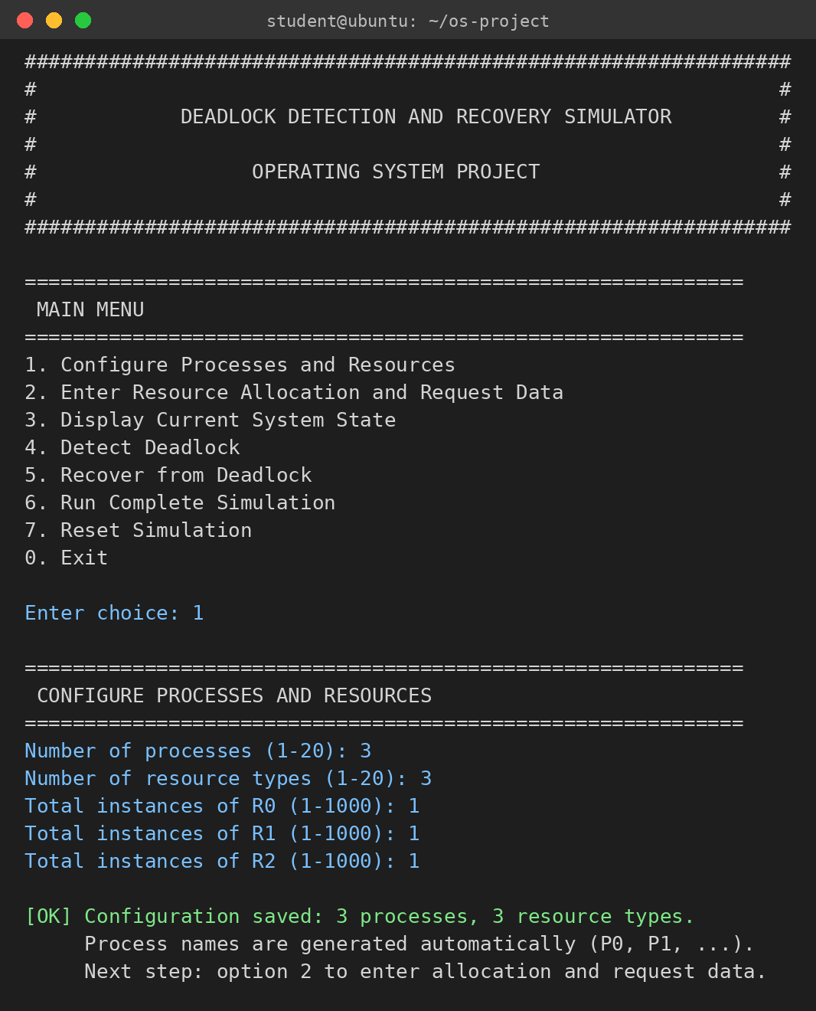
Fig. 1 Start-up banner, main menu and option 1. The user gives 3 processes, 3 resource types and 1 instance of each; process names P0, P1, P2 are generated automatically.
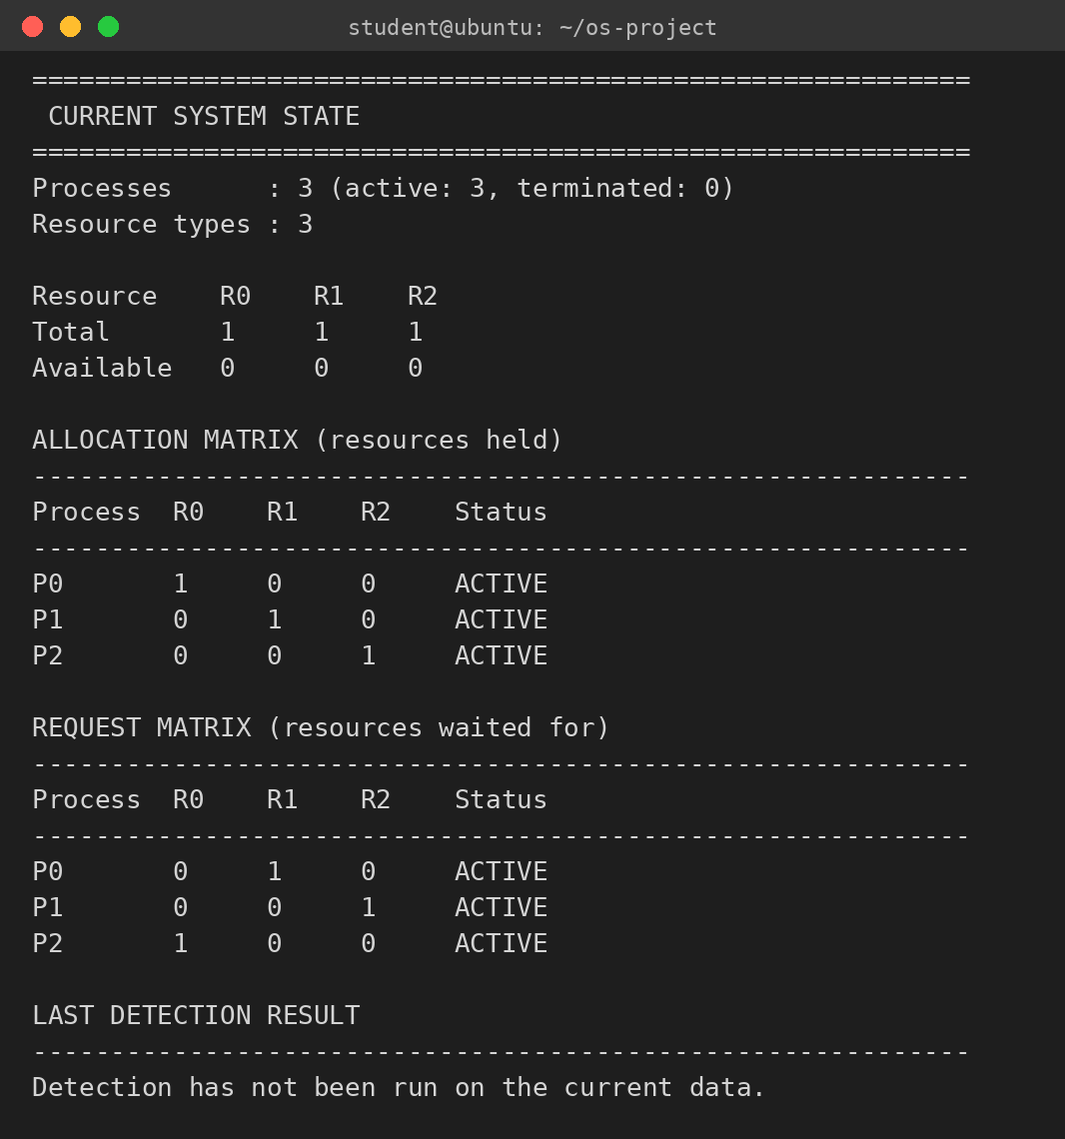
Fig. 2 Option 3, current system state for a circular-wait example. Each process holds one resource (Allocation) and waits for the next one’s (Request); Available is calculated as zero for every type.
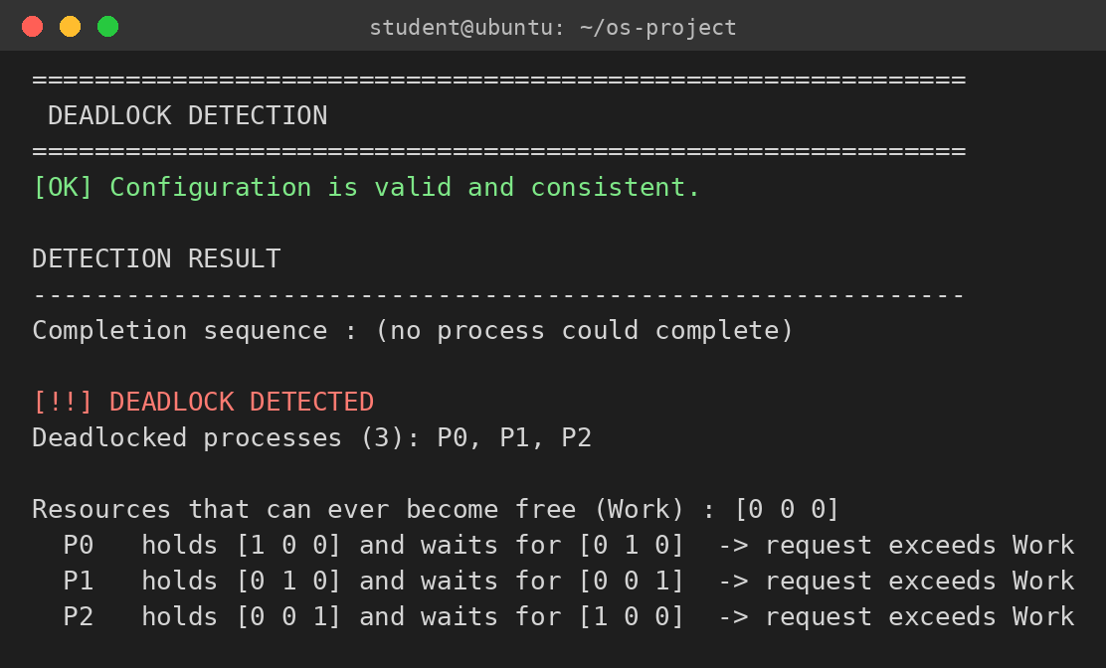
Fig. 3 Option 4, deadlock detection. No process could complete; P0, P1 and P2 are reported as deadlocked, and for each the held and requested vectors are shown against the final Work vector.
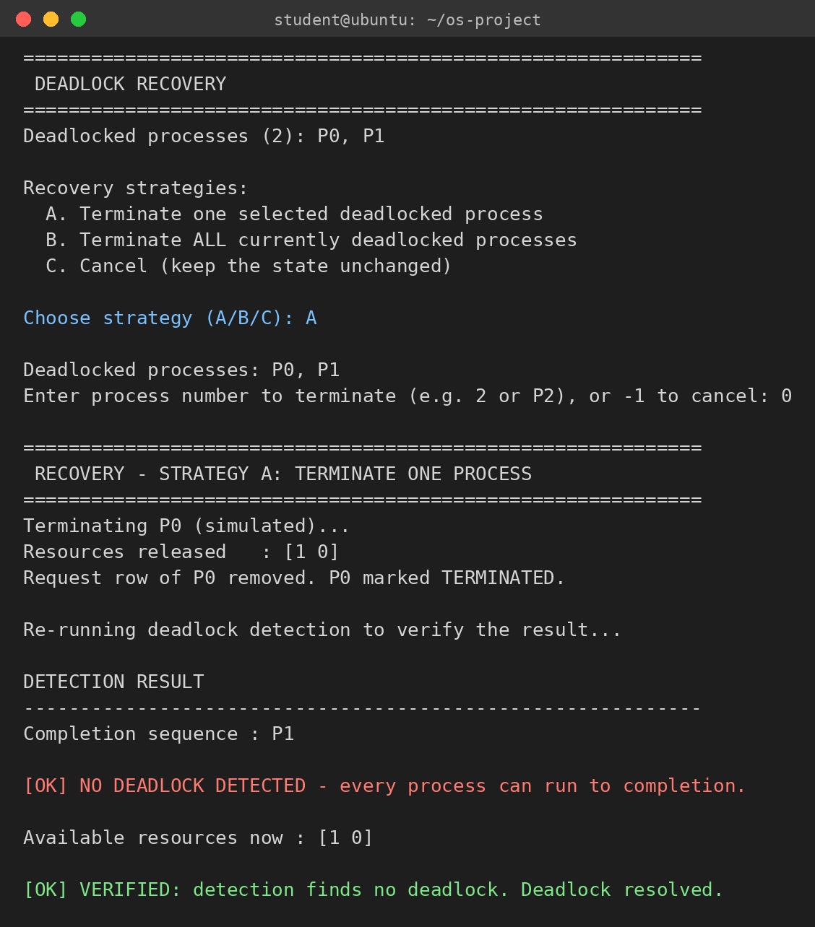
Fig. 4 Option 5, recovery Strategy A on a two-process deadlock. P0 is terminated, [1 0] is released, detection is re-run and P1 can now finish; the result is verified as resolved.
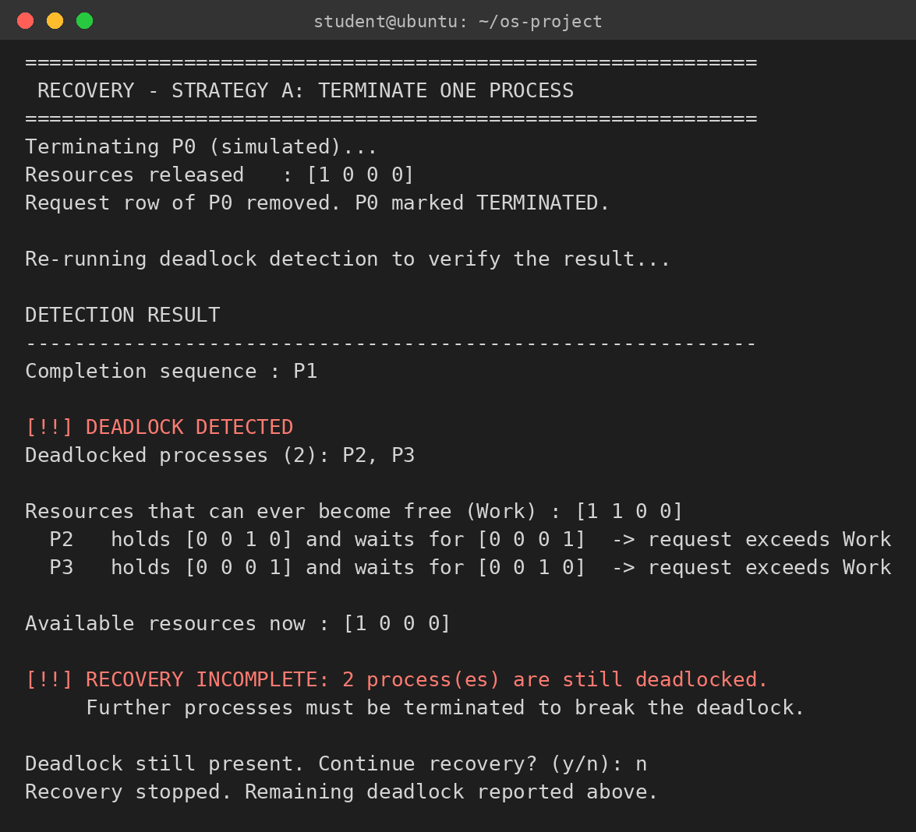
Fig. 5 Recovery Strategy A on a four-process state with two separate deadlocks. Terminating P0 frees P1, but P2 and P3 remain deadlocked and the simulator reports the recovery as incomplete.
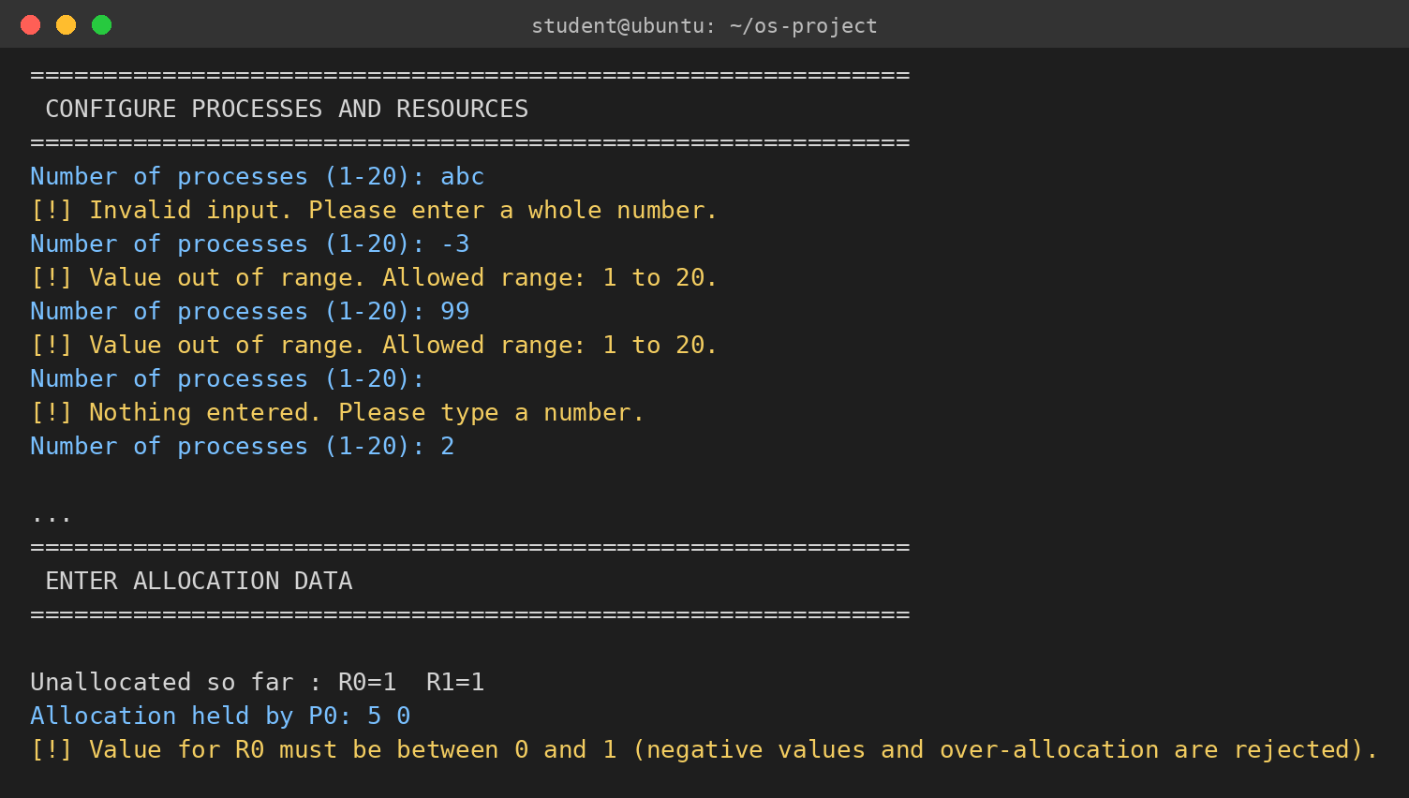
Fig. 6 Input validation. A letter, a negative number, an out-of-range value and an empty line are rejected with a specific message and the prompt repeats; an Allocation value larger than the unallocated instances is also rejected.
7.2 Test cases and results
The test plan has twelve scenarios (T1–T12). Each was run on the compiled program and the output compared with the value expected from the algorithm. All twelve behaved as expected. Table 4 gives the setup and the observed result.
ID | Scenario and setup | Observed result
T1 | Deadlock-free. 3 processes, 2 resource types (totals 5 and 3); P0 and P1 each hold one resource, P2 holds nothing, requests are satisfiable. | No deadlock. Completion sequence P0 → P1; P2 listed as holding nothing.
T2 | Two processes, two resource types, 1 instance each; P0 holds R0 and wants R1, P1 holds R1 and wants R0. | Deadlock detected: P0, P1. Work = [0 0].
T3 | Three processes in a ring: P0 holds R0 wants R1, P1 holds R1 wants R2, P2 holds R2 wants R0. | Deadlock detected: P0, P1, P2. Work = [0 0 0].
T4 | Multiple instances: 3 processes, 2 types of 2 instances; P0 holds [1 0], P1 holds [1 1], P2 holds [0 1]; all request what is not free. | Deadlock detected: P0, P1, P2. Work = [0 0].
T5 | Zero available: 1 resource type of 2 instances, both held; each of 2 processes requests 1 more. | Available = [0]; deadlock detected: P0, P1.
T6 | Some processes hold nothing: 4 processes, P2 and P3 hold nothing and request resources; P0 and P1 are in a circular wait. | Deadlock: P0, P1 only. P2 and P3 are listed as holding no resources and are not blamed.
T7 | Recovery, terminate one selected process (state of T2, victim P0). | [1 0] released; re-detection finds completion sequence P1; verified resolved.
T8 | Recovery, terminate all deadlocked processes (state of T3). | P0, P1, P2 terminated; [1 1 1] released; verified resolved.
T9 | Terminating one process does not fix every deadlock: P0–P1 and P2–P3 are separate circular waits; victim P0. | P1 completes; P2, P3 still deadlocked; “RECOVERY INCOMPLETE” reported.
T10 | Invalid input: “abc”, −3, 99 and an empty line for the process count; Allocation value 5 with only 1 instance; a row with one value instead of two. | Each rejected with a specific message; prompt repeats; no state corrupted.
T11 | Reset (option 7) after data was entered, then enter new data. | Display and detection report “not configured” after reset; the new data is processed correctly (P0 → P1, no deadlock).
T12 | Detection run three times in a row on the T3 state, then display of the state. | The three detection outputs are identical; the state is unchanged.
Table 4 Test scenarios T1–T12 and the results observed from the program
7.3 Worked example: detection trace
Table 5 traces the detection algorithm on the state of T9. Initially nothing is available, so no process can run and all four are deadlocked. After P0 is terminated, its resource R0 returns to Work, P1’s request can be met, and P1 completes; P2 and P3 still wait on each other. The trace matches the simulator’s output in Fig. 5.
Step | Action | Work (R0 R1 R2 R3) | Outcome
0 | Initial state: Work = Available; every process holds something | [0 0 0 0] | No request ≤ Work
1 | Detection on the original state | [0 0 0 0] | P0, P1, P2, P3 deadlocked
2 | Terminate P0 (Strategy A); release [1 0 0 0] | [1 0 0 0] | Available rebuilt
3 | Detection again: P1 requests [1 0 0 0] ≤ Work | [1 0 0 0] | P1 can finish
4 | P1 finishes and releases [0 1 0 0] | [1 1 0 0] | Sequence: P1
5 | P2 needs R3, P3 needs R2; neither ≤ Work | [1 1 0 0] | P2, P3 deadlocked
Table 5 Work vector and outcome at each step for the state of T9
7.4 Discussion
- Detection reports exactly the processes that can never finish. In T6, P2 and P3 are waiting but hold nothing, so they cannot be the cause of a deadlock and are listed as idle instead of being counted among the deadlocked.
- Terminating one process is not always enough (T9). Two independent circular waits need at least two victims, which is why the simulator re-runs detection after every termination and offers to continue recovery instead of declaring success.
- Rebuilding Available from Total and Allocation, instead of adding the victim’s resources to it, means a resource can never be counted twice, and refusing to terminate an already terminated process closes the other way a double release could happen.
- Detection is read-only (T12). Because the state is passed as const and all working data is local, running detection repeatedly gives identical output and never disturbs the simulation; only recovery changes the matrices.
- Strict validation (T10) removes a whole class of bugs. Over-allocation cannot be entered, an incomplete data set is discarded as a whole, and end-of-input ends the program instead of looping.
- The program uses only static arrays. Compiled with -Wall -Wextra -Wpedantic it gives no warnings, and a complete session of configuration, detection, Strategy B recovery and reset ran under AddressSanitizer and UndefinedBehaviorSanitizer with no errors reported. Detection needs at most about 8,000 comparisons for the largest allowed system, so response time is not noticeable.
- CONCLUSION & FUTURE SCOPE

The project set out to build a hands-on tool for deadlock detection and recovery, and this was achieved. The Deadlock Detection and Recovery Simulator lets a user define processes and multiple-instance resources, enter Allocation and Request data, and run the Work/Finish algorithm to learn whether the system is deadlocked and which processes are stuck. It recovers by simulated process termination, one process or all, and verifies each recovery by detecting again, so partial recoveries such as T9 are reported honestly. Twelve test scenarios behaved as expected, strict input validation kept the state consistent, and the program compiles without warnings and runs cleanly under the sanitizers. The tool makes the deadlock conditions and the cost of recovery choices visible, which was the learning goal of the project.
Limitations. The simulator uses process termination only; resource preemption with rollback, which appeared in the original proposal as release or preemption, is not implemented. The victim is chosen by the user or all deadlocked processes are terminated; there is no automatic selection by cost such as the number of resources held. State is entered through the keyboard (scripted by piping) and not read from input files. Sizes are fixed at 20 processes, 20 resource types and 1,000 instances. Detection is matrix-based; no wait-for graph is drawn. The model is a simulation of the state, not of real timing, so it does not reproduce a deadlock arising from thread scheduling.
Future scope
Near term. Add input from files so that test states can be saved and replayed; add a Makefile target that runs all twelve test sessions and compares the output; add cost-based victim selection (for example fewest resources held) as a third strategy.
Medium term. Implement resource preemption with rollback and compare it with termination; draw the wait-for graph and highlight the cycle; add the banker’s algorithm for deadlock avoidance next to detection.
Long term. Add a demonstration with real POSIX threads and mutexes that deadlocks and is detected; extend to distributed wait-for graph detection; build a graphical front end for classroom use.
- REFERENCES

1. A. Silberschatz, P. B. Galvin and G. Gagne, Operating System Concepts, 10th ed., Wiley, 2018 (chapter on deadlocks).
2. A. S. Tanenbaum and H. Bos, Modern Operating Systems, 4th ed., Pearson, 2015 (chapter on deadlocks).
3. E. G. Coffman, M. J. Elphick and A. Shoshani, “System Deadlocks”, ACM Computing Surveys, vol. 3, no. 2, pp. 67–78, 1971.
4. R. C. Holt, “Some Deadlock Properties of Computer Systems”, ACM Computing Surveys, vol. 4, no. 3, pp. 179–196, 1972.
5. E. W. Dijkstra, “Cooperating Sequential Processes”, EWD123, Technological University Eindhoven, 1965.
6. A. N. Habermann, “Prevention of System Deadlocks”, Communications of the ACM, vol. 12, no. 7, pp. 373–377, 1969.
7. E. Knapp, “Deadlock Detection in Distributed Databases”, ACM Computing Surveys, vol. 19, no. 4, pp. 303–328, 1987.
8. Linux kernel documentation, “Runtime locking correctness validator” (lockdep). https://www.kernel.org/doc/html/latest/locking/lockdep-design.html
9. Valgrind documentation, “Helgrind: a thread error detector”. https://valgrind.org/docs/manual/hg-manual.html
10. B. W. Kernighan and D. M. Ritchie, The C Programming Language, 2nd ed., Prentice Hall, 1988.
11. ISO/IEC 9899:2011, Programming languages — C.

