“Grievance Redressal Portal for Institutions”
A Project Report Submitted in the partial fulfillment of the requirements for the award of the degree of
BACHELOR OF TECHNOLOGY
In
DEPARTMENT OF COMPUTER SCIENCE AND INFORMATION TECHNOLOGY
By
M S S M V SAMPATH 2520090005
M SUSHEEL RAO 2520080064
Under the Esteemed Guidance of
[Guide Name]
Assistant Professor
Department of Computer Science and Information Technology
K L (Deemed to be) University
Koneru Lakshmaiah Education Foundation
(Deemed to be University estd. u/s. 3 of the UGC Act, 1956)
Off-Campus: Bachupally-Gandimaisamma Road, Bowrampet, Hyderabad, Telangana - 500 043.
K L (Deemed to be) University
DEPARTMENT OF COMPUTER SCIENCE AND INFORMATION TECHNOLOGY
Declaration
The Project Report entitled “Grievance Redressal Portal for Institutions” is a record of bonafide work of M S S M V SAMPATH – 2520090005, M SUSHEEL RAO – 2520080064 submitted in partial fulfillment of the requirements of the course DATABASE SYSTEMS ENGINEERING AND DISTRIBUTED BACKEND DEVELOPMENT (25CS1302E), Section 10, Team ___, during 2026–2027, Trimester 4, at KLH University. The results embodied in this report have not been copied from any other student, department, or institution.

M S S M V SAMPATH – 2520090005
M SUSHEEL RAO – 2520080064
K L (Deemed to be) University
DEPARTMENT OF COMPUTER SCIENCE AND INFORMATION TECHNOLOGY
CERTIFICATE
This is to certify that the project report entitled “Grievance Redressal Portal for Institutions” is a bonafide work done and submitted by M S S M V SAMPATH – 2520090005, M SUSHEEL RAO – 2520080064 in partial fulfillment of the requirements of the course DATABASE SYSTEMS ENGINEERING AND DISTRIBUTED BACKEND DEVELOPMENT (25CS1302E), Section 10, Team ___, at KLH University during 2026–2027, Trimester 4.

Signature of the Guide
Signature of the Course Coordinator Signature of the HOD

ACKNOWLEDGEMENT
The success of this project would not have been possible without the timely help and guidance rendered by many people. We wish to express our sincere thanks to all those who assisted us in one way or another in the completion of our project.
Our greatest appreciation goes to our Course Coordinator, Dr. ____________, and our guide, [Guide Name], Department of Computer Science and Information Technology, whose tremendous support, encouragement and guidance for this project cannot be expressed in words.
We express our gratitude to Dr. Kaja Shareef, Head of the Department of Computer Science and Information Technology, for providing us with adequate facilities, ways and means by which we were able to complete this project-based lab.
We thank all the members of the teaching and non-teaching staff who assisted us directly or indirectly in the successful completion of this project. Finally, we sincerely thank our parents, friends and classmates for their kind help and cooperation during our work.

M S S M V SAMPATH – 2520090005
M SUSHEEL RAO – 2520080064

ABSTRACT
The Grievance Redressal Portal for Institutions is an intelligent, centralized platform designed to transform the traditional grievance-handling process into a transparent, trackable, and technology-driven system. The portal enables students, faculty, and staff to securely submit grievances related to academics, examinations, infrastructure, hostels, administration, and other institutional services.
Instead of relying on manual complaints and lengthy communication, the system provides real-time grievance tracking, automated categorization, priority-based assignment, status notifications, and role-based access. A combination of SQL and MongoDB is used to efficiently manage structured and flexible data, while a FastAPI-based asynchronous REST backend provides secure APIs with JWT authentication, validation, and automated API documentation.
To improve scalability and reliability, the system adopts a microservices architecture, allowing services such as authentication, grievance management, notifications, and administration to operate independently. REST APIs and Kafka-based asynchronous communication enable efficient interaction between services, while Docker provides consistent containerized deployment.
The system can also incorporate intelligent grievance classification and semantic search to help identify similar complaints and route grievances to the appropriate department. A CI/CD pipeline supports automated testing and deployment, making the platform suitable for real-world institutional environments. Overall, the project demonstrates how modern databases, intelligent automation, microservices, event-driven communication, containerization, and DevOps practices can be combined to create a scalable and accountable solution for institutional grievance management.

INDEX
S.No. | Chapter | Topics
1 | Introduction | 1.1 Background · 1.2 Problem Statement · 1.3 Scope · 1.4 Objectives · 1.5 Importance · 1.6 Target Users
2 | System Requirements | 2.1 Hardware · 2.2 Software · 2.3 Development Tools and Frameworks
3 | Technology Stack | 3.1 Backend · 3.2 Databases · 3.3 Messaging · 3.4 Containerization and CI/CD · 3.5 Version Control · 3.6 Authentication and Security
4 | System Architecture | 4.1 High-Level Architecture Diagram · 4.2 Description of Each Layer · 4.3 Deployment Architecture
5 | Design | 5.1 Database Design Principles · 5.2 ER Diagram / Schema · 5.3 Design Decisions and Assumptions
6 | Implementation | 6.1 Module-wise Implementation · 6.2 Event-Driven Logic · 6.3 API Integration · 6.4 Authentication and Authorization
7 | Features | 7.1 List of Main Features · 7.2 How Each Feature Works
8 | Testing | 8.1 Postman API Testing · 8.2 Integration Testing · 8.3 Tools Used · 8.4 Test Cases and Results
9 | Deployment | 9.1 Steps to Deploy · 9.2 Environment Configuration · 9.3 CI/CD and Hosting
10 | Challenges & Limitations | 10.1 Issues Faced · 10.2 Solutions Applied · 10.3 Current Limitations
11 | Future Enhancements | 11.1 Planned Features · 11.2 Possible Integrations or Optimizations
12 | Conclusion | 12.1 Summary · 12.2 What Was Achieved · 12.3 Skills Learned
13 | References | Documentation, tools, and resources used
14 | Appendices | Sample code · Setup instructions · Default credentials · API summary · Screenshots

CHAPTER 1: INTRODUCTION

1.1 Background of the Project
Educational institutions receive grievances every day — about examination results, timetable clashes, hostel facilities, broken infrastructure, fee and administrative issues, and more. In most institutions these are still raised informally: through handwritten applications, emails, phone calls, messaging groups, or a visit to an office. A complaint raised this way has no tracking number, no visible owner, and no deadline. The person who raised it cannot tell whether it has been seen, and the institution cannot tell which problems are recurring.
The Grievance Redressal Portal for Institutions replaces this informal process with a single, trackable platform. Every grievance is recorded with a unique tracking number, categorized, assigned to a responsible department and officer, and followed through a defined status lifecycle until it is resolved, with the person who raised it notified at each step.

1.2 Problem Statement
Given an institution with multiple departments and a continuous stream of grievances from students, faculty, and staff, the system must reliably answer three questions: who is responsible for a given grievance, what is its current status, and how urgently does it need attention. Handling these manually does not scale, delays resolution, offers no transparency to the complainant, and gives management no consolidated view of recurring issues.

1.3 Scope of the Project
The system covers the full lifecycle of a grievance: secure submission by an authenticated user; automatic categorization and priority assignment; routing to the appropriate department; status updates and comments by the assigned handler; real-time tracking and notifications for the complainant; and an administrative view over all grievances, users, and departments. The system can also incorporate intelligent classification and semantic search to detect similar complaints. Payment processing, multi-institution tenancy, and a native mobile application are treated as out of scope for this submission.

1.4 Objectives
- Allow students, faculty, and staff to submit grievances securely against defined categories such as academics, examinations, infrastructure, hostels, and administration.
- Provide real-time grievance tracking through a unique tracking number and a clear status lifecycle.
- Categorize grievances automatically and assign them by priority to the appropriate department.
- Notify users of status changes through asynchronous, event-driven notifications.
- Enforce role-based access so that each user sees and does only what their role permits.
- Use SQL for structured data and MongoDB for flexible, semi-structured grievance data.
- Build independent, containerized microservices that communicate via REST APIs and Kafka, with automated testing and deployment through a CI/CD pipeline.

1.5 Importance of the Application
A transparent grievance system builds trust between an institution and its community. Complainants know that their issue has been registered and who is handling it; handlers know which cases are most urgent; and administrators can identify recurring problem areas and departments with slow resolution, so that improvements can be targeted rather than guessed.

1.6 Target Users / Audience
The system serves four roles: Complainants (students, faculty, and staff) who submit and track grievances; Department Handlers who review, update, and resolve grievances assigned to their department; Administrators who manage users, departments, categories, and monitor all grievances; and the institution's management, who rely on the administrator's consolidated view.

CHAPTER 2: SYSTEM REQUIREMENTS

2.1 Hardware Requirements
Because the system runs several containers at once (multiple services, two databases, and a Kafka broker), the requirements are higher than for a single-process application. A development or demonstration machine with a quad-core processor, 8 GB of RAM (16 GB recommended), and around 10 GB of free disk space is sufficient to run the full stack on one computer.

2.2 Software Requirements
- Python 3.10 or later, with pip
- PostgreSQL or MySQL (relational database)
- MongoDB (document database)
- Apache Kafka (event streaming)
- Docker and Docker Compose
- Git and a GitHub account
- Postman for API testing, and a modern web browser (for Swagger UI)
- Visual Studio Code or any equivalent editor (recommended)

2.3 Development Tools and Frameworks
FastAPI was used for the asynchronous REST backend; PostgreSQL/MySQL and MongoDB for persistence; JWT for authentication; Apache Kafka for inter-service messaging; Docker for containerization; GitHub with a CI/CD pipeline for source control and automated delivery; and Postman for API testing.

CHAPTER 3: TECHNOLOGY STACK

3.1 Backend
The backend is built with FastAPI, an asynchronous Python framework. FastAPI validates every request and response through typed models, handles concurrent requests efficiently through async I/O, and automatically generates interactive API documentation (Swagger UI and ReDoc) from the code itself, which keeps the documentation permanently in sync with the implementation.

3.2 Databases
The system uses a polyglot persistence approach. A relational SQL database (PostgreSQL/MySQL) stores structured institutional data — users, roles, departments, categories, grievances, assignments, and status history — where relationships and integrity constraints matter. MongoDB stores flexible, semi-structured grievance data — free-text details, attachments metadata, comment threads, classification labels, and notification logs — whose shape varies from grievance to grievance.

3.3 Messaging
Apache Kafka provides event-streaming between microservices. When something noteworthy happens (a grievance is created, assigned, or its status changes), the owning service publishes an event, and interested services — such as the notification service — consume it independently. This decouples services, so a slow or unavailable consumer never blocks the user-facing request.

3.4 Containerization and CI/CD
Each microservice is packaged as a Docker image, and Docker Compose starts the entire stack with one command. A CI/CD pipeline on GitHub automatically runs tests on every push and builds container images, so that releases are consistent and repeatable.

3.5 Version Control
Git was used throughout development, with the source code hosted on GitHub to support collaboration between the two team members.

3.6 Authentication and Security Libraries
Authentication uses JSON Web Tokens (JWT). A user logs in with credentials; the Auth service verifies them against a salted password hash and returns a signed token carrying the user's ID and role. Every protected endpoint verifies this token, and role-based checks ensure, for example, that a complainant can never reach an administrator-only endpoint. Request validation through typed models additionally guards against malformed input.

CHAPTER 4: SYSTEM ARCHITECTURE

4.1 High-Level Architecture Diagram
The system follows a microservices architecture. Clients communicate with the services over REST; services communicate with each other through REST for synchronous requests and through Kafka for asynchronous events. Figure 4.1 shows the overall structure.
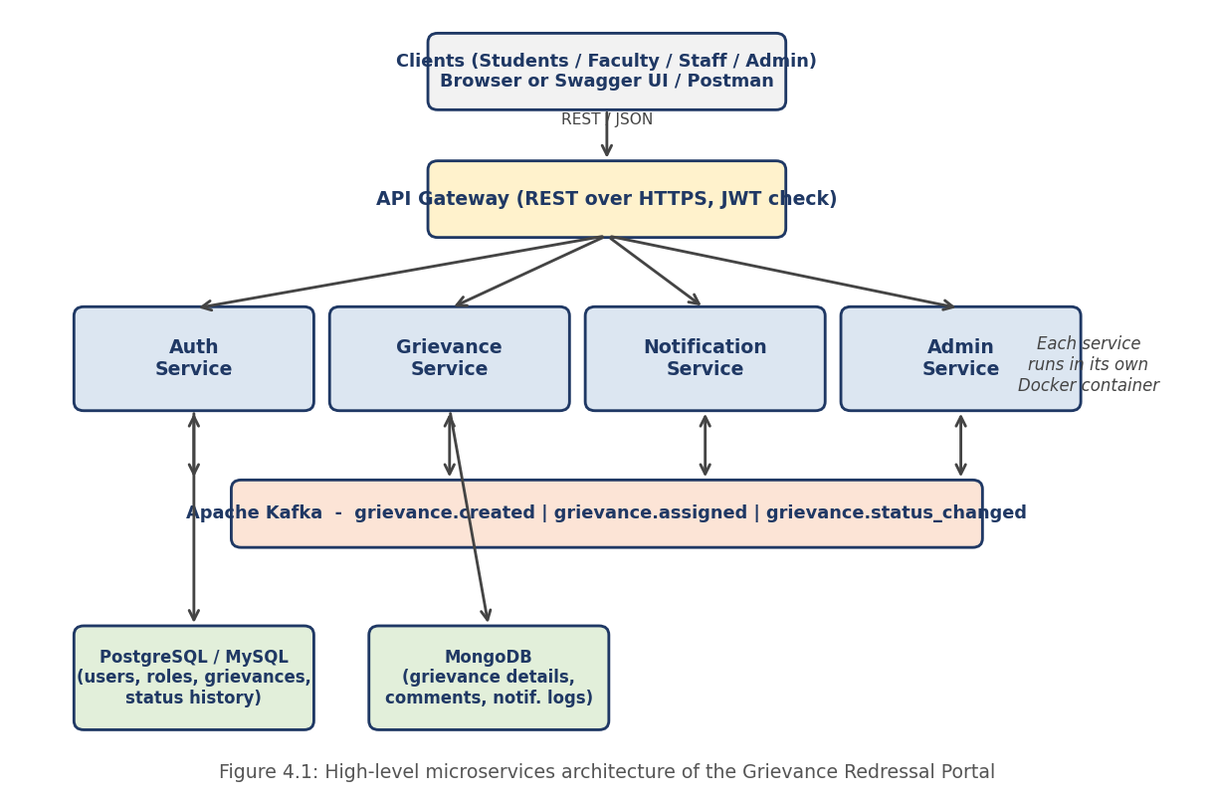

4.2 Description of Each Layer
- Client layer: Users access the system through a web client or API tool. Clients never talk to a database; all data comes from REST calls secured with a JWT.
- Auth Service: Handles registration, login, password hashing, token issuing, and role management.
- Grievance Service: The core service. Accepts new grievances, performs categorization and priority assignment, routes grievances to departments, records status changes, and exposes tracking endpoints. It optionally calls the classification and semantic-search component to label grievances and find similar complaints.
- Notification Service: Consumes Kafka events and informs users of changes (for example, when a grievance is assigned or resolved), keeping a log of every notification.
- Admin Service: Provides administrators with management of departments, categories, handlers, and system-wide statistics.
- Data layer: Each service owns its data. Structured data resides in the SQL database; flexible grievance details and logs reside in MongoDB.

4.3 Deployment Architecture
All services, both databases, and the Kafka broker run as separate Docker containers on a shared Docker network, orchestrated by Docker Compose. Each service exposes its own port, and its interactive API documentation is available at /docs. A CI/CD pipeline builds and tests the images automatically, and the same images can be deployed to a hosted environment without modification (see Chapter 11).

CHAPTER 5: DESIGN

5.1 Database Design Principles
The relational schema was normalized so that each fact is stored in exactly one place, with relationships expressed through foreign keys. Integrity rules are enforced in the database itself using PRIMARY KEY, FOREIGN KEY, UNIQUE, NOT NULL, and CHECK constraints, so that invalid data (a duplicate email, a grievance without a category, an unknown status value) is rejected even if a bug elsewhere in the application tried to insert it. Data that is naturally flexible and varies in shape is stored in MongoDB instead of forcing it into rigid columns.

5.2 ER Diagram / Database Schema
The proposed schema consists of six relational tables and two MongoDB collections, shown in Figure 5.1.
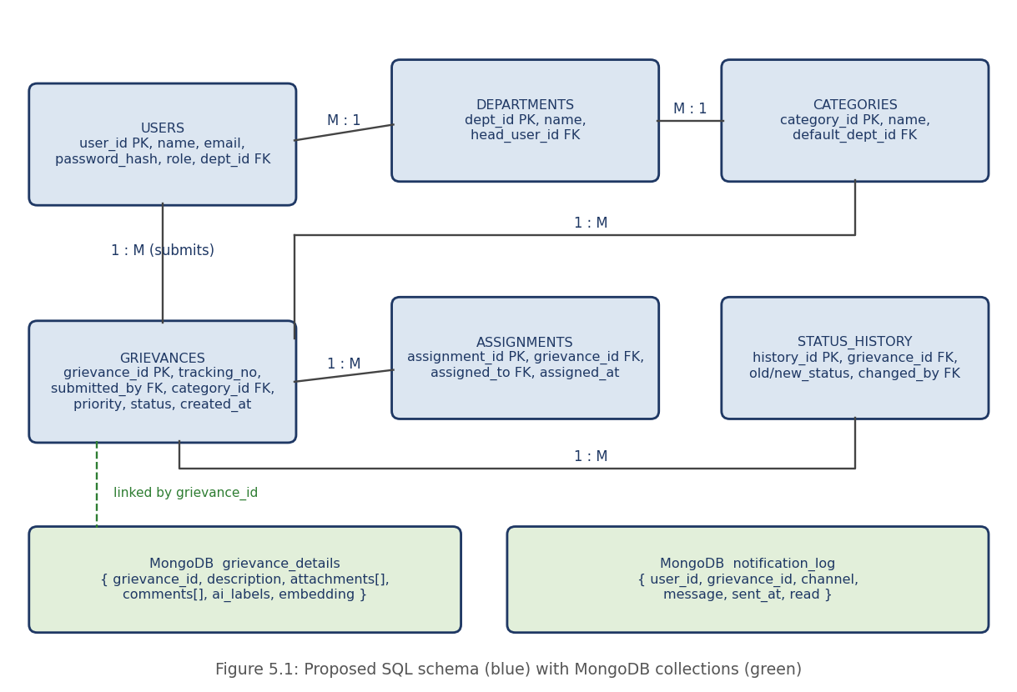
USERS stores every account with a hashed password and a role (complainant, handler, admin). DEPARTMENTS lists the institution's departments and their heads. CATEGORIES defines grievance categories and the default department that handles each. GRIEVANCES holds the core record: tracking number, submitter, category, priority, and current status. ASSIGNMENTS records which handler a grievance is assigned to, and when. STATUS_HISTORY keeps an audit trail of every status change and who made it. In MongoDB, grievance_details holds the free-text description, attachment metadata, comment thread, and classification labels, while notification_log records every notification sent.

5.3 Design Decisions and Assumptions
- SQL plus MongoDB: Structured, relational data that needs integrity and joins goes to SQL; variable, document-shaped data goes to MongoDB. The two are linked by grievance_id.
- Database per service: Each microservice owns its data and exposes it only through its API or through events, so services can be changed and scaled independently.
- Status lifecycle: A grievance moves through Submitted → Under Review → Assigned → In Progress → Resolved → Closed, with Rejected and Escalated as alternative outcomes. Every transition is written to STATUS_HISTORY.
- Priority-based assignment: Each grievance is given a priority (Low, Medium, High, Critical) based on its category and content, and handlers see higher-priority grievances first.
- Eventual consistency: Because services communicate through Kafka, other services learn about changes shortly after they happen rather than instantly; consumers are written to be idempotent so that a repeated event causes no harm.

CHAPTER 6: IMPLEMENTATION

6.1 Module-wise Implementation
The system is implemented as four services — Authentication, Grievance Management, Notification, and Administration — each with its own routes, request/response schemas, business logic, and data-access code.
The most involved logic sits in the Grievance Service's submission workflow. When an authenticated user submits a grievance, the service (1) validates the request against a typed schema; (2) generates a unique tracking number; (3) determines the category — either selected by the user or suggested by the classification component; (4) assigns a priority; (5) routes the grievance to the category's default department and, where possible, a specific handler; (6) stores the structured record in the SQL database and the descriptive details in MongoDB; and (7) publishes a grievance.created event to Kafka. The user receives the tracking number immediately, without waiting for notifications to be sent.

6.2 Event-Driven Logic
Kafka topics carry the events that connect the services: grievance.created, grievance.assigned, and grievance.status_changed. The Notification Service subscribes to these topics and, for each event, builds a message for the affected user and writes it to the notification log. Because producers and consumers are decoupled, the Grievance Service stays fast and responsive even if notification delivery is slow or temporarily unavailable, and the events can be replayed after a failure.
Intelligent classification and semantic search can be attached at the same point: grievance text is converted into a vector representation and compared with existing grievances, so that similar complaints can be identified, linked, and routed to the same department.

6.3 API Integration
All services expose REST APIs with JSON request and response bodies, validated by typed models. FastAPI generates OpenAPI documentation automatically, so every endpoint, parameter, and response can be explored and tried directly from the browser. Services call each other over REST for synchronous needs (for example, verifying a user's role) and use Kafka for everything that can happen asynchronously.

6.4 Authentication and Authorization
Public registration always creates a complainant account; handler and administrator accounts can only be created by an administrator, so a user cannot register their way into elevated access. Login returns a signed, time-limited JWT. Every protected route uses a dependency that verifies the token and extracts the user's identity and role; administrator-only and handler-only routes add a role check that returns 403 Forbidden to any other role. Passwords are stored only as salted hashes, never as plain text.

CHAPTER 7: FEATURES

7.1 List of Main Features
Complainant features (students, faculty, staff):
- Secure registration and login
- Submit a grievance with category, description, and optional attachments
- Receive a unique tracking number
- Track grievance status in real time and view the full history
- Receive notifications on status changes
- Add comments or additional information to an open grievance
Handler and administrator features:
- View grievances assigned to a department, ordered by priority
- Update status, add resolution notes, and escalate when necessary
- Manage users, roles, departments, and categories (administrator)
- Dashboard of grievance counts by status, category, and department (administrator)
- Identify similar or duplicate complaints through semantic search

7.2 How Each Feature Works
- Grievance submission and tracking: On submission, the system stores the grievance, generates a tracking number, and returns it. Entering the tracking number (while logged in) shows the current status and the complete history from STATUS_HISTORY.
- Automated categorization: If the user does not choose a category, or to double-check the chosen one, the classification component labels the grievance from its text, and the category determines the default department.
- Priority-based assignment: Priority is derived from category and content (for example, a safety-related infrastructure complaint ranks above a routine query). Handlers see grievances sorted by priority and age, so urgent cases are dealt with first.
- Status notifications: Every status change publishes an event; the Notification Service consumes it and informs the complainant, recording each message in the notification log.
- Role-based access: Every endpoint declares the roles allowed to use it. A complainant can only view their own grievances; a handler only those of their department; an administrator all.
- Similar-complaint detection: When a new grievance arrives, its text is compared with existing ones. If a close match is found, the handler is shown the related grievances so that they can be resolved together or recognised as a recurring issue.

CHAPTER 8: TESTING

8.1 Postman API Testing
A Postman collection is organised by service (Auth, Grievances, Notifications, Admin). Login requests carry a small test script that stores the returned JWT in a collection variable, and later requests — create grievance, assign, update status — reuse it together with the returned grievance ID, so a complete workflow can be exercised without copying any value by hand.

8.2 Integration Testing
Integration tests run against real containers — the actual databases and Kafka broker started through Docker Compose — rather than mocks. They verify, for example, that a grievance created through the API appears in both databases, that a grievance.created event reaches the Notification Service, and that a status change is recorded in STATUS_HISTORY. The CI/CD pipeline runs these tests automatically on every push.

8.3 Tools Used for Testing
- Postman — manual and scripted API testing
- Swagger UI (auto-generated by FastAPI) — interactive endpoint testing
- pytest — unit and integration tests
- Docker Compose — reproducible test environment
- Database clients (SQL client, MongoDB shell) — direct verification of stored data

8.4 Test Cases and Results
The table below lists the test cases defined for the system. The Actual Result column is to be filled in from the project's own test run.
# | Test Case | Expected Result | Actual Result
1 | Login with a wrong password | 401 Unauthorized
2 | Complainant token calls an admin-only route | 403 Forbidden
3 | Request without a token | 401 Unauthorized
4 | Submit a grievance with a missing required field | 422 validation error
5 | Submit a valid grievance | 201 Created with tracking number; record in SQL and MongoDB
6 | Submit a grievance in a category | Routed to that category's default department
7 | Track a grievance by its owner | Current status and full history returned
8 | Track another user's grievance as a complainant | 403 / 404, access denied
9 | Handler updates status | Status changes; STATUS_HISTORY row added
10 | Status change published to Kafka | Notification Service consumes event; log entry created
11 | Same Kafka event delivered twice | Only one notification created (idempotent)
12 | Submit a near-duplicate grievance | Similar existing grievance(s) listed for the handler
13 | Stop one service container | Other services keep working; events processed after restart
14 | Fresh build with docker compose up | All containers start and health checks pass

CHAPTER 9: DEPLOYMENT

9.1 Steps to Deploy
- Clone the repository from GitHub.
- Copy .env.example to .env and fill in the configuration values.
- Run docker compose up --build to build and start every service, both databases, and Kafka.
- Open each service's /docs page (Swagger UI) to confirm it is running.
- Log in with a seeded administrator account and begin using the system.

9.2 Environment Configuration
All configuration — database connection strings, the JWT signing secret and token expiry, Kafka broker address, and service ports — is read from environment variables defined in a .env file that is never committed to version control. A .env.example file with placeholder values is committed instead, so the required settings are documented without exposing real credentials.

9.3 CI/CD and Hosting
The CI/CD pipeline runs on every push to the repository: it installs dependencies, runs the automated tests, builds the Docker images, and, on the main branch, publishes them to a container registry for deployment. For this submission, the system runs on a local Docker environment, which is appropriate for development and in-class demonstration; because everything is containerized, the same images can be deployed to a cloud host with only configuration changes.

CHAPTER 10: CHALLENGES & LIMITATIONS
Note: this chapter is written from the project's design. Edit it to reflect the actual issues your team faced and the bugs you actually fixed.

10.1 Issues Faced During Development
- Keeping data consistent across two databases: a grievance's structured record (SQL) and its details (MongoDB) are stored separately, and a failure between the two writes could leave them out of step.
- Duplicate or out-of-order events: Kafka delivers messages at least once, so a consumer may receive the same event more than once.
- Coordinating independently running services: services must start in the right order and find each other on the Docker network.
- Securing service endpoints: ensuring every route verifies the token and role, with none accidentally left open.

10.2 Solutions Applied
- The SQL record is written first and is treated as the source of truth; the MongoDB details are written immediately after, keyed by grievance_id, and a failure is reported to the user rather than hidden.
- Consumers are idempotent: each event carries a unique ID, and a consumer that has already processed that ID ignores the repeat.
- Docker Compose health checks and dependency ordering ensure services start only after the databases and Kafka are ready.
- Authentication is implemented as a single reusable dependency applied to every protected route, rather than being repeated route by route.

10.3 Current Limitations or Known Bugs
- Notifications are recorded and delivered within the system; email or SMS delivery is not yet integrated.
- Intelligent classification and semantic search are limited by the amount of grievance data available for tuning.
- The system has been run on a single local Docker deployment and has not been deployed to a public cloud environment.
- Handler and administrator accounts can only be created by an administrator; there is no self-service password reset yet.

CHAPTER 11: FUTURE ENHANCEMENTS

11.1 Planned Features
- Email and SMS notifications in addition to in-app notifications.
- SLA-based automatic escalation: a grievance that stays unresolved beyond its deadline is escalated to a senior officer.
- Analytics dashboards showing resolution time, recurring issues, and department performance.
- Anonymous grievance submission for sensitive complaints, with protected identity handling.
- Multilingual support and a mobile application.

11.2 Possible Integrations or Optimizations
- Deploying on Kubernetes for automatic scaling and self-healing of services.
- Adding an API gateway with rate limiting, and caching for frequently requested data.
- Fine-tuning the classification model and using a dedicated vector database for faster semantic search.
- Integration with the institution's existing student information and single sign-on systems.
- Centralized logging and monitoring (for example, Prometheus and Grafana) for the running services.

CHAPTER 12: CONCLUSION

12.1 Summary of the Project
This project set out to replace slow, opaque, manual grievance handling with a centralized, transparent, and technology-driven system. It combines a FastAPI asynchronous REST backend, SQL and MongoDB databases, JWT-based security, a microservices architecture with Kafka event streaming, Docker containerization, and a CI/CD pipeline into a single platform for institutional grievance management.

12.2 What Was Achieved
The system lets students, faculty, and staff submit grievances securely and track them in real time; categorizes and prioritizes them and routes each to the appropriate department; notifies users of progress through event-driven communication; enforces role-based access; and gives administrators a consolidated view of all grievances. The microservices and containerized deployment make the platform scalable, reliable, and suitable for real-world institutional environments.

12.3 Skills Learned
Working on this project gave practical experience in relational and document database design and in choosing between them; building asynchronous, validated REST APIs with FastAPI; securing APIs with JWT and role-based access; designing microservices and event-driven communication with Kafka; containerizing applications with Docker; automating testing and deployment with CI/CD; and testing systematically, including deliberately trying to break the system's own rules.

CHAPTER 13: REFERENCES
- FastAPI — Official Documentation, https://fastapi.tiangolo.com
- Pydantic — Official Documentation, https://docs.pydantic.dev
- PostgreSQL — Official Documentation, https://www.postgresql.org/docs/
- MySQL Reference Manual, https://dev.mysql.com/doc/
- MongoDB — Official Documentation, https://www.mongodb.com/docs/
- Apache Kafka — Official Documentation, https://kafka.apache.org/documentation/
- Docker — Official Documentation, https://docs.docker.com
- JSON Web Tokens — Introduction, https://jwt.io/introduction
- GitHub Actions — Documentation, https://docs.github.com/actions
- Postman Learning Center, https://learning.postman.com

CHAPTER 14: APPENDICES

Appendix A: Sample Code Snippet
Reusable dependency that verifies the JWT and enforces a role on a route (FastAPI):
from fastapi import Depends, HTTPException, status
from fastapi.security import OAuth2PasswordBearer
import jwt

oauth2 = OAuth2PasswordBearer(tokenUrl="/auth/login")

def current_user(token: str = Depends(oauth2)):
try:
return jwt.decode(token, SECRET_KEY, algorithms=["HS256"])
except jwt.PyJWTError:
raise HTTPException(status.HTTP_401_UNAUTHORIZED, "Invalid token")

def require_role(*roles):
def checker(user = Depends(current_user)):
if user["role"] not in roles:
raise HTTPException(status.HTTP_403_FORBIDDEN, "Not allowed")
return user
return checker

Appendix B: Installation and Setup Instructions
- git clone <repository-url> and cd into the project folder
- cp .env.example .env, then edit the values
- docker compose up --build
- Open each service's /docs page (e.g. http://localhost:8000/docs) in a browser

Appendix C: Default Login Credentials
To be filled in from the seed data used by the project (do not include real passwords):
Role | Email | Password
Admin
Handler
Complainant

Appendix D: API Reference Summary
Proposed endpoints; adjust to match the implemented routes. Full request/response examples are available in each service's Swagger UI and in the Postman collection.
Service | Endpoints
Auth | POST /auth/register, POST /auth/login, GET /auth/me
Grievances | POST /grievances, GET /grievances (own / department), GET /grievances/{id}, GET /grievances/track/{tracking_no}, PUT /grievances/{id}/status, POST /grievances/{id}/comments, GET /grievances/{id}/similar
Notifications | GET /notifications, PUT /notifications/{id}/read
Admin | GET/POST/PUT /departments, GET/POST/PUT /categories, GET/POST /users, PUT /users/{id}/role, GET /stats

Appendix E: Screenshots
To be added from the running application before submission. Suggested order: (1) Login page, (2) Grievance submission form, (3) Tracking page with status history, (4) Handler dashboard, (5) Admin dashboard, (6) Swagger UI, (7) Docker containers running, (8) Postman collection results.

