JAVA AWT BASED- AUTOMATED TRACKING AND ALLOTMENT OF PARKING - SQL CONNECTIVITY USING JDBC

A
Report
Submitted in partial fulfilment of the
Requirements for the award of the Degree of
BACHELOR OF ENGINEERING
IN
INFORMATION TECHNOLOGY

By
B.Sampath <1602-18-737-099>

Department of Information Technology
Vasavi College of Engineering (Autonomous)
Ibrahimbagh, Hyderabad-31
2020

BONAFIDE CERTIFICATE

This to Certify that the project report titled "Automated tracking and allotment of parking" project work of Mr. SAI SAMPATH BANDARU bearing Roll.no:1602-18-737-099 who carried out this project under my supervision in the IV semester for the academic year 2019-2020.

Signature Signature
external examiner internal examiner

ABSTRACT

Numerous vehicles have been parking everyday in the parking area. Inorder to keep the track of the vehicles parked, number of slots left and as well as to calculate the parking fee as per the duration .
We will require five tables for this:
1.user table -for storing the details of the user who manages vehicle, customer, parking slot.
2.vehicle table-for v_id,vehicle type , vehicle owner id , vehicle_name..
3.parking slots-for pid, status of the slot and the type of the parking slot, parking fee
4.customer table-for storing the details of the owners of the vehicles.
5.duration - contains the time duration of the vehicle, duration type, and duration id.
The relationship between various entity sets helps in retrieval of the information, calculation of parking fee and allotment of parking slots in an efficient way.

INTRODUCTION
- REQUIREMENTS FOR STOCK MARKET :
List of tables :
- User1
- Customer
- ParkingSlots
- Vehicles
- Duration

List of attributes with their domain type:
• User
uemail(varchar2)
Uname(varchar2)
Uid(numeric)
Umobilenumber(numeric)

• Customer
Cname(varchar2)
Cid(numeric)
Cpass(varchar2)
Cmobile(number)

- Parking slots
Psid(numeric)
Fee(numeric)
Pstype(varchar2)
Status(varchar2)

- Duration
DurationTime(numeric)
Dtype(varchar2)
Did(numeric)

- Vehicles
Vname (varchar2)
Vtype(varchar2)
Vno(numeric)
Vid(numeric)
Vownerid(number)

- SPECIFIC GOAL OF THE PROJECT:
The main goal is to be achieved through this project is to provide an easy way to allot the parking slot by the user to the customer and keep a track of slots available and the fee for the parking based on the duration for the customer whose vehicle have been parked.

This project also ensures the details of the customers and there vehicles are confidential and stored securely in the database.
SQL particular user, Vehicle, parking slots, Customer table and duration.

- Architecture and technology used:
SQL Plus is the most basic Oracle Database utility with a basic command-line interface, commonly used by users, administrators and programmers.

The interface of SQL Plus is used for creating the database. DDL and DML commands are implemented for operations being executed. The details of various user, Vehicle, parking slots, Customer table and duration are stored in the form of tables in the database.

Eclipse is an Integrated development environment (IDE) used in computer programming. It contains a base workspace and an extensible plug-in system for customizing the environment. Eclipse is written mostly in java and its primary use is for developing Java applications, but it may also be used to develop applications in other programming languages via plug-ins, including Erlang, JavaScripts etc.

The front end application code is written in “Java” using Eclipse. The portal for front end application is designed through Eclipse, runs and has the capacity to connect with the database which has data inserted using SQL.

- DESIGN:
i)ER DIAGRAM:

DDL COMMANDS:

DML COMMANDS:

Implementation
- JAVA Code : (Customer Table)
1)Insert Customer:

import java.awt.*;
import java.awt.event.*;
import java.sql.*;
public class InsertCustomer extends Panel
{
Button insertCustomerButton;
TextField cidText, cnameText, cmobileText, cpassText;
TextArea errorText;
Connection connection;
Statement statement;
public InsertCustomer()
{
try
{
Class.forName("oracle.jdbc.driver.OracleDriver");
}
catch (Exception e)
{
System.err.println("Unable to find and load driver");
System.exit(1);
}
connectToDB();
}

public void connectToDB()
{
try
{
connection = DriverManager.getConnection("jdbc:oracle:thin:@localhost:1521:orcl","it18737099","vasavi");
statement = connection.createStatement();

}
catch (SQLException connectException)
{
System.out.println(connectException.getMessage());
System.out.println(connectException.getSQLState());
System.out.println(connectException.getErrorCode());
System.exit(1);
}
}
public void buildGUI()
{
//Handle Insert Account Button
insertCustomerButton = new Button("Submit");
insertCustomerButton.addActionListener(new ActionListener()
{
public void actionPerformed(ActionEvent e)
{
try
{
Statement statement = connection.createStatement();
//String query = "INSERT INTO sailors (SID,SNAME, RATING, AGE) VALUES (2,'Divya',7,20)";
String query= "INSERT INTO customer VALUES(" + cidText.getText() + ", " + "'" + cnameText.getText() + "'," + cmobileText.getText() + ",'" + cpassText.getText() + "')";
int i = statement.executeUpdate(query);
errorText.append("\nInserted " + i + " rows successfully");
}
catch (SQLException insertException)
{
displaySQLErrors(insertException);
}
}
});

cidText = new TextField(15);
cnameText = new TextField(15);
cmobileText = new TextField(15);
cpassText = new TextField(15);

errorText = new TextArea(10, 40);
errorText.setEditable(false);

Panel first = new Panel();
first.setLayout(new GridLayout(4, 2));
first.add(new Label("customer ID:"));
first.add(cidText);
first.add(new Label("customer Name:"));
first.add(cnameText);
first.add(new Label("mobile number"));
first.add(cmobileText);
first.add(new Label("cpass"));
first.add(cpassText);
first.setBounds(125,90,200,100);

Panel second = new Panel(new GridLayout(4, 1));
second.add(insertCustomerButton);
second.setBounds(125,220,150,100);

Panel third = new Panel();
third.add(errorText);
third.setBounds(125,320,300,200);

setLayout(null);

add(first);
add(second);
add(third);

setSize(500, 600);
setVisible(true);
}

private void displaySQLErrors(SQLException e)
{
errorText.append("\nSQLException: " + e.getMessage() + "\n");
errorText.append("SQLState: " + e.getSQLState() + "\n");
errorText.append("VendorError: " + e.getErrorCode() + "\n");
}

public static void main(String[] args)
{
InsertCustomer sail = new InsertCustomer();

sail.buildGUI();
}
}

2)Update Customer:

import java.awt.*;
import java.awt.event.*;
import java.sql.*;
public class UpdateCustomer extends Panel
{
Button updateCustomerButton;
List customerIDList;
TextField cidText, cnameText, cmobileText, cpassText;
TextArea errorText;
Connection connection;
Statement statement;
ResultSet rs;

public UpdateCustomer()
{
try
{
Class.forName("oracle.jdbc.driver.OracleDriver");
}
catch (Exception e)
{
System.err.println("Unable to find and load driver");
System.exit(1);
}
connectToDB();
}

public void connectToDB()
{
try
{
connection = DriverManager.getConnection("jdbc:oracle:thin:@localhost:1521:orcl","it18737099","vasavi");
statement = connection.createStatement();

}
catch (SQLException connectException)
{
System.out.println(connectException.getMessage());
System.out.println(connectException.getSQLState());
System.out.println(connectException.getErrorCode());
System.exit(1);
}
}

private void loadCustomer()
{
try
{
rs = statement.executeQuery("SELECT CID FROM customer");
while (rs.next())
{
customerIDList.add(rs.getString("CID"));
}
}
catch (SQLException e)
{
displaySQLErrors(e);
}
}

public void buildGUI()
{
customerIDList = new List(10);
loadCustomer();
add(customerIDList);

//When a list item is selected populate the text fields
customerIDList.addItemListener(new ItemListener()
{
public void itemStateChanged(ItemEvent e)
{
try
{
rs = statement.executeQuery("SELECT * FROM customer where CID ="+customerIDList.getSelectedItem());
rs.next();
cidText.setText(rs.getString("CID"));
cnameText.setText(rs.getString("CNAME"));
cmobileText.setText(rs.getString("mobile"));
cpassText.setText(rs.getString("cpass"));
}
catch (SQLException selectException)
{
displaySQLErrors(selectException);
}
}
});

//Handle Update Sailor Button
updateCustomerButton = new Button("Modify");
updateCustomerButton.addActionListener(new ActionListener()
{
public void actionPerformed(ActionEvent e)
{
try
{
Statement statement = connection.createStatement();
int i = statement.executeUpdate("UPDATE customer "
+ "SET cname='" + cnameText.getText() + "', "
+ "cmobile=" + cmobileText.getText() + ", "
+ "cpass ='"+ cpassText.getText() + "' WHERE cid = "
+ customerIDList.getSelectedItem());
errorText.append("\nUpdated " + i + " rows successfully");
customerIDList.removeAll();
loadCustomer();
}
catch (SQLException insertException)
{
displaySQLErrors(insertException);
}
}
});

cidText = new TextField(15);
cidText.setEditable(false);
cnameText = new TextField(15);
cmobileText = new TextField(15);
cpassText = new TextField(15);

errorText = new TextArea(10, 40);
errorText.setEditable(false);

Panel first = new Panel();
first.setLayout(new GridLayout(4, 2));
first.add(new Label("customer ID:"));
first.add(cidText);
first.add(new Label("Customer Name:"));
first.add(cnameText);
first.add(new Label("mobile number"));
first.add(cmobileText);
first.add(new Label("cpass"));
first.add(cpassText);

Panel second = new Panel(new GridLayout(4, 1));
second.add(updateCustomerButton);

Panel third = new Panel();
third.add(errorText);

add(first);
add(second);
add(third);

setSize(500, 600);
setLayout(new FlowLayout());
setVisible(true);

}

private void displaySQLErrors(SQLException e)
{
errorText.append("\nSQLException: " + e.getMessage() + "\n");
errorText.append("SQLState: " + e.getSQLState() + "\n");
errorText.append("VendorError: " + e.getErrorCode() + "\n");
}

public static void main(String[] args)
{
UpdateCustomer ups = new UpdateCustomer();
ups.buildGUI();
}
}

3)Delete Customer:
import java.awt.*;
import java.awt.event.*;
import java.sql.*;
public class DeleteCustomer extends Panel
{
Button deleteCustomerButton;
List customerIDList;
TextField cidText, cnameText, cmobileText, cpassText;
TextArea errorText;
Connection connection;
Statement statement;
ResultSet rs;

public DeleteCustomer()
{
try
{
Class.forName("oracle.jdbc.driver.OracleDriver");
}
catch (Exception e)
{
System.err.println("Unable to find and load driver");
System.exit(1);
}
connectToDB();
}

public void connectToDB()
{
try
{
connection = DriverManager.getConnection("jdbc:oracle:thin:@localhost:1521:orcl","it18737099","vasavi");
statement = connection.createStatement();

}
catch (SQLException connectException)
{
System.out.println(connectException.getMessage());
System.out.println(connectException.getSQLState());
System.out.println(connectException.getErrorCode());
System.exit(1);
}
}

private void loadCustomers()
{
try
{
rs = statement.executeQuery("SELECT * FROM customer");
while (rs.next())
{
customerIDList.add(rs.getString("CID"));
}
}
catch (SQLException e)
{
displaySQLErrors(e);
}
}

public void buildGUI()
{
customerIDList = new List(10);
loadCustomers();
add(customerIDList);

//When a list item is selected populate the text fields
customerIDList.addItemListener(new ItemListener()
{
public void itemStateChanged(ItemEvent e)
{
try
{
rs = statement.executeQuery("SELECT * FROM customer");
while (rs.next())
{
if (rs.getString("CID").equals(customerIDList.getSelectedItem()))
break;
}
if (!rs.isAfterLast())
{
cidText.setText(rs.getString("CID"));
cnameText.setText(rs.getString("customer name"));
cmobileText.setText(rs.getString("mobile number"));
cpassText.setText(rs.getString("cpass"));
}
}
catch (SQLException selectException)
{
displaySQLErrors(selectException);
}
}
});

//Handle Delete Sailor Button
deleteCustomerButton = new Button("Delete");
deleteCustomerButton.addActionListener(new ActionListener()
{
public void actionPerformed(ActionEvent e)
{
try
{
Statement statement = connection.createStatement();
int i = statement.executeUpdate("DELETE FROM customer WHERE CID = "
+ customerIDList.getSelectedItem());
errorText.append("\nDeleted " + i + " rows successfully");
cidText.setText(null);
cnameText.setText(null);
cmobileText.setText(null);
cpassText.setText(null);
customerIDList.removeAll();
loadCustomers();
}
catch (SQLException insertException)
{
displaySQLErrors(insertException);
}
}
});

cidText = new TextField(15);
cnameText = new TextField(15);
cmobileText = new TextField(15);
cpassText = new TextField(15);

errorText = new TextArea(10, 40);
errorText.setEditable(false);

Panel first = new Panel();
first.setLayout(new GridLayout(4, 2));
first.add(new Label("Customer ID:"));
first.add(cidText);
first.add(new Label("Name:"));
first.add(cnameText);
first.add(new Label("cmobile"));
first.add(cmobileText);
first.add(new Label("cpass"));
first.add(cpassText);

Panel second = new Panel(new GridLayout(4, 1));
second.add(deleteCustomerButton);

Panel third = new Panel();
third.add(errorText);

add(first);
add(second);
add(third);

setSize(450, 600);
setLayout(new FlowLayout());
setVisible(true);

}

private void displaySQLErrors(SQLException e)
{
errorText.append("\nSQLException: " + e.getMessage() + "\n");
errorText.append("SQLState: " + e.getSQLState() + "\n");
errorText.append("VendorError: " + e.getErrorCode() + "\n");
}

public static void main(String[] args)
{
DeleteCustomer dels = new DeleteCustomer();
dels.buildGUI();
}
}

Main (Parking Company) :
import java.awt.*;
import java.awt.event.*;

class ParkingCompany extends Frame implements ActionListener
{
String msg = "";
Label ll;
CardLayout cardLO;

//Create Panels for each of the menu items, welcome screen panel and home screen panel with CardLayout
InsertCustomer sail;
UpdateCustomer ups;
DeleteCustomer dels;
UpdateBoat upb;
MakeReservation mks;
Panel home,welcome;

ParkingCompany()
{
cardLO = new CardLayout();

//Create an empty home panel and set its layout to card layout
home = new Panel();
home.setLayout(cardLO);

ll = new Label();
ll.setAlignment(Label.CENTER);
ll.setText("Welcome to parking Company");

//Create welcome panel and add the label to it
welcome = new Panel();
welcome.add(ll);

//create panels for each of our menu items and build them with respective components
sail = new InsertCustomer(); sail.buildGUI();
ups = new UpdateCustomer(); ups.buildGUI();
dels = new DeleteCustomer(); dels.buildGUI();
upb = new UpdateBoat(); upb.buildGUI();
mks= new MakeReservation(); mks.buildGUI();

//add all the panels to the home panel which has a cardlayout
home.add(welcome, "Welcome");
home.add(sail, "InsertCustomer");
home.add(ups, "UpdateCustomer");
home.add(dels, "DeleteCustomer");
home.add(upb, "UpdateBoat");
home.add(mks, "MakeReserve");

// add home panel to main frame
add(home);

// create menu bar and add it to frame
MenuBar mbar = new MenuBar();
setMenuBar(mbar);

// create the menu items and add it to Menu
Menu sailor = new Menu("Customer");
MenuItem item1, item2, item3;
sailor.add(item1 = new MenuItem("Insert Customer"));
sailor.add(item2 = new MenuItem("View Customers"));
sailor.add(item3 = new MenuItem("Delete Customer"));
mbar.add(sailor);

Menu boat = new Menu("users");
MenuItem item4, item5, item6;
boat.add(item4 = new MenuItem("Insert User"));
boat.add(item5 = new MenuItem("View user"));
boat.add(item6 = new MenuItem("Delete Boat"));
mbar.add(boat);

Menu reserve = new Menu("Reservations");
MenuItem item7, item8, item9;
reserve.add(item7 = new MenuItem("Make Reservation"));
reserve.add(item8 = new MenuItem("View Reservation"));
reserve.add(item9 = new MenuItem("Delete Reservation"));
mbar.add(reserve);

// register listeners
item1.addActionListener(this);
item2.addActionListener(this);
item3.addActionListener(this);
item4.addActionListener(this);
item5.addActionListener(this);
item6.addActionListener(this);
item7.addActionListener(this);
item8.addActionListener(this);
item9.addActionListener(this);

// Anonymous inner class which extends WindowAdaptor to handle the Window event: windowClosing
addWindowListener(new WindowAdapter(){
public void windowClosing(WindowEvent we)
{
System.exit(0);
}
});

//Frame properties
setTitle("Parking Company");
Color clr = new Color(0,255,255);
setBackground(clr);
setFont(new Font("SansSerif", Font.BOLD, 14));
setSize(500, 600);
setVisible(true);

}

public void actionPerformed(ActionEvent ae)
{
String arg = ae.getActionCommand();
if(arg.equals("Insert Customer"))
{
cardLO.show(home, "InsertCustomer");
}

else if(arg.equals("View Customers"))
{
cardLO.show(home, "UpdateCustomer");
}

else if(arg.equals("Delete Customer"))
{
cardLO.show(home, "DeleteCustomer");
}

else if(arg.equals("Insert User"))
{
cardLO.show(home, "InsertUser");
}
else if(arg.equals("Make Reservation"))
{
cardLO.show(home, "MakeReserve");
}
}
public static void main(String ... args)
{
new ParkingCompany();
}
}

FOLDER STRUCTURE :
The Eclipse Project has a Folder named src having java files which will perform Insert, Update and Delete Operations.
Navigate to src folder to find all files.

TESTING
The program runs for execution of three basic operations of insertion, update and delete on 5 different table. Along with this, it also has a output column which gives the information about how many rows have been edited. Errors, syntactical or exceptional will be shown if occurred.
HOME PAGE:

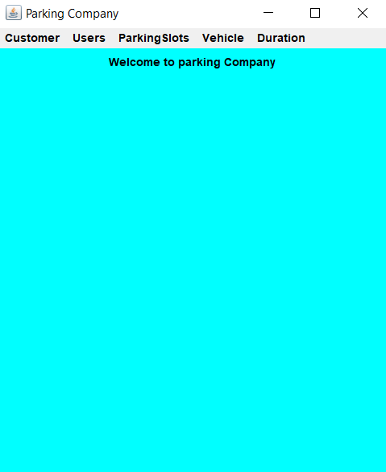

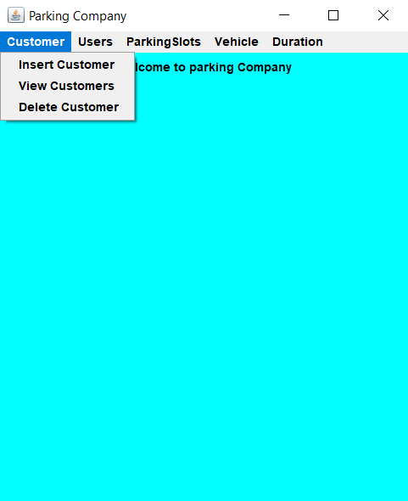

INSERT Customer:

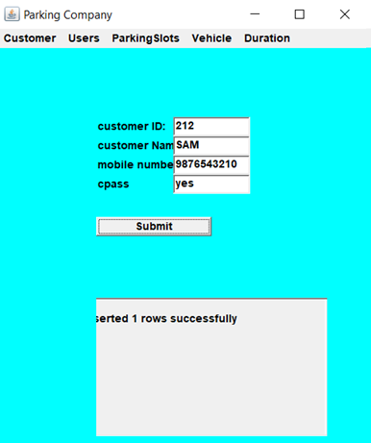

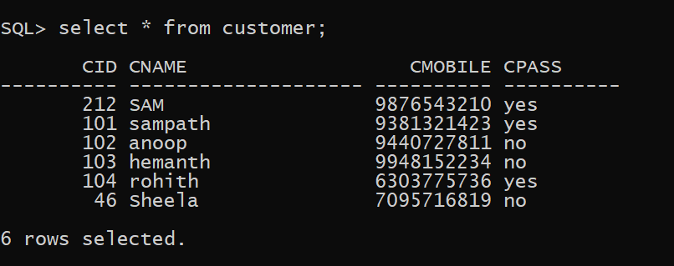

Error (in Insert):
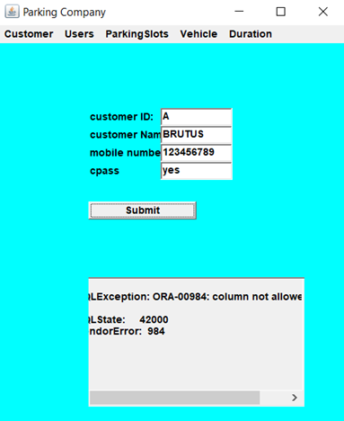

UPDATE Customer :

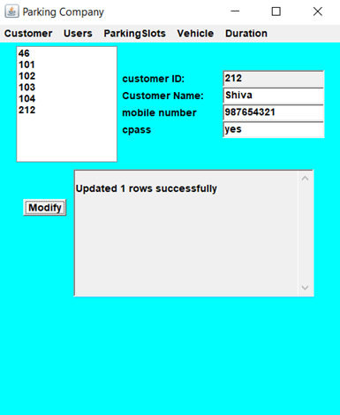

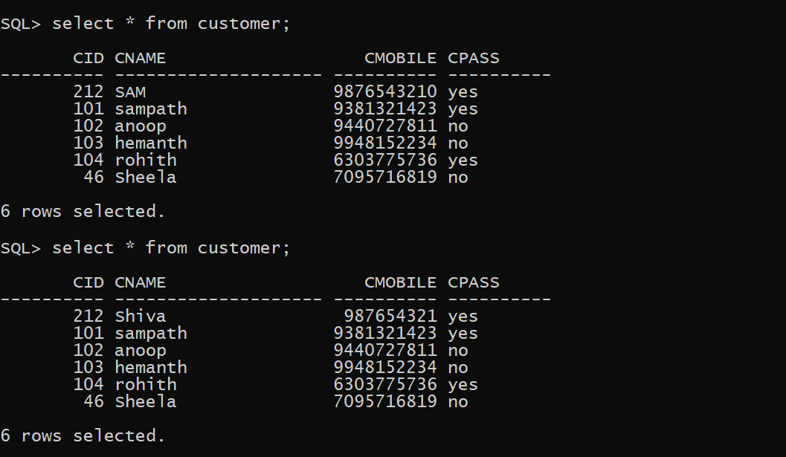

DELETE Customer:

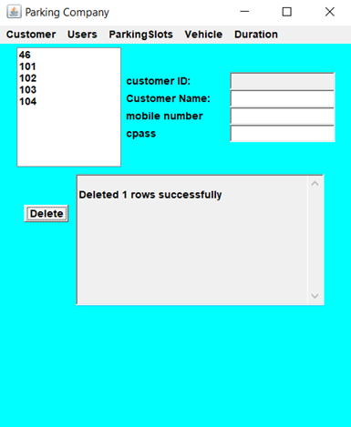

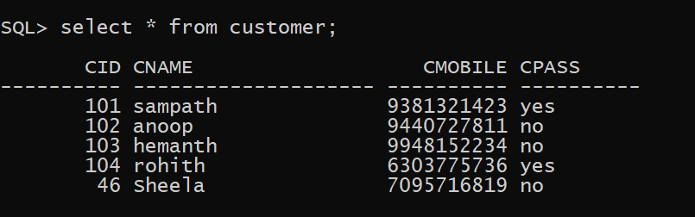

RESULTS
The DML commands, Insert, update and delete for one of the tables in given below:
For Customer table: (in java, as per the application)
Insert : "INSERT INTO customer VALUES(" + cidText.getText() + ", " + "'" + cnameText.getText() + "'," + cmobileText.getText() + ",'" + cpassText.getText() + "')";
Update : "UPDATE customer "
+ "SET cname='" + cnameText.getText() + "', "
+ "cmobile=" + cmobileText.getText() + ", "
+ "cpass ='"+ cpassText.getText() + "' WHERE cid = "
+ customerIDList.getSelectedItem());
Delete : "DELETE FROM customer WHERE CID = "
+ customerIDList.getSelectedItem());

GITHUB LINK:
https://github.com/sampath3112/dbms-assignment

CONCLUSION:
1.Connection with database is established.
2.The values which are given to GUI Application are reflected in Database.

REFERENCES
https://en.wikipedia.org/wiki/Car_parking_system
https://corporate.bepark.eu/parking-management-everything-you-need-to-know
https://www.matrixvideosurveillance.com/parking-management.html
http://www.omnitecgroup.com/Solutions/parking-controls/parking-management-system

