Project Report

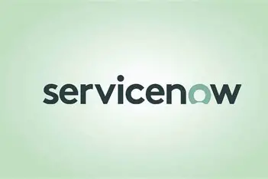

Project Title

**Streamlining Ticket Assignment for Eﬃcient Support Operations**

## Objective:

To design and implement an automated system for efficiently routing support tickets to the appropriate support teams using the ServiceNow platform. This system aims to reduce ticket resolution time, improve team productivity, and enhance overall customer satisfaction.

## Skills Utilized:

* User and Group Management
* Role Management
* Table Configuration
* Access Control Lists (ACLs)
* Flow Designer (Automation)

## Modules Implemented:

1. User Creation
2. Role assignment
3. Group Creation
4. Table Creation
5. Assign Roles and Users to Groups
6. Assign Role to Table
7. ACL Creation
8. Flows Creation & Activation

# User & Group Management

As part of the project setup, users were created to simulate different team members involved in handling support operations. Each user represents a specific role within the IT support structure. To organize these users efficiently, groups were created—specifically the *Certificate Group* and *Platform Group*. These groups help manage responsibilities by categorizing users based on their area of expertise. Assigning users to appropriate groups ensures that tasks are routed correctly and that access permissions can be applied uniformly.

I have done the following specific tasks during this module:

* + Created individual users for support and platform teams.
  + Created the following groups:
    - Certification Group
    - Platform Group
  + Assigned users to relevant groups.

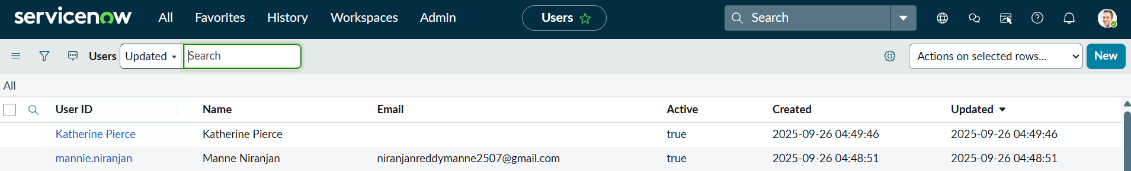

# Roles Creation & Assignment

Roles were created to control what users and groups can access or perform within the ServiceNow instance. These roles define permissions for viewing, editing, or managing data and components. Custom roles were developed to align with the support operation structure and assigned to individual users and their respective groups. This modular role assignment helps manage access efficiently and securely. Additionally, roles were assigned to the custom ticket table to control who could create, view, or update tickets based on their role.

I have done the following specific tasks during this module:

* + Created custom roles as per organizational access needs.
  + Assigned roles to:
* Individual users
* Groups (Certificate, Platform)
* Custom Tables (Operations Ticket Table)

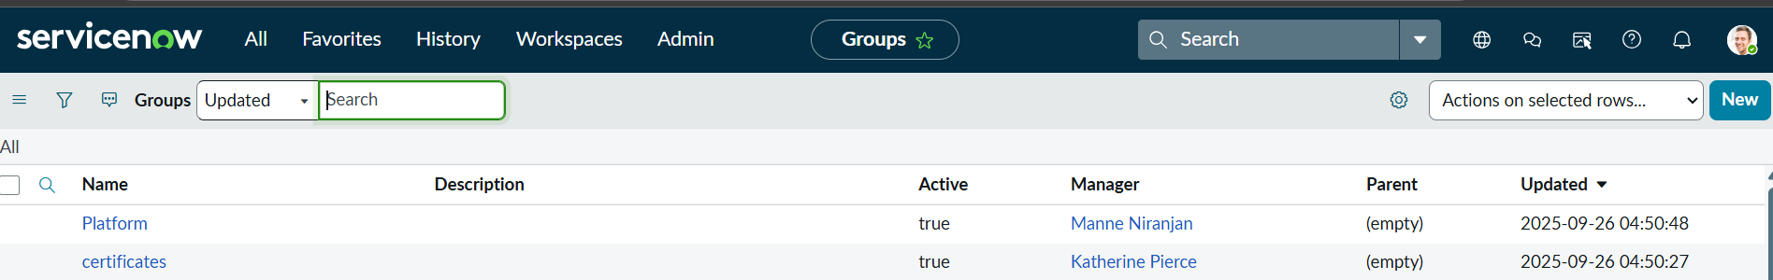

# Table Creation

A custom table was created to manage Operations Tickets. This table was designed to store all ticket-related information, including ticket ID, description, category, priority, and assigned group. Creating a separate table allowed for better customization and control over the ticketing workflow. Role-based access to the table was also configured, ensuring that only authorized users could view or modify ticket records.

I have done the following specific tasks during this module:

* + Created a custom table Operation_Relations to store and manage Operations Support Tickets.
  + Enabled role-based access on this table using ACLs.

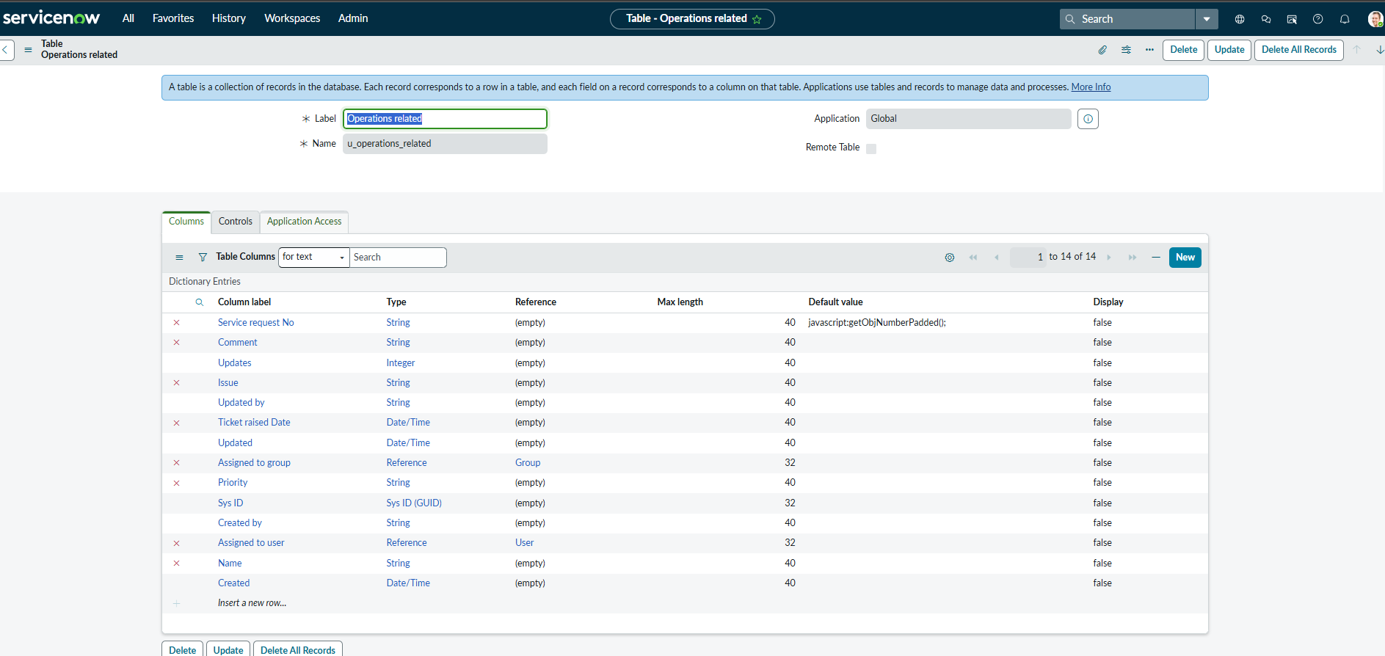

# Assigning Roles to Users and Groups

Once the roles were created, they were assigned to both individual users and groups. This step was essential to enforce the correct level of access and control. For example, users in the Certificate Group were given access only to tickets related to certificate issues, while users in the Platform Group handled platform-related tickets. Assigning roles at both user and group levels helped maintain a clean and manageable access structure.

I have done the following specific tasks during this module:

* + Assigned roles to:
* Users
* Groups
* The "Operations related" table

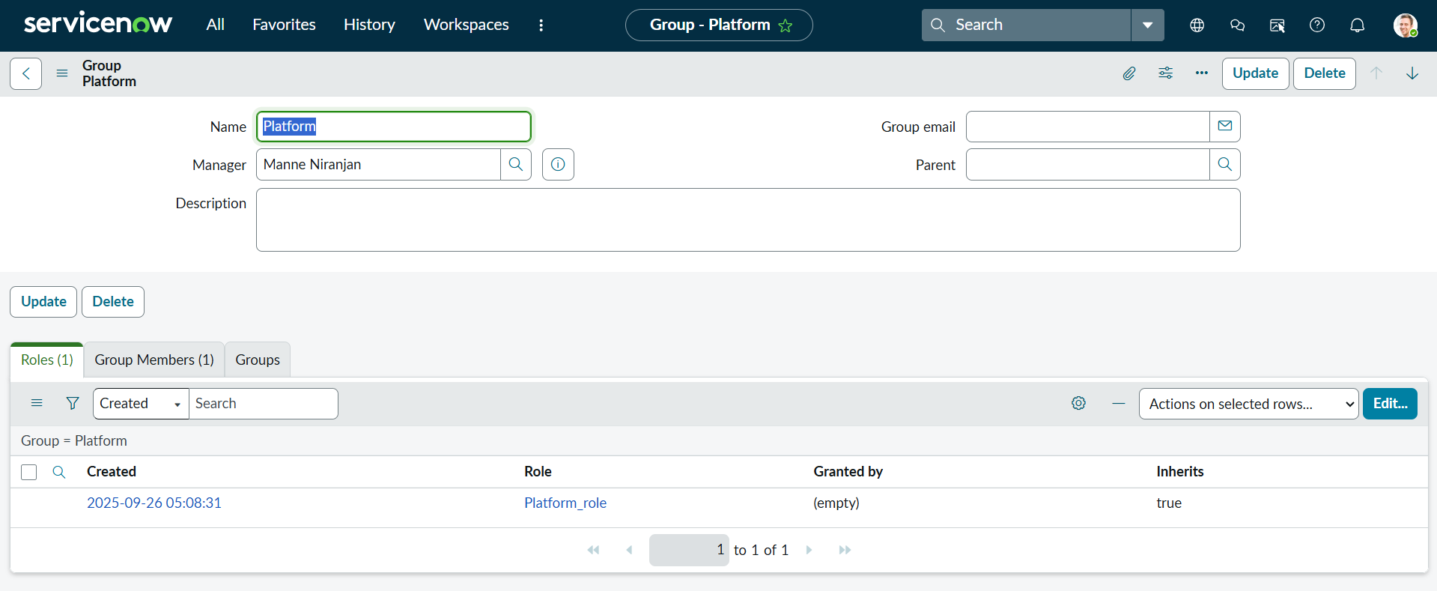 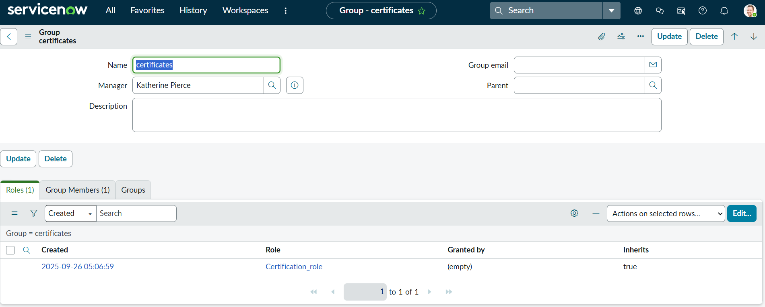

# Access Control Lists (ACLs)

ACLs were created to enforce security at both table and field levels. These ACLs define what actions—such as read, write, create, or delete—a role can perform on a specific resource. For the custom Operations Ticket table, ACLs were set so that only users with the assigned roles could access or modify the data. Field-level ACLs were also configured to restrict sensitive fields to specific administrative roles. This helped ensure data confidentiality and prevented unauthorized access.

I have done the following specific tasks during this module:

* + Created ACLs to protect sensitive data.
  + Ensured only authorized roles can read/write/modify/delete records in the Operations relations table.

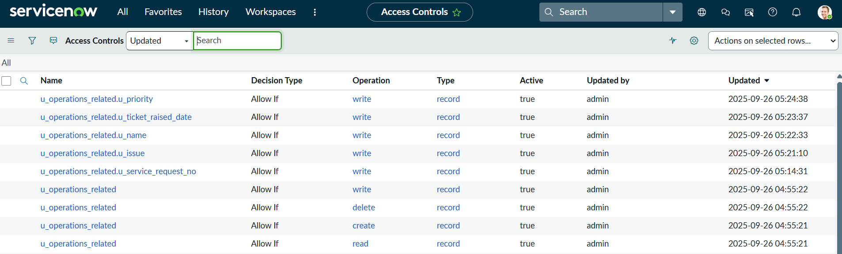

# Flow Designer – Ticket Assignment Flows

Using Flow Designer, two key automation flows were developed to assign tickets to the appropriate group based on ticket category. The first flow automatically assigns tickets categorized as "Certificate Issue" to the Certificate Group, while the second flow routes "Platform Issue" tickets to the Platform Group. These flows trigger automatically when a new ticket is created, ensuring that the assignment is immediate and accurate without manual intervention. This automation reduces resolution time and eliminates human error in the assignment process.

I have done the following specific tasks during this module:

### Flow 1: Assign Ticket to Certificate Group

* + Trigger: New Operations Ticket Created
  + Condition: Category = "Certificate Issue"
  + Action: Assign to "Certificate Group"

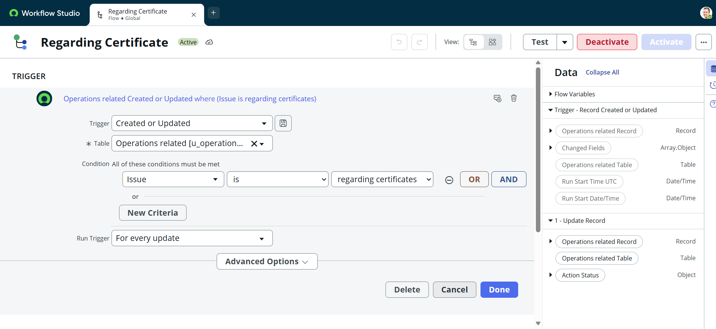

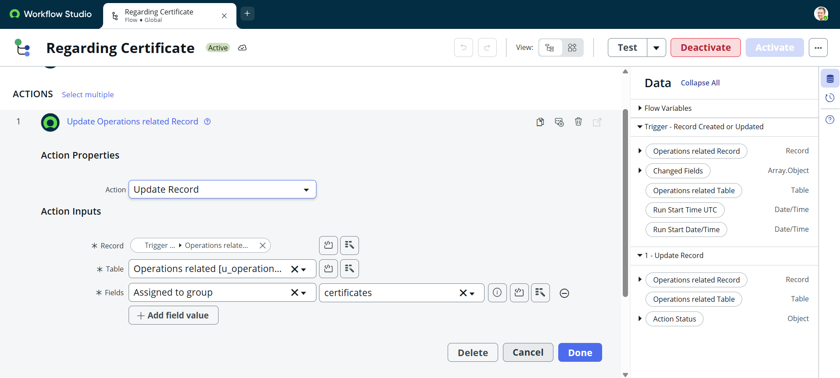

### Flow 2: Assign Ticket to Platform Group

* + Trigger: New Operations Ticket Created
  + Condition: Category = "Platform Issue"
  + Action: Assign to "Platform Group"

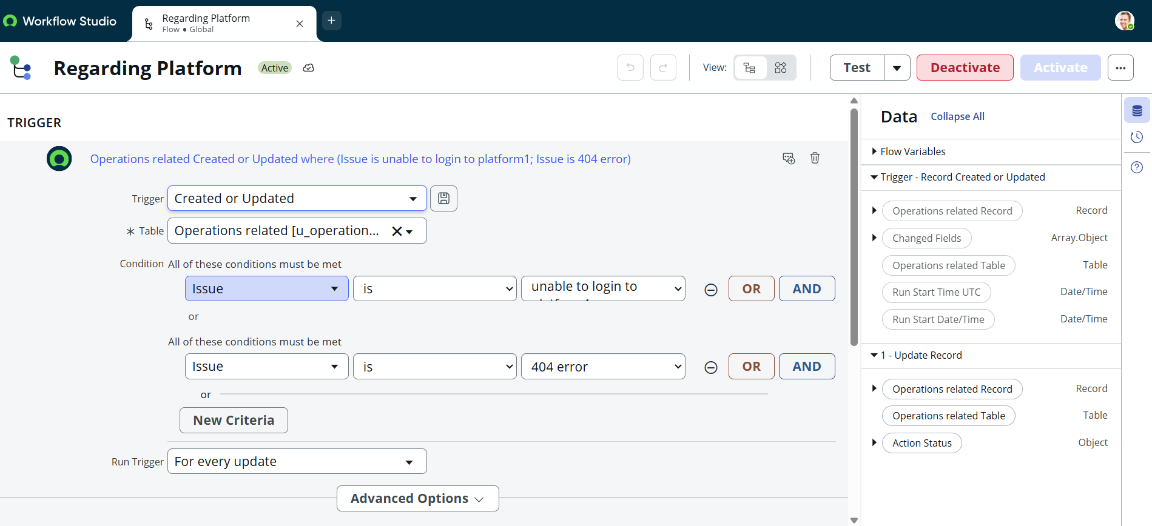

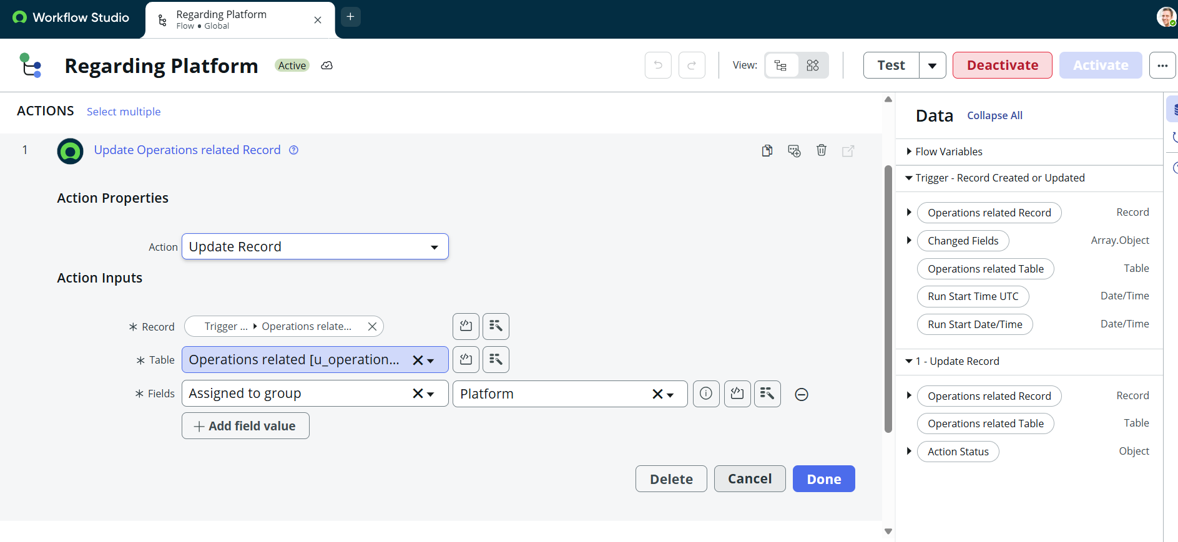

# Demo video link:

[Project Demo](https://drive.google.com/file/d/1Y2gqp9_MuB2NByahu-OrSOxjZaIwbZxc/view?usp=drive_link)

# Conclusion:

This project successfully demonstrates the implementation of an automated ticket assignment system using the ServiceNow platform. By configuring users, groups, roles, custom tables, access controls, and flow-based automation, we streamlined the process of routing support tickets to the appropriate teams. The use of Flow Designer for automatic ticket assignment significantly reduces manual effort, speeds up response times, and enhances operational efficiency. Additionally, role-based access control ensures data security and proper segregation of responsibilities. Overall, this project provided valuable hands-on experience in ServiceNow administration and showcased how low-code platforms can be leveraged to solve real-world IT service management challenges.