Weak-1 ASSESSMENT

EXTRACTION ,TRANSFORM AND LOAD

step 1: open the power bi desktop application.

step 2: on the home screen, click on blank report to access the workspace interface known as the canvas.

step 3: click on get data in the ribbon at the top. choose the file type (e.g., excel, csv, or database) and browse to select the desired file.

step 4: after selecting the file, the navigator window will appear, displaying the available data tables or sheets.

\* select the data table or sheet you need.

\*click load to directly load the data into power bi or transform data to modify it before loading.

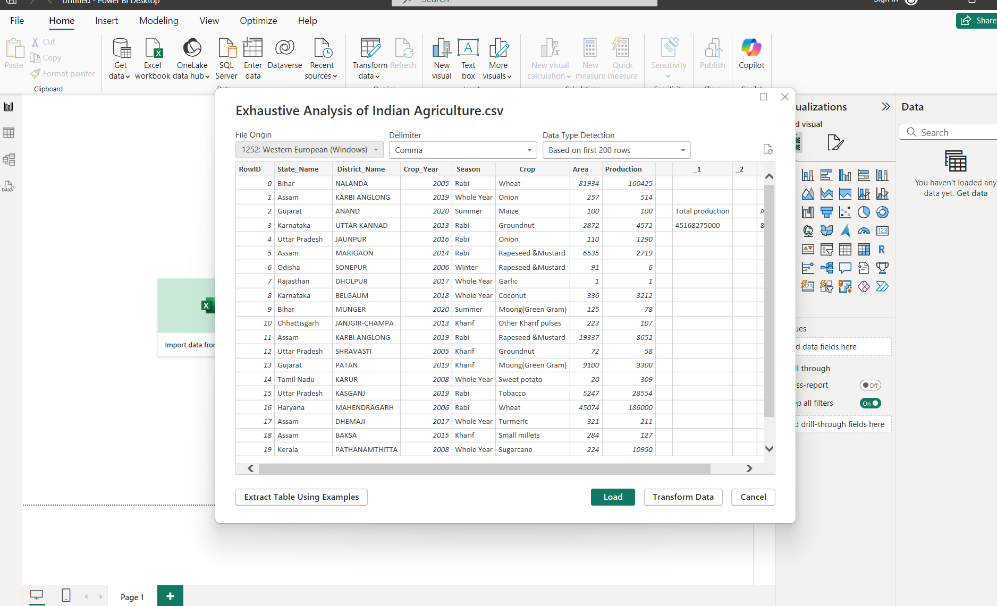step 5: if you clicked load, the data will be directly loaded into power bi, and you'll see the data fields on the right-hand side under fields.

step 6: to transform data, click transform data in the top ribbon. this opens the power query editor.

step 7: in the power query editor, you can see:

\*data preview in the center.

\*Applied steps on the right-hand side, showing all transformations performed.

step 8: to remove a column, right-click the column header in the data preview and select remove.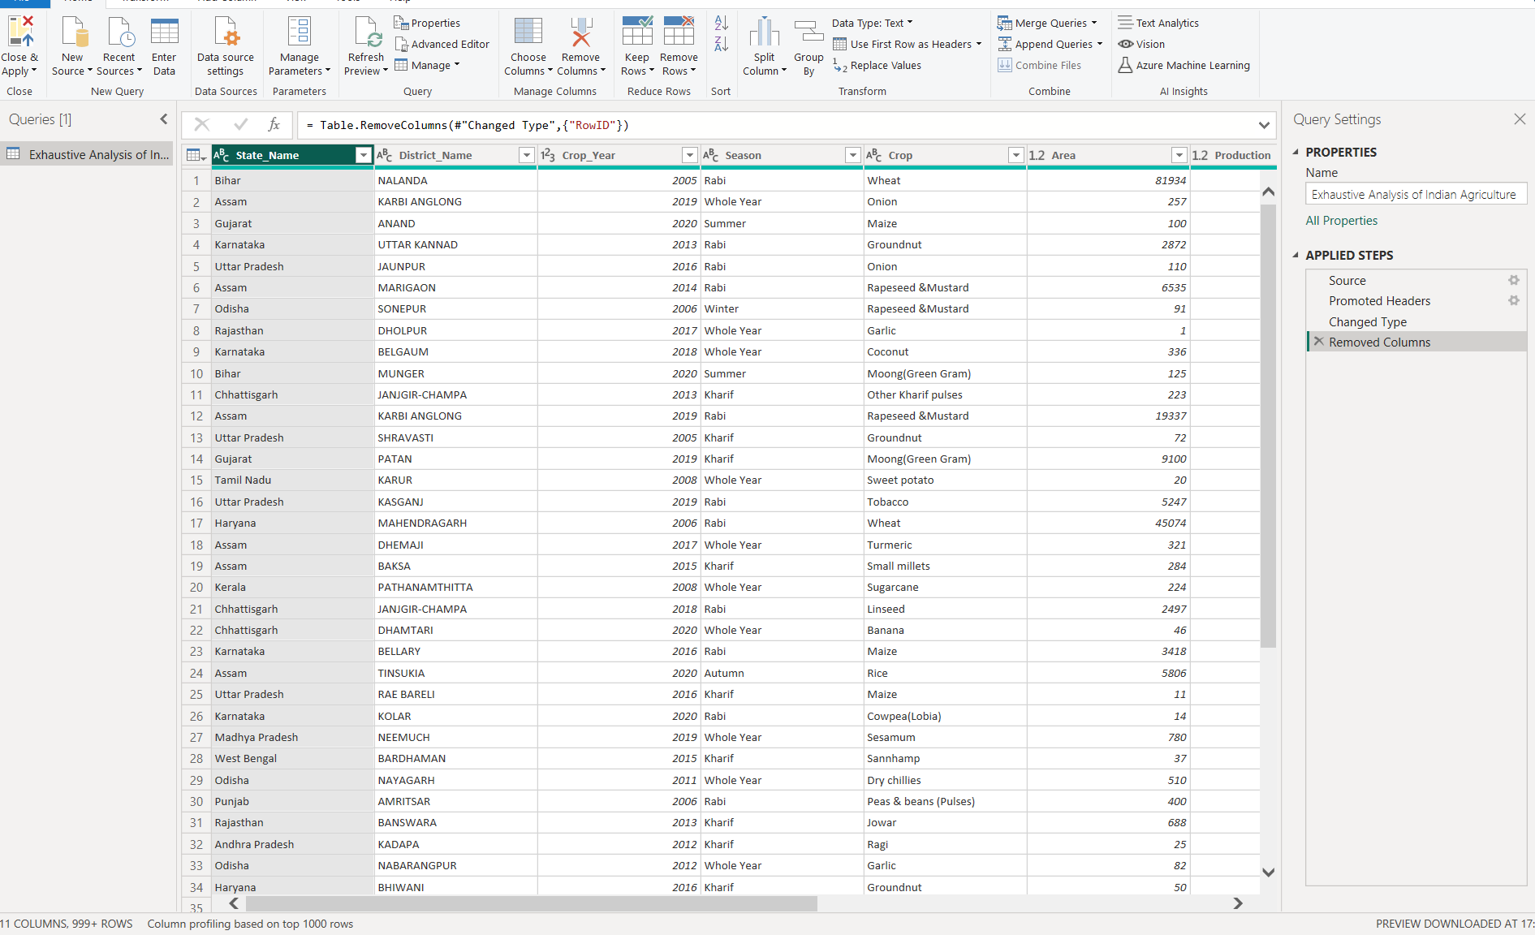

step 9: to undo a transformation, click the cross (x) next to the corresponding step in the applied steps section.

step 10: after completing the transformations, click close & apply in the top-left corner of the power query editor. the updated data will be loaded back into the power bi canvas for further analysis and visualization.