COVID19 PREDICTION WITH DEEP LEARNING ON NEURAL NETWORKS
MAHENDRA SRIRAM BETHA¹, SANGEETHA BADDAM², SAMPATH PANDULA³, CHARITHA GONGATI⁴
Computer Science Department, University of Central Missouri
1101 Innovation Parkway, Lee’s Summit, MO,64086
¹mxb78190@ucmo.edu,²sxb71910@ucmo.edu,
³sxp82580@ucmo.edu, ⁴cxg65380@ucmo.edu

Abstract— COVID-19 is a respiratory disease found in the human body and it was named as COVID-19 disease. COVID-19 is a fiery state of the lung influencing essentially the little air sacs known as alveoli. Side effects normally incorporate a mix of useful or dry hacks, chest torment, fever and trouble relaxing. The seriousness of the condition is variable. COVID-19 is normally brought about by contamination with infections or microbes and less generally by different microorganisms, certain drugs or conditions, for example, immune system illnesses Hazard factors incorporate cystic fibrosis, on-going obstructive pneumonic sickness, asthma, diabetes, cardiovascular breakdown, a background marked by smoking, an unfortunate capacity to hack like following a stroke and a feeble resistant framework. Chest X-ray, blood tests, and culture of the sputum might assist with affirming the finding. The infection might be grouped by where it was gained. Forecasting the spread of COVID-19 is a critical challenge that requires a high degree of accuracy to enable countries to prepare and respond to the pandemic. Unfortunately, the non-availability of publicly accessible approaches poses a challenge for further research. Therefore, it is crucial to determine, evaluate, and benchmark the classifiers to validate their results, particularly in handling medical cases, to prevent incorrect diagnoses and further complications. The data has been analysed based on the other diseases that are related to COVID-19 using the deep learning algorithm and predicts the output. The problem is based on the sector, where the hospitals want to predict the Covid19 depending upon the medical reports of the patients using a deep learning algorithm, it classifies and divides the data into segments and each segment contains only one kind of data that whether the person is suffering from Covid19 or not. In this work, the COVID-19-affected patient records will be taken as input and will be pass them into the deep learning algorithm. The different type of attributes based on the Covid19 is taken and passed to the algorithm.
Keywords— Covid19, Respiratory Disease, Immune System, Anti-biotic, X-ray
- Introduction
The coronavirus disease (COVID-19) is a highly transmissible public health concern that requires preventative measures to reduce transmission rates. While most individuals infected with the virus will experience mild to moderate respiratory illness and recover without requiring specialized treatment, older people and those with underlying medical conditions are at a higher risk of developing severe symptoms. To mitigate the spread of COVID-19, individuals are advised to remain well-informed about the virus and practice respiratory etiquette, such as covering their mouth when coughing and washing their hands frequently.

Bioinformatics is an interdisciplinary field that combines computer science, information science, and medicine to analyze and retrieve health data, and produce meaningful information for the healthcare field. Medical professionals face a daunting challenge when making decisions of using the computer-decision support system to investigate a particular sophisticated disease such as COVID-19. The COVID-19 pandemic is a life-threatening disease that poses a significant threat to global health around the world[1].

One of the critical investigation methods to detect COVID-19 is chest radiography imaging that screens the chest of infected patients. Initial studies have found that chest radiography images can show the abnormalities of the chest of the people infected with COVID-19. Artificial intelligence models such as traditional machine learning and deep learning methods have a high capability to detect COVID-19 with reasonable accuracy prediction using the chest radiography images of the infected patients with COVID-19[2].

Unfortunately, to the best of the authors’ knowledge, these current learning approaches can be non-open sourced and not publicly available, which prevent research from accessing and investigating them for further research. Selection of an efficient automated tool to produce reliable solutions lies on how widely it is used. Current learning methods can produce rapid reliable solutions of COVID-19 with high diagnostic accuracy.

Nowadays, many hospitals and medical research centres use a computer-aided system based on AI to automate the COVID-19 diagnosis instead of analysing the data manually. With a large number of existing automated AI methods, selecting an appropriate method that produces an efficient, fast solution with error-free results is a critical task [3].

As there is no learning classifier for COVID-19 diagnosis that is superior, this puts medical managers in a big challenge to find and evaluate different learning classifiers for COVID-19 diagnosis to select the best method. It becomes more difficult when various learning classifiers and evaluation methods with different criteria are involved.

Moreover, there are various deep learning classifiers to detect COVID-19, and decision-makers face difficulties in deciding on the best method to be used. Subsequently, it is crucial to determine, evaluate, and benchmark the classifiers to validate their results, especially in handling medical cases.

Thus, it is very important to select and use the right deep learning diagnosis method that provides reliable and accurate COVID-19 results. Acquiring such methods is costly, and it also needs extensive evaluation and benchmarking for safety purposes. Conducting a comprehensive evaluation of the classifiers of COVID-19 is not an easy task and requires considering a huge number of measurements [3][4].

The benchmarking and evaluation of COVID-19 diagnosis based on ML have two common criteria, which are time complexity and group reliability. Several sub-criteria belong to the group reliability, including precision, f1-score, recall, average accuracy, error rate, true positive, true negative, false positive, and false negative .
Other studies also used the accuracy criterion to evaluate and benchmark different diagnosis learning methods. However, in the COVID-19 diagnosis, it is important not to limit the use of only the common evaluation metric of accuracy. In the context of the medical field, considering a variety of performance criteria for the diagnosis methods is important. For instance, sensitivity criteria of True Positive, False Positive, True Negative, and False Negative were used for evaluation and benchmarking. Time complexity considers the execution time to provide a diagnosis result. Ultimately, the diagnosis method requires maintaining an accurate and reliable result to ensure the health and safety of patients. The current evaluation methods for COVID-19 diagnosis models fail to meet all the requirements, rendering them less reliable. These methods rely on the calculation of all arguments and are unable to compare different classifiers, thereby failing to score the performance of individual classifiers. Given the multi-objective criteria nature of the benchmarking and evaluation process in COVID-19 classifier systems, this study proposes an integrated methodology to evaluate and benchmark various classifiers. The objective is to develop a framework that combines the performance aspects of COVID-19 classifier model evaluations under one roof. This methodology serves as a valuable tool for decision-makers in medical and health organizations to assess and select the best classifiers system for COVID-19 diagnosis.[5]

Deep learning techniques have emerged as a valuable tool in predicting the spread of diseases and have been widely implemented in recent times. Bioinformatics is an interdisciplinary science that combines computer science, information science, and healthcare. Medical professionals face a significant challenge when making decisions to utilize computer-decision support systems to provide a reliable solution that helps them investigate complex diseases such as COVID-19. Chest radiography imaging is a critical tool for detecting COVID-19 and learning models have been used to detect the virus with reasonable accuracy.

- MOTIVATION
The primary motivation of COVID19 Identification analysis with Deep Learning on Neural Networks is to detect the find out the Covid19 disease in the hospital dataset. In this work, the dataset containing the patient dataset will be taken into consideration. The pre-processing will be applied into the dataset and the noisy and null value data will be removed from the dataset. After the data will be analysed and visualized for further processing. The Convolutional Neural Networks algorithm will be chosen to implementation process. The project evaluation can be tested with the deep learning algorithm prediction results. Since the Convolutional Neural Networks algorithm will be used to predict the Covid19 disease, the accuracy of the algorithm result will be helpful to evaluate the results. The accuracy score of the algorithm in the Covid19 Disease Identification helps to evaluate the dataset.

The Deep learning will be the python-based application which contributes to find out the Covid19 disease early stage. It will be helpful for the human to detect at early and to take necessary treatments in the correct time. The progression of profound learning influences is generally applied to classiﬁcation assignments and portrayals learning. These profound frameworks with numerous layers have been displayed to yield promising execution in removing serious areas of strength for more of information. The streamlining of the goal capability becomes curved in the event that be adjusted one variable and ﬁx the others.

The finding of the application includes the 'Clinical Elements' and 'Clinical Administration' segments of the website pages that report the side effects, prescription and reactions by patients, and related investigations of impacts of various courses of treatments.

Since cross-approval on review information presumably prompts overoptimistic results, cross-approval is improper for this issue. To assess the capacity of the models to anticipate newfound affiliations, we train and test the dataset.

Thus, via consistently consolidating the model for helper side data and the cooperative ﬁlter for the quality sickness affiliations grid, our model learns a significantly more significant portrayal for every quality and illness and gives more exact expectation. The project evaluation can be tested with the deep learning algorithm prediction results. Since the Deep learning algorithm will be used to predict the disease, the accuracy of the algorithm result will be helpful to evaluate the results. The accuracy score of the algorithm in the Covid19 disease identification helps to evaluate the dataset.

- CONTRIBUTION & OBJECTIVE
- The objective of Covid19 disease identification with deep learning is to detect the Covid19 disease in the early stage itself with the available attributes.
- In this work, the dataset containing the hospital patient dataset will be taken into consideration.
- The primary contribution is to apply the deep learning to detect the Covid19 disease.
- The pre-processing will be applied in to the dataset and the noisy and null value data will be removed from the dataset.
- After the data will be analysed and visualized for further processing.
- The Deep Learning neural network algorithm will be chosen to make the good accuracy prediction.
- It will be helpful in all the hospital patient records to detect the Covid19 disease.
- The aspect of correlation coefficient data is less sensitive to disease compared to the Covid19 dataset.
- Distinct attributes of Covid19 disease occurrence can be removed on varying scales to achieve greater accuracy in performance.
- The work aims to find an efficient and reliable automated tool to diagnose COVID-19 with high accuracy.

- RELATEDWORK
The COVID-19 pandemic has had a devastating impact on global health, and as such, healthcare professionals have been working tirelessly to provide the best possible care to those affected. While there are various methods for diagnosing COVID-19, some of these methods require significant resources and time to conduct, making them somewhat inefficient. Therefore, it is essential to find more efficient ways of diagnosing the disease to provide patients with the right treatments and minimize the side effects [5].

One promising approach is the use of computer-assisted AI-based techniques to help medical practitioners interpret chest radiography imaging of COVID-19 and obtain an accurate diagnosis in a short time. Several studies have been conducted to test the effectiveness of these techniques, and the results have been encouraging. For example, Wang et al. (2020) proposed a COVID-Net based on deep convolutional neural network for COVID-19 diagnosis using radiography images of chest screening. The COVID-Net can predict COVID-19 and provide a deep explanation of critical indicators for COVID cases, which could enhance the radiography examination.

Another study by Gozes et al. (2020) developed a computer-aided tool based on AI that analyzes CT images to detect and identify Coronavirus cases automatically. The tool has shown high accuracy in diagnosing COVID-19 using datasets of Chinese COVID-19 cases. Additionally, Chen et al. (2020) proposed a diagnostic model based on deep learning to diagnose COVID-19 using high-quality CT chest images, with good accuracy, sensitivity, and specificity results [5].

Furthermore, Yan et al. (2020) presented a prediction approach based on ML techniques that tracks the severe COVID-19 progress and can even identify potential death cases. The proposed model is useful in early diagnosis to avoid the health consequences of COVID-19 and increase the chances of life. Zheng et al. (2020) proposed another COVID-19 diagnostic tool based on supervised deep learning, which detects COVID-19 by identifying Weak Label for 3D CT Chest imaging. The tool has shown high accuracy in detecting COVID-19 using collected CT images [2].

These studies provide promising insights into the use of AI-based techniques for diagnosing COVID-19, which could significantly improve the efficiency of diagnosing the disease. However, further research is needed to ensure that these techniques are reliable and can be widely used in clinical practice. Therefore, it is crucial to continue exploring these techniques to find the most effective and efficient approach to diagnosing COVID-19, which could ultimately improve patient outcomes.

In the context of COVID-19 diagnosis, we can use machine learning to classify or cluster data. We've developed a model that simplifies the diagnosis process by reducing it to a limited set of classes that includes COVID-19. This approach is more accurate than clustering algorithms and we've explored twelve different machine learning algorithms for this purpose. These include Naive Bayes, Neural Network, Support Vector Machine, and K-Nearest Neighbors, among others.[16]

Naive Bayes is a simple model that assumes observations are independent and can outperform more complex models. Neural Network, on the other hand, is an artificial intelligence technique that can process complex data and perform tasks that are difficult for humans. Support Vector Machine is a well-known model used for binary prediction, while K-Nearest Neighbors uses distance measurements to classify data.

AdaBoost, also known as Adaptive Boosting, is a machine learning meta-algorithm developed by Robert Schapire and Yoav Freund, who were awarded the Gödel Prize for their work in 2003. This algorithm can be utilized in conjunction with various other learning algorithms to enhance performance [16].

The CN2 rule inducer algorithm is a type of rule induction learning algorithm designed to operate even when the training data is imperfect. It is based on the concepts behind both the ID3 and AQ algorithms and generates a set of rules similar to those produced by AQ, but with the added capability of handling noisy data, like ID3. To generate a list of classification rules, the algorithm requires a set of categorized examples, known as a Training Set. Additionally, a set of conditions, called the Simple Condition Set, which can be applied alone or in combination to any instance set, is pre-defined for use in classification [10].

Support vector machine (Polynomial), or the polynomial kernel in machine learning, is a widely used kernel function for SVMs and other kernelized models. It characterizes vector similarity in a feature-space above the original variable's polynomials, enabling the learning of nonlinear models. The polynomial kernel determines similarity by analyzing not only the specified input sample features but also their combinations, known as feature interactions in the regression analysis context. The implicit feature space of a polynomial kernel is identical to that of polynomial regression, but without the combinatorial blow-up in the number of learned parameters. When inputting Boolean features (binary-valued), the features are suitable for logical input of conjunctions [14].

- PROPOSED SYSTEM
The proposed methods aim to find the Covid19 disease with higher standard. The accuracy levels of the identification of the Covid19 disease will be improved with the proposed system. The deep learning on neural network will provide the better solution to solve the problem of identification of the Covid19 disease in the real-world hospital data. The Convolutional Neural Network algorithm will check the data in more compact with training and testing the data. It will provide more accuracy as compared with the other type of techniques. The Covid19 patient dataset will be taken as the input to the application and the dataset will be passed into the Convolutional Neural Network algorithm and the data will be analysed with the different visual graphs.

The proposed approach applies a biased neural network function with effectiveness, enabling reliable recognition of Covid19 disease. The Covid19 disease dataset is given as input to the application and the pre-processing is applied , next the data cleaning is performed after the training and test data are split down and will be passed into Deep Learning algorithm and the Covid19 disease will be predicted. The Covid19 based disease identification with deep learning on neural networks will be the python-based application which contributes to find out the Covid19 disease. It will be helpful in finding of the Covid19 disease based on the attributes of the patient records.

This work seeks to alleviate the issue of a shortage of professional interpreters for X-Ray chest images, which has become particularly acute due to the ongoing epidemic. The proposed architecture diagram in Figure 1 outlines our benchmarking methodology for COVID-19 diagnosis models.
The work aims to provide an integrated methodology for evaluating and benchmarking various classifiers for COVID-19 diagnosis. This methodology serves as a tool to assist decision-makers in medical and health organizations in selecting the best classifiers system for COVID-19 diagnosis by evaluating different classifier models.

The novelty and contributions of the work can be summarized as follows: Construct a multi-criteria decision matrix (DM) based on predetermined evaluation criteria for COVID-19 diagnostic models. The proposed evaluation and benchmarking methodology for selecting the optimal COVID-19 diagnostic model based on x-ray images. Evaluate the proposed benchmarking methodology using samples from the Chest X-ray Dataset of COVID-19.

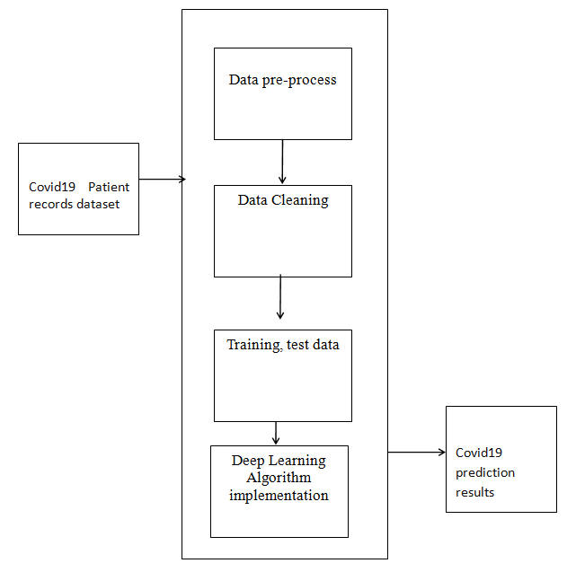

Fig 1 Proposed Architecture diagram

.
The testing and training variables are split and passed into the algorithm for the Covid19 disease prediction. In this algorithm will provide a comprehensive and intelligent solution for discovering high utility item sets, enabling users to access important information and streamline their search processes.

The application will be developed with Google Colab Python Tool as the project can be directly executed in any type computer systems with internet connection. There is no need of any specific software to be installed in the user system. The Colab Tool helps to develop and run the application directly inside the cloud server where the Python library files are installed. The deep learning algorithm libraries are built inside the Colab.

- DATA DESCRIPTION

The dataset for Covid19 disease identification is taken from the source of kaggle dataset. This dataset contains the fields needed for the analysing of the patient dataset. Exploratory examination is a cycle to investigate and comprehend the information and information relationship in a total profundity with the goal that it makes highlight designing and deep learning demonstrating steps smooth and smoothed out for expectation. Exploratory examination assists with validating our presumptions or misleading. Most of the image in a dataset are noisy and contain lots of information. But with feature engineering do, will get more good results. The first step is to import the libraries and load data. After that will take a basic understanding of data like its shape, sample, is there are any NULL values present in the dataset. Understanding the data is an important step for prediction or any deep learning project. It is good that there are no NULL values.

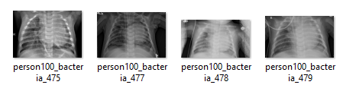

Fig. 2 Sample training dataset

The information about the Covid19 patient records with different types of attributes are collected from kaggle data. The dataset total contains of image dataset with training and testing Covid19 affected images of patients. It will begin from the principal segment and investigate every section and comprehend what influence it makes on the objective segment.

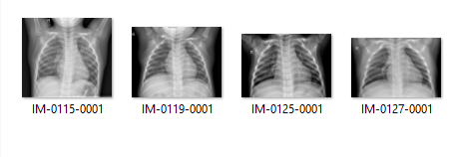
Fig. 3 Sample testing dataset

The dataset of brain x-ray images are downloaded from kaggle website. It has 3 folders train, test, Val which has Covid19 affected, non-affected patient brain x-ray images.
At the necessary step, we will likewise perform pre-processing and include designing undertakings. The point in acting top to bottom exploratory examination is to get ready and clean information for better Deep Learning demonstrating to accomplish elite execution and summed up models. So, it should begin with breaking down and setting up the dataset for expectation.

- EXPERIMENTAL ANALYSIS
The Initial process of loading the dataset into the Google Colab into the drive is the first step in execution process. The image data containing the information of the image with respect to the path and the description of the image location, and the image related style are linked.
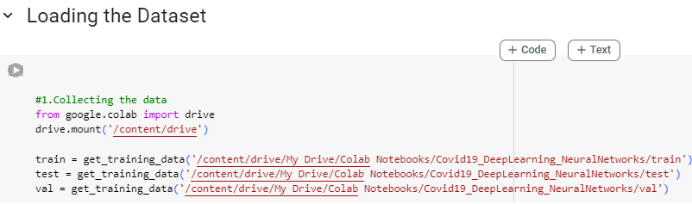

Fig. 4 Load dataset

The pre-processing is applied to the dataset where all the noisy data are removed, and the image is reshaped as per the mapping of 255pixel.

The information has an extremely straightforward design with elements. Each folder is related with the Covid19 disease brain x-ray images.

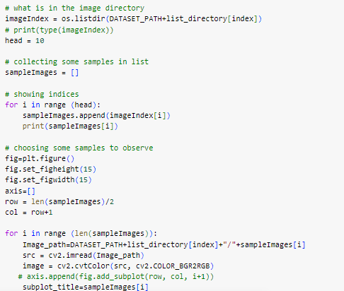

Fig. 5 Image re-shape

The image is re-shaped with the following the protocol of making the size of the image to 255-pixel range in any format types. The noisy data present inside the image is also removed and improves the image quality which will be more helpful in the application of the prediction of the Covid19 disease in the dataset.
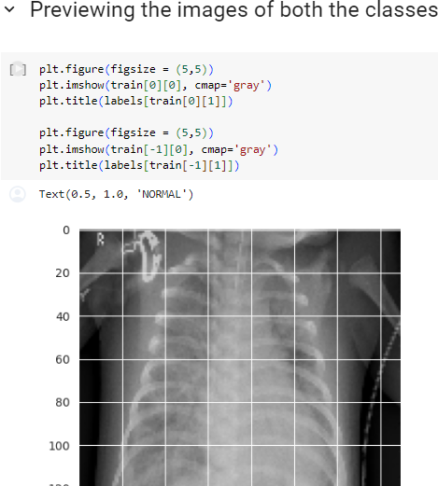

Fig. 6 Covid19 image layout

The image dataset is divided into testing and training to pass in to the neural network model.

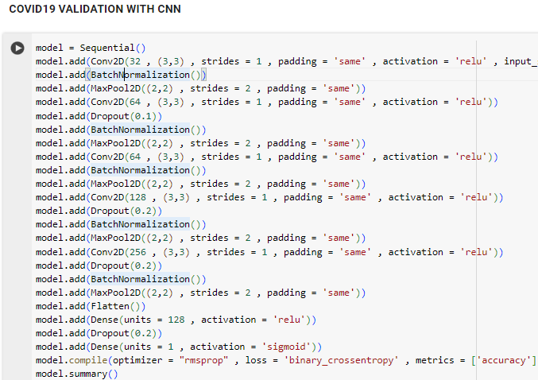

Fig. 7 CNN Validation
The Keras Models Programming interface provides a versatile platform for constructing intricate neural networks by adding and removing layers. The API supports both sequential and functional models with a single input and output or multiple inputs and outputs, respectively. The training module encompasses various methods, including generating the model, optimizer, and loss function, fitting the model and evaluating and predicting input data. Furthermore, the API includes methods for batch data processing, testing, and prediction.
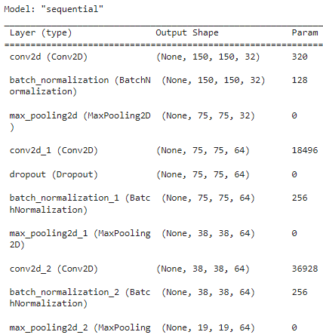

Fig. 8 Sequential model with keras

The accuracy, confusion matrix of the neural network is given below:
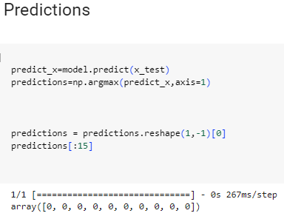
Fig. 9 Predictions

The classification report of the prediction is given below:

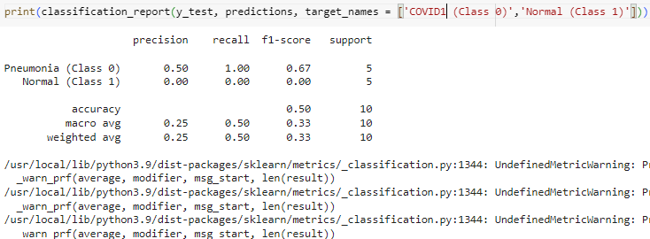
Fig. 10 Classification Report

Heatmaps use color to display data magnitude, enabling easy identification of patterns and anomalies. Brighter, reddish colors are used to represent more common or higher activity values, while darker colors are used to represent less common values or activity. The shading matrix used to define the heatmap is also commonly referred to as the heatmap itself. To plot heatmaps in Seaborn, simply utilize the seaborn.heatmap() function.

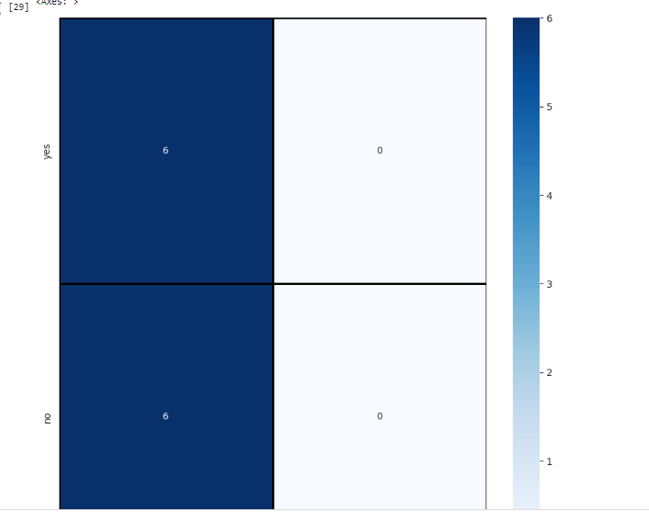

Fig. 11 Heat Map

The heat map matches the Covid19 diseases is present (yes) and not present (no) values in the given dataset.

The attributes of input data has been trained and tested then the model is been build, trained and tested and the predicted output is displayed. Th heat map helps to visualize the data of presence of Covid19 present or not in the given input dataset of the patient images. Data wrangling is a crucial step in data analysis that involves processing raw data in various formats such as merging, grouping, concatenating, and transforming them into a structured format that can be easily analysed. It is a time-consuming process that is necessary for making the data useful and preparing it to be used with another set of data. By performing data wrangling, you can ensure that the data is accurate, complete, and consistent, which is essential for making informed decisions and drawing meaningful insights from the data.

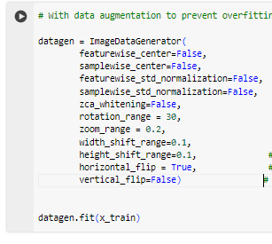

Fig. 12 Image Data Augmentation

The results of the CNN with sequential data analysis provides the accuracy. The validation and testing accuracy were identified while executing the convolutional neural network algorithm.

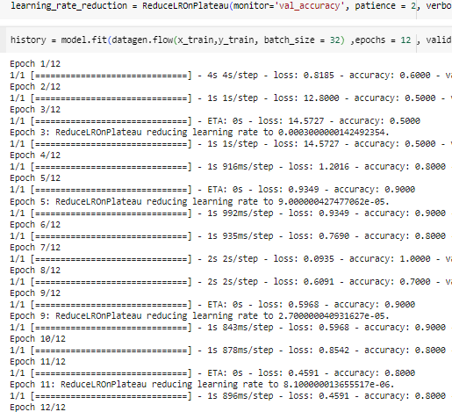

Fig.13: Sequential output

The Convolutional Neural Networks algorithm is applied with creating the sequential model. The output of the sequential model with layers is calculated.
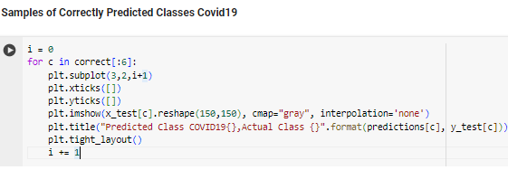

Fig. 14 prediction class layer

The results of the prediction of Covid19 disease identification with the CNN provide the accuracy results.

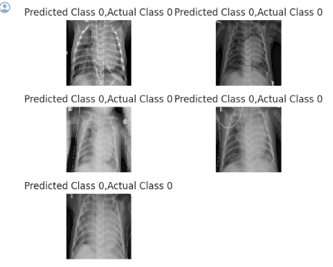
Fig. 15 Prediction Results

The training and validation of the model were evaluated and the accuracy is calculated.

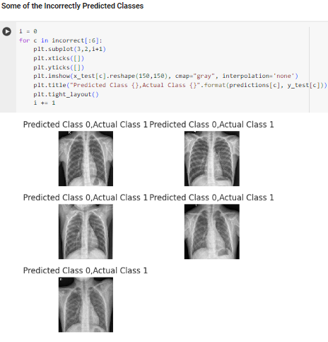
Fig. 16 Incorrect Predictions
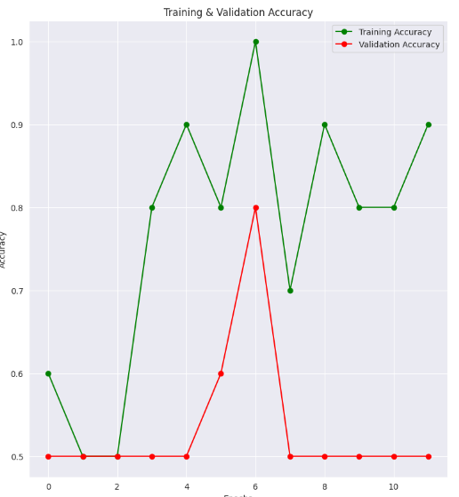
Fig. 17 Training and Validation accuracy

The training and the validation accuracy graph shows the results with graphical format. The trainig accuracy is getting in the increase ratio and it reaches the good saturation point. The validation accuracy is getting in the gradual increase points and reaches the good accuracy .
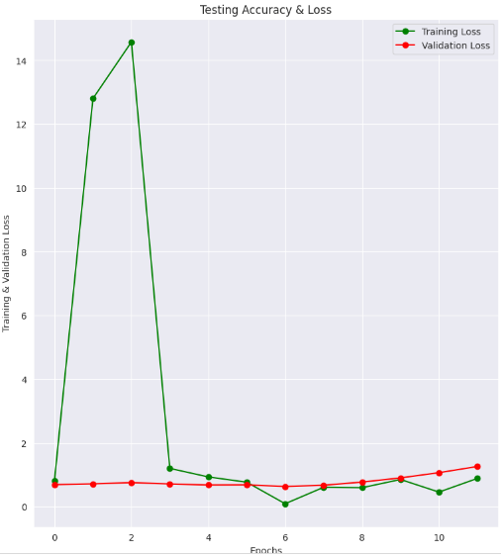

Fig. 18 Training and Validation loss

The training loss is getting in the decrease ratio and it reaches the good saturation point. Thus the Covid19 disease identification accuracy is calculated to make the prediction quality good.

- CONCLUSION

A cutting-edge framework for detecting Covid19 diseases has been developed using deep neural networks and diverse medical data. The framework employs all X-ray images with Covid19 information for model training and data classification. By constructing functional intellectual networks based on signal correlation, the neural network formation is optimized using correlation coefficient information. This methodology greatly enhances diagnostic accuracy compared to traditional approaches, demonstrating that integrating advanced deep learning with medical expertise is an effective way to diagnose neurological disorders in their early stages. The same or similar methodologies can be applied to diagnose other neurological diseases, providing a foundation for ongoing diagnosis in this field. Assessing the effectiveness of deep learning techniques and algorithms for forecasting Covid19 disorders and their subcategories can enhance the model's precision. Additionally, scrutinizing the dataset has enabled us to identify the most suitable feature sets for model fitting. Health departments, clinics, and hospitals can utilize the model for real medical diagnosis, while the study's findings may prove valuable in Covid19 disorder lab experiments. Enhancing accessibility and usability can be achieved through the addition of a Graphical Interface, such as website applications. The application of disease predictive models in varied clinical populations can enhance the performance and limitations of the proposed models, thus refining medical practice. Though prediction remains a challenge, future research is promising and may provide a wealth of clinically useful information if evaluated within the appropriate context.
References

- Li, L., Qin, L., Xu, Z., Yin, Y., Wang, X., Kong, B., Bai, J., Lu, Y., Fang, Z., Song, Q. and Cao, K., 2020. Artificial Intelligence Distinguishes COVID-19 from Community Acquired Pneumonia on Chest CT. Radiology, p.200905.
- Gozes, O., Frid-Adar, M., Greenspan, H., Browning, P.D., Zhang, H., Ji, W., Bernheim, A. and Siegel, E., 2020. Rapid ai development cycle for the coronavirus (covid-19) pandemic: Initial results for automated detection & patient monitoring using deep learning ct image analysis. arXiv preprint arXiv:2003.05037
- MV Villarejo, BG Zapirain, AM Zorrilla.,2013. Algorithms based on CWT and classifiers to control cardiac alterations and stress using an ECG and a SCR. Sensors 13 (5), 6141-6170.
- Xu, X., Jiang, X., Ma, C., Du, P., Li, X., Lv, S., Yu, L., Chen, Y., Su, J., Lang, G. and Li, Y., 2020. Deep learning system to screen coronavirus disease 2019 pneumonia. arXiv preprint arXiv:2002.09334.
- Chen, J., Wu, L., Zhang, J., Zhang, L., Gong, D., Zhao, Y., Hu, S., Wang, Y., Hu, X., Zheng, B. and Zhang, K., 2020. Deep learning-based model for detecting 2019 This work is licensed under a Creative Commons Attribution 4.0 License. For more information, see https://creativecommons.org/licenses/by/4.0/.This article has been accepted for publication in a future issue of this journal, but has not been fully edited. Content may change prior to final publication. Citation information: DOI 10.1109/ACCESS.2020.2995597, IEEE Access 15 novel coronavirus pneumonia on high-resolution computed tomography: a prospective study. medRxiv.
- Yan, L., Zhang, H.T., Xiao, Y., Wang, M., Sun, C., Liang, J., Li, S., Zhang, M., Guo, Y., Xiao, Y. and Tang, X., 2020. Prediction of criticality in patients with severe Covid-19 infection using three clinical features: a machine learning-based prognostic model with clinical data in Wuhan. medRxiv.
- Mohammed, M.A., Ghani, M.K.A., Arunkumar, N.A., Hamed, R.I., Abdullah, M.K. and Burhanuddin, M.A., 2018. A real time computer aided object detection of nasopharyngeal carcinoma using genetic algorithm and artificial neural network based on Haar feature fear. Future Generation Computer Systems, 89, pp.539-547
- Abd Ghani, M.K., Mohammed, M.A., Arunkumar, N., Mostafa, S.A., Ibrahim, D.A., Abdullah, M.K., Jaber, M.M., Abdulhay, E., Ramirez-Gonzalez, G. and Burhanuddin, M.A., 2020. Decision-level fusion scheme for nasopharyngeal carcinoma identification using machine learning techniques. Neural Computing and Applications, 32(3), pp.625-638.
- Mohammed, M.A., Al-Khateeb, B., Rashid, A.N., Ibrahim, D.A., Ghani, M.K.A. and Mostafa, S.A., 2018. Neural network and multi-fractal dimension features for breast cancer classification from ultrasound images. Computers & Electrical Engineering, 70, pp.871-882.
- Ai, T., Yang, Z., Hou, H., Zhan, C., Chen, C., Lv, W., Tao, Q., Sun, Z. and Xia, L., 2020. Correlation of chest CT and RT-PCR testing in coronavirus disease 2019 (COVID-19) in China: a report of 1014 cases. Radiology, p.200642.
- Fang, Y., Zhang, H., Xie, J., Lin, M., Ying, L., Pang, P. and Ji, W., 2020. Sensitivity of chest CT for COVID-19: comparison to RT-PCR. Radiology, p.200432.
- Zheng, C., Deng, X., Fu, Q., Zhou, Q., Feng, J., Ma, H., Liu, W. and Wang, X., 2020. Deep Learningbased Detection for COVID-19 from Chest CT using Weak Label. medRxiv.
- ] Wang, S., Kang, B., Ma, J., Zeng, X., Xiao, M., Guo, J., Cai, M., Yang, J., Li, Y., Meng, X. and Xu, B., 2020. A deep learning algorithm using CT images to screen for Corona Virus Disease (COVID-19). medRxiv.
- Xu, X., Jiang, X., Ma, C., Du, P., Li, X., Lv, S., Yu, L., Chen, Y., Su, J., Lang, G. and Li, Y., 2020. Deep learning system to screen coronavirus disease 2019 pneumonia. arXiv preprint arXiv:2002.09334
- Wang, L. and Wong, A., 2020. COVID-Net: A Tailored Deep Convolutional Neural Network Design for Detection of COVID-19 Cases from Chest Radiography Images. arXiv preprint arXiv:2003.09871.
- Criminisi, A., 2016. Machine learning for medical images analysis.
- Garcia-Chimeno, Y., Garcia-Zapirain, B., GomezBeldarrain, M. et al., 2017. Automatic migraine classification via feature selection committee and machine learning techniques over imaging and questionnaire data. BMC Med Inform Decis Mak 17, 38.
- Wang, W., Xu, Y., Gao, R., Lu, R., Han, K., Wu, G. and Tan, W., 2020. Detection of SARS-CoV-2 in different types of clinical specimens. Jama.
- Ng, M.Y., Lee, E.Y., Yang, J., Yang, F., Li, X., Wang, H., Lui, M.M.S., Lo, C.S.Y., Leung, B., Khong, P.L. and Hui, C.K.M., 2020. Imaging profile of the COVID-19 infection: radiologic findings and literature review. Radiology: Cardiothoracic Imaging, 2(1), p.e200034.
- Huang, C., Wang, Y., Li, X., Ren, L., Zhao, J., Hu, Y., Zhang, L., Fan, G., Xu, J., Gu, X. and Cheng, Z., 2020. Clinical features of patients infected with 2019 novel coronavirus in Wuhan, China. The Lancet, 395(10223), pp.497-506.
.

