DESIGN REPORT – BOM ID: EP 1581
FLANGED ANGLE STOP VALVE WITH MANUAL CONTROL, Ti ALLOY NB150 NP40

M/S ULTRA DIMENSIONS PVT. LTD., VISAKHAPATNAM


Prepared by: |  | Checked by: | Approved by: (DMDE)
Guravaiah V  CAE Engr | Aniket N  CAE Engr | (Ashok Varma R)  (Sr. General Manager)

Table of Contents
1. Revision Log 10
2. Scope 11
2.1. Details of Type of Analysis 11
3. Software/Tools 12
4. References 13
5. Equipment Details 14
5.1. CAD Model 14
5.2. Mass, Material, Centre of gravity and model orientation 19
5.2.1. The weight in FE analysis is tabulated below 19
5.2.2. Centre of gravity 20
5.2.3. Model Orientation 20
5.3. Details of Structural Connections to Surrounding Structure 21
5.4. Working Principle 21
5.4.1. Core working of the valve 21
5.4.2. Load path of the valve for various loading conditions 21
5.5. Components 22
5.5.1. Body 22
5.5.2. Disc 22
5.5.3. Gland 22
5.5.4. Bonnet 22
5.5.5. Flanges 22
5.6. Design Specifications 23
6. Modelling Details 24
6.1. Details of all the non-structural parts which are excluded from the model 24
6.2. Modelling approach for all structural parts 24
6.2.1. Simulation Geometry 24
6.2.2. FE Mesh 25
6.2.3. Mesh Quality criteria 27
6.3. Modelling approach for bolted joints 29
6.4. Modelling approach for welded joints 30
6.4.1. 3D Solid Modelling with Shared Topology and Conforming Mesh (Higher-Fidelity Weld Simulation) 30
6.5. Modelling approach for joints 31
6.6. Modelling approach for gaskets 39
6.7. Modelling approach for interfaces (contacts) 39
6.8. Details of materials models selected 39
7. Details of the Loading and BC 40
7.1. Load Case – 1 MBD Analysis 40
7.1.1. MBD Analysis Results 40
7.2. Load Case – 2 Modal Analysis 42
7.2.1. Modal Analysis Methodology 42
7.2.2. Modal Analysis Boundary Conditions 43
7.2.3. Modal Analysis Results 43
7.2.4. Modal Analysis Conclusions 49
7.3. Load Case - 3 Static Structural Analysis 50
7.3.1. Static Structural Analysis Boundary Conditions 50
7.3.2. Static Structural Analysis Loading Conditions 53
7.3.3. Static Structural Analysis Results 53
7.3.4. Static Structural Analysis Conclusions 68
7.4. Load case - 4 Vibration resistance analysis 68
7.4.1. Vibration Resistance Analysis Methodology 69
7.4.2. Vibration Resistance Analysis Boundary Conditions 69
7.4.3. Vibration Resistance Analysis Loading Conditions 70
7.4.3.1. Load Case - 3.1 Vibration Resistance Analysis in X- Direction 70
7.4.3.2. Load Case - 3.2 Vibration Resistance Analysis in Y- Direction 72
7.4.3.3. Load Case - 3.3 Vibration Resistance Analysis in Z- Direction 73
7.4.4. Vibration Resistance analysis Results 75
7.4.4.1. Analysis Harmonic In X direction 75
7.4.4.2. Analysis Harmonic In Y direction 85
7.4.4.3. Analysis Harmonic In Z direction 94
7.4.5. Harmonic Analysis Conclusions 102
7.5. Load Case - 5 Shock Analysis - Transient Approach 103
7.5.1. Shock Analysis Boundary And Loading Conditions For Transient Analysis 103
7.5.2. Shock Pulse Specifications 107
7.5.3. Results of Shock Analysis 108
7.5.3.1. Analysis Transient in X Direction 108
7.5.3.2. Analysis Transient in Y Direction 122
7.5.3.3. Analysis Transient in Z Direction 136
7.5.4. Shock Analysis Conclusion 148
8. CFD Analysis 150
8.1. Introduction 150
8.2. CFD Analysis Methodology 151
8.3. Assumptions 151
8.4. CFD Mesh 152
8.5. Material Selection 153
8.6. Turbulent Viscous model 153
8.7. Boundary Conditions 154
8.8. Solution Methods 155
8.8.1. Convergence criteria 155
8.9. Results 156
8.9.1. Y+ Plot 156
8.9.2. Velocity distribution 157
8.9.3. Pressure distribution 158
8.9.4. Calculation of valve coefficient 158
8.9.5. CFD Analysis Conclusions 159
9. Material Properties 160
10. Design calculations of the Valve 161
10.1. Pressure Rating of the Valve 161
10.2. Design Validation Valve Wall Thickness Calculations 161
10.3. Design Validation of the Union Bolted Joint and (Body- Bonnet) Flange 161
10.4. Calculation of the Bolt strength and Preload 161
10.5. Flange moments 161
10.6. Effort Required 161
10.7. End Connection Flange Design 161
10.8. End Connection Flange Design 161

List of Figures
Figure 1 - Equipment Details: CAD Model 14
Figure 2 Equipment Details: CAD Model Section View 15
Figure 3 Fluid Volume 16
Figure 4 Item no as Per BOM 17
Figure 5 - Valve Component Description: (BOM) 18
Figure 6 - Model Orientation: Standard Earth Gravity 20
Figure 7 - Simulation Geometry: Valve Geometry for FE Analysis 24
Figure 8 - FE Mesh: Mesh for FE Simulation 26
Figure 9 Element Quality 27
Figure 10 Aspect Ratio 28
Figure 11 Jacobian Ratio 28
Figure 12 Skewness 29
Figure 13 Maximum Corner Angle 29
Figure 14 Share Topology at Pipe and Flange Weld Locations 30
Figure 15 - Modelling approach for joints: Revolute - 2 Disc To 7 Spindle 31
Figure 16 - Modelling approach for joints: Cylindrical - 15 Yoke Sleeve To 10 Stem 32
Figure 17 - Modelling approach for joints: Fixed - 10 Stem To 50 Cylindrical Pin-2 33
Figure 18 - Modelling approach for joints: Revolute - 14 Bonnet To 15 Yoke Sleeve 34
Figure 19 - Modelling approach for joints: Revolute - 14 Bonnet To 19 Gear 35
Figure 20 - Modelling approach for joints: Revolute - 14 Bonnet To 20 Pinion Shaft 36
Figure 21 - Modelling approach for joints: Revolute - 18 Yoke Nut To 15 Yoke Sleeve 37
Figure 22 - Modelling approach for joints: Revolute - 20 Pinion Shaft To 33 Indicator 38
Figure 23 - Modelling approach for joints: General - 12 Bush-1 To 10 Stem 39
Figure 24 Loads Applied in MBD analysis 40
Figure 25 Joint Force at Threaded Joint 41
Figure 26 Joint force at Yoke Sleeve Bearings 41
Figure 27 Joint Forces at Pinion Shaft Bushes 42
Figure 28 - Modal Analysis: Boundary Conditions Modal Analysis 43
Figure 29 - Modal Analysis: Mode 1 at Frequency 36.139 Hz 46
Figure 30 - Modal Analysis: Mode 2 at Frequency 145.71 Hz 47
Figure 31 - Modal Analysis: Mode 3 at Frequency 173.41 Hz 47
Figure 32 - Modal Analysis: Mode 4 at Frequency 188.83 Hz 48
Figure 33 - Modal Analysis: Mode 5 at Frequency 258.18 Hz 48
Figure 34 - Modal Analysis: Mode 6 at Frequency 267.52 Hz 49
Figure 35 - Static Structural Analysis: Boundary Conditions Static Structural Analysis 50
Figure 36 - Static Structural: Total Deformation - End Time 53
Figure 37 - Static Structural: Equivalent (von-Mises) Stress - End Time 54
Figure 38 - Static Structural: Equivalent (von-Mises) Stress - MAT_ASTM_B367_Gr_5 - End Time 54
Figure 39 - Static Structural: Equivalent (von-Mises) Stress - MAT_ASTM_B348_Gr_5 - End Time 55
Figure 40 - Static Structural: Equivalent (von-Mises) Stress - MAT_ASTM_D4066_Nylon66 - End Time 56
Figure 41 - Static Structural: Equivalent (von-Mises) Stress - MAT_BS970_EN19 - End Time 57
Figure 42 - Static Structural: Equivalent (von-Mises) Stress - MAT_BS2874_CA104 - End Time 58
Figure 43 - Static Structural: Equivalent (von-Mises) Stress - MAT_BS970_EN36C - End Time 59
Figure 44 - Static Structural: Equivalent (von-Mises) Stress - MAT_ASTM_A276_S32100 - End Time 60
Figure 45 - Static Structural: Equivalent (von-Mises) Stress - MAT_ASTM_A217_CA15 - End Time 61
Figure 46 - Static Structural: Equivalent (von-Mises) Stress - MAT_ASTM_A240_S32100 - End Time 62
Figure 47 - Static Structural: All - Force Reaction - Fixed Support - End Time 63
Figure 48 - Static Structural: All - Moment Reaction - Fixed Support - End Time 64
Figure 49 - Harmonic Response X: Boundary Conditions 70
Figure 50 - Harmonic Response X: Displacement Amplitude (X) 70
Figure 51 - Harmonic Response Y: Boundary Conditions 72
Figure 52 - Harmonic Response Y: Displacement Amplitude (Y) 72
Figure 53 - Harmonic Response Z: Boundary Conditions 73
Figure 54 - Harmonic Response Z: Displacement Amplitude (Z) 74
Figure 55 - Harmonic Response X: Equivalent (von-Mises) Stress 75
Figure 56 - Harmonic Response X: Equivalent (von-Mises) Stress - MAT_ASTM_B367_Gr_5 76
Figure 57 - Harmonic Response X: Equivalent (von-Mises) Stress - MAT_ASTM_B348_Gr_5 76
Figure 58 - Harmonic Response X: Equivalent (von-Mises) Stress - MAT_ASTM_D4066_Nylon66 77
Figure 59 - Harmonic Response X: Equivalent (von-Mises) Stress - MAT_BS970_EN19 77
Figure 60 - Harmonic Response X: Equivalent (von-Mises) Stress - MAT_BS2874_CA104 78
Figure 61 - Harmonic Response X: Equivalent (von-Mises) Stress - MAT_BS970_EN36C 78
Figure 62 - Harmonic Response X: Equivalent (von-Mises) Stress - MAT_ASTM_A276_S32100 79
Figure 63 - Harmonic Response X: Equivalent (von-Mises) Stress - MAT_ASTM_A217_CA15 79
Figure 64 - Harmonic Response X: Equivalent (von-Mises) Stress - MAT_ASTM_A240_S32100 80
Figure 65 - Harmonic Response X: Frequency Response_MAT_ASTM_B367_Gr_5 80
Figure 66 - Harmonic Response X: Frequency Response_MAT_ASTM_B348_Gr_5 81
Figure 67 - Harmonic Response X: Frequency Response_MAT_ASTM_D4066_Nylon66 81
Figure 68 - Harmonic Response X: Frequency Response_MAT_BS970_EN19 82
Figure 69 - Harmonic Response X: Frequency Response_MAT_BS2874_CA104 82
Figure 70 - Harmonic Response X: Frequency Response_MAT_BS970_EN36C 83
Figure 71 - Harmonic Response X: Frequency Response_MAT_ASTM_A276_S32100 83
Figure 72 - Harmonic Response X: Frequency Response_MAT_ASTM_A217_CA15 84
Figure 73 - Harmonic Response X: Frequency Response_MAT_ASTM_A240_S32100 84
Figure 74 - Harmonic Response Y: Equivalent (von-Mises) Stress 85
Figure 75 - Harmonic Response Y: Equivalent (von-Mises) Stress - MAT_ASTM_B367_Gr_5 85
Figure 76 - Harmonic Response Y: Equivalent (von-Mises) Stress - MAT_ASTM_B348_Gr_5 86
Figure 77 - Harmonic Response Y: Equivalent (von-Mises) Stress - MAT_ASTM_D4066_Nylon66 86
Figure 78 - Harmonic Response Y: Equivalent (von-Mises) Stress - MAT_BS970_EN19 87
Figure 79 - Harmonic Response Y: Equivalent (von-Mises) Stress - MAT_BS2874_CA104 87
Figure 80 - Harmonic Response Y: Equivalent (von-Mises) Stress - MAT_BS970_EN36C 88
Figure 81 - Harmonic Response Y: Equivalent (von-Mises) Stress - MAT_ASTM_A276_S32100 88
Figure 82 - Harmonic Response Y: Equivalent (von-Mises) Stress - MAT_ASTM_A217_CA15 89
Figure 83 - Harmonic Response Y: Equivalent (von-Mises) Stress - MAT_ASTM_A240_S32100 89
Figure 84 - Harmonic Response Y: Frequency Response_MAT_ASTM_B367_Gr_5 90
Figure 85 - Harmonic Response Y: Frequency Response_MAT_ASTM_B348_Gr_5 90
Figure 86 - Harmonic Response Y: Frequency Response_MAT_ASTM_D4066_Nylon66 91
Figure 87 - Harmonic Response Y: Frequency Response_MAT_BS970_EN19 91
Figure 88 - Harmonic Response Y: Frequency Response_MAT_BS2874_CA104 92
Figure 89 - Harmonic Response Y: Frequency Response_MAT_BS970_EN36C 92
Figure 90 - Harmonic Response Y: Frequency Response_MAT_ASTM_A276_S32100 93
Figure 91 - Harmonic Response Y: Frequency Response_MAT_ASTM_A217_CA15 93
Figure 92 - Harmonic Response Y: Frequency Response_MAT_ASTM_A240_S32100 94
Figure 93 - Harmonic Response Z: Equivalent (von-Mises) Stress 94
Figure 94 - Harmonic Response Z: Equivalent (von-Mises) Stress - MAT_BS970_EN19 95
Figure 95 - Harmonic Response Z: Equivalent (von-Mises) Stress - MAT_BS2874_CA104 95
Figure 96 - Harmonic Response Z: Equivalent (von-Mises) Stress - MAT_BS970_EN36C 96
Figure 97 - Harmonic Response Z: Equivalent (von-Mises) Stress - MAT_ASTM_A276_S32100 96
Figure 98 - Harmonic Response Z: Equivalent (von-Mises) Stress - MAT_ASTM_A217_CA15 97
Figure 99 - Harmonic Response Z: Equivalent (von-Mises) Stress - MAT_ASTM_A240_S32100 97
Figure 100 - Harmonic Response Z: Frequency Response_MAT_ASTM_B367_Gr_5 98
Figure 101 - Harmonic Response Z: Frequency Response_MAT_ASTM_B348_Gr_5 98
Figure 102 - Harmonic Response Z: Frequency Response_MAT_ASTM_D4066_Nylon66 99
Figure 103 - Harmonic Response Z: Frequency Response_MAT_BS970_EN19 99
Figure 104 - Harmonic Response Z: Frequency Response_MAT_BS2874_CA104 100
Figure 105 - Harmonic Response Z: Frequency Response_MAT_BS970_EN36C 100
Figure 106 - Harmonic Response Z: Frequency Response_MAT_ASTM_A276_S32100 101
Figure 107 - Harmonic Response Z: Frequency Response_MAT_ASTM_A217_CA15 101
Figure 108 - Harmonic Response Z: Frequency Response_MAT_ASTM_A240_S32100 102
Figure 109 - Transient Analysis: Boundary Conditions 103
Figure 110 - Transient: Transient - Shock Load 104
Figure 111 - Transient Analysis: Boundary Conditions 105
Figure 112 - Transient: Transient - Shock Load 105
Figure 113 - Transient Analysis: Boundary Conditions 106
Figure 114 - Transient: Transient - Shock Load 106
Figure 115 - Shock Analysis: Shock Pulse 107
Figure 116 - Transient X: Total Deformation - End Time 108
Figure 117 - Transient X: Equivalent (von-Mises) Stress - End Time 109
Figure 118 - Transient X: Equivalent (von-Mises) Stress - MAT_ASTM_B367_Gr_5 - End Time 110
Figure 119 - Transient X: Equivalent (von-Mises) Stress - MAT_ASTM_B348_Gr_5 - End Time 111
Figure 120 - Transient X: Equivalent (von-Mises) Stress - MAT_ASTM_D4066_Nylon66 - End Time 112
Figure 121 - Transient X: Equivalent (von-Mises) Stress - MAT_BS970_EN19 - End Time 113
Figure 122 - Transient X: Equivalent (von-Mises) Stress - MAT_BS2874_CA104 - End Time 114
Figure 123 - Transient X: Equivalent (von-Mises) Stress - MAT_BS970_EN36C - End Time 115
Figure 124 - Transient X: Equivalent (von-Mises) Stress - MAT_ASTM_A276_S32100 - End Time 116
Figure 125 - Transient X: Equivalent (von-Mises) Stress - MAT_ASTM_A217_CA15 - End Time 117
Figure 126 - Transient X: Equivalent (von-Mises) Stress - MAT_ASTM_A240_S32100 - End Time 118
Figure 127 - Transient Y: Total Deformation - End Time 122
Figure 128 - Transient Y: Equivalent (von-Mises) Stress - End Time 123
Figure 129 - Transient Y: Equivalent (von-Mises) Stress - MAT_ASTM_B367_Gr_5 - End Time 124
Figure 130 - Transient Y: Equivalent (von-Mises) Stress - MAT_ASTM_B348_Gr_5 - End Time 125
Figure 131 - Transient Y: Equivalent (von-Mises) Stress - MAT_ASTM_D4066_Nylon66 - End Time 126
Figure 132 - Transient Y: Equivalent (von-Mises) Stress - MAT_BS970_EN19 - End Time 127
Figure 133 - Transient Y: Equivalent (von-Mises) Stress - MAT_BS2874_CA104 - End Time 128
Figure 134 - Transient Y: Equivalent (von-Mises) Stress - MAT_BS970_EN36C - End Time 129
Figure 135 - Transient Y: Equivalent (von-Mises) Stress - MAT_ASTM_A276_S32100 - End Time 130
Figure 136 - Transient Y: Equivalent (von-Mises) Stress - MAT_ASTM_A217_CA15 - End Time 131
Figure 137 - Transient Y: Equivalent (von-Mises) Stress - MAT_ASTM_A240_S32100 - End Time 132
Figure 138 - Transient Z: Total Deformation - End Time 136
Figure 139 - Transient Z: Equivalent (von-Mises) Stress - End Time 137
Figure 140 - Transient Z: Equivalent (von-Mises) Stress - MAT_ASTM_B367_Gr_5 - End Time 137
Figure 141 - Transient Z: Equivalent (von-Mises) Stress - MAT_ASTM_B348_Gr_5 - End Time 138
Figure 142 - Transient Z: Equivalent (von-Mises) Stress - MAT_ASTM_D4066_Nylon66 - End Time 139
Figure 143 - Transient Z: Equivalent (von-Mises) Stress - MAT_BS970_EN19 - End Time 140
Figure 144 - Transient Z: Equivalent (von-Mises) Stress - MAT_BS2874_CA104 - End Time 141
Figure 145 - Transient Z: Equivalent (von-Mises) Stress - MAT_BS970_EN36C - End Time 142
Figure 146 - Transient Z: Equivalent (von-Mises) Stress - MAT_ASTM_A276_S32100 - End Time 143
Figure 147 - Transient Z: Equivalent (von-Mises) Stress - MAT_ASTM_A217_CA15 - End Time 144
Figure 148 - Transient Z: Equivalent (von-Mises) Stress - MAT_ASTM_A240_S32100 - End Time 145
Figure 149 (a) Schematic of valve and its (b) sectional view. 150
Figure 150 Extracted fluid domain of EP 1581Valve. 151
Figure 151 CFD Mesh Size 152
Figure 152 Polyhedral grids generated on the exterior surface and hexahedral grids on the internal surface of the valve. 153
Figure 153 Material properties of sea-water. 153
Figure 154 Selection of turbulence model. 154
Figure 155 Mass Balance. 155
Figure 156 Residual plots. 156
Figure 157 Y+ contours on the computational domain. 156
Figure 158 Velocity contours in the computational region of EP 1581. 157
Figure 159 Velocity streamlines in the computational region of EP 1581. 158
Figure 160 Pressure contours in the computational region of EP 1581. 158
Figure 161 Area averaged pressure obtained at the inlet and outlet 158

List of Tables
Table 1 - Revision Log 10
Table 2 - Scope of Design Analysis 11
Table 3 - Software/Tools Used 12
Table 4 - Standard References 13
Table 5 - Weight Balance Table 19
Table 6 - Design Specifications 23
Table 7 - Mesh Parameters 25
Table 8 - Mesh Quality Criteria 27
Table 9 MBD Analysis Boundary Conditions 40
Table 10 Joint Force Summary Table 42
Table 11 – Modal Analysis Boundary Conditions 43
Table 12 - Ratio of Effective Mass to Total Mass 45
Table 13 - Modal Frequencies 46
Table 14 - Modal Analysis Summary 49
Table 15 - Static Structural Boundary Conditions 51
Table 16 - Boundary Conditions Summary - Static Structural 51
Table 17 - All - Force Reaction - Fixed Support - End Time - Tabular Data 63
Table 18 - All - Moment Reaction - Fixed Support - End Time - Tabular Data 64
Table 19 - Bolt Force Summary Table 64
Table 20 - Static Structural Results Summary 68
Table 21 - Vibration Proof Characteristics 69
Table 22 - Displacement Amplitude (X) 71
Table 23 - Vibration Resistance Analysis Settings (X) 71
Table 24 - Displacement Amplitude (Y) 72
Table 25 - Vibration Resistance Analysis Settings (Y) 73
Table 26 - Displacement Amplitude (Z) 74
Table 27 - Vibration Resistance Analysis Settings (Z) 74
Table 28 - Static Structural Results Summary 102
Table 29 - Analysis Settings 104
Table 30 - Analysis Settings 105
Table 31 - Analysis Settings 107
Table 32 - Shock Pulse Specification Table 107
Table 33 - Bolt Loads: Shock in X direction 118
Table 34 - Bolt Loads: Shock in Y direction 132
Table 35 - Bolt Loads: Shock in Z direction 145
Table 36 - Transient Shock Response Summary 148
Table 37 Boundary conditions. 155
Table 38 Parameters used for calculation of valve coefficient. 159

Revision Log
Table 1 - Revision Log
Document Revision number | Date of revision | Description | Remarks
R00 | 29-Apr-26 | Initial Submission

Scope
EQUIPMENT NAME: FLANGED ANGLE STOP VALVE WITH MANUAL CONTROL, Ti ALLOY NB150 NP40
BOM ID: EP 1581
PO No with date: HSV/33/Ti-VVS (28 TYPES-PROTO)/S5/360 dated 28 Jan 26

Details of Type of Analysis
Table 2 - Scope of Design Analysis
S. No. | Analysis Type | Section (In this Document) | Relevant Section of PO | Remarks
Scope of the FE Analysis to check for induced stress at test/strength pressure
1 | Modal Analysis | Section 7.1 | Section - B
2 | Static Analysis | Section 7.2 | Section - B
3 | Harmonic Analysis (Vibration Resistance) | Section 7.3 | Section - B
4 | Shock Analysis | Section 7.4 | Section - B
5 | Multi Body Dynamics | Section 7.5 | Section-B
6 | ABN/SBN | NA | Section-B | Will Be Performed Experimentally
7 | Estimation of the Co-efficient of Hydraulic Resistance through CFD | Section 8 | Section-B
Hand Calculations
7 | Valve Pressure Rating | Section 10 | Section - B | NA
8 | Valve Wall Thickness |  | Section - B
9 | Design of Union Joint |  | Section - B
10 | Bolt Pretensions |  | Section - B
11 | Effort Calculations |  | Section - B
12 | End Flange Selection |  | Section - B

Software/Tools
Table 3 - Software/Tools Used
S. No. | Software | System configuration | Versions
1 | SolidWorks | Dual Intel Xeon E5-2680; 128GB RAM; NVIDIA Quadro P4000 | 2020
2 | Ansys | Dell Precision 7820; Xeon Gold 6138; 20 cores; 128GB RAM | 2024 R1

References
Table 4 - Standard References
S. No. | Reference type (Standard Journal paper etc.) | Reference Number | Title | Revision year | Referred for
1 | Standard | Standard ASME PCC 1 | Guidelines for Pressure Boundary Bolted Joint Assembly | 2019 | Bolt Pretentions
2 | Standard | ASME section Sec II Part D | Boiler and Pressure Vessels 2023 | 2023 | Material Properties, and other design aspect
3 | Standard | ASME Sec VIII Div 1 | Gasket Seating | 2023 | Gasket selection
4 | Standard | ASME B16.34 | Valve body thickness | 2020 | Valve body thickness
5 | Standard | ASME Sec VIII Div 2-part 5 | Stress Linearization | 2023 | Stress Linearization
6 | Standard | IEC 60534-2-1/ ANSI/ISA-75.01.01 | Flow Capacity Sizing 2011 | 2011 | CV calculations
7 | Standard | GOST 1536 76/ ASME Sec VIII Div1 | Specification for Valves for interface dimensions |  | Flange Design
8 | BOOK |  | Design of Valve and Fittings by GH Pearson |  | Effort calculations

Equipment Details

CAD Model

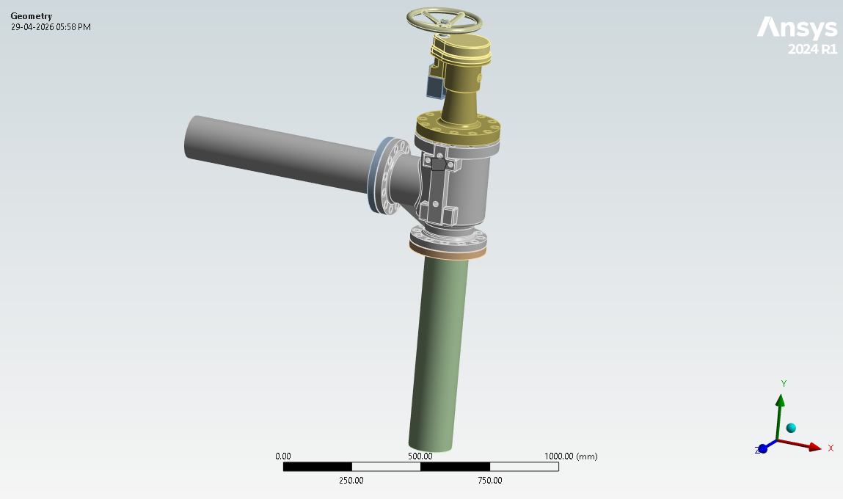
Figure 1 - Equipment Details: CAD Model
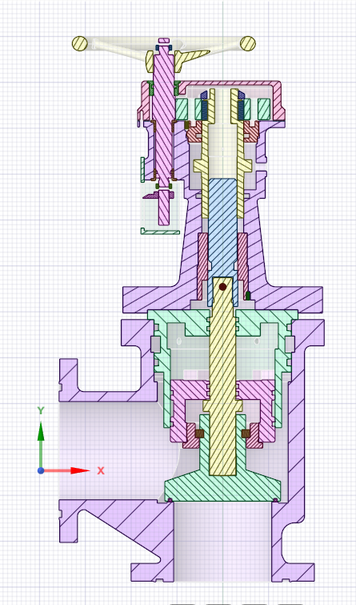
Figure 2 Equipment Details: CAD Model Section View

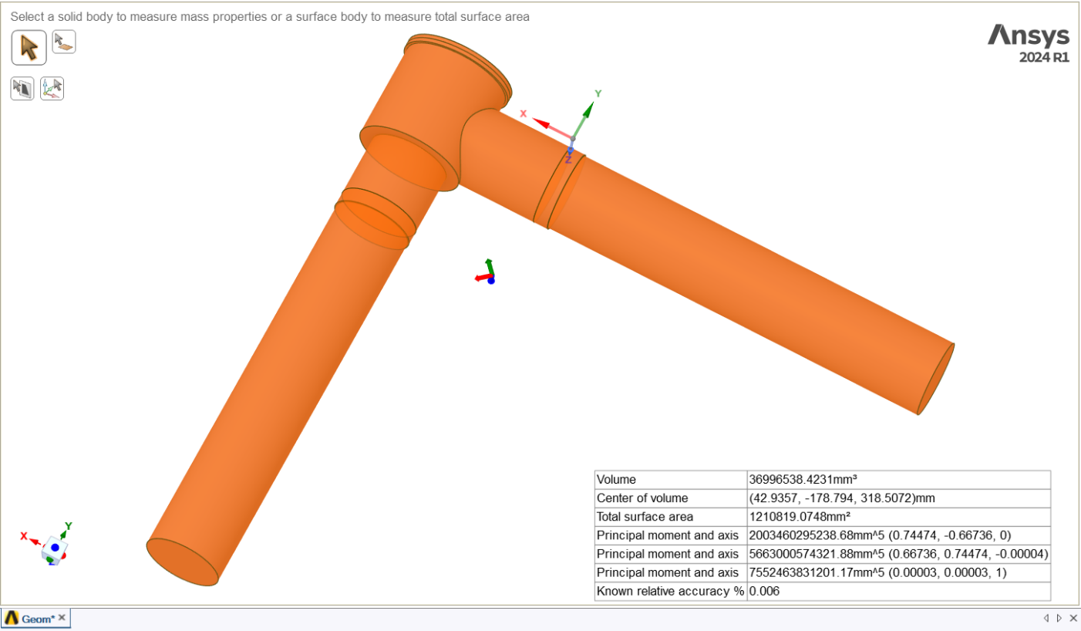
Figure 3 Fluid Volume

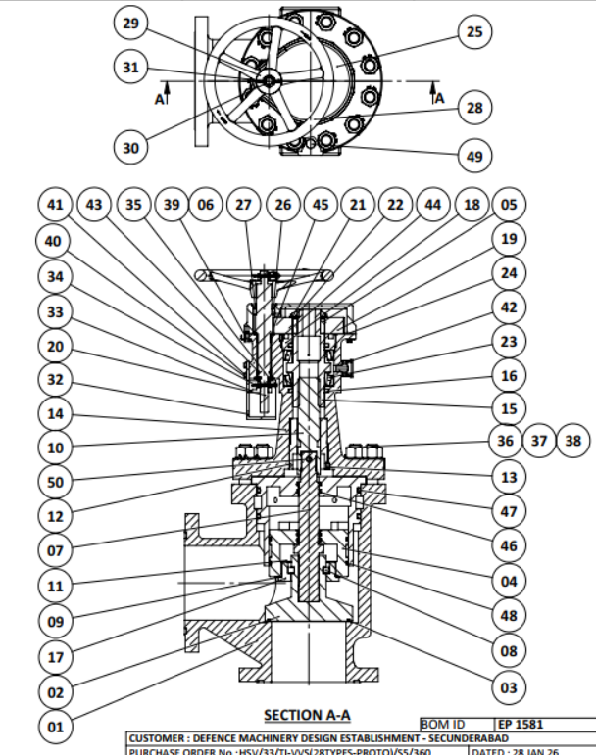
Figure 4 Item no as Per BOM
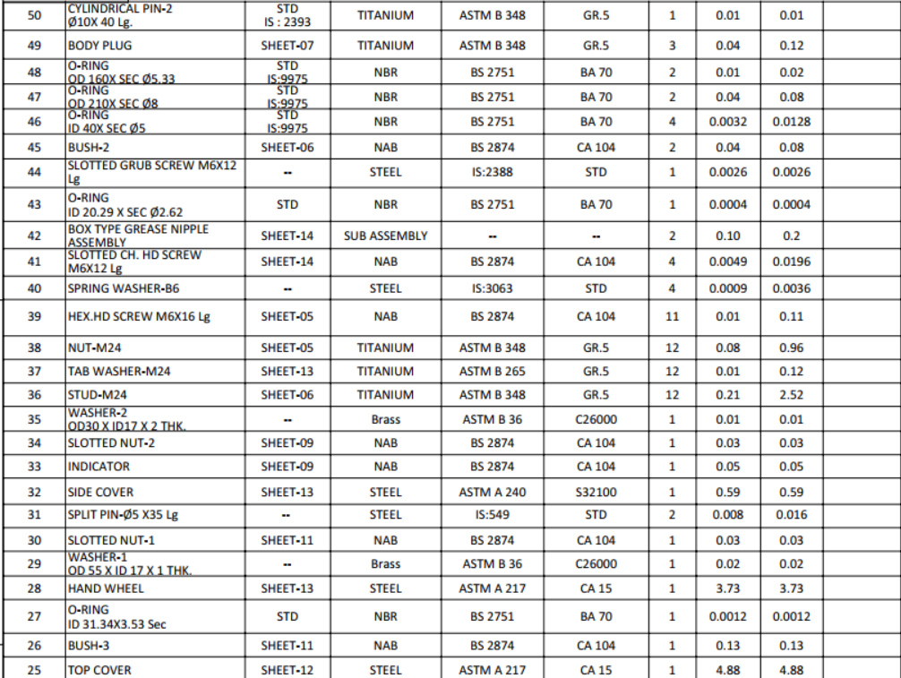
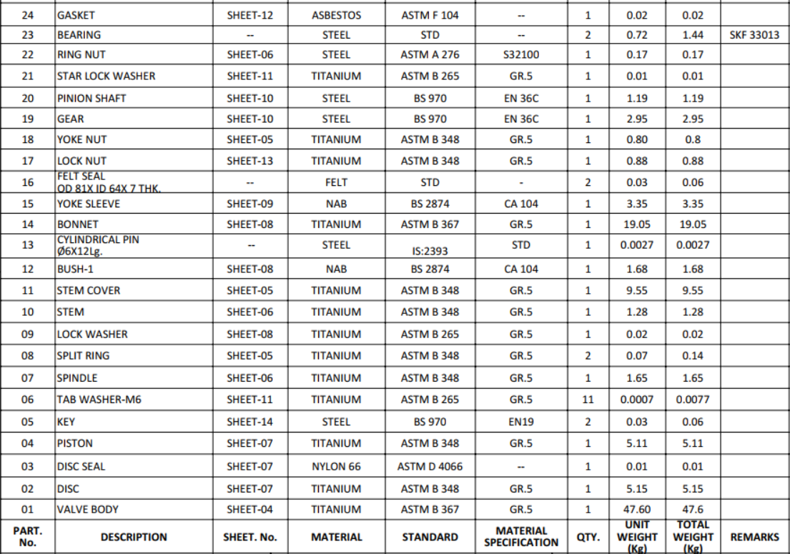
Figure 5 - Valve Component Description: (BOM)

Mass, Material, Centre of gravity and model orientation

The weight in FE analysis is tabulated below
Table 5 - Weight Balance Table
Sl. No. | Body Name | Material | Mass (FE Weight) (kg) | Dwg. Weight (kg)
1 | 1 Body | ASTM B 367 Gr.5 | 46.87267 | 47.6
2 | 2 Disc | ASTM B 348 Gr.5 | 5.07028 | 5.15
3 | 3 Disc Seal | ASTM D4066- Nylon 66 | 0.01454 | 0.01
4 | 4 Piston | ASTM B 348 Gr.5 | 4.98349 | 5.11
5 | 5 Key | BS 970 EN19 | 0.02636 | 0.03
6 | 5 Key | BS 970 EN19 | 0.02636 | 0.03
7 | 7 Spindle | ASTM B 348 Gr.5 | 1.62764 | 1.65
8 | 8 Split Ring | ASTM B 348 Gr.5 | 0.07357 | 0.07
9 | 8 Split Ring | ASTM B 348 Gr.5 | 0.07357 | 0.07
10 | 10 Stem | ASTM B 348 Gr.5 | 1.25449 | 1.28
11 | 11 Stem Cover | ASTM B 348 Gr.5 | 9.40327 | 9.55
12 | 12 Bush-1 | BS 2874 CA 104 | 1.66385 | 1.68
13 | 14 Bonnet | ASTM B 367 Gr.5 | 18.72133 | 19.05
14 | 15 Yoke Sleeve | BS 2874 CA 104 | 3.0184 | 3.35
15 | 17 Lock Nut | ASTM B 348 Gr.5 | 0.86686 | 0.88
16 | 18 Yoke Nut | ASTM B 348 Gr.5 | 0.78264 | 0.80
17 | 19 Gear | BS 970 EN36C | 2.87994 | 2.95
18 | 20 Pinion Shaft | BS 970 EN36C | 1.15555 | 1.19
19 | 22 Ring Nut | ASTM A 240 S32100 | 0.16414 | 0.17
20 | 25 Top Cover | ASTM A 217 CA15 | 4.76128 | 4.88
21 | 26 Bush-3 | BS 2874 CA 104 | 0.11761 | 0.13
22 | 28 Hand Wheel | ASTM A 217 CA15 | 3.63539 | 3.37
23 | 30 Slotted Nut-1 | BS 2874 CA 104 | 0.02331 | 0.03
24 | 32 Side Cover | ASTM A 240 S32100 | 0.59525 | 0.59
25 | 33 Indicator | BS 2874 CA 104 | 0.04599 | 0.05
26 | 34 Slotted Nut-2 | BS 2874 CA 104 | 0.02217 | 0.03
27 | 45 Bush-2 | BS 2874 CA 104 | 0.03995 | 0.04
28 | 45 Bush-2 | BS 2874 CA 104 | 0.03995 | 0.04
29 | 50 Cylindrical Pin-2 | ASTM B 348 Gr.5 | 0.01388 | 0.01
30 | Outlet Pipe | ASTM B 367 Gr.5 | 11.10508 | -
31 | Outlet Flange | ASTM B 367 Gr.5 | 4.83997 | -
32 | Inlet Pipe | ASTM B 367 Gr.5 | 11.10508 | -
33 | Inlet Flange | ASTM B 367 Gr.5 | 4.83997 | -
34 | Gasket 1 | ASTM D4066- Nylon 66 | 0.01534 | -
35 | Gasket 2 | ASTM D4066- Nylon 66 | 0.01534 | -
 | Total Weight From 1 To 29 |  | 107.9737 | 109.79

Centre of gravity
a) Centroid Location is (X, Y, Z) = (201.2666, 102.1355, 320.2737) mm
b) Limiting Dimensions (L X B X H): (405 X 320 X 832) mm

Model Orientation
Standard earth gravity of 9806.6 mm/s² is applied in the -Z Direction.
Note: As per the instructions and information provided by the equipment manufacturer, the valve is required to remain in the close position during operation. Therefore, only the physics corresponding to this common operating condition has been simulated in the present analysis.
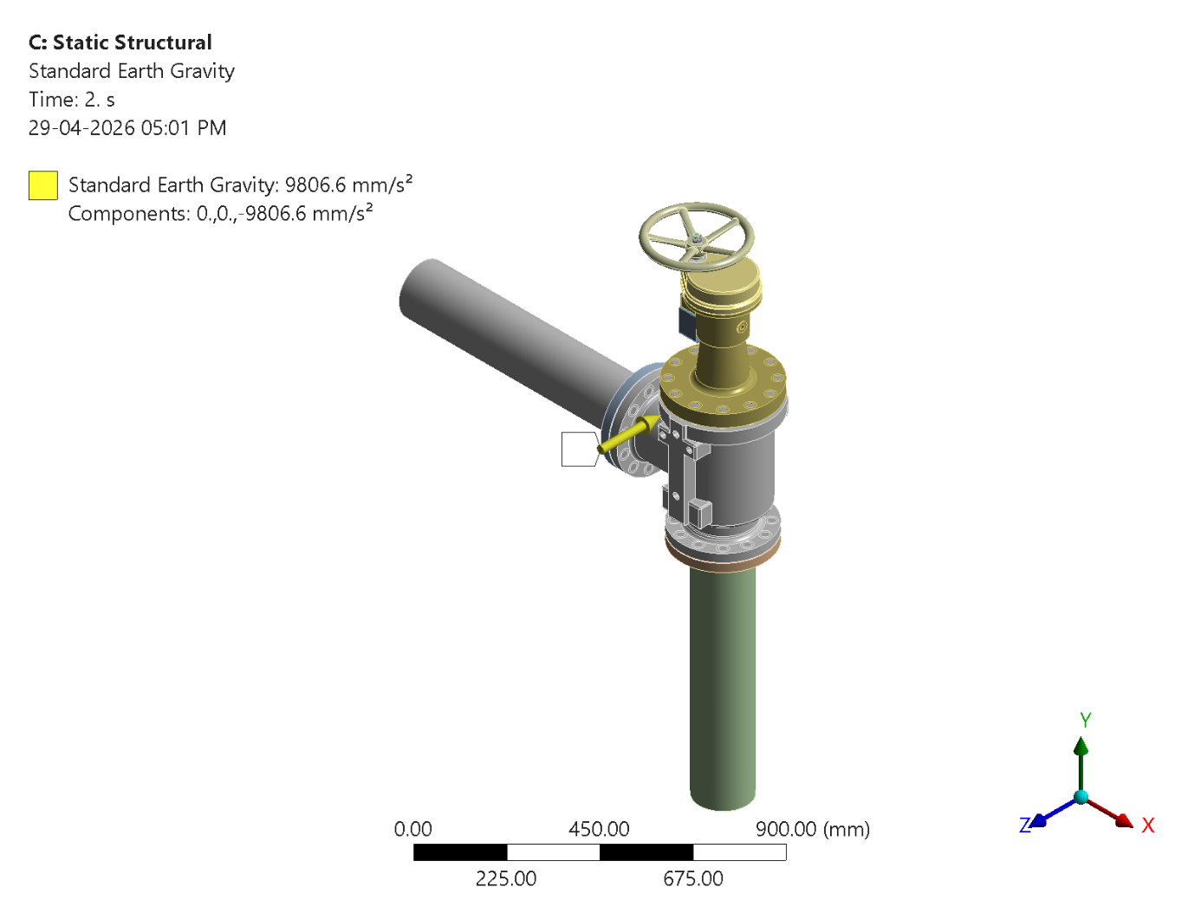
Figure 6 - Model Orientation: Standard Earth Gravity

Details of Structural Connections to Surrounding Structure
a) Valve assembly is connected to the piping by flanges at the both ends with 12 sets of M20 bolts.
b) Body of the valve and Bonnet is connected through 12 sets of M24 bolts with Nuts and Tab washers. Fluid flow happens through the body of the valve.
c) Stem cover is seated in the body of the valve. Stem cover allows the axial moment of Spindle assembly to the body of the valve. O-rings are there to arrest fluid leakage, between Stem cover and spindle.
d) Spindle assembly is fixed to the Stem at the top. The rotation of hand wheel is converted to axial motion of the spindle assembly through Stem via gear drive.
e) Stem is connected to the bonnet through the Yoke Sleeve. Yoke Sleeve is fixed to the bonnet at the outer side through bearings; the inner side of the Yoke Sleeve allows the motion of the stem through the threads. The Yoke Sleeve is rotated through the gear placed at top. The Gear is driven by the handwheel through pinion shaft.
f) Disc is fixed with the spindle at the bottom. Disc moves axially inside the valve body to regulate the flow. At the fully closed condition, the disc gets seated on the valve body.

Working Principle

Core working of the valve
A flanged angled stop valve operates by moving the disc in a linear motion perpendicular to the flow of the fluid to either block, allow, or regulate its passage. The term "angle-way" indicates that the fluid flows in a perpendicular path through the valve body, minimizing pressure loss when fully open.

Load path of the valve for various loading conditions
Under normal operating conditions, the dominant loading consists of internal pressure, piping reactions, and self-weight. The pressure loading on the cavity produces membrane and bending stresses in the valve body shell.
These loads are subsequently transferred through the valve body to the flange regions / support interface, where they are reacted by the adjoining piping and structural supports. Piping axial forces, bending moments, and torsional effects applied at the flanges are directly transmitted into the body, resulting in localized stress intensification at the flange neck and body transitions.
For modal analysis, the objective is to characterize the global and local vibration response of the valve structure. Excitation is assumed to be transmitted primarily through the support/flange interface from the connected piping system or structural support. The valve body forms the primary structural path for vibration transmission, while the stem disc assembly behaves as a coupled internal subsystem.
In harmonic analysis, imposed base motion or force excitation applied at the support locations propagates through the body and bonnet assembly. Dynamic amplification is expected in regions of stiffness discontinuity, such as the bonnet connection, flange transitions, and stem interface. The disc and stem experience secondary vibration response due to their mechanical coupling with the bonnet and seat.
For transient shock or impulsive loading scenarios, the excitation is transmitted to the valve primarily through the support or flange boundary or through CG. The shock input induces rapid acceleration of the valve body, producing inertia forces throughout the mass of the structure. These inertia effects dominate the structural response rather than conventional static force transfer.
The body mass reacts first, followed by delayed inertial response of the bonnet, stem, and disc assembly due to relative motion and compliance within the structure. Stress concentrations are expected at regions of geometric discontinuity, including flange necks, bonnet attachment areas, and body seat transitions. The transient loads are ultimately transmitted back through the supports to the adjoining piping or structural framework.

Components

Body
Function: The body houses all internal components and has flanged ends for connecting to the pipeline. The straight design positions the inlet and outlet is at a 180-degree.

Disc
Function: The disc is the movable component that allows or blocks fluid flow. It lifts to allow fluid flow in the desired direction and closes to prevent backflow.

Gland
Function: Gland is to compress the gland packing, creating a seal around the spindle to prevent fluid leakage.

Bonnet
Function: The bonnet covers the top of the valve body and houses the nut-stud assembly and other components. It can be removed for maintenance.

Flanges
Function: The flanges are integral parts of the valve body, drilled according to standard flange patterns (such as ANSI, DIN, or JIS) for easy bolting to the pipeline. Gaskets are used between the flanges and the pipeline to ensure a leak-proof connection.

Design Specifications
Table 6 - Design Specifications
Parameter | Value | Unit
Diameter Nominal (DN) | 150 | mm
Pressure Nominal (PN) | 4 | MPa
End Connection | FLANGE to FLANGE
Type | ANGLE STOP VALVE
Flowrate | 110 | m³/h
Working Medium | Sea Water
Working Temperature | Negative 2 to Positive 50 | ℃
Weight of Valve | 90.8 ± 10% | Kg
Material | TITANIUM ALLOY
Manufacturing Method | Casting

Modelling Details

Details of all the non-structural parts which are excluded from the model
The non-structural and soft components such as O-ring, split pin, washers, Felt Seal, Nuts, Body Plugs will be excluded in the FE model, as their contribution to overall structural strength and stiffness is negligible. The exclusion of these parts simplified the model while maintaining sufficient accuracy for evaluating the valves structural integrity under operating and transient loading conditions.

Modelling approach for all structural parts
The Valve components must be compatible with sea water environment. The valve must withstand operating loads and environmental loads i.e., shock loads and propeller induced vibrations.
This analysis aims to address the following key aspects:
Structural Integrity: Perform a structural analysis of the Valve to determine stresses, deformations, vibration responses, and potential failure modes. Ensure that the valve's components can withstand the mechanical forces generated during operation and environmental loads.
FE model has been made like the geometry. Only features like markings, logos and threads are de-featured in the model for geometry simplification. Connecting Flanges and pipes are simulated with the valve assembly.

Simulation Geometry
The geometry considered for the FE analysis is shown below.
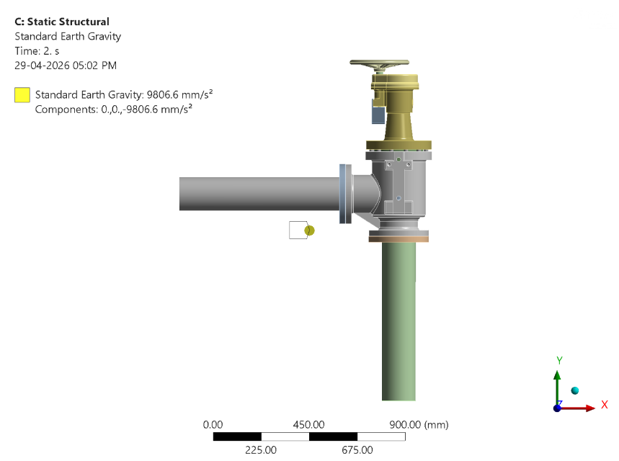
Figure 7 - Simulation Geometry: Valve Geometry for FE Analysis

FE Mesh
Table 7 - Mesh Parameters
Sl. No. | Sizing Name | Element Size
1 | 28 Hand Wheel | 9
2 | 30 Slotted Nut-1 | 3
3 | 20 Pinion Shaft | 5
4 | 25 Top Cover | 9
5 | 26 Bush-3 | 5
6 | 19 Gear | 2
7 | 22 Ring Nut | 3
8 | 15 Yoke Sleeve | 5
9 | Keys | 2
10 | 14 Bonnet | 7
11 | 18 Yoke Nut | 5
12 | 45 Bush-2 | 2
13 | 1 Body | 10
14 | 10 Stem | 5
15 | 12 Bush-1 | 5
16 | 11 Stem Cover | 7
17 | 7 Spindle | 5
18 | 2 Disc | 7
19 | 4 Piston | 5
20 | 17 Lock Nut | 5
21 | split ring | 3
22 | 50 Cylindrical Pin-2 | 1
23 | 3 Disc Seal | 2
24 | Flanges | 7
25 | Pipes | 5
26 | 32 Side Cover | 7
27 | 34 Slotted Nut-2 | 3
 | Total Elements | 1138767
 | Total Nodes | 1916079
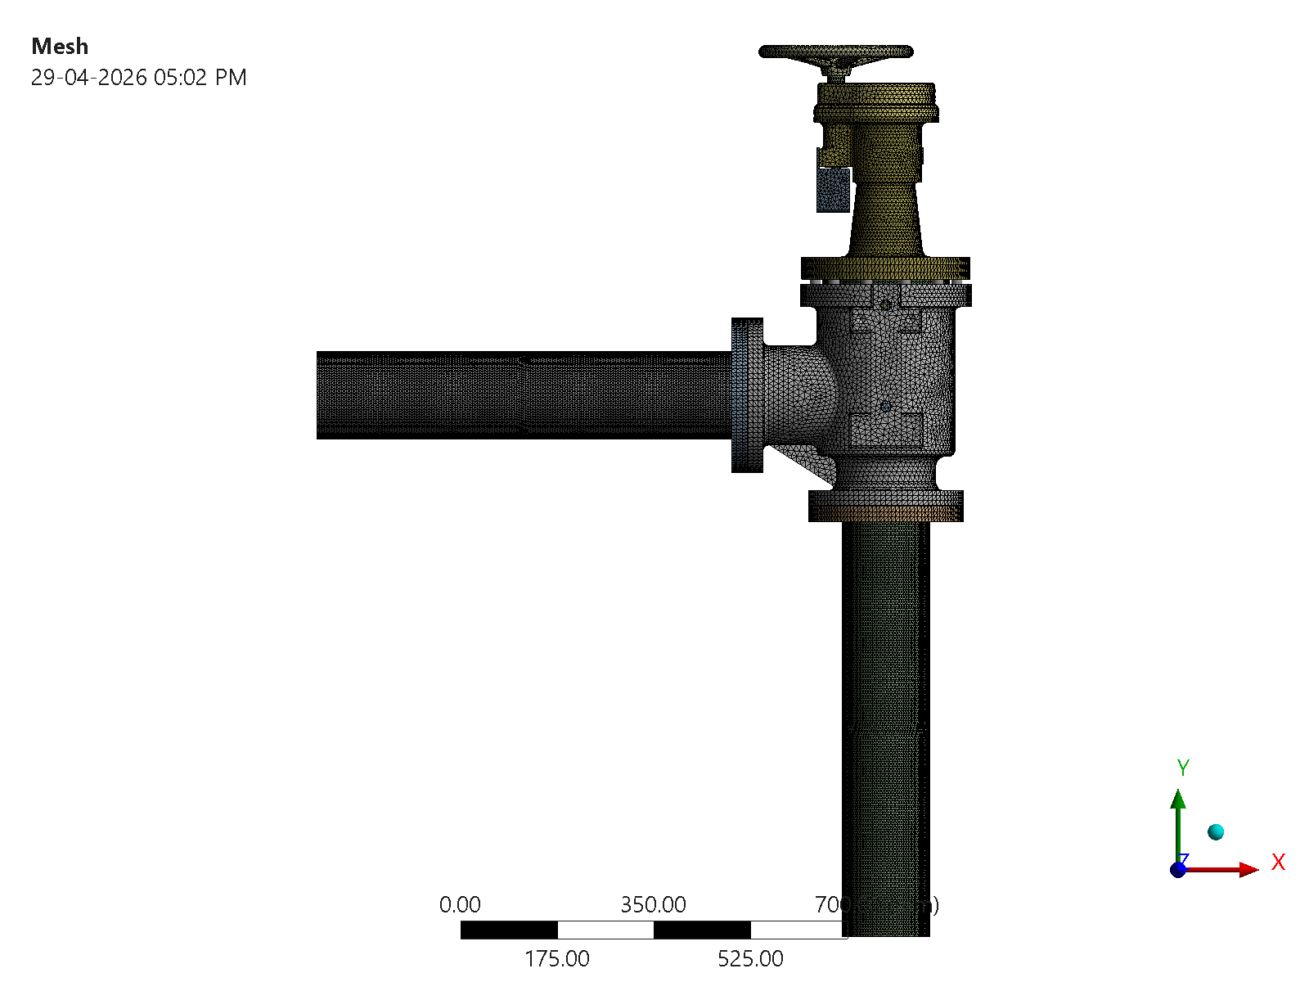
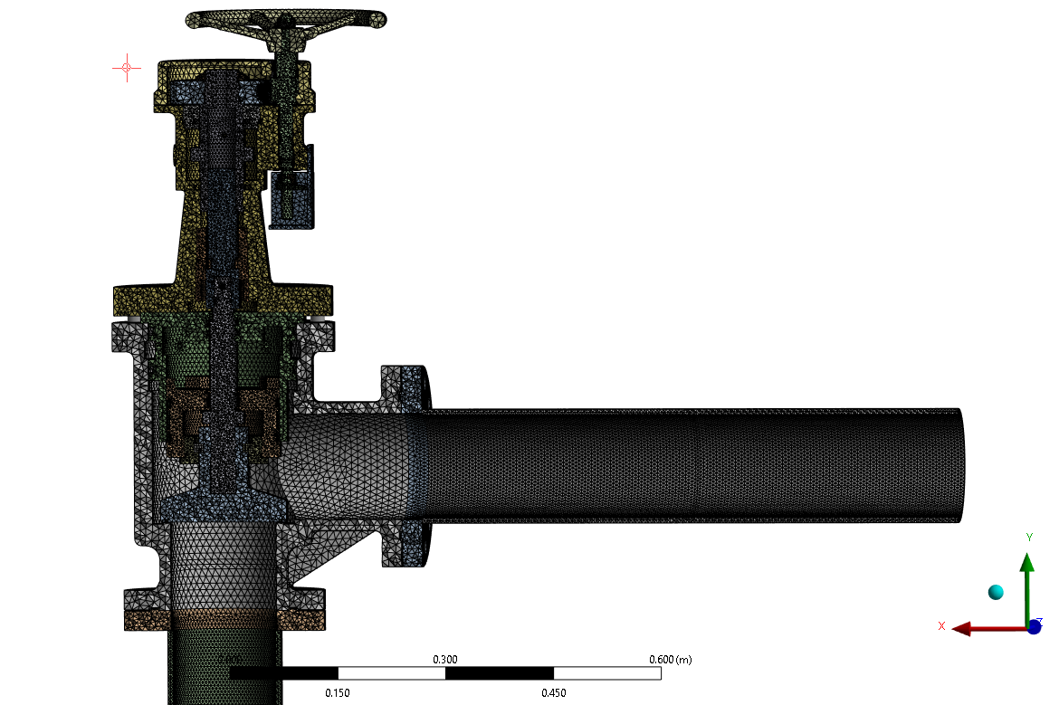
Figure 8 - FE Mesh: Mesh for FE Simulation
The pipe is meshed with the 2 quadratic elements across the thickness with minimum 5 nodes to cater the bending mode of the pipe.

Mesh Quality criteria
Table 8 - Mesh Quality Criteria
Parameter | Ideal Range | Acceptable Range | Status
Element Quality | ~ 1 | >0.75 for 75% of Elements | Within the acceptance range
Aspect Ratio | 1 to 5 | <= 10 (Structural) | Within the acceptance range
Skewness | 0-0.25 | <= 0.85 (warning), <= 0.95 (error) | Within the acceptance range
Jacobian Ratio (Structural) | ~ 1 | <= 40 | Within the acceptance range
Determinant of Jacobian (FEA) | Positive | > 0 | Within the acceptance range
Taper (Structural) | ~ 0 | <= 0.5 | Within the acceptance range
Maximum Angle (Triangles/Quads) | 60-90 deg | <= 120 deg | Within the acceptance range

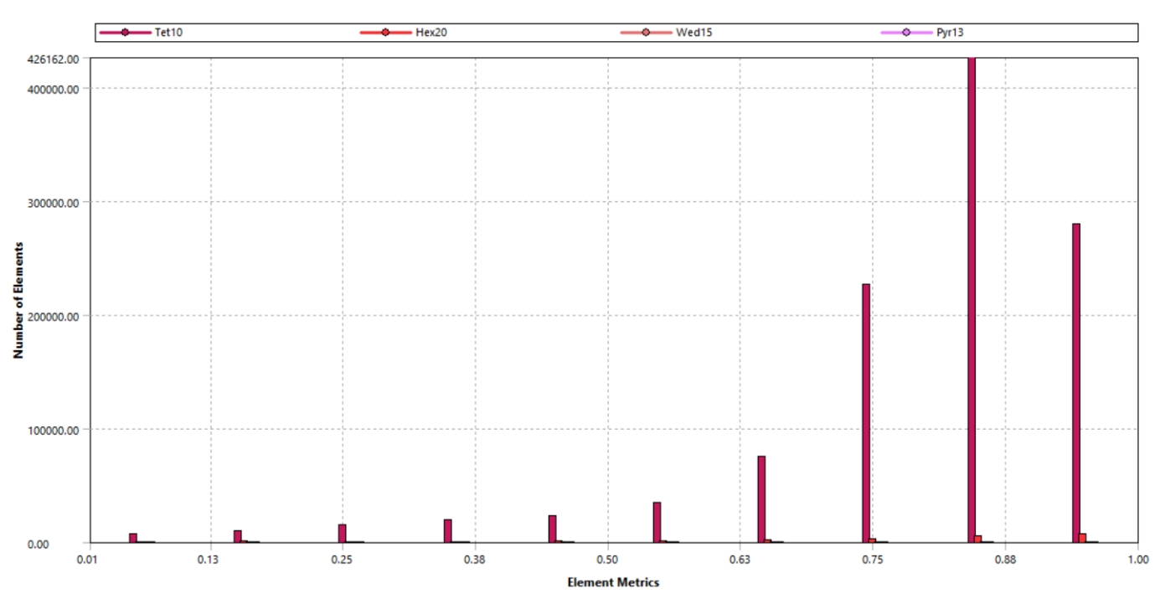
Figure 9 Element Quality
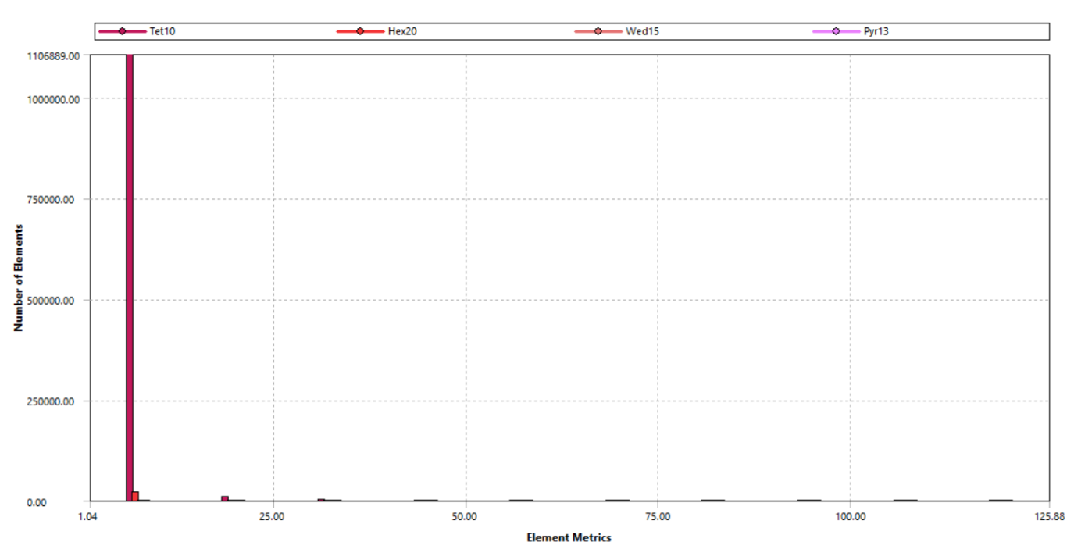
Figure 10 Aspect Ratio
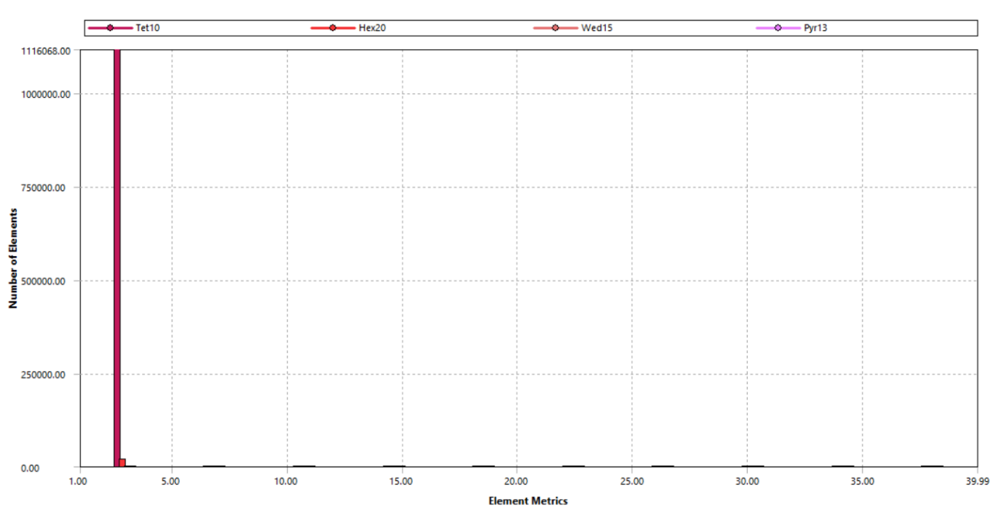
Figure 11 Jacobian Ratio
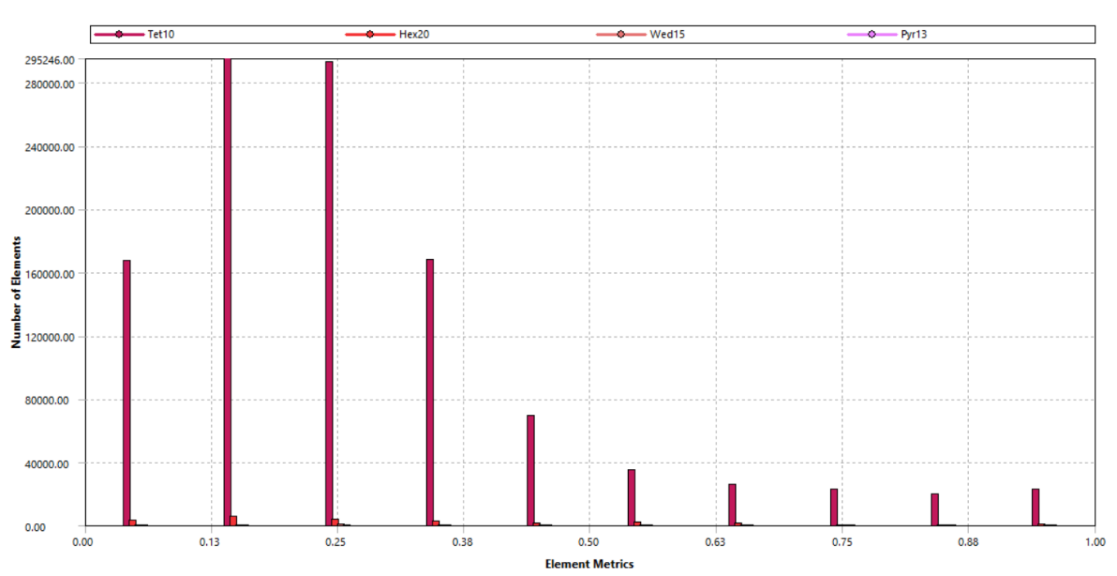
Figure 12 Skewness
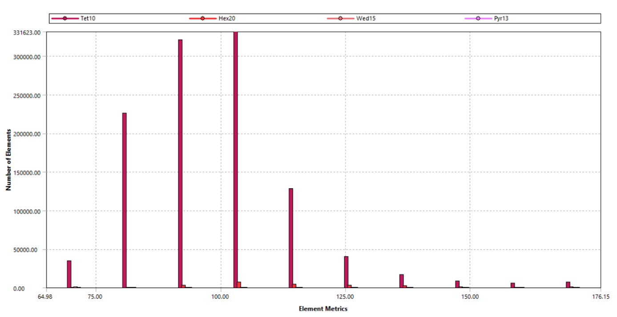
Figure 13 Maximum Corner Angle

Modelling approach for bolted joints
a) Bonnet to Body: Beam element is modelled between Bonnet and Body connection and meshed with BEAM188 elements.

b) Flange to Flange: Beam element is modelled between Flange-to-flange connection and meshed with BEAM188 elements.
Washers of 1.5D are be created around the bolt seating areas. Bolt length was reduced by scoping the tap hole (bolts end at half of the height of the Tap Hole). The beam element is tied to the nut contact area with the connecting body.
Note: The forces (Axial) as well as Shear) at the joint interfaces will be provided in the final design report.

Modelling approach for welded joints

3D Solid Modelling with Shared Topology and Conforming Mesh (Higher-Fidelity Weld Simulation)
The second methodology applies a full 3D solid modelling approach, with shared topology across welded regions to generate a conforming mesh and common interface nodes. This provides a physically realistic bonded representation of welded continuity without reliance on contact definitions.
This method is particularly suitable for cases involving severe loading such as vibration, harmonic excitation, transient shock, seismic actions, or high operating pressure levels. It provides improved capability to evaluate localized stresses and structural response near welded regions, while still maintaining code consistent treatment of welds as continuous structural connections, unless a specific weld fatigue or fracture assessment is required.
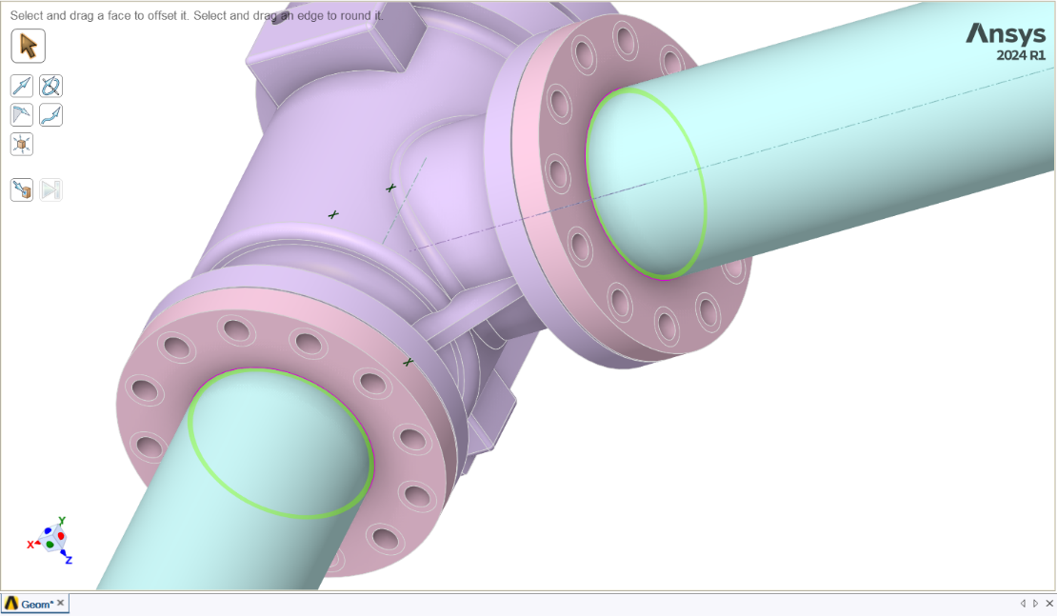
Figure 14 Share Topology at Pipe and Flange Weld Locations

Modelling approach for joints
The valve handle has 1 DOF, and it rotates around its axis. The revolute joint in the valves will be modelled using the connections, Insert body to body joint approach. The stationary part such as valve bonnet will be considered as scope and moving part like handle to be mobile.
The local coordinate system will be used, where its Z axis will be aligned to the axis of the valve stem.
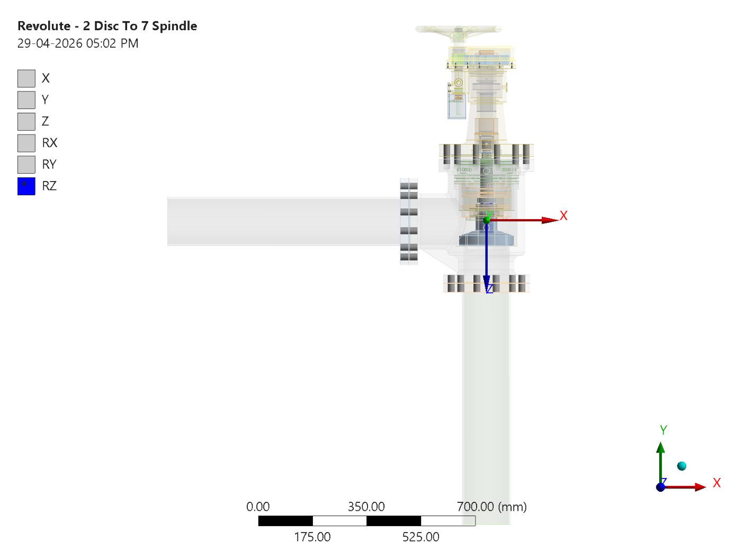
Figure 15 - Modelling approach for joints: Revolute - 2 Disc To 7 Spindle
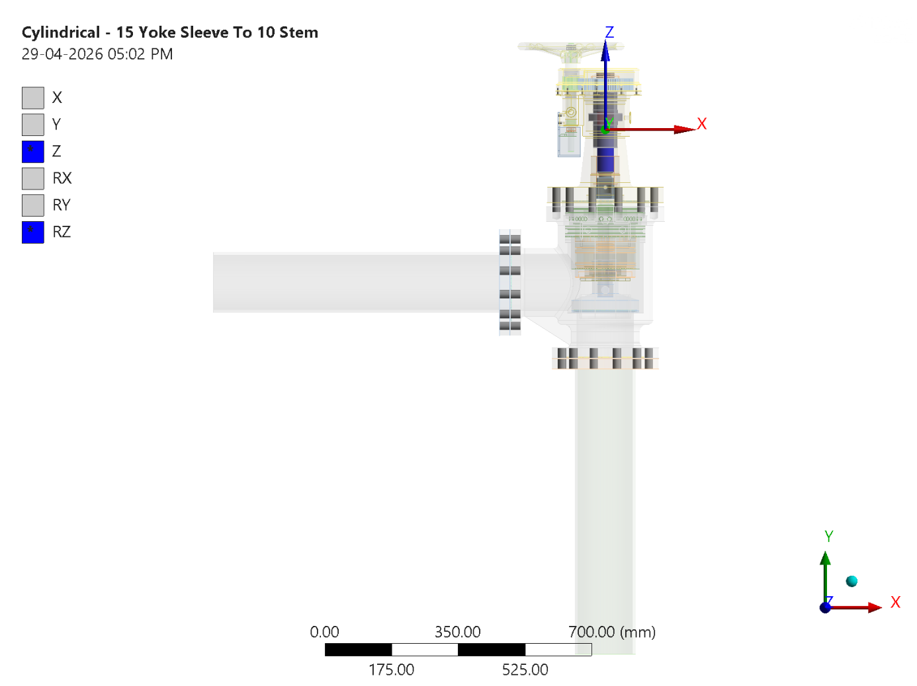
Figure 16 - Modelling approach for joints: Cylindrical - 15 Yoke Sleeve To 10 Stem
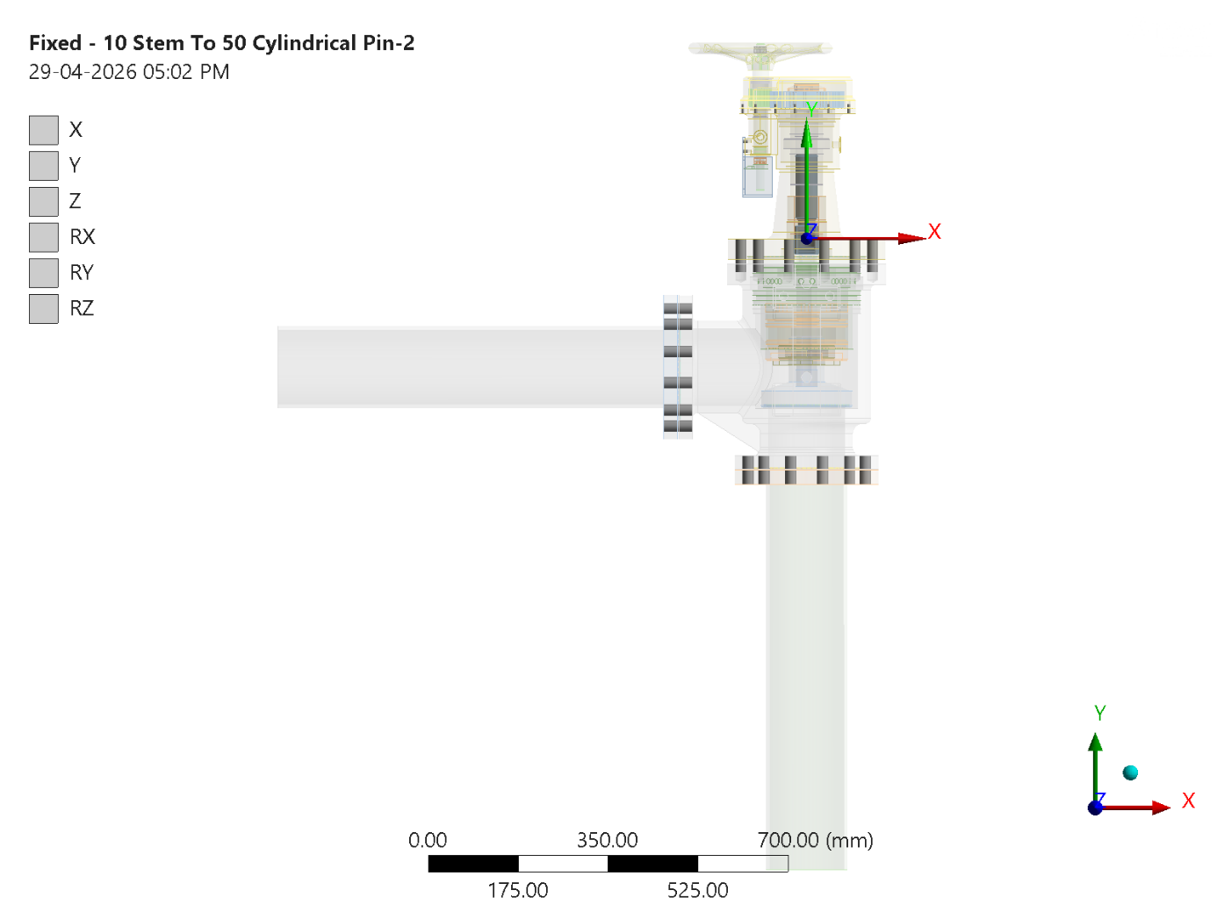
Figure 17 - Modelling approach for joints: Fixed - 10 Stem To 50 Cylindrical Pin-2
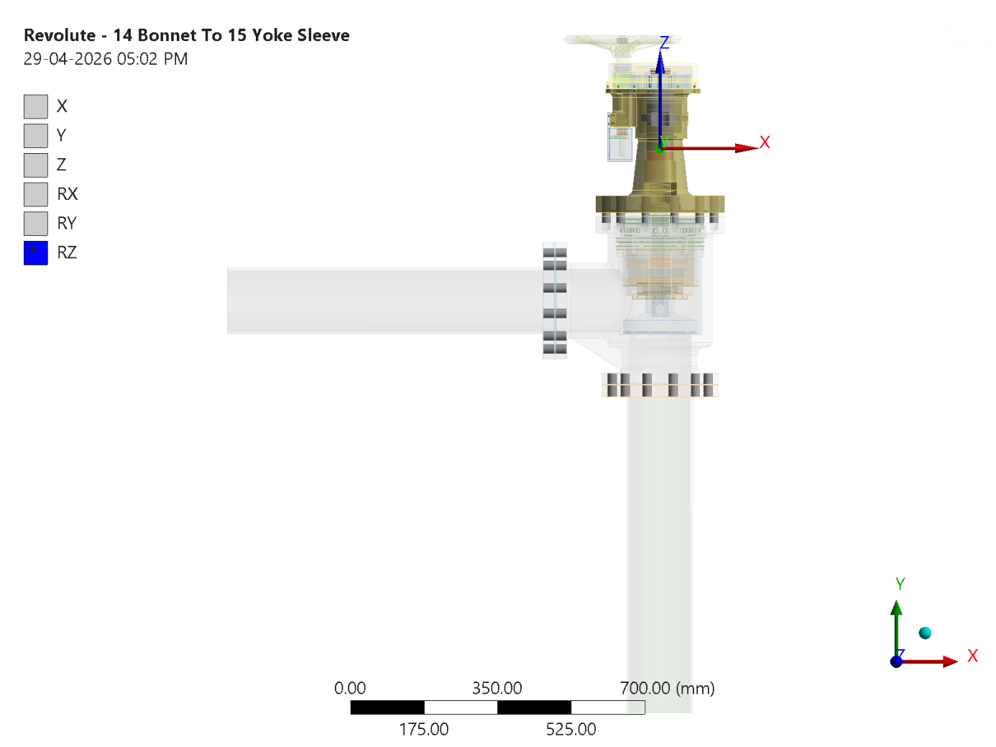
Figure 18 - Modelling approach for joints: Revolute - 14 Bonnet To 15 Yoke Sleeve
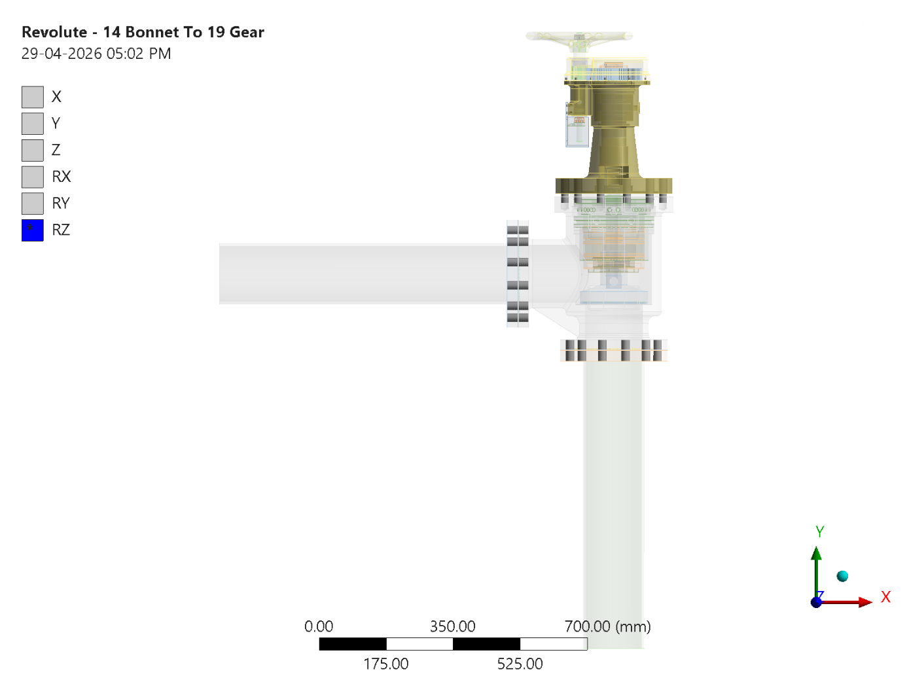
Figure 19 - Modelling approach for joints: Revolute - 14 Bonnet To 19 Gear
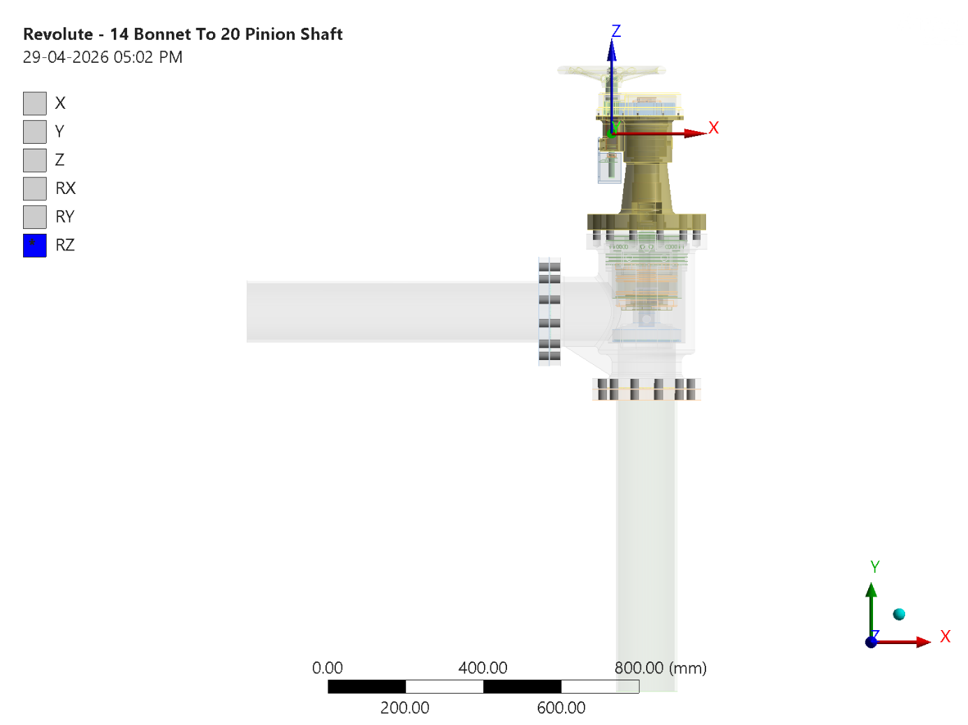
Figure 20 - Modelling approach for joints: Revolute - 14 Bonnet To 20 Pinion Shaft
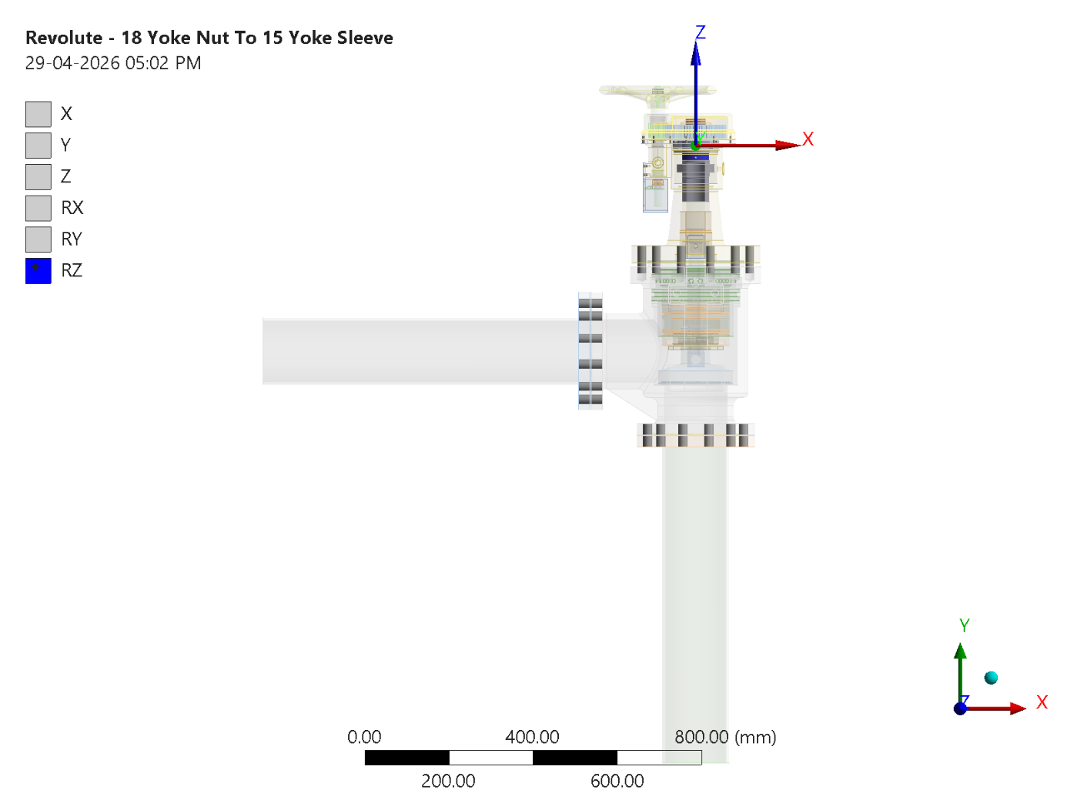
Figure 21 - Modelling approach for joints: Revolute - 18 Yoke Nut To 15 Yoke Sleeve
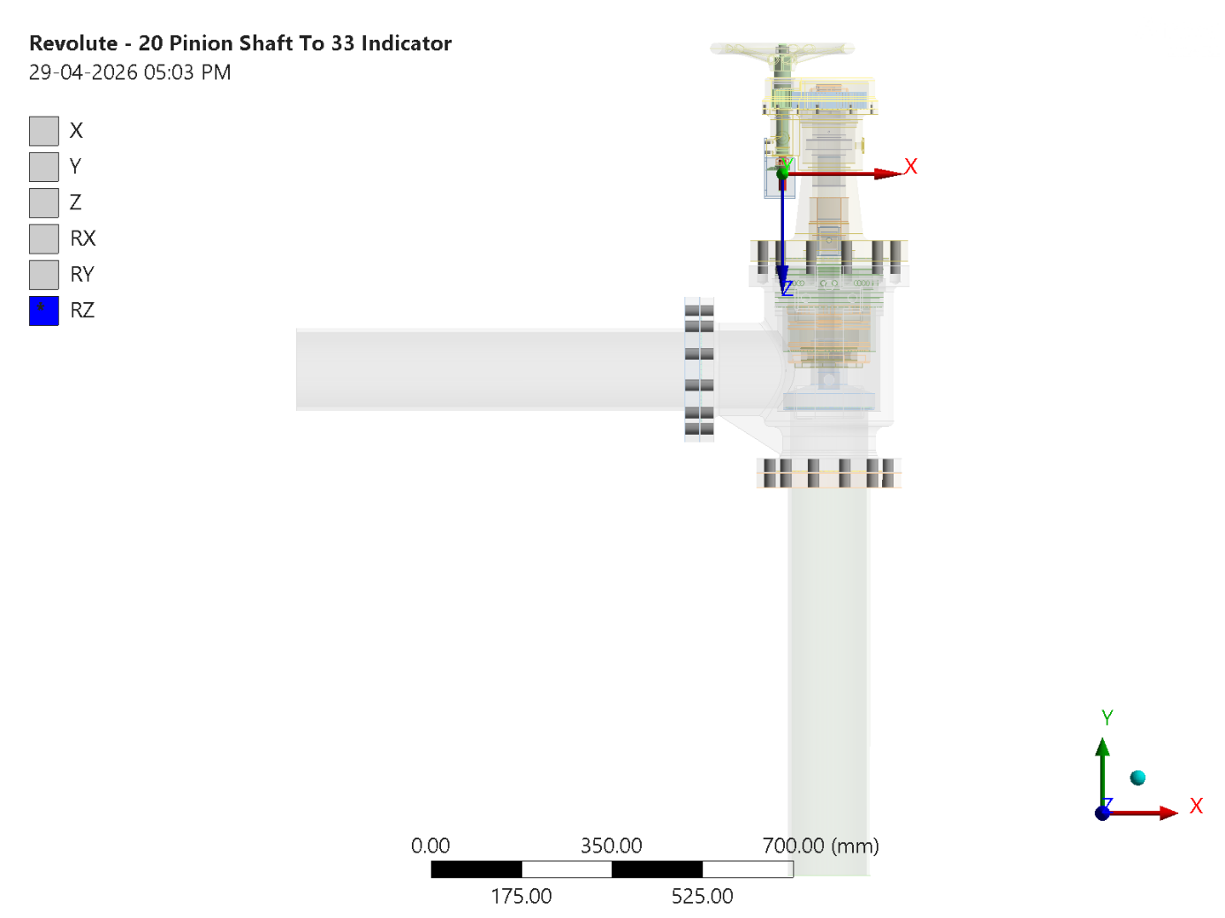
Figure 22 - Modelling approach for joints: Revolute - 20 Pinion Shaft To 33 Indicator
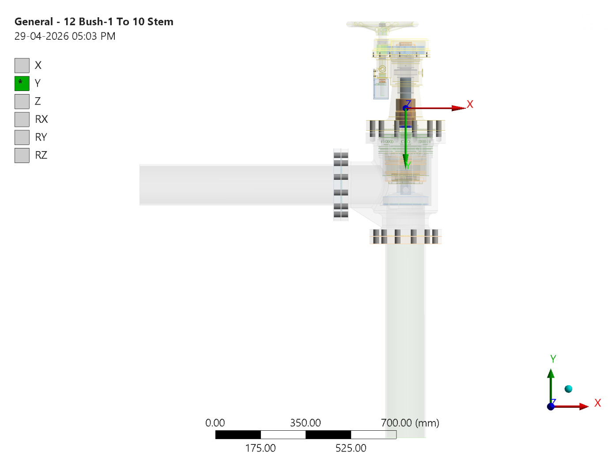
Figure 23 - Modelling approach for joints: General - 12 Bush-1 To 10 Stem

Modelling approach for gaskets
Frictional contacts are used for metal to gasket contacts at counter flange and gasket interface, with friction coefficient of 0.15. Gaskets will be modelled with linear material properties using the actual thickness. The Friction coefficient for Nylon to SS pair is very low and lies in the range of 0.05 to 0.15.

Modelling approach for interfaces (contacts)
All other parts without sliding motions were considered as bonded contact. The contacts between spindle and contacting bodies except in threaded regions where relative motion is required are modelled as no separation. Dry Friction coefficient for Metal-to-metal contacts is 0.5, For metal to gasket contacts 0.15 is taken as friction coefficient.

Details of materials models selected
For all the materials, Linear Isotropic material models were considered as the analysis is performed for elastic limits. Working temperature is between -2 ℃ to 50 ℃, which is deemed as not high to affect material properties.

Details of the Loading and BC

Load Case – 1 MBD Analysis
The multibody dynamic analysis is performed to find the forces generated at the joints which can be used to apply on joints while solving the static structural analysis. In this the actual behaviour of the joints is modelled in order to facilitate the actual motion.
Table 9 MBD Analysis Boundary Conditions
Sl. No. | Loading or BC | Location | Value
A | Standard Earth Gravity | CG | 9.8066 m/s²
B | Rotation | Handwheel | 360 degrees

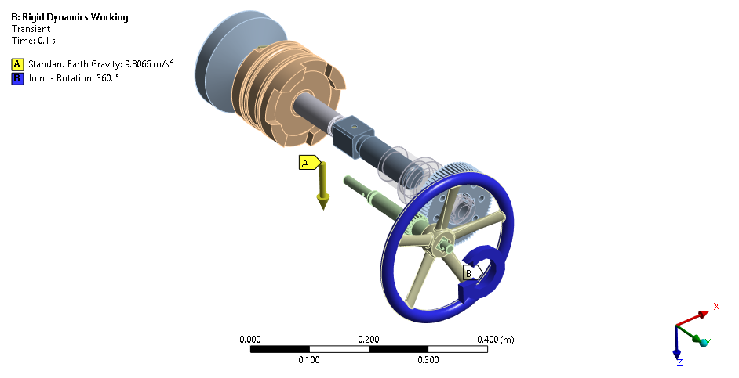
Figure 24 Loads Applied in MBD analysis

MBD Analysis Results
The Joint force at bushes, bearings and screw joints is evaluated and used as input in the Static Analysis. The other joint’s reaction is not required as these also generated in the static analysis, due to applied forces.
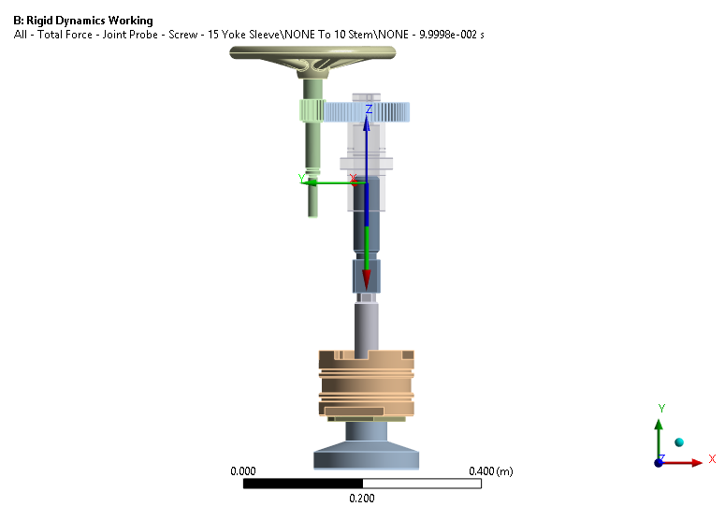
Figure 25 Joint Force at Threaded Joint
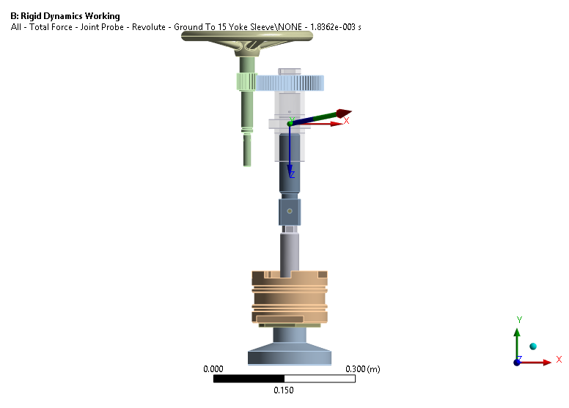
Figure 26 Joint force at Yoke Sleeve Bearings
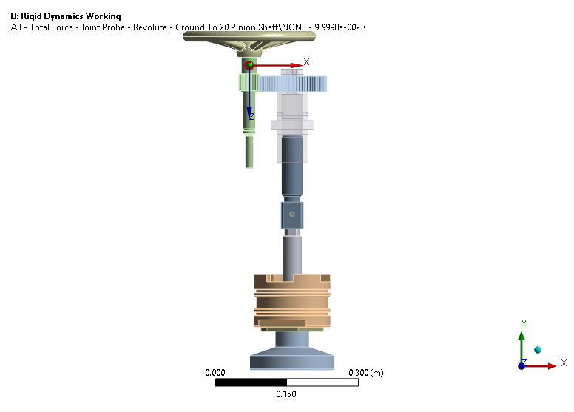
Figure 27 Joint Forces at Pinion Shaft Bushes
Table 10 Joint Force Summary Table
Sr. No. | Location | Force [N]
1 | Screw Joint at Yoke Sleeve and Stem | 25.211 N
2 | Bearings at Yoke Sleeve | 231.51 N
3 | Bushes at Pinion Shaft | 323.37 N

Load Case – 2 Modal Analysis
The modal analysis is performed to find the mode shapes and the fundamental natural frequencies of the structures, valves in this case. The objective is to obtain the mass participation factor of more than 80% for more mass to be included in succeeding the harmonic and transient analysis.

Modal Analysis Methodology
The Finite Element (FE) modal analysis has been meticulously conducted, employing the Block Lanczos method, with a comprehensive selection of modes. Specifically, a substantial number of modes have been included in the analysis to ensure that the cumulative modal mass participation exceeds 80% across all three mutually perpendicular directions encompassing both translations and rotations.
a) Modal Analysis without any operating loads will be performed to find the actual frequency and mode shapes.
b) Ensure at least 80 % Mass participation is achieved. We may limit the mass participation below 80 %, if the resultant frequencies are deemed to be high enough.

Modal Analysis Boundary Conditions
Table 11 – Modal Analysis Boundary Conditions
Sl. No. | Loading or BC | Location | Value
A | Fluid Mass | Distributed at Wet Surface | 33.456 Kg
B | Fixed | Pipe End | -
C | SKF Bearings | 15 Yoke Sleeve
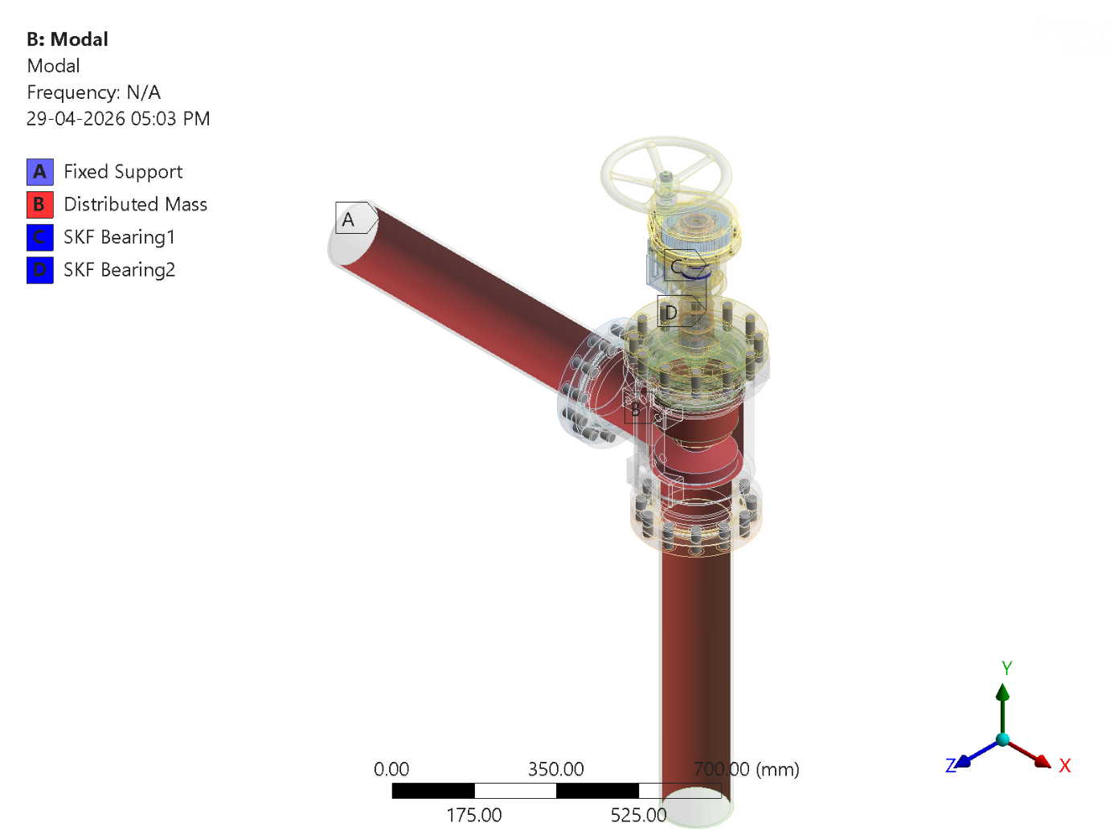
Figure 28 - Modal Analysis: Boundary Conditions Modal Analysis

Modal Analysis Results
The modal analysis results consist of two components the mass participation summary. The mass participation summary can be used to evaluate the number of modes to extract. The bottom line for mass participation factor is 80%. Here the mass participation of above 80% is achieved in non con strained directions. The Table Ratio of Effective Mass to Total Mass shows the achieved ratio of Effective Mass to Total Mass. This indicate that the number of extracted Modes are sufficient to Mode Superposition Analysis.

Table 12 - Ratio of Effective Mass to Total Mass
Mode | Frequency [Hz] | X Direction | Y Direction | Z Direction | Rotation X | Rotation Y | Rotation Z
1 | 36.1387 | 0.325557E-05 | 0.370223E-05 | 0.767487 | 0.146251 | 0.249109 | 0.107570E-05
2 | 145.711 | 0.272464 | 0.939157E-02 | 0.773764E-05 | 0.500242E-02 | 0.142975 | 0.345692
3 | 173.408 | 0.263757E-04 | 0.391281E-04 | 0.931298E-01 | 0.187182 | 0.327936E-01 | 0.716412E-04
4 | 188.827 | 0.646335E-12 | 0.594445E-06 | 0.728887E-02 | 0.277976E-02 | 0.128337E-02 | 0.691161E-05
5 | 258.181 | 0.162929E-02 | 0.184519E-01 | 0.418334E-05 | 0.920896E-02 | 0.970181E-03 | 0.695307E-02
6 | 267.516 | 0.388191E-02 | 0.841938E-03 | 0.239594E-01 | 0.644488E-02 | 0.267657E-01 | 0.685120E-05
7 | 268.538 | 0.344161E-01 | 0.343381E-02 | 0.139935E-02 | 0.601686E-03 | 0.117888E-01 | 0.117000E-02
8 | 275.806 | 0.389463E-01 | 0.826500 | 0.774496E-03 | 0.421128 | 0.358216E-01 | 0.229722
9 | 278.178 | 0.749725E-04 | 0.312926E-01 | 0.175022E-01 | 0.388296E-02 | 0.513663E-01 | 0.103383E-01
10 | 322.200 | 0.563423 | 0.208977E-01 | 0.567214E-04 | 0.105227E-01 | 0.285919 | 0.909246E-01
11 | 485.968 | 0.343933E-07 | 0.407465E-07 | 0.121671E-04 | 0.231116E-04 | 0.870633E-04 | 0.505632E-07
12 | 538.006 | 0.824538E-03 | 0.565595E-02 | 0.879669E-07 | 0.303271E-02 | 0.359520E-03 | 0.530252E-01
13 | 598.077 | 0.237830E-05 | 0.114854E-04 | 0.507823E-02 | 0.295986E-01 | 0.971462E-02 | 0.456856E-06
14 | 668.519 | 0.731068E-07 | 0.826787E-08 | 0.618420E-06 | 0.589065E-05 | 0.170980E-04 | 0.178446E-07
15 | 668.590 | 0.210300E-05 | 0.587222E-06 | 0.422163E-07 | 0.332667E-06 | 0.159995E-05 | 0.290250E-07
16 | 668.922 | 0.795817E-08 | 0.302850E-08 | 0.205700E-05 | 0.324436E-06 | 0.112963E-05 | 0.229445E-08
17 | 669.021 | 0.266963E-06 | 0.300518E-06 | 0.235152E-07 | 0.113930E-06 | 0.255792E-06 | 0.820482E-07
18 | 688.418 | 0.724297E-02 | 0.461220E-02 | 0.288383E-05 | 0.225497E-02 | 0.412364E-02 | 0.105460E-02
19 | 718.434 | 0.862893E-04 | 0.173682E-03 | 0.945484E-05 | 0.790563E-04 | 0.118556E-03 | 0.166197E-01
20 | 746.961 | 0.107582E-08 | 0.399540E-05 | 0.207906E-01 | 0.161625E-03 | 0.267545E-01 | 0.138541E-05
Sum |  | 0.923024 | 0.921311 | 0.937506 | 0.828160 | 0.879970 | 0.755588

Table 13 - Modal Frequencies
Mode | Frequency [Hz]
1. | 36.139
2. | 145.71
3. | 173.41
4. | 188.83
5. | 258.18
6. | 267.52
7. | 268.54
8. | 275.81
9. | 278.18
10. | 322.2
11. | 485.97
12. | 538.01
13. | 598.08
14. | 668.52
15. | 668.59
16. | 668.92
17. | 669.02
18. | 688.42
19. | 718.43
20. | 746.96
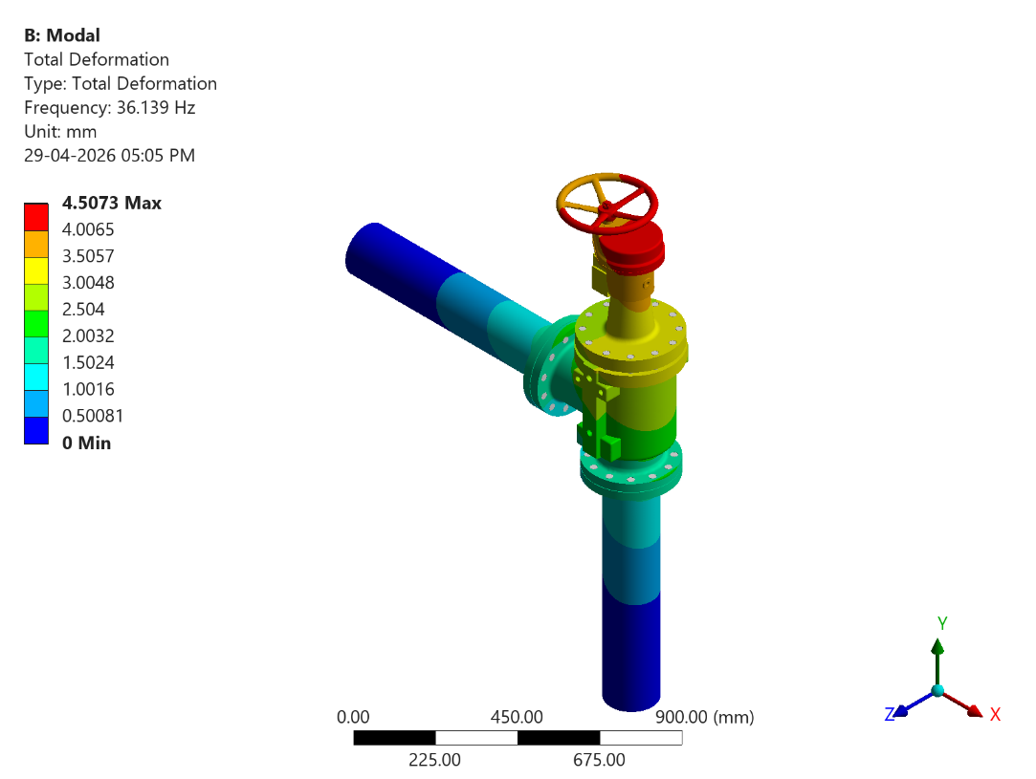
Figure 29 - Modal Analysis: Mode 1 at Frequency 36.139 Hz
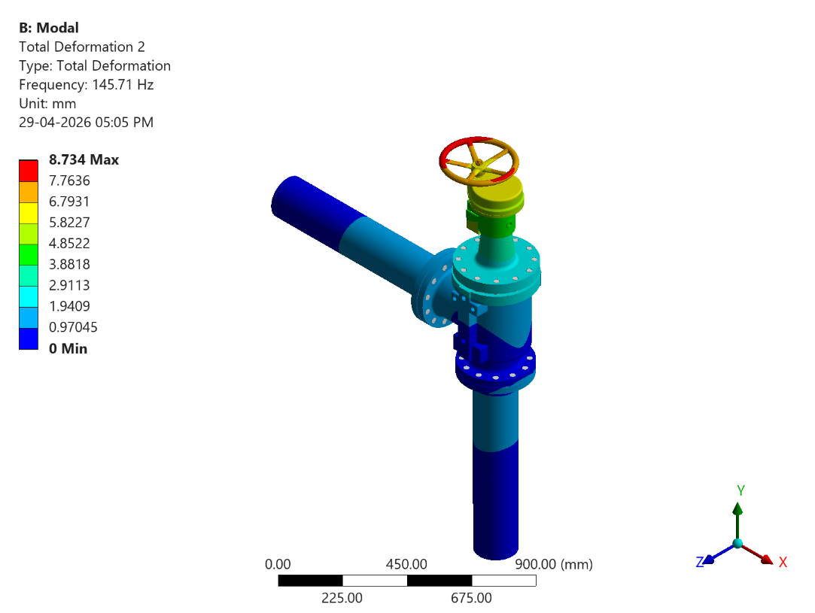
Figure 30 - Modal Analysis: Mode 2 at Frequency 145.71 Hz
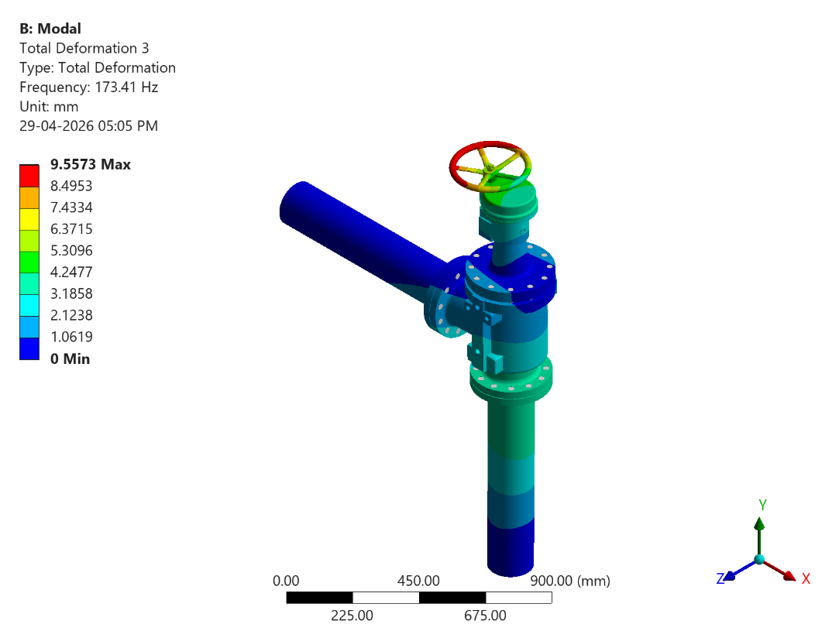
Figure 31 - Modal Analysis: Mode 3 at Frequency 173.41 Hz
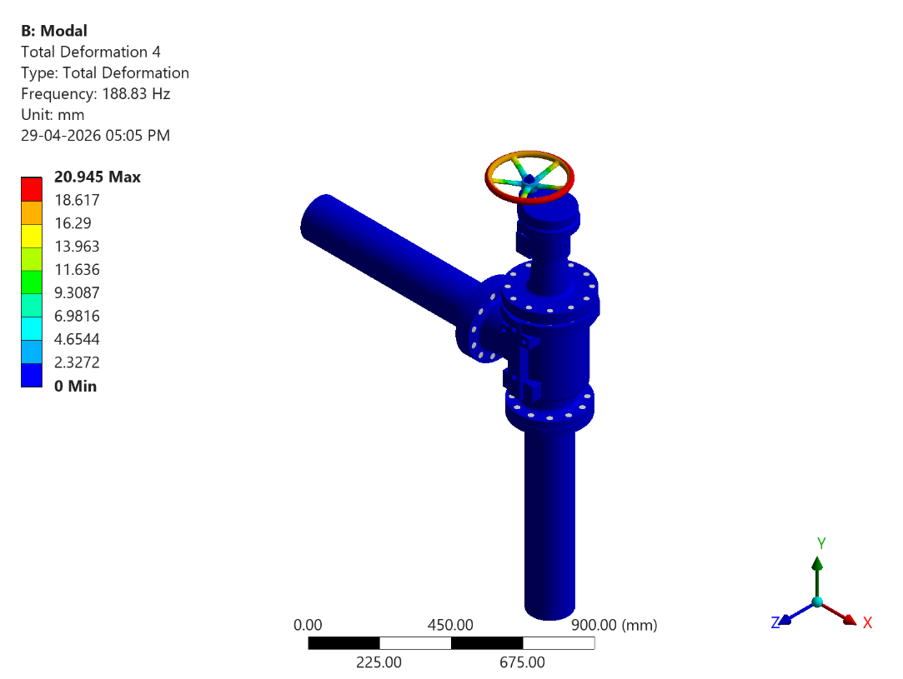
Figure 32 - Modal Analysis: Mode 4 at Frequency 188.83 Hz
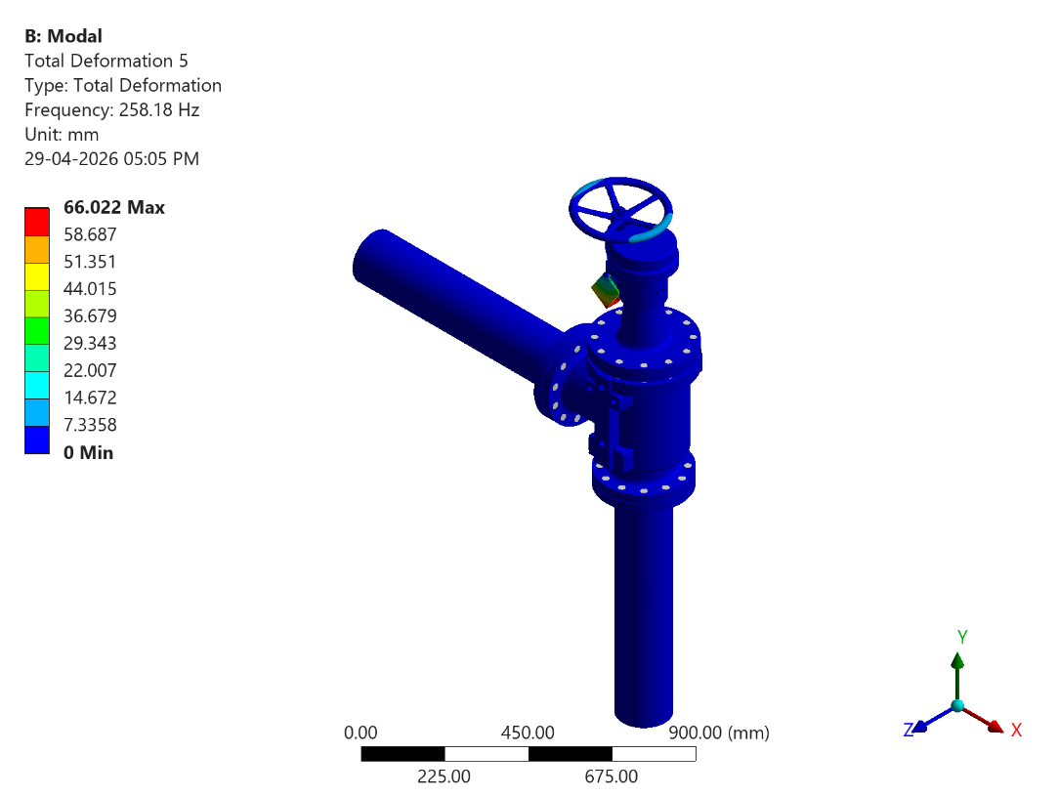
Figure 33 - Modal Analysis: Mode 5 at Frequency 258.18 Hz
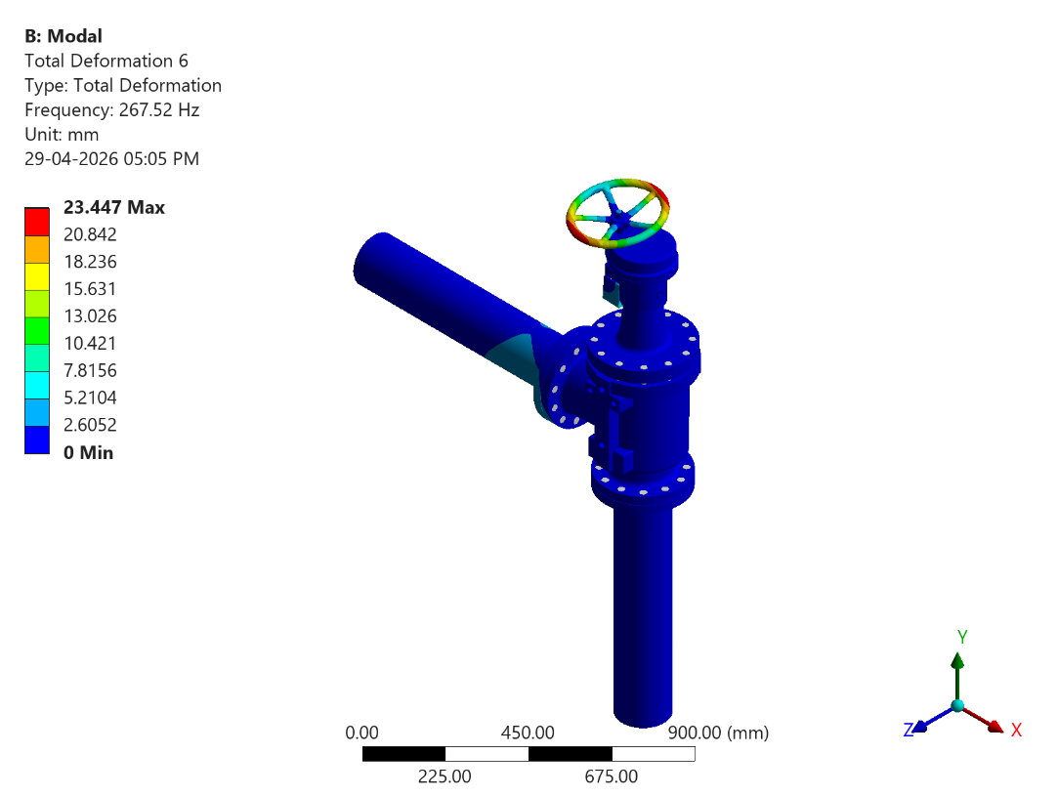
Figure 34 - Modal Analysis: Mode 6 at Frequency 267.52 Hz

Modal Analysis Conclusions
The Modal Analysis is performed to extract the modes of vibration of the structure. The Fundamental frequency of vibration was found to be 36.139Hz. As this is less than 160 Hz therefore the Transient Shock approach will be used to perform the Shock Analysis.
Table 14 - Modal Analysis Summary
Sl. No | Frequency (Hz) | Operating Frequency | Dominant in Direction | Remark
1. | 36.14 | 3 to 33 Hz | Rotation about X & Rotation about Y Direction & Z Direction | Not in or near operating Frequency
2. | 145.71 | 3 to 33 Hz | Rotation about Y Direction & X Direction & Rotation about Z Direction | Not in or near operating Frequency
3. | 173.41 | 3 to 33 Hz | Rotation about X | Not in or near operating Frequency
4. | 188.83 | 3 to 33 Hz | Z Direction | Not in or near operating Frequency
5. | 258.18 | 3 to 33 Hz | Y Direction | Not in or near operating Frequency
6. | 267.52 | 3 to 33 Hz | Rotation about Y | Not in or near operating Frequency

Load Case - 3 Static Structural Analysis
The Finite Element (FE) Static Structural analysis is conducted with the primary objective of assessing the structural integrity and strength of the valve under actual operating loads while the valve is in closed condition. This comprehensive analysis accounts for several critical loads that act upon the various components of the valve during its operational phases. The analysis aims to precisely evaluate the stresses experienced by these valve components, and subsequently, these results will be compared against the allowable limits stipulated for the materials used in the valve's construction.

Static Structural Analysis Boundary Conditions
The boundary conditions for the finite element structural analysis have been established such that all degrees of freedom are rigidly constrained at both the Inlet and Outlet faces of the Valve, as illustrated in the Figure below.
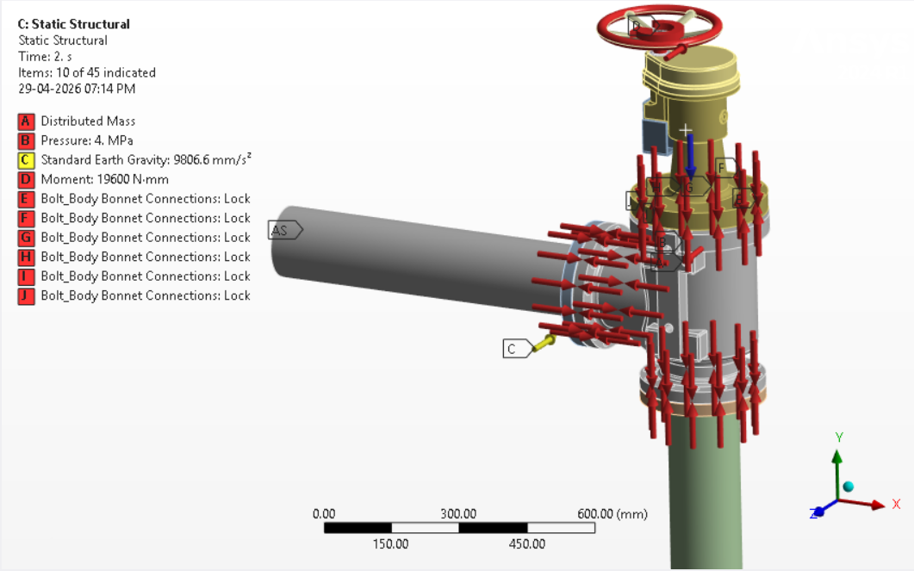
Figure 35 - Static Structural Analysis: Boundary Conditions Static Structural Analysis
Table 15 - Static Structural Boundary Conditions
Sl. No. | Loading or BC | Location | Value
1 | Remote Displacement (Rotation of the Spindle is Arrested) | Disc | Ux=Uy=Uz=Rx =Rz=Free Ry=0
2 | Fixed | Pipe End | Ux=Uy=Uz=Rx=Ry=Rz=0

Table 16 - Boundary Conditions Summary - Static Structural
Sr. No | Name of BC | Location of BC | Value of BC
1 | Fixed Support | Outlet Pipe | --
2 | Standard Earth Gravity | Negative Z Axis | --
3 | Pressure | Wet Surface | 4 [MPa]
4 | Moment | 28 Hand Wheel | 19600 [N mm]
5 | Force (From MBD) | 20 Pinion Shaft | 323.37 [N]
6 | Joint – Force (from MBD) | Joint Load | -25.211 [N]
7 | Bolt_Body Bonnet Connections | -- | 13849.18 [N]
8 | Bolt_Body Bonnet Connections | -- | 13849.18 [N]
9 | Bolt_Body Bonnet Connections | -- | 13849.18 [N]
10 | Bolt_Body Bonnet Connections | -- | 13849.18 [N]
11 | Bolt_Body Bonnet Connections | -- | 13849.18 [N]
12 | Bolt_Body Bonnet Connections | -- | 13849.18 [N]
13 | Bolt_Body Bonnet Connections | -- | 13849.18 [N]
14 | Bolt_Body Bonnet Connections | -- | 13849.18 [N]
15 | Bolt_Body Bonnet Connections | -- | 13849.18 [N]
16 | Bolt_Body Bonnet Connections | -- | 13849.18 [N]
17 | Bolt_Body Bonnet Connections | -- | 13849.18 [N]
18 | Bolt_Body Bonnet Connections | -- | 13849.18 [N]
19 | Bolt_Outlet Flange Connections | -- | 9774.8 [N]
20 | Bolt_Outlet Flange Connections | -- | 9774.8 [N]
21 | Bolt_Outlet Flange Connections | -- | 9774.8 [N]
22 | Bolt_Outlet Flange Connections | -- | 9774.8 [N]
23 | Bolt_Outlet Flange Connections | -- | 9774.8 [N]
24 | Bolt_Outlet Flange Connections | -- | 9774.8 [N]
25 | Bolt_Outlet Flange Connections | -- | 9774.8 [N]
26 | Bolt_Outlet Flange Connections | -- | 9774.8 [N]
27 | Bolt_Outlet Flange Connections | -- | 9774.8 [N]
28 | Bolt_Outlet Flange Connections | -- | 9774.8 [N]
29 | Bolt_Outlet Flange Connections | -- | 9774.8 [N]
30 | Bolt_Outlet Flange Connections | -- | 9774.8 [N]
31 | Bolt_Inlet Flange Connections | -- | 9774.8 [N]
32 | Bolt_Inlet Flange Connections | -- | 9774.8 [N]
33 | Bolt_Inlet Flange Connections | -- | 9774.8 [N]
34 | Bolt_Inlet Flange Connections | -- | 9774.8 [N]
35 | Bolt_Inlet Flange Connections | -- | 9774.8 [N]
36 | Bolt_Inlet Flange Connections | -- | 9774.8 [N]
37 | Bolt_Inlet Flange Connections | -- | 9774.8 [N]
38 | Bolt_Inlet Flange Connections | -- | 9774.8 [N]
39 | Bolt_Inlet Flange Connections | -- | 9774.8 [N]
40 | Bolt_Inlet Flange Connections | -- | 9774.8 [N]
41 | Bolt_Inlet Flange Connections | -- | 9774.8 [N]
42 | Bolt_Inlet Flange Connections | -- | 9774.8 [N]

Static Structural Analysis Loading Conditions

Static Structural Analysis Results
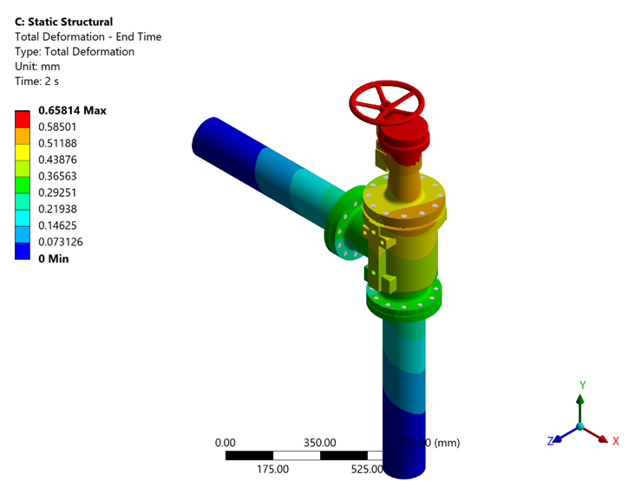
Figure 36 - Static Structural: Total Deformation - End Time
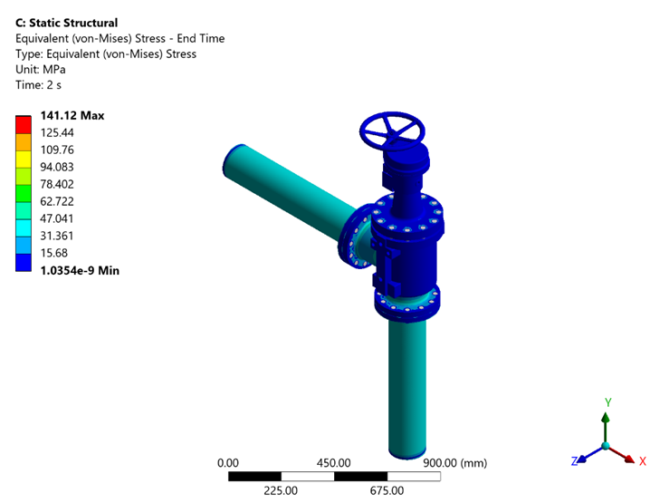
Figure 37 - Static Structural: Equivalent (von-Mises) Stress - End Time
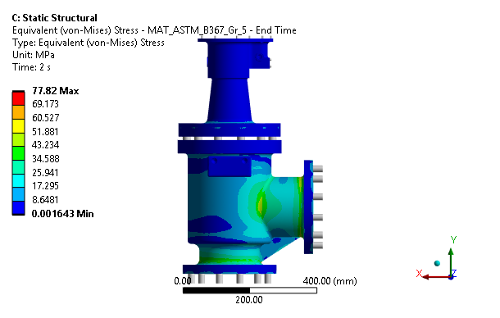
Figure 5 - Static Structural: Equivalent (von-Mises) Stress - MAT_ASTM_B367_Gr_5 - End Time
The computed maximum stress of 77.82 MPa is found to be below the permissible stress of 255.71 MPa, confirming that the component will perform reliably under the given loading.

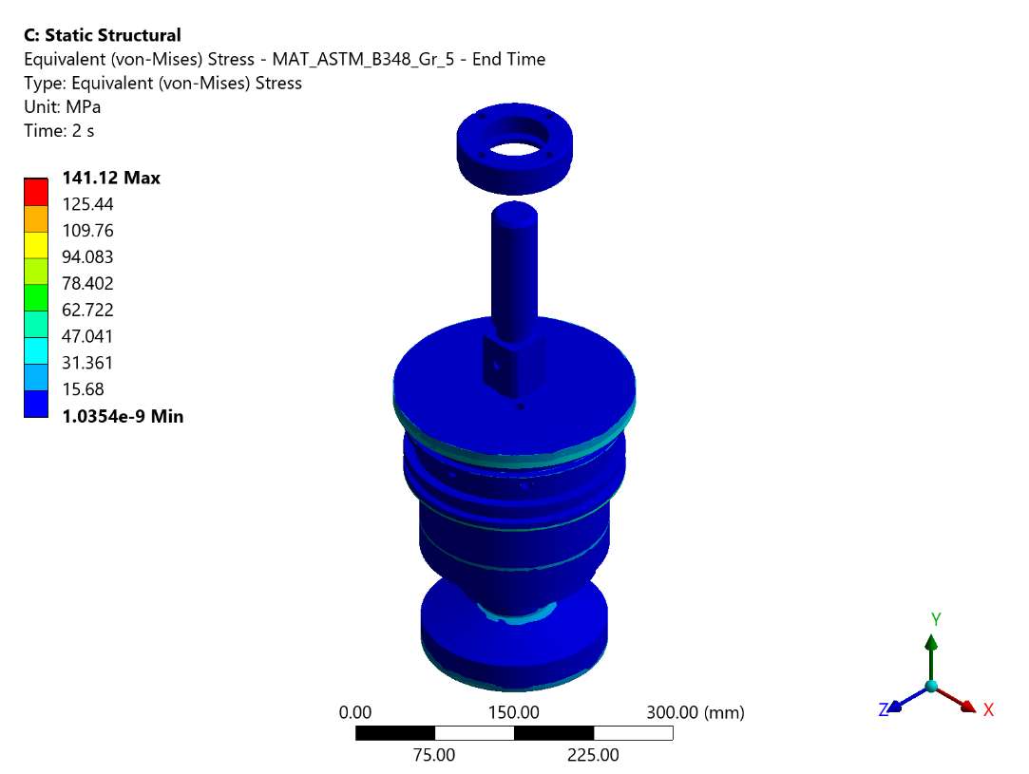
Figure 6 - Static Structural: Equivalent (von-Mises) Stress - MAT_ASTM_B348_Gr_5 - End Time
The stress distribution shows a peak value of 141.124 MPa at the most critically loaded region, which is within the acceptable limit of 255.71 MPa. The design is deemed satisfactory.
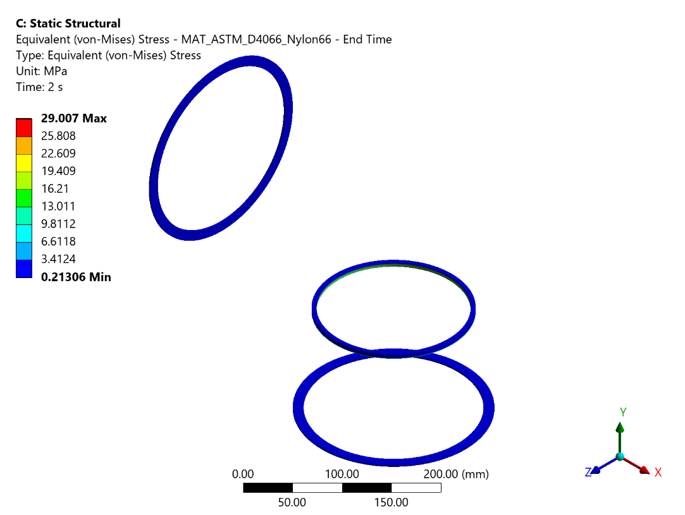
Figure 7 - Static Structural: Equivalent (von-Mises) Stress - MAT_ASTM_D4066_Nylon66 - End Time
From the FEA results, the maximum stress developed is 29.007 MPa against an allowable Yield of 84 MPa. Hence the component is safe.
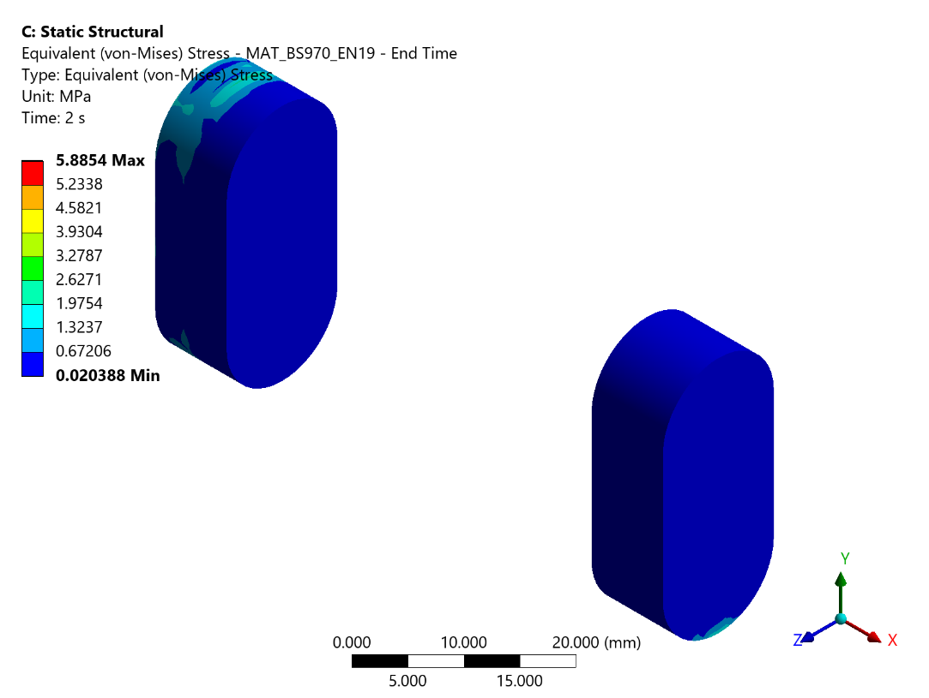
Figure 8 - Static Structural: Equivalent (von-Mises) Stress - MAT_BS970_EN19 - End Time
The computed maximum stress of 5.885 MPa is found to be below the permissible stress of 199 MPa, confirming that the component will perform reliably under the given loading.
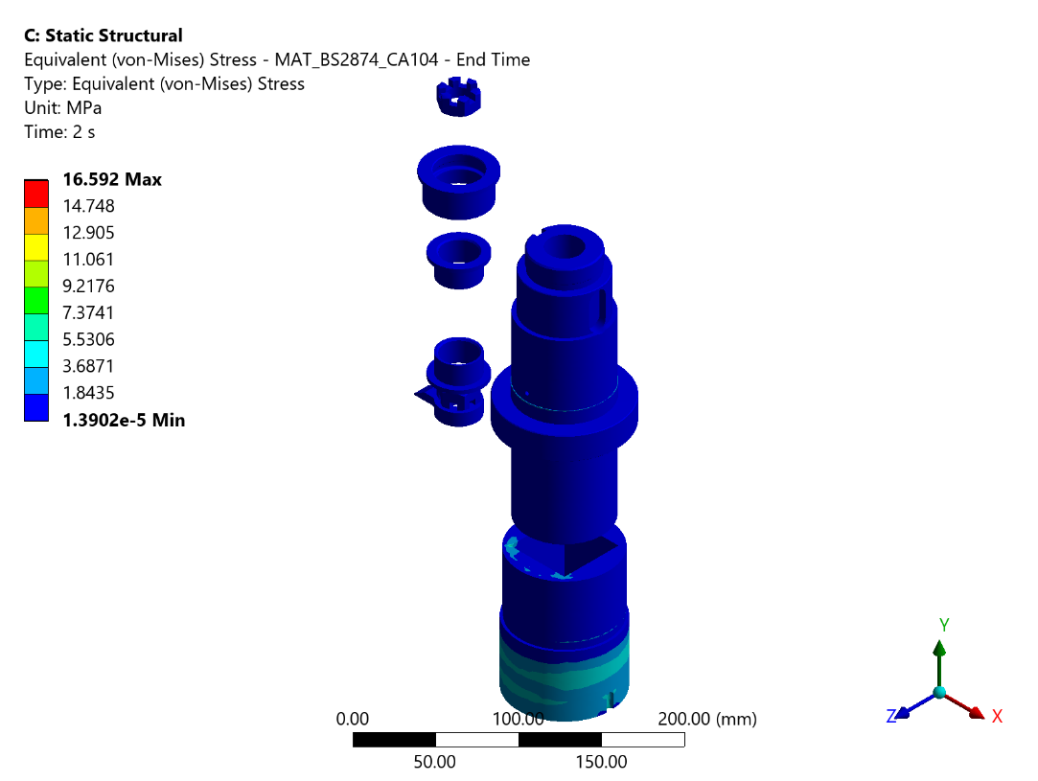
Figure 9 - Static Structural: Equivalent (von-Mises) Stress - MAT_BS2874_CA104 - End Time
Analysis results confirm that the highest stress value of 16.592 MPa does not breach the allowable threshold of 185.71 MPa. The component meets the design safety criteria.
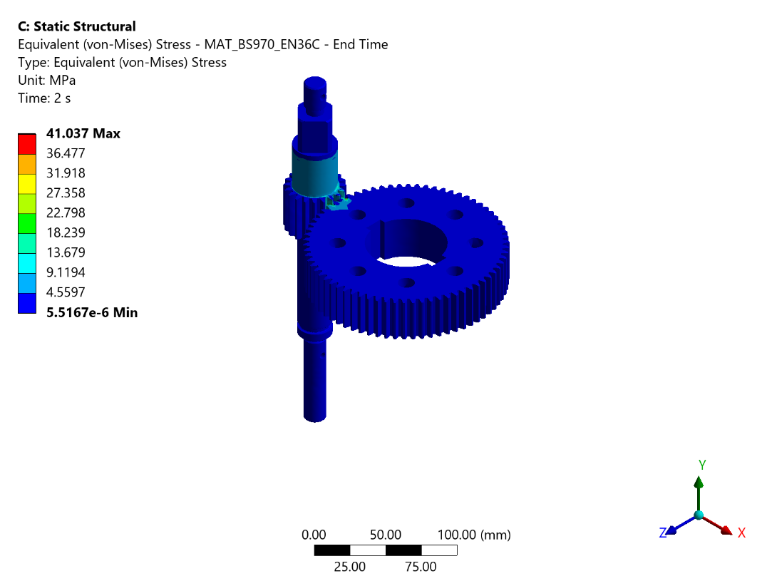
Figure 10 - Static Structural: Equivalent (von-Mises) Stress - MAT_BS970_EN36C - End Time
The maximum equivalent stress observed is 41.037 MPa, which is within the allowable limit of 286 MPa. The design is therefore considered safe under the applied loading conditions.
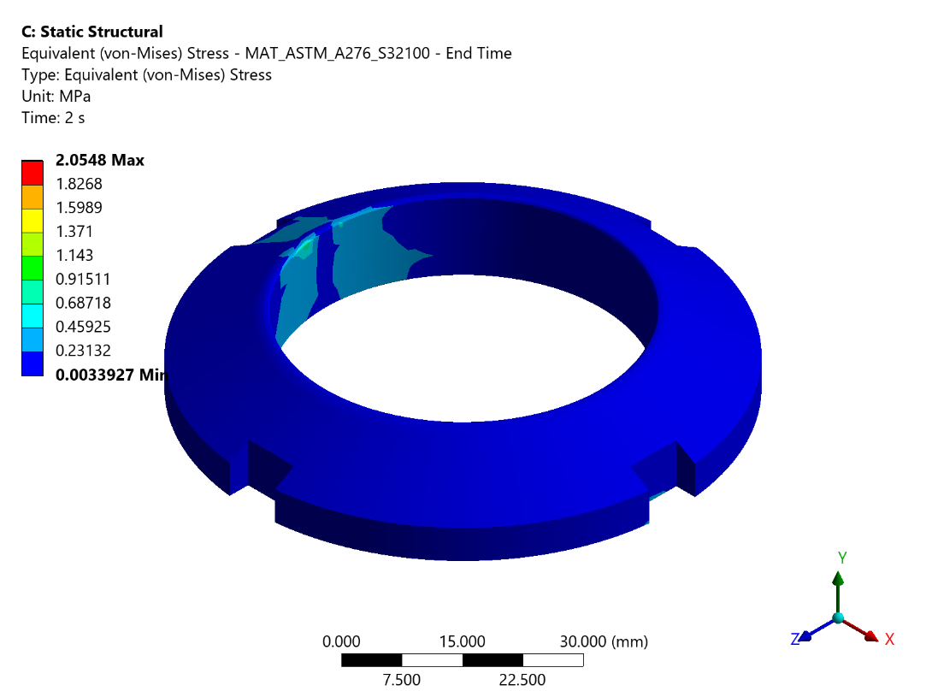
Figure 11 - Static Structural: Equivalent (von-Mises) Stress - MAT_ASTM_A276_S32100 - End Time
The equivalent stress contour reveals a maximum value of 2.055 MPa, which is less than the allowable limit of 136.67 MPa. Hence the component is structurally adequate.
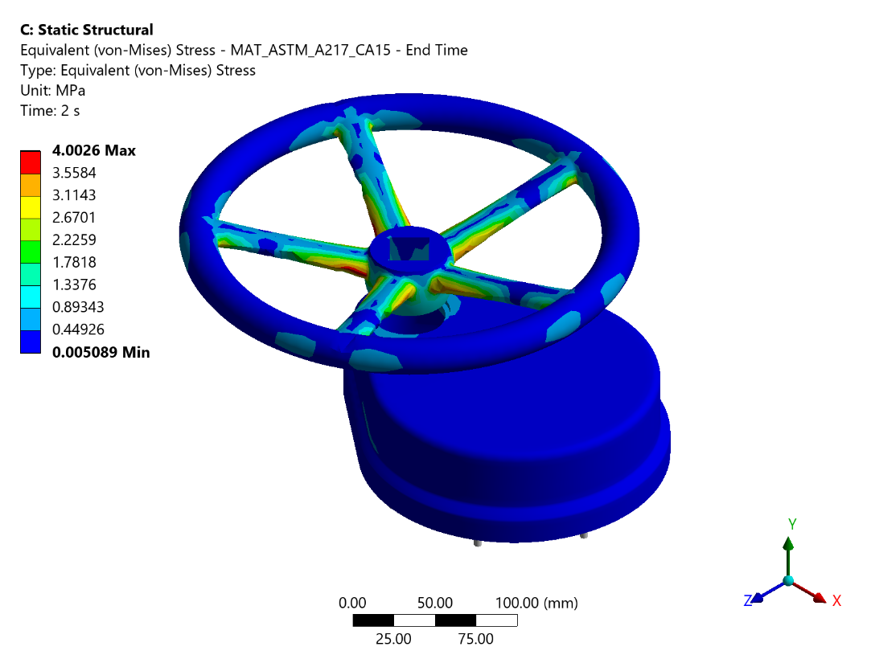
Figure 12 - Static Structural: Equivalent (von-Mises) Stress - MAT_ASTM_A217_CA15 - End Time
The stress distribution shows a peak value of 4.003 MPa at the most critically loaded region, which is within the acceptable limit of 177.14 MPa. The design is deemed satisfactory.
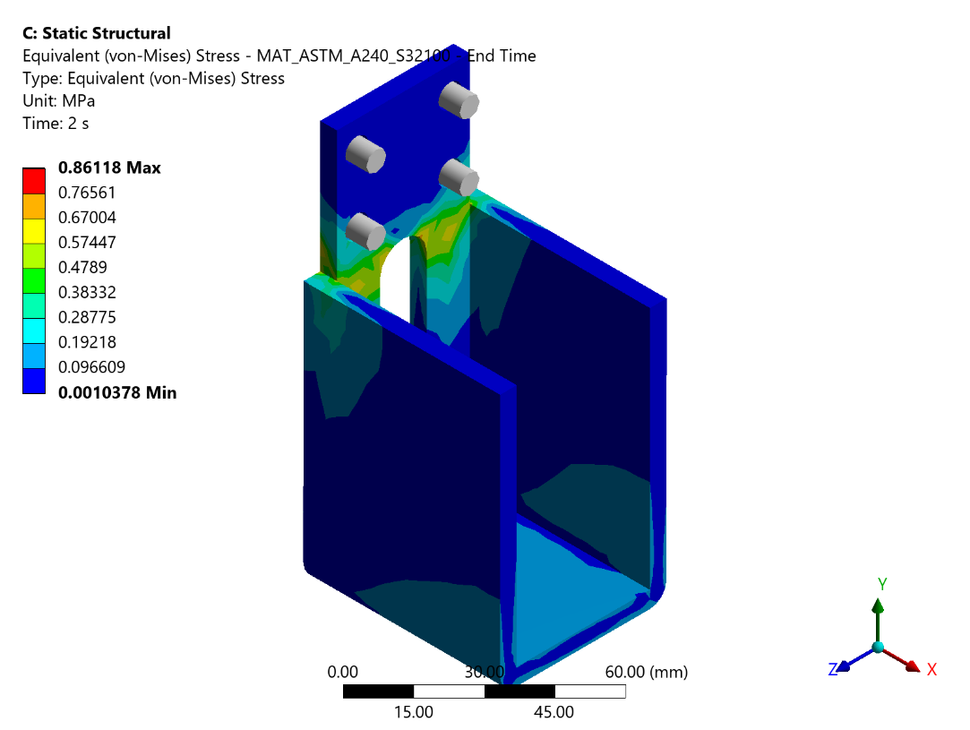
Figure 13 - Static Structural: Equivalent (von-Mises) Stress - MAT_ASTM_A240_S32100 - End Time
The equivalent stress contour reveals a maximum value of 0.861 MPa, which is less than the allowable limit of 136.67 MPa. Hence the component is structurally adequate.
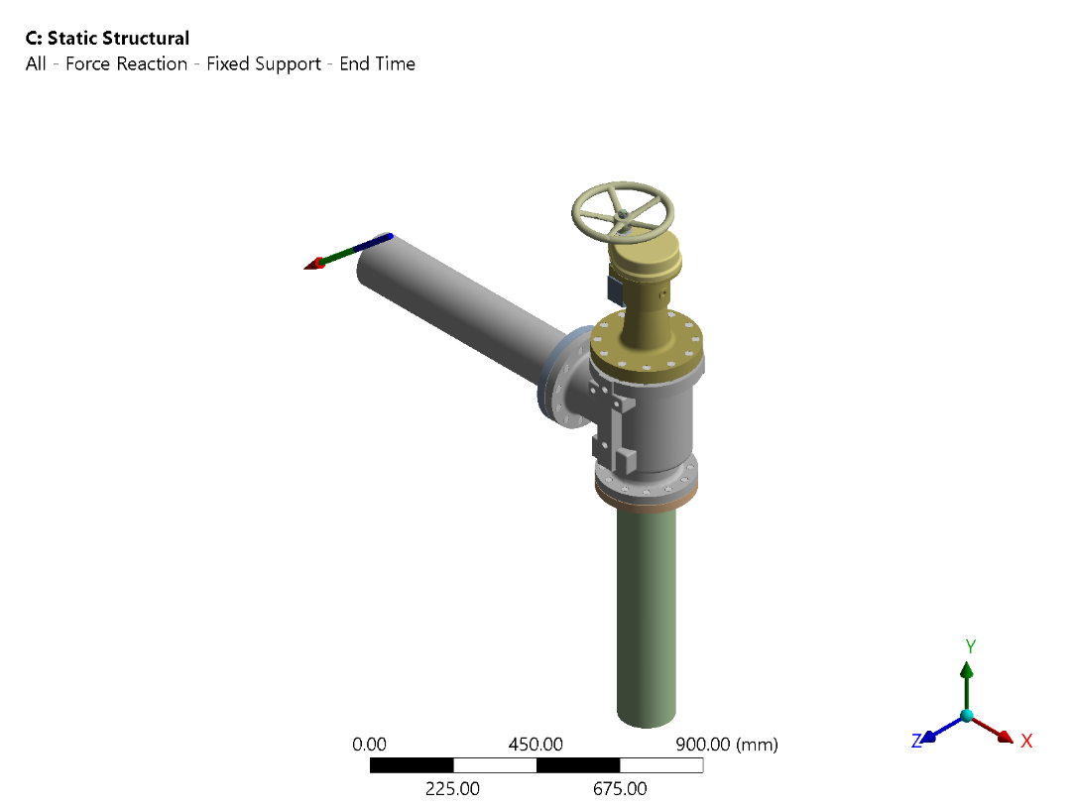
Figure 14 - Static Structural: All - Force Reaction - Fixed Support - End Time
Table 1 - All - Force Reaction - Fixed Support - End Time - Tabular Data
Time (S) | Reaction In X Direction (N) | Reaction In Y Direction (N) | Reaction In Z Direction (N) | Total Reaction (N)
0.2 | 1.1119e-006 | -3.0263e-006 | 346.85 | 346.85
0.4 | 2.2158e-006 | -6.0523e-006 | 693.69 | 693.69
0.7 | 3.8776e-006 | -1.0592e-005 | 1214. | 1214.
1. | 5.5394e-006 | -1.5131e-005 | 1734.2 | 1734.2
1.2 | -13210 | -10843 | 2049.9 | 17213
1.4 | -26421 | -21687 | 2365.6 | 34263
1.7 | -46236 | -37952 | 2839. | 59885
2. | -66052 | -54217 | 3312.5 | 85518
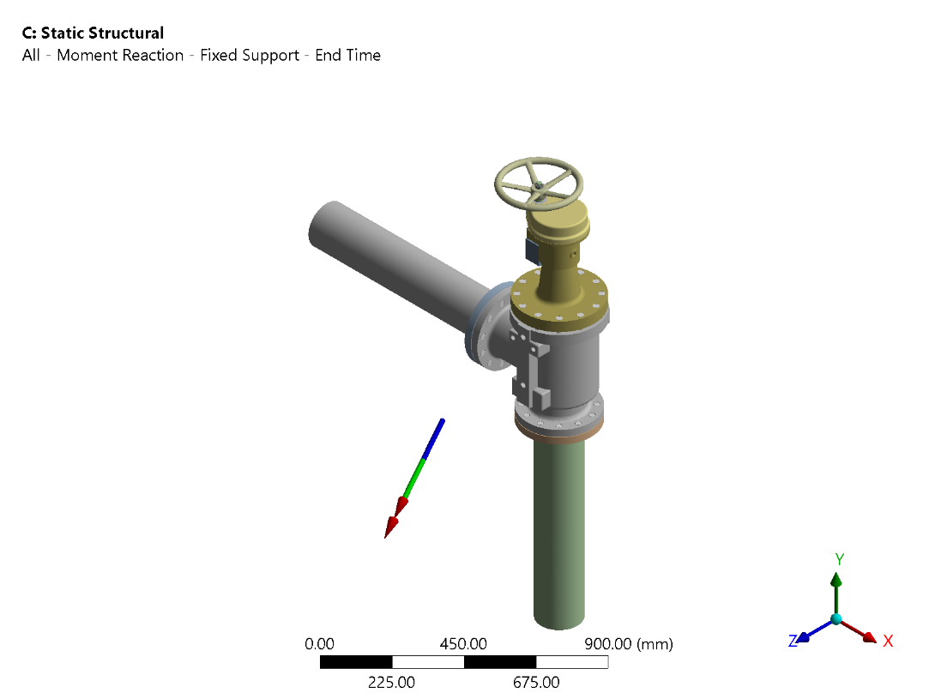
Figure 15 - Static Structural: All - Moment Reaction - Fixed Support - End Time
Table 2 - All - Moment Reaction - Fixed Support - End Time - Tabular Data
Time (S) | Reaction In X Direction (N) | Reaction In Y Direction (N) | Reaction In Z Direction (N) | Total Reaction (N)
0.2 | 1.774e+005 | -1.4315e+005 | -1.9917e-004 | 2.2795e+005
0.4 | 3.5479e+005 | -2.863e+005 | -4.0247e-004 | 4.559e+005
0.7 | 6.2088e+005 | -5.0103e+005 | -6.5965e-004 | 7.9783e+005
1. | 8.8698e+005 | -7.1575e+005 | -1.0574e-003 | 1.1398e+006
1.2 | 1.0725e+006 | -8.6826e+005 | 8.8638e+005 | 1.6401e+006
1.4 | 1.2581e+006 | -1.0208e+006 | 1.7728e+006 | 2.4015e+006
1.7 | 1.5364e+006 | -1.2495e+006 | 3.1023e+006 | 3.6805e+006
2. | 1.8147e+006 | -1.4783e+006 | 4.4319e+006 | 5.012e+006

Table 19 - Bolt Force Summary Table
Bolt No | Bolt Connection Group | Max Axial Force (N) | Max Shear Force (N) | Bolt Area (mm2) | Normal Stress (MPa) | Shear Stress (MPa) | Yield Stress MPa
1 | 1 Body To 14 Bonnet | 13966 | 115.61 | 368.3 | 37.9202 | 0.3139 | 825
2 | 1 Body To 14 Bonnet | 13849 | 116.7 | 368.3 | 37.6025 | 0.3169 | 825
3 | 1 Body To 14 Bonnet | 13849 | 115.07 | 368.3 | 37.6025 | 0.3124 | 825
4 | 1 Body To 14 Bonnet | 13849 | 144.54 | 368.3 | 37.6025 | 0.3925 | 825
5 | 1 Body To 14 Bonnet | 14067 | 133.13 | 368.3 | 38.1944 | 0.3615 | 825
6 | 1 Body To 14 Bonnet | 14020 | 134.7 | 368.3 | 38.0668 | 0.3657 | 825
7 | 1 Body To 14 Bonnet | 13849 | 117.76 | 368.3 | 37.6025 | 0.3197 | 825
8 | 1 Body To 14 Bonnet | 13849 | 59.211 | 368.3 | 37.6025 | 0.1608 | 825
9 | 1 Body To 14 Bonnet | 13849 | 47.784 | 368.3 | 37.6025 | 0.1297 | 825
10 | 1 Body To 14 Bonnet | 13887 | 98.114 | 368.3 | 37.7057 | 0.2664 | 825
11 | 1 Body To 14 Bonnet | 13956 | 109.2 | 368.3 | 37.893 | 0.2965 | 825
12 | 1 Body To 14 Bonnet | 13996 | 114.79 | 368.3 | 38.0016 | 0.3117 | 825
13 | Outlet Flange To 1 Body | 9774.8 | 105.04 | 303.4 | 32.2175 | 0.3462 | 825
14 | Outlet Flange To 1 Body | 9774.8 | 64.796 | 303.4 | 32.2175 | 0.2136 | 825
15 | Outlet Flange To 1 Body | 9774.8 | 146.35 | 303.4 | 32.2175 | 0.4824 | 825
16 | Outlet Flange To 1 Body | 9774.8 | 280.29 | 303.4 | 32.2175 | 0.9238 | 825
17 | Outlet Flange To 1 Body | 9774.8 | 339.27 | 303.4 | 32.2175 | 1.1182 | 825
18 | Outlet Flange To 1 Body | 9774.8 | 261.76 | 303.4 | 32.2175 | 0.8628 | 825
19 | Outlet Flange To 1 Body | 9774.8 | 108.06 | 303.4 | 32.2175 | 0.3562 | 825
20 | Outlet Flange To 1 Body | 9774.8 | 43.161 | 303.4 | 32.2175 | 0.1423 | 825
21 | Outlet Flange To 1 Body | 9774.8 | 60.867 | 303.4 | 32.2175 | 0.2006 | 825
22 | Outlet Flange To 1 Body | 9774.8 | 269.72 | 303.4 | 32.2175 | 0.889 | 825
23 | Outlet Flange To 1 Body | 9774.8 | 217.06 | 303.4 | 32.2175 | 0.7154 | 825
24 | Outlet Flange To 1 Body | 9774.8 | 196.55 | 303.4 | 32.2175 | 0.6478 | 825
25 | Inlet Flange To 1 Body | 9774.8 | 123.2 | 303.4 | 32.2175 | 0.4061 | 825
26 | Inlet Flange To 1 Body | 9774.8 | 122.02 | 303.4 | 32.2175 | 0.4022 | 825
27 | Inlet Flange To 1 Body | 9774.8 | 71.197 | 303.4 | 32.2175 | 0.2347 | 825
28 | Inlet Flange To 1 Body | 9774.8 | 95.355 | 303.4 | 32.2175 | 0.3143 | 825
29 | Inlet Flange To 1 Body | 9774.8 | 147.76 | 303.4 | 32.2175 | 0.487 | 825
30 | Inlet Flange To 1 Body | 9774.8 | 191.8 | 303.4 | 32.2175 | 0.6322 | 825
31 | Inlet Flange To 1 Body | 9774.8 | 210.05 | 303.4 | 32.2175 | 0.6923 | 825
32 | Inlet Flange To 1 Body | 9774.8 | 200.1 | 303.4 | 32.2175 | 0.6595 | 825
33 | Inlet Flange To 1 Body | 9774.8 | 171.59 | 303.4 | 32.2175 | 0.5656 | 825
34 | Inlet Flange To 1 Body | 9774.8 | 118.01 | 303.4 | 32.2175 | 0.389 | 825
35 | Inlet Flange To 1 Body | 9774.8 | 108.18 | 303.4 | 32.2175 | 0.3566 | 825
36 | Inlet Flange To 1 Body | 9774.8 | 142.5 | 303.4 | 32.2175 | 0.4697 | 825
37 | 14 Bonnet To 25 Top Cover | -0.0017 | 0.063 | 20.1 | -8.70E-05 | 0.0031 | 320
38 | 14 Bonnet To 25 Top Cover | 0.0034 | 0.024 | 20.1 | 0.0002 | 0.0012 | 320
39 | 14 Bonnet To 25 Top Cover | 0.1769 | 0.0744 | 20.1 | 0.0088 | 0.0037 | 320
40 | 14 Bonnet To 25 Top Cover | 0.0232 | 0.0523 | 20.1 | 0.0012 | 0.0026 | 320
41 | 14 Bonnet To 25 Top Cover | 0.0598 | 0.0597 | 20.1 | 0.003 | 0.003 | 320
42 | 14 Bonnet To 25 Top Cover | -0.0118 | 0.0855 | 20.1 | -0.0006 | 0.0043 | 320
43 | 14 Bonnet To 25 Top Cover | -0.0292 | 0.114 | 20.1 | -0.0015 | 0.0057 | 320
44 | 14 Bonnet To 25 Top Cover | 0.3708 | 0.1675 | 20.1 | 0.0184 | 0.0083 | 320
45 | 14 Bonnet To 25 Top Cover | 0.1327 | 0.113 | 20.1 | 0.0066 | 0.0056 | 320
46 | 14 Bonnet To 25 Top Cover | 0.1488 | 0.0669 | 20.1 | 0.0074 | 0.0033 | 320
47 | 14 Bonnet To 25 Top Cover | -0.0086 | 0.0596 | 20.1 | -0.0004 | 0.003 | 320
48 | 14 Bonnet To 32 Side Cover | 0.0411 | 0.0392 | 20.1 | 0.002 | 0.0019 | 320
49 | 14 Bonnet To 32 Side Cover | -0.1386 | 0.1265 | 20.1 | -0.0069 | 0.0063 | 320
50 | 14 Bonnet To 32 Side Cover | -0.0082 | 0.0401 | 20.1 | -0.0004 | 0.002 | 320
51 | 14 Bonnet To 32 Side Cover | 0.6798 | 0.1238 | 20.1 | 0.0338 | 0.0062 | 320

Static Structural Analysis Conclusions
Table 20 - Static Structural Results Summary
Sr. No | Material | Maximum Occurs On | Stresses Observed(MPa) | Allowable Stress(MPa) | Remarks
1 | ASTM B 367 Gr.5 | 1 Body | 77.82 | 255.71 | Stresses less than allowable
2 | ASTM B 348 Gr.5 | 2 Disc | 141.124 | 255.71 | Stresses less than allowable
3 | ASTM D4066- Nylon 66 | 3 Disc Seal | 29.007 | 84 | Stresses less than allowable
4 | BS 970 EN19 | 5 Key | 5.885 | 199 | Stresses less than allowable
5 | BS 2874 CA 104 | 12 Bush-1 | 16.592 | 185.71 | Stresses less than allowable
6 | BS 970 EN36C | 19 Gear | 41.037 | 256.0 | Stresses less than allowable
7 | ASTM A 240 S32100 | 22 Ring Nut | 2.055 | 136.67 | Stresses less than allowable
8 | ASTM A 217 CA15 | 28 Hand Wheel | 4.003 | 177.14 | Stresses less than allowable
9 | ASTM A 240 S32100 | 32 Side Cover | 0.861 | 136.67 | Stresses less than allowable

Load case - 4 Vibration resistance analysis
FE Vibration Resistance analysis is a dynamic response analysis of structure. It aims to simulate the response of a structure under propeller induced vibrations. The vibration Resistance tests consist of following four types of tests.
a) Test for Detection of Resonance Frequencies:
The test is carried out at frequencies ranging from 3-33 Hz with amplitude of oscillations of platform 1.75-0.16 mm. Test frequencies of sinusoidal vibrations are varied gradually upwards or downwards in the entire frequency range (rate of variation of frequency is not more than 5 Hz/min) and at resonant frequency of equipment the response vibration amplitude of the equipment would be maximum and corresponding frequency will be the first Resonance frequency. There could be multiple resonance frequencies in the frequency range of 3-33 Hz. However, the frequency with highest amplitude would be considered for Test.
b) Vibration Proof Characteristics Test:
This test shall be carried out by gradually increasing the frequency of oscillations in each sub range (refer Table below) from lower to higher frequency and vice versa.
Table 21 - Vibration Proof Characteristics
Frequency Range | Vibration Amplitude |  | Duration for Vibration Resistance in min | Duration for Vibration Proof Characteristic Test in min
 | Amplitude Test Platform / Table in (mm) | Acceleration of Test Platform / Table in (g)
Upto 10 Hz Incl. | 1.75 | 0.7 | 24 | >2
Above 10 - Upto 20 Hz Incl. | 0.44 | 0.7 | 24 | >2
Above 20 - Upto 25 Hz Incl. | 0.28 | 0.7 | 24 | >2
Above 25 - Upto 30 Hz Incl. | 0.2 | 0.7 | 24 | >2
Above 30 -Upto 33 Hz Incl. | 0.16 | 0.7 | 24 | >2

Here, the given amplitude of oscillations or vibro-acceleration is maintained. The duration of the effect of vibration in each sub-range of frequencies should be adequate for checking parameters, characteristics of the equipment, but not less than 2 minutes. While testing for vibration proof characteristics equipment should be made to perform its functions. For the propulsion motors and rotating machinery, they may be operated on idle run and for Heat Exchangers and fittings the flow of working liquid through the equipment may be stopped, but the pressure of the liquid in the cavities of the equipment should correspond to its working state.
With the equipment performing its functions, test is carried out only when the equipment is in the normal installed position in directions technically feasible on a vibration shaker test stand. In the remaining directions the test is carried out without the equipment performing its functions.

Vibration Resistance Analysis Methodology
FE Vibration Resistance analysis is to study how a structure or system responds to harmonic (periodic) excitations or loads. It is commonly employed in engineering and physics to understand how structures and components behave under cyclic loads, such as vibrations or oscillations. Analysis has been carried out by mode superposition method.

Vibration Resistance Analysis Boundary Conditions
As we the Mode Superposition methodology is used the boundary conditions of modal analysis remains same in the Vibration Resistance analysis.

Vibration Resistance Analysis Loading Conditions

Load Case - 3.1 Vibration Resistance Analysis in X- Direction
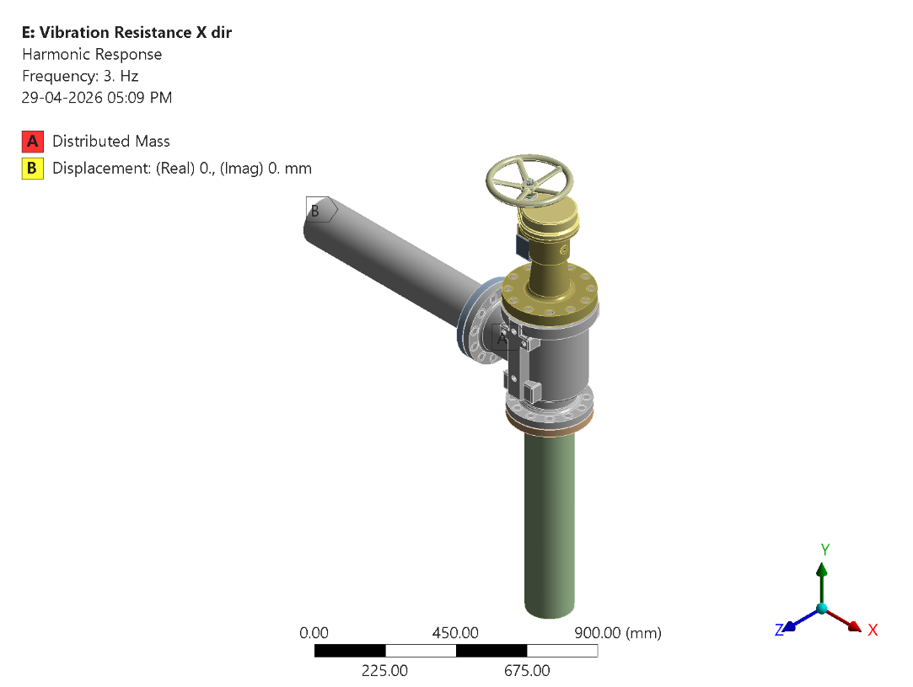
Figure 49 - Harmonic Response X: Boundary Conditions
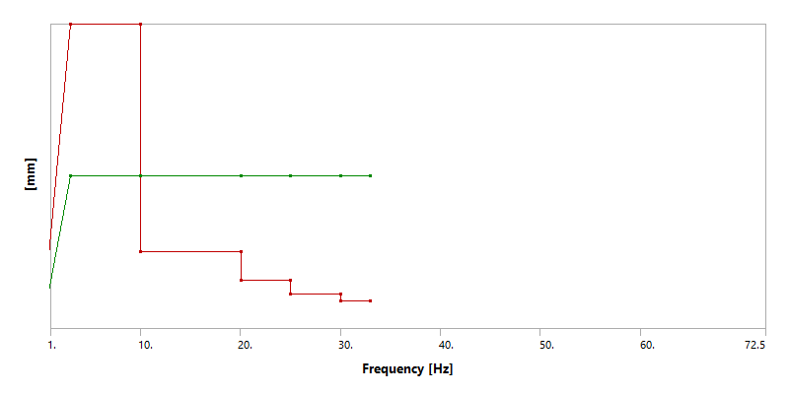
Figure 50 - Harmonic Response X: Displacement Amplitude (X)
Table 22 - Displacement Amplitude (X)
Frequency [Hz] | Magnitude [mm] | Phase Angle [deg]
0. | 0. | 0.
3. | 1.75 | 0.
10. | 1.75 | 0.
10.01 | 0.44 | 0.
20. | 0.44 | 0.
20.01 | 0.28 | 0.
25. | 0.28 | 0.
25.01 | 0.2 | 0.
30. | 0.2 | 0.
30.01 | 0.16 | 0.
33. | 0.16 | 0.
Table 23 - Vibration Resistance Analysis Settings (X)
Property | Value
Boundary Condition | Fixed Support
Type | Displacement
Base Excitation | Yes
Absolute Result | Yes
Define By | Magnitude - Phase
Magnitude | Tabular Data
Phase Angle | Tabular Data
Direction | X Axis
Suppressed | No

Load Case - 3.2 Vibration Resistance Analysis in Y- Direction
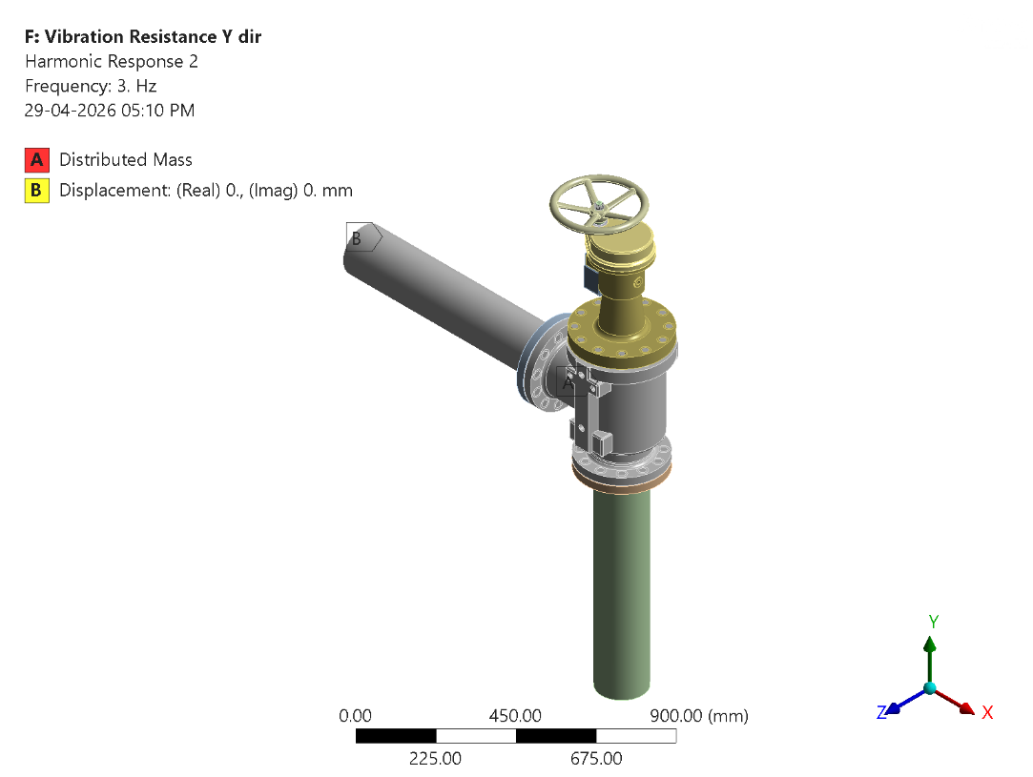
Figure 51 - Harmonic Response Y: Boundary Conditions

Figure 52 - Harmonic Response Y: Displacement Amplitude (Y)
Table 24 - Displacement Amplitude (Y)
Frequency [Hz] | Magnitude [mm] | Phase Angle [deg]
0. | 0. | 0.
3. | 1.75 | 0.
10. | 1.75 | 0.
10.01 | 0.44 | 0.
20. | 0.44 | 0.
20.01 | 0.28 | 0.
25. | 0.28 | 0.
25.01 | 0.2 | 0.
30. | 0.2 | 0.
30.01 | 0.16 | 0.
33. | 0.16 | 0.
Table 25 - Vibration Resistance Analysis Settings (Y)
Property | Value
Boundary Condition | Fixed Support
Type | Displacement
Base Excitation | Yes
Absolute Result | Yes
Define By | Magnitude - Phase
Magnitude | Tabular Data
Phase Angle | Tabular Data
Direction | Y Axis
Suppressed | No

Load Case - 3.3 Vibration Resistance Analysis in Z- Direction
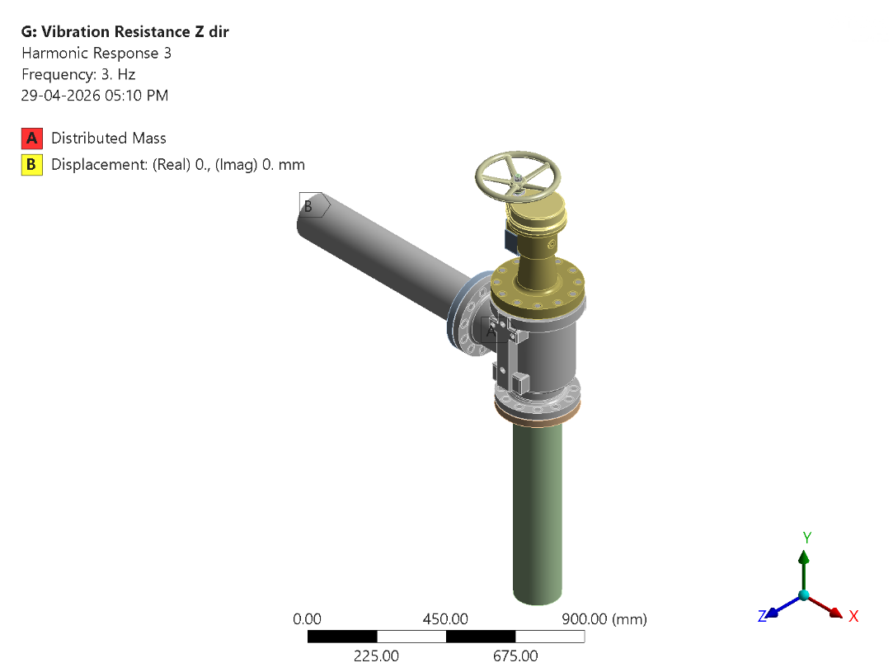
Figure 53 - Harmonic Response Z: Boundary Conditions

Figure 54 - Harmonic Response Z: Displacement Amplitude (Z)
Table 26 - Displacement Amplitude (Z)
Frequency [Hz] | Magnitude [mm] | Phase Angle [deg]
0. | 0. | 0.
3. | 1.75 | 0.
10. | 1.75 | 0.
10.01 | 0.44 | 0.
20. | 0.44 | 0.
20.01 | 0.28 | 0.
25. | 0.28 | 0.
25.01 | 0.2 | 0.
30. | 0.2 | 0.
30.01 | 0.16 | 0.
33. | 0.16 | 0.
Table 27 - Vibration Resistance Analysis Settings (Z)
Property | Value
Boundary Condition | Fixed Support
Type | Displacement
Base Excitation | Yes
Absolute Result | Yes
Define By | Magnitude - Phase
Magnitude | Tabular Data
Phase Angle | Tabular Data
Direction | Z Axis
Suppressed | No

Vibration Resistance analysis Results

Analysis Harmonic In X direction
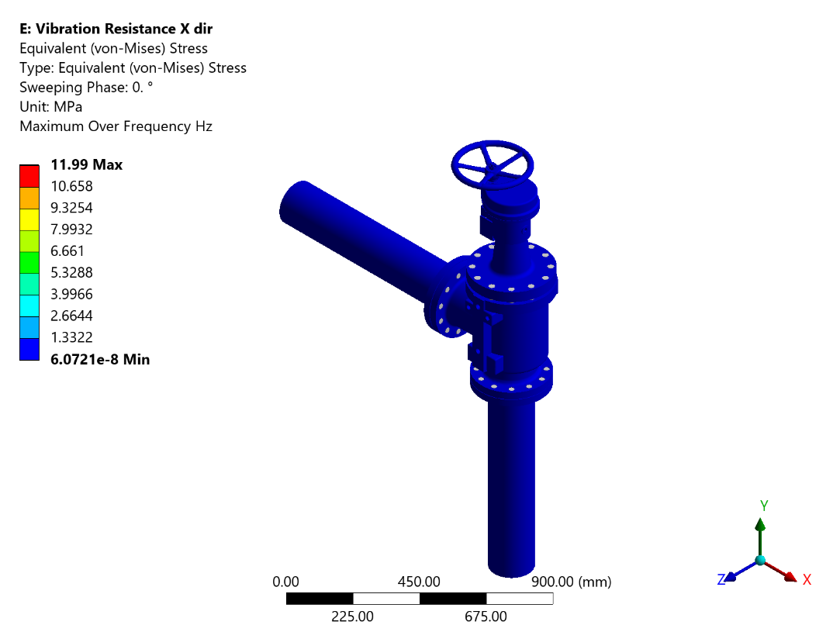
Figure 16 - Harmonic Response X: Equivalent (von-Mises) Stress
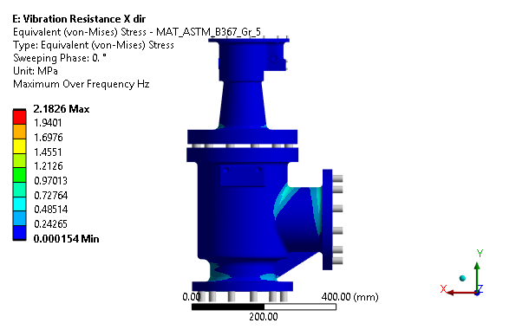
Figure 17 - Harmonic Response X: Equivalent (von-Mises) Stress - MAT_ASTM_B367_Gr_5
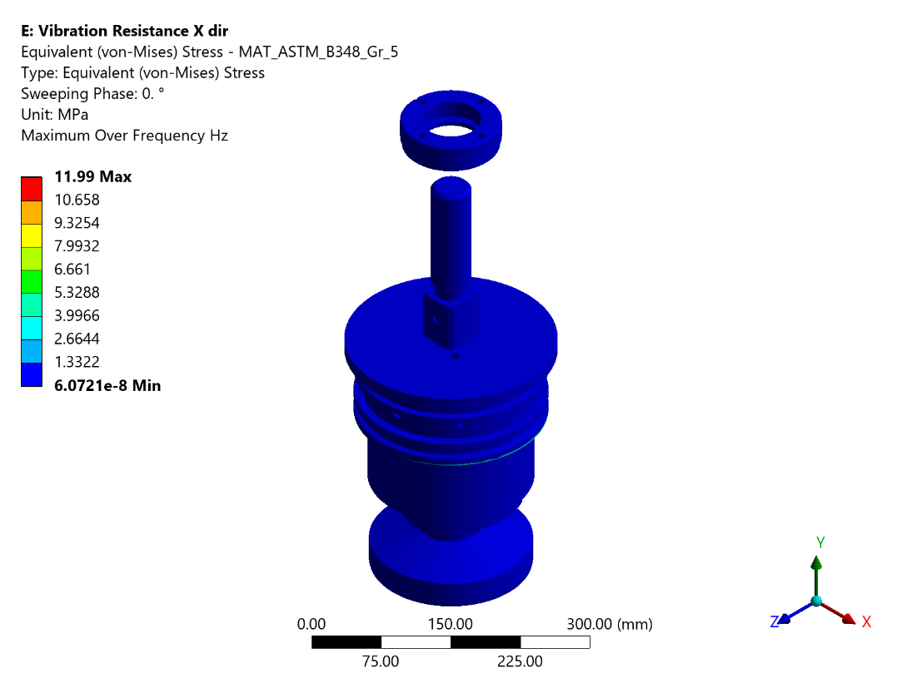
Figure 18 - Harmonic Response X: Equivalent (von-Mises) Stress - MAT_ASTM_B348_Gr_5
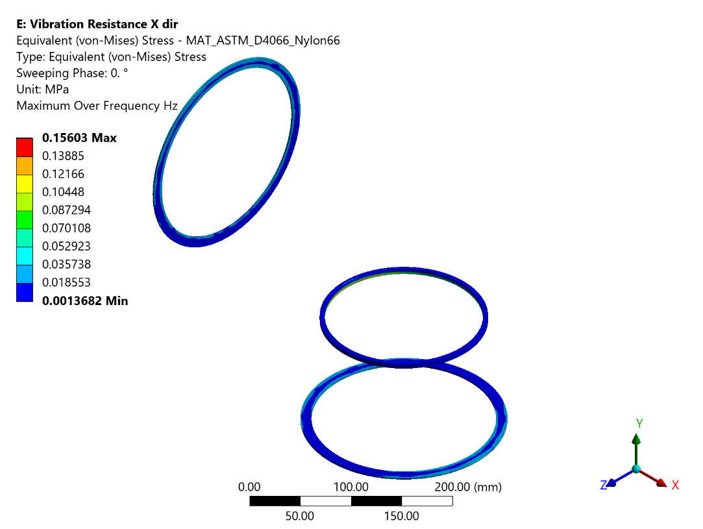
Figure 19 - Harmonic Response X: Equivalent (von-Mises) Stress - MAT_ASTM_D4066_Nylon66
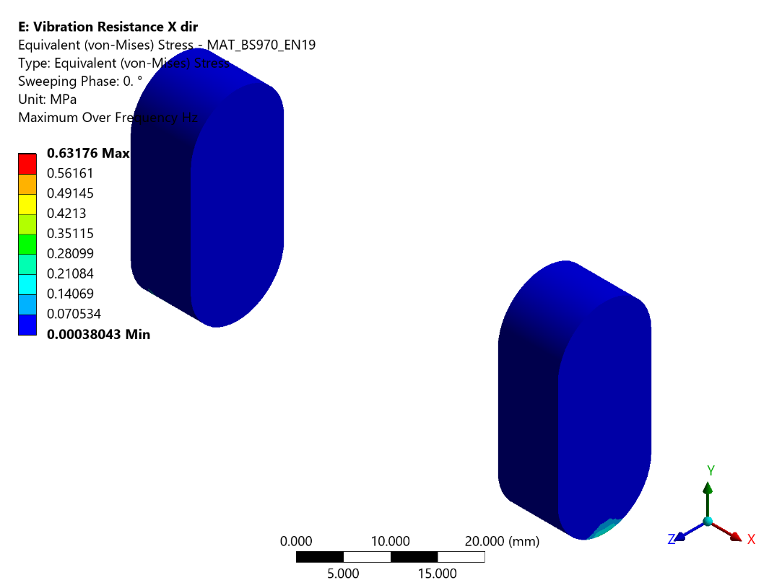
Figure 20 - Harmonic Response X: Equivalent (von-Mises) Stress - MAT_BS970_EN19
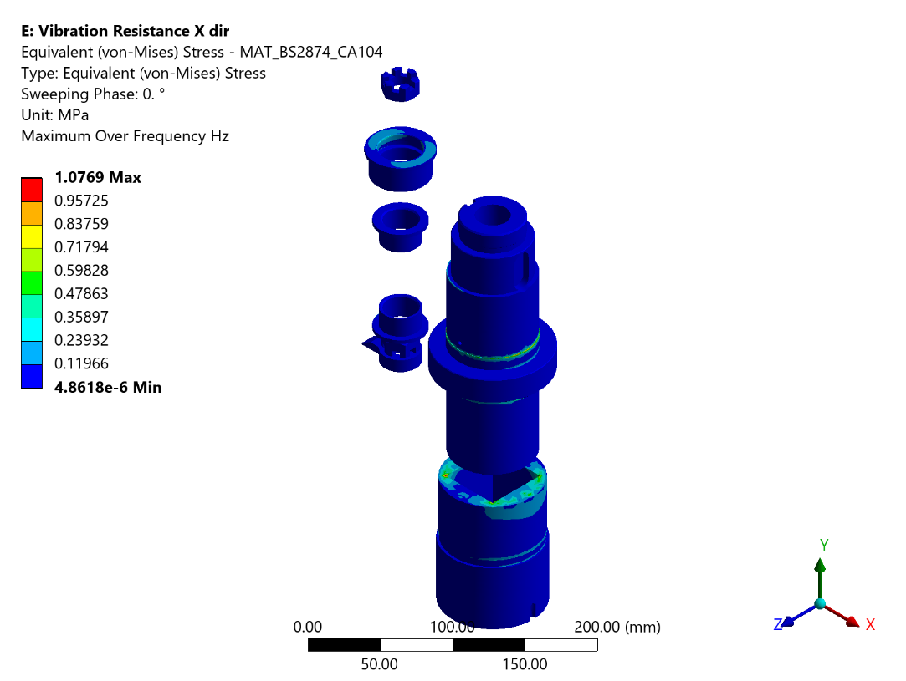
Figure 21 - Harmonic Response X: Equivalent (von-Mises) Stress - MAT_BS2874_CA104
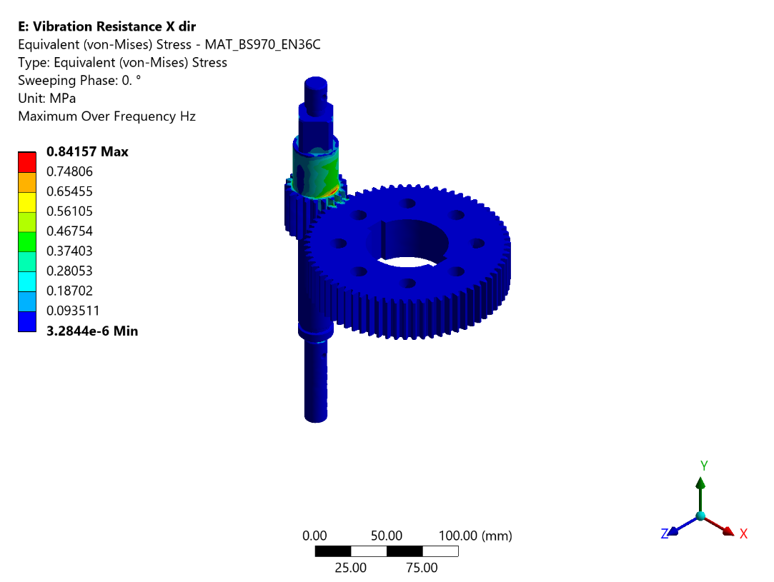
Figure 22 - Harmonic Response X: Equivalent (von-Mises) Stress - MAT_BS970_EN36C
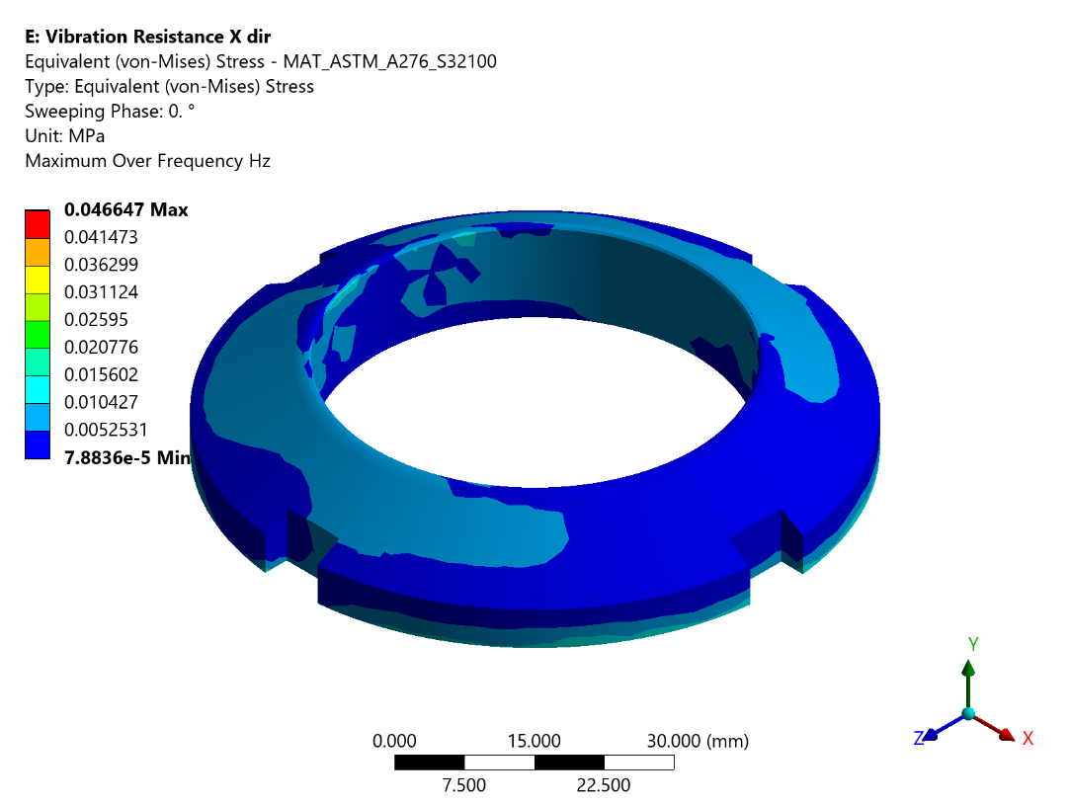
Figure 23 - Harmonic Response X: Equivalent (von-Mises) Stress - MAT_ASTM_A276_S32100
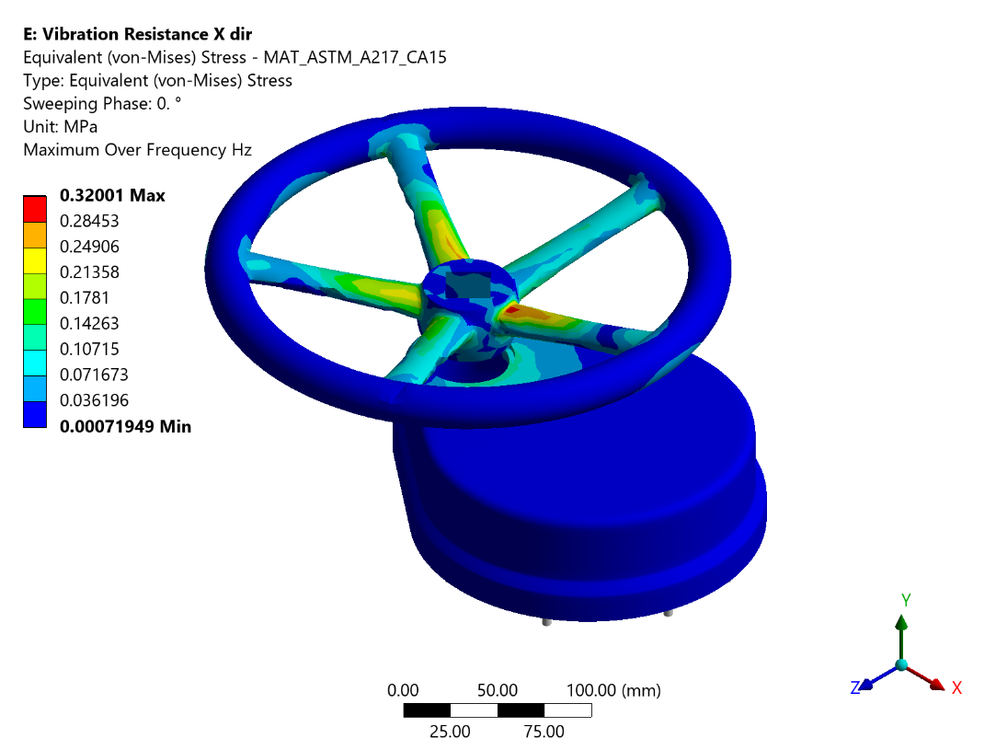
Figure 24 - Harmonic Response X: Equivalent (von-Mises) Stress - MAT_ASTM_A217_CA15
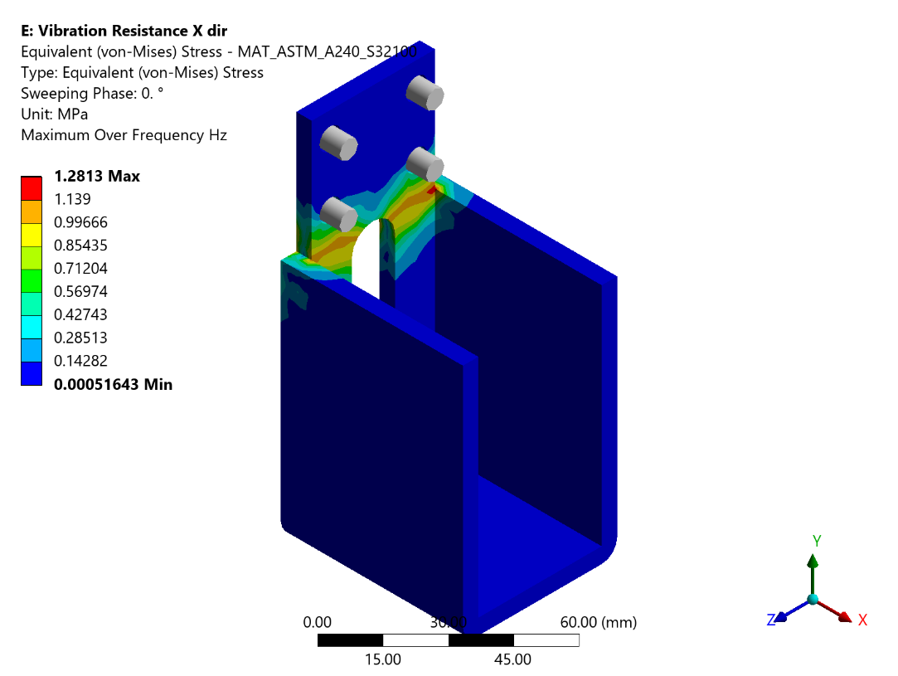
Figure 25 - Harmonic Response X: Equivalent (von-Mises) Stress - MAT_ASTM_A240_S32100
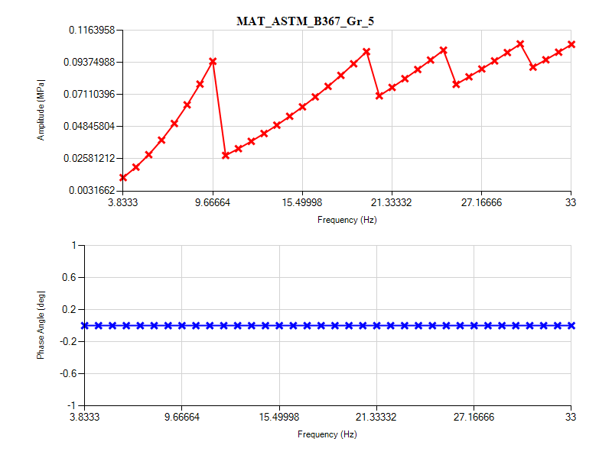
Figure 26 - Harmonic Response X: Frequency Response_MAT_ASTM_B367_Gr_5
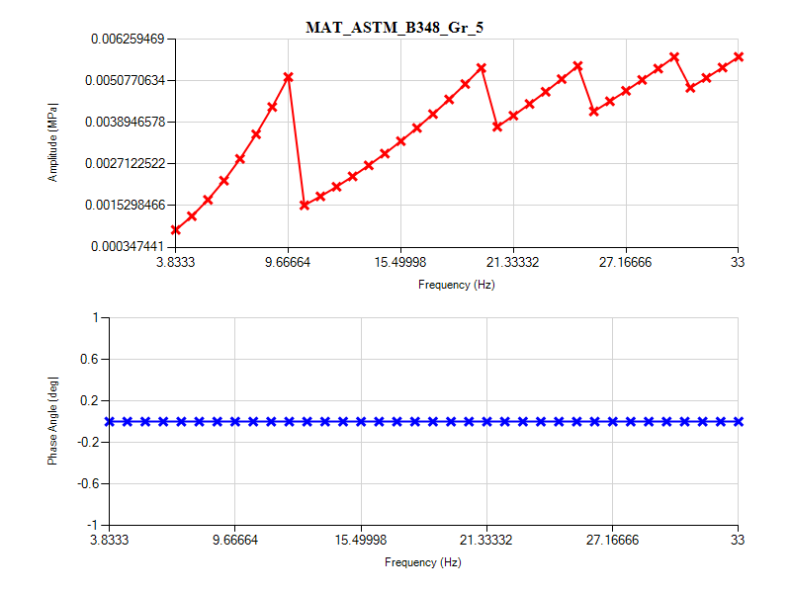
Figure 27 - Harmonic Response X: Frequency Response_MAT_ASTM_B348_Gr_5
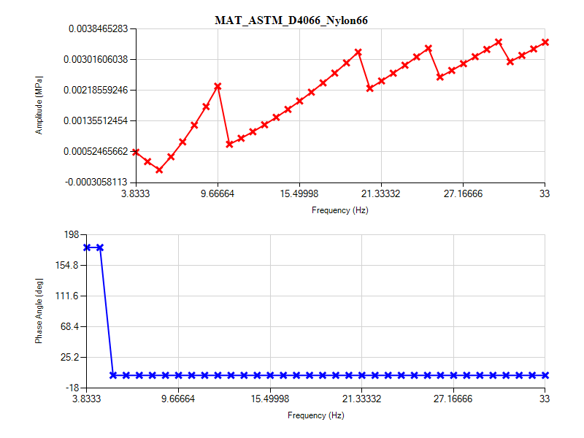
Figure 28 - Harmonic Response X: Frequency Response_MAT_ASTM_D4066_Nylon66
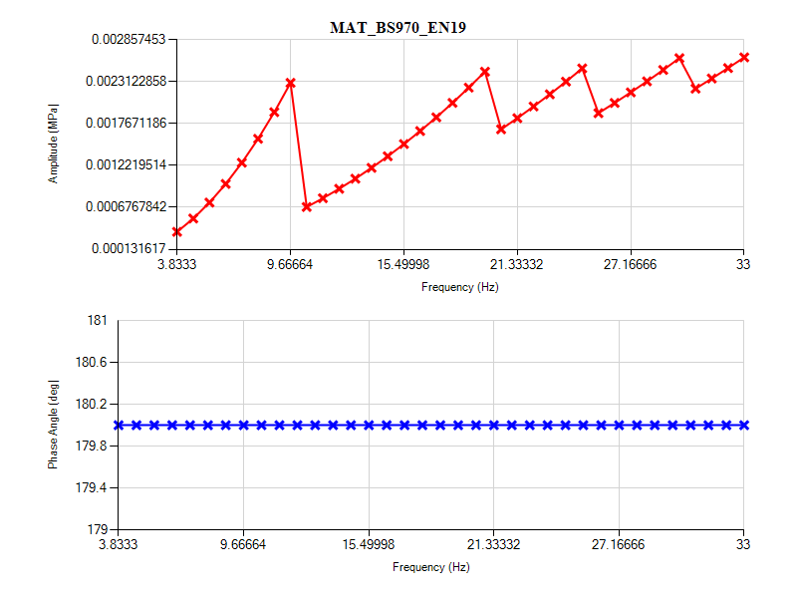
Figure 29 - Harmonic Response X: Frequency Response_MAT_BS970_EN19
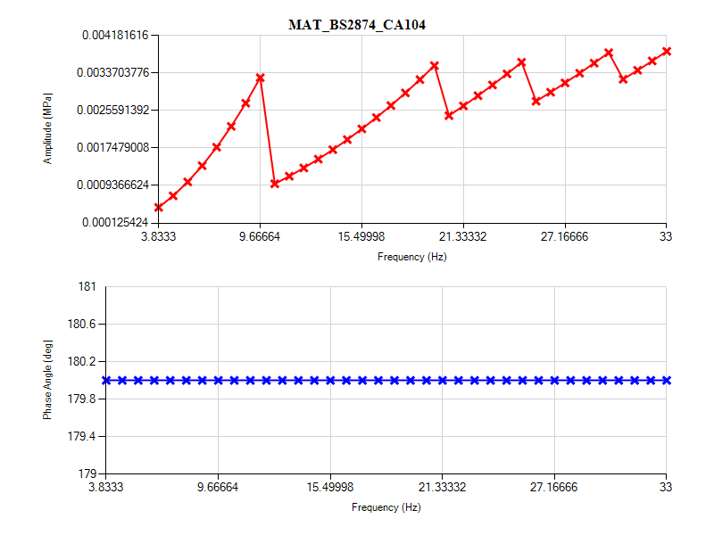
Figure 30 - Harmonic Response X: Frequency Response_MAT_BS2874_CA104
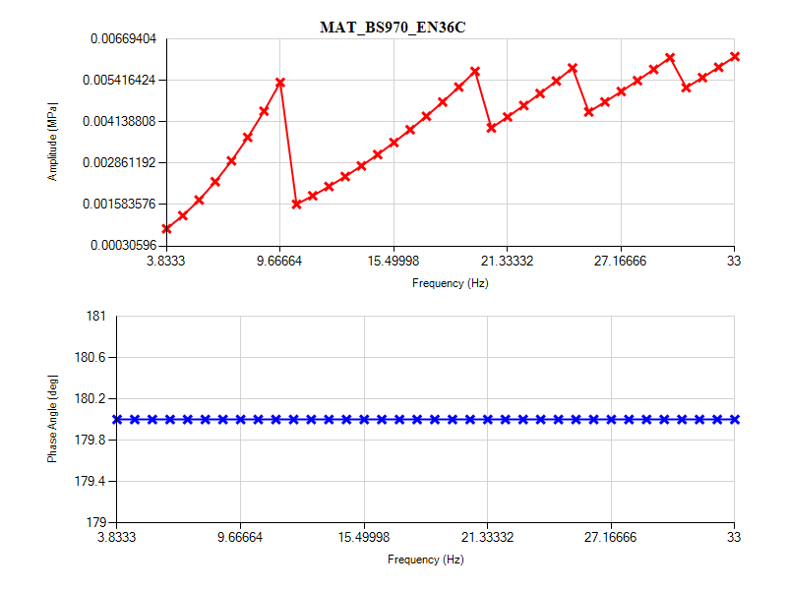
Figure 31 - Harmonic Response X: Frequency Response_MAT_BS970_EN36C
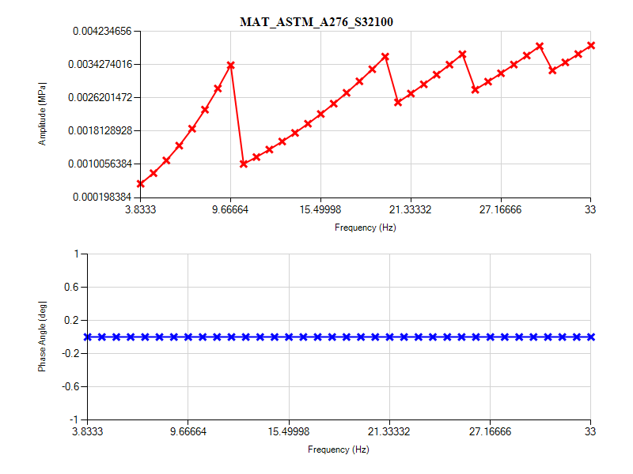
Figure 32 - Harmonic Response X: Frequency Response_MAT_ASTM_A276_S32100
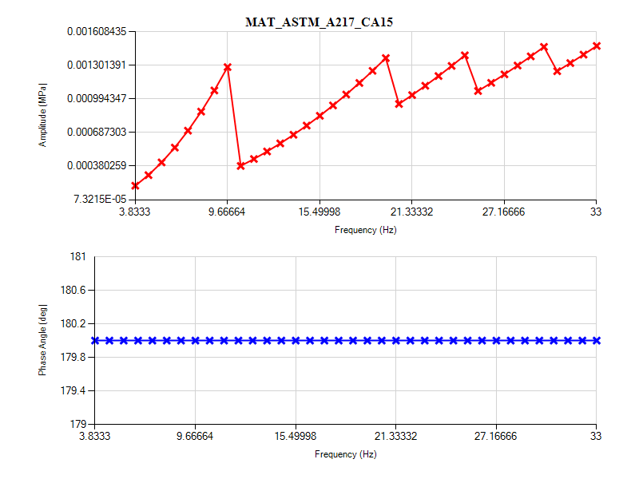
Figure 33 - Harmonic Response X: Frequency Response_MAT_ASTM_A217_CA15
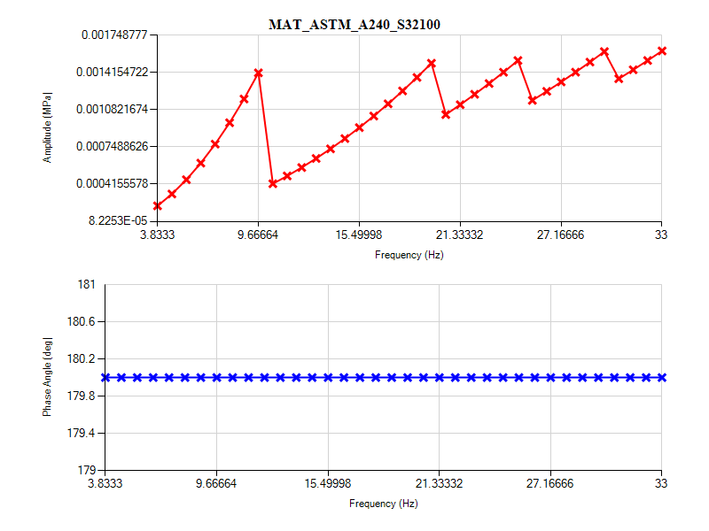
Figure 34 - Harmonic Response X: Frequency Response_MAT_ASTM_A240_S32100

Analysis Harmonic In Y direction
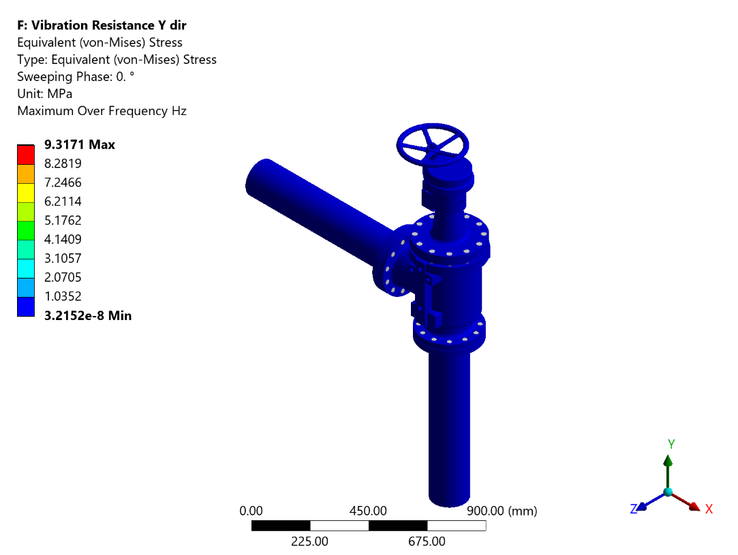
Figure 35 - Harmonic Response Y: Equivalent (von-Mises) Stress
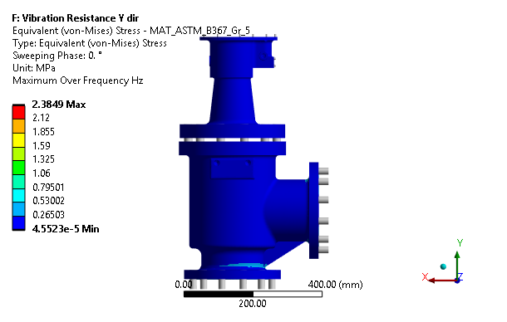
Figure 36 - Harmonic Response Y: Equivalent (von-Mises) Stress - MAT_ASTM_B367_Gr_5
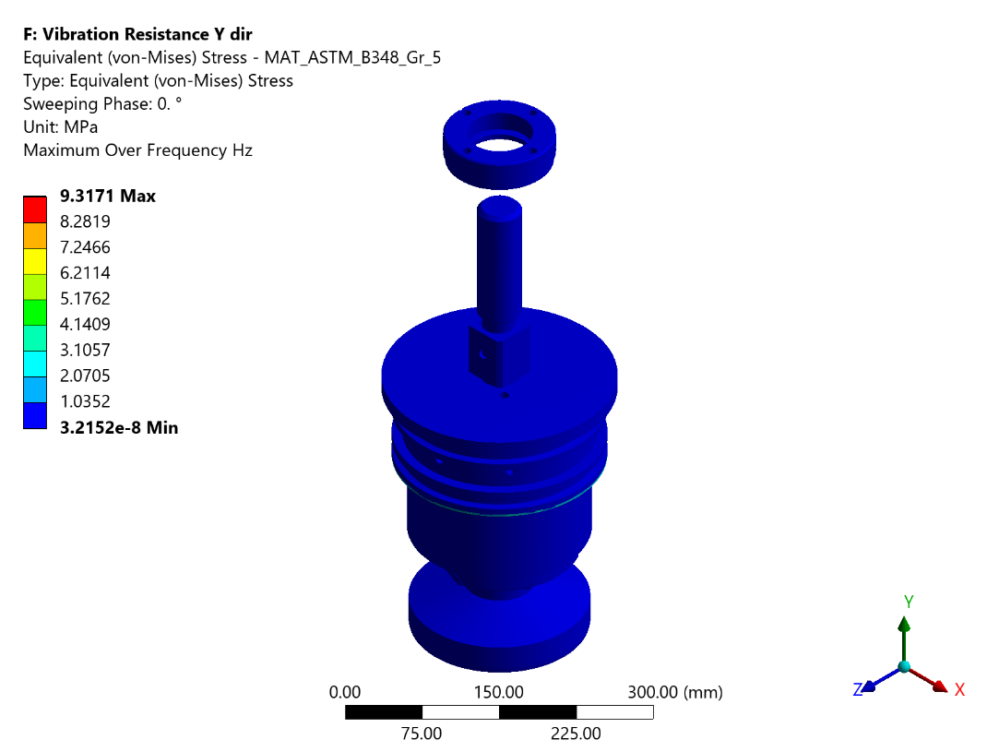
Figure 37 - Harmonic Response Y: Equivalent (von-Mises) Stress - MAT_ASTM_B348_Gr_5
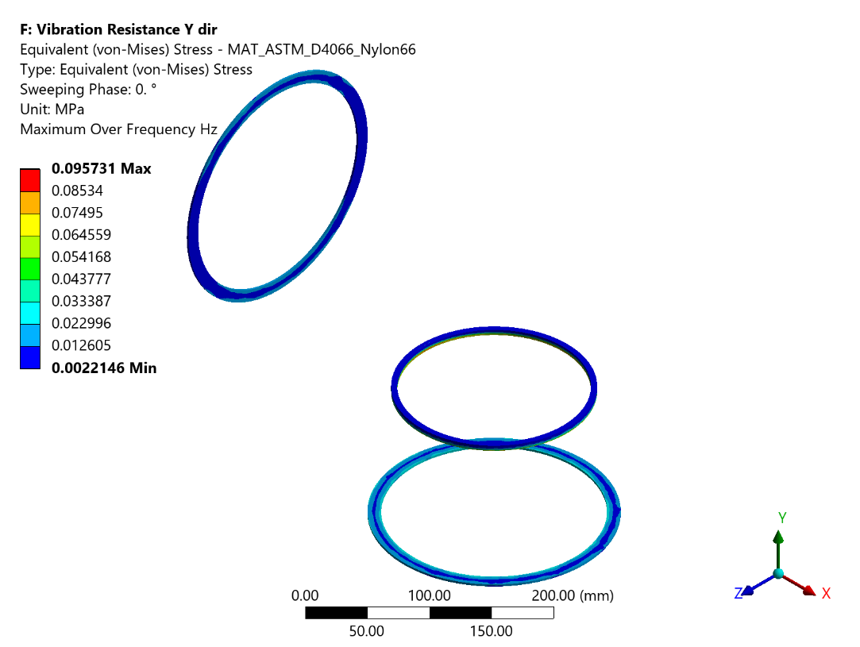
Figure 38 - Harmonic Response Y: Equivalent (von-Mises) Stress - MAT_ASTM_D4066_Nylon66
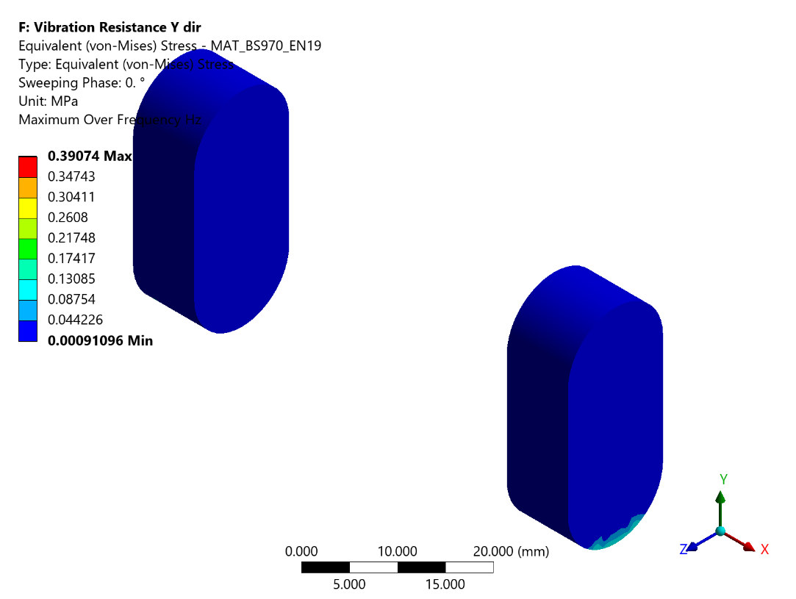
Figure 39 - Harmonic Response Y: Equivalent (von-Mises) Stress - MAT_BS970_EN19
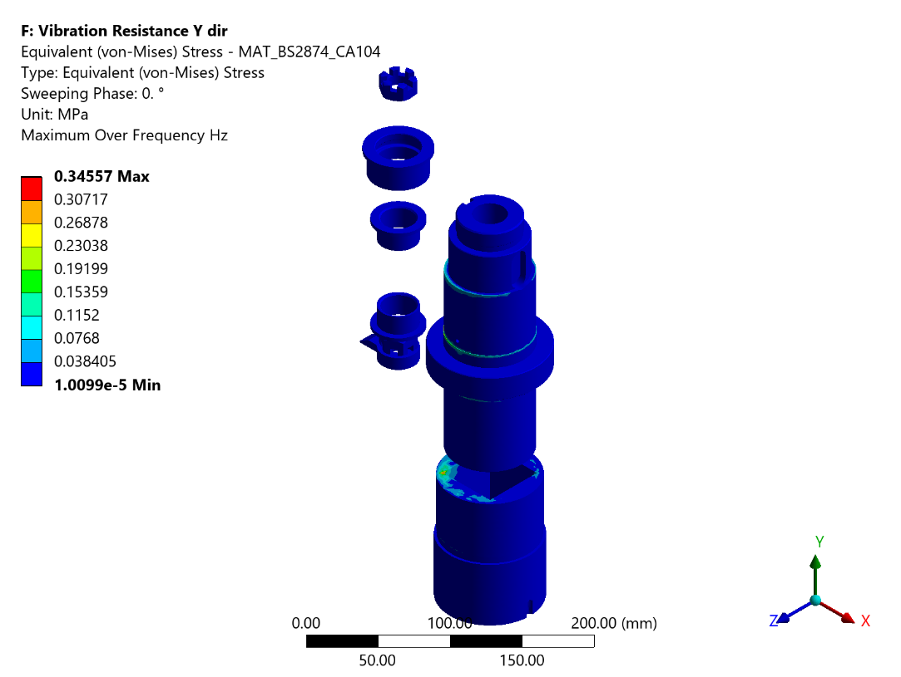
Figure 40 - Harmonic Response Y: Equivalent (von-Mises) Stress - MAT_BS2874_CA104
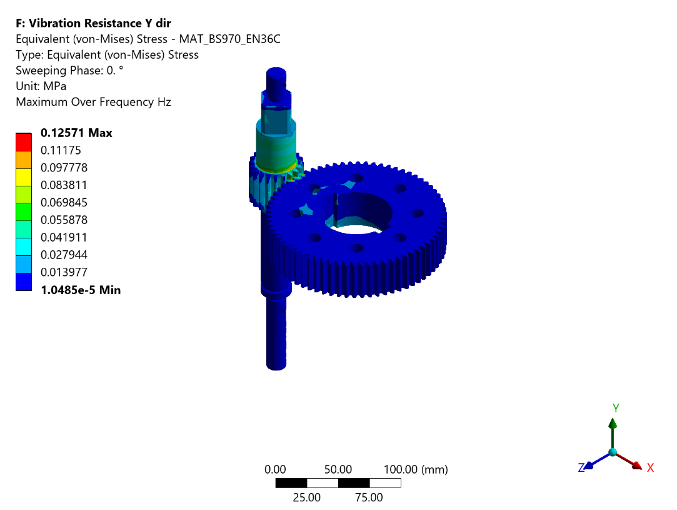
Figure 41 - Harmonic Response Y: Equivalent (von-Mises) Stress - MAT_BS970_EN36C
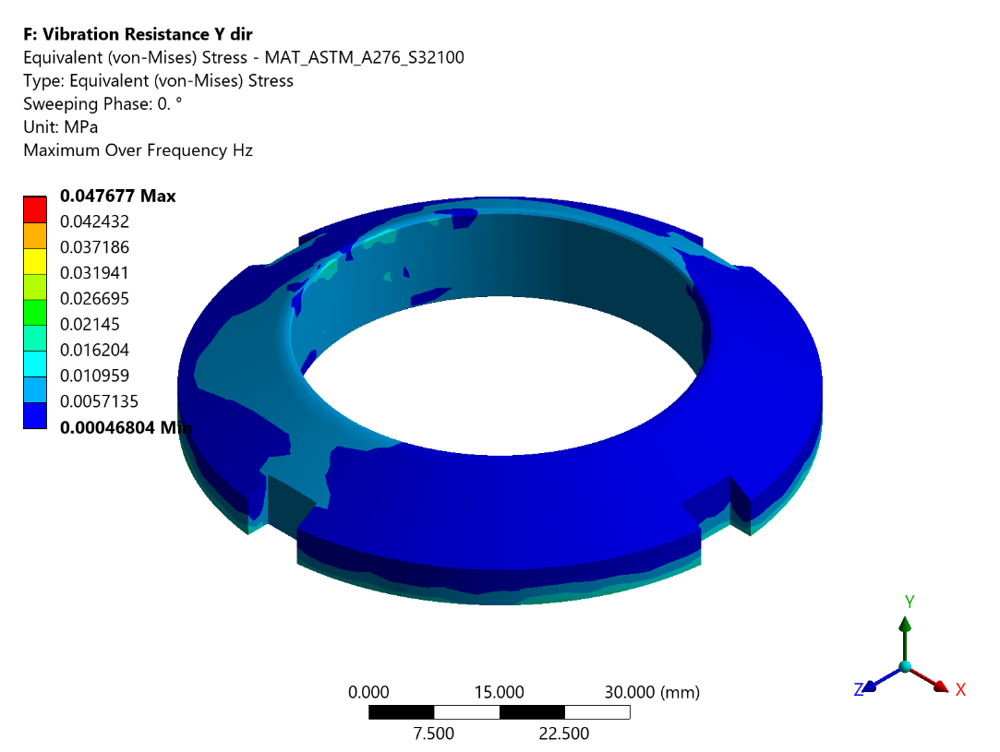
Figure 42 - Harmonic Response Y: Equivalent (von-Mises) Stress - MAT_ASTM_A276_S32100
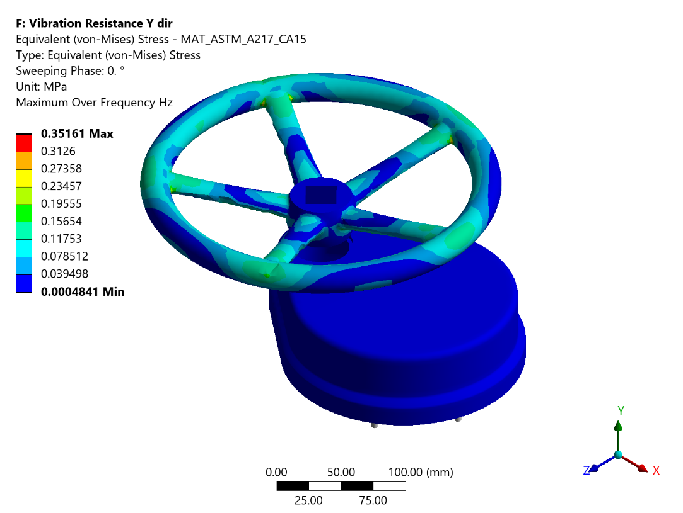
Figure 43 - Harmonic Response Y: Equivalent (von-Mises) Stress - MAT_ASTM_A217_CA15
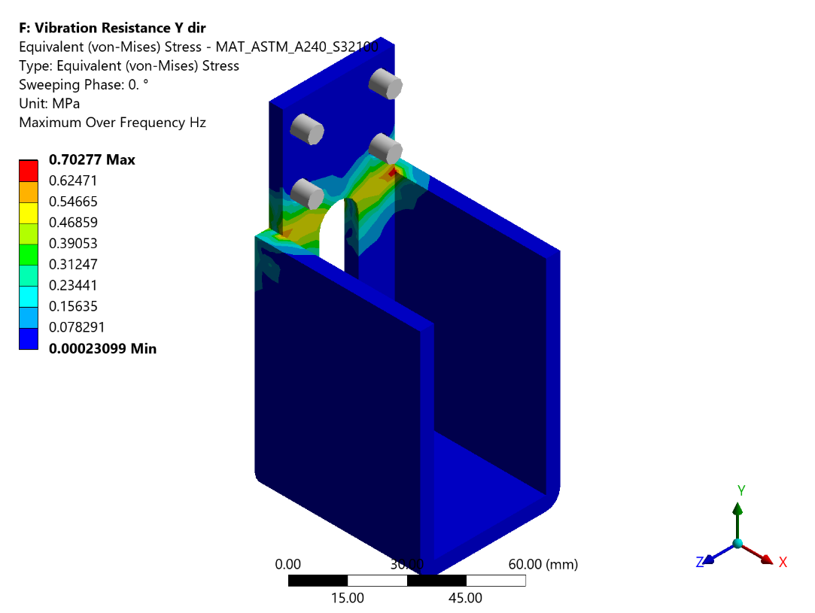
Figure 44 - Harmonic Response Y: Equivalent (von-Mises) Stress - MAT_ASTM_A240_S32100
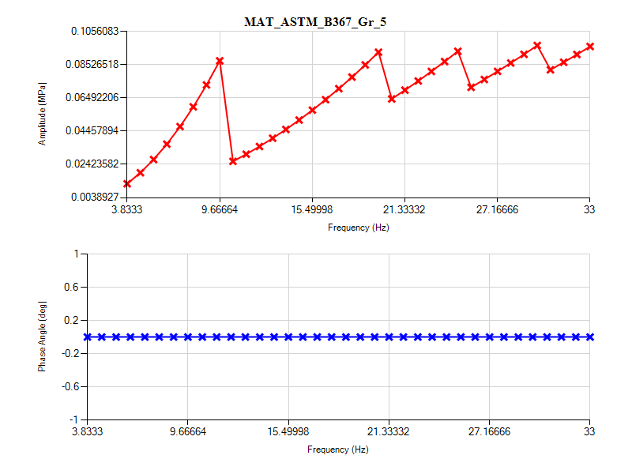
Figure 45 - Harmonic Response Y: Frequency Response_MAT_ASTM_B367_Gr_5
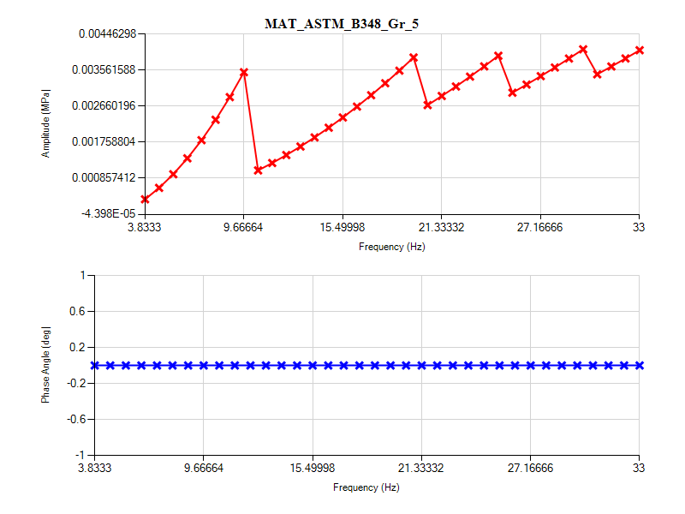
Figure 46 - Harmonic Response Y: Frequency Response_MAT_ASTM_B348_Gr_5
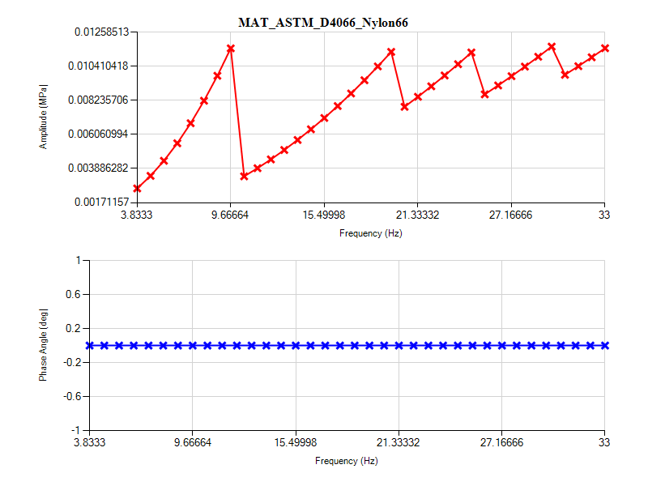
Figure 47 - Harmonic Response Y: Frequency Response_MAT_ASTM_D4066_Nylon66
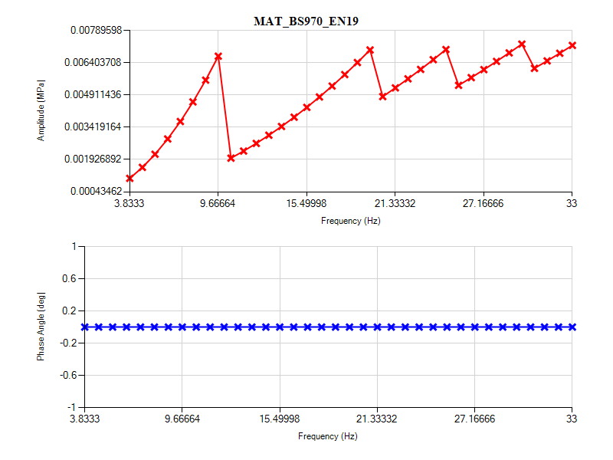
Figure 48 - Harmonic Response Y: Frequency Response_MAT_BS970_EN19
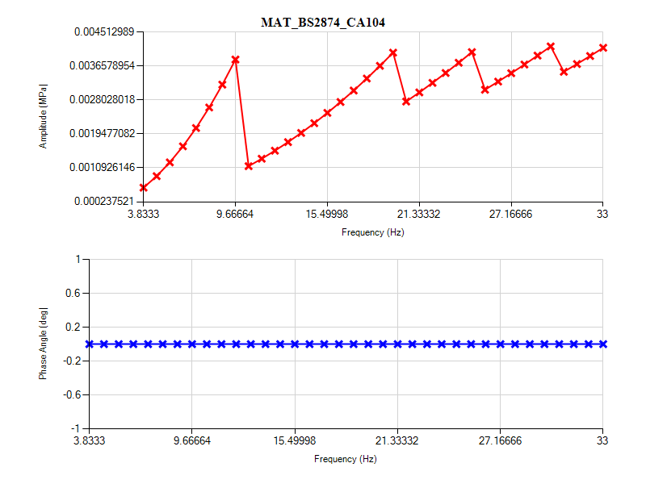
Figure 49 - Harmonic Response Y: Frequency Response_MAT_BS2874_CA104
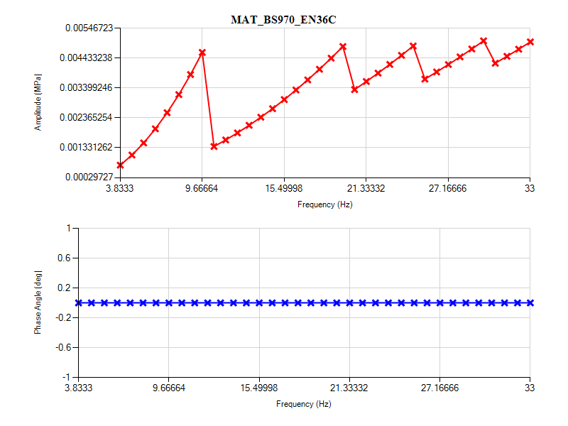
Figure 50 - Harmonic Response Y: Frequency Response_MAT_BS970_EN36C
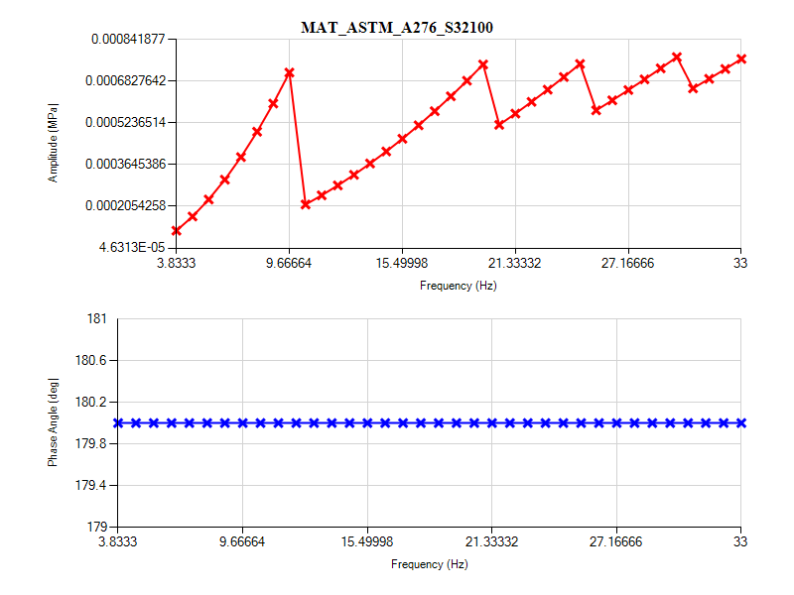
Figure 51 - Harmonic Response Y: Frequency Response_MAT_ASTM_A276_S32100
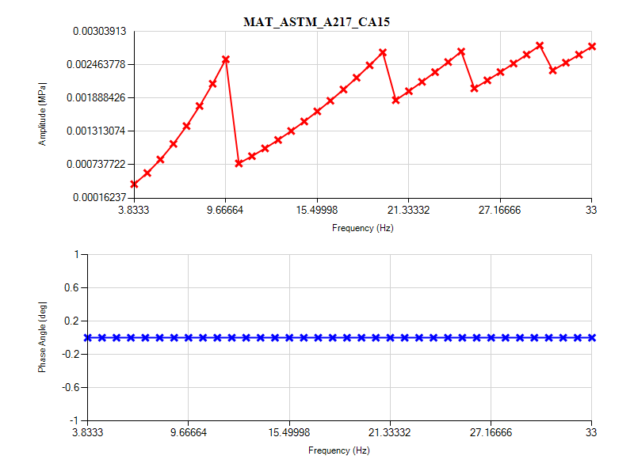
Figure 52 - Harmonic Response Y: Frequency Response_MAT_ASTM_A217_CA15
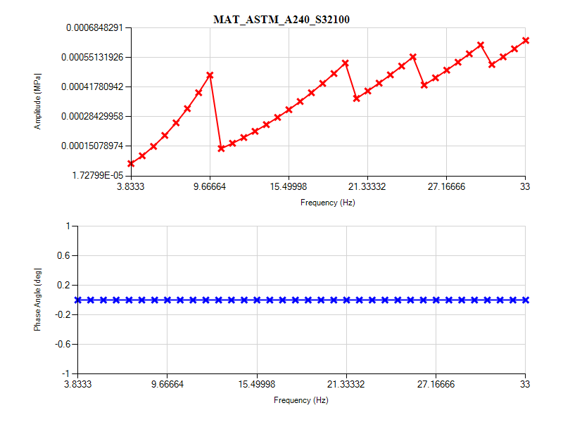
Figure 53 - Harmonic Response Y: Frequency Response_MAT_ASTM_A240_S32100

Analysis Harmonic In Z direction
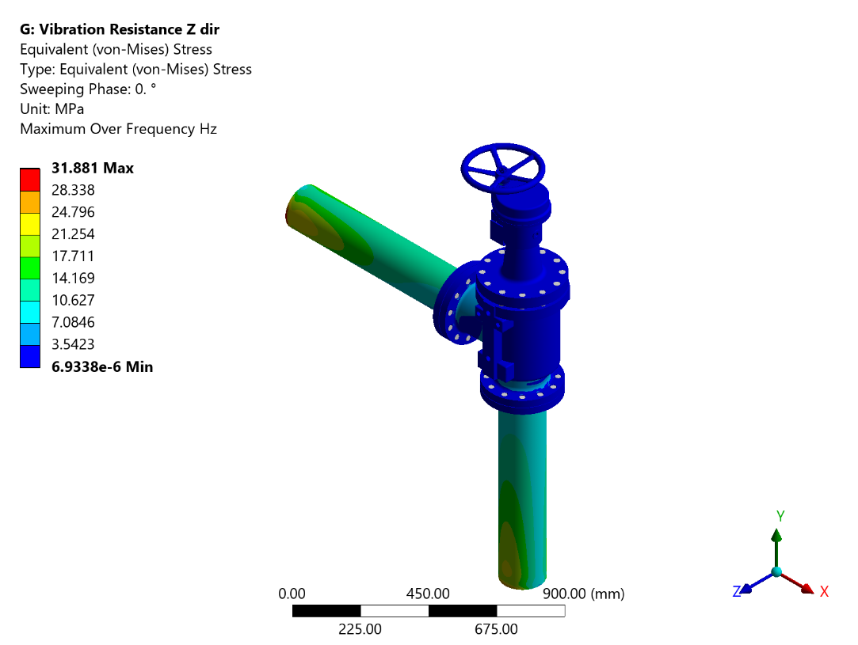
Figure 54 - Harmonic Response Z: Equivalent (von-Mises) Stress
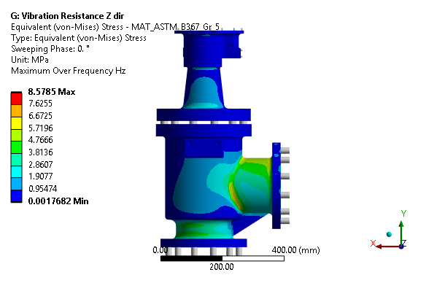
Figure 55 - Harmonic Response Z: Equivalent (von-Mises) Stress - MAT_ASTM_B367_Gr_5
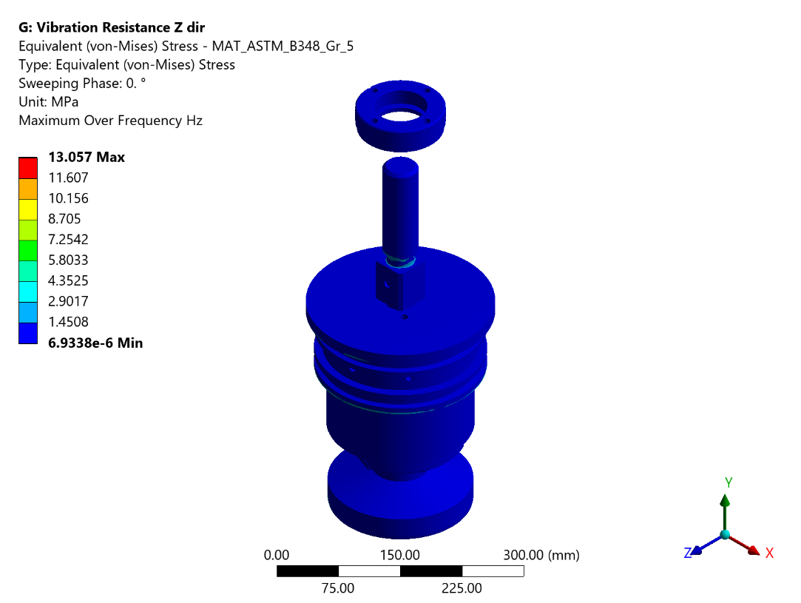
Figure 56 - Harmonic Response Z: Equivalent (von-Mises) Stress - MAT_ASTM_B348_Gr_5
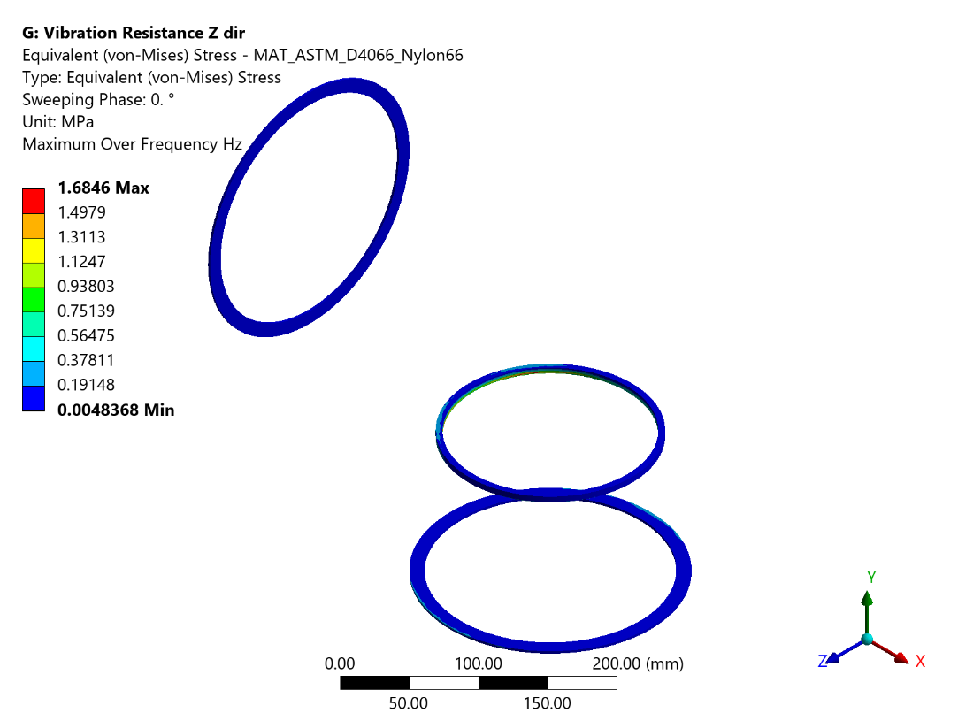
Figure 57 - Harmonic Response Z: Equivalent (von-Mises) Stress - MAT_ASTM_D4066_Nylon66
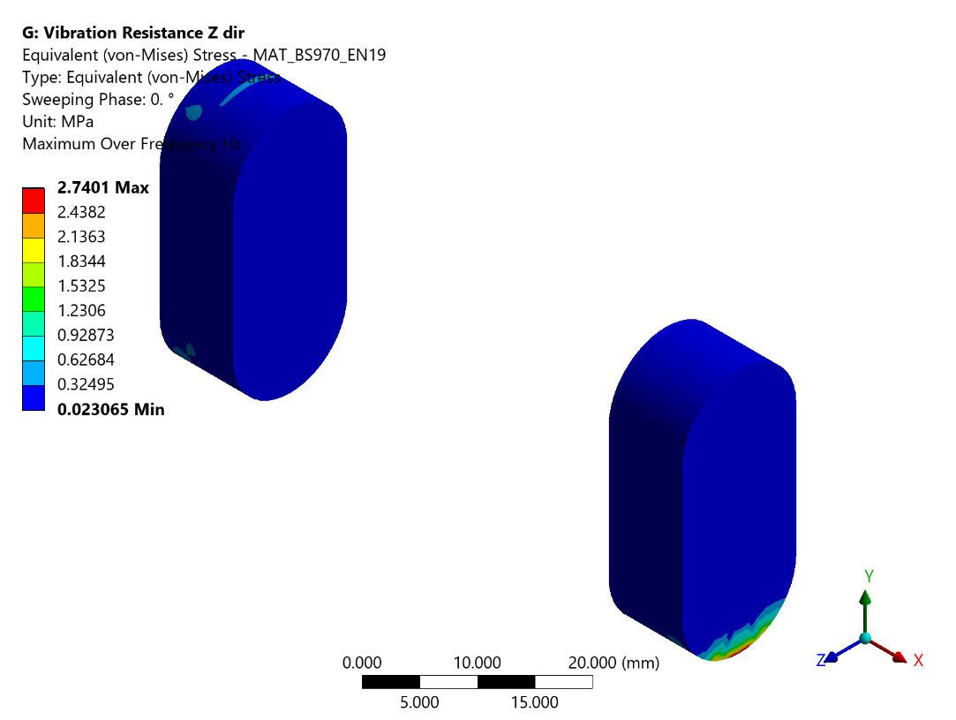
Figure 58 - Harmonic Response Z: Equivalent (von-Mises) Stress - MAT_BS970_EN19
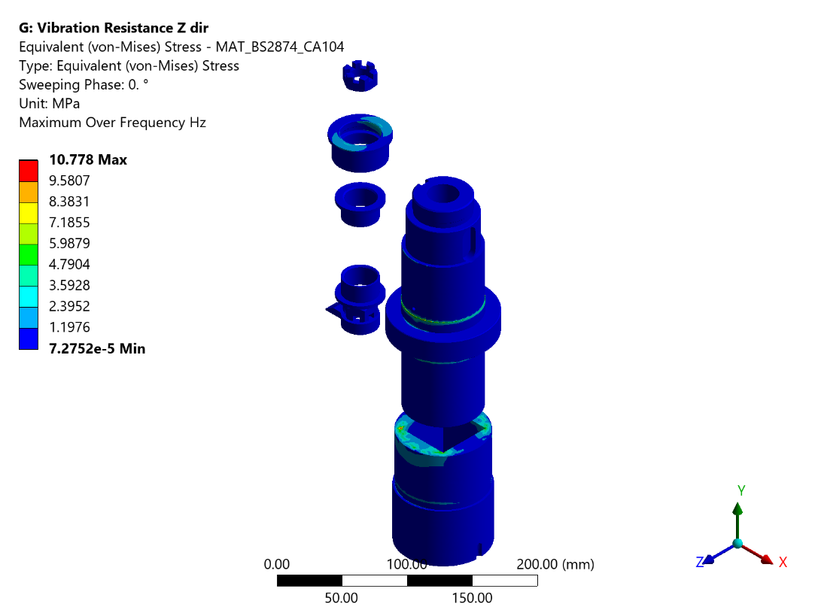
Figure 59 - Harmonic Response Z: Equivalent (von-Mises) Stress - MAT_BS2874_CA104
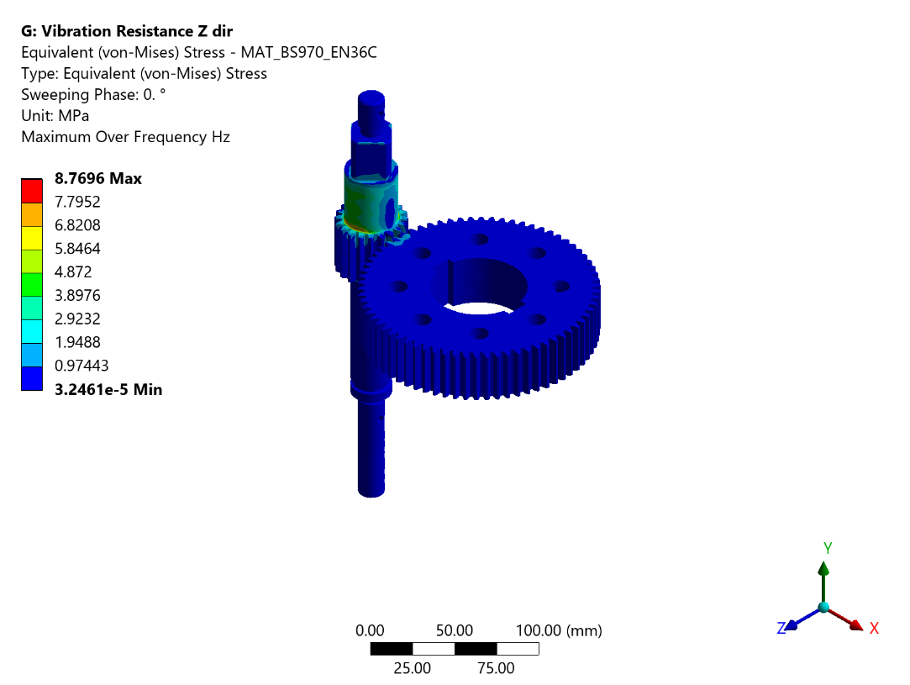
Figure 60 - Harmonic Response Z: Equivalent (von-Mises) Stress - MAT_BS970_EN36C
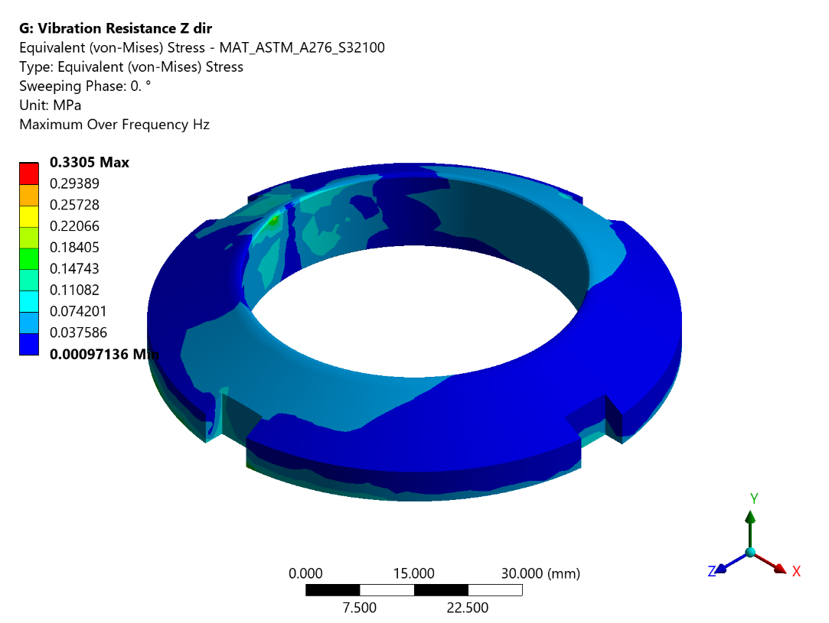
Figure 61 - Harmonic Response Z: Equivalent (von-Mises) Stress - MAT_ASTM_A276_S32100
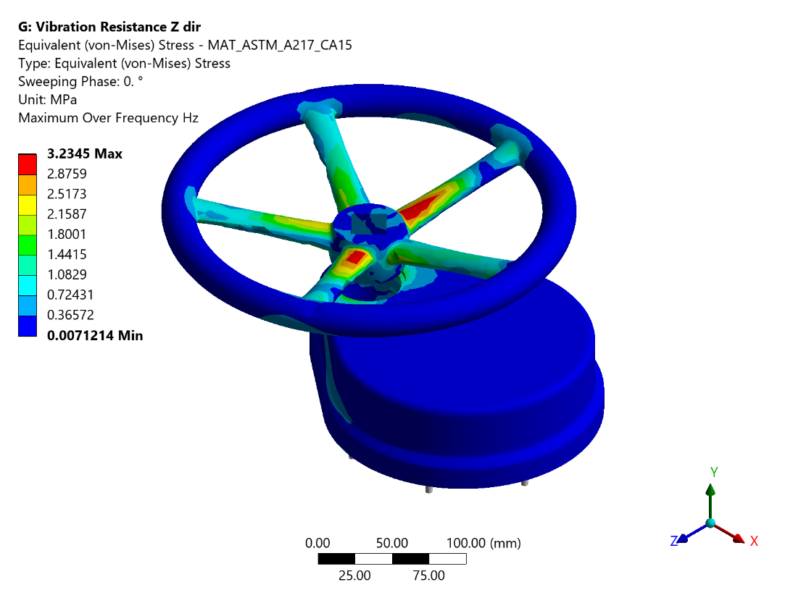
Figure 62 - Harmonic Response Z: Equivalent (von-Mises) Stress - MAT_ASTM_A217_CA15
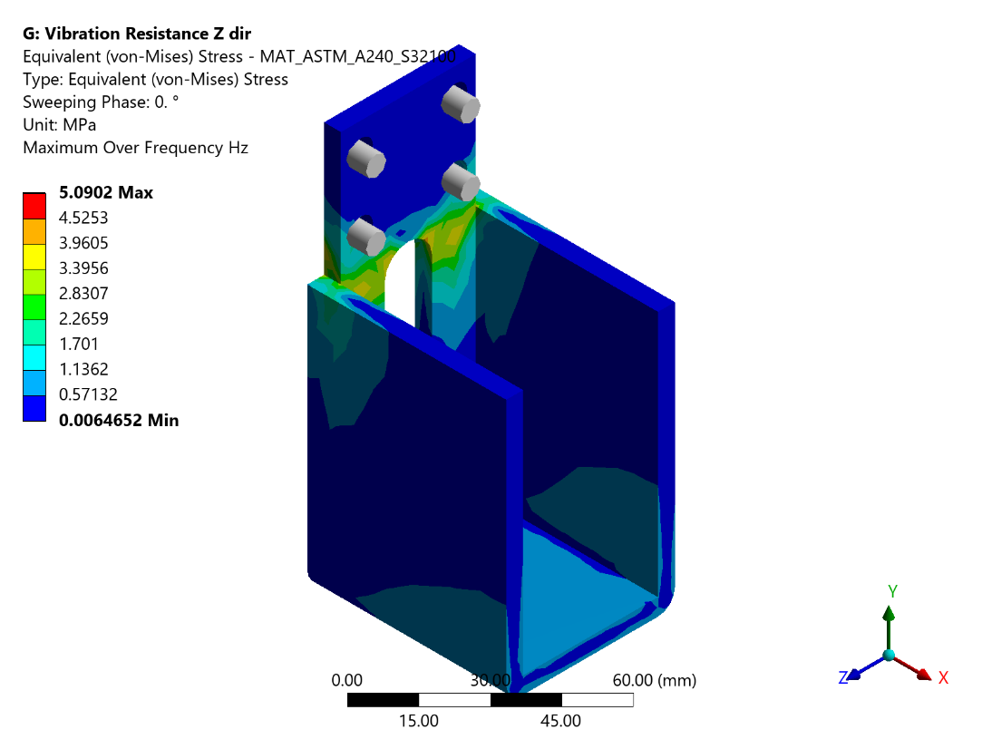
Figure 63 - Harmonic Response Z: Equivalent (von-Mises) Stress - MAT_ASTM_A240_S32100
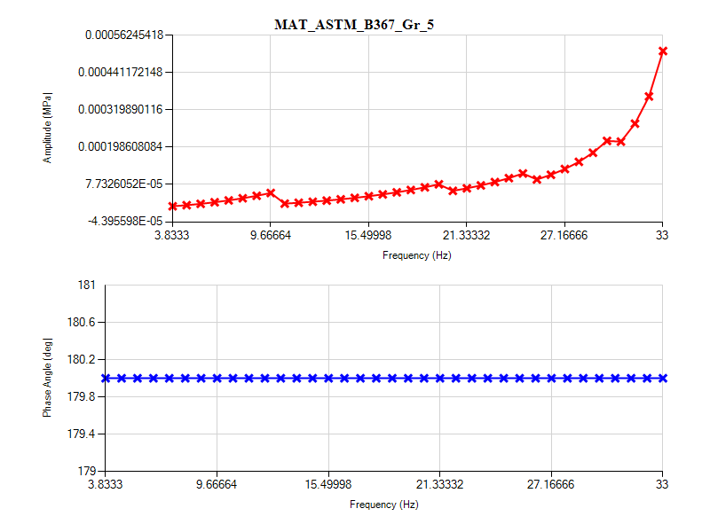
Figure 64 - Harmonic Response Z: Frequency Response_MAT_ASTM_B367_Gr_5
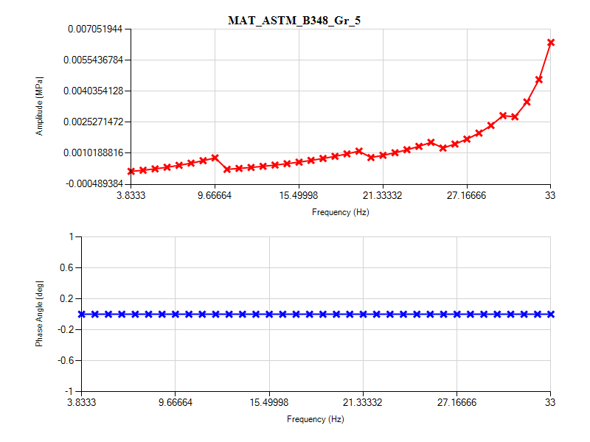
Figure 65 - Harmonic Response Z: Frequency Response_MAT_ASTM_B348_Gr_5
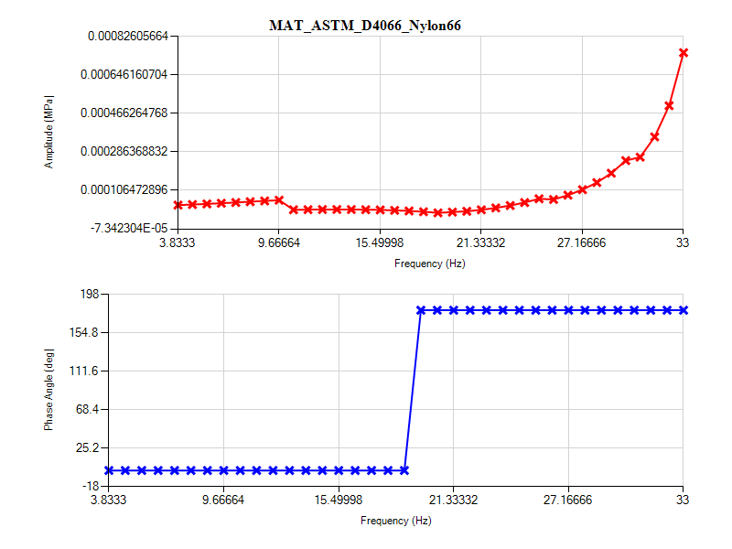
Figure 66 - Harmonic Response Z: Frequency Response_MAT_ASTM_D4066_Nylon66
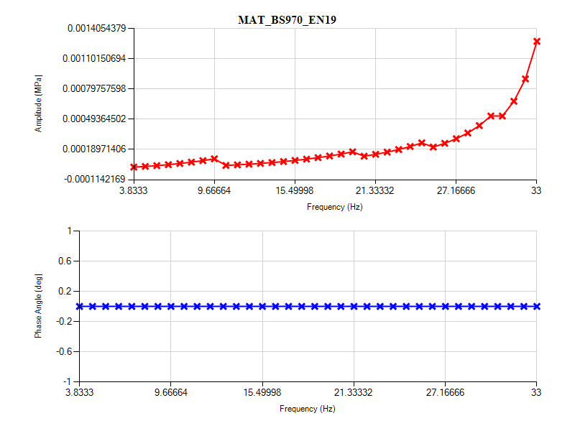
Figure 67 - Harmonic Response Z: Frequency Response_MAT_BS970_EN19
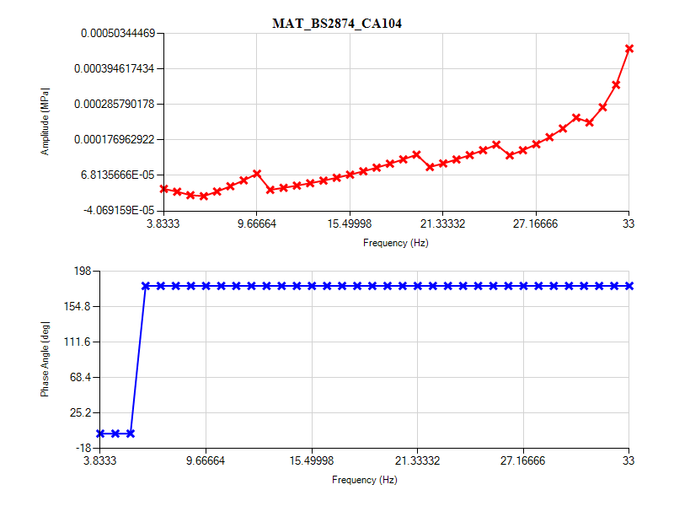
Figure 68 - Harmonic Response Z: Frequency Response_MAT_BS2874_CA104
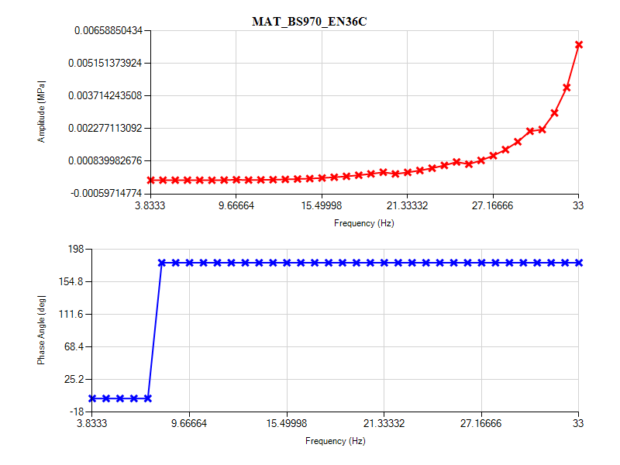
Figure 69 - Harmonic Response Z: Frequency Response_MAT_BS970_EN36C
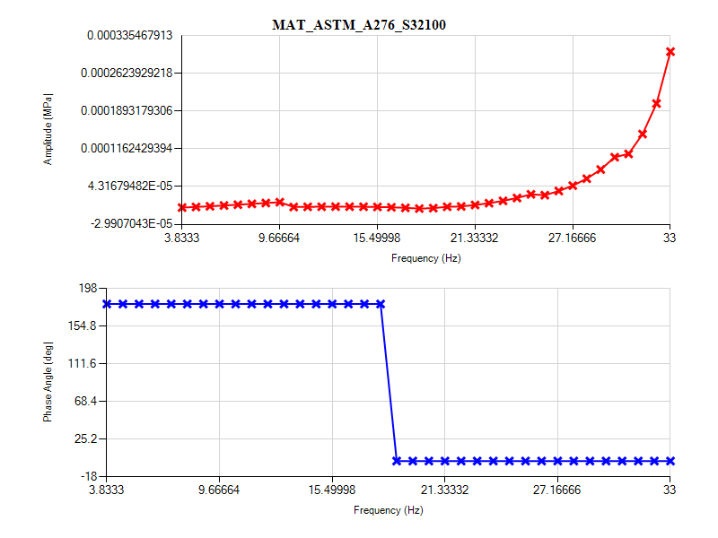
Figure 70 - Harmonic Response Z: Frequency Response_MAT_ASTM_A276_S32100
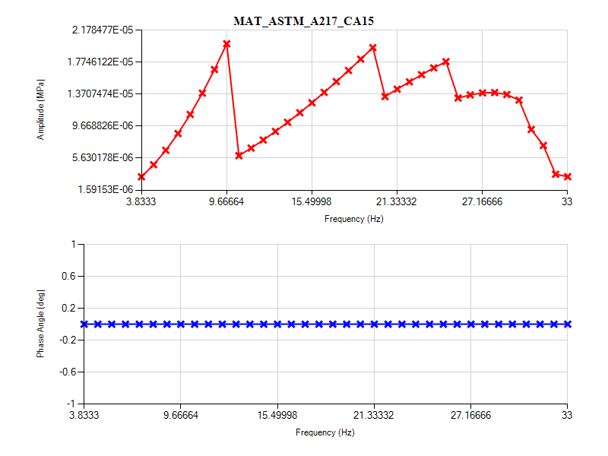
Figure 71 - Harmonic Response Z: Frequency Response_MAT_ASTM_A217_CA15
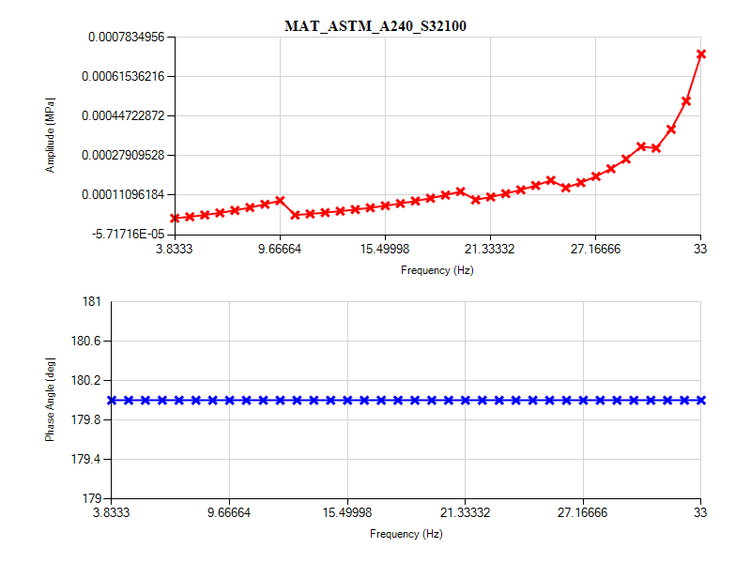
Figure 72 - Harmonic Response Z: Frequency Response_MAT_ASTM_A240_S32100

Mapping of materials to the Cases as per
- Case (a): Carbon & Low Alloy Steels
- Case (b): Series 3XX Stainless Steels & Nickel Alloys
- Case (c): Wrought 70–30 Copper–Nickel
- Case (d): Ni–Cr–Mo–Fe Alloys
- Case (e): High Strength Bolting
Table 26 Material Case Mapping according to ANNEX 3-F DESIGN FATIGUE CURVES of ASME BPVC.VIII.2-2023
Material | UNS | Type | Case
ASTM A217 CA15 | J91150 | Ferrous | a (martensitic carbon/low alloy steel)
BS 970 EN19 | G41400 | Ferrous | a (martensitic carbon/low alloy steel)
BS 970 EN36C | G93100 | Ferrous | a (martensitic carbon/low alloy steel)
ASTM A 276 S32100 | S32100 | Ferrous | b (3XX stainless steel)
ASTM A 240 S32100 | S32100 | Ferrous | b (3XX stainless steel)
BS 2874 CA104 | C63000 | Non-Ferrous | NAB
ASTM B 367 Gr.5 | R56400 | Non-Ferrous | Ti Gr 5
ASTM B 348 Gr.5 | R56400 | Non-Ferrous | Ti Gr 5

Harmonic Analysis Conclusions
Table 28 - Static Structural Results Summary
Sr. No. | Direction | Material | Maximum Occurs On | Stresses Observed (MPa) | Allowable Stress (MPa) | Remarks
1 | Along X Axis | ASTM B 367 Gr.5 | 1 Body | 2.1826 | 237.5560851 | Stresses less than allowable
2 | Along X Axis | ASTM B 348 Gr.5 | 4 Piston | 11.99 | 237.5560851 | Stresses less than allowable
3 | Along X Axis | ASTM D4066- Nylon 66 | 3 Disc Seal | 0.15569 | Refer Note 1
4 | Along X Axis | BS 970 EN19 | 5 Key | 0.63141 | 57.21082297 | Stresses less than allowable
5 | Along X Axis | BS 2874 CA 104 | 12 Bush-1 | 1.0756 | 59.55630959 | Stresses less than allowable
6 | Along X Axis | BS 970 EN36C | 20 Pinion Shaft | 0.84086 | 52.61616193 | Stresses less than allowable
7 | Along X Axis | ASTM A 276 S32100 | 22 Ring Nut | 0.046613 | 65.1775787 | Stresses less than allowable
8 | Along X Axis | ASTM A 217 CA15 | 28 Hand Wheel | 0.31959 | 52.86741182 | Stresses less than allowable
9 | Along X Axis | ASTM A 240 S32100 | 32 Side Cover | 1.2804 | 65.1775787 | Stresses less than allowable
10 | Along Y Axis | ASTM B 367 Gr.5 | 1 Body | 2.3849 | 237.5560851 | Stresses less than allowable
11 | Along Y Axis | ASTM B 348 Gr.5 | 4 Piston | 9.3175 | 237.5560851 | Stresses less than allowable
12 | Along Y Axis | ASTM D4066- Nylon 66 | 3 Disc Seal | 0.09562 | Refer Note 1 | Stresses less than allowable
13 | Along Y Axis | BS 970 EN19 | 5 Key | 0.39067 | 57.21082297 | Stresses less than allowable
14 | Along Y Axis | BS 2874 CA 104 | 15 Yoke Sleeve | 0.364576 | 59.55630959 | Stresses less than allowable
15 | Along Y Axis | BS 970 EN36C | 19 Gear | 0.12565 | 52.61616193 | Stresses less than allowable
16 | Along Y Axis | ASTM A 276 S32100 | 22 Ring Nut | 0.0476 | 65.1775787 | Stresses less than allowable
17 | Along Y Axis | ASTM A 217 CA15 | 28 Handwheel | 0.3516 | 52.86741182 | Stresses less than allowable
18 | Along Y Axis | ASTM A 240 S32100 | 32 Side Cover | 0.70264 | 65.1775787 | Stresses less than allowable
19 | Along Z Axis | ASTM B 367 Gr.5 | 1 Body | 8.5785 | 237.5560851 | Stresses less than allowable
20 | Along Z Axis | ASTM B 348 Gr.5 | 4 Piston | 13.051 | 237.5560851 | Stresses less than allowable
21 | Along Z Axis | ASTM D4066- Nylon 66 | 3 Disc Seal | 1.63 | Refer Note 1 | Stresses less than allowable
22 | Along Z Axis | BS 970 EN19 | 5 Key | 2.6166 | 57.21082297 | Stresses less than allowable
23 | Along Z Axis | BS 2874 CA 104 | 12 Bush -1 | 10.295 | 59.55630959 | Stresses less than allowable
24 | Along Z Axis | BS 970 EN36C | 20 Pinion Shaft | 8.3706 | 52.61616193 | Stresses less than allowable
25 | Along Z Axis | ASTM A 276 S32100 | 22 Ring Nut | 0.31474 | 65.1775787 | Stresses less than allowable
26 | Along Z Axis | ASTM A 217 CA15 | 28 Handwheel | 3.0835 | 52.86741182 | Stresses less than allowable
27 | Along Z Axis | ASTM A 240 S32100 | 32 Side Cover | 4.8676 | 65.1775787 | Stresses less than allowable
Note 1: Reliable fatigue curves for ASTM D4066 Nylon 66 are not available. Additionally, the gaskets and seals are bought-out items and are classified as consumables. Extra quantities of these items will be supplied as onboard spares.
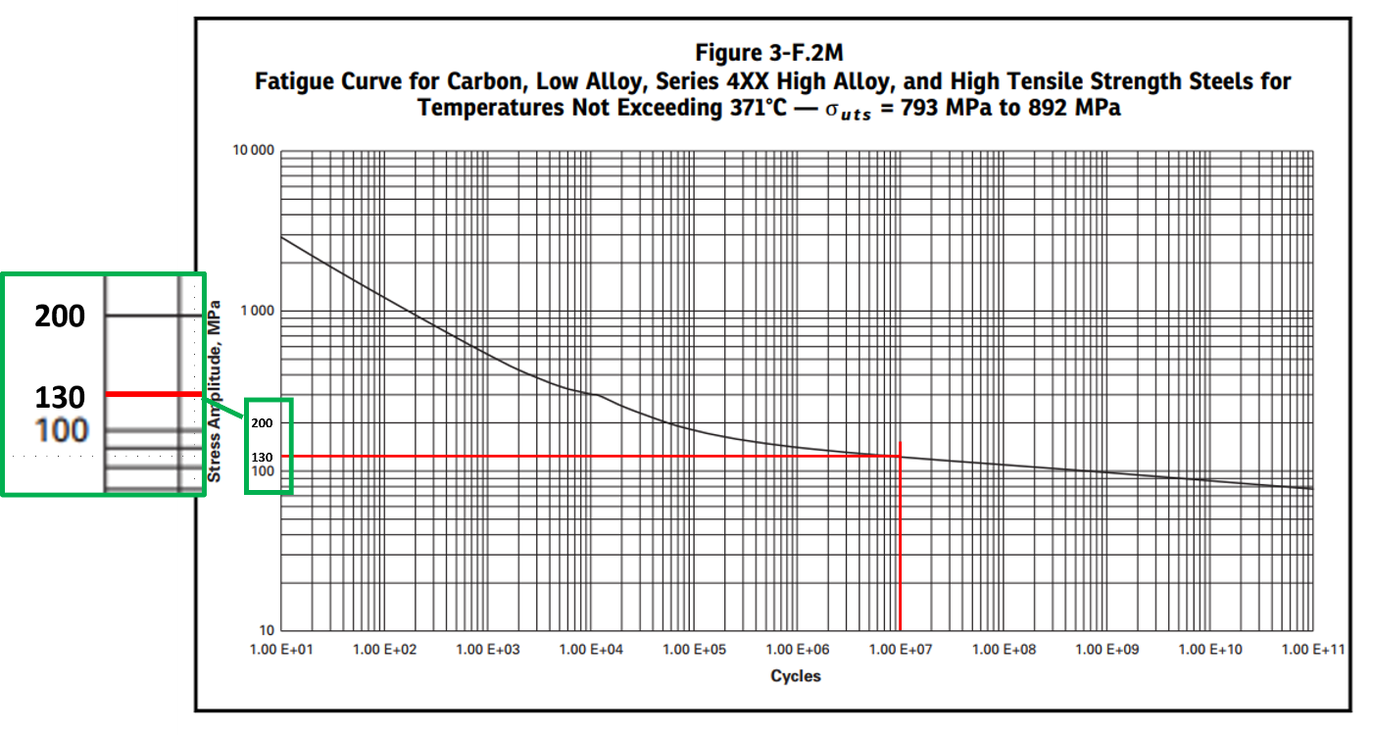
(a)
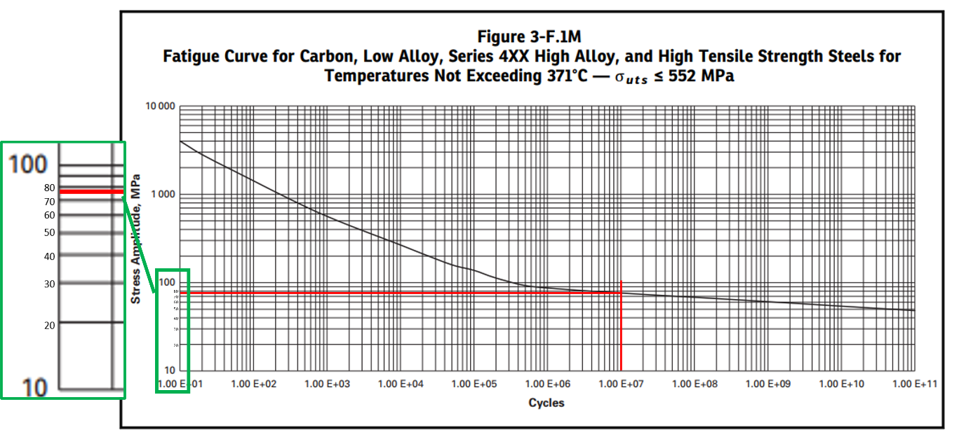
(b)
Figure 74 Martensitic carbon/low alloy steel fatigue curve (ASME BPVC.VIII.2-2023, Page 161,162)
Table 28 Allowable calculations for the Martensitic carbon/low alloy steel
Material | UTS | Stress at at 10^7 Cycles | Surface Roughness Factor | Fatigue Allowable
ASTM A217 CA15 | 620 | 92.67219917 | 0.570477579 | 52.86741179
BS 970 EN36C | 1000 | 130 | 0.404739707 | 52.61616193
BS 970 EN19 | 695 | 108.8547718 | 0.525570189 | 57.21082297
The Surface Finish Factor using equation (Chapter 6, Equation 6.7 e, Pg. 329) is calculated. Machine Design - An Integrated Approach by Robert L. Norton.
Here A= 57.7 and b= -0.718 are used though the minimum surface finish for any of the component will be as machined.
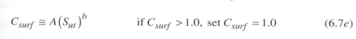
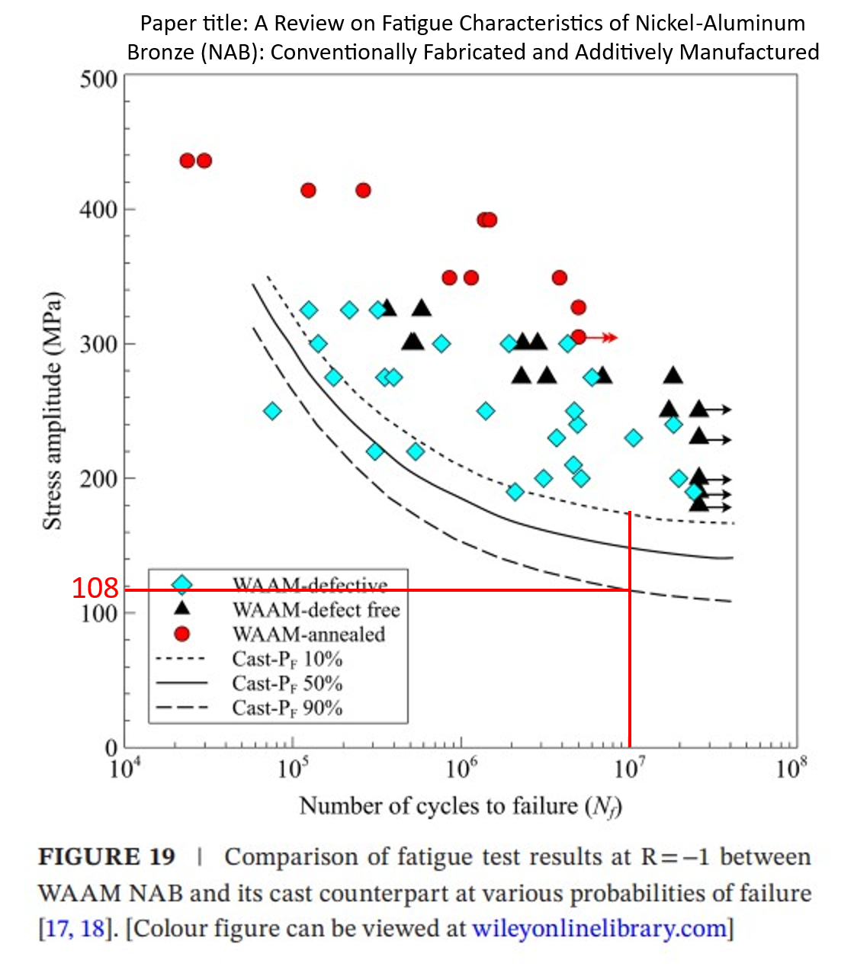
- Roshan et al
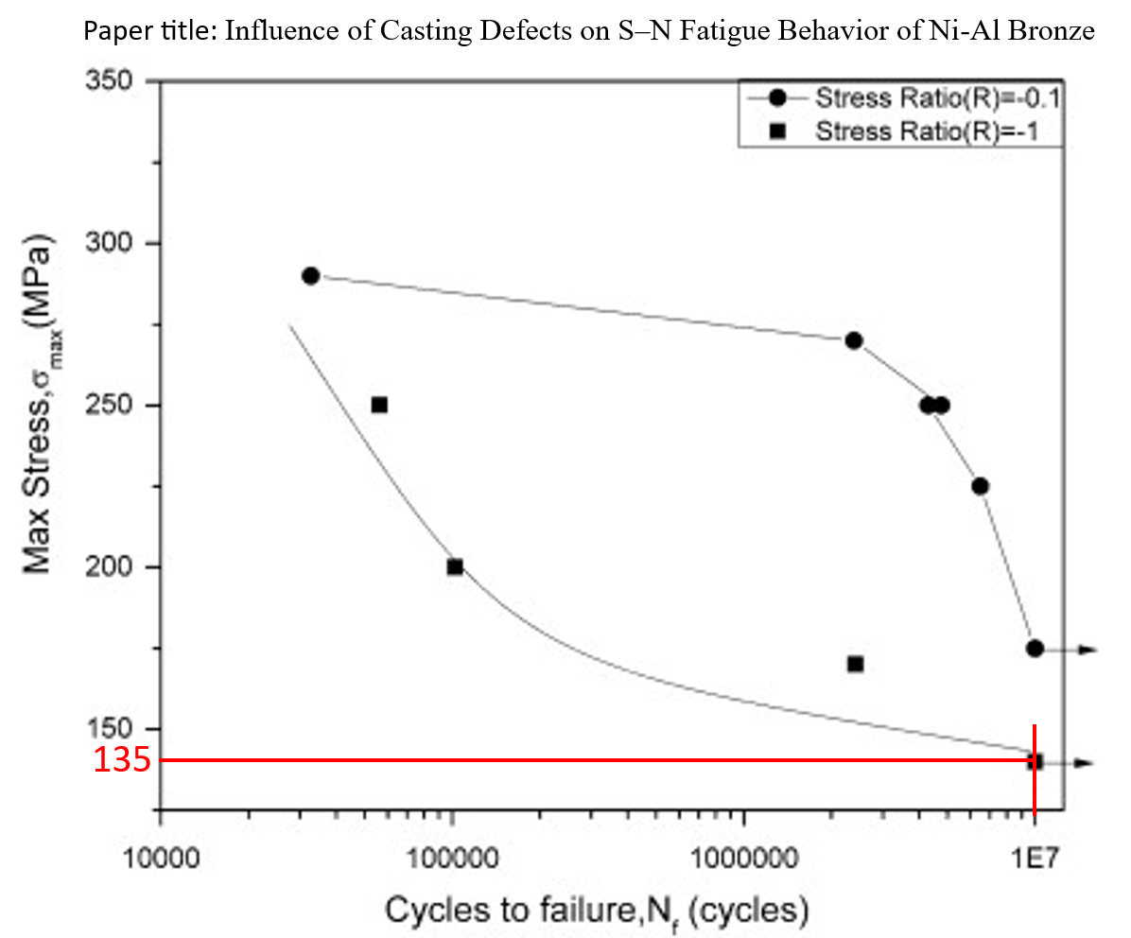
- Sarkar et al
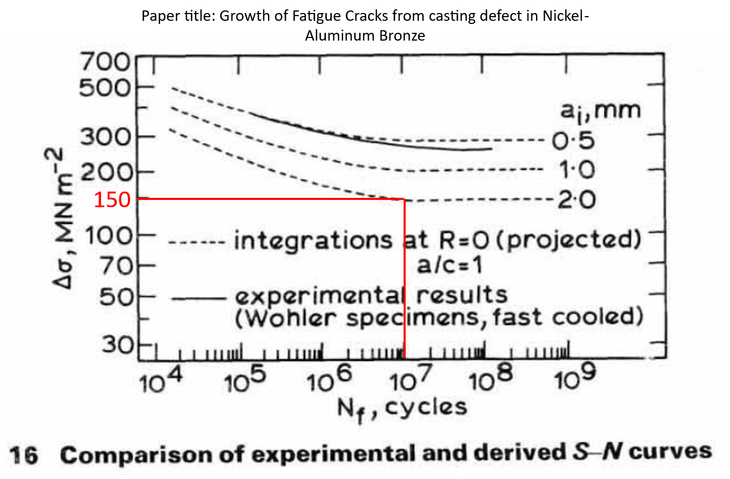(c) Taylor and Knott 1982
Figure 75 NAB Fatigue Curves
Table 29 Allowable calculations for NAB
Material | Surface Roughness Factor |  | Fatigue Allowable
 |  | Page 80
 |  | Figure 75 (a) of this report
BS2874 CA104 | 0.551447311 | 108 | 59.55630959

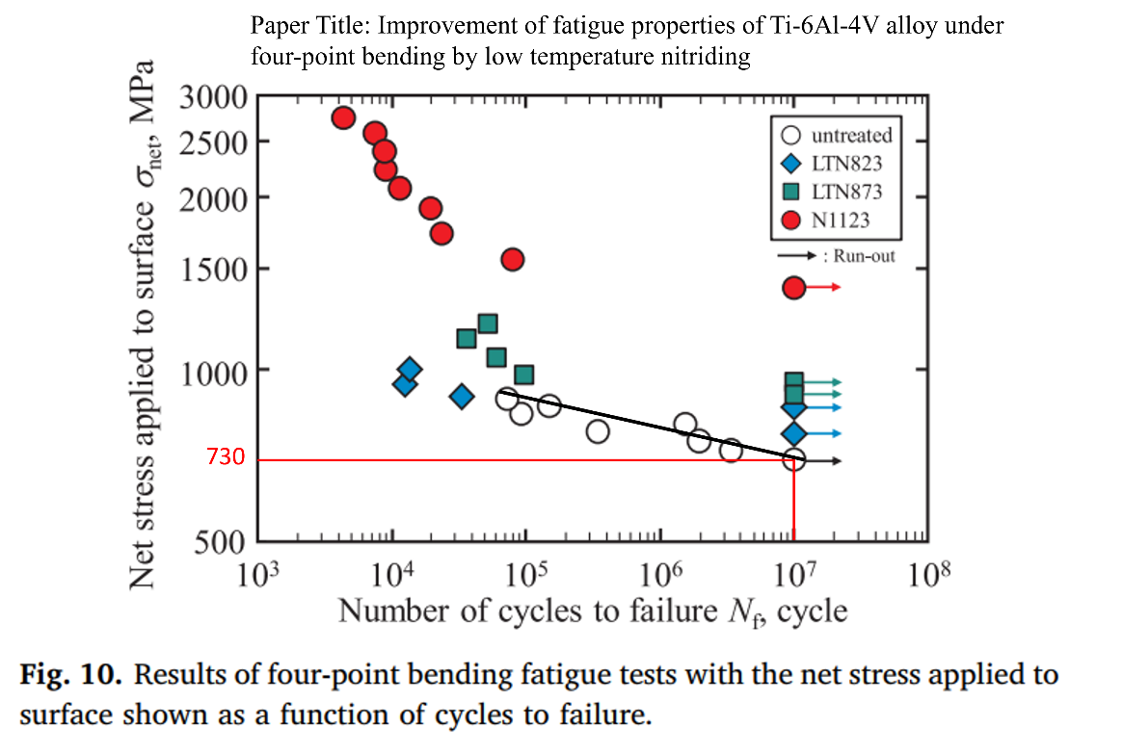
(a) Kikuchi et al
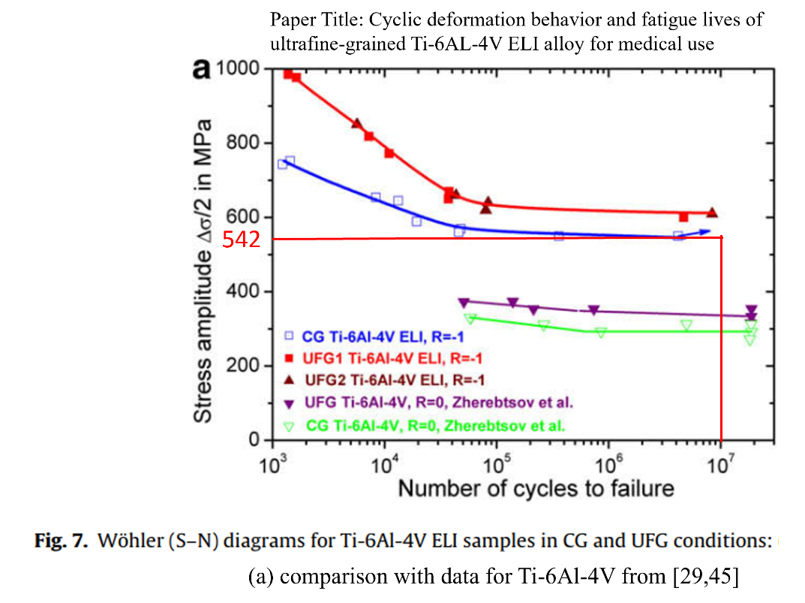
(b) Siatova et al
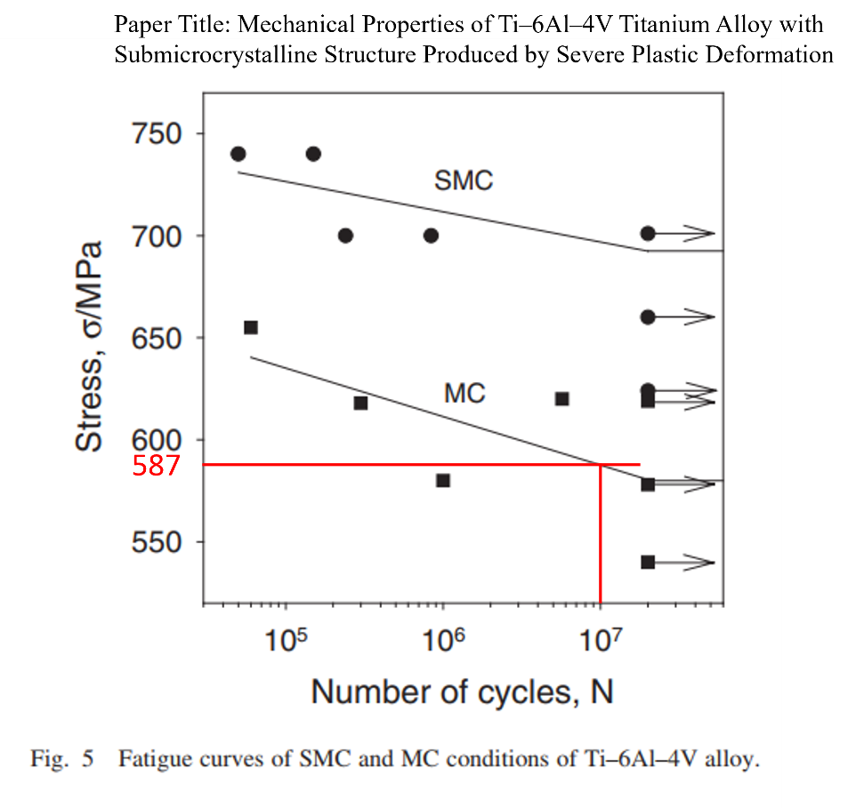
(c) Zherebtsov et al
Figure 76 Ti Gr 5 Fatigue Curves
Table 30 Allowable Calculations for Ti Gr 5
Material | Surface Roughness Factor | Page 81 of this Report | Fatigue Allowable
 |  | Figure 76 (b)
ASTM B 367 Gr.5 | 0.43829536 | 542 | 237.5560851
ASTM B 348 Gr.5 | 0.43829536 | 542 | 237.5560851

Load Case - 5 Shock Analysis - Transient Approach
Shock analysis has been conducted to replicate and evaluate the structural integrity of the valve under the dynamic shock loads which experiences when subjected to the K-200 Shock testing machine.
For shock analysis, two distinct methodologies are available: the transient shock approach and the Equivalent Static approach. The selection between these approaches is based on critical parameter namely, the first natural frequency of the structure as determined in the modal analysis.
In this specific scenario, the first natural frequency of the valve established through modal analysis is above the threshold of 160 Hz. Consequently, the chosen methodology for simulating and estimating the shock strength of the valve is the Equivalent Static Approach. This approach effectively captures and quantifies the valve's ability to withstand and respond to the shock loads it experiences during its operation on the K-200 Shock testing machine. Shock analysis is performed in 3 directions of shock loads i.e., X, Y and Z direction.

Shock Analysis Boundary And Loading Conditions For Transient Analysis
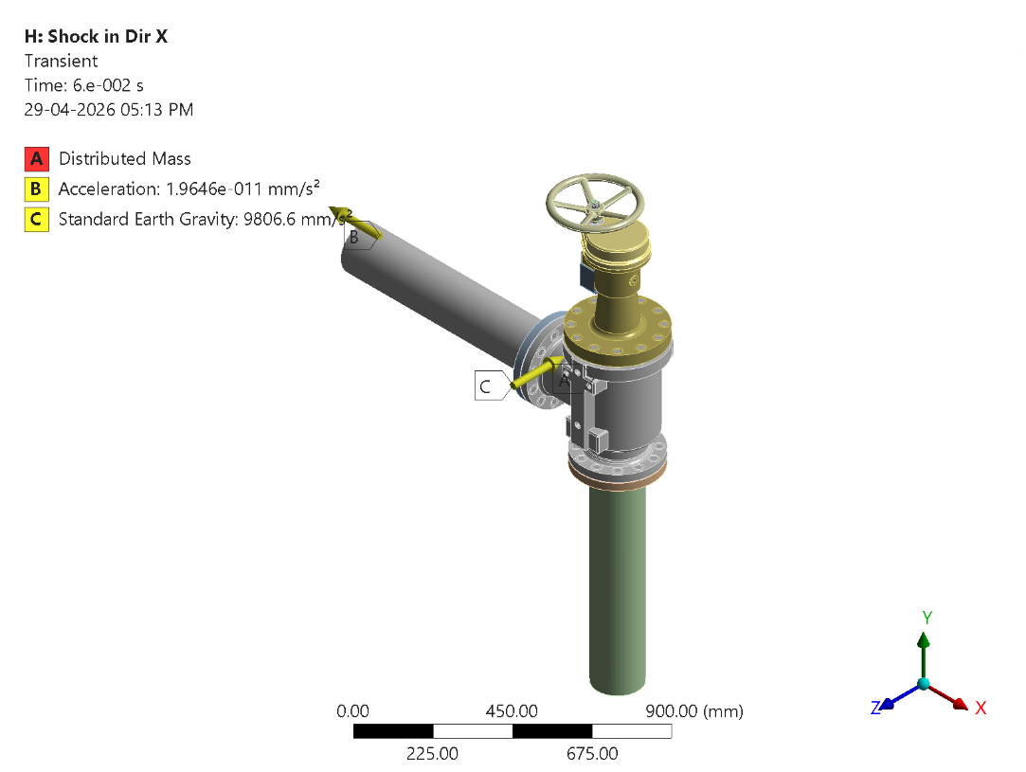
Figure 109 - Transient Analysis: Boundary Conditions
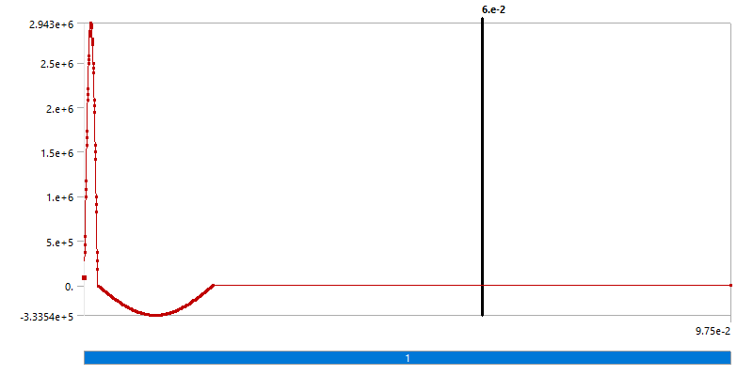
Figure 110 - Transient: Transient - Shock Load
Table 29 - Analysis Settings
Property | Value
Boundary Condition | Fixed Support
Base Excitation | Yes
Absolute Result | No
Magnitude | Tabular Data
Direction | X Axis
Suppressed | No
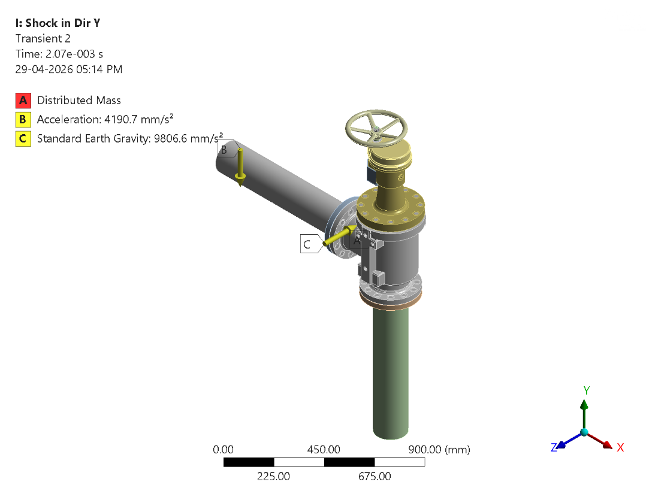
Figure 111 - Transient Analysis: Boundary Conditions
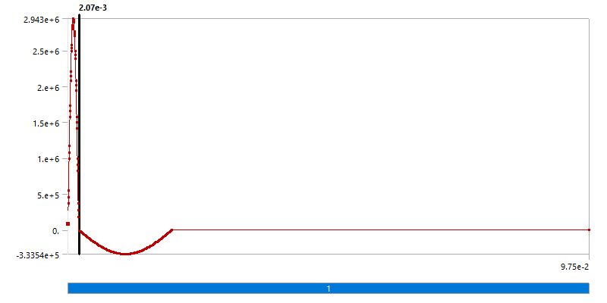
Figure 112 - Transient: Transient - Shock Load
Table 30 - Analysis Settings
Property | Value
Boundary Condition | Fixed Support
Base Excitation | Yes
Absolute Result | No
Magnitude | Tabular Data
Direction | Y Axis
Suppressed | No
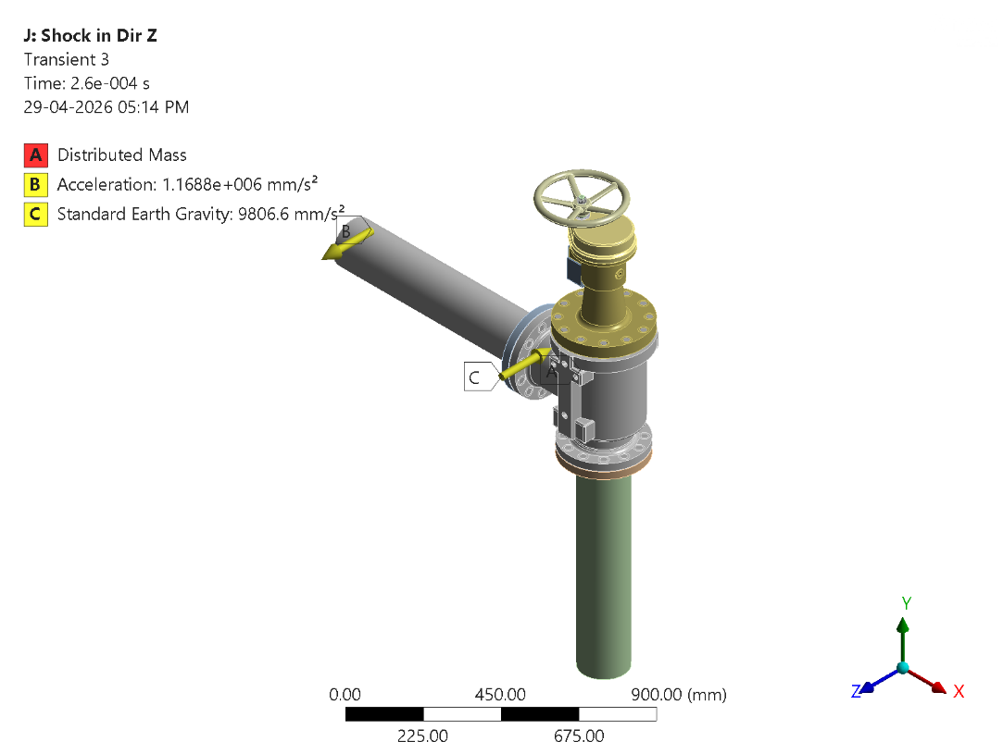
Figure 113 - Transient Analysis: Boundary Conditions
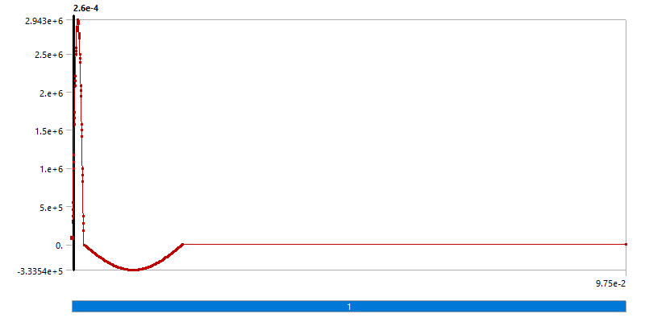
Figure 114 - Transient: Transient - Shock Load
Table 31 - Analysis Settings
Property | Value
Boundary Condition | Fixed Support
Base Excitation | Yes
Absolute Result | No
Magnitude | Tabular Data
Direction | Z Axis
Suppressed | No

Shock Pulse Specifications
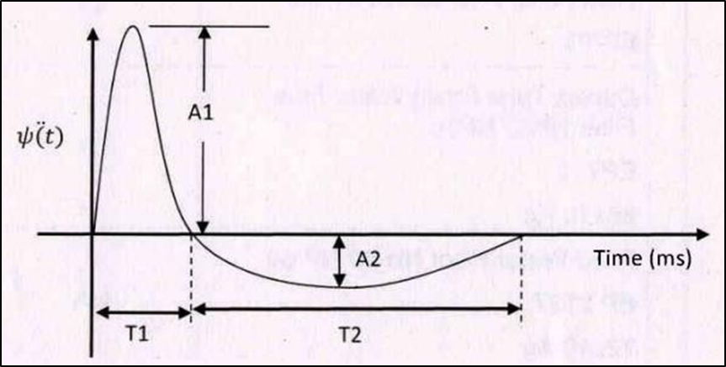
Figure 115 - Shock Analysis: Shock Pulse
Table 32 - Shock Pulse Specification Table
 | Vertical |  |  |  | Longitudinal |  |  |  | Horizontal
Weight (Kg) upto | A1 | T1 | A2 | T2 | A1 | T1 | A2 | T2 | A1 | T1 | A2 | T2
 | g | ms | g | ms | g | ms | g | ms | g | ms | g | ms
60 | 180 | 3 | 83.5 | 6.5 | 220 | 2.5 | 59.5 | 9 | 280 | 3 | 94 | 9
140 | 170 | 2 | 36 | 9.5 | 245 | 2.5 | 54 | 11.5 | 300 | 2 | 34 | 17.5
200 | 130 | 2.5 | 35 | 9 | 280 | 2.5 | 90.5 | 7.5 | 280 | 2 | 34 | 16.5

Results of Shock Analysis

Analysis Transient in X Direction
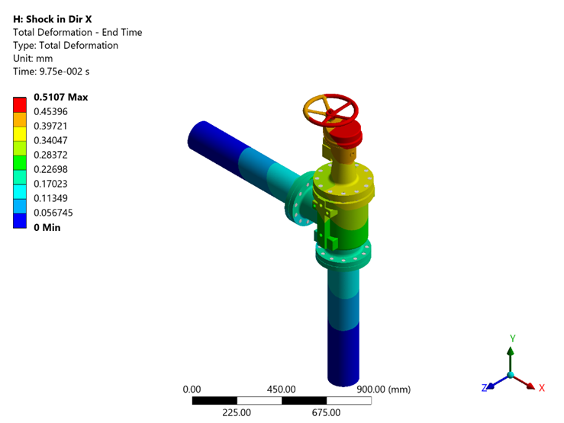
Figure 116 - Transient X: Total Deformation - End Time
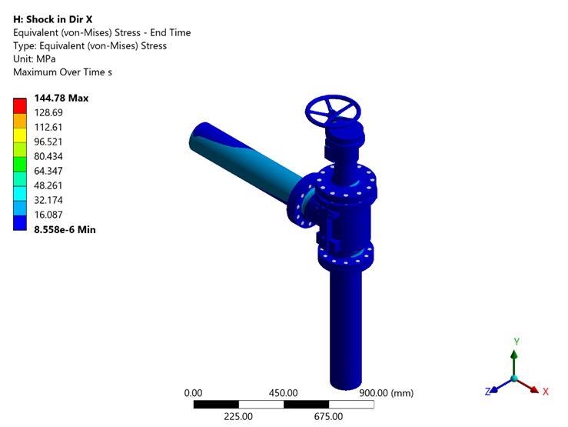
Figure 117 - Transient X: Equivalent (von-Mises) Stress - End Time
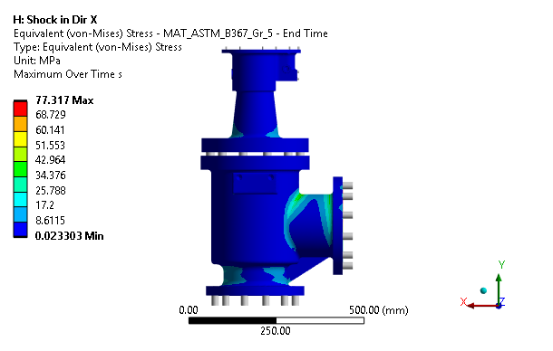
Figure 75 - Transient X: Equivalent (von-Mises) Stress - MAT_ASTM_B367_Gr_5 - End Time
The stress distribution shows a peak value of 77.317 MPa at the most critically loaded region, which is within the Static Allowable limit of 255.71 MPa. The design is deemed satisfactory.
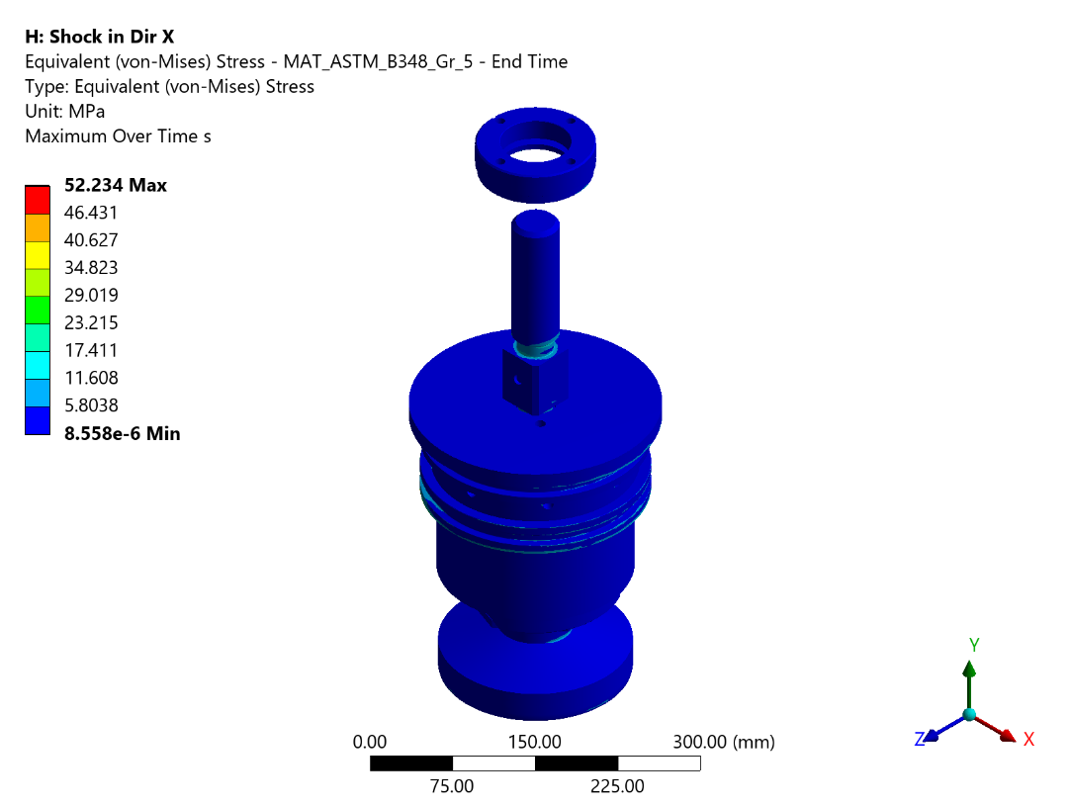
Figure 76 - Transient X: Equivalent (von-Mises) Stress - MAT_ASTM_B348_Gr_5 - End Time
The peak Von Mises stress in the component is 52.234 MPa, remaining below the Static Allowable stress of 255.71 MPa. The structural integrity of the component is confirmed.
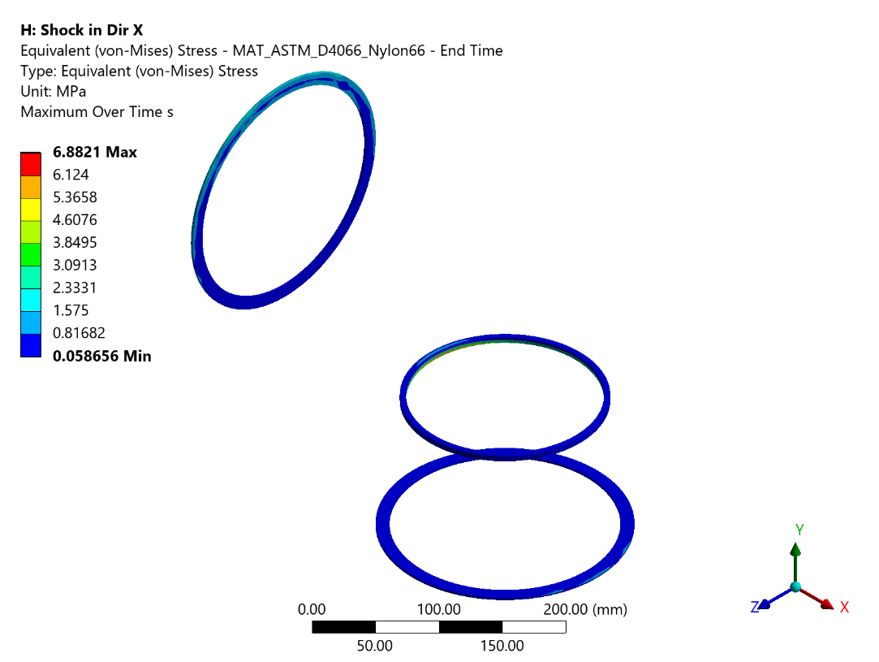
Figure 77 - Transient X: Equivalent (von-Mises) Stress - MAT_ASTM_D4066_Nylon66 - End Time
The stress distribution shows a peak value of 6.882 MPa at the most critically loaded region, which is within the Static Allowable limit of 28.57 MPa. The design is deemed satisfactory.
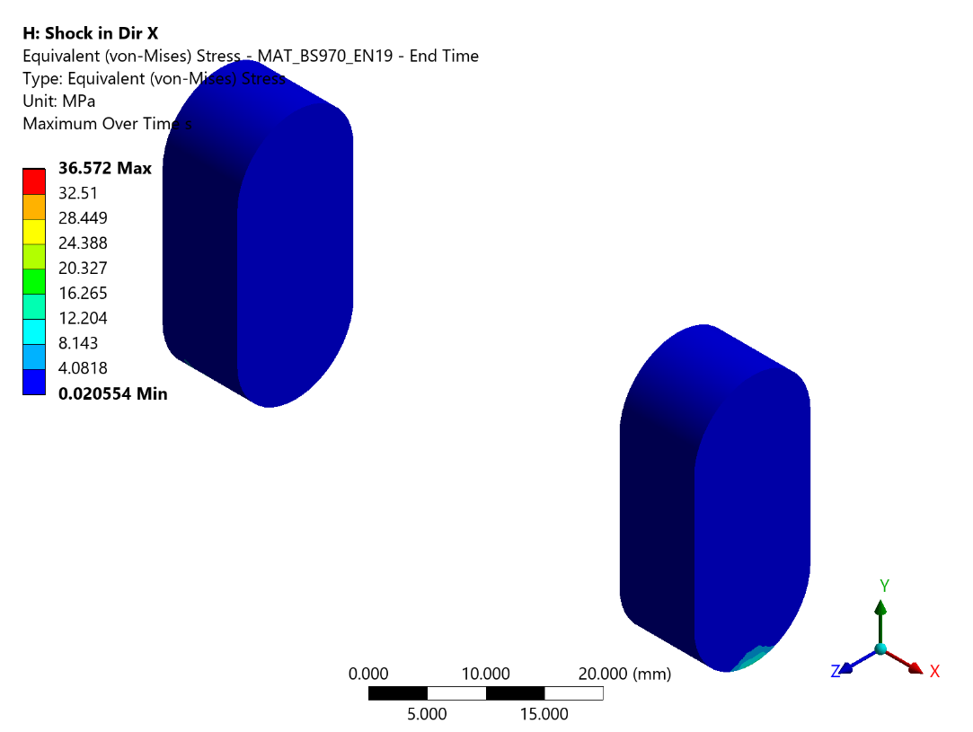
Figure 78 - Transient X: Equivalent (von-Mises) Stress - MAT_BS970_EN19 - End Time
FE analysis indicates a maximum stress of 36.572 MPa at the critical location, which does not exceed the Static Allowable stress of 199 MPa. The component satisfies the strength requirements.
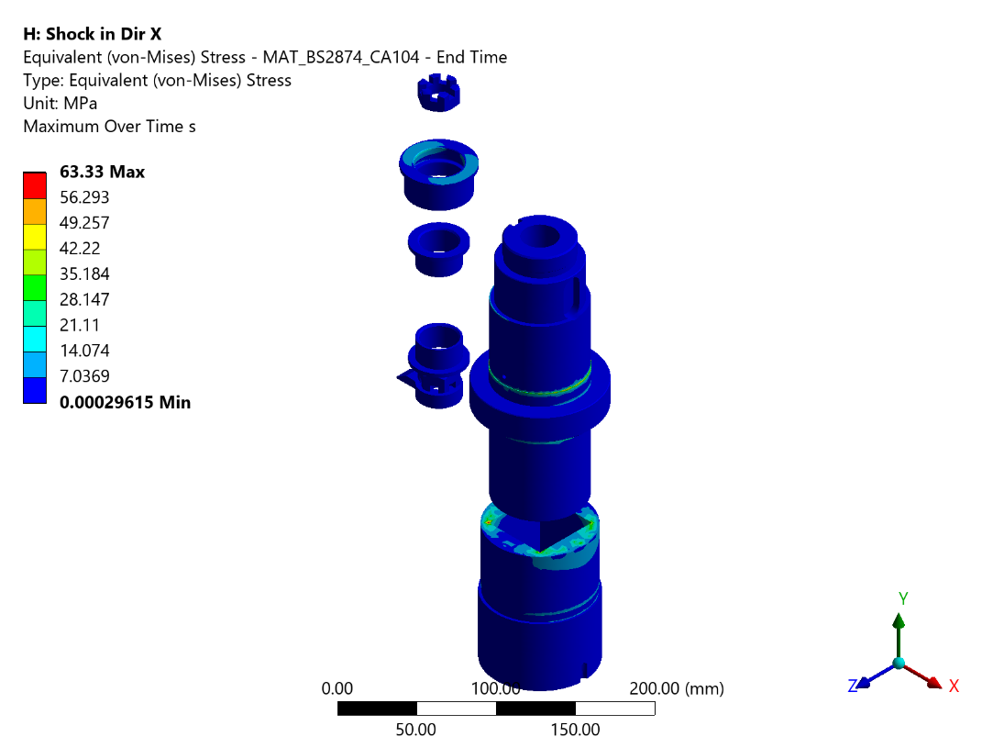
Figure 79 - Transient X: Equivalent (von-Mises) Stress - MAT_BS2874_CA104 - End Time
From the FEA results, the maximum stress developed is 63.33 MPa against an Static Allowable of 185.71 MPa. The factor of safety is adequate and the component is safe.
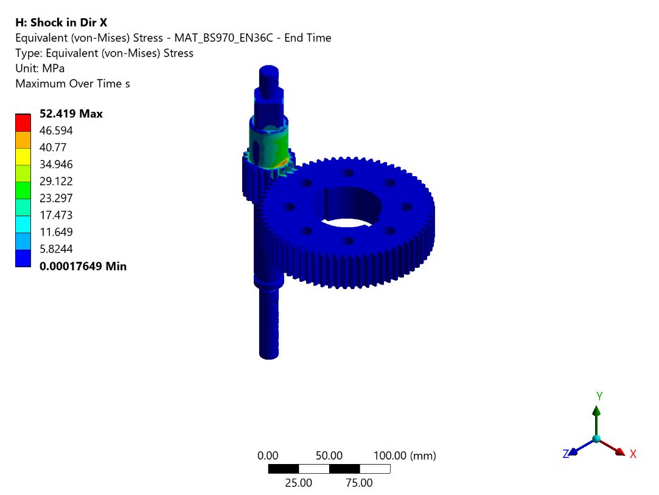
Figure 80 - Transient X: Equivalent (von-Mises) Stress - MAT_BS970_EN36C - End Time
The computed maximum stress of 52.419 MPa is found to be below the Static Allowable stress of 286 MPa, confirming that the component will perform reliably under the given loading.
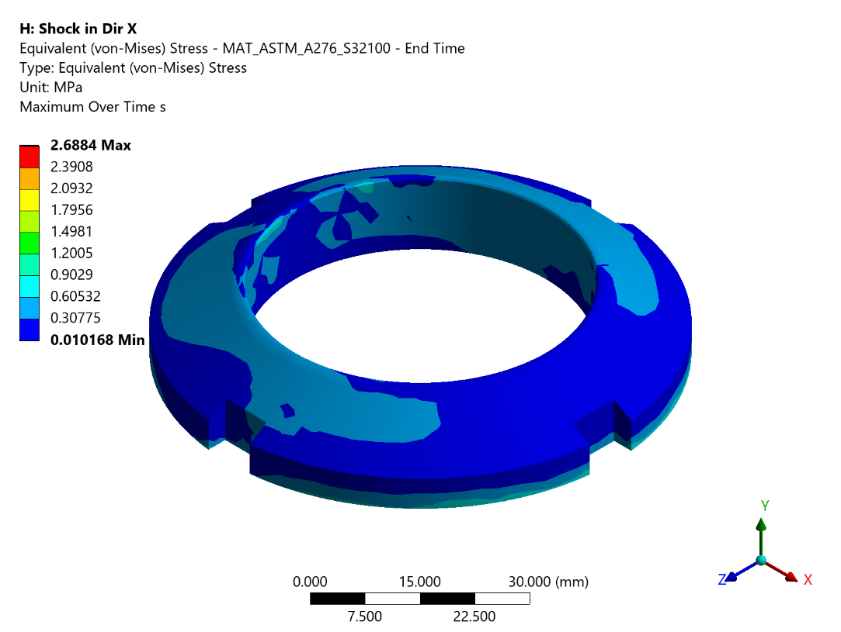
Figure 81 - Transient X: Equivalent (von-Mises) Stress - MAT_ASTM_A276_S32100 - End Time
From the FEA results, the maximum stress developed is 2.688 MPa against an Static Allowable of 136.67 MPa. The factor of safety is adequate and the component is safe.
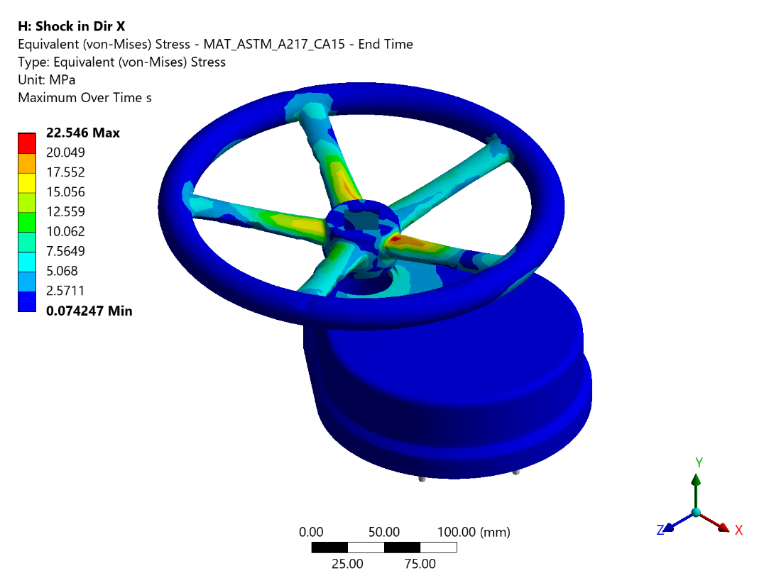
Figure 82 - Transient X: Equivalent (von-Mises) Stress - MAT_ASTM_A217_CA15 - End Time
The stress distribution shows a peak value of 22.546 MPa at the most critically loaded region, which is within the Static Allowable limit of 177.14 MPa. The design is deemed satisfactory.
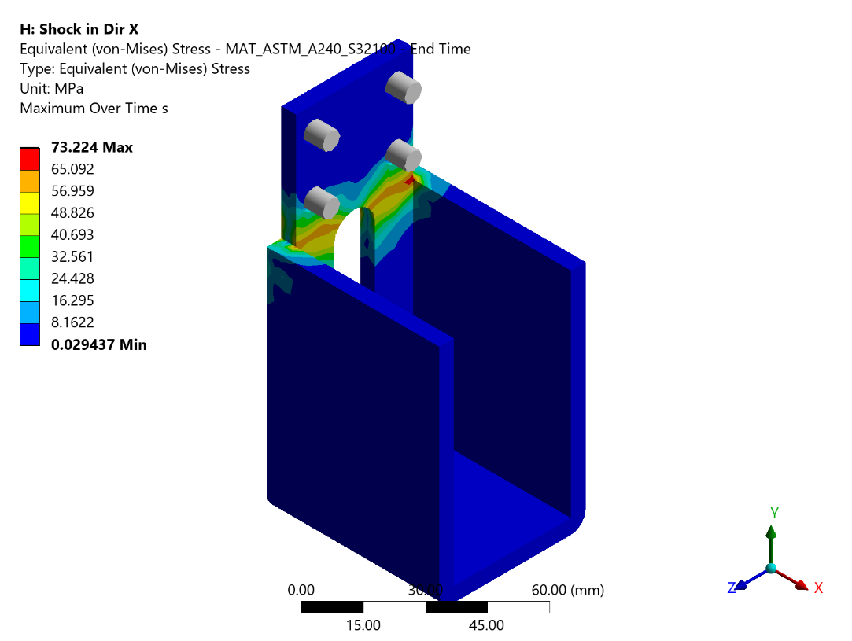
Figure 83 - Transient X: Equivalent (von-Mises) Stress - MAT_ASTM_A240_S32100 - End Time
FE analysis indicates a maximum stress of 73.224 MPa at the critical location, which does not exceed the Static Allowable stress of 136.67 MPa. The component satisfies the strength requirements.
Table 33 - Bolt Loads: Shock in X direction
Bolt No | Bolt Connection Group | Max Axial Force (N) | Max Shear Force (N) | Bolt Area (mm2) | Normal Stress (MPa) | Shear Stress (MPa) | Yield Stress MPa
1 | 1 Body To 14 Bonnet | 96.072 | 95.297 | 368.3 | 0.2609 | 0.2587 | 825
2 | 1 Body To 14 Bonnet | 89.81 | 111.7 | 368.3 | 0.2439 | 0.3033 | 825
3 | 1 Body To 14 Bonnet | 367.12 | 64.75 | 368.3 | 0.9968 | 0.1758 | 825
4 | 1 Body To 14 Bonnet | 200.1 | 11.496 | 368.3 | 0.5433 | 0.0312 | 825
5 | 1 Body To 14 Bonnet | 43.292 | 31.656 | 368.3 | 0.1175 | 0.086 | 825
6 | 1 Body To 14 Bonnet | 33.341 | 35.644 | 368.3 | 0.0905 | 0.0968 | 825
7 | 1 Body To 14 Bonnet | 196.25 | 12.941 | 368.3 | 0.5329 | 0.0351 | 825
8 | 1 Body To 14 Bonnet | 422.76 | 60.44 | 368.3 | 1.1479 | 0.1641 | 825
9 | 1 Body To 14 Bonnet | 114.85 | 103.68 | 368.3 | 0.3118 | 0.2815 | 825
10 | 1 Body To 14 Bonnet | 83.666 | 102.16 | 368.3 | 0.2272 | 0.2774 | 825
11 | 1 Body To 14 Bonnet | 143.88 | 48.917 | 368.3 | 0.3907 | 0.1328 | 825
12 | 1 Body To 14 Bonnet | 150.05 | 35.751 | 368.3 | 0.4074 | 0.0971 | 825
13 | Outlet Flange To 1 Body | 244.89 | 192.62 | 303.4 | 0.8072 | 0.6349 | 825
14 | Outlet Flange To 1 Body | 320.63 | 226.5 | 303.4 | 1.0568 | 0.7465 | 825
15 | Outlet Flange To 1 Body | 289.86 | 223.29 | 303.4 | 0.9554 | 0.736 | 825
16 | Outlet Flange To 1 Body | 323.24 | 209.92 | 303.4 | 1.0654 | 0.6919 | 825
17 | Outlet Flange To 1 Body | 313.41 | 201.98 | 303.4 | 1.033 | 0.6657 | 825
18 | Outlet Flange To 1 Body | 213.88 | 180.11 | 303.4 | 0.7049 | 0.5936 | 825
19 | Outlet Flange To 1 Body | 130.15 | 169.41 | 303.4 | 0.429 | 0.5584 | 825
20 | Outlet Flange To 1 Body | 83.883 | 165.72 | 303.4 | 0.2765 | 0.5462 | 825
21 | Outlet Flange To 1 Body | 64.174 | 145.86 | 303.4 | 0.2115 | 0.4808 | 825
22 | Outlet Flange To 1 Body | 90.79 | 140.36 | 303.4 | 0.2992 | 0.4626 | 825
23 | Outlet Flange To 1 Body | 149.95 | 153.56 | 303.4 | 0.4942 | 0.5061 | 825
24 | Outlet Flange To 1 Body | 65.431 | 134.43 | 303.4 | 0.2157 | 0.4431 | 825
25 | Inlet Flange To 1 Body | 183.94 | 157.45 | 303.4 | 0.6063 | 0.519 | 825
26 | Inlet Flange To 1 Body | 199.67 | 118.9 | 303.4 | 0.6581 | 0.3919 | 825
27 | Inlet Flange To 1 Body | 200.79 | 92.97 | 303.4 | 0.6618 | 0.3064 | 825
28 | Inlet Flange To 1 Body | 171.64 | 104.2 | 303.4 | 0.5657 | 0.3434 | 825
29 | Inlet Flange To 1 Body | 55.364 | 127.74 | 303.4 | 0.1825 | 0.421 | 825
30 | Inlet Flange To 1 Body | 206.66 | 149.03 | 303.4 | 0.6811 | 0.4912 | 825
31 | Inlet Flange To 1 Body | 393.81 | 163.51 | 303.4 | 1.298 | 0.5389 | 825
32 | Inlet Flange To 1 Body | 506.26 | 172.15 | 303.4 | 1.6686 | 0.5674 | 825
33 | Inlet Flange To 1 Body | 523.44 | 200.18 | 303.4 | 1.7252 | 0.6598 | 825
34 | Inlet Flange To 1 Body | 350.52 | 222.79 | 303.4 | 1.1553 | 0.7343 | 825
35 | Inlet Flange To 1 Body | 107.85 | 194.43 | 303.4 | 0.3555 | 0.6408 | 825
36 | Inlet Flange To 1 Body | 464.58 | 227.81 | 303.4 | 1.5312 | 0.7509 | 825
37 | 14 Bonnet To 25 Top Cover | 0.584 | 0.8518 | 20.1 | 0.0291 | 0.0424 | 320
38 | 14 Bonnet To 25 Top Cover | 9.6448 | 0.2918 | 20.1 | 0.4798 | 0.0145 | 320
39 | 14 Bonnet To 25 Top Cover | 5.1359 | 1.0333 | 20.1 | 0.2555 | 0.0514 | 320
40 | 14 Bonnet To 25 Top Cover | 4.0825 | 1.0616 | 20.1 | 0.2031 | 0.0528 | 320
41 | 14 Bonnet To 25 Top Cover | 0.5756 | 0.8479 | 20.1 | 0.0286 | 0.0422 | 320
42 | 14 Bonnet To 25 Top Cover | 0.7476 | 1.1651 | 20.1 | 0.0372 | 0.058 | 320
43 | 14 Bonnet To 25 Top Cover | 1.6967 | 1.2317 | 20.1 | 0.0844 | 0.0613 | 320
44 | 14 Bonnet To 25 Top Cover | 1.9451 | 1.1065 | 20.1 | 0.0968 | 0.055 | 320
45 | 14 Bonnet To 25 Top Cover | 0.7294 | 1.1048 | 20.1 | 0.0363 | 0.055 | 320
46 | 14 Bonnet To 25 Top Cover | 0.4869 | 1.0326 | 20.1 | 0.0242 | 0.0514 | 320
47 | 14 Bonnet To 25 Top Cover | 0.5813 | 1.0853 | 20.1 | 0.0289 | 0.054 | 320
48 | 14 Bonnet To 32 Side Cover | 6.2128 | 2.6622 | 20.1 | 0.3091 | 0.1324 | 320
49 | 14 Bonnet To 32 Side Cover | 0.7721 | 20.927 | 20.1 | 0.0384 | 1.0411 | 320
50 | 14 Bonnet To 32 Side Cover | 6.5264 | 2.7331 | 20.1 | 0.3247 | 0.136 | 320
51 | 14 Bonnet To 32 Side Cover | 2.2697 | 20.525 | 20.1 | 0.1129 | 1.0211 | 320

Analysis Transient in Y Direction
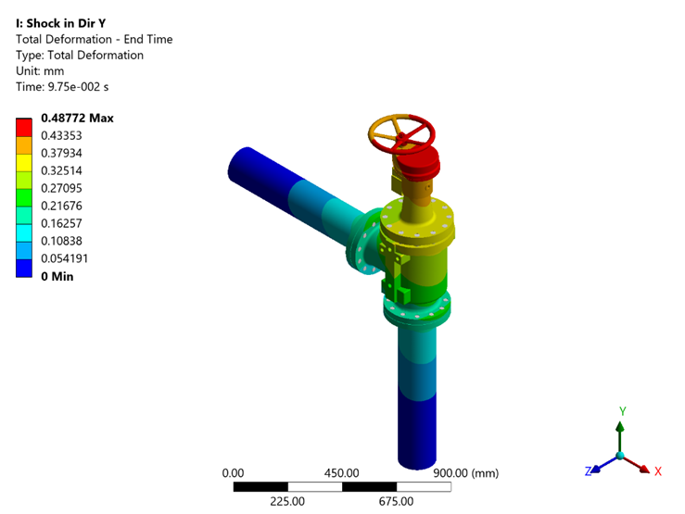
Figure 127 - Transient Y: Total Deformation - End Time
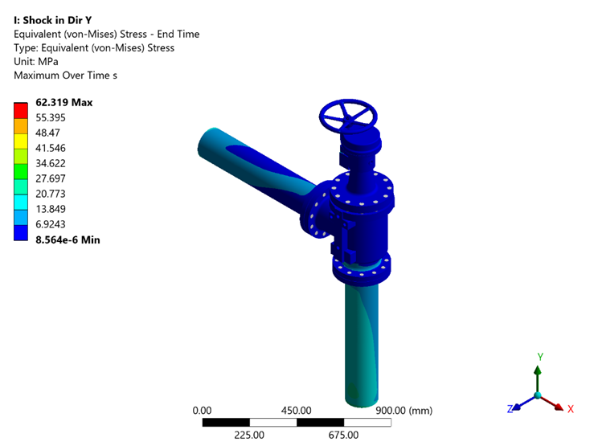
Figure 128 - Transient Y: Equivalent (von-Mises) Stress - End Time
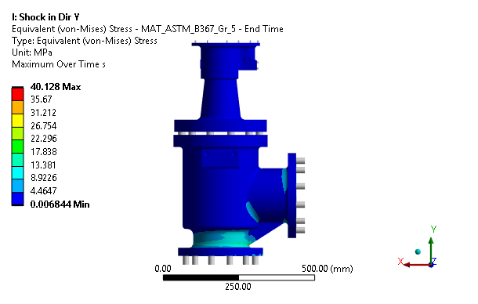
Figure 86 - Transient Y: Equivalent (von-Mises) Stress - MAT_ASTM_B367_Gr_5 - End Time
FE analysis indicates a maximum stress of 40.128 MPa at the critical location, which does not exceed the Static Allowable stress of 255.71 MPa. The component satisfies the strength requirements.
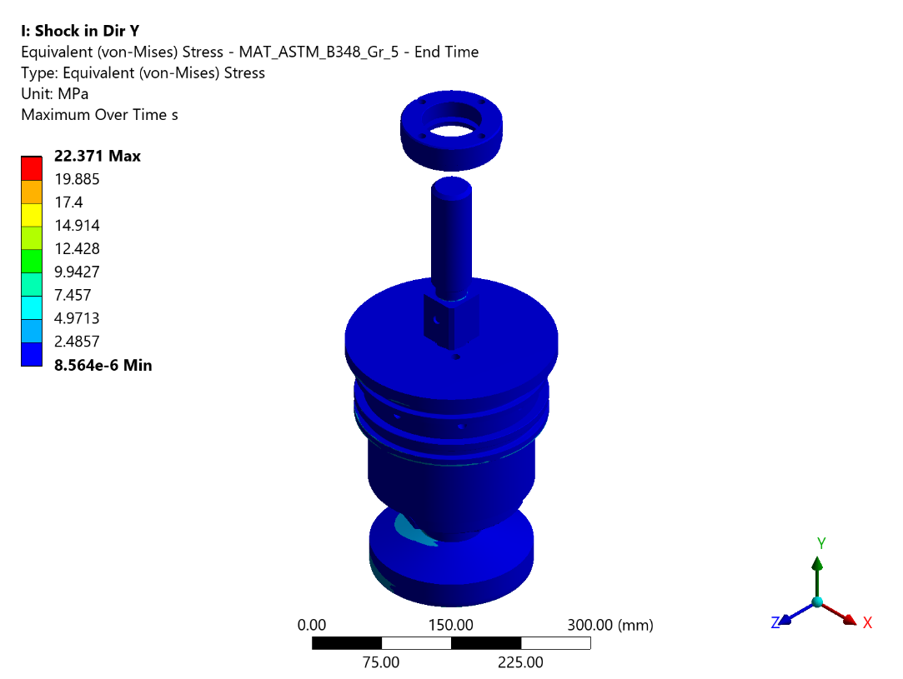
Figure 87 - Transient Y: Equivalent (von-Mises) Stress - MAT_ASTM_B348_Gr_5 - End Time
The equivalent stress contour reveals a maximum value of 22.371 MPa, which is less than the allowable limit of 255.71 MPa. Hence the component is structurally adequate.
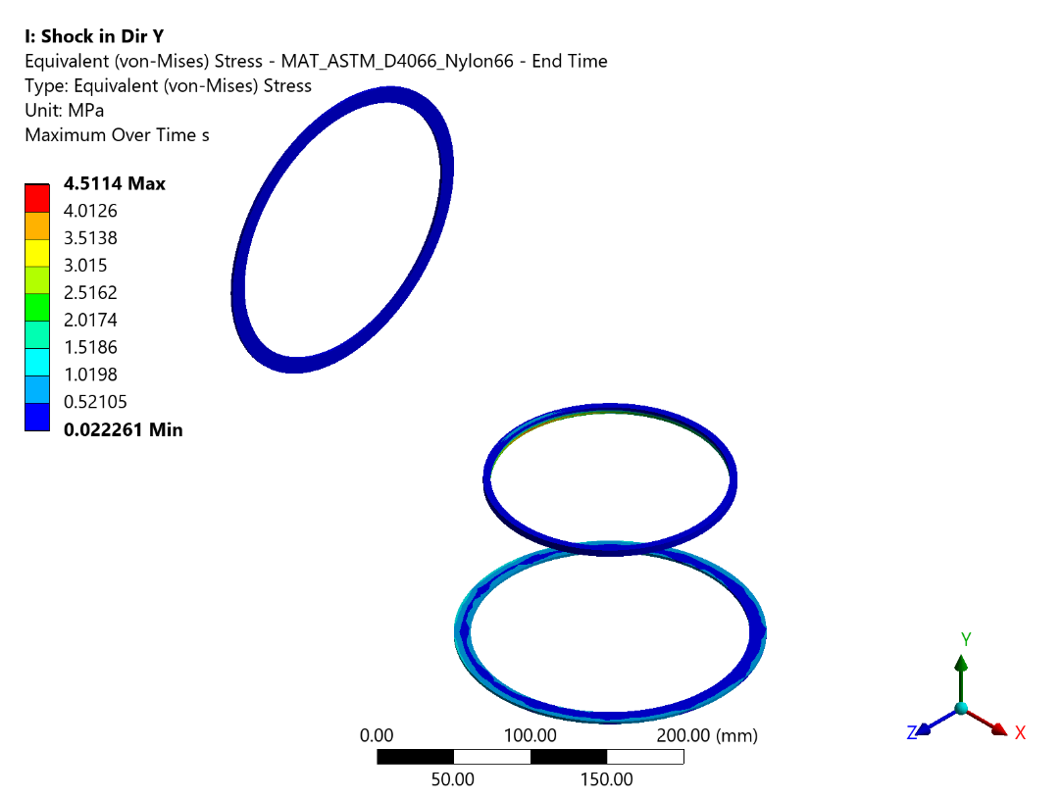
Figure 88 - Transient Y: Equivalent (von-Mises) Stress - MAT_ASTM_D4066_Nylon66 - End Time
Analysis results confirm that the highest stress value of 4.511 MPa does not breach the Static Allowable threshold of 28.57 MPa. The component meets the design safety criteria.
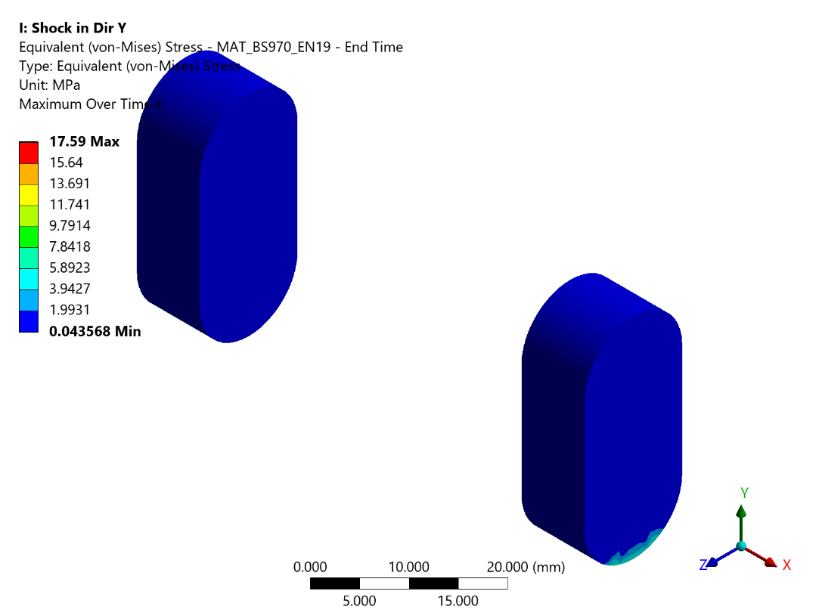
Figure 89 - Transient Y: Equivalent (von-Mises) Stress - MAT_BS970_EN19 - End Time
From the FEA results, the maximum stress developed is 17.59 MPa against an Static Allowable of 199 MPa. The factor of safety is adequate and the component is safe.
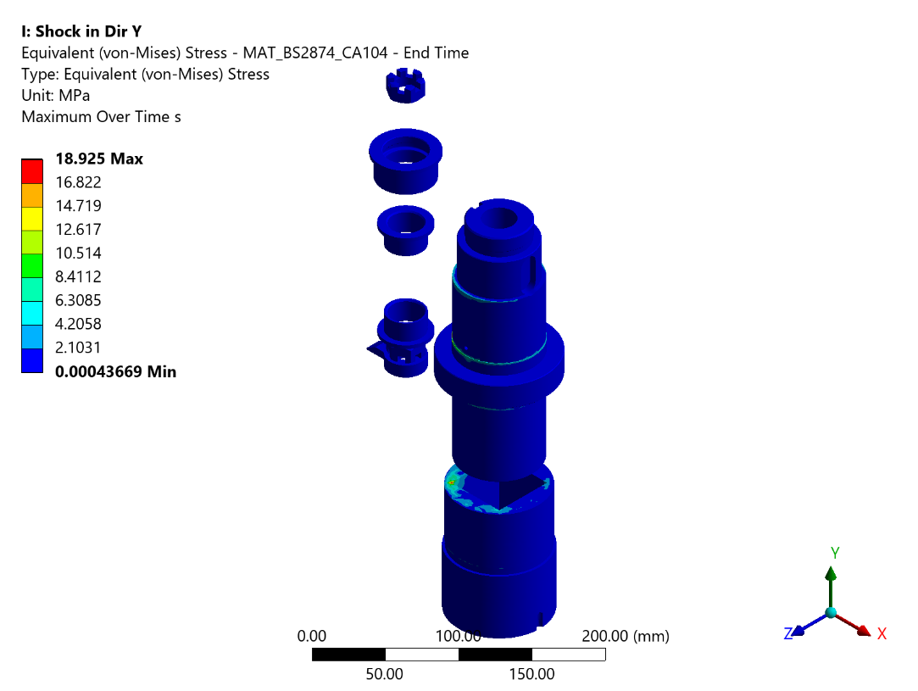
Figure 90 - Transient Y: Equivalent (von-Mises) Stress - MAT_BS2874_CA104 - End Time
The maximum equivalent stress observed is 18.925 MPa, which is within the Static Allowable limit of 185.71 MPa. The design is therefore considered safe under the applied loading conditions.
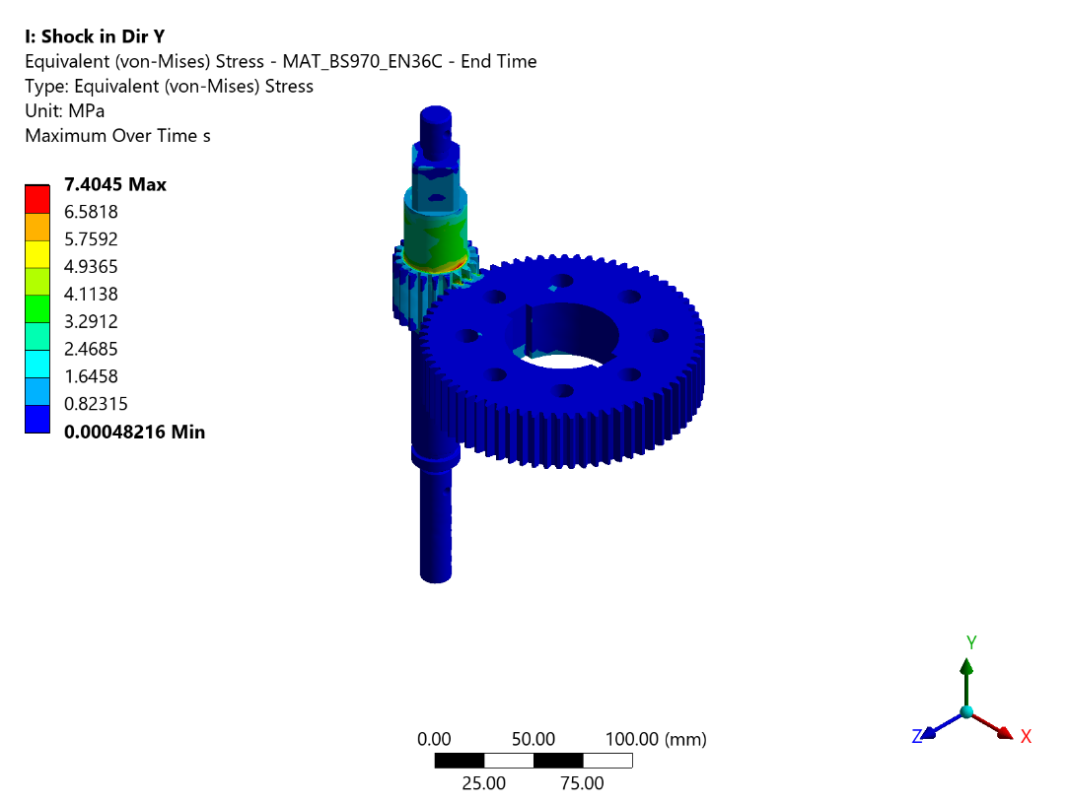
Figure 91 - Transient Y: Equivalent (von-Mises) Stress - MAT_BS970_EN36C - End Time
The equivalent stress contour reveals a maximum value of 7.405 MPa, which is less than the Static Allowable limit of 286.0 MPa. Hence the component is structurally adequate.
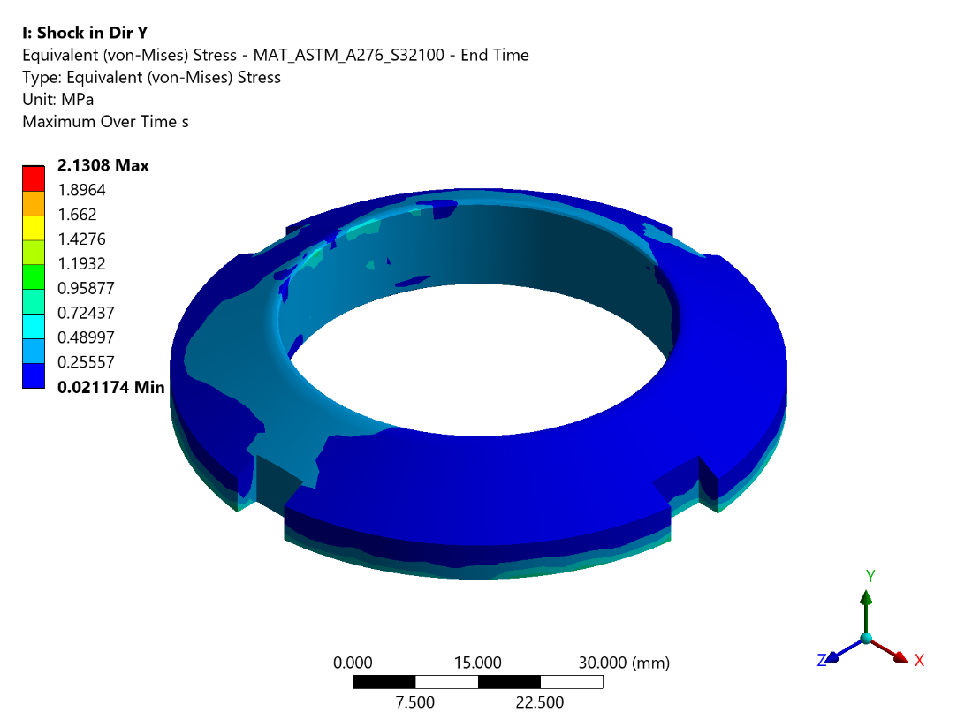
Figure 92 - Transient Y: Equivalent (von-Mises) Stress - MAT_ASTM_A276_S32100 - End Time
The stress distribution shows a peak value of 2.131 MPa at the most critically loaded region, which is within the Static Allowable limit of 136.67 MPa. The design is deemed satisfactory.
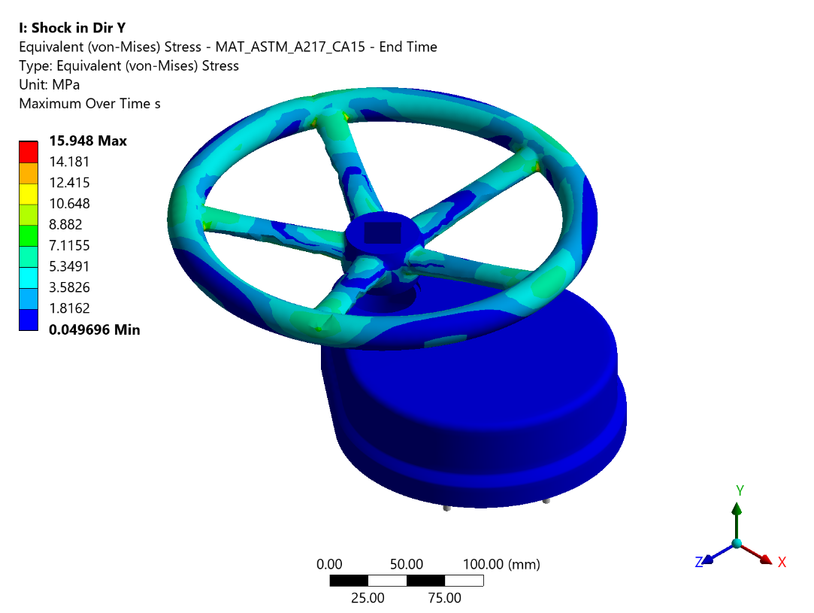
Figure 93 - Transient Y: Equivalent (von-Mises) Stress - MAT_ASTM_A217_CA15 - End Time
Analysis results confirm that the highest stress value of 15.948 MPa does not breach the Static Allowable threshold of 177.14 MPa. The component meets the design safety criteria.
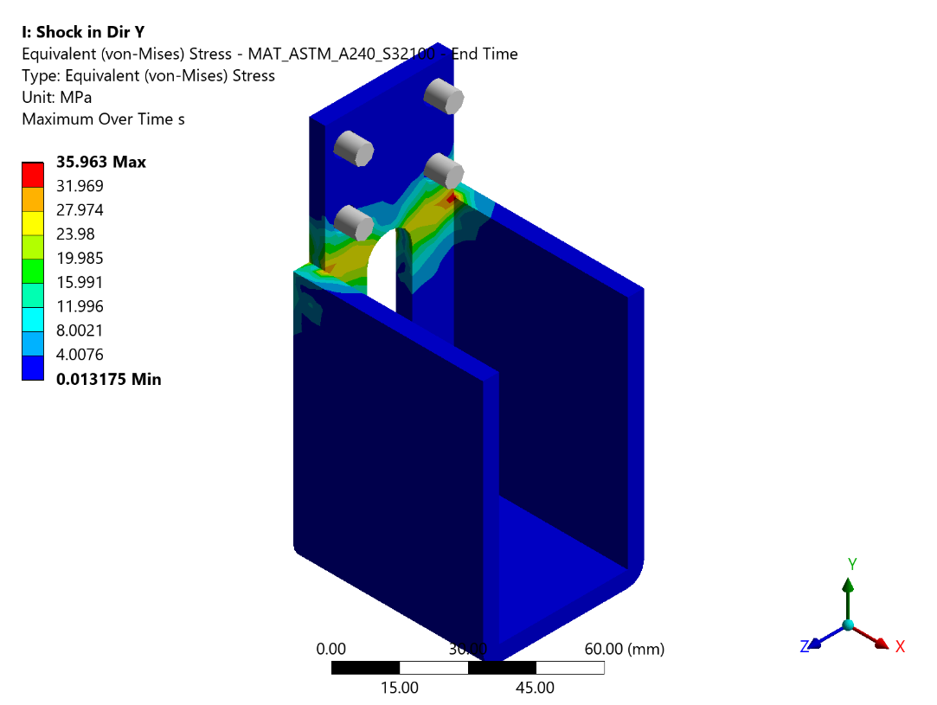
Figure 94 - Transient Y: Equivalent (von-Mises) Stress - MAT_ASTM_A240_S32100 - End Time
FE analysis indicates a maximum stress of 35.963 MPa at the critical location, which does not exceed the Static Allowable stress of 136.67 MPa. The component satisfies the strength requirements.
Table 34 - Bolt Loads: Shock in Y direction
Bolt No | Bolt Connection Group | Max Axial Force (N) | Max Shear Force (N) | Bolt Area (mm2) | Normal Stress (MPa) | Shear Stress (MPa) | Yield Stress MPa
1 | 1 Body To 14 Bonnet | 79.923 | 14.839 | 368.3 | 0.217 | 0.0403 | 825
2 | 1 Body To 14 Bonnet | 131.93 | 14.961 | 368.3 | 0.3582 | 0.0406 | 825
3 | 1 Body To 14 Bonnet | 190.15 | 7.2786 | 368.3 | 0.5163 | 0.0198 | 825
4 | 1 Body To 14 Bonnet | 148.4 | 17.953 | 368.3 | 0.4029 | 0.0487 | 825
5 | 1 Body To 14 Bonnet | 43.338 | 16.361 | 368.3 | 0.1177 | 0.0444 | 825
6 | 1 Body To 14 Bonnet | 30.067 | 16.882 | 368.3 | 0.0816 | 0.0458 | 825
7 | 1 Body To 14 Bonnet | 151.53 | 25.105 | 368.3 | 0.4114 | 0.0682 | 825
8 | 1 Body To 14 Bonnet | 318.45 | 15.34 | 368.3 | 0.8646 | 0.0417 | 825
9 | 1 Body To 14 Bonnet | 249.14 | 20.765 | 368.3 | 0.6765 | 0.0564 | 825
10 | 1 Body To 14 Bonnet | 100.2 | 20.283 | 368.3 | 0.2721 | 0.0551 | 825
11 | 1 Body To 14 Bonnet | 65.802 | 11.441 | 368.3 | 0.1787 | 0.0311 | 825
12 | 1 Body To 14 Bonnet | 63.271 | 10.076 | 368.3 | 0.1718 | 0.0274 | 825
13 | Outlet Flange To 1 Body | 50.184 | 268.1 | 303.4 | 0.1654 | 0.8837 | 825
14 | Outlet Flange To 1 Body | 64.231 | 275.31 | 303.4 | 0.2117 | 0.9074 | 825
15 | Outlet Flange To 1 Body | 53.955 | 238.52 | 303.4 | 0.1778 | 0.7862 | 825
16 | Outlet Flange To 1 Body | 56.478 | 210.89 | 303.4 | 0.1862 | 0.6951 | 825
17 | Outlet Flange To 1 Body | 58.921 | 198.43 | 303.4 | 0.1942 | 0.654 | 825
18 | Outlet Flange To 1 Body | 43.476 | 179.37 | 303.4 | 0.1433 | 0.5912 | 825
19 | Outlet Flange To 1 Body | 65.876 | 159.65 | 303.4 | 0.2171 | 0.5262 | 825
20 | Outlet Flange To 1 Body | 120.68 | 144.82 | 303.4 | 0.3978 | 0.4773 | 825
21 | Outlet Flange To 1 Body | 124.26 | 136.85 | 303.4 | 0.4096 | 0.4511 | 825
22 | Outlet Flange To 1 Body | 129.54 | 176.61 | 303.4 | 0.427 | 0.5821 | 825
23 | Outlet Flange To 1 Body | 93.813 | 226.23 | 303.4 | 0.3092 | 0.7456 | 825
24 | Outlet Flange To 1 Body | 124.42 | 142.44 | 303.4 | 0.4101 | 0.4695 | 825
25 | Inlet Flange To 1 Body | 111.43 | 113.54 | 303.4 | 0.3673 | 0.3742 | 825
26 | Inlet Flange To 1 Body | 85.508 | 108.12 | 303.4 | 0.2818 | 0.3564 | 825
27 | Inlet Flange To 1 Body | 65.474 | 95.282 | 303.4 | 0.2158 | 0.314 | 825
28 | Inlet Flange To 1 Body | 72.805 | 104.01 | 303.4 | 0.24 | 0.3428 | 825
29 | Inlet Flange To 1 Body | 57.801 | 123.11 | 303.4 | 0.1905 | 0.4058 | 825
30 | Inlet Flange To 1 Body | 56.212 | 144.49 | 303.4 | 0.1853 | 0.4762 | 825
31 | Inlet Flange To 1 Body | 64.614 | 162.56 | 303.4 | 0.213 | 0.5358 | 825
32 | Inlet Flange To 1 Body | 66.527 | 173.05 | 303.4 | 0.2193 | 0.5704 | 825
33 | Inlet Flange To 1 Body | 61.711 | 175.84 | 303.4 | 0.2034 | 0.5796 | 825
34 | Inlet Flange To 1 Body | 110.4 | 149.27 | 303.4 | 0.3639 | 0.492 | 825
35 | Inlet Flange To 1 Body | 118.28 | 125.11 | 303.4 | 0.3898 | 0.4124 | 825
36 | Inlet Flange To 1 Body | 85.525 | 167.94 | 303.4 | 0.2819 | 0.5535 | 825
37 | 14 Bonnet To 25 Top Cover | 2.5319 | 0.2078 | 20.1 | 0.126 | 0.0103 | 320
38 | 14 Bonnet To 25 Top Cover | 1.6256 | 0.0431 | 20.1 | 0.0809 | 0.0021 | 320
39 | 14 Bonnet To 25 Top Cover | 3.2205 | 0.0849 | 20.1 | 0.1602 | 0.0042 | 320
40 | 14 Bonnet To 25 Top Cover | 2.2699 | 0.1219 | 20.1 | 0.1129 | 0.0061 | 320
41 | 14 Bonnet To 25 Top Cover | 2.5438 | 0.2229 | 20.1 | 0.1266 | 0.0111 | 320
42 | 14 Bonnet To 25 Top Cover | 2.6702 | 0.1811 | 20.1 | 0.1328 | 0.009 | 320
43 | 14 Bonnet To 25 Top Cover | 3.9604 | 0.2013 | 20.1 | 0.197 | 0.01 | 320
44 | 14 Bonnet To 25 Top Cover | 4.1528 | 0.3003 | 20.1 | 0.2066 | 0.0149 | 320
45 | 14 Bonnet To 25 Top Cover | 2.8515 | 0.2539 | 20.1 | 0.1419 | 0.0126 | 320
46 | 14 Bonnet To 25 Top Cover | 2.5705 | 0.2503 | 20.1 | 0.1279 | 0.0125 | 320
47 | 14 Bonnet To 25 Top Cover | 2.5527 | 0.1832 | 20.1 | 0.127 | 0.0091 | 320
48 | 14 Bonnet To 32 Side Cover | 1.9212 | 0.2435 | 20.1 | 0.0956 | 0.0121 | 320
49 | 14 Bonnet To 32 Side Cover | 6.5167 | 7.5373 | 20.1 | 0.3242 | 0.375 | 320
50 | 14 Bonnet To 32 Side Cover | 1.9822 | 0.2537 | 20.1 | 0.0986 | 0.0126 | 320
51 | 14 Bonnet To 32 Side Cover | 7.8221 | 7.2081 | 20.1 | 0.3892 | 0.3586 | 320

Analysis Transient in Z Direction
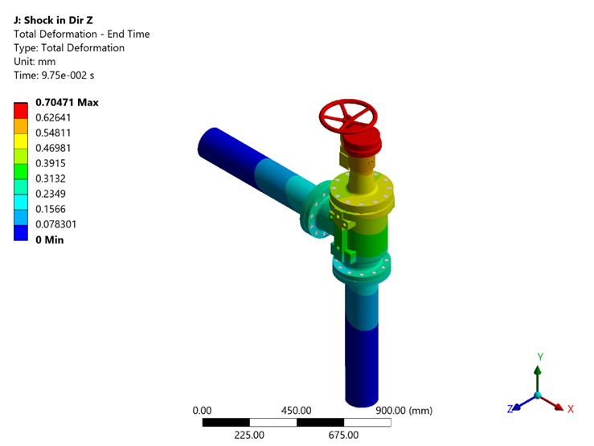
Figure 138 - Transient Z: Total Deformation - End Time
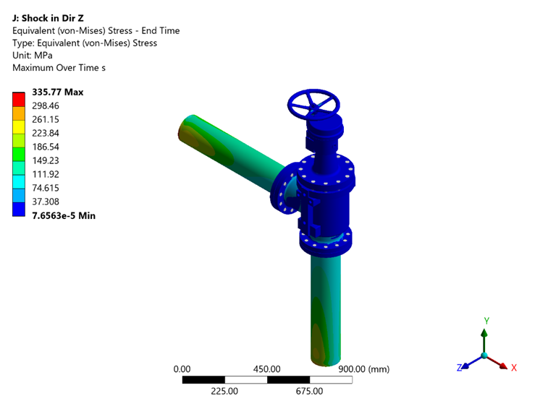
Figure 139 - Transient Z: Equivalent (von-Mises) Stress - End Time
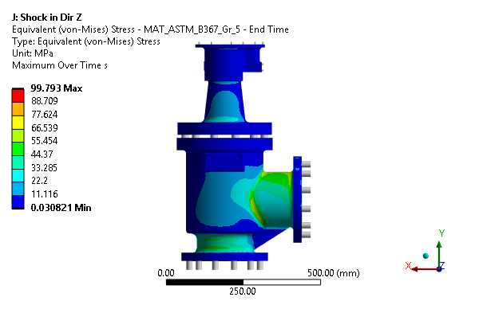
Figure 97 - Transient Z: Equivalent (von-Mises) Stress - MAT_ASTM_B367_Gr_5 - End Time
The stress distribution shows a peak value of 99.793 MPa at the most critically loaded region, which is within the Static Allowable limit of 255.71 MPa. The design is deemed satisfactory.
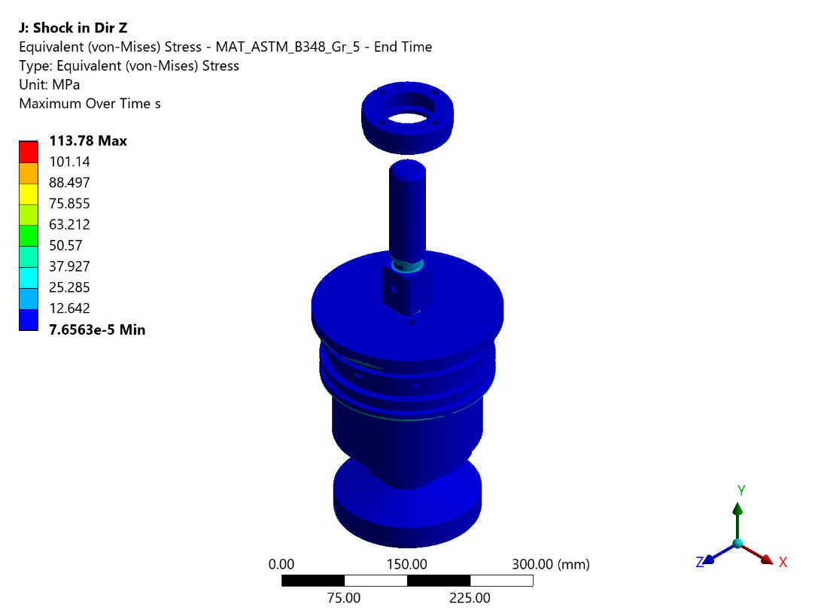
Figure 98 - Transient Z: Equivalent (von-Mises) Stress - MAT_ASTM_B348_Gr_5 - End Time
The computed maximum stress of 113.782 MPa is found to be below the Static Allowable of 255.71 MPa, confirming that the component will perform reliably under the given loading.
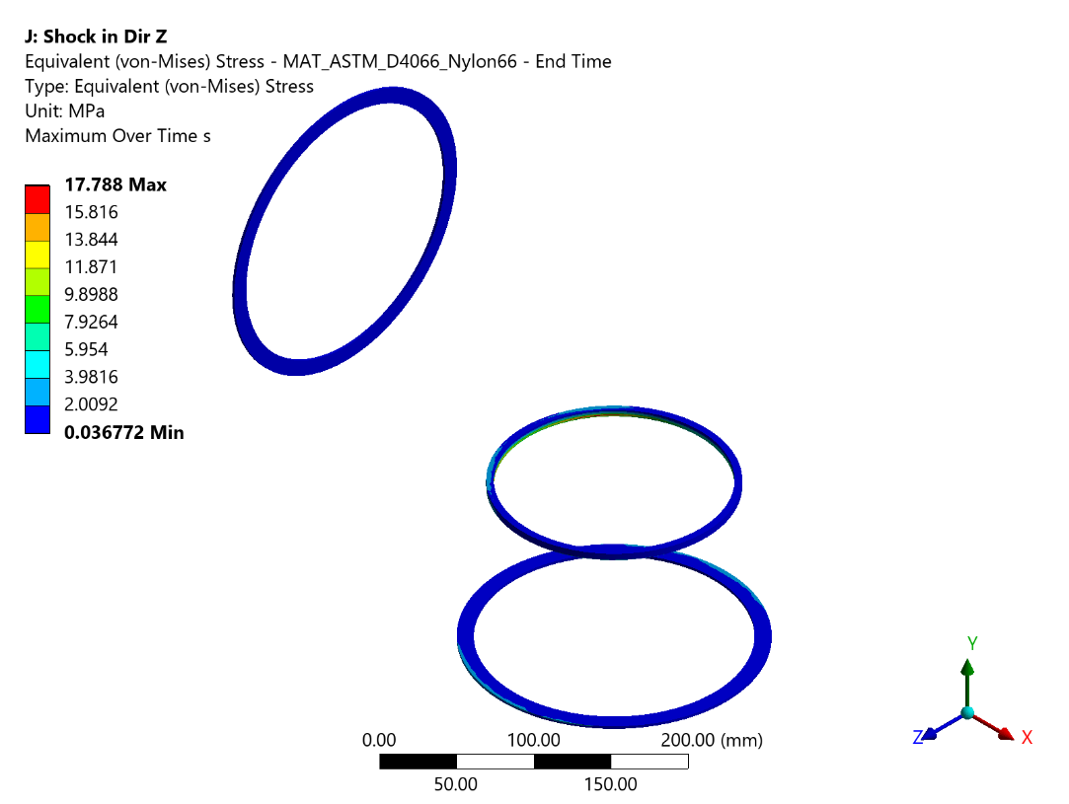
Figure 99 - Transient Z: Equivalent (von-Mises) Stress - MAT_ASTM_D4066_Nylon66 - End Time
Maximum stress computed from the finite element solution is 17.788 MPa, well within the Static Allowable of 28.57 MPa. No structural failure is anticipated.
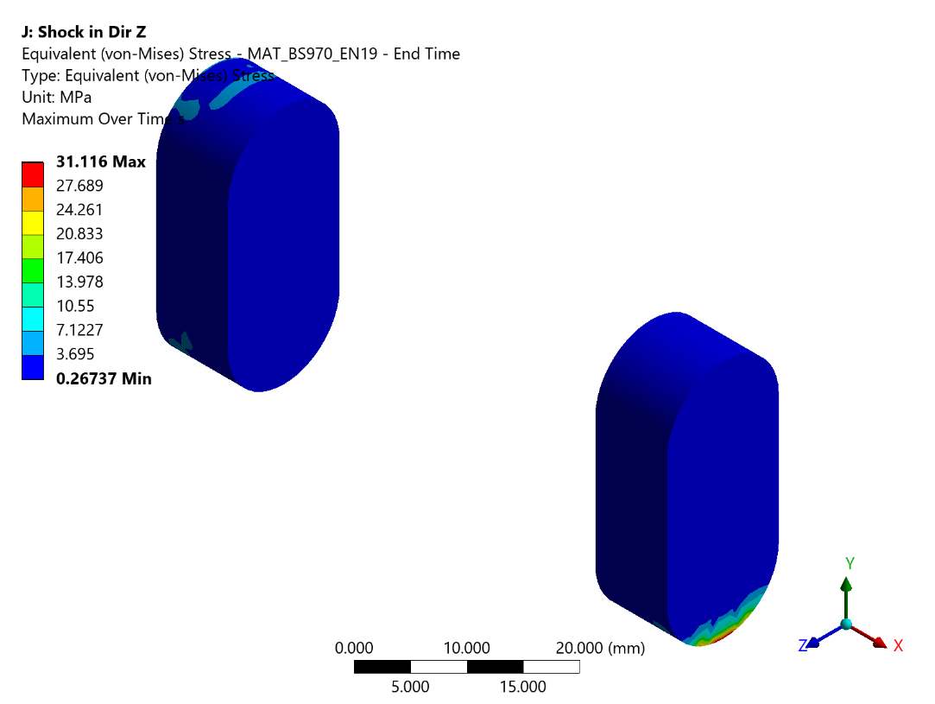
Figure 100 - Transient Z: Equivalent (von-Mises) Stress - MAT_BS970_EN19 - End Time
The equivalent stress contour reveals a maximum value of 31.116 MPa, which is less than the Static Allowable limit of 199 MPa. Hence the component is structurally adequate.
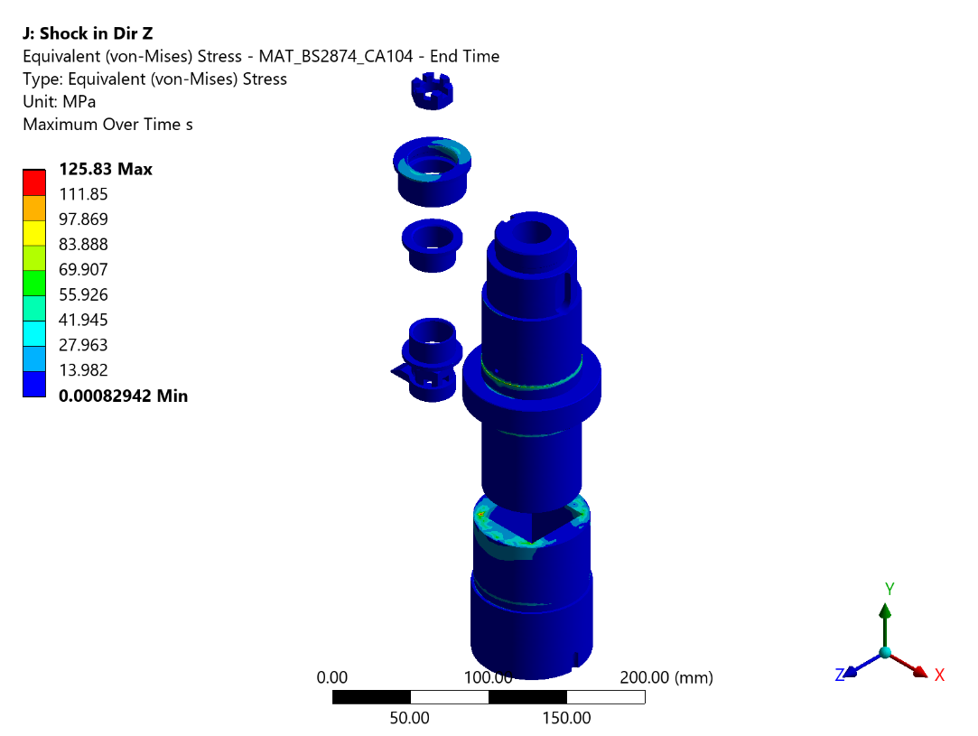
Figure 101 - Transient Z: Equivalent (von-Mises) Stress - MAT_BS2874_CA104 - End Time
The stress distribution shows a peak value of 125.832 MPa at the most critically loaded region, which is within the Static Allowable limit of 185.71 MPa. The design is deemed satisfactory.
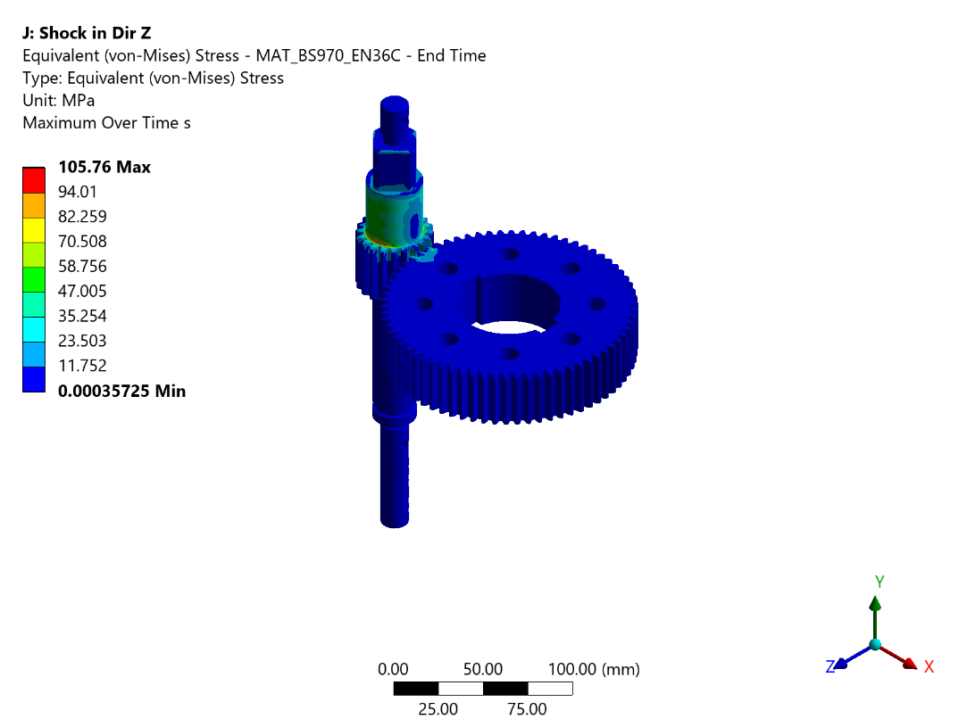
Figure 102 - Transient Z: Equivalent (von-Mises) Stress - MAT_BS970_EN36C - End Time
The peak Von Mises stress in the component is 105.761 MPa, remaining below the Static Allowable of 286.0 MPa. The structural integrity of the component is confirmed.
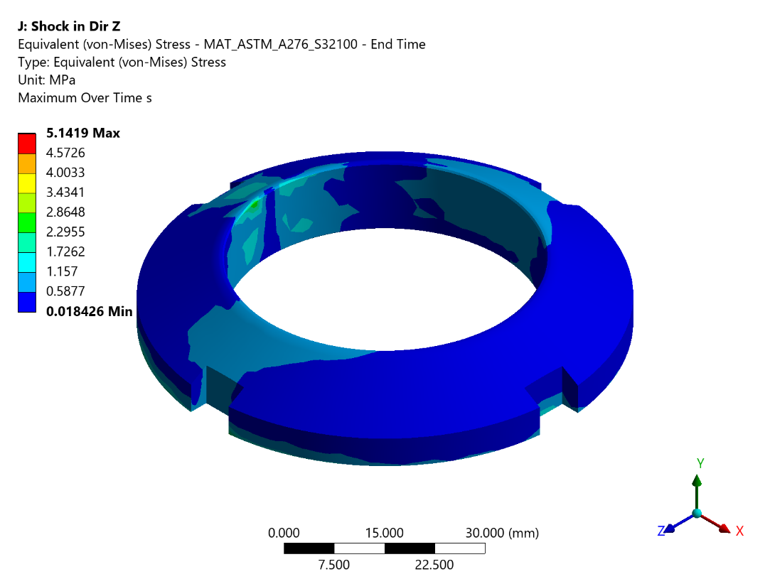
Figure 103 - Transient Z: Equivalent (von-Mises) Stress - MAT_ASTM_A276_S32100 - End Time
From the FEA results, the maximum stress developed is 5.142 MPa against an Static Allowable of 136.67 MPa. The factor of safety is adequate and the component is safe.
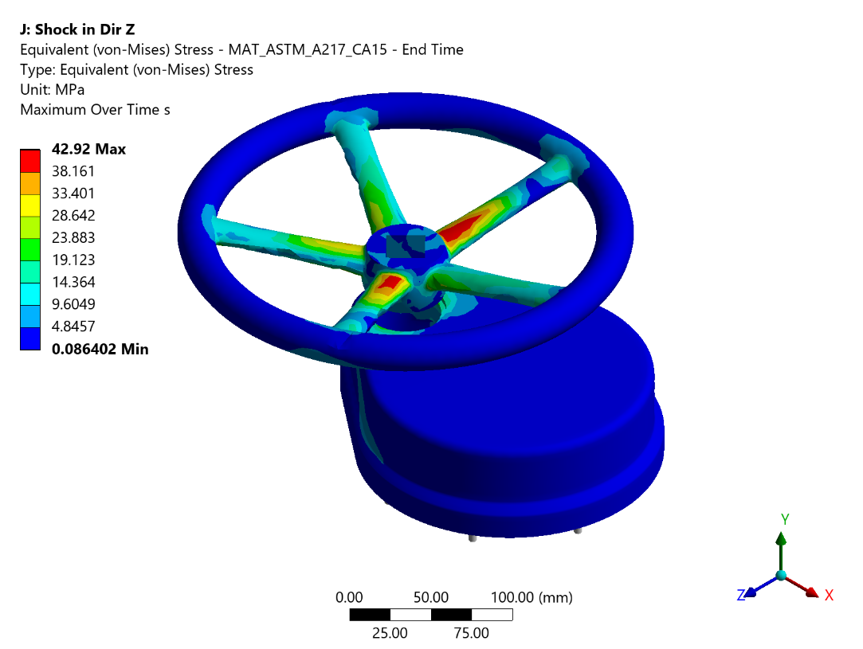
Figure 104 - Transient Z: Equivalent (von-Mises) Stress - MAT_ASTM_A217_CA15 - End Time
The stress distribution shows a peak value of 42.92 MPa at the most critically loaded region, which is within the Static Allowable limit of 177.14 MPa. The design is deemed satisfactory.
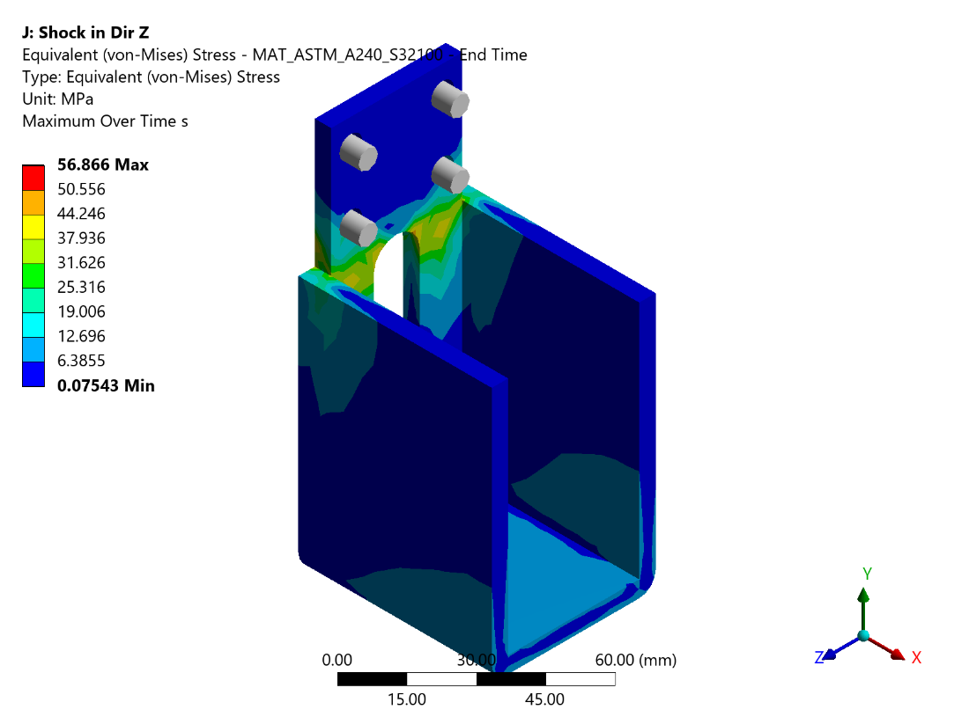
Figure 105 - Transient Z: Equivalent (von-Mises) Stress - MAT_ASTM_A240_S32100 - End Time
FE analysis indicates a maximum stress of 56.866 MPa at the critical location, which does not exceed the Static Allowable stress of 136.67 MPa. The component satisfies the strength requirements.
Table 35 - Bolt Loads: Shock in Z direction
Bolt No | Bolt Connection Group | Max Axial Force (N) | Max Shear Force (N) | Bolt Area (mm2) | Normal Stress (MPa) | Shear Stress (MPa) | Yield Stress MPa
1 | 1 Body To 14 Bonnet | 525.32 | 74.863 | 368.3 | 1.4263 | 0.2033 | 825
2 | 1 Body To 14 Bonnet | 614.13 | 14.029 | 368.3 | 1.6675 | 0.0381 | 825
3 | 1 Body To 14 Bonnet | 398.44 | 80.333 | 368.3 | 1.0818 | 0.2181 | 825
4 | 1 Body To 14 Bonnet | 51.128 | 88.648 | 368.3 | 0.1388 | 0.2407 | 825
5 | 1 Body To 14 Bonnet | 54.369 | 42.58 | 368.3 | 0.1476 | 0.1156 | 825
6 | 1 Body To 14 Bonnet | 268.46 | 69.969 | 368.3 | 0.7289 | 0.19 | 825
7 | 1 Body To 14 Bonnet | 56.667 | 167.99 | 368.3 | 0.1539 | 0.4561 | 825
8 | 1 Body To 14 Bonnet | 1210.7 | 176.39 | 368.3 | 3.2873 | 0.4789 | 825
9 | 1 Body To 14 Bonnet | 1451.3 | 127.84 | 368.3 | 3.9405 | 0.3471 | 825
10 | 1 Body To 14 Bonnet | 469.77 | 150.03 | 368.3 | 1.2755 | 0.4074 | 825
11 | 1 Body To 14 Bonnet | 51.052 | 140.56 | 368.3 | 0.1386 | 0.3816 | 825
12 | 1 Body To 14 Bonnet | 268.62 | 121.9 | 368.3 | 0.7294 | 0.331 | 825
13 | Outlet Flange To 1 Body | 584.8 | 4764.9 | 303.4 | 1.9275 | 15.705 | 825
14 | Outlet Flange To 1 Body | 490.16 | 5328.7 | 303.4 | 1.6156 | 17.5633 | 825
15 | Outlet Flange To 1 Body | 196.48 | 5680.9 | 303.4 | 0.6476 | 18.7241 | 825
16 | Outlet Flange To 1 Body | 192.72 | 5685 | 303.4 | 0.6352 | 18.7376 | 825
17 | Outlet Flange To 1 Body | 465.77 | 5327.1 | 303.4 | 1.5352 | 17.558 | 825
18 | Outlet Flange To 1 Body | 569.14 | 4793.9 | 303.4 | 1.8759 | 15.8006 | 825
19 | Outlet Flange To 1 Body | 433.05 | 4249.2 | 303.4 | 1.4273 | 14.0053 | 825
20 | Outlet Flange To 1 Body | 227.85 | 3845.7 | 303.4 | 0.751 | 12.6753 | 825
21 | Outlet Flange To 1 Body | 61.518 | 3637.6 | 303.4 | 0.2028 | 11.9895 | 825
22 | Outlet Flange To 1 Body | 211 | 3812.1 | 303.4 | 0.6955 | 12.5646 | 825
23 | Outlet Flange To 1 Body | 437.47 | 4209 | 303.4 | 1.4419 | 13.8728 | 825
24 | Outlet Flange To 1 Body | 35.951 | 3623.9 | 303.4 | 0.1185 | 11.9443 | 825
25 | Inlet Flange To 1 Body | 1875.9 | 2663 | 303.4 | 6.1829 | 8.7772 | 825
26 | Inlet Flange To 1 Body | 629.98 | 2446.8 | 303.4 | 2.0764 | 8.0646 | 825
27 | Inlet Flange To 1 Body | 703.56 | 2452.3 | 303.4 | 2.3189 | 8.0827 | 825
28 | Inlet Flange To 1 Body | 1983.1 | 2690.7 | 303.4 | 6.5363 | 8.8685 | 825
29 | Inlet Flange To 1 Body | 2550.4 | 3171 | 303.4 | 8.4061 | 10.4515 | 825
30 | Inlet Flange To 1 Body | 2051.5 | 3795.2 | 303.4 | 6.7617 | 12.5089 | 825
31 | Inlet Flange To 1 Body | 1453.8 | 4324.8 | 303.4 | 4.7917 | 14.2544 | 825
32 | Inlet Flange To 1 Body | 541.12 | 4622.6 | 303.4 | 1.7835 | 15.236 | 825
33 | Inlet Flange To 1 Body | 501.07 | 4615.1 | 303.4 | 1.6515 | 15.2113 | 825
34 | Inlet Flange To 1 Body | 2618.2 | 3730.8 | 303.4 | 8.6295 | 12.2966 | 825
35 | Inlet Flange To 1 Body | 2815.9 | 3130.3 | 303.4 | 9.2811 | 10.3174 | 825
36 | Inlet Flange To 1 Body | 1500.7 | 4293.3 | 303.4 | 4.9463 | 14.1506 | 825
37 | 14 Bonnet To 25 Top Cover | 0.9539 | 2.3069 | 20.1 | 0.0475 | 0.1148 | 320
38 | 14 Bonnet To 25 Top Cover | 0.4335 | 1.1854 | 20.1 | 0.0216 | 0.059 | 320
39 | 14 Bonnet To 25 Top Cover | 17.654 | 0.8494 | 20.1 | 0.8783 | 0.0423 | 320
40 | 14 Bonnet To 25 Top Cover | 16.868 | 0.8773 | 20.1 | 0.8392 | 0.0436 | 320
41 | 14 Bonnet To 25 Top Cover | 1.1749 | 2.2736 | 20.1 | 0.0585 | 0.1131 | 320
42 | 14 Bonnet To 25 Top Cover | 6.0882 | 2.2829 | 20.1 | 0.3029 | 0.1136 | 320
43 | 14 Bonnet To 25 Top Cover | 14.13 | 2.9336 | 20.1 | 0.703 | 0.146 | 320
44 | 14 Bonnet To 25 Top Cover | 12.988 | 3.0754 | 20.1 | 0.6462 | 0.153 | 320
45 | 14 Bonnet To 25 Top Cover | 5.5561 | 2.3065 | 20.1 | 0.2764 | 0.1148 | 320
46 | 14 Bonnet To 25 Top Cover | 3.9658 | 2.0464 | 20.1 | 0.1973 | 0.1018 | 320
47 | 14 Bonnet To 25 Top Cover | 4.3522 | 2.0572 | 20.1 | 0.2165 | 0.1023 | 320
48 | 14 Bonnet To 32 Side Cover | 2.6198 | 2.5141 | 20.1 | 0.1303 | 0.1251 | 320
49 | 14 Bonnet To 32 Side Cover | 44.291 | 8.3372 | 20.1 | 2.2035 | 0.4148 | 320
50 | 14 Bonnet To 32 Side Cover | 2.5569 | 2.5721 | 20.1 | 0.1272 | 0.128 | 320
51 | 14 Bonnet To 32 Side Cover | 43.676 | 7.9931 | 20.1 | 2.1729 | 0.3977 | 320

Shock Analysis Conclusion
Table 36 - Transient Shock Response Summary
Sr. No. | Material | Static Allowable Stress (MPa) | Shock in Positive X Direction  Maximum Occurs on | Shock in Positive X Direction  Stresses Observed (MPa) | Shock in Positive Y Direction  Maximum Occurs on | Shock in Positive Y Direction  Stresses Observed (MPa) | Shock in Positive Z Direction  Maximum Occurs on | Shock in Positive Z Direction  Stresses Observed (MPa) | Remarks
1 | ASTM B367 Gr 5 | 256 | 1 Body | 77.317 | 1 Body | 40.128 | 1 Body | 99.793 | Stresses less than Static allowable
2 | ASTM D4066 Nylon66 | 28 | 3 Disc Seal | 6.882 | 3 Disc Seal | 4.511 | 3 Disc Seal | 17.788 | Stresses less than Static allowable
3 | ASTM A217 CA15 | 177 | 28 Hand Wheel | 22.546 | 28 Hand Wheel | 15.948 | 28 Hand Wheel | 42.920 | Stresses less than Static allowable
4 | BS970 EN19 | 199 | 5 Key | 36.572 | 5 Key | 17.590 | 5 Key | 31.116 | Stresses less than Static allowable
5 | ASTM A240 S32100 | 138 | 32 Side Cover | 73.224 | 32 Side Cover | 35.963 | 32 Side Cover | 56.866 | Stresses less than allowable
6 | ASTM B348 Gr 5 | 256 | 11 Stem Cover | 52.234 | 2 Disc | 22.371 | 2 Disc | 113.782 | Stresses less than Static allowable
7 | ASTM A276 S32100 | 138 | 22 Ring Nut | 2.688 | 22 Ring Nut | 2.131 | 22 Ring Nut | 5.142 | Stresses less than Static allowable
8 | BS970 EN36C | 286 | 20 Pinion Shaft | 52.419 | 20 Pinion Shaft | 7.405 | 20 Pinion Shaft | 105.761 | Stresses less than Static allowable
9 | BS2874 CA104 | 186 | 12 Bush-1 | 63.330 | 12 Bush-1 | 18.925 | 12 Bush-1 | 125.832 | Stresses less than Static allowable

CFD Analysis

Introduction
CFD analysis of a valve is required to understand and optimize fluid flow distribution inside it. The study will be helpful in predicting the:
- Pressure distribution in the valve.
- Identifying high velocity regions and vortex shedding.
- Flow distribution leading to losses.
- Sizing of valve using valve coefficient.
- Reduce prototype testing costs
Figure 146(a) shows the computational domain used for the CFD analysis as per EP 1581. The complete valve geometry along with its sectional view is presented in Figure 146(b).
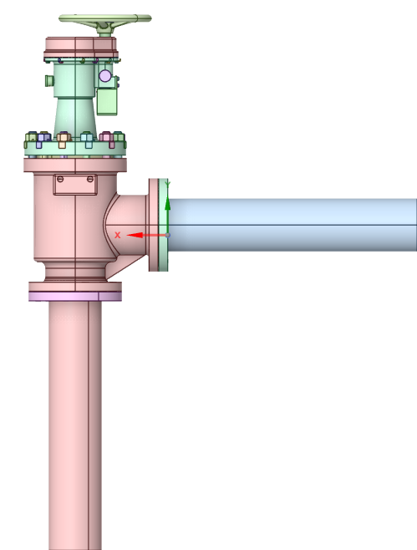 | 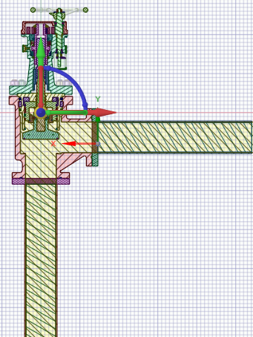
(a) | (b)
Figure 149 (a) Schematic of valve and its (b) sectional view.
The fluid domain is extracted from the above-mentioned geometry. The inlet and outlet pipe sections are extended beyond 5D, where D represents the pipe bore diameter, to allow the flow to become fully developed prior to entering the valve. The extracted fluid region and the fluid domain is presented in Figure 147.
Bore diameter: 40 mm
Extended fluid domain: 5×50 mm = 200 mm
The extended pipe region of the fluid is 200 mm.
 | 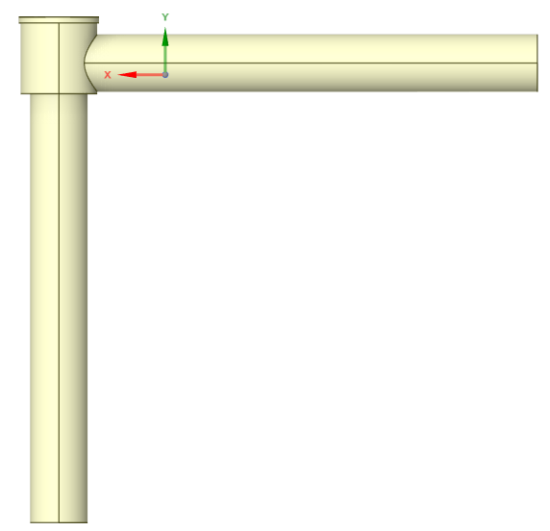
Figure 150 Extracted fluid domain of EP 1581Valve.

CFD Analysis Methodology
Incompressible, Steady state CFD analysis has been carried out in Valve fully open condition to calculate the flow coefficient of Valve.

Assumptions
- No slip boundary condition has been considered at the wetted surfaces.
- No mass imbalance between the inlet and outlet is considered.
- No transient effects are considered in the analysis.

CFD Mesh
In a CFD simulation, the generated grids discretize the fluid domain into small computational volumes. The governing differential equation are solved numerically using these grids.
A properly generated grid helps capture important flow features such as velocity gradients, pressure variations, and boundary layer effects. Mesh quality affects the accuracy, stability, and convergence of solution. Therefore, a proper grid is essential for obtaining reliable CFD results.
In the present simulation, the control volume is discretized using poly hexacore mesh. The polyhedral grids are generated at the surface and inner core is hexahedral. Proper successive increasing grids are generated at the boundaries with three layers of inflation. The aspect ratio and skewness have been kept well within the allowable limits. The aspect ratio is less than 100 and skewness is less than 0.8. The number of cells generated in control volume for simulation is 1044217.
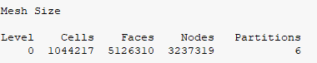
Figure 151 CFD Mesh Size
The grids generated on the external surface and inner core of the fluid domain of the valve is presented in Figure 149.
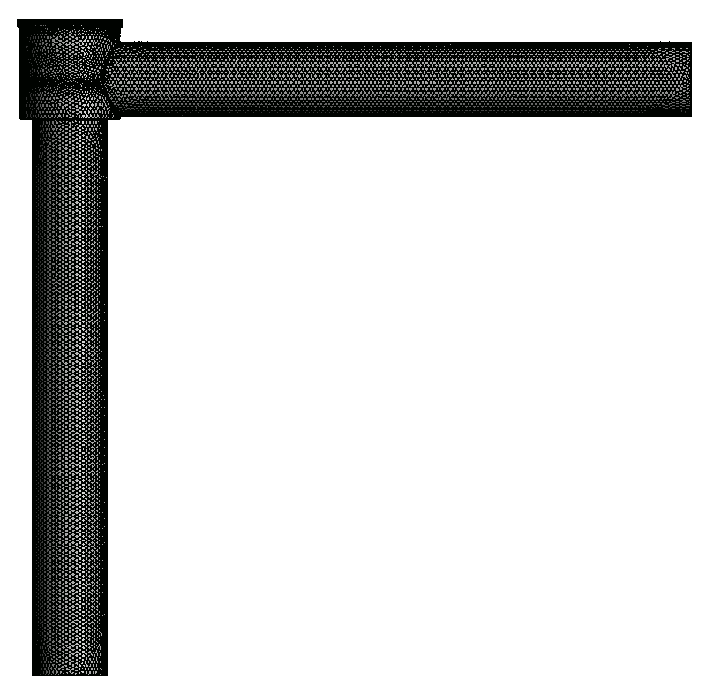 | 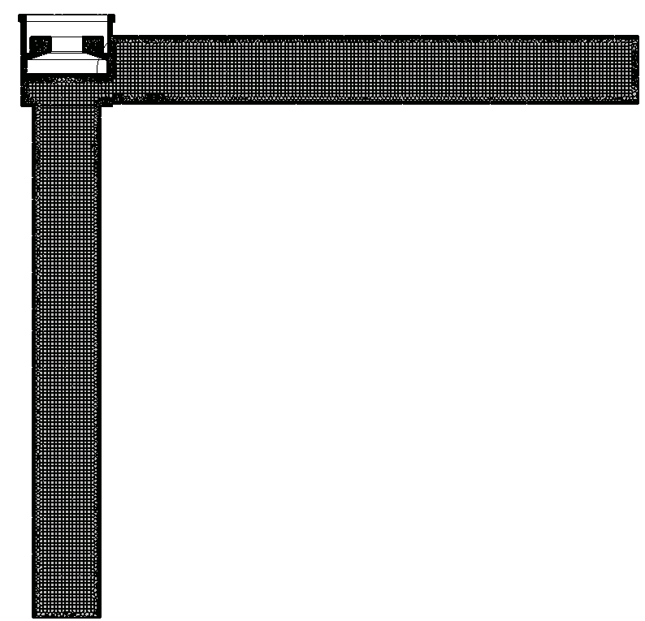
(a)
Figure 152 Polyhedral grids generated on the exterior surface and hexahedral grids on the internal surface of the valve.

Material Selection
Sea water flow through the valve EP 1581. The density of Sea water is 1025 kg/m³. Viscosity of Sea water is 0.001003 kg/(m-s). Material properties of Sea water are shown in Figure 150.
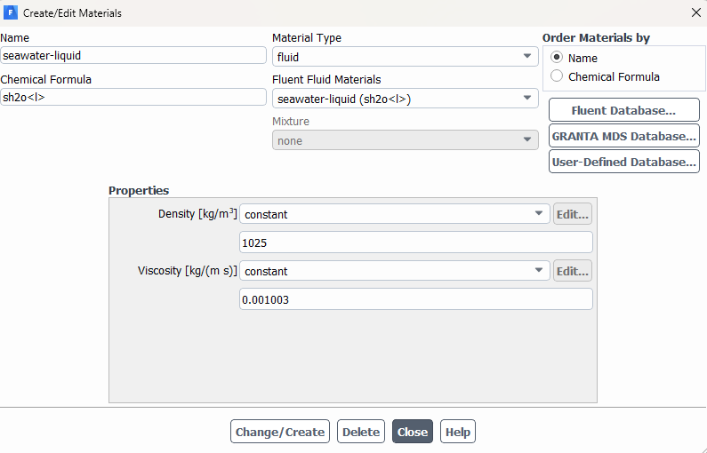
Figure 153 Material properties of sea-water.

Turbulent Viscous model
Turbulence modeling is essential for accurate and feasible simulation of real-world turbulent flows. Turbulence model is required in CFD to account for the effects of turbulent fluctuations on the mean flow without resolving all turbulent scales. Turbulence models provide closure to the Reynolds-averaged Navier–Stokes equations by modeling the additional stress terms.
The mass flow (m*) in the valve is 110 m³/hr.
Bore diameter (D) is 0.04 m.
Area of pipe (A) = $\frac{π×D^{2}}{4} =$0.001963 m²
Velocity of sea water at the valve inlet = $\frac{m^{*}}{ρA×3600}$= 15.56 m/s
Reynolds number = $Re=\frac{ρVD}{μ}$ = 4.5×10⁵
Reynolds number is more than 4000. Therefore, the flow is turbulent in nature.
The k–ε turbulence model with enhanced wall treatment is used to accurately predict turbulent flows near solid boundaries. Enhanced wall treatment relaxes strict y⁺ requirements but performs best when the mesh is fine enough to achieve y⁺. Therefore, the k–ε model with enhanced wall treatment is well suited for complex internal flows such as those in valves and piping systems.
The k–ε turbulence model with enhanced wall function is selected which is shown in Figure 151.
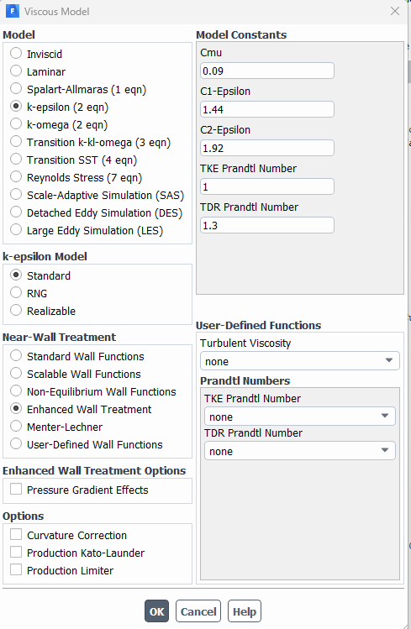
Figure 154 Selection of turbulence model.

Boundary Conditions
To simulate sea waterflow through the valve EP1581, the following boundary conditions have been used:
Table 37 Boundary conditions.
Sl. No. | Boundary | Boundary conditions
1. | Inlet | Pressure inlet | 4000000 Pa
2. | Outlet | Mass flow outlet | 31.32 kg/s
3. | Wall | Wall | No-slip

Solution Methods
The flow in the valve is considered to be steady and incompressible. Pressure velocity coupling has been achieved using Coupled method. Pressure, momentum and turbulence have been discretized using second order upwind scheme.

Convergence criteria
The flow in the valve is considered to be steady and incompressible. Pressure velocity coupling has been achieved using Coupled method. Pressure, momentum and turbulence has been discretized using second order upwind scheme.
Convergence criteria
The convergence criteria are set at 10⁻³ for mass momentum and turbulence equations. Other than this it is also checked that that mass balance has been achieved.
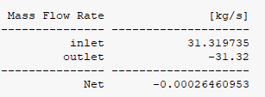
Figure 155 Mass Balance.
The residual plots obtained for simulation has been presented in Figure 153 which shows that residuals have reached lower than 10⁻³. Mass balance has also been achieved. Thus, the solution is converged.
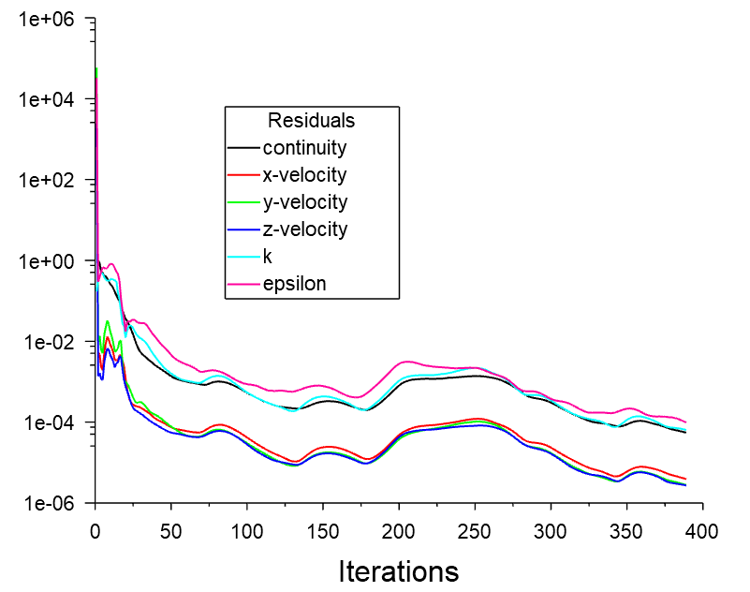
Figure 156 Residual plots.

Results

Y+ Plot
The Y+ contours obtained for the flow conditions is plotted in Figure 154. The plot shows distribution of Y+ from 30 to 300. However, wall enhanced treatment has been used for turbulence modelling. Therefore, the Y+ values will not affect the results.
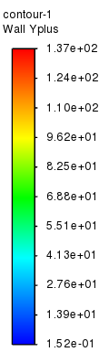 | 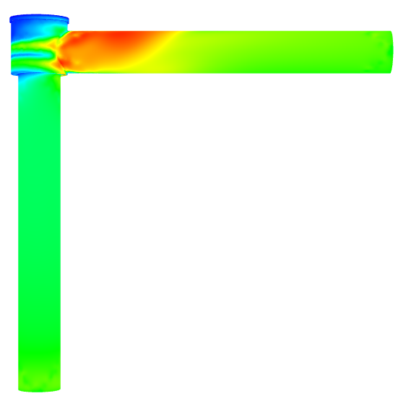  Figure 157 Y+ contours on the computational domain.

Velocity distribution
The velocity distribution in the valve has been presented in Figure 155. The velocity increases at the orifice of the valve. A high velocity region if 4.26 m/s is observed at the exit of the valve. This indicates that the flow will be incompressible.
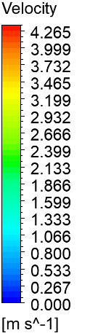 | 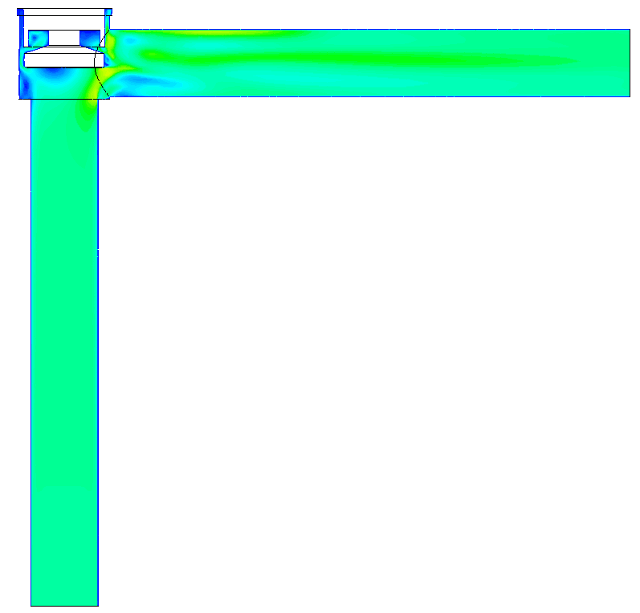 | 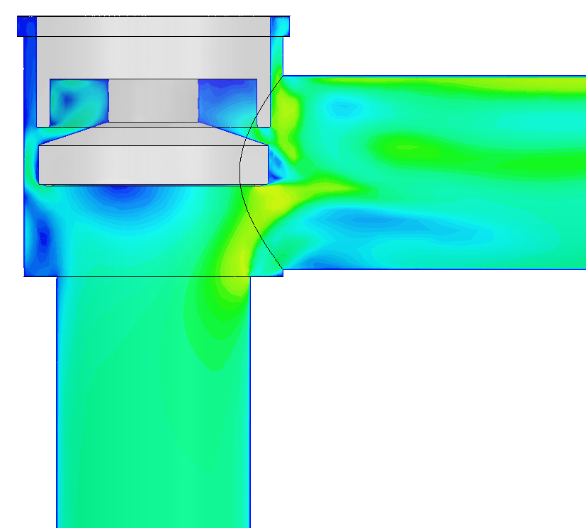
Figure 158 Velocity contours in the computational region of EP 1581.
The velocity streamlines are shown in Figure 159 to visualize the eddy dissipation in the valve EP 1581. The lines show that the flow in the valve is nearly smooth until it reaches the orifice region of the valve.
 | 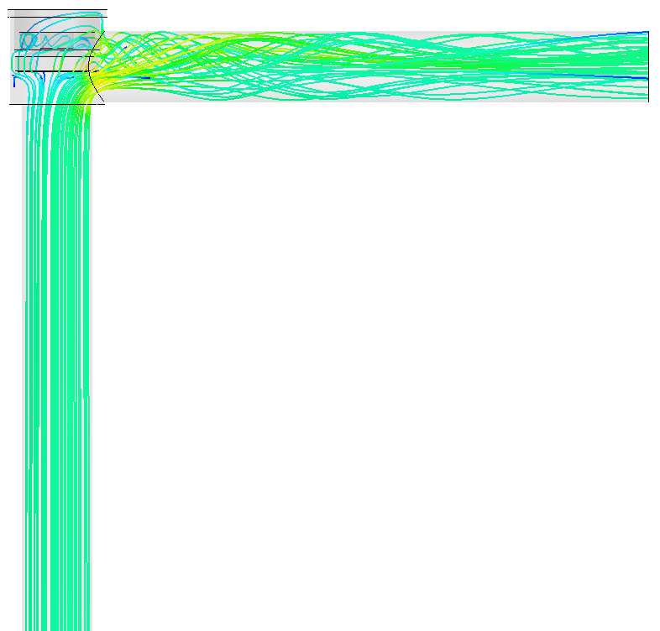 | 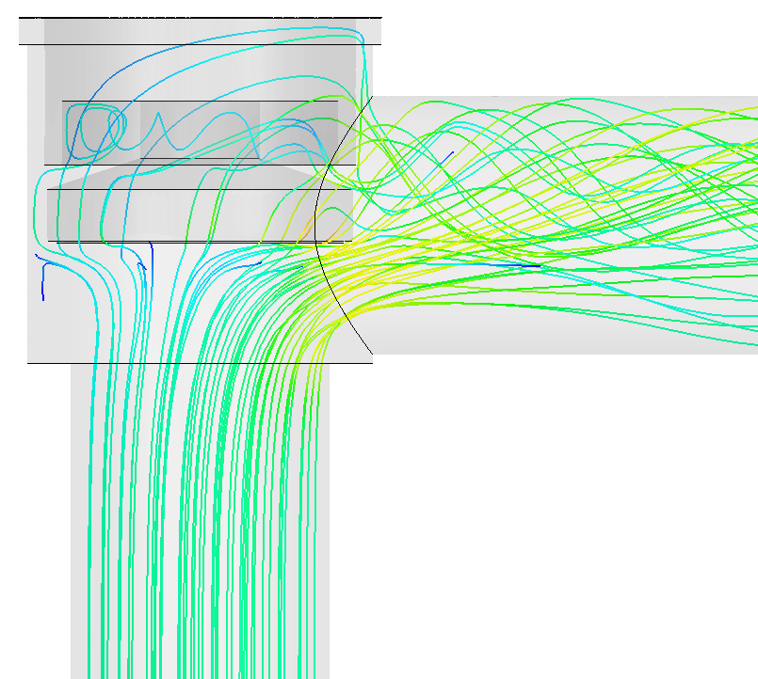
Figure 159 Velocity streamlines in the computational region of EP 1581.

Pressure distribution
The pressure contour in the valve is presented in Figure 160. The pressure distribution shows that there is a drop-in pressure after orifice region. A maximum pressure of 4000000 Pa is supplied at the inlet. The pressure drops to 3994723.4 Pa at the outlet. A pressure drop of 3734 Pa is obtained in the valve for a mass flow rate of 31.32 kg/s.
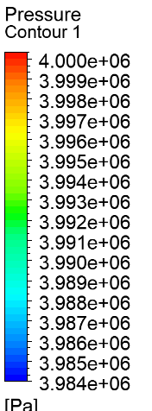 | 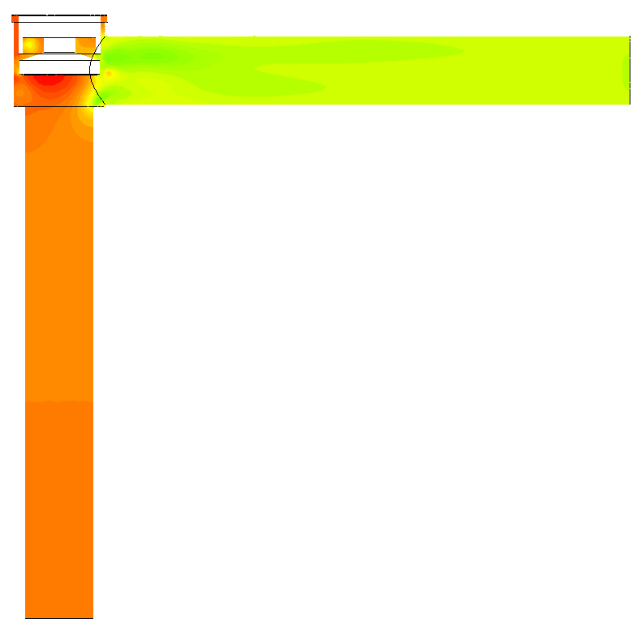 | 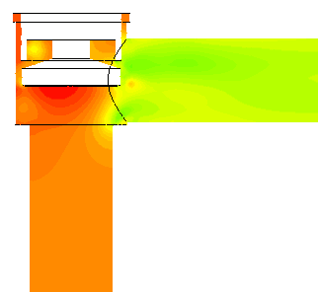
Figure 160 Pressure contours in the computational region of EP 1581.
Area averaged pressure obtained at the inlet and outlet of the valve is Pressure at inlet and outlet is 3998457 Pa and 3994723.4 Pa, respectively.
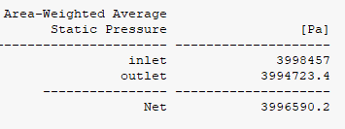
Figure 161 Area averaged pressure obtained at the inlet and outlet

Calculation of valve coefficient
The valve coefficient (commonly denoted as C_{v}) indicates how much fluid can flow through a valve for a specified pressure drop when the valve is fully open.
It is defined as the flow rate of water (in US gallons per minute) at 60°F that passes through a valve with a pressure drop of 1 psi.
Table 38 Parameters used for calculation of valve coefficient.
 | SI Unit |  |  | US Unit
Inlet pressure (P_{in}) | 3998457 | [Pa] |  | 579.91 | [psi]
Outlet Pressure (P_{out}) | 3994723 | [Pa] |  | 579.38 | [psi]
Mass flow rate (m*) | 31.32 | [kg/s]
Volume flow rate | 110 | [m³/hr] |  | 484.308 | gpm
Pressure difference (∆P) | 3734 | [Pa] |  | 0.54 | [psi]
Density of seawater ($ρ$) | 1025 | [kg/m³]
Density of water ($ρ_{o}$) | 1000 | [kg/m³]

$$ρ/{ρ_{o}}=1.025$$
Valve coefficient $C_{v}=\frac{Q}{N_{1}}\sqrt{\frac{ρ/{ρ_{o}}}{∆P}}$ = 708.79
The coefficient of valve obtained from CFD simulation is 708.79 gpm/psi^{0.5}.

CFD Analysis Conclusions
The Achieved CV value is 708.79 which is greater than the required value of 4, thus the flow path established through design of the is satisfactory as per requirement.

Material Properties
Material | UNS | Material Type | Density | Young’s Modulus @ 50 ℃ | Poisson’s ratio | Reference | Yield Strength | Ultimate Tensile Strength | Elongation |  | Static Allowable | Reference
 |  |  | kg/m3 | GPa |  |  | MPa | MPa | % |  | MPa
ASTM B 367 Gr.5 | R56400 | Non-Ferrous (Excluding Aluminum) | 4430 | 114.3 | 0.33 | Metals Handbook VOL 2, Properties and Selection: Nonferrous Alloys and Special-Purpose Materials, Introduction to Titanium and Titanium Alloys, 1781  ASME BPVC Sec II ,P-D, 2019, Table PRD , Page no. 899 for Density & Possion ratio and Table TM-5 -Modulus of Elasticity for Titanium, 2019 | 825 | 895 | 6  Refer Note (4) | TABLE S6-1,TENSILE REQUIREMENTS, ASME BPVC.II.B-2023,542.  ASTM B367: 2013 Sec II Part-B, Table S6-1 Tensile Requirements, Page no. 552 @ C-5 | 256 | Refer Note (1)
ASTM B 348 Gr.5 | R56400 | Non-Ferrous (Excluding Aluminum) | 4430 | 114.3 | 0.33 |  | 825 | 895 | 10 | TABLE 2 Tensile Requirements, ASME BPVC.II.B-2023,504. ASTM B348: 2013 Sec II Part-B, Table 2 Tensile Requirements, Page no. 511 @ Grade-5 | 256 | Refer Note (1)
BS 2874 CA 104 | C63000 Refer Note (3) | Aluminum | 7580 | 120 | 0.33 | ASME BPVC Section II, D, 2023 Pg. 1148 to 1155 | 320 | 650 | 12 | BS2874, Pg 10 | 186 | Refer Note (1)
BS 970 EN19 | G41400 | Ferrous | 7750 | 202.67 | 0.3 | ASME BPVC Section II, D, 2023 Pg. 1148 to 1155 | 525 | 695 | 22 | BS 970, Pg 92 (47 of PDF) | 199 | Refer Note (1)
BS 970 EN36C | G93100 | Ferrous | 7750 | 189.67 | 0.3 | ASME BPVC Section II, D, 2023 Pg. 1148 to 1155 | 850 | 1000 | 13 | BS 970, Pg 128 (65 of PDF) | 286 | Refer Note (1)
ASTM A 276 S32100 | S32100 | Ferrous | 8030 | 193 | 0.31 | ASME BPVC Section II, D, 2023 Pg. 1148 to 1155 | 205 | 515 | 30 | Table 2 Mechanical Requirements, ASTM276 | 138 | Refer Note (1)
ASTM A 217 CA15 | J91150 | Ferrous | 7700 | 199 | 0.31 | ASME BPVC Section II, D, 2023 Pg. 1148 to 1155 | 450 | 620 | 18 | Table 1A, ASME BPVC.II.D.M-2023, 116-118 | 177 | Table 1A, ASME BPVC.II.D.M-2023, 52-53-54
ASTM A 240 S32100 | S32100 | Ferrous | 8000 | 193 | 0.31 | ASME BPVC Section II, D, 2023 Pg. 1148 to 1155 | 205 | 515 | 30 | Table 1A, ASME BPVC.II.D.M-2023, 116-118 | 138 | Table 1A, ASME BPVC.II.D.M-2023, 112-114
ASTM D 4066 -- |  | Non-Ferrous (Excluding Aluminium) | 1150 | 3.3 | 0.4 |  | 84 | 85 | 50 |  | 25 | ASTM D 4066 --

Notes
- If Not Available in Table 1A the values are calculated based on min (2*YS/3, UTS/3,5). For Bolting Applications, the Yield Strength is considered as the Allowable.
- The Nearest ISO designation is CuAl10Fe5Ni5, the UNS is corresponding to CuAl10Fe5Ni5 is C95820.
- The Nearest ISO designation is CuAl10Ni5Fe4, the UNS is corresponding to CuAl10Ni5Fe4 is C63000.
- As per the information received, the material is suggested by the DMDE.

Design calculations of the Valve
Pressure Rating of the Valve & Design Validation Valve Wall Thickness Calculations as per ASME B16.34-2020 is not available in case of the Titanium Alloys. Thus, the design of the thickness is validated here with Lames Theory of Thick Cylinders.
 |  | Stresses at Inner Surface (r = ri)
1 | Input | Internal Body Test Pressure | 8 | MPa | PO Specifications
2 | Input | Minimum Internal Radius (ri) | 75 | mm | Dwg
3 | Input | Minimum thickness | 15 | mm | Dwg
4 | Input | Outside Radius (ro) | 90 | mm | Dwg
5 | OUTPUT | Radial Stress (σr_inner): | -8 | MPa | Lame's equation: -Pi
6 | OUTPUT | Tangential (Hoop) Stress (σt_inner): | 8 * (90^2 + 75^2) / (90^2 - 75^2) = 44.36364 | MPa | Lame's equation: Pi * (ro^2 + ri^2) / (ro^2 - ri^2)
7 | OUTPUT | Axial Stress (σl_inner): | 8 * 75^2 / (90^2 - 75^2) = 18.18182 | MPa | Lame's equation: Pi * ri^2 / (ro^2 - ri^2)
8 | OUTPUT | Von Mises Stress (σv_inner): | sqrt(3) * 8 * 90^2 / (90^2 - 75^2) = 45.34824 | MPa | Lame's simplified equation: sqrt(3) * Pi * ro^2 / (ro^2 - ri^2)
9 | OUTPUT | Material Allowable Stress: | 256 | MPa | ASME BPVC Sec II Part D
11 | OUTPUT | Comparison Result: | ACCEPTABLE |  | Comparison of stresses
12 | OUTPUT | Status: | The calculated Von Mises stress is within the material's allowable limits. |  | Result of comparison

Design Validation of the Union Bolted Joint and (Body- Bonnet) Flange
According to Mandatory Appendix 2, Rules for Bolted Flange Connections with Ring Type Gaskets, ASME BPVC.VIII.1-2023, Pg. 337 Onwards.
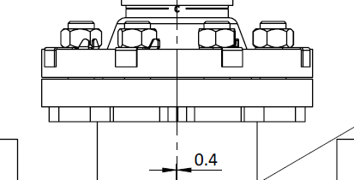
Figure 115 Union Bolted Joint and (body- bonnet) Flange

Bolt load calculations
Table 39 Union Bolt Design
Sl. No. | IN/OP | Parameter | Notation/ Formula | Value | Unit | Reference
1 | Input | Working Pressure (P) | P | 4 | MPa | PO
2 | Input | Bolt Material | ASTM B 348 Gr.5
3 | Input | Static Allowable for Bolt Material | Sa | 256 | MPa | Table 3, ASME BPVC.II.D.M-2023,426-428, Line 1
4 | Input | Gasket Factor, m | m | 0 |  | Table 2-5.1, Gasket Materials and Contact Facings, Gasket Factors m for Operating Conditions and Minimum Design Seating Stress y, Pg 345, Section VIII Div 1, ASME BPVC, 2023
5 | Input | Gasket Factor, y | Y | 0 | MPa
6 | Input | Gasket Width | N | 10 | mm | Table 10, Pg. 12 of Gost 12815-80
7 | Input |  | b0=N/2 = 5/2 | 5 |  | Table 2-5.2, Effective Gasket Width, Pg 347, Section VIII Div 1, ASME BPVC, 2023
8 | Input | Gasket Seating Width |  | 5
9 | Input | Gasket Inside diameter | Di | 210 | mm | Table 10, Pg. 12 of Gost 12815-80
10 | Input | Number of Bolts |  | 12 |  | Table 10, Pg. 12 of Gost 12815-80
11 | Input | Diameter of Gasket Load Reaction, The Gasket Load Reaction Point Taken as Gland Outside Diameter for Maximum Preload condition | 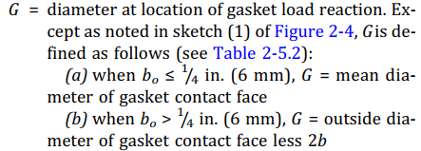 | 230 |  | MANDATORY APPENDIX 2, Section2-3, Pg. 338 Section VIII Div 1, ASME BPVC, 2023
12 | Output | Operating Load | 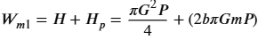 | Pi/4*230^2*4=16619 0.2514 |  | MANDATORY APPENDIX 2, Section2-5, Pg. 340 Section VIII Div 1, ASME BPVC, 2023
13 | Output | Gasket seating load |  | 3.14*5*230*0 = 0 |  | MANDATORY APPENDIX 2, Section2-5, Pg. 344 Section VIII Div 1, ASME BPVC, 2023
14 | Output | Bolt Load | MAX (WM1, WM2) | 166190.2514
15 | Output | Total cross‐sectional area of bolts required | Bolt Load/ Static allowable of the bolt material | 166190.2514/256 = 649.1806694 | mm^2
16 | Output | Cross-sectional area per bolt (required) (Am) | Total area required/ Number of Bolts | 649.1806694/12= 54.09838912 | mm^2
17 | Input | Nominal Bolt Size | Dbsc | 24 | mm
18 | Input | Pitch | P | 3 | mm
19 | Output | Actual Cross-Sectional Area (Ab) | (PI*(Dbsc-0.9382P) ^2)/4 | (PI*(24-0.9382*3) ^2)/4=352.5041494 | mm^2 | Table H-1M Bolt Root and Tensile Stress Areas (Metric Threads), Appendix-H, at Pg. 59 of ASME PCC-1–2019
20 | Output | FOS | Ab/Am | 352.5041494/352.5041494 = 6.515982364
21 | Output | Comparison Result: | ACCEPTABLE |  |  | Comparison of Areas as per Section 2.5 (d) at Pg. 344 of Section VIII Div 1, ASME BPVC, 2023
22 | Output | Status: | Ab> Am thus, M24×3 is safe for use in this design. |  |  | Result of comparison
23 | Output | Bolt Preload Required | Bolt Load/ Number of Bolts | 166190.2514/12 = 13849.18761 | N
25 | Output | Tightening Torque | 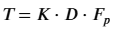 | 0.13*24*13849.18761= 43209.46536. | Nmm | ASME PCC 1

Sr. No | IN/OP | Parameter | Value | Unit | Reference
1 | Input | dbsc (Nominal Dia) | 24 | mm
2 | Input | P (Pitch) | 3 | mm
3 | Input | Bolt UTS | 895 | MPa | TABLE 2 Tensile Requirements, ASME BPVC.II.B-2023,504
4 | Input | Nut UTS | 895 | MPa | TABLE 2 Tensile Requirements, ASME BPVC.II.B-2023,504
5 | Input | Tolerance Grade | 6 | ~
6 | Input | pos_ext | g' | ~
7 | Input | pos_int | H' | ~
8 | Input | Target FOS (Input) | 2 | ~ | User Target
9 | Output | THREAD TENSILE STRESS AREA (As) | 352.505 | mm2 | ASME B1.13M Section B-1
10 | Output | dmin (Min Major Dia - Bolt) | 23.577 | mm | Table 14, ASME B1.13M
11 | Output | d2min (Min Pitch Dia - Bolt) | 21.803 | mm
12 | Output | D1max (Max Pitch Dia - Nut) | 21.252 | mm | Table 15, ASME B1.13M
13 | Output | D2max (Max Minor Dia - Nut) | 22.316 | mm
14 | Output | NUT THREAD SHEAR AREA (Asn) | 1916.683 | mm2 | ASME B1.13M Section B-2
15 | Output | BOLT THREAD SHEAR AREA (Ass) | 1410.019 | mm2
16 | Output | Tensile strength of Bolt | 315.492 | kN | ASME B1.13M Section B-3
17 | Output | Shear strength of Nut Threads | 857.716 | kN
18 | Output | Shear strength of Bolt Thread | 630.983 | kN
19 | Output | LENGTH OF ENGAGEMENT | 34.847 | mm | Calculated
Note: It is recommended to increase the Tap Hole length up to 35 mm.

$$\begin{matrix}AS_{n} & =\frac{3.1416}{p}LEd\text{ min. } \\ & \left[\frac{p}{2}+0.57735\left(d\text{ min. }-D_{2}\text{ max. }\right]\right. \\ AS_{s} & =\frac{3.1416}{p}LED_{1}\text{ max. } \\ & \left[\frac{p}{2}+0.57735\left(d_{2}\text{ min. }-D_{1}\text{ max. }\right]\right.\end{matrix}\begin{matrix}AS_{n} & =\frac{3.1416}{3}(34.817*23.577\text{)} \\ & \left[\frac{3}{2}+0.57735\left(23.577 -22.316) \right] =1916.68 \right. \\ AS_{s} & =\frac{3.1416}{3}(34.817*22.210) \\ & \left[\frac{3}{2}+0.57735\left(21.803 -21.252) \right]\right.=1410.019\end{matrix}$$
Where, ASn = minimum thread shear area for internal threads, mm2
ASs = minimum thread shear area for external threads, mm2
LE = length of engagement

Flange moments
Sl. No. | IN/OP | Parameter | Formula And Unit If Any | Value | Reference
1 | Input | Flange Design Bolt Load (W) | N | 166190.2514
2 | Input | Outside Diameter of Flange (A) | mm | 310 | DWG & Pg. 338 of ASME BPVC Sec VIII, Div 1
3 | Input | Inside diameter of flange (B) | mm | 210
4 | Input | Bolt‐circle diameter (c) | mm | 265
5 | Input | Thickness of hub at small end, for other integral type flanges (g0) | mm | 20
6 | Input | Thickness of hub at back of flange (g1) | mm | 20
 |  | g1/g0 |  | 1
7 | Input | Flange Thickness (t) | mm | 40
8 | Input | Gasket Factor (m) |  | 0 | Table 2-5.1, Pg. 345 of ASME BPVC.VIII.1-2023
9 | Input | Min. Design Seating Stress (y) |  | 0
10 | Input | G (mm) Dia of Gland seat | mm | 230 | Gland Major Diameter, Location of Load Reaction
 | Input | Hub Length (h) | mm | 70 | Pg. 338 of ASME BPVC Sec VIII, Div 1
11 | Input | Factor, h0=√(B*g0 ) | √(B*g0 ) = √(210*20 ) | 64.80740698 | Pg. 338 of ASME BPVC Sec VIII, Div 1
12 | Input | Factor, K=(A/B) | A/B =310/210 | 1.476190476 | Figure 2-7.1, of ASME BPVC Sec VIII, Div 1
13 | Input | Factor Z, involving K | 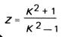 | $\frac{{1.47}^{2}+1}{{1.47}^{2}-1}$= 2.696153846
14 | Input | Factor Y, involving K | 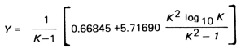 | $\frac{1}{1.47-1}\left[0.66845+5.71690\frac{{1.47}^{2}\log_{10}{1.47}}{{1.47}^{2}-1}\right]=$5.156519083
15 | Input | Factor U, involving K | 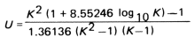 | $\frac{{1.47}^{2}\left(1+8.55246\log_{10}*1.47\right)-1}{1.36136\left({1.47}^{2}-1\right)(1.47-1)}=$5.666491835
16 | Input | T= factor involving K | 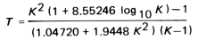 | $$\frac{{1.47}^{2}\left(1+8.55246\log_{10}*⁡1.47\right)-1}{\left(1.04720+1.9448{*1.47}^{2}\right)(1.47-1)}$$  = 1.721042321
17 | Input | Factor, V |  | 0.550103 | factor for integral type flanges (from Figure  2-7.3), of ASME BPVC SEC VIII, DIV I
18 | Input | Factor, f |  | 1 | Figure 2-7.6, for g1/g0=1, of ASME BPVC SEC VIII, DIV I
19 | Input | Factor, B1 | B+g0 = 210+20 | 230 | B + go for integral type flanges when f is equal  to or greater than one, at Pg. 338 of ASME BPVC SEC VIII DIV I
20 | Input | Factor, F |  | 0.90892 | factor for integral type flanges (from Figure  2-7.2), of ASME BPVC SEC VIII, DIV I
21 | Input | Factor, d | 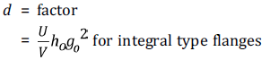 | $\frac{5.667}{0.550103}*64.81*{20}^{2}$ = 267026.8241 | Pg. 338 of ASME BPVC SEC VIII DIV I
22 | Input | Factor, e | 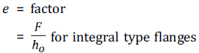 | 0.90892/64.81 = 0.01402494 | Pg. 338 of ASME BPVC SEC VIII DIV I
23 | Input | Factor, L | 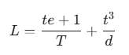 | $\frac{40*0.01402+1}{1.72}+\frac{{40}^{3}}{267026.82}$ = 1.146683395 | Pg. 339 of ASME BPVC SEC VIII DIV I
24 | Input | Factor, R | 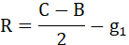 | $\frac{265-210}{2}-20$ = 7.5 | Pg. 339 of ASME BPVC SEC VIII DIV I
25 | Input | Static Allowable for ASTM B 367 Gr.5 | MPa | 256 | Table 1A, ASME BPVC.II.D.M-2023, 116-118
26 | Output | hd |  | 7.5+0.5*20 = 17.5 | Table 2-6, Moment Arms for Flange Loads Under Operating Conditions, at Pg.348 of ASME BPVC SEC VIII Div I
27 | Output | hg | 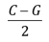 | (265-230)/2  = 17.5
28 | Output | ht | 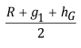 | $\frac{17.5+20+17.5}{2}$= 22.5
29 | Output | H |  | 0.785*230^2*4 = 166106 | Pg. 338 of ASME BPVC SEC VIII DIV I
30 | Output | HD |  | 0.785*210^2*4= 138474 | Pg. 339 of ASME BPVC SEC VIII DIV I
31 | Output | HG |  | 166190.2514 - 166106 = 84.2513749 | as Wm1-H=0
32 | Output | HT |  | 166106-138474 = 27632 | Pg. 339 of ASME BPVC SEC VIII DIV I
33 | Output | MT |  | 27632*22.5 = 621720 | Components of the Moment due to HT, HD, HG
34 | Output | MD |  | 138474* 17.5 = 2423295
35 | Output | MG |  | 84.251*17.5 = 1474.399061
36 | Output | total moment acting upon the flange, for the operating  conditions | MT+MD+MG | 621720 + 2423295 + 1474.399061 = 3046489.399 | M0=MG+MT+MD
37 | Output | Longitudinal hub stress (SH) |  | $\frac{1*3046489.399}{1.1467*{20}^{2}*210}$ = 31.62837371 | 2-7 CALCULATION OF FLANGE STRESSES, at Pg. 346 of ASME BPVC SEC VIII, Div I
38 | Output | Radial flange stress (SR) |  | $\frac{\left(1.33*40*0.01402+1\right)*3046489.399}{1.1467*{40}^{2}*210}$= 13.80678784
39 | Output | Tangential flange stress (ST) |  | $\frac{5.156*3046489.399}{{40}^{2}*210}-2.696*13.8067$= 9.528587526 | 2-7 CALCULATION OF FLANGE STRESSES, at Pg. 348 of ASME BPVC SEC VIII, Div I
 |  | ALLOWABLE FLANGE DESIGN STRESSES
40 | Output | SH<1.5*Static Allowable |  | 384 | Section 2-8 ALLOWABLE FLANGE DESIGN STRESSES, Para (a) (1) (-b) at Pg. 355 of ASME BPVC SEC VIII Div I
41 | Output | SR<Static Allowable |  | 256 | Section 2-8 ALLOWABLE FLANGE DESIGN STRESSES, Para (a) (2) at Pg. 355 of ASME BPVC SEC VIII Div I
42 | Output | ST<Static Allowable |  | 256 | Section 2-8 ALLOWABLE FLANGE DESIGN STRESSES, Para (a) (3) at Pg. 355 of ASME BPVC SEC VIII Div I
43 | Output | (SH+SR)/2<Static Allowable |  | 256 | Section 2-8 ALLOWABLE FLANGE DESIGN STRESSES, Para (a) (4) at Pg. 355 of ASME BPVC SEC VIII Div I
44 | Output | (SH+ST)/2<Static Allowable |  | 256 | Section 2-8 ALLOWABLE FLANGE DESIGN STRESSES, Para (a) (4) at Pg. 355 of ASME BPVC SEC VIII Div I
45 | Output | Longitudinal hub stress (SH) |  | ACCEPTED | 31.628<384
46 | Output | Radial flange stress (SR) |  | ACCEPTED | 13.807<256
47 | Output | Tangential flange stress (ST) |  | ACCEPTED | 9.529<256
48 | Output | SH+SR |  | ACCEPTED | 45.435<256
49 | Output | SH+ST |  | ACCEPTED | 41.157<256
50 | Output | Flange Rigidity |  | $\frac{52.14*0.55010*3046489.399}{1.1467*{20}_{o}^{2}*0.3*64.807*200*1000}=$0.05076059 | Table 2-14 Flange Rigidity Factors at Pg. 358 of ASME BPVC SEC VIII Div I

Effort Required
The methodology described in the book entitled “The Design of Valves and Fittings by G.H. Pearson” is used here to calculate the effort required to calculate the effort required to manually operated valve.
Initially, the total force required to operate the valve is calculated as follows

- Total axial force acting on the spindle (Page 36-37)
  - Fa is the total axial load due to Axial force to resist the pressure load (P), Axial Clamping force at seating, and Friction force
$$F_{a}=F_{Pressure}+F_{s}+F_{f}$$
  - Axial force to resist the pressure load
$$F_{Pressure}=P×\frac{π}{4}×{d_{0}}^{2}$$
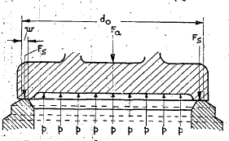
Figure 116 components the Fa and Fs
  - Axial clamping force at seating
$$F_{s}=2×π{×d}_{0}×w×P$$
  - Friction force at Oring Interface (Derived from first Principles)
$$F_{f}=μ_{oring}×π×P×d_{oring}×h_{oring}$$
    - $h_{oring}$ is the Height of Oring interfacing with spindle
    - $d_{oring}$ is the internal diameter of the Oring
The following image describes the terminology associate with the power screws. (Chapter 4, Page 52)
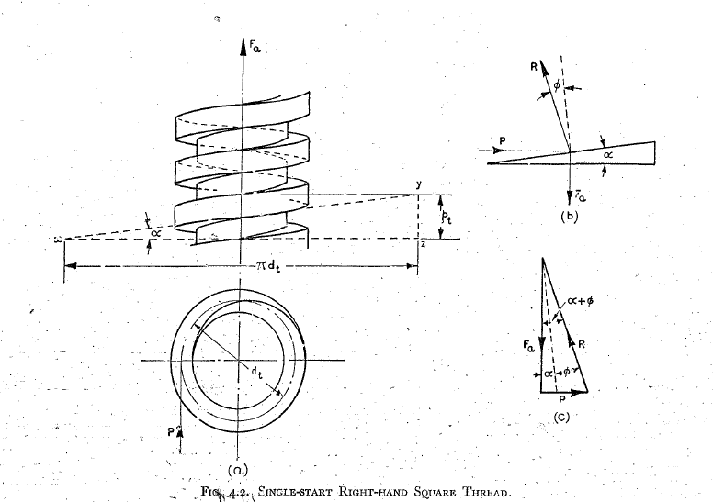
Figure 117 Single start Right-Handed Square Thread
- The Mean Thread Diameter can be denoted by d_{t}, D_{m}, D_{2,}
- The p denotes the Pitch of the thread,
- Alpha (α) is thread inclination angle, given by following formula,
$$\tan{α}=\frac{p}{π*dt}$$
- Phi ($∅)$ is the friction angle
$$\tan{∅}=μ$$
- The friction angle needs the correction as per the thread angle
Table 40 Relation between thread angle and coefficient of frictions
 | Trapezoidal Thread | Metric Thread | Square Thread
Angle (β) | 15° | 30° | 0°
Adjusted friction $μ'$ | $$μ^{'}=\frac{μ}{\cos{15}}$$ | $$μ^{'}=\frac{μ}{\cos{30}}$$ | $$μ^{'}=\frac{μ}{\cos{0}}$$
Corrected Friction angle ($∅')$ | $$\tan^{-1}\left(\frac{μ}{\cos{15}}\right)$$ | $$\tan^{-1}\left(\frac{μ}{\cos{30}}\right)$$ | $$\tan^{-1}\left(μ\right)$$

- The efficiency of the screw is given by, (Page 58)
$$η_{screw}=\frac{\tan{α}}{\tan\left(α+∅'\right)}$$
- The torque required to actuate the spindle is given by, (Page 66)

$$T=F_{Effort}×R_{HW}=\frac{F_{a}×pitch}{2×π×η_{screw}}$$
$$F_{Effort}=\frac{T}{R_{HW}}$$
- Length of the Thread Engagement based to bearing pressure.
$l_{t}=\frac{2F_{a}}{πd_{m}f_{\overset{˙}{p}}}$ = $\frac{2*123178.7064}{π*33*99}$ = 24.001
$f_{\overset{˙}{p}}$ is the maximum allowable intensity of bearing pressure. The allowable $f_{\overset{˙}{p}}$ is estimated from the materials compressive / contact strength. Here stem material is NAB BS 2874 CA104. The formula from the below. $σ_{y}$ is the yield tensile strength.

$f_{p}=(0.12$ to 0.22$)×σ_{y}$ = 0.12*825 = 99

- Length of the Thread Engagement if given by the following formula
$$L_{e}=\frac{2×F_{a}}{π×d_{t}×τ_{all}}$$

Table 41 Effort required and the length of thread engagement for Spindle
Sr. No | IN/OP | Parameter | Value | Unit | Reference
1 | Input | Working Pressure, P | 4 | MPa | PO
2 | Input | Disc Dia , do | 177 | mm | DWG
3 | Input | Seating Width (mm), w | 5 | mm | DWG
4 | Input | Handwheel Dia (mm), 2*R_{HW} | 280 | mm | DWG
5 | Input | Mean Diameter of the Thread (Dbsc) | 44 | mm | DWG
6 | Input | Pitch (p) | 7 | mm | DWG
7 | Input | O-ring Dia, $d_{oring}$ | 40 | mm | DWG
8 | Input | O-ring width, $h_{oring}$ | 20 | mm | DWG
9 | Input | mu O-ring | 0.25 |  | DWG
 | Input | Type of Thread | Trapezoidal |  | DWG
10 | Input | Static allowable of Internal thread, Stem Bush | 186 | MPa | Refer to Materials data table
11 | Input | Static Allowable of external thread, Spindle | 256 | MPa | Refer to Materials data table
12 | Input | Allowable Shear stress of Internal thread | 93 | MPa | 0.5 * Static Allowable
13 | Input | Allowable Shear stress of External thread | 128 | MPa | 0.5 * Static Allowable
14 | Output | Force acting on the Disc, F_{pressure} | 98422.95624 | N | DWG
15 | Output | Axial Clamping force at seating, F_{s} | 22242.47599 | N | DWG
16 | Output | Friction Force. F_{f} | 2513.274123 | N | DWG
17 | Output | Total Force, Fa | 123178.7064 | N | DWG
18 | Output | Thread Mean Dia, Dm | 40.5 | mm | DWG
19 | Output | Tan (Alpha) =$\frac{p}{π*dt}$ | 0.055016524 |  | DWG
20 | Output | Alpha | 3.149039972 | Degree | DWG
21 | Output | Mu at metal interface | 0.15 |  | DWG
22 | Output | Thread Angle (Beta) | 15 | Degree | DWG
23 | Output | 1/Cos (Beta) | 1.03527618 |  | DWG
24 | Output | Adjusted mu= Mu at metal interface*1/Cos (Beta) | 0.155291427 |  | DWG
25 | Output | Friction Angle (ATAN(Adjusted mu)), $∅'$ | 8.82703806 | Degree | DWG
26 | Output | $$\tan\left(α+∅'\right)$$ | 0.21212022 |  | DWG
27 | Output | Screw Efficiency, $η_{screw}$ | 0.259364824 |  | DWG
28 | Output | Torque Required, T | 529106.0587 | N mm | DWG
29 | Output | Manual Effort Required | 3779.328991 | N | DWG
30 | Output | Length of Thread Engagement= 2*Fa/pi () *Dm*Sall = 2*123178.7/pi () *40.5 *128 | 15.12692901 | mm | Actual Engagement length is 94 mm
31 | Output | Length of Thread Engagement for bearing pressure (refer sec 103, point ix) | 24.001 | mm | Actual Engagement length is 94 mm
31 | Input | Core Diameter of External Thread, d3 | 36.5 | mm
32 | Input | Core Diameter at Internal Thread | 44.5 | mm
33 | Output | Thread Thickness at Root of External Thread | 4.58 | mm | Pitch-e (refer figure 118)
34 | Output | Thread Thickness at Root of Internal Thread | 4.58 | mm | Pitch-e (refer figure 118)
35 | Output | Number of Threads in Engagement | 2.160989859 |  | Length of Thread Engagement/ Pitch
36 | Output | Transvers Shear Stress of External Thread | 108.5362206 | MPa | <128 MPa Allowable shear Strength
37 | Output | Transvers Shear Stress of Internal Thread | 89.02409107 | MPa | <93 MPa Allowable Shear Strength
Thread Strength in Case of Shock Load
37 | Input | Valve Mass | 110 | Kg
38 | Input | Shock Acceleration | 300 | G
39 | Input | Inertia Force (Mass * Acceleration) , Shock Load = 9.81*(110*300) | 323730 | N
40 | Output | Length of Thread Engagement= 2*Fa/pi ()*Dm*Sall = 2*323730/ pi ()*40.5*128 | 39.75557849 | mm | Actual Engagement length is 94 mm
 |  | Length of Thread Engagement with bearing pressure = 2*Fa/pi () *Dm*$f_{p}$ = 2*323730/pi () *40.5 *99 | 51.39 | mm | Actual Engagement length is 94 mm
41 | Output | Core Diameter of External Thread, d3 | 36.5 | mm
42 |  | Core Diameter at Internal Thread | 44.5 | mm
43 | Output | Thread Thickness at Root of External Thread | 4.58 | mm
44 | Output | Thread Thickness at Root of Internal Thread | 4.58 | mm
45 | Output | Number of Threads In Engagement | 5.679368356 |  | Length of Thread Engagement/ Pitch
46 | Output | Transvers Shear Stress of External Thread =  Force/(Pi*Core Diameter of External Thread*Thread Thickness at Root*Number of Threads in Engagement) | 108.5362206 | MPa | <128 MPa Allowable shear Strength
47 | Output | Transvers Shear Stress of Internal Thread = Force/ (Pi*Core Diameter of Internal Thread*Thread Thickness at Root*Number of Threads in Engagement) | 89.02409107 | MPa | <93 MPa Allowable Shear Strength

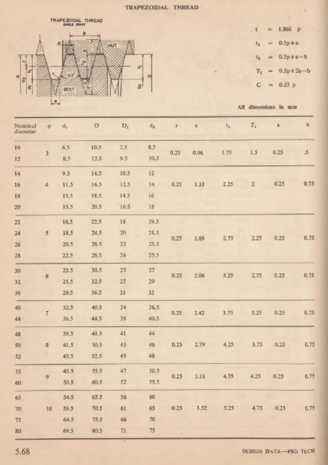
Figure 118 PSG Design Data Book Details of Trapezoidal Threads

End Connection Flange Design
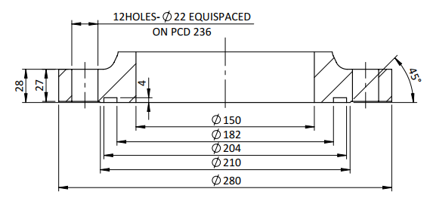
Figure 119 Typical End Connection Design
Table 42 End Connection Flange Design
Sr. No | Parameter | Value | Reference
 | design pressure | 4 MPa | PO
 | Nominal Pipe Size (NPS)/ (Dy as per Gost 12815-80) | 150 mm | Table 4.2
 | Outside dia of the end Flange (D) | 280 mm | Table 10, Pg. 12 of Gost 12815-80
 | PCD (D1) | 236 mm | Table 10, Pg. 12 of Gost 12815-80
 | D2 | 204 mm | Table 10, Pg. 12 of Gost 12815-80
 | D3 | 182 mm | Table 10, Pg. 12 of Gost 12815-80
 | Depth of Groove (h) | 4 mm | Table 10, Pg. 12 of Gost 12815-80
 | Bolt Hole Diameter (d) | 22 mm | Table 10, Pg. 12 of Gost 12815-80
 | Number of Bolts (n) | 12 Nos. | Table 10, Pg. 12 of Gost 12815-80
 | Nominal Diameter of Stud | M20 | Table 10, Pg. 12 of Gost 12815-80
 | Nut Factor, k | 0.13

Table 43 Tightening torque and preload calculations
Sl. No. | IN/OP | Parameter | Notation/ Formula | Value | Unit | Reference
1 | Input | Working Pressure (P) | P | 4 | MPa | PO
2 | Input | Bolt Material | ASTM B 348 Gr.5
3 | Input | Static Allowable for Bolt Material | Sa | 256 | MPa | Table 3,ASME BPVC.II.D.M-2023,422-425, Line 44
4 | Input | Gasket Factor, m | m | 2 |  | Table 2-5.1, Gasket Materials and Contact Facings,Gasket Factors m for Operating Conditions and Minimum Design Seating Stress y, Pg 345,Section VIII Div 1, ASME BPVC, 2023
5 | Input | Gasket Factor, y | Y | 11 | MPa
6 | Input | Gasket Width | N | 11 |  | Table 10, Pg. 12 of Gost 12815-80
7 | Input |  | b0=N/2 | 5.5 |  | Table 2-5.2, Effective Gasket Width, Pg 347, Section VIII Div 1, ASME BPVC, 2023
8 | Input | Gasket Seating Width |  | 5.5
9 | Input | Gasket Inside diameter | Di | 182 | mm | Table 10, Pg. 12 of Gost 12815-80
10 | Input | Number of Bolts |  | 12 |  | Table 10, Pg. 12 of Gost 12815-80
11 | Input | Diameter of Gasket Load Reaction, The Gasket Load Reaction Point Taken as Gland Outside Diameter for Maximum Preload condition |  | 193 |  | MANDATORY APPENDIX 2, Section2-3, Pg. 338 Section VIII Div 1, ASME BPVC, 2023
12 | Output | Operating Load |  | 0.785*193^2*4 = 117297.6449 |  | MANDATORY APPENDIX 2, Section2-5, Pg. 340 Section VIII Div 1, ASME BPVC, 2023
13 | Output | Gasket seating load |  | = 36682.80662 |  | MANDATORY APPENDIX 2, Section2-5, Pg. 344 Section VIII Div 1, ASME BPVC, 2023
14 | Output | Bolt Load | MAX (WM1, WM2) | 117297.6449
15 | Output | Total cross‐sectional area of bolts required | Bolt Load/ Static allowable of the bolt material | 458.1939254 | mm^2
16 | Output | Cross-sectional area per bolt (required) (Am) | Total area required/ Number of Bolts | 38.18282712 | mm^2
17 | Input | Nominal Bolt Size | Dbsc | 20 | mm
18 | Input | Pitch | P | 2.5 | mm
19 | Output | Actual Cross-Sectional Area (Ab) | (PI*(Dbsc-0.9382P) ^2)/4 | 244.7945482 | mm^2 | Table H-1M Bolt Root and Tensile Stress Areas (Metric Threads), Appendix-H, at Pg. 59 of ASME PCC-1–2019
20 | Output | FOS | Ab/Am | 6.411116375
21 | Output | Comparison Result: | ACCEPTABLE |  |  | Comparison of Areas as per Section 2.5 (d) at Pg. 344 of Section VIII Div 1, ASME BPVC, 2023
22 | Output | Status: | Ab> Am thus, M20×2.5 is safe for use in this design. |  |  | Result of comparison
23 | Output | Bolt Preload Required | Bolt Load/ Number of Bolts | 9774.803742 | N
25 | Output | Tightening Torque, with k=0.13 |  | 25414.48973 | N mm | ASME PCC 1

