DESIGN ANALYSIS REPORT OF

WELDED PLANE PIPE FLANGE

BOM ID - EP 2737 – S5

NAME OF THE FIRM:
M/s ULTRA DIMENSIONS PVT. LTD., VISAKHAPATNAM

Prepared by: | Checked by: | Approved by: (DMDE)
Tarun P  (CAE Engr) | (Ashok Varma R)  (Sr. General Manager)

LIST OF CONTENT

1. Revision log 8
2. Current design based on previous reference design/drawing 8
3. Scope 8
3.1. Details of types of analysis. 9
Thickness Calculation of Welded Plane Pipe Flange 9
Design Validation Flange Thickness Calculations 9
Bolt Preload Calculations 9
4. Software/ Tools 10
5. References 10
6. Equipment details 11
6.1. Model 11
6.1.1. 3D Model 11
6.1.2. Sectional View 11
6.1.3. 2D Drawing 12
6.1.4. Welded Flange Design 12
6.2. Mass, Centre of gravity, model orientation and materials as per drawing 13
6.2.1. The weight of FE analysis is tabulated below: - 13
6.2.2. Centre of Gravity 13
6.2.3. Model Orientation 13
6.3. Details of structural connections to surrounding structure 14
6.4. Working Principle. 14
6.5. Input data / Technical Specifications. 14
7. Modelling details 15
7.1. Details of all the non-structural parts, which are excluded from the model (N.A) 15
7.2. Modelling approach for all structural part 15
7.3. Modelling approach for bolted joints 19
7.4. Modelling approach for welded joints (Not Applicable) 20
7.5. Modelling approach for joints (Not Applicable) 20
7.6. Modelling approach for interfaces (contacts) 20
7.7. Details of materials models selected 21
8. Loads and Boundary conditions 21
8.1. Static Structural Analysis 21
8.1.1. Methodology. 21
8.1.2. Environment & Boundary Conditions. 22
8.1.3. Standard Earth Gravity 22
8.1.4. Fixed Supports: 22
8.1.5. Pressure: 23
8.1.6. Weight of Fluid 24
8.2. Modal Analysis 24
8.2.1. Methodology 24
8.2.2. Fixed Supports 24
8.3. Vibration Resistance Analysis 25
8.3.1. Methodology 25
8.3.2. Loading Conditions 25
8.3.3. Fixed Support 25
8.3.4. Excitation in X- Direction 26
8.3.5. Excitation in Y- Direction 26
8.3.6. Excitation in Z- Direction 27
8.4. Shock Analysis - Equivalent Static Approach 27
8.4.1. Methodology 27
8.4.2. Loading Conditions 28
8.4.3. Shock Pulse Specifications: 28
8.4.4. Shock Acceleration 29
9. Material Properties & Static allowable Strength. 32
10. Results & Discussions 32
10.1. Modal Analysis 32
10.1.1. Modal Analysis: Conclusions 35
10.2. Static Structural Analysis 36
10.3. Static structural analysis: Conclusion 39
10.4. Vibration Resistance Analysis 39
10.4.1. Vibration Resistance Analysis in X – Direction 39
10.4.2. Vibration Resistance Analysis in Y – Direction 42
10.4.3. Vibration Resistance Analysis in Z – Direction 44
10.4.4. Vibration resistance Analysis – Conclusion 47
10.5. Shock Analysis – Equivalent Static Approach 47
10.5.1. Equivalent Static Analysis in positive X – Direction 47
10.5.2. Equivalent Static Analysis in positive Y – Direction 50
10.5.3. Equivalent Static Analysis in positive Z – Direction 52
10.5.4. Equivalent Static Analysis in negative X –Direction 55
10.5.5. Equivalent Static Analysis in negative Y – Direction 57
10.5.6. Equivalent Static Analysis in negative Z – Direction 59
10.5.7. Result Summary – Equivalent Static Analysis 62
11. MECHANICAL DESIGN CALCULATION 63
11.1. Thickness Calculation of Welded Plane Pipe Flange 63
11.2. Design Validation Flange Thickness Calculations 63
11.3. Bolt Preload Calculations 67
11.4. Fatigue Strength Calculations 67

LIST OF FIGURES

Figure 1: 3D Model of the Welded plane pipe flange 12
Figure 2: Sectional View 12
Figure 3: 2D Drawing 13
Figure 4: Welded Plane Pipe Flange NTD 117-96 13
Figure 5: Model Orientation 15
Figure 6: Mesh 17
Figure 7: Aspect ratio 18
Figure 8: Skewness 19
Figure 9: Jacobian ratio 19
Figure 10: Mesh quality 20
Figure 11: Maximum Corner Angle 20
Figure 12: 1D Beam with rigid connection (RB2) 21
Figure 13: Contacts 21
Figure 14: Standard Earth Gravity 23
Figure 15: Fixed Support. Fixed in all DOFs 24
Figure 16: Pressure 24
Figure 17: Fixed Support. Fixed in all DOFs 25
Figure 18: Fixed Support. Fixed in all DOFs 26
Figure 19: Excitation of 0.7g in X-Direction 27
Figure 20: Excitation of 0.7g in Y-Direction 27
Figure 21: Excitation of 0.7g in Z-Direction 28
Figure 22: Shock Pulse Nomenclature 29
Figure 23: Shock Acceleration of 280g in + X Direction 30
Figure 24: Shock Acceleration of 280g in + Y Direction 30
Figure 25: Shock Acceleration of 280g in + Z Direction 31
Figure 26: Shock Acceleration of 94g in - X Direction 31
Figure 27: Shock Acceleration of 94g in – Y Direction 32
Figure 28: Shock Acceleration of 94g in - Z Direction 32
Figure 29: Ratio of Effective Mass to Total mass 33
Figure 30: Mode 1 at Frequency of 421.12 Hz 34
Figure 31: Mode 2 at Frequency of 421.13 Hz 34
Figure 32: Mode 3 at Frequency of 949.22 Hz 35
Figure 33: Mode 4 at Frequency of 1293.3 Hz 35
Figure 34 Mode 5 at Frequency of 1293.4 Hz 36
Figure 35: Mode 6 at Frequency of 1334.1 Hz 36
Figure 36: Total Deformation of Welded Plane Pipe Flange Assembly 37
Figure 37: Equivalent Von-mises Stress of Welded Plane Pipe Flange Assembly 38
Figure 38 : Equivalent Von-mises Stress of Welded Plane Pipe Flange 38
Figure 39: Reaction Force of 171.7 N in Z-Direction 39
Figure 40: Frequency response on the Flange in X – direction 40
Figure 41: Frequency response acceleration for a frequency range of 3 – 33 Hz 41
Figure 42: Total Deformation of Welded Plane Pipe Flange Assembly 41
Figure 43: Equivalent Von-Misses Stress of Welded Plane Pipe Flange Assembly 42
Figure 44: Equivalent Von-Misses Stress of Welded Plane Pipe Flange 42
Figure 45: Frequency response on the Flange in Y – direction 43
Figure 46: Frequency response acceleration for a frequency range of 3 – 33 Hz 43
Figure 47: Total Deformation of Welded Plane Pipe Flange Assembly 44
Figure 48: Equivalent Von-mises of Stress Welded Plane Pipe Flange Assembly. 44
Figure 49: Equivalent Von-Misses Stress of Welded Plane Pipe Flange 45
Figure 50: Frequency response on the Flange in Z – direction 45
Figure 51: Frequency response acceleration for a frequency range of 3 – 33 Hz 46
Figure 52: Total Deformation of Welded Plane Pipe Flange Assembly 46
Figure 53: Equivalent Von-mises Stress of Welded Plane Pipe Flange Assembly 47
Figure 54: Equivalent Von-Misses Stress of Welded Plane Pipe Flange 47
Figure 55: Total Deformation of Welded Plane Pipe Flange Assembly 48
Figure 56: Force Reaction of 48093 N For -X Application of the Shock 49
Figure 57: Equivalent Von-Misses Stress of Welded Plane Pipe Flange Assembly 49
Figure 58: Equivalent Von-Misses Stress of Welded Plane Pipe Flange 50
Figure 59: Total Deformation of Welded Plane Pipe Flange Assembly 51
Figure 60: Force Reaction of 48093 N For -Y Application of the Shock 51
Figure 61: Equivalent Von-Misses Stress of Welded Plane Pipe Flange Assembly 52
Figure 62: Equivalent Von-Misses Stress of Welded Plane Pipe Flange 52
Figure 63: Total Deformation of Welded Plane Pipe Flange Assembly 53
Figure 64: Force Reaction of 48265 N For -Z Application of the Shock 54
Figure 65: Equivalent Von-Misses Stress of Welded Plane Pipe Flange Assembly 54
Figure 66: Equivalent Von-Misses Stress of Welded Plane Pipe Flange 55
Figure 67: Total Deformation of Welded Plane Pipe Flange Assembly 56
Figure 68: Force Reaction of 48265 N For negative X Application of the Shock 56
Figure 69: Equivalent Von-Misses Stress Welded Plane Pipe Flange Assembly 57
Figure 70: Equivalent Von-Misses Stress of Welded Plane Pipe Flange 57
Figure 71: Total Deformation of Welded Plane Pipe Flange Assembly 58
Figure 72: Force Reaction of 48265 N For negative Y Application of the Shock 59
Figure 73: Equivalent Von-Misses Stress of Welded Plane Pipe Flange Assembly 59
Figure 74: Equivalent Von-Misses Stress of Welded Plane Pipe Flange 60
Figure 75: Total Deformation of Welded Plane Pipe Flange Assembly 61
Figure 76: Force Reaction of 48265 N For negative Y Application of the Shock 61
Figure 77: Equivalent Von-Misses Stress of Welded Plane Pipe Flange Assembly 62
Figure 78: Equivalent Von-Misses Stress of Welded Plane Pipe Flange 62

LIST OF TABLES
Table 1: Revision Log 8
Table 2: Current Design changes comparison Table w.r.t previous reference design/ drawing of NTD-117-96. 8
Table 3:Scope of Design Analysis 9
Table 4: References 10
Table 5: Mass Balance 13
Table 6: Centre of gravity 13
Table 7: Technical Specifications 14
Table 8: Mesh Control 16
Table 9: Mesh Quality 16
Table 10: Material Properties 21
Table 11: Shock Pulse Specifications 28
Table 12: Material Properties 32
Table 13: Material allowable strength – Static and Fatigue 32
Table 14 Modal Frequencies 36
Table 15: Bolt Loads for Static Structural Analysis 38
Table 16:Static Structural Analysis Conclusion 39
Table 17: Bolt Loads: Shock in Positive X direction 49
Table 18: Bolt Loads: Shock in Positive Y direction 52
Table 19: Bolt Loads: Shock in Positive Z direction 54
Table 20: Bolt Loads: Shock in Negative X direction 57
Table 21: Bolt Loads: Shock in Negative Y direction 59
Table 22: Bolt Loads: Shock in Negative Z direction 62
Table 23: Result Summary – Equivalent Static Analysis 62
Table 24: Shell Thickness of Butt Weld Pipe Flange 63
Table 25: Flange Thickness calculation 63
Table 26: Bolt pretension calculations 67
Table 27: Fatigue Strength Calculations 67
Table 28: Surface Finish Factors 69
Table 29: Reliability Factors 71

DESIGN ANALYSIS REPORT

Revision log
Table 1: Revision Log
Document Revision number | Date of revision | Description
R00 |  | Initial Submission

Current design based on previous reference design/drawing
Table 2: Current Design changes comparison Table w.r.t previous reference design/ drawing of NTD-117-96.
Ser No | BOM ID | NTD – 117-96 | EP2737 | Remarks
1 | Nominal Dia (mm) | NTD – 117-96  Table 4.12 at pressure 1Mpa and at material steel refer figure no.4 | 100
2 | Nominal Pressure (Kgf/Cm2) |  | 10
3 | Type |  | Loose type Flange
4 | End Connection |  | Flange to Flange
5 | Working Medium |  | Air
6 | Working Temperature |  | -10 TO 55
7 | Weight |  | 1.94± 03%
8 | Material |  | SS
9 | Manufacturing Method |  | CDF
10 | Model view | 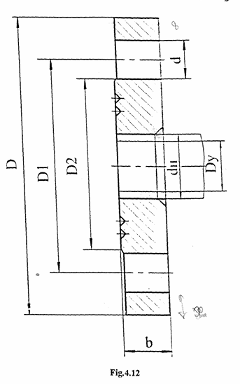 | 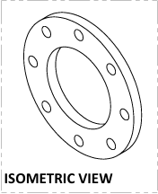

Scope
Equipment Name: WELDED PLANE PIPE FLANGE, SS NB100 NP10
BOM ID : EP-2737
PO No with date: HSS/38/SS&NAB-OLF’S /S5/314 dated on 24 Jul 2025

Details of types of analysis.
Scope of the FE Analysis is to evaluate the induced stresses under maximum operating pressure
Following analysis are being submitted in the current report.
Table 3:Scope of Design Analysis
S.no | Analysis type | Sections |  | Relevant section of PO | Remarks
 |  | Loading Condition | FE Results
1 | Static Structural Analysis | 8.1 | 10.1 | Sec- B | --
2 | Modal Analysis | 8.2 | 10.2 | Sec- B | --
3 | Vibration Analysis | 8.3 | 10.3 | Sec- B | --
4 | Shock Analysis | 8.4 | 10.4 | Sec- B | --
5 | Fatigue Analysis | NA | NA | N.A | Indicated in the P.O. However, FE Analysis is not carried out as there is no Cyclic load.
 | Mechanical Design Calculations
6 | Thickness Calculation of Welded Plane Pipe Flange | 11.1 |  | Sec- B | --
7 | Design Validation Flange Thickness Calculations | 11.2 |  | Sec- B | --
8 | Bolt Preload Calculations | 11.3 |  | Sec- B | --
9 | Fatigue Calculations | 11.4 |  | Sec- B | --

Software/ Tools
The software’s/tools used for design, pre-processor, solver, and post-processer for all types of analysis is as follows:
S.NO: | Process | Software used | Version
1 | 3D Modelling | Solidworks | 2025
2 | Pre-processer | Ansys Space claim & Design Modeller | 2025 R2
3 | Solver | Ansys Enterprise | 2025 R2
4 | Post-processer | Ansys Mechanical | 2025 R2

References
List of references are tabulated below:
Table 4: References
S.no. | Reference type (Standard/Jonal paper/etc) | Reference Number | Title | Revision year and date | Referred for
1 | Standard | ASME PCC-1-2019 | Guidelines for Pressure Boundary Bolted Flange Joint Assembly | 2019 | Bolt Pretension Calculations
2 | Standard | ASME BPVC SEC II, Part D | Boiler and Pressure Vessels Codes- Materials | 2023 | Material Properties
3 | Standard | ASME section VIII Div 1 | Boiler and Pressure Vessels Codes | 2023 | Shell Thickness Calculations
4 | Standard | NDT 117-96 | Flange section | 2024 | Flange design
5 | Test Book |  | Machine Design – Robert L. Norton |  | Endurance limit

Equipment details

Model

3D Model
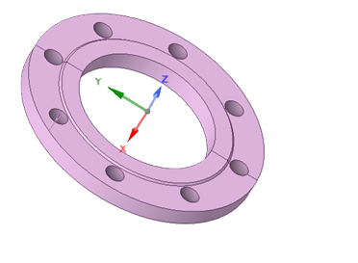
Welded plane pipe flange
Sectional View
Figure 1: 3D Model of the Welded plane pipe flange

Sectional View
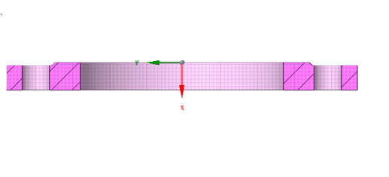

Figure 2: Sectional View

2D Drawing
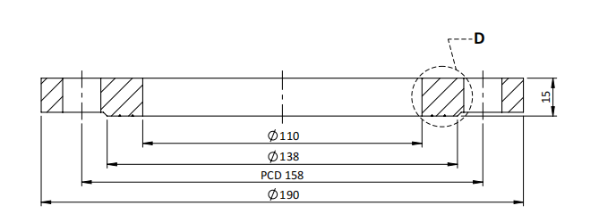
Figure 3: 2D Drawing

Welded Flange Design
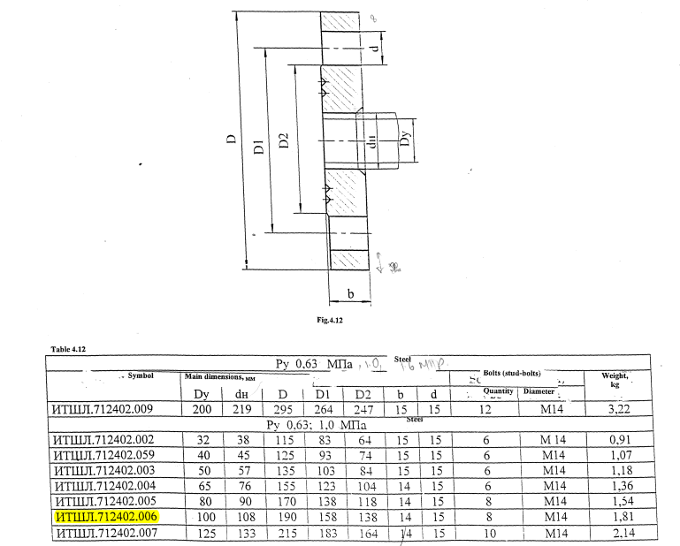
Figure 4: Welded Plane Pipe Flange NTD 117-96
The Welded Plane Pipe Flange is designed / selected based on GOST Std i.e., NTD 117-96 w.r.t Bore diameter of 100 mm as indicated in the PO. (Reference- NDT 117-96, Table -4.12, Page No. 97).

Mass, Centre of gravity, model orientation and materials as per drawing

The weight of FE analysis is tabulated below: -
Table 5: Mass Balance
S.No. | Part Name | Material Std/Grade | Qty | Drawing (Kg) | FE Model Mass (Kg)
1 | Welded plane Pipe Flange | ASTM A 182 F32100 | 1 | 1.94±3% | Model Mass (Excluding Extended pipes & Counter Flanges) | Total Mass
 |  |  |  |  | 1.9598 | 17.182

Centre of Gravity

The centre of gravity (CG) of the Welded Plane Pipe Flange Calculated as
Table 6: Centre of gravity
From the reference coordinate  cg. W_{t}= ʃ x dw  X_{CG} = -1.5 mm  Y_{CG} = 0 mm  Z_{CG} = 0 mm | 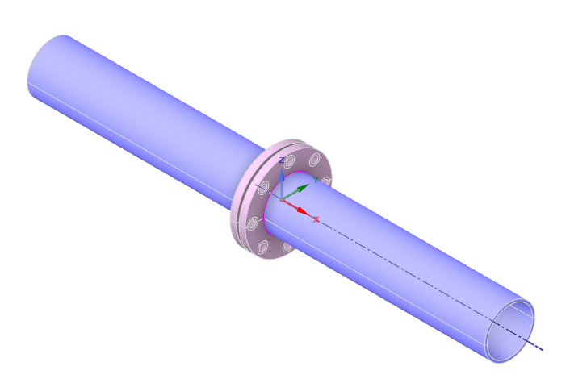

Model Orientation


Figure 5: Model Orientation

Details of structural connections to surrounding structure
5D Length Extended Pipes: 5D length (five times the pipe’s internal diameter) pipe modelled to meet real time standards and to ensure stable flow for instrumentation. 5D length pipes are modelled at outlets of the different Welded Plane Pipe Flange for testing the realistic behaviour. These pipes are modelled in Ansys Design modeller / Space Claim and given thickness based on pressure and bore as per GOST standard. The 5D extended pipes are modelled as 3D elements. The 5D length pipes and Different Welded Plane Pipe Flange are to be connected by welding in on board condition. To evaluate this weld scenario, node to node merge option opted in Ansys simulation.

Working Principle.
A Welded Plane Pipe Flange is an online fitting equipment. This welded Plane Pipe Flange involves permanently joining a flange to a pipe with a weld, then using bolts and gasket to create a leak-tight, demountable joint with another flange or equipment, relying on controlled compression to deform the gasket into surface imperfections for a seal, especially in high pressure systems. The flange itself is welded to the pipe and then the assembly is bolted to another flanged surface, with the gasket compressed between them to block fluid paths. It features a 180 degree straightway, making it ideal for tight spaces.

Input data / Technical Specifications.
The Finite Element Analysis (FEA) of the Welded Plane Pipe Flange is carried out by considering the following technical specifications and design parameters: -
Table 7: Technical Specifications
S.No | Parameter | Value
1 | Nominal Bore | 100 mm
2 | Working Pressure | 10 kg/cm²
3 | Working Medium | Air
5 | Weight | 1.959 kg
6 | Material | ASTM A 182 F321

Modelling details

Details of all the non-structural parts, which are excluded from the model (N.A)

Modelling approach for all structural part
The three-dimensional geometry of the Welded Plane Pipe Flange was developed using CAD modelling software based on the design dimensions and assembly drawings. The Finite Element (FE) model was generated from this geometry to accurately represent the structural configuration of the Welded Plane Pipe Flange for analysis purposes.
The FE model primarily consist of 3D solid 187 elements for all the main pressure-retaining components such as the Welded Plane Pipe Flange. The 5D extended pipes consists of 3D solid 187elements. The FE model of the Welded Plane Pipe Flange was discretized using 3D solid elements (SOLID 187) for the total Flange assembly by means of Finite Element Method (FEM).
A second order mesh model has been adopted for analysis. The mesh quality was carefully checked for aspect ratio, skewness, element distortion, etc (as mentioned in below), and found to be within acceptable limits. The final mesh consisted of approximately 170440 elements and 294125 nodes, providing a good balance between computational efficiency and solution accuracy.
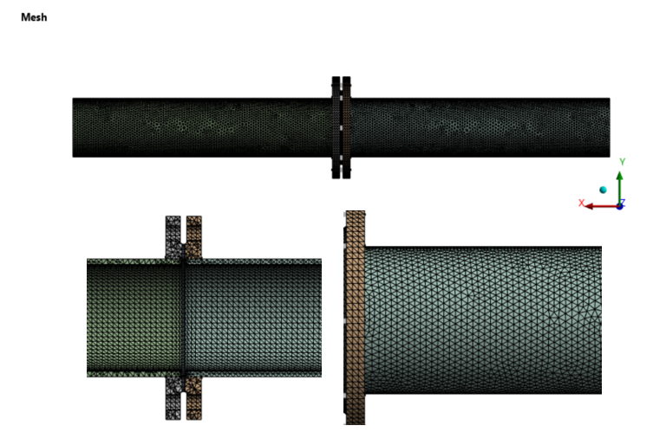
Figure 6: Mesh
Table 8: Mesh Control
S. No. | Parameter | Value
1 | Type of Element | Tetrahedron and 1D Beam (Solid 187, Beam 188)
2 | Type of method | Patch Conforming
3 | Element Size | 5 mm
4 | Control Sizing | Curvature control
5 | No. of Elements | 170440
6 | No. of Nodes | 294125
7 | Quality | 1

Table 9: Mesh Quality
S. No. | Parameter | Range | Value
1 | Aspect Ratio | < | 10
2 | Skewness | < | 0.31
3 | Jacobian ratio | > | 0.97
5 | Element Quality | = | 0.77
6 | Maximum Corner Angle | = | 100°

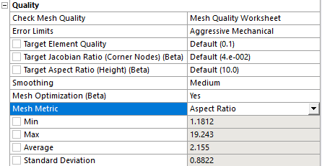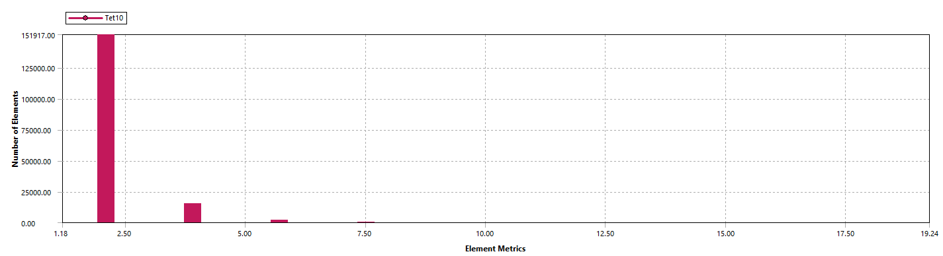
Figure 7: Aspect ratio
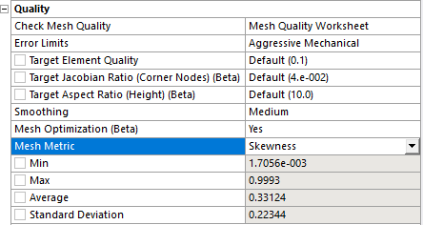
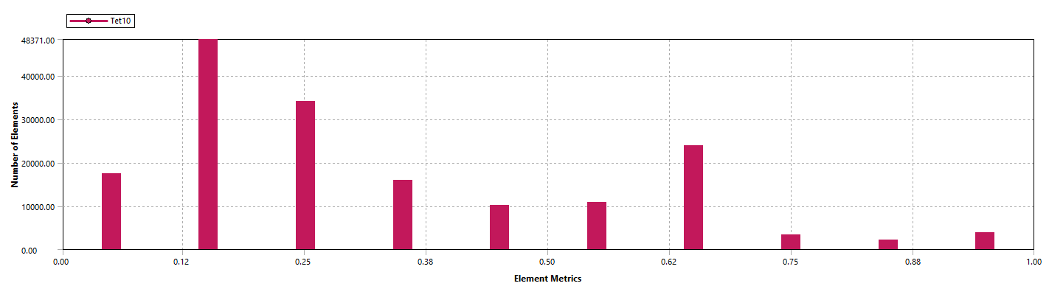
Figure 8: Skewness
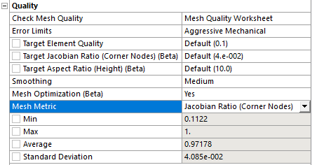
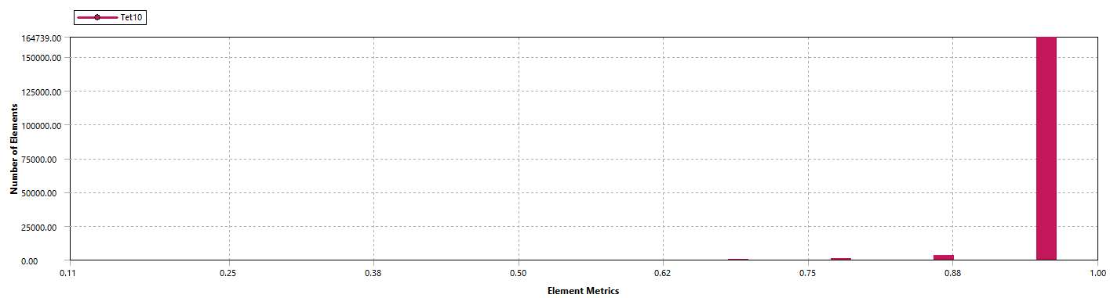Figure 9: Jacobian ratio
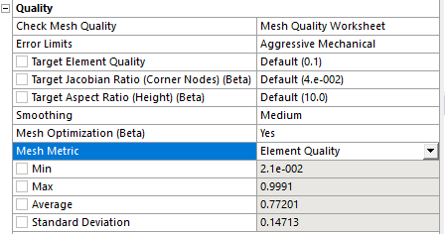

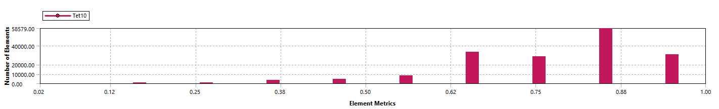
Figure 10: Mesh quality
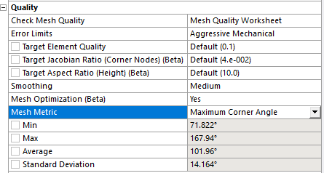
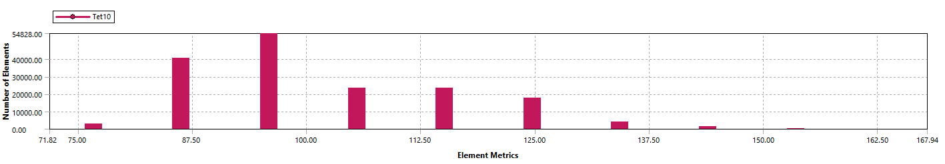
Figure 11: Maximum Corner Angle

Modelling approach for bolted joints
Bolted joints between two connected flanges are represented using beam elements. Each beam element is connected to the flanges by modelling the washer area as a rigid connection (RB2) at both ends of the beam. In this analysis, bolts and studs are not explicitly modelled in order to reduce the number of nodes and overall computational effort.

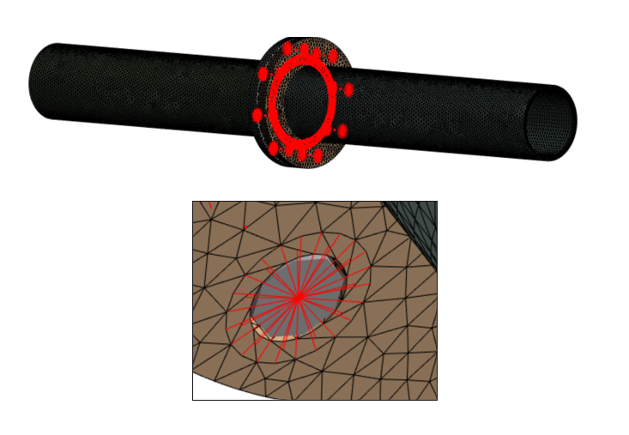
Figure 12: 1D Beam with rigid connection (RB2)

Modelling approach for welded joints (Not Applicable)

Modelling approach for joints (Not Applicable)

Modelling approach for interfaces (contacts)
The contact is modelled like this Flange to Gasket one end it is connect like bounded contact and another side of Gasket and another Flange it is connect with frictional contact, and Flange 5D extended pipes were connected by node-to-node merge.
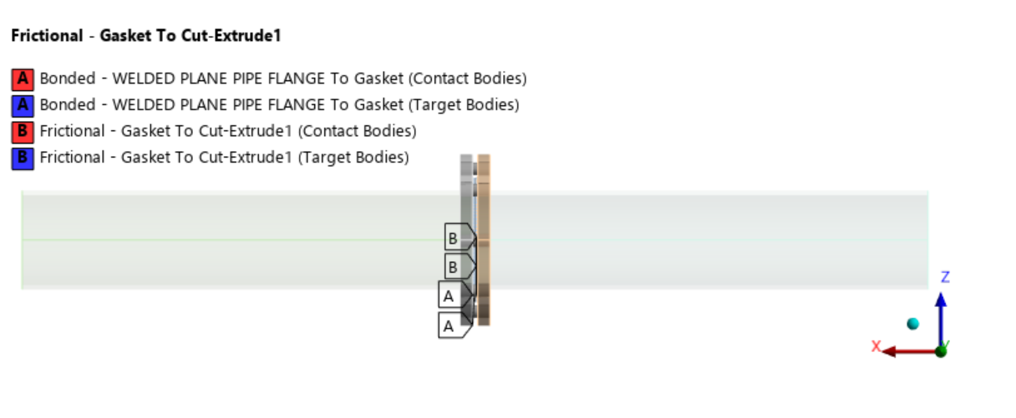
Figure 13: Contacts

Details of materials models selected
The following materials models are selected in the FEA for analysis:
(a) Physical Property i.e. Density
(b) Linear Elastic i.e. Isotropic Elasticity
(c) Strength i.e. Tensile Yield and Tensile Ultimate
Table 10: Material Properties

Loads and Boundary conditions
ASTM A 182 F32100 |  |  |  | References
S.No | Property | Value | Units
1 | Density | 8030 | Kg/m^3 | ASME Sec II Part D-2023, Table PRD, Page No. 1154 (series 300)
2 | Elastic Modulus | 195 | GPa | ASME Sec II Part D-2023, Table TM1, Group G, Pg No. 1148
3 | Poisson’s Ratio | 0.31 |  | ASME Sec II Part D-2023, Table PRD, Page No. 1154 (series 300)
4 | Yield Strength | 205 | MPa / (N/mm^2) | ASME Sec II Part D-2023, Pg No. 112, Group 20
5 | Tensile Strength | 515 | MPa / (N/mm^2)
6 | % of Elongation | 30 | % | ASTM A182/A182M-12a, Table 3, Pg- 11
7 | Static Allowable Strength (Min (2/3YTS or 1/3.5UTS)) | 136.67 | MPa / (N/mm^2) | ASME Sec II Part D-2023, Pg No. 114, Group 20

Static Structural Analysis
Static structural analysis is carried out to ensure structural integrity of components under steady-state operating loads such as nominal (working) pressure and self-weight.

Methodology.
The analysis aims to ensure that the Welded Plane Pipe Flange can safely withstand the applied internal pressure and self-weight without excessive deformation or yielding. The finite element model consists of 3D solid elements. Specific Gravity loading is also included to account for the self-weight of the components. The resulting stresses and deformations are to be evaluated.

Environment & Boundary Conditions.
The following Environment & Boundary conditions are as follows: -
The boundary conditions for the Finite Element Modal analysis have been established such that all degrees of freedom are rigidly constrained at both the Inlet and Outlet faces of the Valve, as illustrated below.

Standard Earth Gravity
Standard Earth Gravity 9.81 m/s^2 or 9806.6 mm/s^2 is applied. The purpose of including this load is to account for the weight of the components and ensure that the structural analysis takes into consideration the effects of gravity.

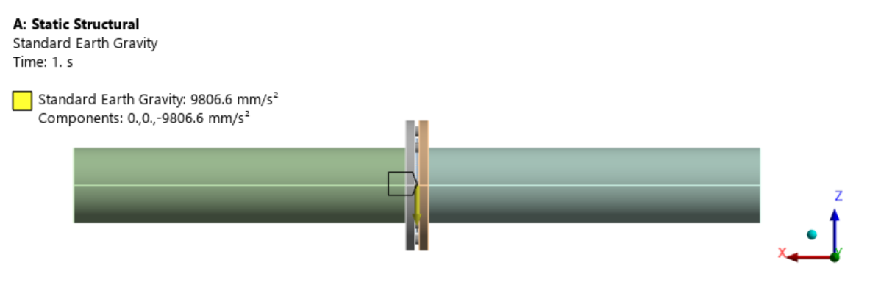
Figure 14: Standard Earth Gravity

Fixed Supports:
The Welded Plane Pipe Flange end side faces are considered as fixed.

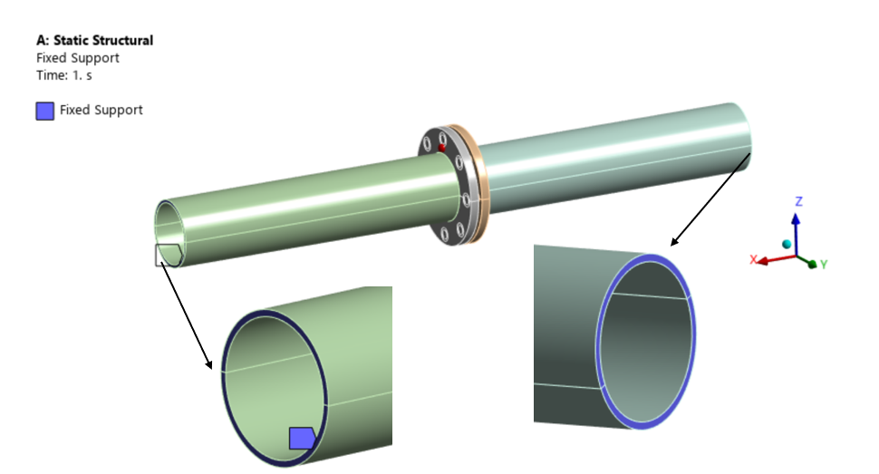
Figure 15: Fixed Support. Fixed in all DOFs

Pressure:
In the Finite Element (FE) analysis of the Welded Plane Pipe Flange, the operating pressure of 10 kgf/cm² (1 MPa) has been applied on the internal surface.

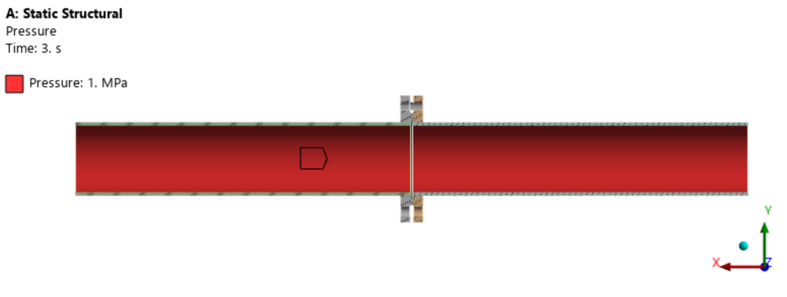
Figure 16: Pressure

Weight of Fluid
Fluid Medium is air, therefor the weight of air has negligible weight, its gravitational effect is ignored in Static Structural analysis.

Modal Analysis
Modal analysis is a powerful engineering technique used to understand and characterize the dynamic behaviour of structures, systems, and components. Modal analysis primarily focuses on identifying the natural frequencies, mode shapes, and damping properties of a structure, all of which are vital in predicting how it will respond to external forces and vibrations. Un-damped Eigen value and Eigen vector analysis is performed to estimate the natural frequencies with 20 No. of modes.

Methodology
The Finite Element (FE) modal analysis has been meticulously conducted, employing the Block Lanczos method, with a comprehensive selection of modes. Specifically, a substantial number of modes have been included in the analysis to ensure that the cumulative modal mass participation exceeds 80% across all three mutually perpendicular directions encompassing both translations and rotations.
The boundary conditions for the Finite Element Modal analysis have been established such that all degrees of freedom are rigidly constrained at both the Inlet and Outlet end faces of the Welded Plane Pipe Flange, as illustrated below.

Fixed Supports
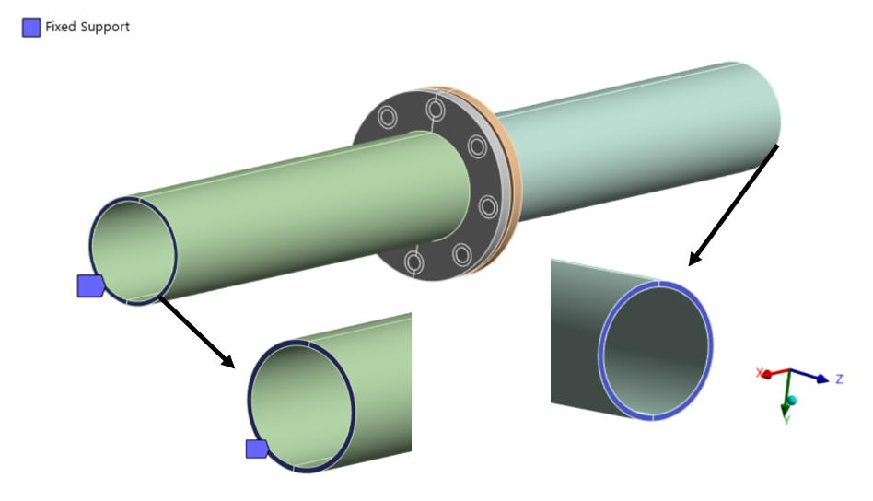
Figure 17: Fixed Support. Fixed in all DOFs

Vibration Resistance Analysis
FE Vibration Resistance analysis is a dynamic response analysis of structure. It aims to simulate the response of a structure under propeller induced vibrations.

Methodology
FE Vibration Resistance analysis is to study how a structure or system responds to harmonic (periodic) excitations or loads. It is commonly employed in engineering and physics to understand how structures and components behave under cyclic loads, such as vibrations or oscillations. Analysis has been carried out by mode superposition method.

Loading Conditions
A Finite Element (FE) Vibration Resistance analysis has been meticulously conducted, encompassing a frequency range spanning from 3 to 33 Hz, subjecting the system to an acceleration of 0.7g, which translates to approximately 6867 mm/s², applied in three mutually perpendicular directions. In this analysis, the acceleration is defined as the base excitation, simulating the dynamic loading conditions experienced by the system.

Fixed Support
The boundary conditions for the Finite Element Vibration Resistance analysis have been established such that all degrees of freedom are rigidly constrained at both the Inlet and Outlet end faces of the Welded Plane Pipe Flange, as illustrated below:

Figure 18: Fixed Support. Fixed in all DOFs

Excitation in X- Direction

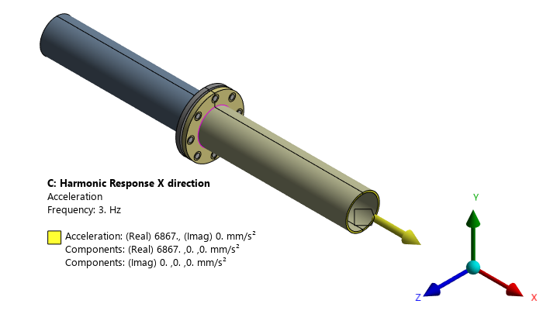
Figure 19: Excitation of 0.7g in X-Direction

Excitation in Y- Direction
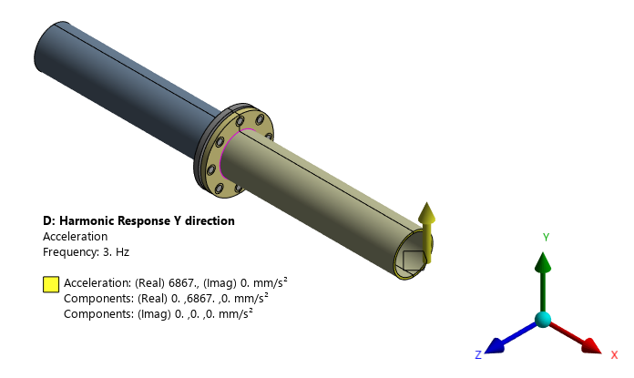
Figure 20: Excitation of 0.7g in Y-Direction

Excitation in Z- Direction
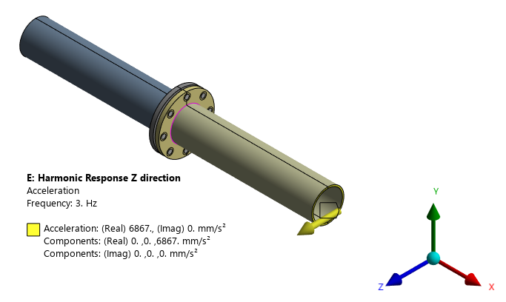
Figure 21: Excitation of 0.7g in Z-Direction

Shock Analysis - Equivalent Static Approach
Shock analysis has been meticulously conducted to replicate and evaluate the structural integrity of the Welded Plane Pipe Flange under the dynamic shock loads which experiences when subjected to the K-200 Shock testing machine.

Methodology
In the realm of shock analysis, two distinct methodologies are available: the transient shock approach and the Equivalent Static approach. The selection between these approaches hinges on a critical parameter namely, the first natural frequency of the Welded Plane Pipe Flange as determined in the modal analysis.
In this specific scenario, the first natural frequency of the Welded Plane Pipe Flange established through modal analysis is far exceeds the threshold of 160 Hz, measuring at an impressive 363.59 Hz. Consequently, the chosen methodology for simulating and estimating the shock strength of the Welded Plane Pipe Flange is the Equivalent Static Approach. This approach effectively captures and quantifies the Welded Plane Pipe Flange ability to withstand and respond to the shock loads it experiences during its operation on the K-200 Shock testing machine.
Equivalent Static analysis is performed in 06 directions of shock loads i.e., +X, -X, +Y, - Y, +Z and –Z direction.

Loading Conditions
The boundary conditions for the Equivalent Static analysis have been established such that all degrees of freedom are rigidly constrained at both the Inlet and Outlet faces of the Welded Plane Pipe Flange, as illustrated below.
In the Finite Element (FE) Static Structural analysis of the Welded Plane Pipe Flange we have taken into account the maximum operating pressure, which is 10 kgf/cm².
This load represents the gravitational force acting on the entire structure due to the Earth's gravitational field. It is typically applied as a uniform downward force with a magnitude equal to the product of the mass of the structure and the acceleration due to gravity (9.81 m/s^2 or 9806.6 mm/s^2). The purpose of including this load is to account for the weight of the components and ensure that the structural analysis takes into consideration the effects of gravity.

Shock Pulse Specifications:

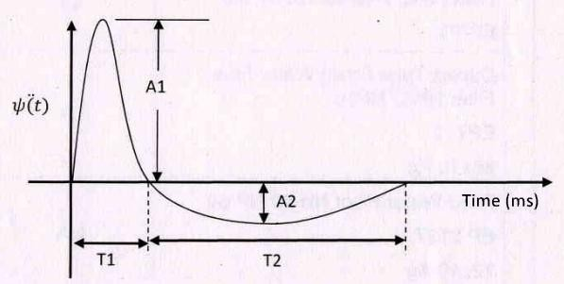
Figure 22: Shock Pulse Nomenclature

Table 11: Shock Pulse Specifications
Direction of Impact  Wt | Longitudinal (X) |  |  |  | Vertical (Y) |  |  |  | Horizontal (Z)
 | A1 | T1 | A2 | T2 | A1 | T1 | A2 | T2 | A1 | T1 | A2 | T2
0-60 kg | 220 | 2.5 | 59.5 | 9 | 180 | 3 | 83.5 | 6.5 | 280 | 3 | 94 | 9

Shock Acceleration
Maximum Shock acceleration in both positive and negative direction out of all the three mutual perpendicular direction are considered in the analysis i.e., 280G in +X, +Y & +Z direction and 94G in -X, -Y & -Z direction in addition to the operating loads i.e., self-weight and pressure. The accelerations considered in the different analysis cases are illustrated below.
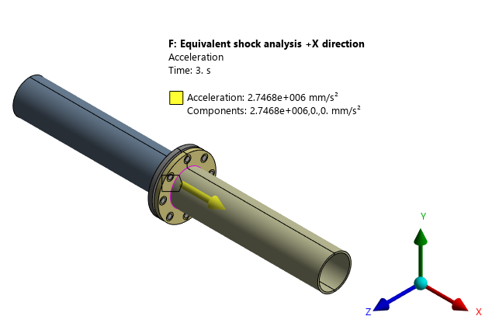
Figure 23: Shock Acceleration of 280g in + X Direction
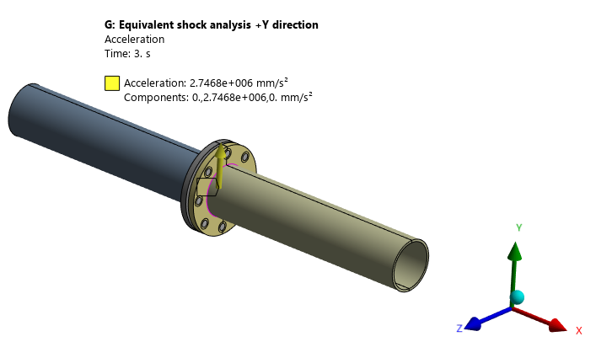
Figure 24: Shock Acceleration of 280g in + Y Direction

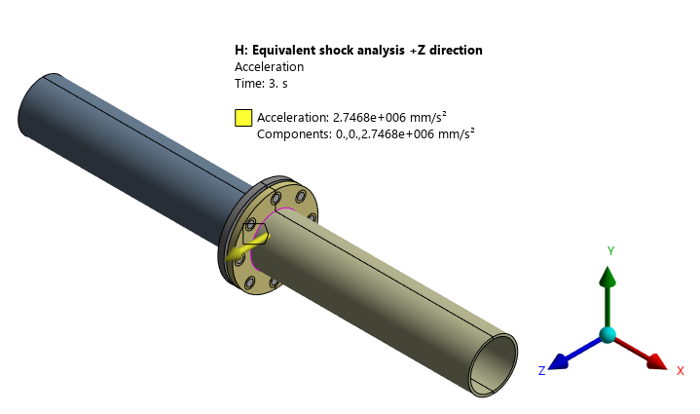
Figure 25: Shock Acceleration of 280g in + Z Direction
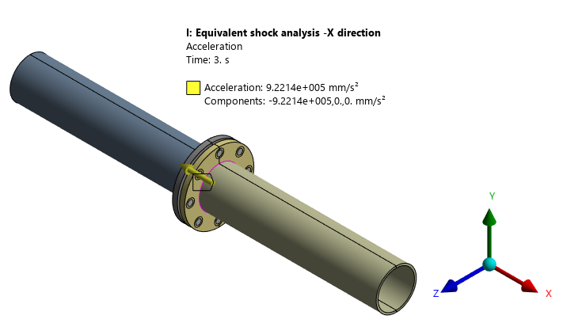
Figure 26: Shock Acceleration of 94g in - X Direction
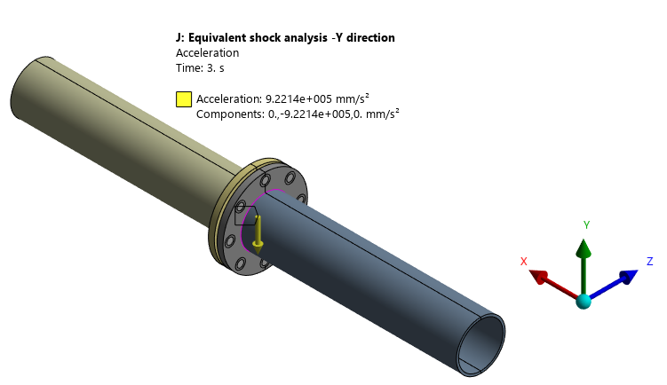
Figure 27: Shock Acceleration of 94g in – Y Direction

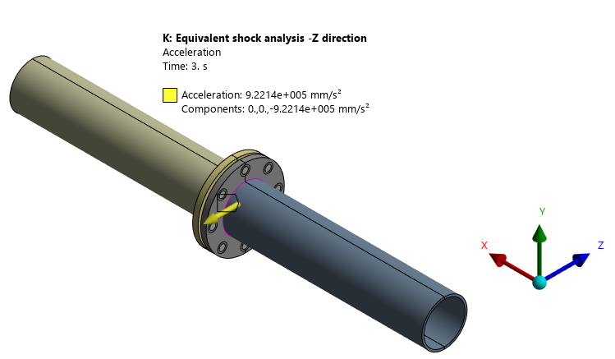
Figure 28: Shock Acceleration of 94g in - Z Direction

Material Properties & Static allowable Strength.
Table for material properties.
Table 12: Material Properties
Trade name of Material | Material Grade | Young’s Modulus (GPa) | Density (kg/m3) | Poisson’s Ratio | Reference Standard
ASTM A 182 | F32100 | 195 | 8030 | 0.31 | ASME Section II, Part D

Table 13: Material allowable strength – Static and Fatigue
Trade name of Material |  | Material Grade | Yield (MPa) | Ultimate Tensile Strength (MPa) | % Elongation | Static Allowable (MPa) | Fatigue Allowable  (MPa) Base Material | Fatigue Allowable  (MPa) Welds
ASTM A 182 |  | F32100 | 205 | 515 | 30 | 136.67 | 68.2 | N.A
*Allowable stresses for Strength: Min of (1/3.5 x UTS) or
(2/3 x Yield strength)

Results & Discussions

Modal Analysis
Natural frequencies and corresponding mode shapes are evaluated for Butt Weld Pipe Flange. To comprehensively capture the system's behaviour under dynamic loads, a total of 30 modes have been extracted, ensuring that the cumulative mass participation exceeds 80%.
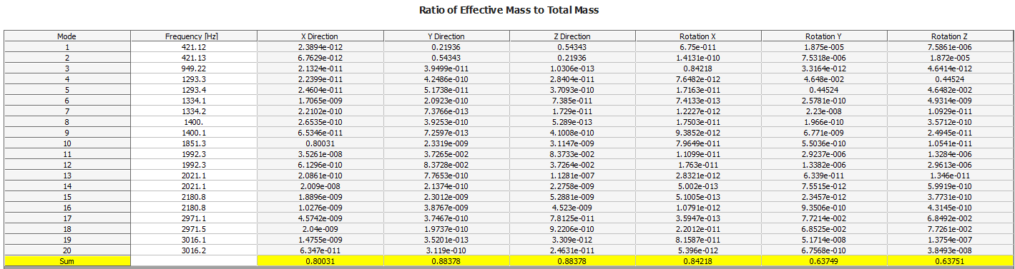
Figure 29: Ratio of Effective Mass to Total mass

In the analysis minimum mass participation of 76% of the total mass participates in the modes corresponding to translations along the X, Y and Z directions, as well as rotations about the X, Y and Z directions. This mass participation is referred to the structural stiffness of the Weld Plane Pipe Flange, which is particularly pronounced in these six degrees of freedom.
The extracted modes, along with their corresponding 06 mode shapes and the associated mass participation percentages in each mode, are presented in the following illustrations.
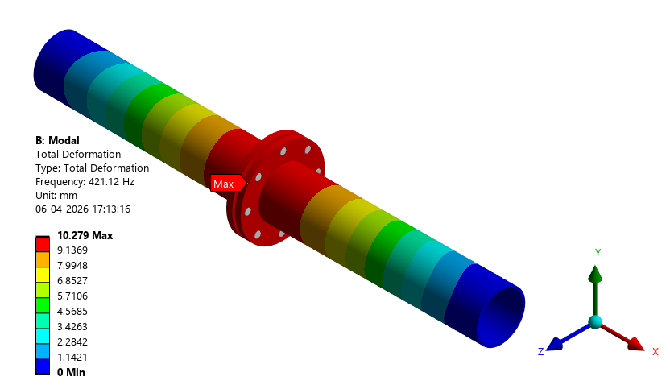
Figure 30: Mode 1 at Frequency of 421.12 Hz
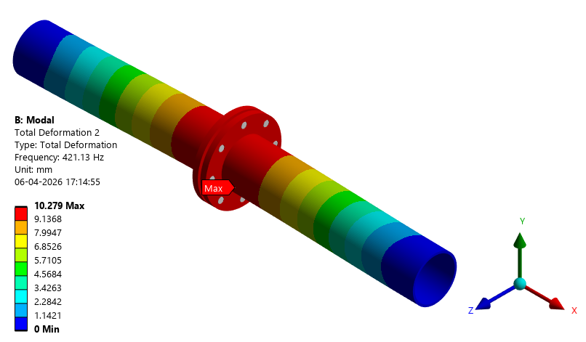
Figure 31: Mode 2 at Frequency of 421.13 Hz

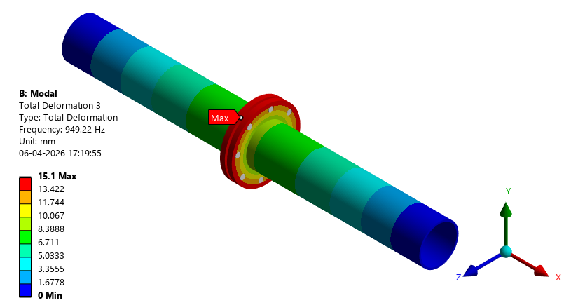
Figure 32: Mode 3 at Frequency of 949.22 Hz
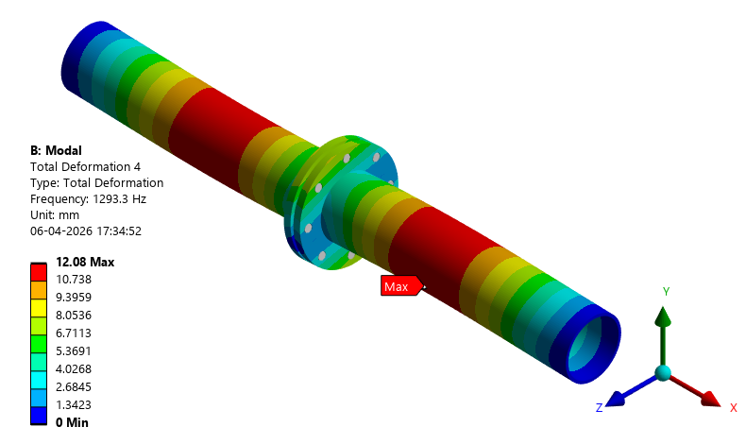
Figure 33: Mode 4 at Frequency of 1293.3 Hz

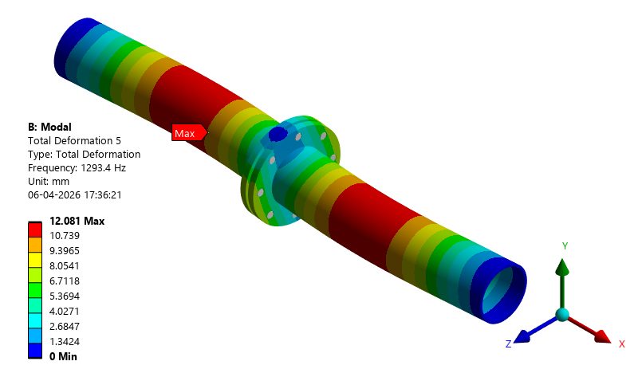
Figure 34 Mode 5 at Frequency of 1293.4 Hz
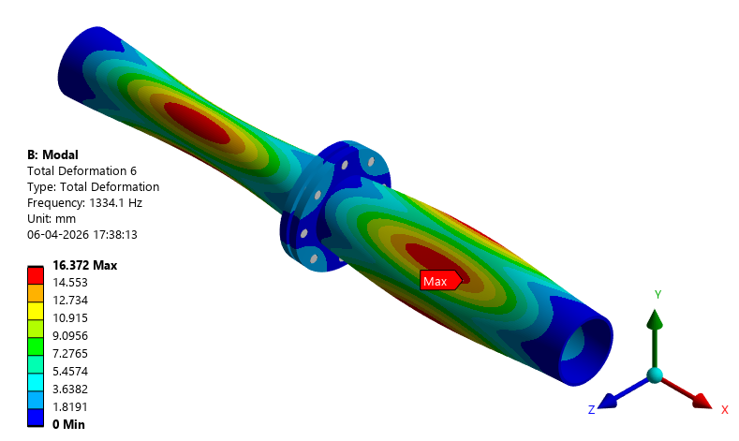
Figure 35: Mode 6 at Frequency of 1334.1 Hz

Modal Analysis: Conclusions
The Modal Analysis is performed to extract the modes of vibration of the structure. The Fundamental frequency of vibration was found to be 421 Hz. As this is more than the 160 Hz the Equivalent Static approach will be used to perform the Shock Analysis.

Table 14 Modal Frequencies
Sl. No | Frequency (Hz) | Operating Frequency | Dominant in Direction | Remark
1. | 421.12 | 3 to 33 Hz | Z Direction | Not in or near operating Frequency
2. | 421.13 | 3 to 33 Hz | Y Direction | Not in or near operating Frequency
3. | 949.22 | 3 to 33 Hz | Rotation about Y Direction | Not in or near operating Frequency
4. | 1293.3 | 3 to 33 Hz | Rotation about Z Direction | Not in or near operating Frequency
5. | 1293.4 | 3 to 33 Hz | Rotation about Y Direction | Not in or near operating Frequency
6. | 1334.1 | 3 to 33 Hz | X Direction | Not in or near operating Frequency

Static Structural Analysis
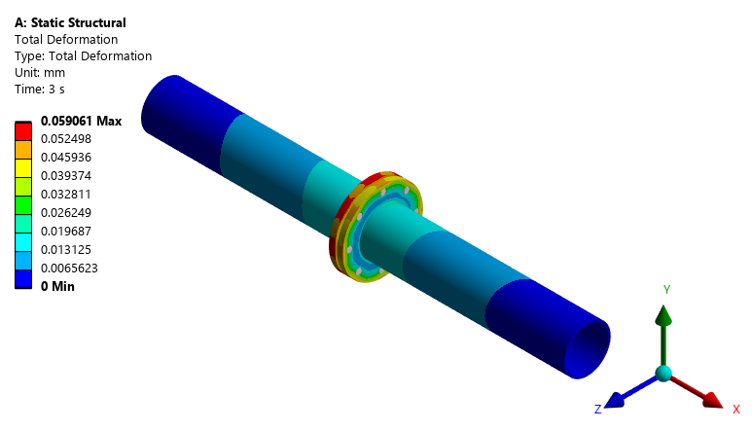
Figure 36: Total Deformation of Welded Plane Pipe Flange Assembly
The Total Deformation of 0.059 MPa is observed in the Welded Plane Pipe Flange.
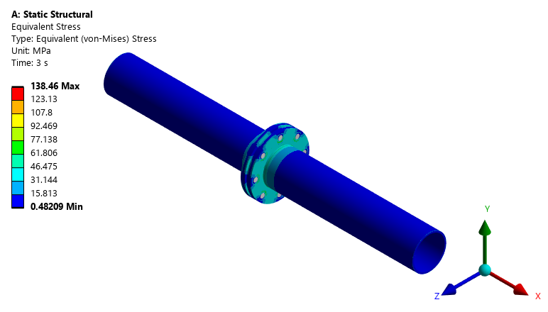
Figure 37: Equivalent Von-mises Stress of Welded Plane Pipe Flange Assembly
In the comprehensive evaluation of the Welded Plane Pipe Fange under operating conditions, which include the effects of self-weight and a pressure of 10 bar, the maximum stress observed is 138.46 MPa which is localized.
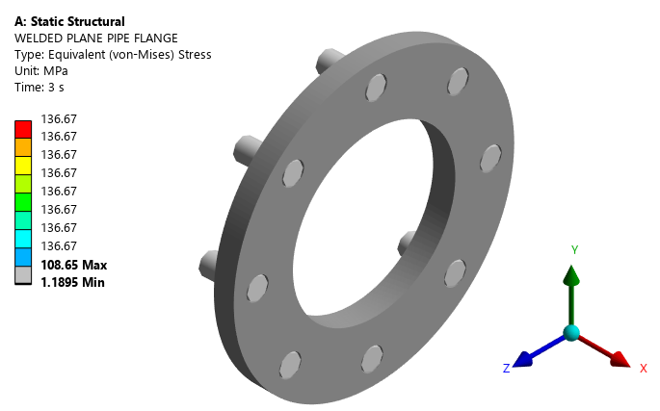
Figure 38 : Equivalent Von-mises Stress of Welded Plane Pipe Flange
The maximum stress observed in the component made of ASTM A182 F32100 is 108.65 MPa. The static allowable strength of the material i.e.137 MPa. Consequently, the stresses induced in components made of ASTM A182 F32100 are within the static allowable strength of the material.
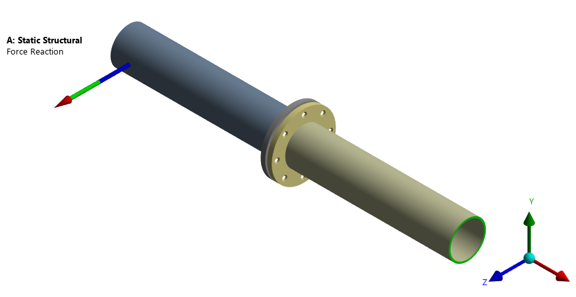
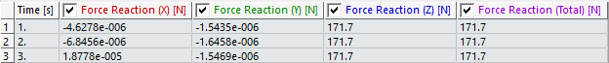
Figure 39: Reaction Force of 171.7 N in Z-Direction

The exact force equilibrium cannot be established in this load case as the pressure is applied on multiple surfaces and in all direction.
Table 15: Bolt Loads for Static Structural Analysis
Bolt No | Maximum Axial Force (N) | Maximum Shear Force (N) | Tensile Stress Area mm² | Shear Stress Area mm2 | Normal Stress | Shear Stress | Yield Stress MPa | Conclusion
Flange to Counter Flange |  |  | Mean Dia | Root Dia
1 | 11833 | 376.02 | 115 | 100 | 102.895652 | 3.7602 | 205 | Accepted
2 | 11833 | 383.19 | 115 | 100 | 102.895652 | 3.8319 | 205 | Accepted
3 | 11833 | 388.49 | 115 | 100 | 102.895652 | 3.8849 | 205 | Accepted
4 | 11833 | 394.07 | 115 | 100 | 102.895652 | 3.9407 | 205 | Accepted
5 | 11833 | 398.62 | 115 | 100 | 102.895652 | 3.9862 | 205 | Accepted
6 | 11833 | 414.53 | 115 | 100 | 102.895652 | 4.1453 | 205 | Accepted
7 | 11833 | 398.9 | 115 | 100 | 102.895652 | 3.989 | 205 | Accepted
8 | 11833 | 385.12 | 115 | 100 | 102.895652 | 3.8512 | 205 | Accepted

Static structural analysis: Conclusion
The stresses obtained on this section were found to be less than the allowable limits for all the simulated structural component. This indicates that the design is safe under the given loading and boundary conditions.
Table 16:Static Structural Analysis Conclusion
Sr. No | Material | Maximum Occurs on | Stresses Observed (MPa) | Allowable Stress (MPa) | Remarks
1 | ASTM A182 F321 | Flange | 108.65 | 136.67 | Stresses less than allowable

Vibration Resistance Analysis

Vibration Resistance Analysis in X – Direction
Harmonic Response of Welded Plane Pipe Flange component simulated for a frequency range of 3 – 33 Hz with amplitude of 0.7g acceleration in X - direction. Response plots and stresses are illustrated as follows:
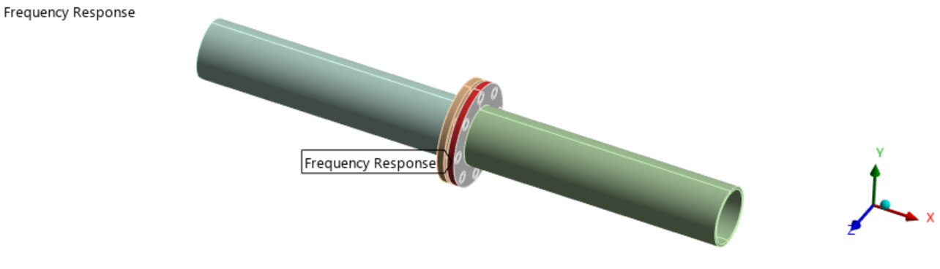
Figure 40: Frequency response on the Flange in X – direction

Frequency response is measured on the Flange which is flexible in the Assembly.
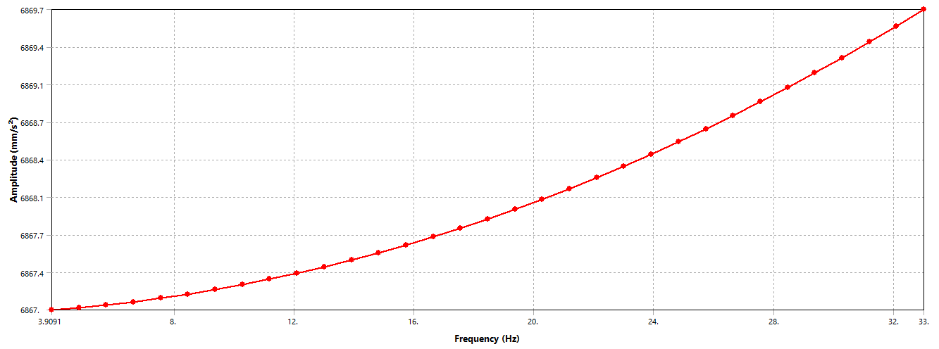
Figure 41: Frequency response acceleration for a frequency range of 3 – 33 Hz
Maximum amplitude of 6869.7 mm/s2 is observed on the Welded Plane Pipe Flange.

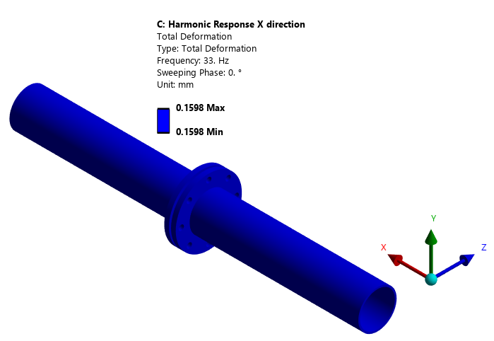
Figure 42: Total Deformation of Welded Plane Pipe Flange Assembly
Maximum deformation of 0.159mm is observed in Welded Plane Pipe Flange Assembly.
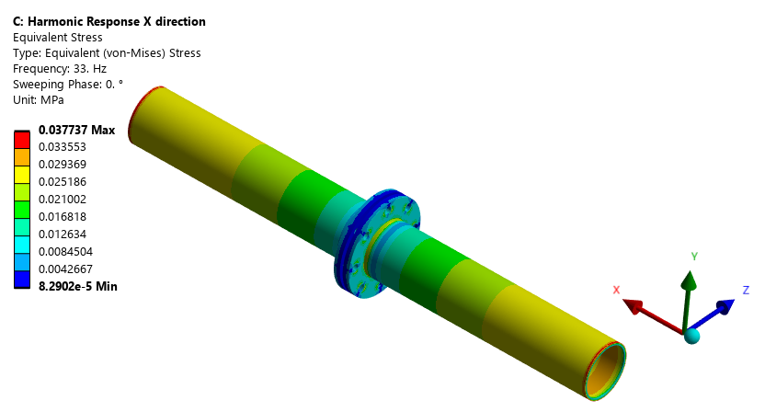
Figure 43: Equivalent Von-Misses Stress of Welded Plane Pipe Flange Assembly
The maximum Stress observed in Welded Plane Pipe Flange Assembly material made of ASTM A182 F32100 is 0.037 MPa which is within the Fatigue allowable value of 68.20 MPa.

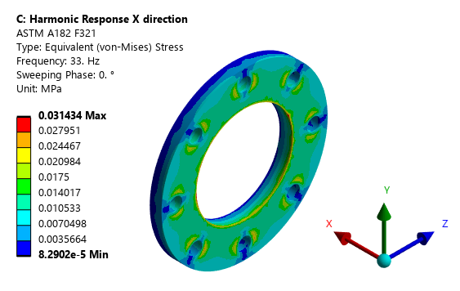
Figure 44: Equivalent Von-Misses Stress of Welded Plane Pipe Flange
The maximum Stress observed in Welded Plane Pipe Flange material made of ASTM A182 F32100 is 0.031 MPa which is within the Fatigue allowable value of 68.20 MPa.

Vibration Resistance Analysis in Y – Direction
Harmonic Response of Welded Plane Pipe Flange component simulated for a frequency range of 3 – 33 Hz with amplitude of 0.7g acceleration in Y - direction. Response plots and stresses are illustrated as follows:
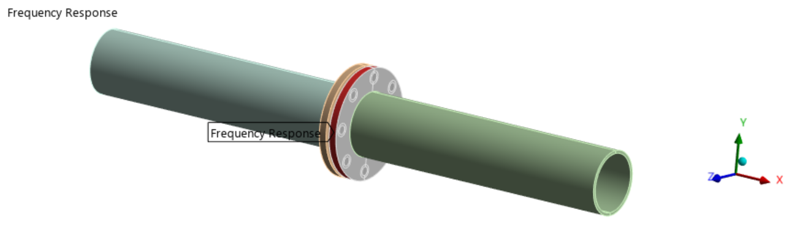
Figure 45: Frequency response on the Flange in Y – direction

Frequency response is measured on the Flange which is flexible in the Assembly.

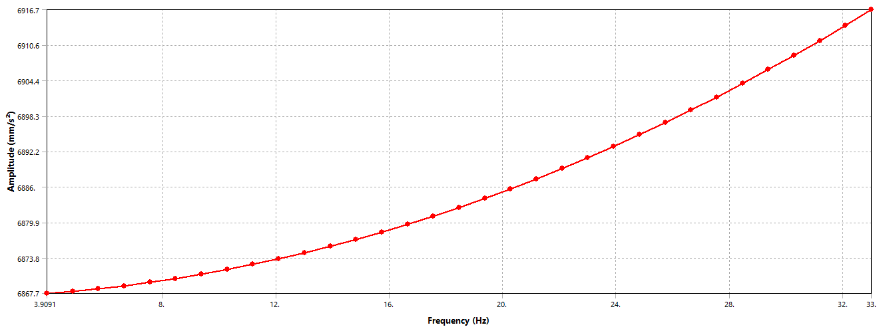
Figure 46: Frequency response acceleration for a frequency range of 3 – 33 Hz
Maximum amplitude of 6916.7 mm/s2 is observed on the Welded Plane Pipe Flange.

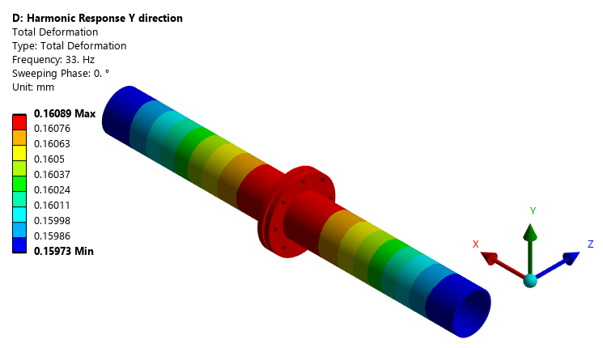
Figure 47: Total Deformation of Welded Plane Pipe Flange Assembly
Maximum deformation of 0.160mm is observed in Welded Plane Pipe Flange Assembly.

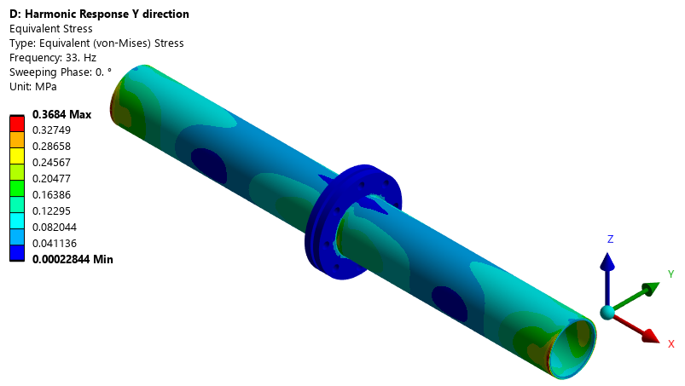
Figure 48: Equivalent Von-mises of Stress Welded Plane Pipe Flange Assembly.
Maximum stress of 0.36 MPa is observed at a frequency of 33 Hz.
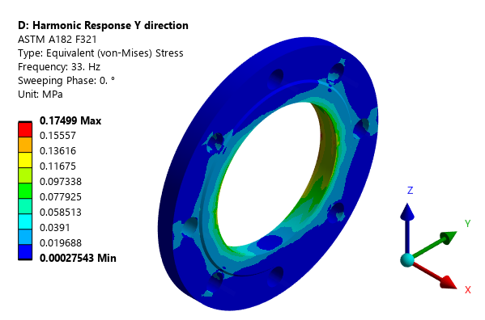
Figure 49: Equivalent Von-Misses Stress of Welded Plane Pipe Flange
The maximum Stress observed in Welded Plane Pipe Flange material made of ASTM A182 F32100 is 0.174 MPa which is within the Fatigue allowable value of 68.20 MPa.

Vibration Resistance Analysis in Z – Direction
Harmonic Response of Welded Plane Pipe Flange component simulated for a frequency range of 3 – 33 Hz with amplitude of 0.7g acceleration in Z - direction. Response plots and stresses are illustrated as follows


Figure 50: Frequency response on the Flange in Z – direction

Frequency response is measured on the Flange which is flexible in the Assembly.
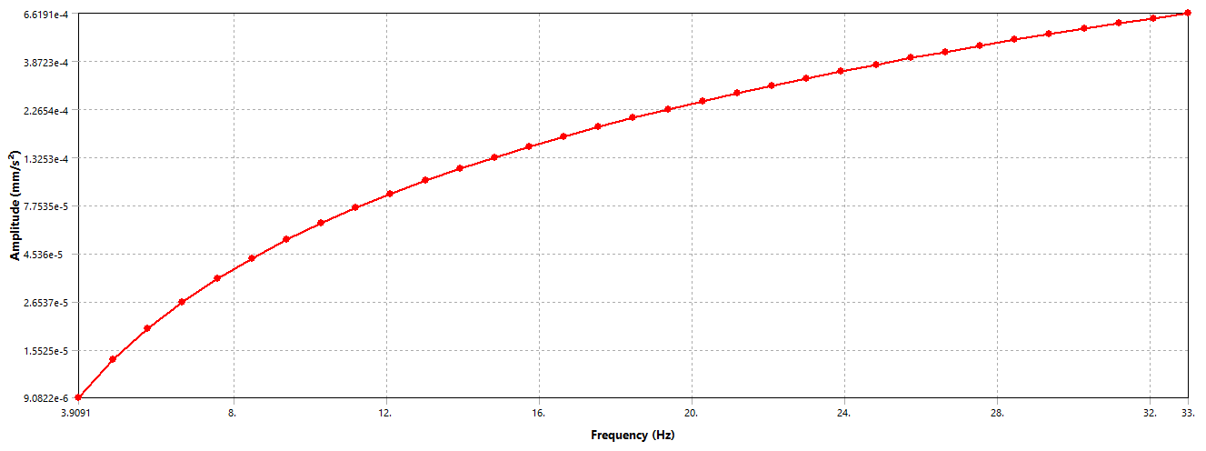
Figure 51: Frequency response acceleration for a frequency range of 3 – 33 Hz
Maximum amplitude of 6916.7 mm/s2 is observed on the Welded Plane Pipe Flange.

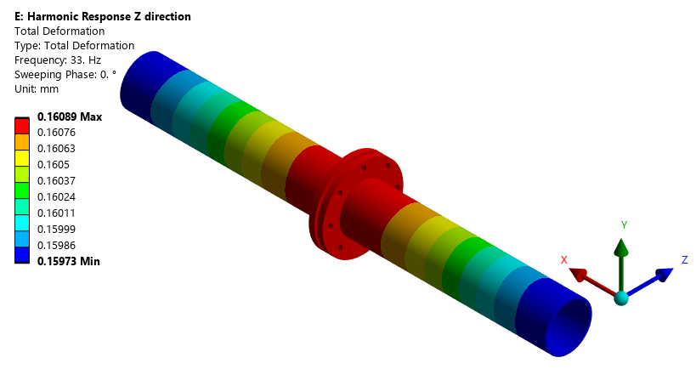
Figure 52: Total Deformation of Welded Plane Pipe Flange Assembly
Maximum deformation of 0.160 mm is observed in Welded Plane Pipe Flange Assembly.

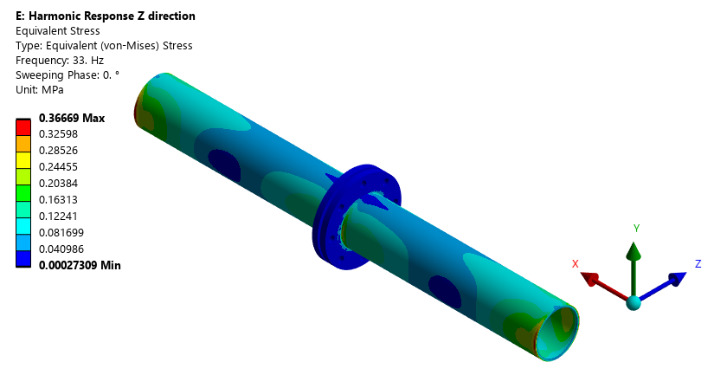
Figure 53: Equivalent Von-mises Stress of Welded Plane Pipe Flange Assembly
Maximum stress of 0.366 MPa is observed at a frequency of 33 Hz.

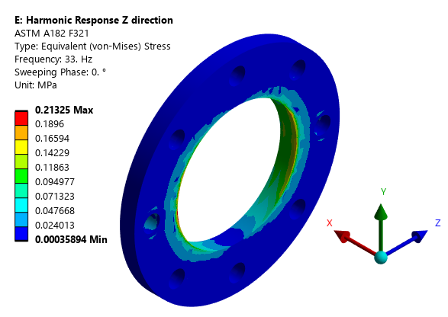
Figure 54: Equivalent Von-Misses Stress of Welded Plane Pipe Flange
The maximum Stress observed in Welded Plane Pipe Flange material made of ASTM A182 F32100 is 0.213 MPa which is within the Fatigue allowable value of 68.20 MPa.

Vibration resistance Analysis – Conclusion

Sl. No. | Analysis | Component | Material | Peak Frequency (Hz) | Maximum Stress (MPa) | Fatigue Allowable (MPa)
1 | Harmonic Response X | Plane Flange | ASTM A182 F321 | 33 | 0.031 | 68.2
2 | Harmonic Response Y | Plane Flange | ASTM A182 F321 | 33 | 0.074 | 68.2
3 | Harmonic Response Z | Plane Flange | ASTM A182 F321 | 33 | 0.213 | 68.2

Shock Analysis – Equivalent Static Approach

Equivalent Static Analysis in positive X – Direction
The stresses induced in the various components of the Welded Plane Pipe Flange under operating loads and shock acceleration in positive X - direction are illustrated as follows:
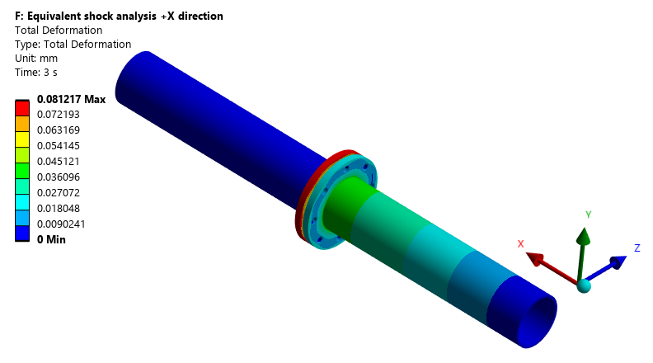
Figure 55: Total Deformation of Welded Plane Pipe Flange Assembly
The Total Deformation of 0.081 mm is observed in the Welded Plane Pipe Flange Assembly
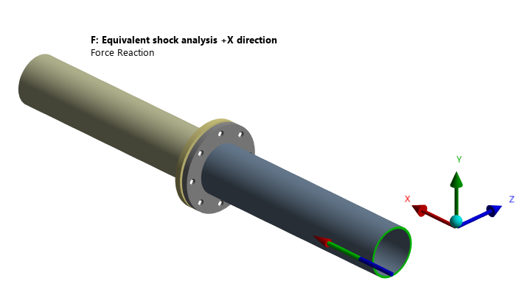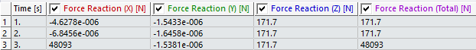
Figure 56: Force Reaction of 48093 N For -X Application of the Shock

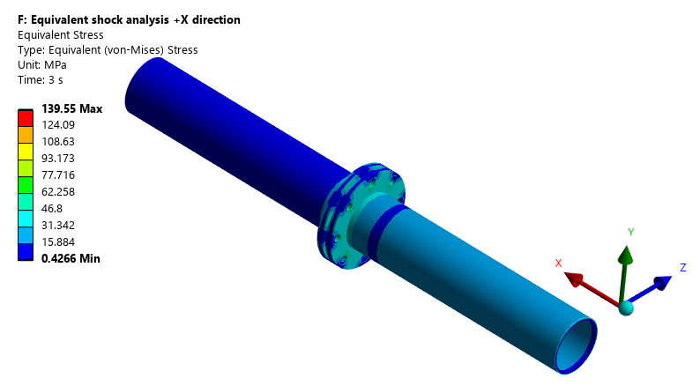
Figure 57: Equivalent Von-Misses Stress of Welded Plane Pipe Flange Assembly
The Maximum stress of 139.5 MPa is observed in the Welded Plane Pipe Flange Assembly.
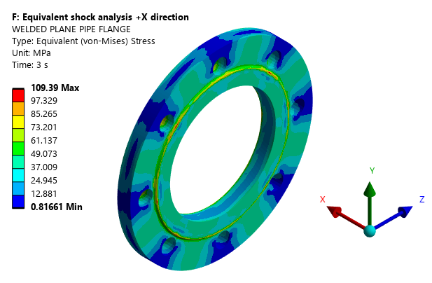
Figure 58: Equivalent Von-Misses Stress of Welded Plane Pipe Flange
The maximum stress observed in the component made of ASTM A182 F32100 is 109.39 MPa. The permissible shock strength of the material i.e., 624.14 MPa. Consequently, the stresses induced in components made of ASTM A182 F32100 are within the shock allowable strength.
Table 17: Bolt Loads: Shock in Positive X direction
Bolt No | Maximum Axial Force (N) | Maximum Shear Force (N) | Tensile Stress Area mm² | Shear Stress Area mm2 | Normal Stress | Shear Stress | Yield Stress MPa | Conclusion
Flange to Counter Flange |  |  | Mean Dia | Root Dia
1 | 11833 | 380.87 | 115 | 100 | 102.89565 | 3.8087 | 205 | Accepted
2 | 11833 | 388.37 | 115 | 100 | 102.89565 | 3.8837 | 205 | Accepted
3 | 11833 | 393.9 | 115 | 100 | 102.89565 | 3.939 | 205 | Accepted
4 | 11833 | 399.5 | 115 | 100 | 102.89565 | 3.995 | 205 | Accepted
5 | 11833 | 403.65 | 115 | 100 | 102.89565 | 4.0365 | 205 | Accepted
6 | 11833 | 419.41 | 115 | 100 | 102.89565 | 4.1941 | 205 | Accepted
7 | 11833 | 403.74 | 115 | 100 | 102.89565 | 4.0374 | 205 | Accepted
8 | 11833 | 389.83 | 115 | 100 | 102.89565 | 3.8983 | 205 | Accepted

Equivalent Static Analysis in positive Y – Direction
The stresses induced in the various components of the welded Plane Pipe Flange under operating loads and shock acceleration in positive Y - direction are illustrated as follows:

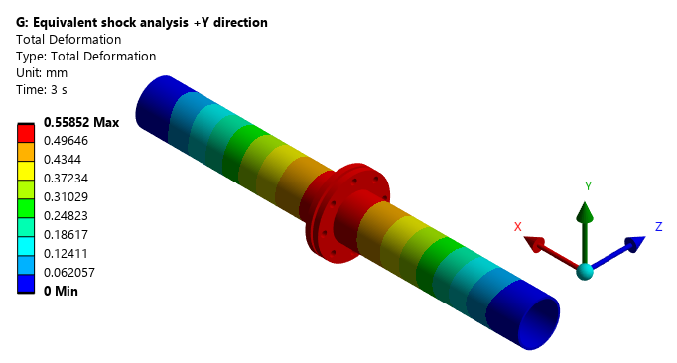
Figure 59: Total Deformation of Welded Plane Pipe Flange Assembly
The Total Deformation of 0.558 mm is observed in the Welded Plane Pipe Flange Assembly.
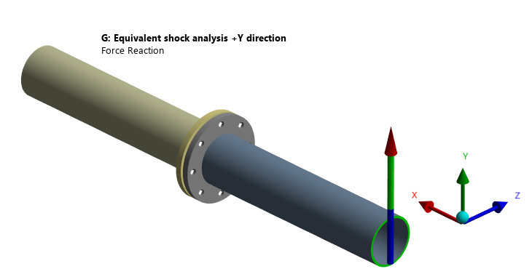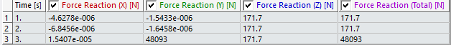
Figure 60: Force Reaction of 48093 N For -Y Application of the Shock

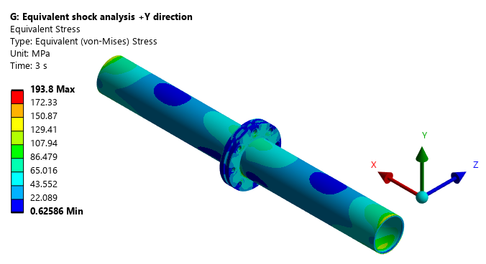
Figure 61: Equivalent Von-Misses Stress of Welded Plane Pipe Flange Assembly
The Maximum stress of 193.8 MPa is observed in the Welded Plane Pipe Flange Assembly.

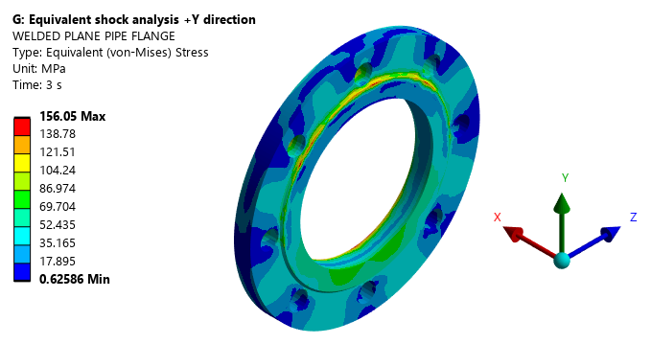
Figure 62: Equivalent Von-Misses Stress of Welded Plane Pipe Flange
The maximum stress observed in the component made of ASTM A182 F32100 is 156.05 MPa. The permissible shock strength of the material i.e., 624.14 MPa. Consequently, the stresses induced in components made of ASTM A182 F32100 are within the shock allowable strength.
Table 18: Bolt Loads: Shock in Positive Y direction
Bolt No | Maximum Axial Force (N) | Maximum Shear Force (N) | Tensile Stress Area mm² | Shear Stress Area mm2 | Normal Stress | Shear Stress | Yield Stress MPa |  | Conclusion
Flange to Counter Flange |  |  | Mean Dia | Root Dia
1 | 15916 | 436.36 | 115 | 100 | 138.4 | 4.3636 | 205 | Accepted
2 | 11833 | 388.37 | 115 | 100 | 102.89565 | 3.8837 | 205 | Accepted
3 | 11836 | 402.44 | 115 | 100 | 102.92174 | 4.0244 | 205 | Accepted
4 | 11833 | 416.62 | 115 | 100 | 102.89565 | 4.1662 | 205 | Accepted
5 | 11833 | 429.31 | 115 | 100 | 102.89565 | 4.2931 | 205 | Accepted
6 | 11833 | 463.77 | 115 | 100 | 102.89565 | 4.6377 | 205 | Accepted
7 | 11833 | 468.22 | 115 | 100 | 102.89565 | 4.6822 | 205 | Accepted
8 | 14148 | 467.13 | 115 | 100 | 123.02609 | 4.6713 | 205 | Accepted

Equivalent Static Analysis in positive Z – Direction
The stresses induced in the various components of the welded Plane Pipe Flange under operating loads and shock acceleration in positive Z - direction are illustrated as follows:
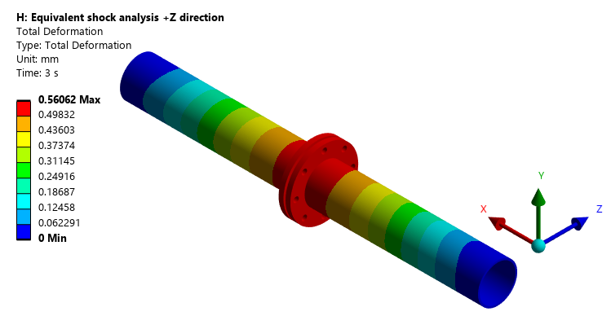
Figure 63: Total Deformation of Welded Plane Pipe Flange Assembly
The Total Deformation of 0.560 mm is observed in the Welded Plane Pipe Flange Assembly
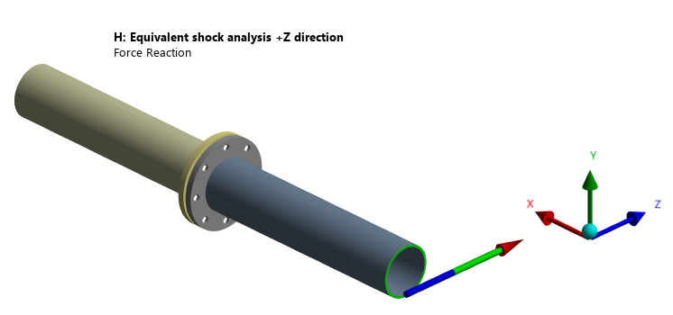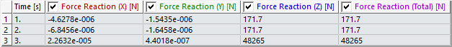
Figure 64: Force Reaction of 48265 N For -Z Application of the Shock
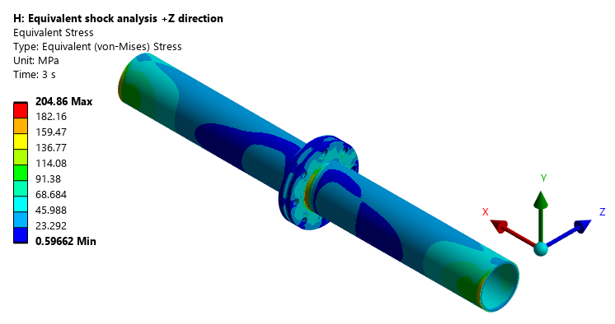
Figure 65: Equivalent Von-Misses Stress of Welded Plane Pipe Flange Assembly
The Maximum stress of 204.86 MPa is observed in the Welded Plane Pipe Flange Assembly.
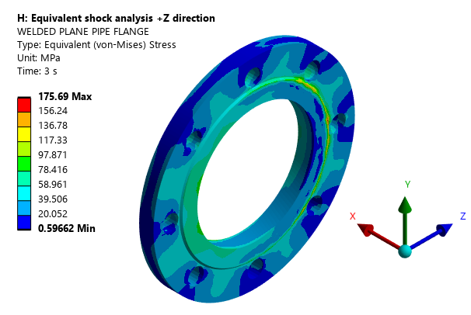
Figure 66: Equivalent Von-Misses Stress of Welded Plane Pipe Flange
The maximum stress observed in the component made of ASTM A182 F32100 is 175.69 MPa. The permissible shock strength of the material i.e., 624.14 MPa. Consequently, the stresses induced in components made of ASTM A182 F32100 are within the shock allowable strength.
Table 19: Bolt Loads: Shock in Positive Z direction
Bolt No | Maximum Axial Force (N) | Maximum Shear Force (N) | Tensile Stress Area mm² | Shear Stress Area mm2 | Normal Stress | Shear Stress | Yield Stress MPa | Conclusion
Flange to Counter Flange |  |  | Mean Dia | Root Dia
1 | 15916 | 451.49 | 115 | 100 | 138.4 | 4.5149 | 205 | Accepted
2 | 14150 | 466.28 | 115 | 100 | 123.04348 | 4.6628 | 205 | Accepted
3 | 15901 | 449.3 | 115 | 100 | 138.26957 | 4.493 | 205 | Accepted
4 | 14222 | 416.22 | 115 | 100 | 123.66957 | 4.1622 | 205 | Accepted
5 | 11833 | 410.84 | 115 | 100 | 102.89565 | 4.1084 | 205 | Accepted
6 | 11833 | 438.76 | 115 | 100 | 102.89565 | 4.3876 | 205 | Accepted
7 | 11833 | 425.29 | 115 | 100 | 102.89565 | 4.2529 | 205 | Accepted
8 | 14148 | 435.38 | 115 | 100 | 123.02609 | 4.3538 | 205 | Accepted

Equivalent Static Analysis in negative X –Direction
The stresses induced in the various components of the welded Plane Pipe Flange under operating loads and shock acceleration in negative X direction are illustrated as follows:
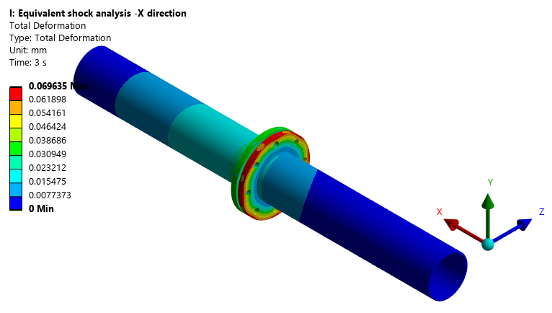
Figure 67: Total Deformation of Welded Plane Pipe Flange Assembly
The Total Deformation of 0.069 mm is observed in the Welded Plane Pipe Flange Assembly
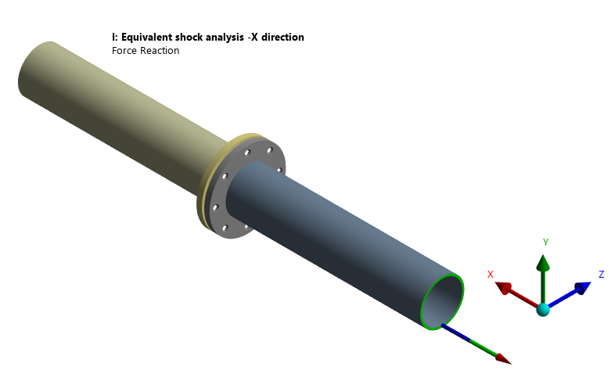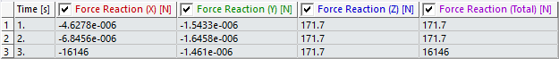
Figure 68: Force Reaction of 48265 N For negative X Application of the Shock

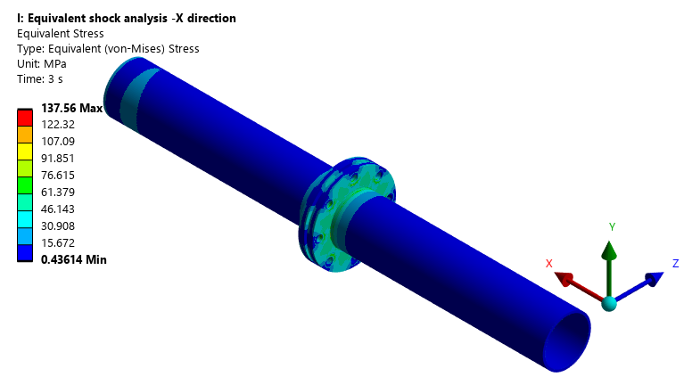
Figure 69: Equivalent Von-Misses Stress Welded Plane Pipe Flange Assembly
The Maximum stress of 137.56 MPa is observed in the Welded Plane Pipe Flange assembly.
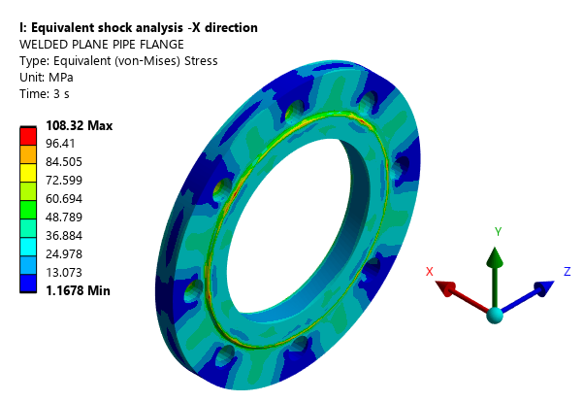
Figure 70: Equivalent Von-Misses Stress of Welded Plane Pipe Flange
The maximum stress observed in the component made of ASTM A182 F32100 is 108.32 MPa. The permissible shock strength of the material i.e., 514.02 MPa. Consequently, the stresses induced in components made of ASTM A182 F32100 are within the shock allowable strength.
Table 20: Bolt Loads: Shock in Negative X direction
Bolt No | Maximum Axial Force (N) | Maximum Shear Force (N) | Tensile Stress Area mm² | Shear Stress Area mm2 | Normal Stress | Shear Stress | Yield Stress MPa | Conclusion
Flange to Counter Flange |  |  | Mean Dia | Root Dia
1 | 11833 | 440.86 | 115 | 100 | 102.895652 | 4.4086 | 205 | Accepted
2 | 11833 | 446.45 | 115 | 100 | 102.895652 | 4.4645 | 205 | Accepted
3 | 11836 | 451.09 | 115 | 100 | 102.921739 | 4.5109 | 205 | Accepted
4 | 11833 | 456.85 | 115 | 100 | 102.895652 | 4.5685 | 205 | Accepted
5 | 11833 | 458.88 | 115 | 100 | 102.895652 | 4.5888 | 205 | Accepted
6 | 11833 | 479.13 | 115 | 100 | 102.895652 | 4.7913 | 205 | Accepted
7 | 11833 | 464.49 | 115 | 100 | 102.895652 | 4.6449 | 205 | Accepted
8 | 11833 | 453.83 | 115 | 100 | 102.895652 | 4.5383 | 205 | Accepted

Equivalent Static Analysis in negative Y – Direction
The stresses induced in the various components of the welded Plane Pipe Flange under operating loads and shock acceleration in negative Y - direction are illustrated as follows:
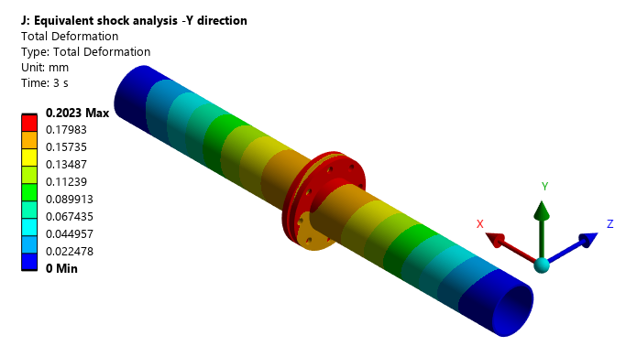
Figure 71: Total Deformation of Welded Plane Pipe Flange Assembly
The Total Deformation of 0.202 mm is observed in the Welded Plane Pipe Flange Assembly
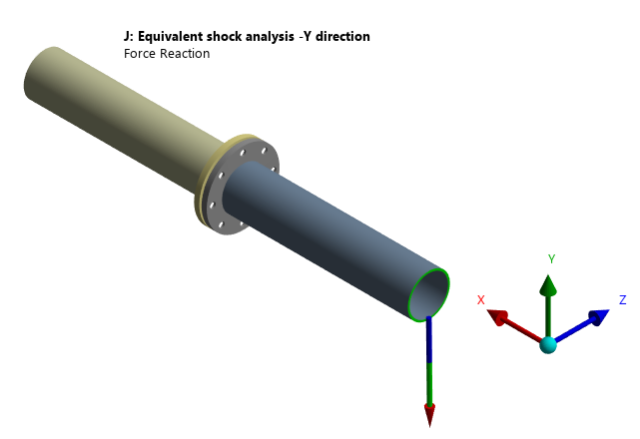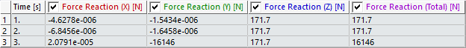
Figure 72: Force Reaction of 48265 N For negative Y Application of the Shock

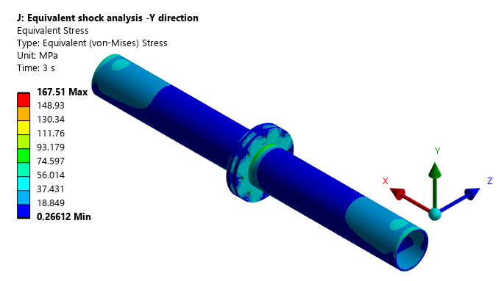
Figure 73: Equivalent Von-Misses Stress of Welded Plane Pipe Flange Assembly
The Maximum stress of 167.51 MPa is observed in the Welded Plane Pipe Flange.
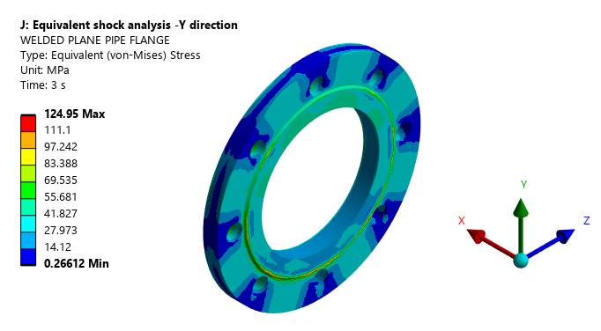
Figure 74: Equivalent Von-Misses Stress of Welded Plane Pipe Flange
The maximum stress observed in the component made of ASTM A182 F32100 is 124.95 MPa. The permissible shock strength of the material i.e., 514.02 MPa. Consequently, the stresses induced in components made of ASTM A182 F32100 are within the shock allowable strength.
Table 21: Bolt Loads: Shock in Negative Y direction
Bolt No | Maximum Axial Force (N) | Maximum Shear Force (N) | Tensile Stress Area mm² | Shear Stress Area mm2 | Normal Stress | Shear Stress | Yield Stress MPa | Conclusion
Flange to Counter Flange |  |  | Mean Dia | Root Dia
1 | 11833 | 380.87 | 115 | 100 | 102.895652 | 3.8087 | 205 | Accepted
2 | 11833 | 388.37 | 115 | 100 | 102.895652 | 3.8837 | 205 | Accepted
3 | 11836 | 408.19 | 115 | 100 | 102.921739 | 4.0819 | 205 | Accepted
4 | 12364 | 418.07 | 115 | 100 | 107.513043 | 4.1807 | 205 | Accepted
5 | 12888 | 414.5 | 115 | 100 | 112.069565 | 4.145 | 205 | Accepted
6 | 12394 | 419.41 | 115 | 100 | 107.773913 | 4.1941 | 205 | Accepted
7 | 11833 | 403.74 | 115 | 100 | 102.895652 | 4.0374 | 205 | Accepted
8 | 11833 | 389.83 | 115 | 100 | 102.895652 | 3.8983 | 205 | Accepted

Equivalent Static Analysis in negative Z – Direction
The stresses induced in the various components of the Butt-welded Pipe Flange under operating loads and shock acceleration in negative Z - direction are illustrated as follows:
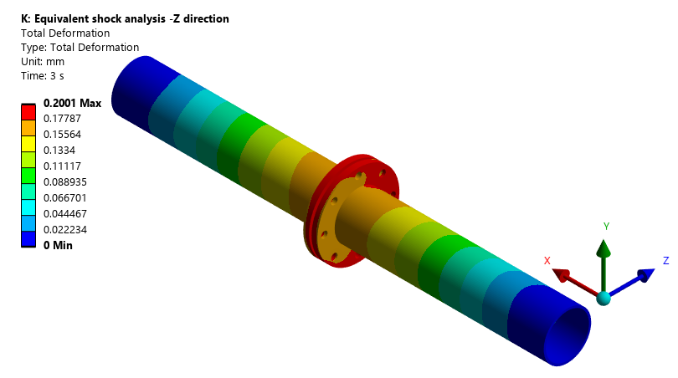
Figure 75: Total Deformation of Welded Plane Pipe Flange Assembly
The Total Deformation of 0.20 mm is observed in the Welded Plane Pipe Flange Assembly
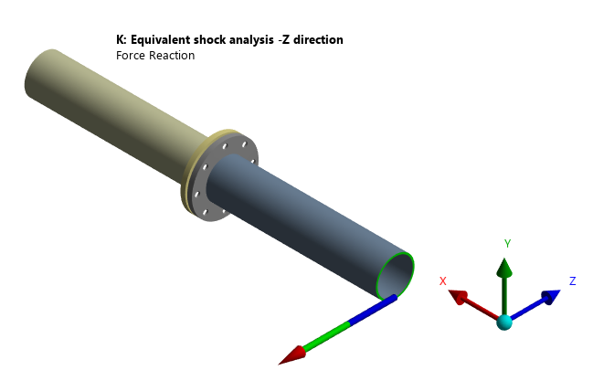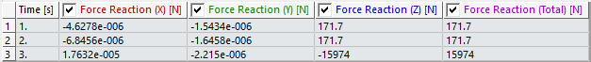
Figure 76: Force Reaction of 48265 N For negative Y Application of the Shock

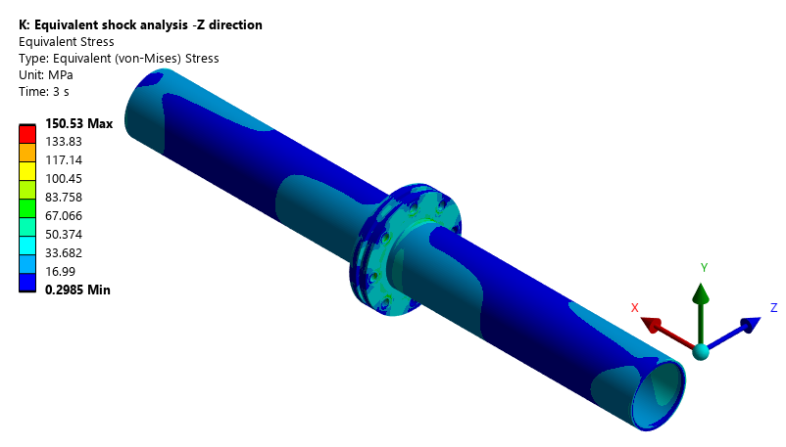
Figure 77: Equivalent Von-Misses Stress of Welded Plane Pipe Flange Assembly
The Maximum stress of 150.53 MPa is observed in the Welded Plane Pipe Flange Assembly.
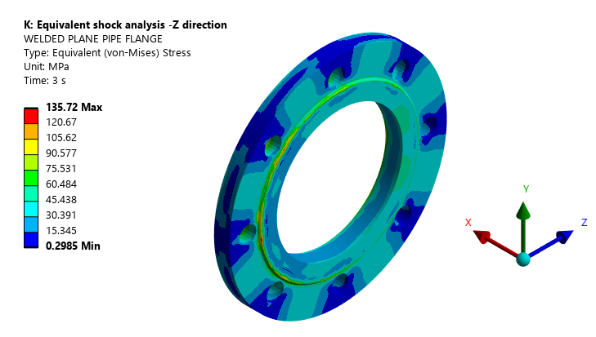
Figure 78: Equivalent Von-Misses Stress of Welded Plane Pipe Flange
The maximum stress observed in the component made of ASTM A182 F32100 is 111.79 MPa. The permissible shock strength of the material i.e., 514.02 MPa. Consequently, the stresses induced in components made of ASTM A182 F32100 are within the shock allowable strength.
Table 22: Bolt Loads: Shock in Negative Z direction
Bolt No | Maximum Axial Force (N) | Maximum Shear Force (N) | Tensile Stress Area mm² | Shear Stress Area mm2 | Normal Stress | Shear Stress | Yield Stress MPa | Conclusion
Flange to Counter Flange |  |  | Mean Dia | Root Dia
1 | 11833 | 380.87 | 115 | 100 | 102.895652 | 3.8087 | 205 | Accepted
2 | 11833 | 388.37 | 115 | 100 | 102.895652 | 3.8837 | 205 | Accepted
3 | 11836 | 393.99 | 115 | 100 | 102.921739 | 3.9399 | 205 | Accepted
4 | 11833 | 401.46 | 115 | 100 | 102.895652 | 4.0146 | 205 | Accepted
5 | 11833 | 418.01 | 115 | 100 | 102.895652 | 4.1801 | 205 | Accepted
6 | 12371 | 438.78 | 115 | 100 | 107.573913 | 4.3878 | 205 | Accepted
7 | 12885 | 418 | 115 | 100 | 112.043478 | 4.18 | 205 | Accepted
8 | 12885 | 389.83 | 115 | 100 | 112.043478 | 3.8983 | 205 | Accepted

Result Summary – Equivalent Static Analysis

Table 23: Result Summary – Equivalent Static Analysis
Input Shock Load | Component | Material | Shock Allowable Strength (MPa) | Max. Stress (MPa)
Acceleration of 280g in (+Ve) X Direction | Welded Flange Flange | ASTM A182 F32100 | 624.14 | 109.35
Acceleration of 280g in (+Ve) Y Direction | Welded Flange Flange |  |  | 156.05
Acceleration of 280g in (+Ve) Z Direction | Welded Flange Flange |  |  | 175.69
Acceleration of 94g in (-Ve) X Direction | Welded Flange Flange |  | 514.02 | 108.32
Acceleration of 94g in (-Ve) Y Direction | Welded Flange Flange |  |  | 124.95
Acceleration of 94g in (-Ve) Z Direction | Welded Flange Flange |  |  | 111.79

MECHANICAL DESIGN CALCULATION

Thickness Calculation of Welded Plane Pipe Flange
Table 24: Shell Thickness of Butt Weld Pipe Flange
SL. | DESCRIPTION | UNIT | Values | REMARKS
(a) | DESIGN PRESSURE, P | MPa | 6.3 | As per Drawings
(b) | WELDED PLANE PIPE FLANGE INNER DIAMETER, d | mm | 40 | As per Drawings
(c) | MATERIAL |  | ASTM A 182 F321 | Row 20, Pg. 112 of ASME BPVC 2023 Sec II Part D
(d) | UTS | MPa | 515 | Row 20, Pg. 113 of ASME BPVC 2023 Sec II Part D
(e) | YTS | MPa | 205
(f) | MAXIMUM ALLOWABLE STRENGTH @ 55.0°C | MPa | 136.67 | Min(((1/3.5)*UTS),((2/3)*YTS))  Row 20, Pg. 114 of ASME BPVC 2023 Sec II Part D
(g) | MINIMUM REQUIRED THICKNESS | mm | 0.69 | t=PR/(SE-0.6P) (As per UG27 of Sec VIII Div.1)
(h) | PROVIDED THICKNESS | mm | 2.5 | As per Drawings
(i) | FACTOR OF SAFETY |  | 3.62 | Provided thickness/ Required thickness

Design Validation Flange Thickness Calculations
The selected Flange type – considered as an Loose Type
Table 25: Flange Thickness calculation
Sl. No | Parameter | Formula and Unit | Value | Reference / Standard
1 | Design Pressure | MPa | 1 | User selection
2 | Manufacturing Type |  | CDF | PO
3 | Working Temperature | °C | -10 to 55℃ | PO
4 | Flange Material |  | ASTM A 182 F321 | Row 20, ASME PBVC Sec II Part-D, Page no. 112, 2023
5 | No of Bolts |  | 8(M14) | As per NDT 117-96, Pg No 85
6 | Bolt Material |  | ASTM A276 S32100 | ASTM A276-06, Table 2, Type 321, Page no- 4
7 | Flange allowable Strength | MPa | 138 | Row 20, Pg. 114 of ASME BPVC 2023 Sec II Part D
8 | Bolt allowable Strength: | MPa | 138 | Min(((1/3.5)*UTS),((2/3)*YTS))
9 | Flange OD, A | mm | 190 | As per Drawing
10 | PCD, C | mm | 158
11 | Flange Thickness, t | mm | 13.5
12 | Flange Bore, B | mm | 100
GASKET DETAILS
13 | Parameter | Formula and Unit | Value | Reference / Standard
14 | Gasket Type |  | Ring Type
15 | Gasket, OD | mm | 138 | As Gasket details are not indicated in the Drawing, considered as per Groove dimension provided in the Drawing.
16 | Gasket, ID | mm | 110
17 | Gasket Reaction Diameter, G | mm | 124 | G=( OD+ ID)/2
18 | Gasket Factor, m |  | 0 | Table 2-5.1, Pg. 345 of ASME BPVC.VIII.1-2023
19 | Gasket Seating Stress, Y | MPa | 0
20 | Gasket Contact Width, N | mm | 14 | N=(GASKET OD-GASKET ID)/2
21 | Basic Gasket Seating Width, b0 | mm | 3.5 | Table 2-5.2, Pg. 345 of ASME BPVC.VIII.1-2023
22 | EFFECTIVE GASKET SEATING WIDTH, b | mm | 3.5 | Table 2-5.2, Pg. 345 of ASME BPVC.VIII.1-2023
23 | Design Bolt Load For Operating Condition, Wm1 | N | 12070.16 | Section 2.5 (C) at Pg. 344 of Section VIII Div 1, ASME BPVC, 2023
24 | Provided Bolting Area, Ab | mm² | 1230.88 | 0.785*No of bolts*bolt dia^2
25 | Required Bolting Area, Am | mm² | 87.465 | Pg. 338 of ASME BPVC.VIII.1-2023
26 | Ab> Am thus, M14×2 is safe for use in this design
27 | Total Hydrostatic End Force on the Area Inside of Flange, HD | HD = 0.785²*B²*P (N) | 7850.00 | Pg. 339 of ASME BPVC SEC VIII Div I
28 | Arm Length on which Hydrostatic Load Applicable, hD | hd = R+0.5*g1 (mm) | 29.00 | Table 2-6, Moment Arms for Flange Loads Under Operating Conditions, at Pg.348 of ASME BPVC SEC VIII Div I
29 | Moment due to Hydrostatic end force, MD | M_{D} = H_{D}*h_{D}  N-mm | 227650.00 | MD=hD*HD
30 | Total Hydrostatic end force, H | N | 12070.16 | 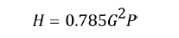
31 | Difference between flange design bolt load & total hydrostatic end force, HG | N | 0.00 | AS Wm1-H
32 | Arm length on which HG applicable, hG | 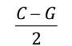  mm | 17.00 | Table 2-6, Moment Arms for Flange Loads Under Operating Conditions, at Pg.348 of ASME BPVC SEC VIII Div I
33 | Moment Due To HG, MG | N-mm | 0.00 | MG=hg*HG
34 | Difference Between Total Hydrostatic End Force & Hydrostatic End Force on Inside Flange Area, HT | N | 4220.16 | 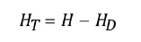
 | Arm length on which HT applicable, hT | 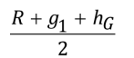mm | 23.00 | Table 2-6, Moment Arms for Flange Loads Under Operating Conditions, at Pg.348 of ASME BPVC SEC VIII Div I
35 | Moment due to HT, MT | N-mm | 396312.59 | MT=hT*HT
36 | Total Moment, M0 | N-mm | 97063.68 | Mo=MT+MG+MD
37 | FACTORS |  |  | Figure 2-7.1, of ASME BPVC Sec VIII, Div 1
38 | K |  | 1.9
39 | Y |  | 3.19
40 | T |  | 1.54
41 | U |  | 3.51
42 | Z |  | 1.77
 | CHECKING FLANGE FOR STRESS
43 | Type of Flange |  | Loose type
44 | Tangential Flange Stress, ST |  | 56.87 | 2-7 CALCULATION OF FLANGE STRESSES, at Pg. 348 of ASME BPVC SEC VIII, Div I
45 | ALLOWABLE FLANGE DESIGN STRESSES
46 | ST<Static Allowable | MPa | 138 | Section 2-8 ALLOWABLE FLANGE DESIGN STRESSES, Para (a) (3) at Pg. 355 of ASME BPVC SEC VIII Div I
47 | Tangential flange stress (ST) |  | ACCEPTED | 56.87<138
48 | REQUIRED FLANGE THICKNESS, tr | mm | 7.50 | ASME Sec VIII Div-1,2023 Eq-2, Pg No. 36
49 | Factor of Safety, FOS |  | 1.801 | Provided thickness / Required Thickness

Bolt Preload Calculations
As per ASME PCC-1–2019, APPENDIX J, CALCULATION OF TARGET TORQUE, Pg. 62 the bolt preload can be calculated using the following formula:
The preload F can be determined from
$$F=A_{s}σ_{y}P_{\%}$$
Where,
As = tensile stress area of the thread, mm² (see Appendix H of ASME PCC -1)
P% = percentage utilization factor for material yield strength (default value typically 50%; i.e., P% = 0.5)
σ_{y} = minimum yield strength of the bolt material, N/mm2 (lb/in.2)
Table 26: Bolt pretension calculations
Parameter | M14 × 2 | Reference
$$A_{s}=0.7854 (dbsc - 0.9382*P)^2$$ | 115.4394091 | Nonmandatory Appendix B, para. B-1 of ASME B1.13M-2005, Pg. 52
Basic Major Diameter (d_{bsc}) | 14
Pitch(p) | 2
P% | 0.5 | ASME PCC-1–2019, APPENDIX J, CALCULATION OF TARGET TORQUE, Pg. 62
σ_{y} (ASTM A276 S321:1986 Table 4, Pg. 10) | 205
Preload (F) | 11832.54N

Fatigue Strength Calculations
Table 27: Fatigue Strength Calculations
Name of the Component | Body
Material | ASTM A182 F321
Ultimate Strength, Mpa | 505
Load Factor, C_{load}  (Refer. Norton Eq. 6.7a) | 0.7
Size Factor, C_{size} 0.6  For Larger size | 0.60
Surface finish Factor, C_{surf}  (Refer. Norton Eq. 6.7e) | 0.88
Temperature factor, C_{temp}  (Refer. Norton Eq. 6.7f) | 1
Reliability Factor, C_{reliab}  (Refer. Norton table 6-4) | 0.702
Endurance limit = 0.5*UTS for Ferrous  = 0.4*UTS for Non-Ferrous | 257.5
Corrected Endurance Strength, Se =C_{load}*C_{size}*C_{surf}*C_{reliab}*C_{temp}*S_{e}' | 68.2

References considered in the above calculations are as follows. Which are the extracts of the Machine Design an Integrated Approach by Norton.
Theoretical Fatigue Strength or Endurance Limit
It is considered as 0.5*Ultimate Tensile Strength for Ferrous materials and 0.4*Ultimate Tensile Strength for Non-Ferrous Materials.
The endurance limit is the maximum stress level a material can withstand for an infinite number of loading cycles without experiencing fatigue failure. It is particularly relevant for materials like steel, where a horizontal line on an S-N curve indicates that below this stress level, the material will theoretically not fail from repeated stress. For other materials like aluminium, a true endurance limit may not exist, and they are instead characterized by fatigue strength, which is the stress level a material can withstand for a specific number of cycles (e.g., 107 cycles).
Goodman equation (for combined mean and alternating stress)
This equation is used to predict fatigue failure under combined stress conditions.
• (𝜎a/𝑆𝑒)+(𝜎m/𝑆𝑢𝑡)=1
• 𝜎a= stress amplitude
• 𝑆𝑒= endurance limit (fatigue strength at a specific number of cycles)
• 𝜎m= mean stress
• 𝑆𝑢𝑡= ultimate tensile strength
Fatigue Strength or Corrected Endurance Strength.
The corrected endurance limit formula is
S𝑒=𝐾𝑎𝐾𝑏𝐾𝑐𝐾𝑑𝑆𝑒 ′
S𝑒=𝐾𝑎𝐾𝑏𝐾𝑐𝐾𝑑𝑆′𝑒
where S𝑒 is the corrected endurance limit, and
S𝑒 ′ is the endurance limit of a standard rotating-beam specimen. The factors K𝑎, 𝐾𝑏, 𝐾𝑐, and 𝐾𝑑 account for surface finish, size, reliability, and stress concentration, respectively.
- Load Factor
Components are subjected to bending and axial depends on the direction of the load application. On a conservative side, minimum load factor i.e., 0.7 is considered in the calculations.
The above explain the concept of a strength-reduction load factor (𝑪𝒍𝒐𝒂𝒅𝐶𝑙𝑜𝑎𝑑) used in fatigue analysis, specifically for axial loading. It highlights that most published fatigue strength data is based on rotating bending tests, which necessitates the use of this factor for cases involving axial loading.
• The strength-reduction load factor (𝑪𝒍𝒐𝒂𝒅) is applied to account for the difference between axial and rotating bending fatigue strengths.
• For bending, the load factor is 𝑪𝒍𝒐𝒂𝒅=𝟏.
• For axial loading, the load factor is 𝑪𝒍𝒐𝒂𝒅=𝟎.𝟕𝟎

1 Bending
Load Factor (K_{load} ) = 0.7 Axial
0.59 Pure Torsion

K_{load} = 0.7
- Surface Finish Factor
Surface finish factor is considered based on the graph given below i.e., UTS and Surface Roughness of component. Maximum surface roughness achieved in the manufacturing will be 3.2 microns. On a conservative side, factor corresponding to 63 microns is considered in the calculations.
Surface Condition Factor (K_{surf}) = a × UTS^{b}
Table 28: Surface Finish Factors
Parameters for Surface Modification Factor
S.No | Surface Finish | Coefficient (a) | Exponent (b)
1 | Ground | 1.58 | -0.085
2 | Machined or Cold-drawn | 4.51 | -0.265
3 | Hot-Rolled | 57.7 | -0.718
4 | As forged | 272 | -0.0995

- Size Factor
Size factor considered based on the reference given below i.e., if the size of the component < 8 mm then Size factor will be 1, otherwise, the factor will be calculated based on the formulae given below. Maximum size of the component in 03 mutual perpendicular directions is considered as size of the component in the calculations.
The text describes a method for determining the equivalent diameter (𝑑𝑒𝑞𝑢𝑖𝑣) of a non-cylindrical part for use in fatigue analysis, specifically with Equation 6.7b in Norton textbook. The method, suggested by Kuguel, involves finding the cross-sectional area of the non-round part that is stressed above 95% of its maximum stress (𝐴95) and using it to calculate an equivalent diameter.
Equation 6.7b is used to calculate the size factor (𝐶𝑠𝑖𝑧𝑒) for cylindrical parts.
For non-cylindrical parts, an equivalent diameter (𝑑𝑒𝑞𝑢𝑖𝑣) is used to apply Equation 6.7b.
The equivalent diameter is calculated using the area (𝐴95) of the part stressed between 95% and 100% of its maximum stress.
The formulas provided are for calculating 𝐶𝑠𝑖𝑧𝑒 for different diameters and for calculating d𝑒𝑞𝑢𝑖𝑣 using 𝐴95
Size Factor (K size ) = 1 (for Axial Load).
Ksize = 1
- Temperature Factor
Temperature factor is considered is 1 as the operating temperature of the Pump is <4500C
corresponding to a Reliability of 99.99% i.e., 0.702 is considered in the calculations.
The temperature factor (Ctemp or Kt or Kd) is a modifying factor used in calculation as the corrected
fatigue endurance limit or fatigue strength of a material. The factor influences accounts for the
reduction in a material’s fatigue resistance when it operates at elevated temperatures above a
threshold.
Se = Ka Kb Kc Kd Ke Kf Se
Where Kd is the temperature factor.

T < 4500C
Temperature Factor (KTemp) = 1 – 0.0058 (T – 450) 4500C < T < 4500C
1 – 0.0032 (T – 450) 4500C < T < 4500C

(KTemp) = 1 (Since the Environmental conditions is < 4500C).
- Reliability Factor
Reliability factor is fatigue calculation is a multiplier that adjusts the material’s endurance strength to account for the statistical probability of failure. The reliability factor, symbolized as Cr or Ke used to modify the theoretical endurance limit (Se) of a material that reflects required survival rate. Reliability factor increased as the factor is increased, also incorporating this factor design factor is lowered, which reduces the risk of failure. This is because a component with a high reliability requirement must be designed to withstand lower stresses than a component with a lower reliability requirement.
Table 29: Reliability Factors
S.No | Reliability | Transformation Variable (Za) | Reliability Factor (KR)
1 | 50 | 0 | 1
2 | 90 | 1.288 | 0.897
3 | 95 | 1.645 | 0.868
4 | 99 | 2.326 | 0.814
5 | 99.9 | 3.091 | 0.753
6 | 99.99 | 3.719 | 0.702
7 | 99.999 | 4.265 | 0.659
8 | 99.9999 | 4.753 | 0.602
Table 16:
Reliability Factor (KR) = 0.814
Environmental Factor (KEnv) = 1
Fatigue Strength (Ke) = KLoad × KSize × KSurf × KTemp × KR × KEnv × Se|
(Se| = X × UTS)

