CONTRACT | JOB TITLE | APPLYING FOR
2 YEARS | DOMESTIC HELPER | OMAN - MUSCAT

الاسم الكامل | NAPILI, JANICE ASUNCION | NAME IN FULL
Passport details
 |  |  | الرقـــــم | P1310436A | NUMBER |  |  |  | الجنسية |  | FILIPINO |  | NATIONALITY
 |  |  | تاريخ الصدور | DECEMBER 21, 2016 | DATE OF ISSUE |  |  |  | الديانة |  | CATHOLIC |  | RELIGION
 |  |  | مكان الصدور | DFA ANGELES | PLACE OF ISSUE |  |  |  | تاريخ الميلاد |  | JULY 17, 1985 |  | DATE OF BIRTH
 |  |  | تاريخ الانتهاء | DECEMBER 20, 2021 | DATE OF EXP. |  |  |  | العمر |  | 32 |  | AGE
 |  |  |  |  |  |  |  |  | مكان الميلاد |  | ANGELES CITY |  | PLACE OF BIRTH
 |  | 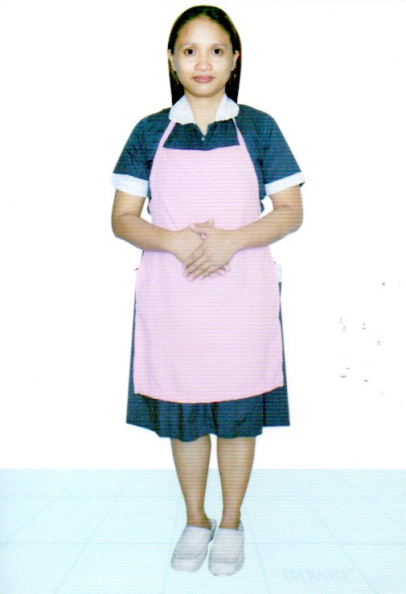 |  |  |  |  |  |  | مكان السكن |  | D-3 B-65 I-IIEPZA P. CACUTUD, ANGELES PAMPANGASINGLE |  | LIVING TOWN
 |  |  |  |  |  |  |  |  | الحالة الاجتماع |  | SINGLE |  | MARITAL STATUS
 |  |  |  |  |  |  |  |  | عدد الاطفال |  | 2 |  | NO. OF CHILDREN
 |  |  |  |  |  |  |  |  | الوزن |  | 50 KGS. |  | WEIGHT
 |  |  |  |  |  |  |  |  | الطول |  | 152 CM |  | HEIGHT
 |  |  |  |  |  |  |  |  | لون البشرة |  | FAIR |  | COMPLEXION
 |  |  |  |  |  |  |  |  | الدرجة العلمية |  | COLLEGE GRADUATE |  | EDUCAT. Q.G.
 |  |  |  |  |  |  |  | اجادة اللغات KNOWLEDGE OF LANGUAGES
 |  |  |  |  |  |  |  | عربـــي ARABIC |  |  |  | انجليزي ENGLISH
 |  |  |  |  |  |  |  | لاشئ |  |  |  |  |  | POOR
 |  |  |  |  |  |  |  | وسط |  |  |  |  |  | FAIR
 |  |  |  |  |  |  |  | ممتاز |  |  |  |  |  | FLUENT
 |  |  |  |  |  |  |  | لخبرة خارج البلد PREVIOUS EMPLOYMENT ABROAD
 |  |  |  |  |  |  |  | البلد |  |  |  |  |  | COUNTRY
 |  |  |  |  |  |  |  | المدة |  |  |  |  |  | PERIOD
 |  |  |  |  |  |  |  | WORK EXPERANCE
 |  |  |  |  |  |  |  | WASHING  الغسيل |  | COOKING  الطبخ |  | CLEANING  التنظيف |  | BABY SITTING  تربية الاطفال
 |  |  |  |  |  |  |  | YES |  | YES |  | YES |  | YES

