# **Guess Flag Game**

# Overview

This is a simple quiz time trivia game. User needs to select an answer from the given options. For each question there are 15 seconds to answer. A wrong answer or no answer before the time runs out will result into a game life lost .When there are no lives then user will not be able to answer the rest of the questions and have to play the game again. The result contains the overall progress in all categories.

There are multiple categories and each category has some levels. User need answer all questions to attain max level. There are both text and picture based questions, questions are loaded from the xml and related pictures are stored in the Resources Directory.

# Getting Started

Getting Started First of all download latest version of Google Admob official plugin from the link below https://github.com/googleads/googleads-mobile-unity/releases

After downloading and importing google admob plugin in your game. Add “ADS_ENABLED” without quotes in the Scripting defined symbols of your Player Settings.

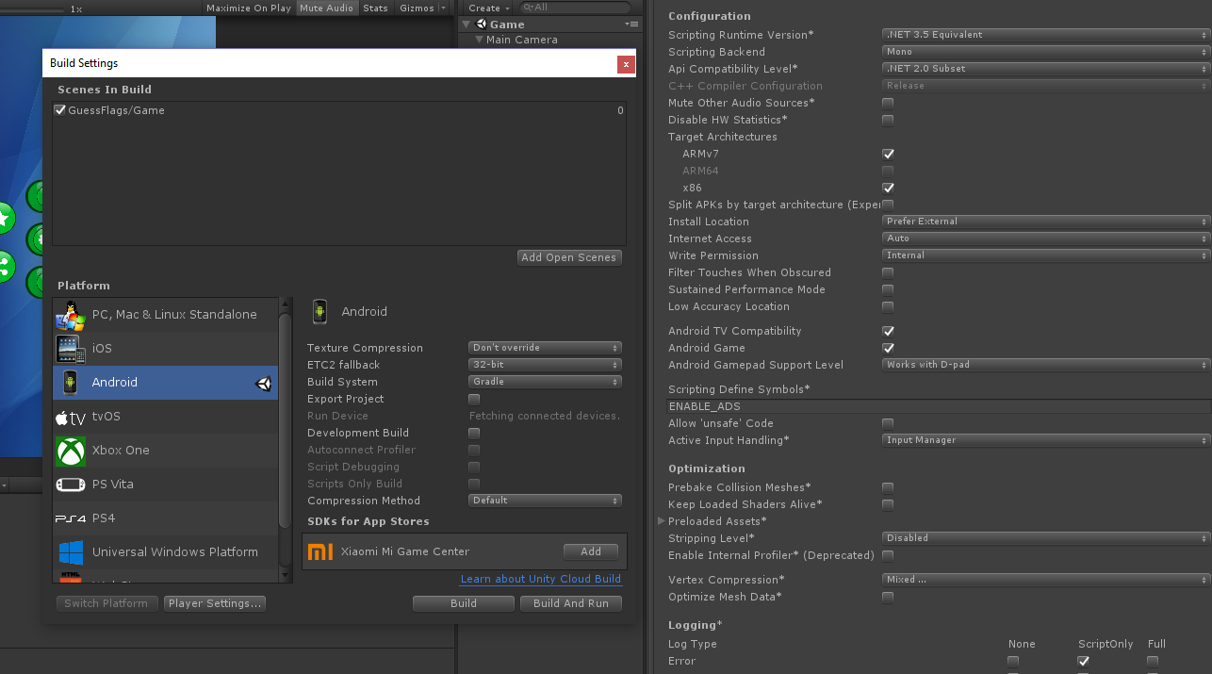

Open folder Guess>Scenes and add both scene to your game’s build settings (can be accessed by pressing ctrl-shift-B).

Now you need to simply open the scene in the directory to test the game out.

Changing Admob Ad’s ID: Create ad id’s for banner and interstitial ads and put them in AdsManager.cs script.

Changing Questions: Simply update the flags by adding more or removing flags from the GameView GameObject.

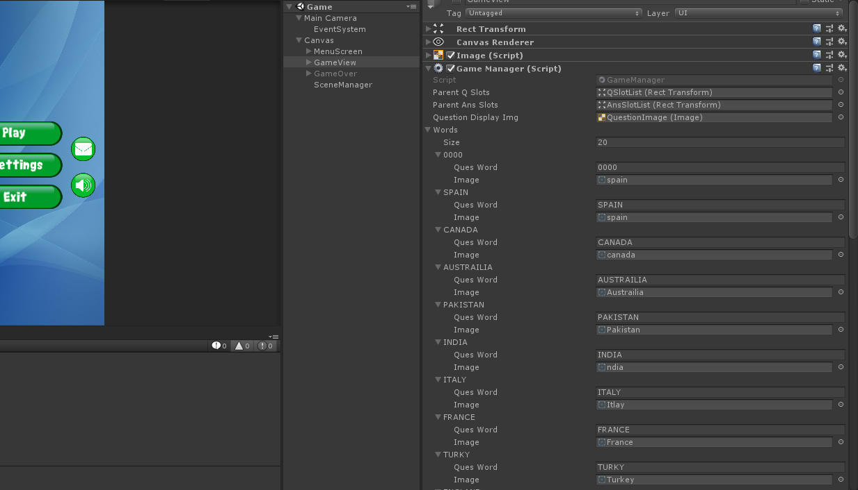

# Features

* Easy to understand and with full source code.
* Can be configured easily and quickly.
* Google Admob banner and Interstitial Ads
* More questions can be added
* Homogenous UI with no cluttered and unnecessary graphics.
* You can reskin it with a minimal effort.
* Clean and concise way to add more questions or revamp the game.
* Many Questions can be added.

# Scripting Reference

## Classes:

### GameManager:

This script is responsible for managing the game as its name suggest. This scripts helps in loading questions and for storing as well. It also computes score for each question and grants coins.

### AdsManager:

This script when enabled will show a banner and interstitial ads after each time you return back to landing screen. Coins against reward video is also configured.

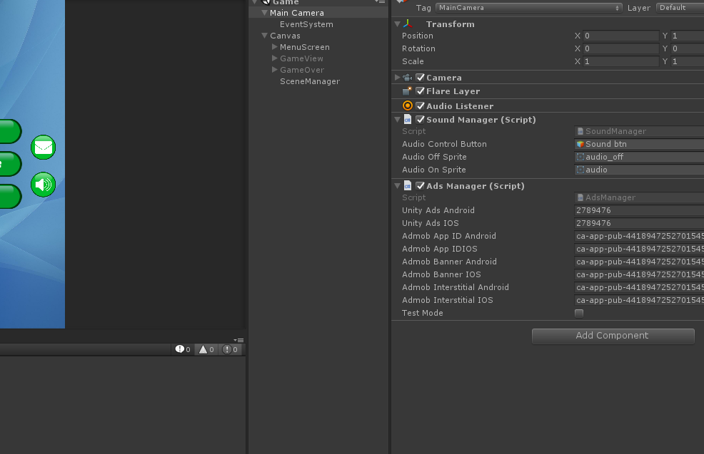

UIManager: This script is responsible for managing all the UI. From category selection to listing score and info regarding the category, showing info screen and transition from one screen to another is all done with the help of this script.

# Help and Support

If you like our package please take a minute out and rate us.

Our Asset Store Page: <https://www.assetstore.unity3d.com/en/#!/search/page=1/sortby=popularity/query=publisher:22181>

Email: info.curioassets@gmail.com

Facebook: <https://www.facebook.com/CurioAssets/>