Hi Charlie

Here’s a quick set of instructions to get the certificates for Jenna:

Log onto the server in question.

Run MMC.msc

Add/remove snap-in -> certificates -> local computer Look in the Personal store for the certificate from the JM Endur template Right-click and Export Select the ‘base 64’ option. Do not export the private key Give it a file name of something like ‘servername_base64’

Send to Jenna in a zip file with all the others

This exported cert is used to match against the one the server is presenting in Tomcat to validate the server is who it says it is. As it’s being used for the validation on the client side it should not have the private key as part of it (it’s less secure if you give the private key as well).

Hope this makes sense? I’m back from hols on Monday if you want to chat through it in more detail.

Cheers

Colin

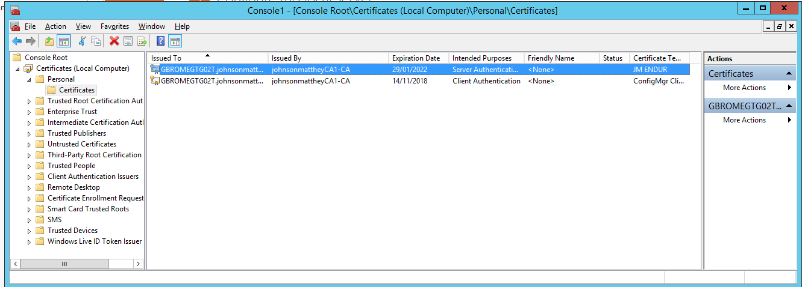

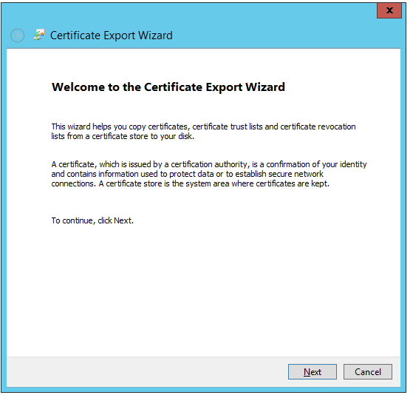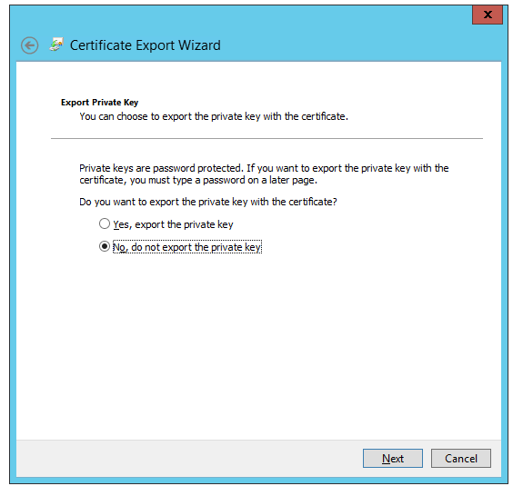

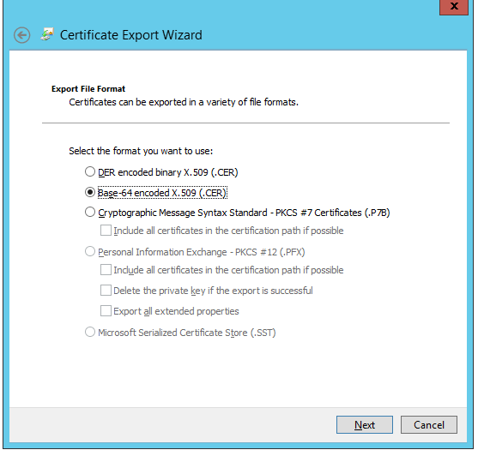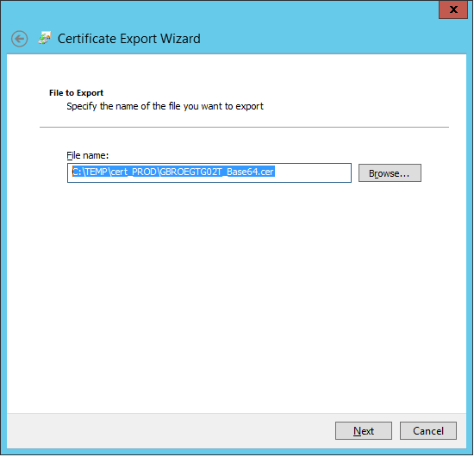

C:\TEMP\cert_PROD\GBROMEGTG02T_Base64.cer

C:\TEMP\cert_PROD\GBROMEOLG01U_Base64.cer

