Endur Deployment Document

# Overview

| Deployment | | | |
| --- | --- | --- | --- |
| Summary of the Change | This will appear in Release Email  <Summary> | | |
| Description of the Change | This will appear in Release Email  <Release Note> | | |
| **Section 1: Change Requestor, Implementer and Contacts** | | | |
| JM Ivanti CR Reference No | In all cases this should be the JM SR/CR reference # | Contact Details | Email, Mobile phone and landline number  <name> |
| JM Owner/Requestor of Change | Name(s) and organisation initially requesting this change  <Owner> | Subject Matter Expert | Name of the owner responsible + Email + contact number  <Contact> |
| Region | ALL  UK  US HK SH | Dependencies | Other ongoing developments  None |
| **Section 2: Implementation and Outage Window** | | | |
| Outage Required? | Yes  No | Restart Service | Any service restart needed?  None |
| Details of the outage, services impacted etc. | List the services that will be unavailable during the outage  If there is No Outage, please state NONE  None | | |
| **Item** | | **Item** | |
| User Table Creation | Yes  No | User Table Static data | Yes  No |
| APM Page | Yes  No | JVS/OC Import | Yes  No |
| DMS Import | Yes  No | Manual Configuration | Yes  No |
| TPM EOD Change | Yes  No | Security Change | Yes  No |
| CMM Import | Yes  No | Stored Procs | Yes  No |

# File Presentation

|  |
| --- |
| Zip up all the directories from the top level, attach as an attachment to the Jira/email, please do not embed files into this document.  Provide a quick screenshot of what you expect the unzipped file will look like, expand out the sub directories if they show anything interesting  Provide test evidence in a separate document. |

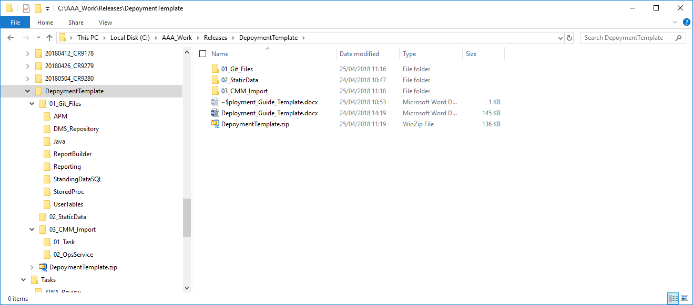

# Git repository

|  |
| --- |
| The release process will need files to be imported into a git branch ahead of deployment.  These will be reviewed, tracked, merged within Git so that the correct versions of each file is added to Production.  Even so please provide a CMM export of any files changed. |

|  |  |  |  |
| --- | --- | --- | --- |
| Type  APM, DMS, SQL, Java | Project  Applicable for JVS only | Package/Directory  Directory or package if known | File Name  File name with extension |
| Not applicable |  |  |  |

**Feature Branch: <GIT feature branch name>**

# Deployment

## Java Source Files

|  |
| --- |
| Detail the import order of any project/files from folder 01_Git_Files – Please provide the CMM of all file changes |

|  |  |
| --- | --- |
| Project/File Name | Description |
| As above | As Above |

## User Table -Static Data Import

|  |
| --- |
| Detail the .csv(new records) or SQL insert scripts (updates to existing) to be run in the order presented, drop the files into folder 02_StaticData  For new records I prefer .csv files, for any changes to existing records a script will be needed please. |

|  |  |
| --- | --- |
| File Name  USER_const_repository.csv | Description  Adds new records to the USER_const_repository table |
| Not applicable |  |

## CMM Import

|  |
| --- |
| Detail each CMM deployment item that is needed proceed each with a numeric value to indicate the order to be imported, drop the files into folder 03_CMM_Import, from experience several smaller CMM imports are easier than one big manifest file, and only select the items you have changed. |

|  |  |  |
| --- | --- | --- |
| Type  Task, Ops Service, Report Builder etc. | File Name .manifest.xml  01_Tasks, 02_OpsService, 03_ReportBuilder | Description |
| Not applicable |  |  |

## DMS Import

|  |
| --- |
| To avoid contamination, **only supply DMS changes that you have changed**, and try to work on the most up to date version as possible, any conflicts have to be resolved manually which means that changes have to be applied a second time (painful and problematic)  Feel free to provide several imports if needed |

|  |  |  |
| --- | --- | --- |
| Type  Document Type/Category. | File Name .xsd + .olc  Name each of the files you expect to be chnaged | Description |
| Not applicable |  |  |

## Manual Configuration Items

|  |
| --- |
| Add each manual config change here, add in the order to be added and break each category into a different heading. Detail the journey to how to get to the correct screen if needed.  Provide screenshots – especially of the unusual configuration items, and the final state if there are multiple possibilities. |

### Item <insert name>

Launch <Insert Service>, For each item in the following table add/amend the following record.

(Feel free to alter dimensions of table.)

|  |  |  |  |
| --- | --- | --- | --- |
| Item  Item_123 | New Value1  123 | New Value2  01/01/2018 | New Value3  Dummy Text Value |
| Not applicable |  |  |  |

Click Save

## Security Group

|  |
| --- |
| Each new object where security can be applied:  When you CMM export any endur entity that needs security groups applied (Query, TPM process, Report Builder + others)  the security groups are NOT copied over, other single dimension security items are copied over – so security groups need to be detailed and applied manually. |

|  |  |  |  |
| --- | --- | --- | --- |
| Type  Task, Ops Service, Report Builder etc. | Task  Task_123 | Security  UK Back Office | Description  EOD task for the UK Back office team |
| Not applicable |  |  |  |

## Security Privileges

|  |
| --- |
| Each new security privilege needed to enable this deployment: |

|  |  |  |  |
| --- | --- | --- | --- |
| Priv. ID | Privileges  Wonderful function | Security Group  UK Back Office | Description  Needed by Back Office teams |
| Not applicable |  |  |  |

## Validation Steps

|  |
| --- |
| This section should contain any additional validation steps needed. |

## Activate

|  |
| --- |
| This section should contain any final switch on. |

# Rollback

|  |
| --- |
| Detail rollback steps, deactivate Ops Services, revert which scripts, delete tasks etc.– this does not have to be a complete reversal of the above, just enough to turn off/reverse the feature in case of an emergency.  If User Table static data has changed, then please provide rollback script.  Please indicate how long reversion might take |

|  |  |  |
| --- | --- | --- |
| **Type**  Task/Scripts/Ops Service etc | **Name** | **Rollback Method**  Delete Task/Rollback/Run Script |
|  |  |  |
|  |  |  |

|  |  |
| --- | --- |
| Rollback time (round up to nearest hour): | 1 Hr |