CMPE283 : Virtualization
Assignment 3: Instrumenting KVM

Question2:
- Install m4, bison, and git before starting the below.
- Get to the folder where you want the files to be downloaded.
- Clone the linux kernel tree from github using
git clone https://github.com/torvalds/linux.git

- change your directory to linux using
cd linux

- get your commit using the command
git log

- the first commit id is the one you need to use
commit 625e2001e99e82ea3eb5b0370a428a4328b9166b

- Modify the vmx.c file located at the arch/x86/kvm/ so that the statistics will be captured and printed. The function “static int vmx_handle_exit(struct kvm_vcpu *vcpu)” needs to be modified.
- Change your directory to linux and then run the make menuconfig command, choose the default setting , save and exit.
- Update the kernel using the following commands :
sudo make -j4
sudo make modules -j4
sudo make modules_install -j4
sudo make install -j4

- Once done reboot the system.
- Install “virt-manager” and its required libraries. Start a new virtual machine using an “vir-manager” and an ISO image of Ubuntu. Exit the virtual machine.
- Now in the host system check the message buffer of the kernel using dmesg, the messages will provide you with the exit statistic data.
- Once the output is according to your liking commit the code and get the “diff” file using the following commands:
git add -A
git commit -m “Assignment 3”
git diff HEAD~ >cmpe283-3.diff

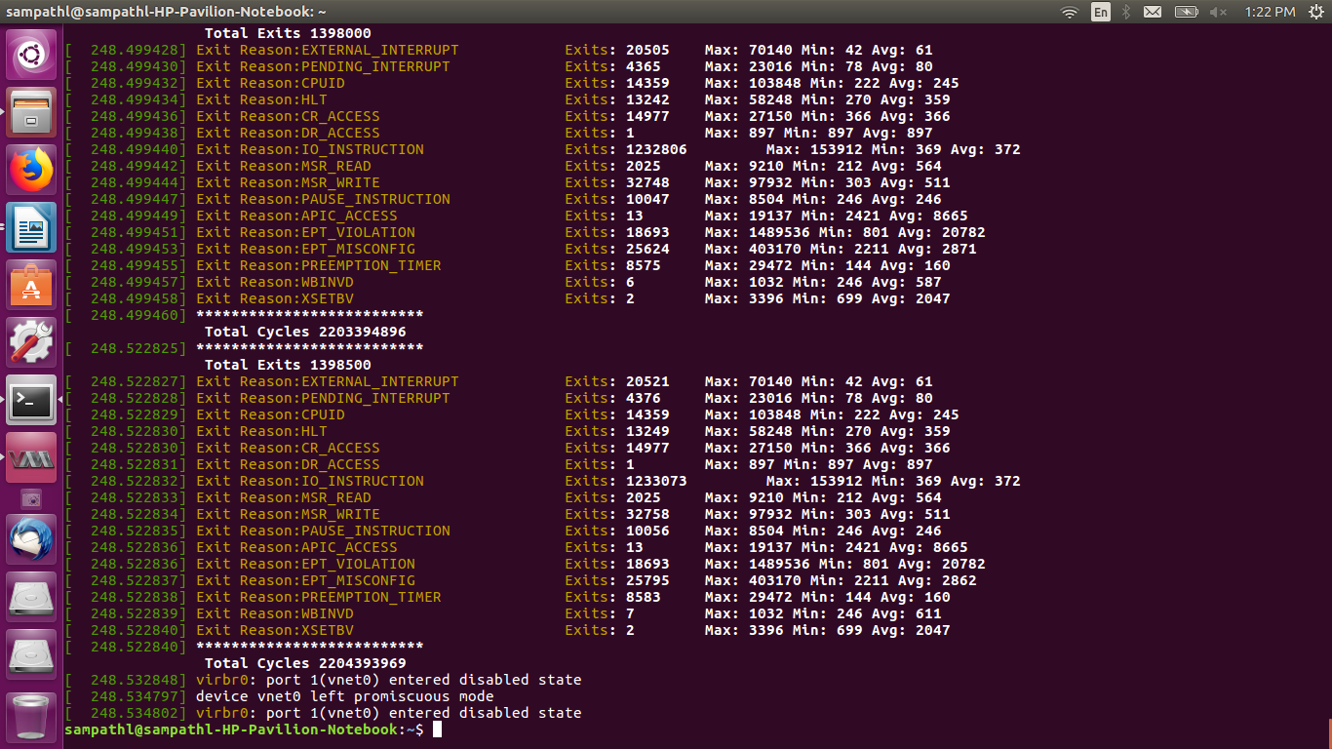
3. Note whether or not you used a larger count of exits between outputs (1000 or 2000 exits vs the
suggested 500).
I have used 500 count of exits for the output.

4. Sample output:

5. From the output statistics it is clear that only 16 types of exits occur, the number of the exits vary a lot from 1( DR_ACCESS ) to 1233073 (IO_INSTRUCTION ). which infer that most of the exits occur for IO operations.
The Total Cycles 2204393969 , Total Exits 1398500 as indicated in the output are pretty high.

