SigSparse - Self-Pruning Neural Network Case Study
AI Engineering Internship Submission
Name: Sampath Magapu
Email: sampathmagapu11@gmail.com
Portfolio: https://sampathmagapu.github.io/SampathM_Portfolio/

1. Interest in the Role and Company
I am genuinely interested in this role because it aligns with my focus on AI engineering, backend systems, and building real-world intelligent applications. The combination of Python-based backend development, LLM integration, and scalable system design is exactly the direction I want to grow in.
This opportunity stands out because it emphasizes practical implementation, debugging, reasoning, and system-level thinking rather than just theoretical knowledge. I am particularly interested in working on problems that involve combining machine learning models with production-grade backend systems and intelligent workflows.

2. Project Overview
The objective of this project was to build a self-pruning neural network that not only performs classification but also learns to suppress unnecessary weights during training.
This was achieved by introducing a learnable gating mechanism on top of each weight and applying an L1 regularization penalty to encourage sparsity.
Core Idea
Each weight is controlled by a learnable gate:
g = sigmoid(g_score)
W_pruned = W ⊙ g
The total loss is:
Loss = Classification Loss + λ × Sparsity Loss
The sparsity term pushes gate values toward smaller values, reducing the influence of less important connections.

3. Implementation Details
3.1 Dataset
- Dataset used: CIFAR-10
- Image size: 32 × 32 × 3
- Preprocessing: normalization and batching
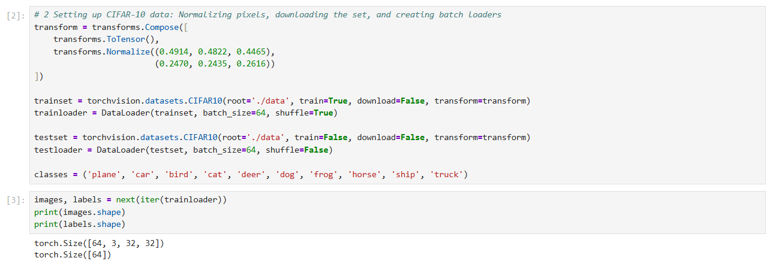
File name: fig1_cifar10_batch_shape.png

3.2 Custom Prunable Layer
Implemented a custom layer with:
- learnable weights
- learnable bias
- learnable gate_scores
- sigmoid gating
- element-wise gated weights
This ensures gradients flow through both weights and gates.

3.3 Model Architecture
The model is designed as a feed-forward neural network that uses custom prunable layers to enable learnable weight suppression.
- Input Flattening:
The CIFAR-10 images of size $3×32×32$are first flattened into a 1D vector of size $3072$. This is necessary because fully connected layers expect vector inputs rather than 2D images.
- PrunableLinear Layers:
The network consists of multiple custom PrunableLinear layers. Each layer contains:
  - standard weights and bias
  - an additional learnable parameter called gate_scores
  - sigmoid-based gates $g=σ(g_{score})$
These gates are multiplied element-wise with the weights, producing:
$$W_{pruned}=W⊙g$$
This allows the network to learn which connections are important and which can be suppressed.
- ReLU Activation:
After each hidden prunable layer, a ReLU activation function is applied. This introduces non-linearity, enabling the network to learn complex patterns beyond simple linear relationships.
- Final Classification Layer:
The last prunable layer maps the learned features to 10 output neurons, corresponding to the 10 CIFAR-10 classes. The output represents raw class scores (logits), which are later used to compute classification loss.
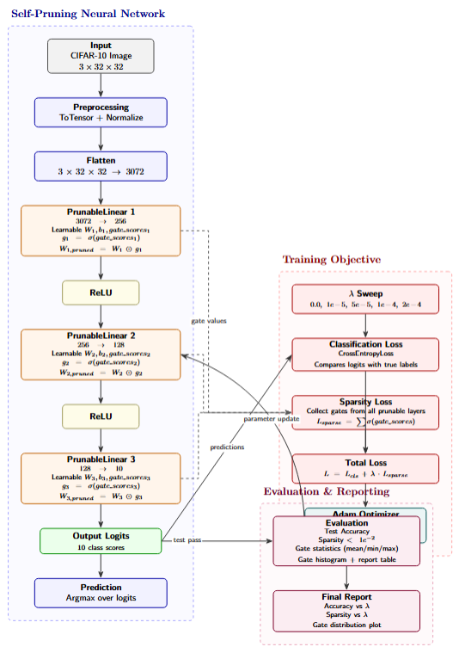
File name: fig2_model_architecture.png
3.4 Training Setup
- Optimizer: Adam
- Loss: CrossEntropy + λ × Sparsity Loss
- Sparsity Loss: sum of gate values
- Evaluation metrics:
  - accuracy
  - sparsity (threshold < 1e-2)
  - gate statistics
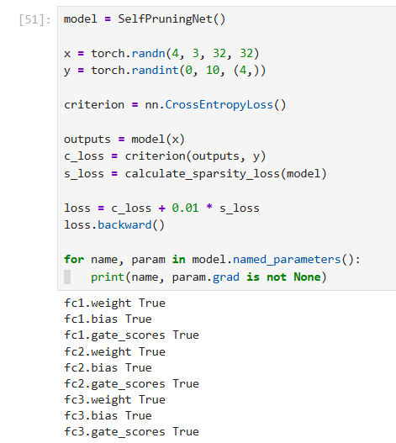
File name: fig3_gradient_flow_check.png

4. Experimental Results
Lambda | Accuracy | Sparsity
0.0 | 53.10% | 0.00%
1e-5 | 54.74% | 0.00%
5e-5 | 54.07% | 0.00%
1e-4 | 52.98% | 0.00%
2e-4 | 51.41% | 0.00%
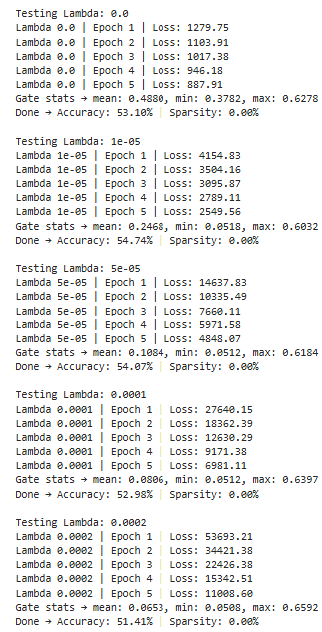
File name: fig4_lambda_sweep_table_or_chart.png

5. Analysis and Observations
- Increasing λ reduces average gate values
- Small λ improves generalization slightly
- Higher λ reduces accuracy due to over-regularization
- Gates move toward smaller values (~0.05) but do not reach zero
Key Insight
This model achieves soft sparsity, not hard pruning.
- Sigmoid outputs are always in (0,1)
- Gates approach zero but do not become exactly zero
- This creates feature suppression rather than strict feature removal

6. Gate Distribution Analysis
A histogram of gate values was used to analyze pruning behavior.
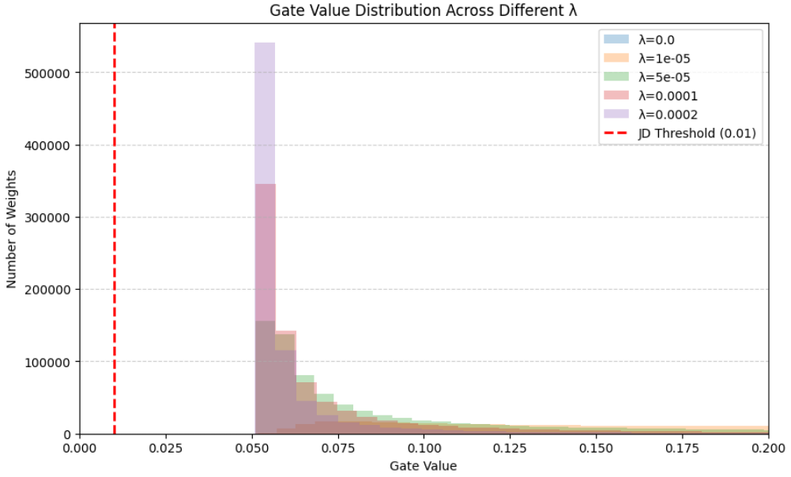
File name: fig5_gate_distribution_best_lambda.png
Observations
- Distribution shifts toward smaller values as λ increases
- Most values cluster around 0.05–0.1
- No spike at zero due to sigmoid limitation

7. Additional Feature:
To extend this project into a real AI system, I plan to add:
LLM-Based Explanation Layer
- FastAPI endpoint: /explain-results
- Input: experiment results (λ, accuracy, sparsity)
- Output: natural language explanation
This demonstrates:
- backend system design
- LLM integration
- real-world usability
File name: fig6_system_flow_gemini_api.png

8. Future Improvements
- Implement Hard-Concrete / L0 gating for true sparsity
- Add post-training threshold pruning
- Build FastAPI backend service
- Add minimal interactive frontend (λ slider + plots)
- Add caching for repeated analysis
- Store experiment logs for reproducibility

9. Problems Faced and Learnings
1. Environment Instability
- GPU setup issues and kernel crashes
- Learned importance of stable environment setup
2. Execution Order Bugs
- NameError due to running cells out of order
- Learned importance of structured execution
3. Missing Methods
- get_gates() not defined properly
- Learned correct class structuring
4. Dataset Handling
- Re-downloading issues
- Learned proper dataset reuse
5. Python Logic Error
- epochs = 3 or 5 always evaluates to 3
- Learned to avoid such expressions
6. Incorrect Tensor Usage
- Used .data instead of proper tensor handling
- Learned correct PyTorch practices
7. Lambda Scaling
- Initially ineffective λ values
- Learned importance of loss scaling
8. Sparsity Loss Design
- Tried multiple formulations
- Learned sum-based loss is effective
9. Threshold Misinterpretation
- Expected hard sparsity
- Learned sigmoid produces soft sparsity
10. Optimization Behavior
- Gates stabilize near ~0.05
- Learned about equilibrium in optimization
11. Interpretation Mistake Risk
- Avoided claiming false pruning
- Learned importance of honest reporting

10. Final Technical Summary
This project successfully implemented:
- custom prunable neural layer
- sigmoid-based gating
- L1 sparsity regularization
- CIFAR-10 training pipeline
- λ-based experimentation
- accuracy vs sparsity analysis
- gate distribution visualization
The model demonstrates soft pruning behavior and a clear trade-off between performance and sparsity.

11. Conclusion
This project strengthened my understanding of:
- neural network optimization
- sparsity mechanisms
- debugging real ML systems
- balancing theory with practical behavior
It reflects my approach to engineering:
not just building models, but understanding how they behave under constraints.

