Vehicle Dashboards

Name

Institution Affiliated

Vehicle Dashboards

**Introduction**

Vehicles are something that has revolutionized the way that the public and personal transport sector works. Automobiles refer to anything that has an engine and four wheels that propels itself using the internal combustion engine. Over the years, the automobile industry has experienced exponential growth and advancements. The automobile industry has been the industry leader on the technological front and has served to revolutionize every aspect of human life. The automobile industry has not been shy about making progress and being bold in the designs of their vehicles and their interiors. Notably, one of the things that have undergone an immense transformation and changes in automobiles is the Dashboard. Each automotive manufacturer has tried to reinvent the wheel in a manner of speaking by completely overhauling their cars' interior and dashboard. One can differentiate the dashboard of one manufacturer from the other simply by looking at the dashboard and everything located on and within it.

**Types of Dashboards**

As earlier stated, each automotive manufacturer has completely overhauled the look of the interior and the dashboard. Some of their designs have become synonymous with each car manufacturer and without looking at the emblem on the steering wheel, one can state which automotive company the car belongs to. In the early years, the dashboard referred to a piece of wood or leather that was placed at the front of a sleigh or carriage to shield and protect the driver from debris and other materials that got thrown up in front of the carriage by the horses pulling it. This simple design was kept even when the first horseless carriages got developed. This simple dashboard design evolved as the cars themselves developed into more complex designs far from the first vehicles created in the 19th century.

Rather than just protect the occupants of the vehicle from mud and debris, the dashboard became a key component that protected the people inside the vehicle from the heat produced by the engine and the fluids within the said engine. As the development of the car progressed, the design of dashboard took up a more complex design and mechanical complexity, forming a convenient location to place minor controls and gauges to monitor the state of the engine and the car in general. This evolution is what opened the door to the modern dashboards seen in the current cars of today.

**BMW Dashboard**

BMW has one of the best dashboards that is packed with a lot of features and components. For instance, it features a central infotainment unit through which people can interact and make changes to the car. Depending on the model and the year of manufacture, the dashboard can have digital or analog gauges comprising the tachometer and the speedometer among other things. 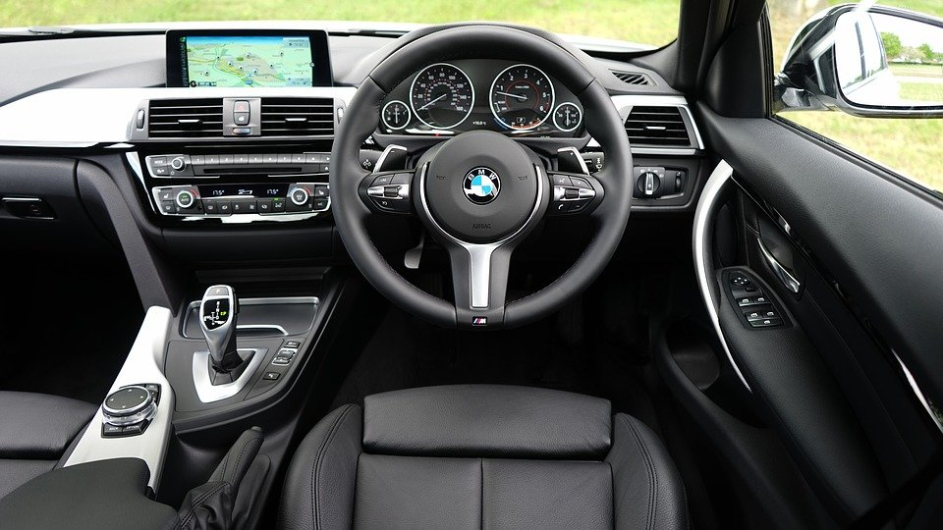

**Bentley Dashboard**

Bentley Motors is part of the Volkswagen group. The automotive company has made a name for itself by creating luxury sedans and SUVs. It is based in Britain and its headquarters is in Crewe in England. Bentley is known for their elegant designs and expensive tastes which are apparent in the interior of their cars. The Bentley dashboard is interactive with different displays and features that show the luxury and class to which the cars target customers. The Dashboard features the elegant and expensive materials and fabrics that the company uses to make them such as quilted leather and wood. 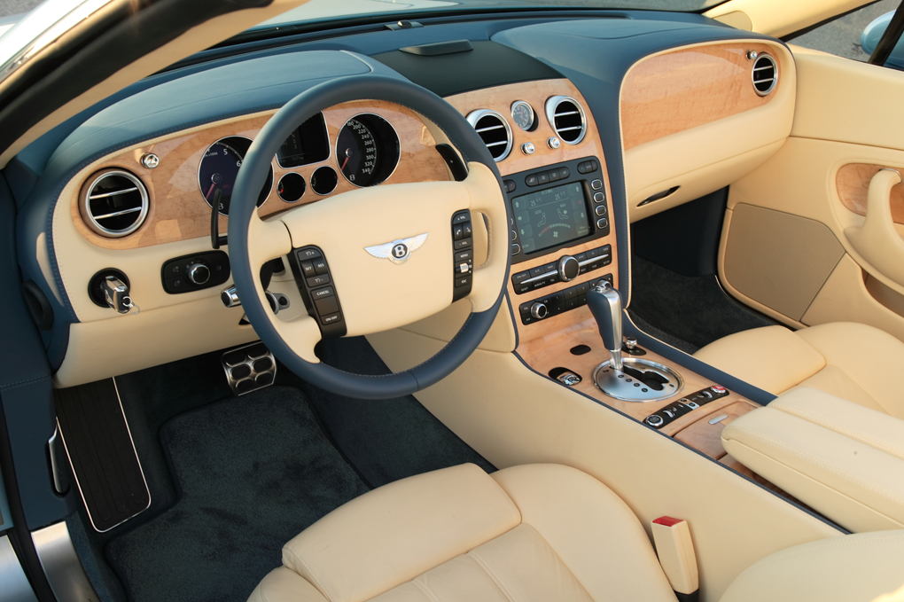

**Mercedes Dashboard**

Mercedes is another name that is synonymous with luxury. The German automotive marque is a company that has made a name for itself in the automotive industry and set itself apart when it comes to luxury. The all-new Mercedes S class is a testament to this fact. The dashboard features a wide infotainment console that is immersive and also doubles as a gauge cluster immediately in front of the driver.

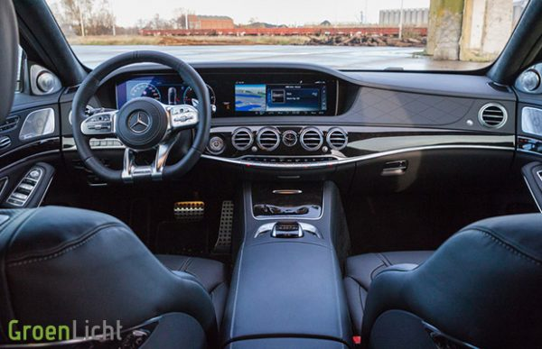

**Toyota Dashboard**

Toyota is one of the biggest companies in the automotive industry. Toyota is based in Japan and they have made and sold millions of cars all over the world. Their cars are affordable and reliable. Toyota has gotten with the program and has also strived to make the dashboards of their cars as futuristic and modern as they can. Take for instance the newer models of the Toyota Crown range.

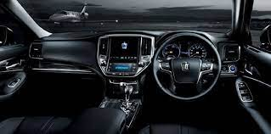

**Ford Dashboard**

Ford Motor Company is an automotive company from the US. The company has its headquarters in Michigan. The dashboard on some of the fords is not as futuristic or luxurious as the first three automotive companies. However, it has also undergone some changes to make it look more modern. It is also relatively simple and minimalist compared to the others.

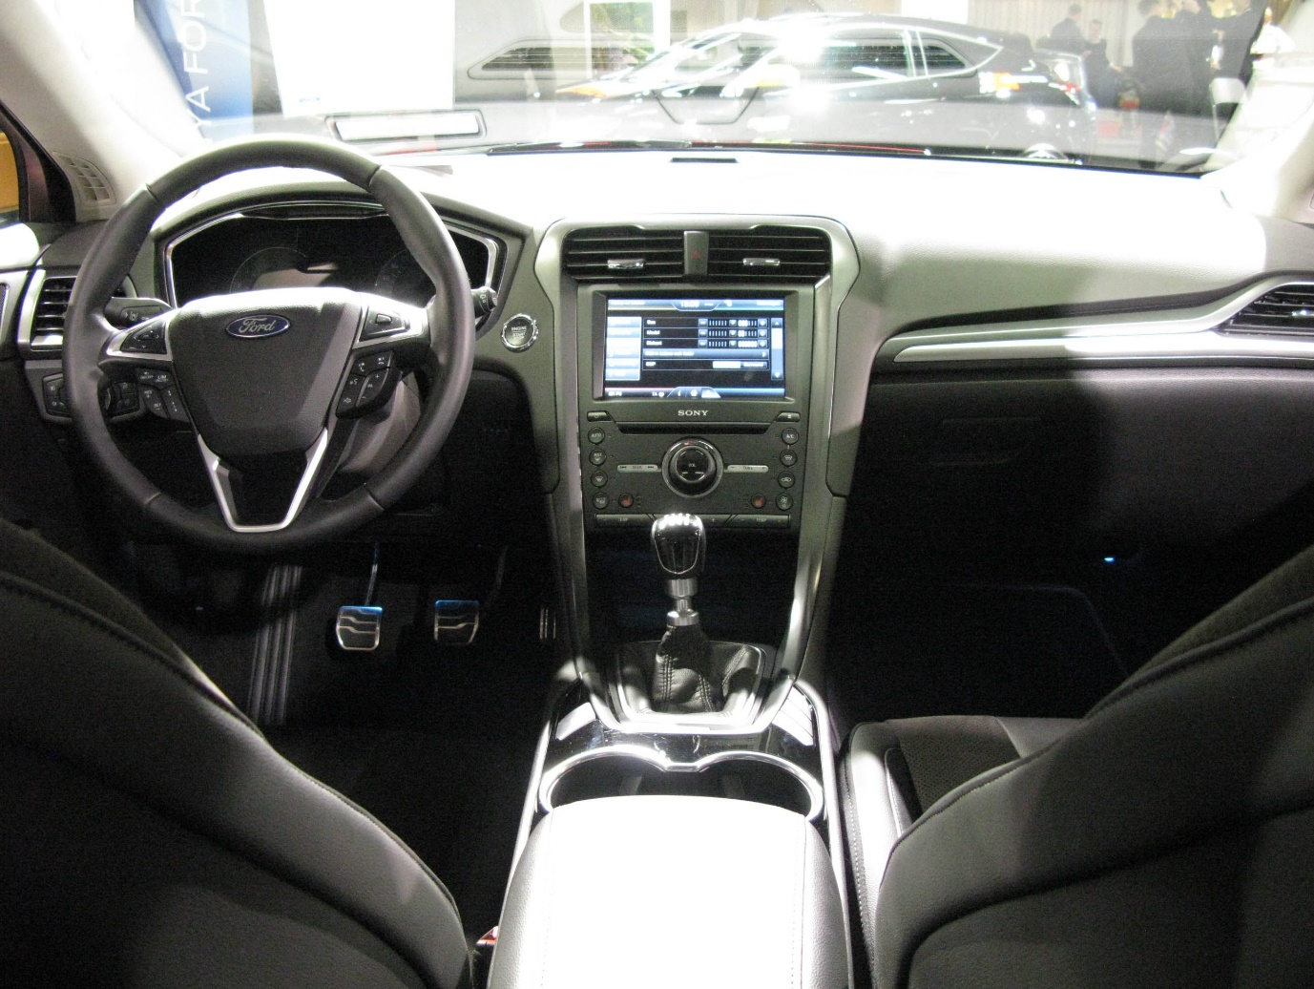

**Pros and Cons**

It is clear that the current dashboard designs have undergone various changes for various reasons. With any advancements, there are some benefits and challenges to the new designs of the dashboards. Some of the pros include the fact that many of them feature the Heads Up Display feature that projects essential information onto the windscreen of the vehicle. A heads-up display is handy as it will enable the driver to avoid any distractions associated with constantly looking down at the cluster gauge to identify the speed at which they are traveling. It also enables the driver to monitor the overall stats of the car like water and oil temperatures without looking for the indicators on the cluster gauge. Haeuslschmid et al. (2017) state that heads up display present vehicle related info close to the road. Heads ups display also improves the overall safety of the drivers and the people inside the cars as the drivers are not distracted while driving. According to Haque et al. (2016), young drivers are more prone to being distracted. Having the heads-up display will enable drivers to keep an eye on the road at all times and be aware of everything that is taking place around them.

There are also some risks associated with these types of dashboards. The more and larger the screens on the dashboard, the easy it is for the driver to get distracted. Take, for instance, Tesla. The dashboards feature a massive infotainment unit at the center, right beside the driver. These screens allow the drivers to watch movies and do all sorts of things while they are on the road. They can cause a significant distraction for the drivers, resulting in accidents. These dashboards also contain a variety of electronic components that are bound to become faulty and might affect the normal functioning of the vehicle. The majority of people might find it difficult to navigate the modern features and have a hard time enjoying their vehicles and the different features.

**Common Features**

Some of the common features on car dashboards include the speedometer that helps limit or maintain the speed at which an individual is driving. Dashboards also have a tachometer that displays the rotations of the engine and shaft. It also has an odometer the measures the mileage of the vehicles. These are some of the contemporary features of the dashboard. Other features include indicators to show if there is something wrong with the vehicle such as the ABS light indicator among others. They may also contain low tire pressure indicators, airbag failure indicators among others. Some of the newer features include temperature control dials or buttons, a cup holder, ashtray, light control systems, and entertainment systems. Some of the rare features that are not found in all vehicles include a heads-up display, a navigation system, and an infotainment unit.

**Controls**

Dashboards have various controls with which drivers get to interact with as they drive. Some of the common controls that drivers use include temperature controls depending on the prevailing weather conditions as they drive. On a hot day, they are likely to set the temperatures low and vice versa. The other control that drivers interact with includes the hazard switch or button. They use it to indicate to other road users to drive carefully. The steering wheel also controls as it assists the drivers to determine the direction in which they want to go. The light controls are another thing that drivers interact with on a daily basis. They can use eth light horn, or switch the lights on and off depending on the time of day that they are driving.

**Mistakes**

Some of the common mistakes that an individual can make include pushing the wrong button while driving as the designs are interactive and more immersive than ever. The buttons or switches can have multiple functions and it can be difficult to understand them all at once. The dashboards might also not have all the buttons and switches labeled or assigned a function hence it can be difficult to know exactly what they do. With the impressiveness of the new dashboard designs, it is also very easy for a person to get sidetracked with what they were doing as there are a lot of features and aspects to take in at once.

**Conclusion**

In the early years, the dashboard referred to a piece of wood or leather that was placed at the front of a sleigh or carriage to shield and protect the driver from debris and other materials that got thrown up in front of the carriage by the horses pulling it. However, the simple dashboard design evolved as the cars themselves developed into more complex designs far from the first vehicles created in the 19th century. The current dashboard designs are more interactive and are continuing to develop as car technology continues to progress.

Reference

Haeuslschmid, R., Klaus, C., & Butz, A. (2017, September). Presenting information on the driver’s demand on a head-up display. In IFIP Conference on Human-Computer Interaction (pp. 245-262). Springer, Cham.

Haque, M. M., Oviedo-Trespalacios, O., Debnath, A. K., & Washington, S. (2016). Gap acceptance behavior of mobile phone–distracted drivers at roundabouts. Transportation research record, 2602(1), 43-51.