ANIL NEERUKONDA INSTITUTE OF TECHNOLOGY & SCIENCES
(AUTONOMOUS)
(Permanent Affiliation by Andhra University & Approved by AICTE)
Accredited by NBA (ECE, EEE, CSE, IT, Mech, Civil & Chemical) & NAAC with A+ Grade) Sangivalasa-531162,
Bheemunipatnam Mandal, Visakhapatnam District
A MINI PROJECT WORK ON..
EMPLOYEE RECORD SORTING AND SEARCHING SYSTEM
This project is submitted by
Team Number: 7
A25126510034 | N. SAMPATH SAI
A25126510036 | P. SOHAIL KHAN
A25126510037 | P. MANIKANTA
A25126510058 | U. ABHISHEK
A25126510065 | V. ROHITH
Under the Guidance of Dr.B.Meena
Department of Computer Science and Engineering in
partial fulfilment of the requirements for the award of
ANIL NEERUKONDA INSTITUTE OF TECHNOLOGY AND SCIENCES

Bachelor of Technology in
COMPUTER SCIENCE AND ENGINEERING
2025-2029
Dr.B.Meena Prof.G.Srinivas
Faculty Incharge Head of the Department
Computer Science and Engineering

CERTIFICATE
This is to certify that the project document entitled “EMPLOYEE RECORD SORTING AND SEARCHING SYSTEM” submitted by the following students of II/IV B.Tech – CSE, Academic Year 2026–2027, is a bonafide record of the work carried out by them under my supervision and guidance.
A25126510034 | N. Sampath Sai
A25126510036 | P. Sohail Khan
A25126510037 | P. Manikanta
A25126510058 | U. Abhishek
A25126510065 | V. Rohith
The document has been submitted in partial fulfillment of the requirements for the course Data Structures and Algorithms, and has not been submitted to any other university or institution for the award of any degree or diploma.
Dr. B. Meena Head of the Department
Faculty, Data Structures and Algorithms Department of CSE
ANITS, Visakhapatnam ANITS, Visakhapatnam
Signature Signature
Date: Place: Visakhapatnam

DECLARATION
We hereby declare that the project work entitled “EMPLOYEE RECORD SORTING AND SEARCHING SYSTEM” is an original piece of work carried out by us under the guidance of Dr. B. Meena, Faculty of Data Structures and Algorithms, Anil Neerukonda Institute of Technology and Sciences (ANITS), Visakhapatnam.
We further declare that:
- The work reported in this document is entirely our own and has not been copied from any other source without due acknowledgement.
- All results and behaviour described were obtained by running the implemented program, and the algorithms follow standard descriptions from the literature.
- This document has not been submitted to any other university or institution, either in full or in part, for the award of any degree, diploma, or certificate.
Place: Visakhapatnam Date:
A25126510034 | N. Sampath Sai
A25126510036 | P. Sohail Khan
A25126510037 | P. Manikanta
A25126510058 | U. Abhishek
A25126510065 | V. Rohith

ACKNOWLEDGEMENT
The successful completion of this project would not have been possible without the support and guidance of several people, to whom we owe our sincere gratitude.
We express our deepest gratitude to Dr. B. Meena, Faculty of Data Structures and Algorithms, ANITS, for her guidance, patience and constructive feedback at every stage of this project.
We extend our sincere thanks to the Head of the Department of Computer Science and Engineering, ANITS, for providing the academic environment, laboratory facilities and institutional support needed to carry out this project.
We are also grateful to the Management of ANITS for encouraging a culture of learning and innovation among students, and for the computing facilities that made our development and testing possible.
Finally, we thank our family members and friends for their continuous support, encouragement and patience throughout the project.

ABSTRACT
As the number of employees in an organisation grows, maintaining their records on paper or in scattered files becomes slow and error-prone. Finding one person’s details, correcting a salary, or arranging the list in a useful order can take a long time when it is done by hand. This project, the Employee Record Sorting and Searching System, is a console-based application written in C that addresses these problems using structures, arrays, searching and sorting algorithms, and file handling.
Each employee is stored as a record that holds an ID, a name, a department and a salary. The records are kept in a fixed-size array of structures that can hold up to 100 employees. The system uses Linear Search to find an employee by ID or by name, and Bubble Sort to arrange the records in ascending order of ID, name or salary. Linear Search checks the records one by one from the first record, while Bubble Sort repeatedly compares adjacent records and swaps those that are out of order.
The system provides a menu-driven interface with operations to add, display, search, sort, update and delete employee records, and to save them to a text file. Records are stored in the text file emp.txt, are loaded automatically when the program starts, and are saved again on request or when the program exits. Input is read line by line and validated, so that invalid numbers, empty text and over-long text are rejected with a clear message.
The report explains the problem and objectives, the representation of employee records, file handling, the searching and sorting algorithms, the working of the system, its modules and data structures, the flowcharts, the source code, sample outputs, testing, complexity analysis, applications, advantages, limitations and conclusion. The main contribution of the project is the practical application of standard searching and sorting algorithms and basic file handling to a simple, understandable record-management problem.
Keywords: Employee Records, Structures, Arrays, Linear Search, Bubble Sort, File Handling, CRUD Operations, Time Complexity, C Programming.

1. Aim
The aim of this project is to develop an Employee Record Sorting and Searching System in the C programming language. The system stores the ID, name, department and salary of each employee as a record, and lets the user manage these records through a simple menu. Searching is done with Linear Search by employee ID or by employee name, and sorting is done with Bubble Sort by ID, name or salary. The records can also be added, displayed, updated and deleted, and they are saved to and loaded from the text file emp.txt so that the data is not lost when the program is closed.
The project demonstrates the practical use of structures, arrays, algorithms and file handling in C, and shows how a small but complete record-management application can be built from these basic ideas.

2. Problem Statement
Managing employee information manually becomes difficult as the number of employees increases. Finding or updating a specific record can take extra time, and records kept by hand can contain errors or become disorganised. It is also hard to arrange the records in a particular order, for example by salary or by name, without rewriting the whole list.
To solve this problem, each employee can be represented as a structure containing the ID, name, department and salary, and all the structures can be stored together in an array. A menu-driven program can then provide the common operations on these records: adding a new employee, displaying all employees, searching by ID or name, sorting by ID, name or salary, updating the details of an employee, and deleting an employee. The records can be written to a text file and read back, so that they are available the next time the program is run.
The proposed system uses Linear Search to locate records and Bubble Sort to arrange them, and it checks every value entered by the user (numbers, text length and duplicate IDs) before it is stored. The resulting program is simple, easy to understand, and suitable for demonstrating the Data Structures and Algorithms concepts studied in the course.

3. Introduction

3.1 Employee Record Management
Every organisation keeps information about the people who work in it. For each employee, the basic details usually include an identification number, a name, the department in which the employee works, and the salary. An employee record management system stores these details in an organised way and allows them to be viewed and changed whenever required.

3.2 Need for an Employee Record System
When records are maintained manually, the same information may be written in several places, searching for one employee means reading through many pages, and a small mistake can go unnoticed. A computerised system reduces the time needed to find a record, keeps all employees in a uniform format, and makes it easy to correct or remove information.

3.3 Records Using Structures and Arrays
In C, a structure groups several related values of different types under one name. The Employee structure of this project groups an integer ID, two character arrays for the name and the department, and a floating-point salary. An array of such structures stores many employees one after another, and the position of an employee in the array is called its index. The program keeps a counter cnt that tells how many positions of the array are currently in use.

3.4 Searching and Sorting
Searching is the process of finding a particular record among many records. Sorting is the process of arranging records in a particular order, such as ascending order of ID, alphabetical order of name, or increasing order of salary. Both are basic operations of data structures and algorithms, and they are used in almost every application that stores a list of items.

3.5 Role of Linear Search
Linear Search starts at the first record and compares each record, in turn, with the value that is being searched for. It stops when a matching record is found or when all records have been checked. In this project, Linear Search is used to find an employee by ID (function findEmployeeById()) and to find employees by name (a loop that compares the entered name with each stored name using strcmp()). Linear Search does not need the records to be sorted, so it can be used immediately after a new record is added.

3.6 Role of Bubble Sort
Bubble Sort compares two neighbouring records and swaps them if they are in the wrong order. When this is repeated over the whole list again and again, the larger values move step by step towards the end of the list, like bubbles rising in water, and after enough passes the list is sorted. In this project, Bubble Sort is used by the Sort() function to arrange the whole records in ascending order of ID, name or salary. Because entire records are swapped, the ID, name, department and salary of an employee always stay together.

3.7 Role of File Handling
Data kept only in an array is lost when the program ends. File handling lets the program write the records to a text file and read them back later. In this project, the file emp.txt is used. The function Save() writes the records with fprintf(), and the function Load() reads them back with fgets() and sscanf() when the program starts.

3.8 Objective of the Project
The main objective of this project is to develop a simple employee record management system in C using structures, arrays, searching, sorting and file handling. The specific objectives are:
- To store the ID, name, department and salary of each employee in a structure, and to keep up to 100 such records in an array.
- To provide a menu-driven interface for adding, displaying, searching, sorting, updating and deleting employee records.
- To search for an employee by ID or by name using Linear Search.
- To sort the records by ID, name or salary using Bubble Sort.
- To update and delete employee records using the employee ID.
- To save the records to the text file emp.txt and load them again when the program starts.
- To validate the input so that invalid numbers, empty text, over-long text and duplicate IDs are rejected.
The project gives a practical understanding of how basic data structures and algorithms are used to solve a real-life record-management problem.

4. Employee Record Representation

4.1 The Employee Structure
Each employee is represented by one structure of type struct Employee. The structure is declared as follows:
struct Employee {
int id;
char name[50];
char department[50];
float salary;
};

Field | Type | Meaning
id | int | Unique employee ID. Two employees cannot have the same ID.
name | char[50] | Employee name. Accepted input is 1 to 20 characters.
department | char[50] | Department of the employee, for example CSE, ECE or IT. Accepted input is 1 to 15 characters.
salary | float | Salary of the employee, displayed with two digits after the decimal point.

4.2 Array of Records
All employees are stored in the global array struct Employee emp[MAX]; where MAX is defined as 100. The global integer cnt stores the number of employees currently stored. A new employee is placed at emp[cnt] and then cnt is incremented, so the valid indices are 0 to cnt - 1. The program refuses to add a new employee when cnt has reached MAX, and prints “Maximum employee limit reached.”
For example, after the three employees entered in the sample run have been added, the array holds the following records:
Index | ID | Name | Department | Salary
0 | 101 | Ananya Rao | CSE | 45000.00
1 | 103 | Rahul Kumar | ECE | 52000.00
2 | 102 | Meera Shah | IT | 48000.00

4.3 Operations on the Records
The program supports the four basic operations on records, often called CRUD operations, together with searching, sorting and file storage:
Operation | How it is done in the program
Create | AddEmployee() reads the four values, rejects a duplicate ID, and appends the record at emp[cnt].
Read | DisplayEmployee() prints all records in a table; Search() finds one record by ID or all records with a given name.
Update | Update() finds the record by ID and replaces its name, department and salary (the ID is not changed).
Delete | Delete() finds the record by ID, shifts all later records one position to the left, and decreases cnt.
Sort | Sort() arranges the records with Bubble Sort by ID, name or salary.
Store | Save() writes the records to emp.txt and Load() reads them back at start-up.

5. File Handling and Record Storage

5.1 Why File Handling Is Needed
The array emp[] exists only while the program is running. To keep the records permanently, they are written to the text file emp.txt. This file is created in the folder from which the program is run.

5.2 Format of emp.txt
Save() writes the records as a formatted table, so that the file is also readable by a person. The columns are separated by spaces and have fixed widths: 8 characters for the ID, 20 for the name, 15 for the department and 12 for the salary. For the records of the sample run the file contains:
==============================================================
EMPLOYEE RECORDS
==============================================================

ID Name Department Salary
--------------------------------------------------------------
101 Ananya Rao CSE 45000.00
102 Meera Reddy CSE 50000.00

==============================================================

5.3 Saving the Records
The file is opened in write mode with fopen("emp.txt", "w"), which replaces the previous contents. If the file cannot be opened, the message “Error: Could not open emp.txt” is displayed and nothing is written. Otherwise the heading lines, the column titles and one line per employee are written with fprintf(), the file is closed with fclose(), and the message “Records saved successfully to emp.txt” is displayed. Records are saved when the user chooses option 7, and automatically when the user chooses option 8 (Exit).

5.4 Loading the Records
When the program starts, Load() opens emp.txt in read mode. If the file does not exist, the function simply returns and the program starts with no records. Otherwise it reads the file line by line with fgets(). Lines that start with “=”, “-” or a blank line, and the column-title line that starts with “ID”, are skipped. Every other line is split with sscanf(line, "%d %20c %15c %29s", ...), which reads the ID, exactly 20 characters for the name, exactly 15 characters for the department, and the salary text. The padding spaces at the end of the name and the department are removed by removeTrailingSpaces(), the salary is converted with atof(), and the record is appended to the array as long as cnt is less than MAX. At the start, the program prints how many records were loaded, or “No previous employee records found.” when there were none.

6. Algorithms Used
Algorithms are step-by-step instructions used to solve a particular problem. The main algorithms used in this project are:
- Linear Search (for searching by ID and by name)
- Bubble Sort (for sorting by ID, name or salary)

6.1 Linear Search
Linear Search, also called sequential search, checks the records one after another from the first record. It does not require the records to be in any particular order.
Steps of Linear Search by ID (as implemented in findEmployeeById())
- Start at the first record, emp[0].
- Compare the ID of the current record with the ID that is being searched for.
- If they are equal, return the index of the current record.
- Otherwise move to the next record and repeat from step 2 until all cnt records have been checked.
- If no record matched, return -1, which means “not found”.
Pseudocode
findEmployeeById(id):
for i = 0 to cnt - 1:
if emp[i].id == id:
return i
return -1

Search by Name
When the user searches by name, Search() reads the name and compares it with the name of every record using strcmp(). The comparison is exact and case-sensitive. Because several employees can have the same name, the loop does not stop at the first match; it displays every matching record, and prints “Employee not found.” only if no record matched. Employee IDs are unique, so a search by ID can stop at the first match.
Example
Searching for ID 103 in the records [101, 103, 102] compares 101 (no match) and then 103 (match), so the record at index 1 is returned and displayed: Rahul Kumar, ECE, 52000.00 (see Section 12).
Advantages of Linear Search
- Very easy to understand and implement.
- Works on unsorted data, so it can be used right after records are added, updated or deleted.
- Needs no extra memory.
- Fast enough for a small array of at most 100 records.

6.2 Bubble Sort
Bubble Sort arranges the records in ascending order. In one pass it compares each pair of neighbouring records and swaps them if the left record should come after the right record. After the first pass the largest record has moved to the end, after the second pass the second largest is in its place, and so on.
Steps of Bubble Sort (as implemented in Sort())
- If there are no records, display a message and return.
- Read the sorting choice: 1 for ID, 2 for name, 3 for salary. Any other value displays “Invalid choice.” and returns.
- Repeat for i = 0 to cnt - 2 (one pass for each i).
- In each pass, repeat for j = 0 to cnt - i - 2 and compare emp[j] with emp[j + 1] using the chosen key: the integer IDs or the salaries are compared with the > operator, and the names are compared with strcmp().
- If emp[j] is greater than emp[j + 1], swap the two complete records using a temporary structure temp.
- After all passes, display “emp sorted successfully.” and show the sorted records.
Pseudocode
Sort():
read choice (1 = ID, 2 = Name, 3 = Salary)
for i = 0 to cnt - 2:
for j = 0 to cnt - i - 2:
if key(emp[j]) > key(emp[j + 1]):
temp = emp[j]
emp[j] = emp[j + 1]
emp[j + 1] = temp
display all records

Example
Sorting the IDs [101, 103, 102] in ascending order takes the following passes:
Pass | Comparisons | Result after the pass
1 | 101 vs 103: no swap; 103 vs 102: swap | 101, 102, 103
2 | 101 vs 102: no swap | 101, 102, 103 (sorted)

Since the whole record is swapped, the names, departments and salaries move together with their IDs. The program output for this example is shown in Section 12.
Properties of the Implementation
- Records are swapped only when the left key is strictly greater than the right key, so employees with equal keys keep their original relative order (the sort is stable).
- Sorting changes the order of the array in memory. The file emp.txt changes only when the records are saved.
- The program always performs all passes; it does not stop early when the list is already sorted.

6.3 Update and Delete
Update() first finds the record with findEmployeeById(), displays its current details, and then reads the new name, department and salary directly into the same array element. The ID is not changed. Delete() finds the record in the same way and then moves every record after it one position to the left (emp[i] = emp[i + 1]) and decreases cnt, so that no gap is left in the array.

6.4 Time Complexity
Let n be the number of employee records currently stored (n ≤ MAX = 100).
Operation (function) | Time complexity | Remarks
findEmployeeById() | O(n) | Linear Search; best case O(1) when the ID is the first record.
Search by name | O(n) | Checks every record with strcmp() so that all matches are shown.
AddEmployee() | O(n) | Duplicate-ID check; the new record itself is added in O(1).
DisplayEmployee() | O(n) | Prints every record once.
Sort() – Bubble Sort | O(n²) | About n(n − 1)/2 comparisons in every case; up to n(n − 1)/2 swaps in the worst case.
Update() | O(n) | O(n) to find the record, then O(1) to change it.
Delete() | O(n) | O(n) to find the record and O(n) to shift the later records.
Save() / Load() | O(n) | One line is written or read per record.

6.5 Space Complexity and Assumptions
The record array has a fixed size of MAX = 100 structures. Each structure occupies about 108 bytes on a typical system, so the array needs roughly 10.8 KB, which is O(MAX) space and does not grow with the input. Bubble Sort needs only one extra structure (temp), so it sorts in place with O(1) additional space. Linear Search needs no additional space.
The following assumptions are made: the number of employees does not exceed MAX = 100; every employee ID is unique; names are at most 20 characters and departments at most 15 characters; and the text file emp.txt is created by this program, so that it follows the column layout described in Section 5.

7. Working of the System
The Employee Record Sorting and Searching System is a menu-driven console program. All data is stored in the array of structures, and the user chooses the operations from a menu that is repeated until the user chooses Exit.

7.1 Initialisation
When the program starts, main() calls Load() to read any records saved earlier in emp.txt. It then prints the title and a message showing how many records were loaded, or “No previous employee records found.” if the file is missing or empty.

7.2 Menu-Driven Operation
After initialisation, the program repeatedly displays the menu EMPLOYEE RECORD MANAGEMENT SYSTEM inside a while (1) loop and reads the choice with readI(). A switch statement runs the selected operation:
Choice | Menu option | What the program does | Function used
1 | Add Employee | Reads ID, name, department and salary and stores a new record. | AddEmployee()
2 | Display All emp | Prints all records as a table. | DisplayEmployee()
3 | Search Employee | Searches by ID or by name and displays the matching record(s). | Search()
4 | Sort emp | Sorts the records by ID, name or salary and displays them. | Sort()
5 | Update Employee | Changes the name, department and salary of an employee found by ID. | Update()
6 | Delete Employee | Removes the employee with the given ID. | Delete()
7 | Save Records | Writes all records to emp.txt. | Save()
8 | Exit | Saves the records, prints a thank-you message and ends the program. | Save(), return 0
other | (invalid choice) | Prints “Invalid choice. Please try again.” and shows the menu again. | default case

7.3 Adding an Employee (Option 1)
If cnt has reached MAX, the program prints “Maximum employee limit reached.” and returns. Otherwise it reads the ID with readI() and checks it with findEmployeeById(); if the ID already exists, it prints “Employee ID already exists.” and returns without adding anything. It then reads the name (1 to 20 characters), the department (1 to 15 characters) and the salary, stores the new record at emp[cnt], increments cnt and prints “Employee added successfully.”

7.4 Displaying Employees (Option 2)
If there are no records, the message “No employee records found.” is displayed. Otherwise a table with the columns ID, Name, Department and Salary is printed, with one row for each record and the salary shown with two decimal places.

7.5 Searching (Option 3)
The user chooses 1 to search by ID or 2 to search by name. For a search by ID, the program reads the ID, calls findEmployeeById(), and displays either the record found or “Employee not found.” For a search by name, the program reads the name and compares it with every stored name; every matching record is displayed. Any other choice prints “Invalid choice.”

7.6 Sorting (Option 4)
The user chooses the key (1 = ID, 2 = Name, 3 = Salary). Bubble Sort then rearranges the array in ascending order of that key, the message “emp sorted successfully.” is shown, and the sorted table is displayed.

7.7 Updating (Option 5) and Deleting (Option 6)
For both operations the user enters the employee ID. If it is not found, “Employee not found.” is displayed. For an update, the current details are shown and the new name, department and salary are read, followed by “Employee updated successfully.” For a delete, the later records are shifted left and “Employee deleted successfully.” is displayed.

7.8 Saving and Exiting (Options 7 and 8)
Option 7 calls Save() and returns to the menu. Option 8 calls Save() and then prints “Thank you for using the system.” and “Program terminated successfully.” before the program ends. Changes that are made but not saved with option 7 are therefore still saved automatically when the user exits through option 8.
Main Steps
- Load – read the records saved earlier from emp.txt.
- Display Menu – show the eight menu options and read the user’s choice.
- Enter Data – enter the employee details, the ID or name to search for, or the sorting key.
- Apply Algorithm – use Linear Search (option 3) or Bubble Sort (option 4), or modify the array (options 1, 5, 6).
- Display Result – show the message or the table of records and return to the menu.
- Save / Exit – write the records to emp.txt on option 7 or when exiting with option 8.

8. Modules Involved
The program is organised into the following modules. Each module is implemented by one or more C functions.
No. | Module | Function(s)
1 | Input Reading and Validation Module | readI(), readF(), readS()
2 | Record Search Module | findEmployeeById(), Search()
3 | Record Addition Module | AddEmployee()
4 | Record Display Module | DisplayEmployee(), DisplayEmplyee()
5 | Sorting Module (Bubble Sort) | Sort()
6 | Record Update Module | Update()
7 | Record Deletion Module | Delete()
8 | File Handling Module | Save(), Load(), removeTrailingSpaces()
9 | Menu-Driven User Interface Module | main()

8.1 Input Reading and Validation Module
Purpose: To read numbers and text from the keyboard safely.
How it works: Each function prints a message, reads a whole line with fgets() and checks it. readI() and readF() use sscanf() with the format "%d %c" or "%f %c"; the input is accepted only if exactly one value was converted, so a line such as “12abc” or “45 x” is rejected, and the user is asked again with “Invalid input. Please enter a number.” readS() removes the newline, rejects an empty string (“Input cannot be empty.”) and rejects a string longer than the allowed maximum (“Please enter maximum n characters.”). All three functions repeat until the input is valid.
Contribution to the system: Because every value is read as a line and then converted, wrong input cannot leave stray characters in the input buffer or put invalid data into the records.

8.2 Record Search Module
Purpose: To find a record by ID or by name.
How it works: findEmployeeById() performs Linear Search over the first cnt records and returns the index of the matching record or -1. Search() offers the choice between searching by ID (using findEmployeeById()) and searching by name (a loop with strcmp()), and displays the result with DisplayEmplyee().
Contribution to the system: It is used not only for searching, but also by AddEmployee() (duplicate check), Update() and Delete() to locate a record.

8.3 Record Addition Module
Purpose: To add a new employee to the array.
How it works: AddEmployee() checks that the array is not full, reads the ID, rejects a duplicate ID, reads the name, department and salary into a temporary structure newEmp, copies it to emp[cnt] and increments cnt.
Contribution to the system: It creates the records and keeps every ID unique.

8.4 Record Display Module
Purpose: To show the stored records.
How it works: DisplayEmployee() prints the heading, the column titles and one formatted row for every record using printf() with fixed field widths. DisplayEmplyee(Index) prints the four fields of one record on separate labelled lines; it is used by Search() and Update().
Contribution to the system: It lets the user view the result of every other operation.

8.5 Sorting Module (Bubble Sort)
Purpose: To arrange the records in ascending order.
How it works: Sort() reads the key (ID, name or salary) and runs two nested loops that compare neighbouring records and swap them through the temporary structure temp whenever they are in the wrong order, as described in Section 6.2. It then calls DisplayEmployee() to show the sorted list.
Contribution to the system: It provides the sorting feature of the project.

8.6 Record Update Module
Purpose: To correct or change the details of an existing employee.
How it works: Update() finds the employee by ID, shows the current details, and reads the new name, department and salary into the same array element, using the same validation as when adding a record.
Contribution to the system: It allows records to be corrected without deleting and re-entering them.

8.7 Record Deletion Module
Purpose: To remove an employee.
How it works: Delete() finds the employee by ID, shifts all later records one position to the left to close the gap, and decreases cnt.
Contribution to the system: It keeps the array continuous, so all loops from 0 to cnt - 1 remain correct.

8.8 File Handling Module
Purpose: To keep the records between runs of the program.
How it works: Save() writes the heading, the column titles and all records to emp.txt with fprintf(). Load() reads emp.txt with fgets(), skips heading lines, splits each data line with sscanf(), trims the padding spaces with removeTrailingSpaces(), and appends the record to the array.
Contribution to the system: It makes the data persistent.

8.9 Menu-Driven User Interface Module
Purpose: To interact with the user and call the required operation.
How it works: main() loads the records, displays the title, and then runs an infinite while (1) loop that prints the menu, reads the choice with readI() and calls the corresponding function through a switch statement. Choice 8 saves the records and ends the program.
Contribution to the system: It ties all the modules together and provides the only interface to the user (a text-based console interface).

8.10 Input Validation and Error Handling
The checks that keep the data consistent are spread over several functions and are summarised below.
Situation | Where handled | Behaviour
Non-numeric or incomplete number entered | readI(), readF() | Prints “Invalid input. Please enter a number.” (or “…a valid number.” for salary) and asks again.
Empty name or department | readS() | Prints “Input cannot be empty.” and asks again.
Name longer than 20 or department longer than 15 characters | readS() | Prints “Please enter maximum n characters.” and asks again.
Duplicate employee ID | AddEmployee() | Prints “Employee ID already exists.” and does not add the record.
More than 100 employees | AddEmployee() | Prints “Maximum employee limit reached.”
ID not found | Search(), Update(), Delete() | Prints “Employee not found.”
Search, display or sort with no records | Search(), DisplayEmployee(), Sort() | Prints “No employee records found.” or “No employee records available to sort.”
Invalid search or sort choice | Search(), Sort() | Prints “Invalid choice.” and returns to the menu.
Invalid menu choice | main(), default case | Prints “Invalid choice. Please try again.”
emp.txt cannot be opened for writing | Save() | Prints “Error: Could not open emp.txt”.
emp.txt does not exist at start-up | Load() | Returns silently; the program starts with no records.

9. Data Structures Used in the Project
This section describes the data structures that are actually used in the C implementation.
Data structure | Declared / used as | Used by
Structure | struct Employee { int id; char name[50]; char department[50]; float salary; } | All modules
Array of structures | struct Employee emp[MAX]; (MAX = 100) | Add, display, search, sort, update, delete, save, load
Record counter | int cnt | All modules that loop over the records
Temporary structure | struct Employee temp; struct Employee newEmp; | Sort() (swap), AddEmployee()
Character arrays (strings) | char name[50], char department[50], char in[100], char line[150] | readS(), Search(), Load()
File pointer | FILE *file | Save(), Load()

9.1 Structure (struct Employee)
The structure groups everything the program needs to know about one employee in a single unit. Copying one record into another, which is needed for sorting and deleting, is a single assignment such as emp[j] = emp[j + 1]; the name, the department and the salary are copied together with the ID.

9.2 Array of Structures
The global array emp[MAX] holds all records one after another in memory. Direct access by index makes loops over the records simple, and swapping or shifting records is done by assignment. The disadvantage is that the size is fixed at 100 records.

9.3 Record Counter
The array has room for 100 records, but only the first cnt of them are meaningful. cnt is increased when a record is added or loaded, and decreased when a record is deleted. Every loop in the program runs from 0 to cnt - 1.

9.4 Temporary Structure
To swap two neighbouring records, Bubble Sort copies emp[j] into temp, copies emp[j + 1] into emp[j], and finally copies temp into emp[j + 1]. AddEmployee() reads a new record into the local structure newEmp first, so that nothing is stored in the array if the ID turns out to be a duplicate.

9.5 Character Arrays (Strings)
Names and departments are stored as null-terminated character arrays. The string functions of <string.h> that are used are strcmp() (comparing names in Search() and Sort()), strcpy() (copying the trimmed name and department in Load()), strlen() and strcspn() (checking length and removing the newline in readS() and removeTrailingSpaces()).

9.6 File Pointer
A FILE pointer is used by Save() and Load() to access emp.txt through fopen(), fprintf(), fgets() and fclose().

10. Flowchart
Figure 10.1 shows the flow of the complete program, from loading the saved records to the menu loop and the eight options.
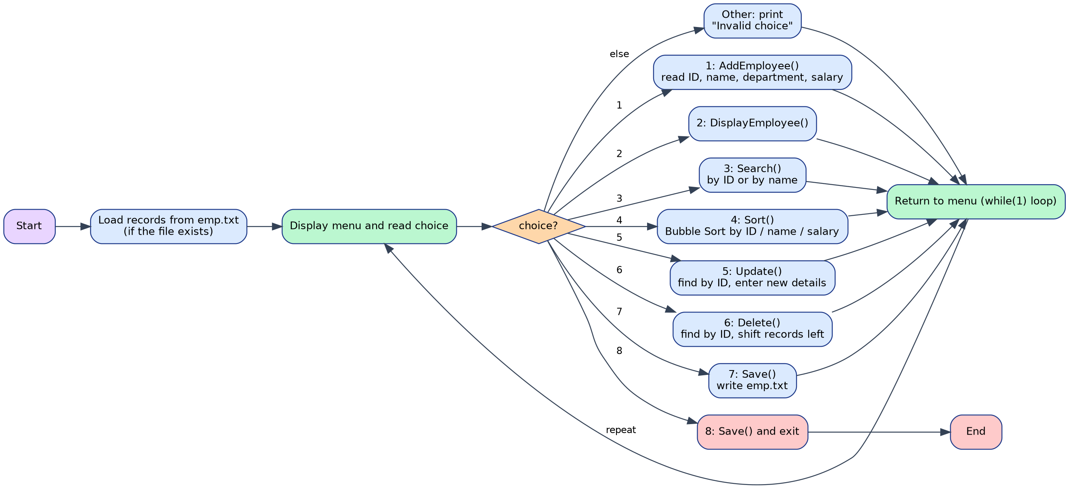
Figure 10.1: Flowchart of the menu-driven program
Figure 10.2 shows the flow of the sorting operation, which uses Bubble Sort.
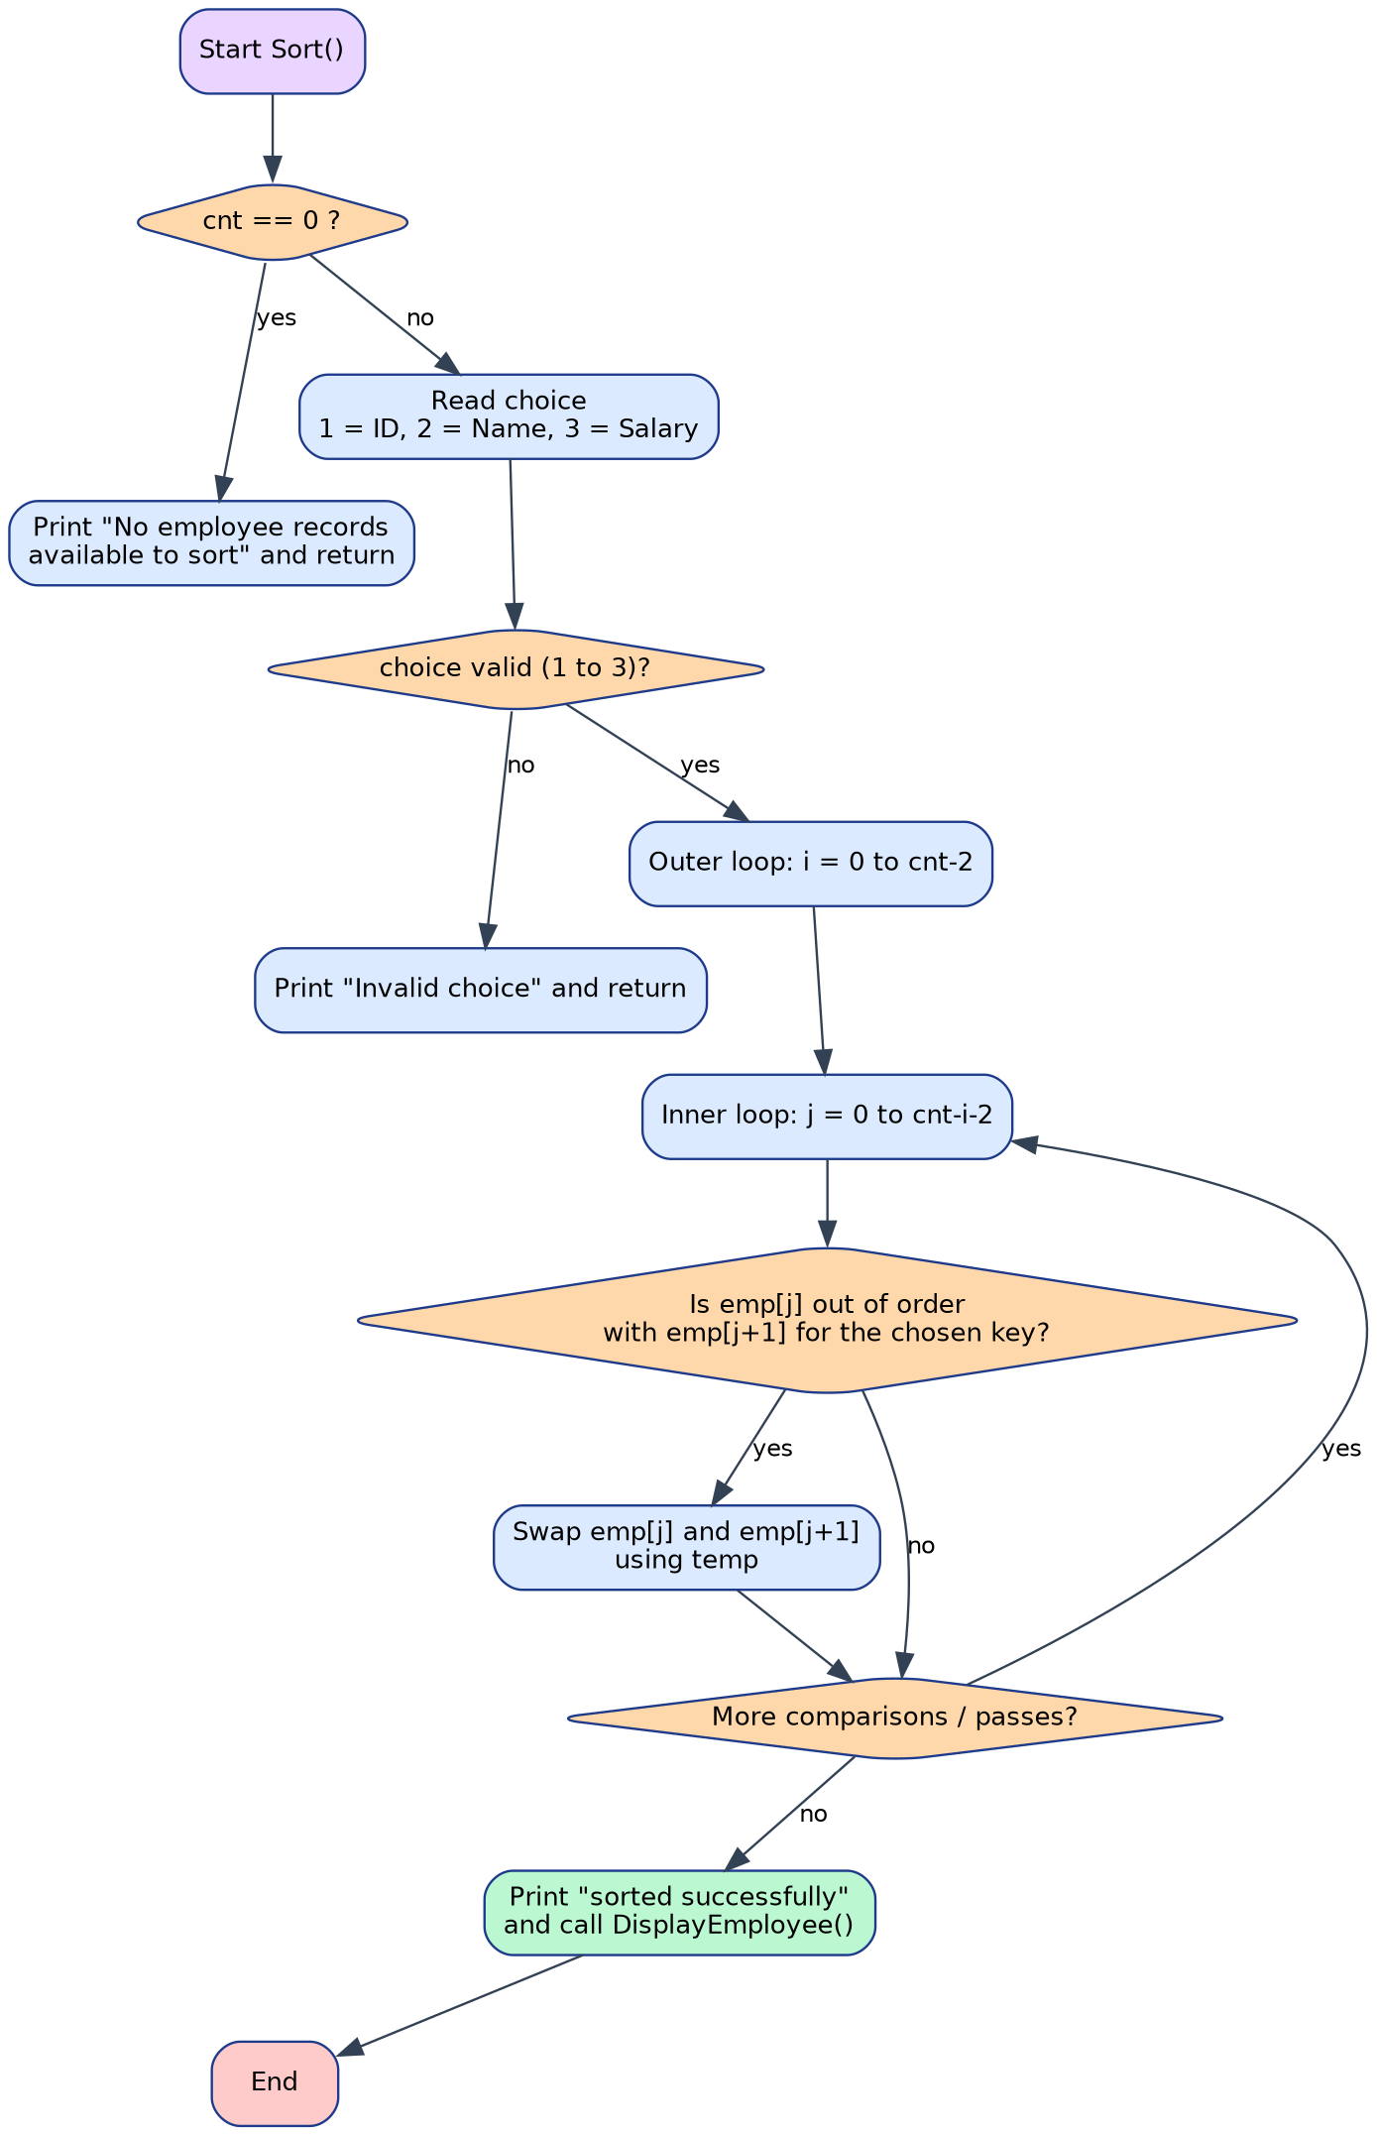
Figure 10.2: Flowchart of the Sort() function (Bubble Sort)

11. Source Code:
#include <stdio.h>
#include <stdlib.h>
#include <string.h>
#define MAX 100
struct Employee {
int id;
char name[50];
char department[50];
float salary;
};
struct Employee emp[MAX];
int cnt=0;
//READ INTEGER
int readI(char msg[]) {
char in[100];
int val;
char ext;
while(1) {
printf("%s",msg);
if (fgets(in,sizeof(in),stdin)!=NULL) {
if (sscanf(in,"%d %c",&val,&ext)==1) {
return val;
}
}
printf("Invalid input. Please enter a number.\n");
}
}
//READ FLOAT
float readF(char msg[]) {
char in[100];
float val;
char ext;
while(1) {
printf("%s",msg);
if (fgets(in,sizeof(in),stdin)!=NULL) {
if (sscanf(in,"%f %c",&val,&ext)==1) {
return val;
}
}
printf("Invalid input. Please enter a valid number.\n");
}
}
//READ STRING
void readS(char msg[], char val[], int size, int maxLen) {
while(1) {
printf("%s",msg);
if(fgets(val,size,stdin)!=NULL) {
val[strcspn(val,"\n")]='\0';
if(strlen(val)== 0) {
printf("Input cannot be empty.\n");
continue;
}
if (strlen(val)>maxLen) {
printf("Please enter maximum %d characters.\n",maxLen);
continue;
}
return;
}
}
}
//FIND EMPLOYEE BY ID
int findEmployeeById(int id) {
int i;
for (i = 0;i < cnt;i++) {
if (emp[i].id==id) {
return i;
}
}
return -1;
}
//DISPLAY ONE EMPLOYEE
void DisplayEmplyee(int Index) {
printf("\n---------------------------------------------\n");
printf("Employee ID : %d\n",emp[Index].id);
printf("Name : %s\n",emp[Index].name);
printf("Department : %s\n",emp[Index].department);
printf("Salary : %.2f\n",emp[Index].salary);
printf("---------------------------------------------\n");
}
//ADD EMPLOYEE
void AddEmployee() {
struct Employee newEmp;
if (cnt>=MAX) {
printf("\nMaximum employee limit reached.\n");
return;
}
printf("\n========== ADD EMPLOYEE ==========\n");
newEmp.id=readI("Enter Employee ID: ");
// CHECKS WHETHER ID ALREADY EXISTS
if(findEmployeeById(newEmp.id)!=-1) {
printf("\nEmployee ID already exists.\n");
return;
}
readS("Enter Employee Name: ",newEmp.name,sizeof(newEmp.name),20);
readS("Enter Department: ",newEmp.department,sizeof(newEmp.department),15);
newEmp.salary=readF("Enter Salary: ");
emp[cnt]=newEmp;
cnt++;
printf("\nEmployee added successfully.\n");
}
// DISPLAY ALL EMPLOYEES
void DisplayEmployee() {
int i;
if (cnt==0) {
printf("\nNo employee records found.\n");
return;
}
printf("\n==============================================================\n");
printf(" EMPLOYEE RECORDS\n");
printf("==============================================================\n");
printf("%-8s %-20s %-15s %-12s\n","ID","Name","Department","Salary");
printf("--------------------------------------------------------------\n");
for (i = 0; i < cnt; i++) {
printf("%-8d %-20s %-15s %-12.2f\n",emp[i].id,emp[i].name,emp[i].department,emp[i].salary);
}
printf("\n==============================================================\n");
}
// SEARCH EMPLOYEE
void Search() {
int choice;
int id;
int Index;
char name[50];
int found=0;
int i;
if (cnt==0) {
printf("\nNo employee records found.\n");
return;
}
printf("\n========== SEARCH EMPLOYEE ==========\n");
printf("1. Search by ID\n");
printf("2. Search by Name\n");
choice=readI("Enter your choice: ");
if (choice==1) {
id=readI("Enter Employee ID: ");
Index=findEmployeeById(id);
if (Index==-1) {
printf("\nEmployee not found.\n");
}
else {
printf("\nEmployee found:\n");
DisplayEmplyee(Index);
}
}
else if(choice==2) {
readS("Enter Employee Name: ",name,sizeof(name),49);
for (i=0;i<cnt;i++) {
if(strcmp(emp[i].name, name)==0) {
printf("\nEmployee found:\n");
DisplayEmplyee(i);
found=1;
}
}
if(found==0) {
printf("\nEmployee not found.\n");
}
}
else {
printf("\nInvalid choice.\n");
}
}
// SORT emp(BUBBLE SORT)
void Sort() {
int choice;
int i;
int j;
int swap;
struct Employee temp;
if(cnt==0) {
printf("\nNo employee records available to sort.\n");
return;
}
printf("\n========== SORT emp ==========\n");
printf("1. Sort by ID\n");
printf("2. Sort by Name\n");
printf("3. Sort by Salary\n");
choice=readI("Enter your choice: ");
if(choice<1||choice>3) {
printf("\nInvalid choice.\n");
return;
}
for(i=0;i<cnt-1;i++) {
swap=0;
for(j=0;j<cnt-i-1;j++) {
if(choice==1) {
if(emp[j].id>emp[j + 1].id) {
swap=1;
}
}
else if(choice==2) {
if (strcmp(emp[j].name,emp[j + 1].name) > 0) {
swap=1;
}
}
else if(choice==3) {
if(emp[j].salary>emp[j + 1].salary) {
swap=1;
}
}
if(swap) {
temp=emp[j];
emp[j]=emp[j + 1];
emp[j + 1]=temp;
swap = 0;
}
}
}
printf("\nemp sorted successfully.\n");
DisplayEmployee();
}
// UPDATE EMPLOYEE
void Update() {
int id;
int Index;
printf("\n========== UPDATE EMPLOYEE ==========\n");
id=readI("Enter Employee ID to update: ");
Index=findEmployeeById(id);
if(Index==-1) {
printf("\nEmployee not found.\n");
return;
}
printf("\nCurrent employee details:\n");
DisplayEmplyee(Index);
printf("\nEnter new details:\n");
readS("Enter New Name: ",emp[Index].name,sizeof(emp[Index].name),20);
readS("Enter New Department: ",emp[Index].department,sizeof(emp[Index].department),15);
emp[Index].salary=readF("Enter New Salary: ");
printf("\nEmployee updated successfully.\n");
}
// DELETE EMPLOYEE
void Delete() {
int id;
int Index;
int i;
printf("\n========== DELETE EMPLOYEE ==========\n");
id=readI("Enter Employee ID to delete: ");
Index=findEmployeeById(id);
if(Index==-1) {
printf("\nEmployee not found.\n");
return;
}
for(i=Index;i<cnt-1;i++) {
emp[i]=emp[i + 1];
}
cnt--;
printf("\nEmployee deleted successfully.\n");
}
void removeTrailingSpaces(char str[]) {
int length;
length = strlen(str);
while(length>0&&(str[length - 1]==' '||str[length - 1]=='\n'||str[length - 1]=='\r')) {
str[length - 1]='\0';
length--;
}
}
// SAVE RECORDS
void Save() {
FILE *file;
int i;
file=fopen("emp.txt", "w");
if(file==NULL) {
printf("\nError: Could not open emp.txt\n");
return;
}
fprintf(file,"==============================================================\n");
fprintf(file," EMPLOYEE RECORDS\n");
fprintf(file,"==============================================================\n\n");
fprintf(file,"%-8s %-20s %-15s %-12s\n","ID","Name","Department","Salary");
fprintf(file,"--------------------------------------------------------------\n");
for(i=0;i<cnt;i++) {
fprintf(file,"%-8d %-20s %-15s %-12.2f\n",emp[i].id,emp[i].name,emp[i].department,emp[i].salary);
}
fprintf(file,"\n==============================================================\n");
fclose(file);
printf("\nRecords saved successfully to emp.txt\n");
}
// LOAD RECORDS
void Load() {
FILE *file;
char line[150];
file=fopen("emp.txt","r");
if(file==NULL) {
return;
}
while(fgets(line,sizeof(line),file)!=NULL) {
struct Employee temp;
char nameePart[21];
char departPart[16];
char salPart[30];
if(line[0]=='='||line[0]=='-'||line[0]=='\n'||line[0]=='\r') {
continue;
}
if(strncmp(line,"ID",2)==0) {
continue;
}
if(sscanf(line,"%d %20c %15c %29s",&temp.id,nameePart,departPart,salPart)==4) {
nameePart[20]='\0';
departPart[15]='\0';
removeTrailingSpaces(nameePart);
removeTrailingSpaces(departPart);
strcpy(temp.name,nameePart);
strcpy(temp.department,departPart);
temp.salary = atof(salPart);
if(cnt<MAX) {
emp[cnt]=temp;
cnt++;
}
}
}
fclose(file);
}
// MAIN FUNCTION
int main() {
int choice;
Load();
printf("\n====================================================\n");
printf(" EMPLOYEE RECORD MANAGEMENT SYSTEM\n");
printf("====================================================\n");
if(cnt>0) {
printf("%d employee record(s) loaded from emp.txt\n",cnt);
}
else {
printf("No previous employee records found.\n");
}
while(1) {
printf("\n==============================================\n");
printf(" EMPLOYEE RECORD MANAGEMENT SYSTEM\n");
printf("==============================================\n");
printf("1. Add Employee\n");
printf("2. Display All emp\n");
printf("3. Search Employee\n");
printf("4. Sort emp\n");
printf("5. Update Employee\n");
printf("6. Delete Employee\n");
printf("7. Save Records\n");
printf("8. Exit\n");
printf("==============================================\n");
choice=readI("Enter your choice: ");
switch(choice) {
case 1:AddEmployee();break;
case 2:DisplayEmployee();break;
case 3:Search();break;
case 4:Sort();break;
case 5:Update();break;
case 6:Delete();break;
case 7:Save();break;
case 8:Save();
printf("\nThank you for using the system.\n");
printf("Program terminated successfully.\n");
return 0;
default:printf("\nInvalid choice. Please try again.\n");
}
}
return 0;
}

11.1 Observations on the Source Code
The following points were noticed while analysing the code. They do not affect the sample outputs shown in this report, and are listed only so that the limitations of the implementation are stated clearly.
No. | Observation | Effect
1 | readI(), readF() and readS() repeat until valid input is read. If the input stream ends (end of file), fgets() returns NULL and the loops cannot finish. | Works for normal keyboard input; input redirected from a file that ends early would make the program wait forever.
2 | Only the format of numbers is checked, not their range. Negative or zero IDs and salaries are accepted. | Meaningless values can be stored if the user enters them.
3 | Search by name uses strcmp(), so the whole name must be typed exactly, including upper and lower case. | “ananya rao” does not find “Ananya Rao”.
4 | In Sort(), the flag swap is reset after every comparison, so the passes never stop early. | The sort always makes n(n − 1)/2 comparisons. This is harmless for at most 100 records.
5 | Sorting, updating and deleting change only the array in memory. emp.txt changes only when the records are saved. | Changes are lost if the program is stopped abnormally before option 7 or 8.
6 | Load() depends on the fixed column widths written by Save() (20 characters for the name, 15 for the department). | emp.txt should be created by the program; hand-editing that breaks the alignment may prevent a line from loading.
7 | Records are stored in a fixed array of 100 structures. | More than 100 employees cannot be stored.
8 | The menu text and some messages use the short form “emp” (for example “Display All emp”), and the function that displays one employee is named DisplayEmplyee(). | Cosmetic only.

12. Output:
The following screenshots show one complete run of the program. Three employees are added, the records are displayed, searched and sorted, one employee is updated and another is deleted, and the records are saved before the program exits.
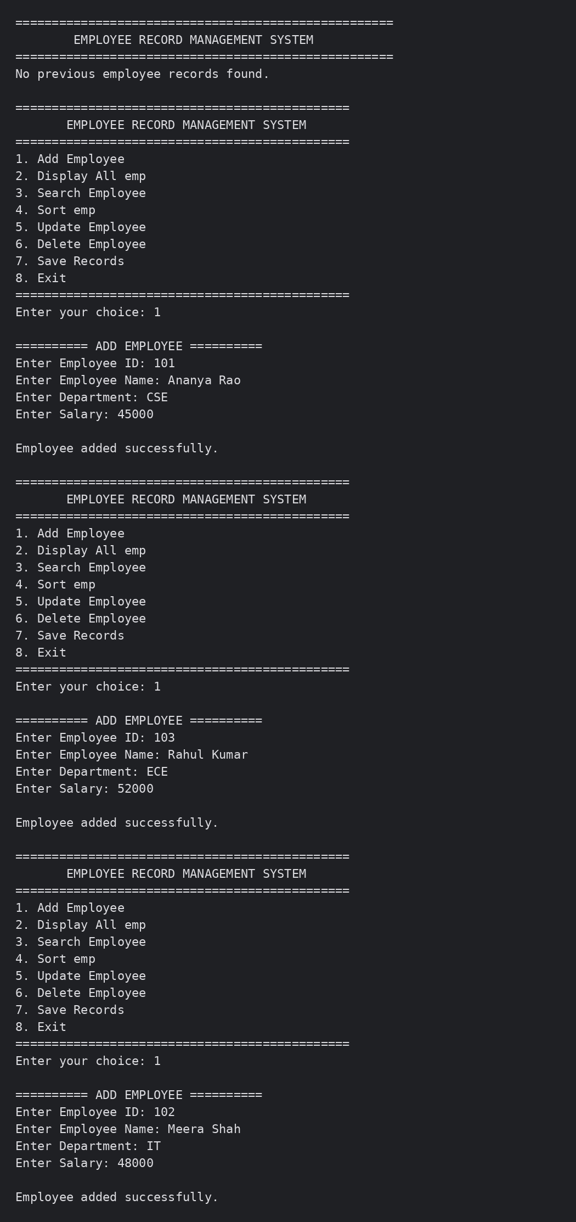
Figure 12.1: Program start (no previous records) and adding three employees (Option 1)
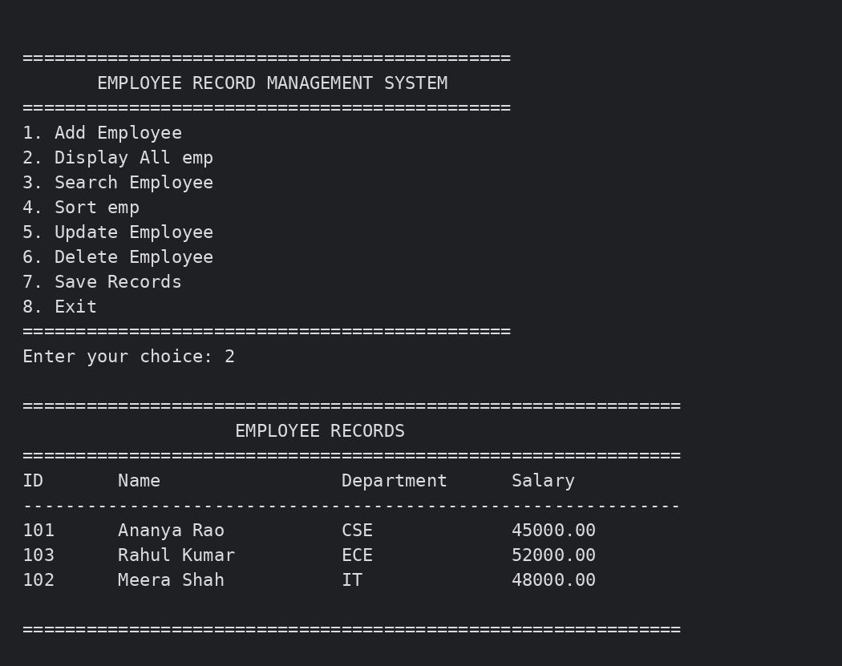
Figure 12.2: Displaying all employees in the order in which they were added (Option 2)
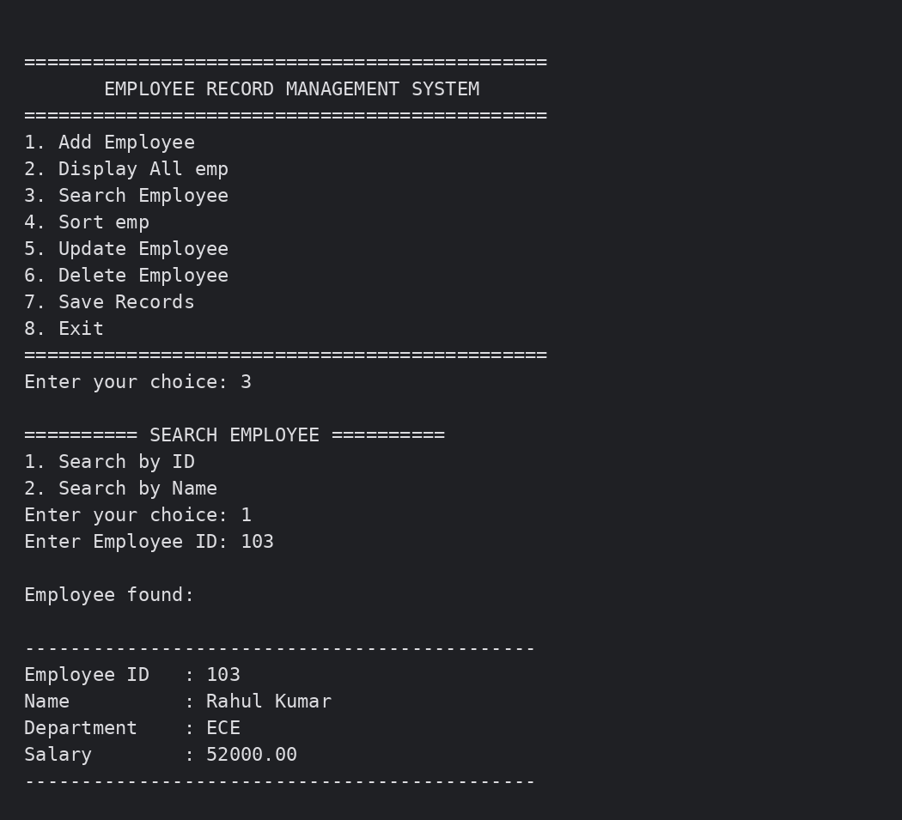
Figure 12.3: Searching for an employee by ID (Option 3)
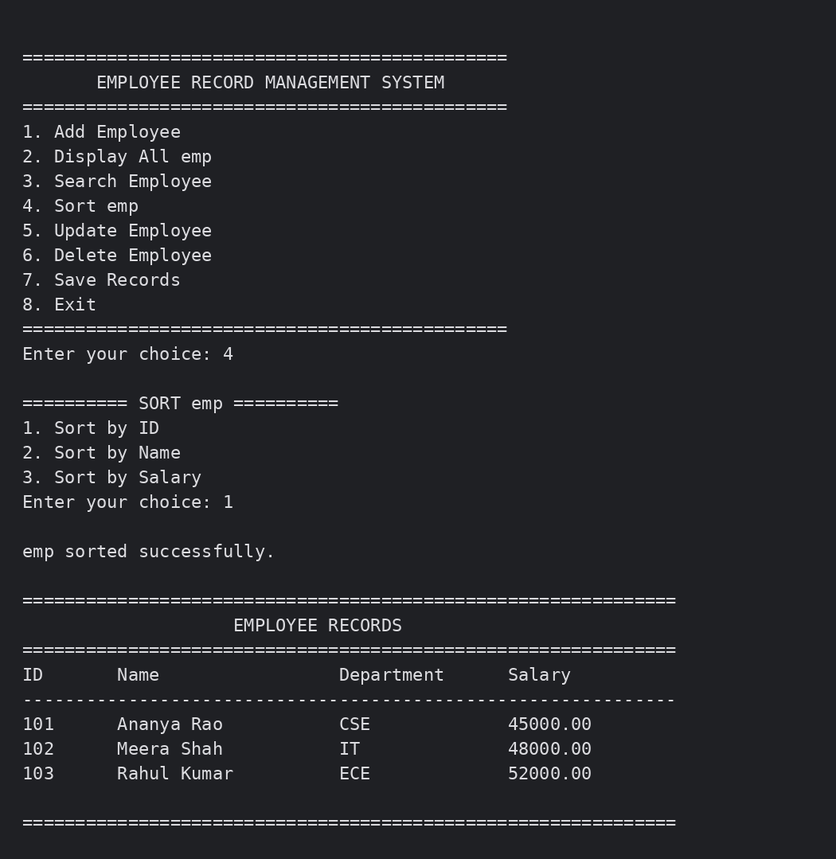
Figure 12.4: Sorting the records by ID using Bubble Sort (Option 4)
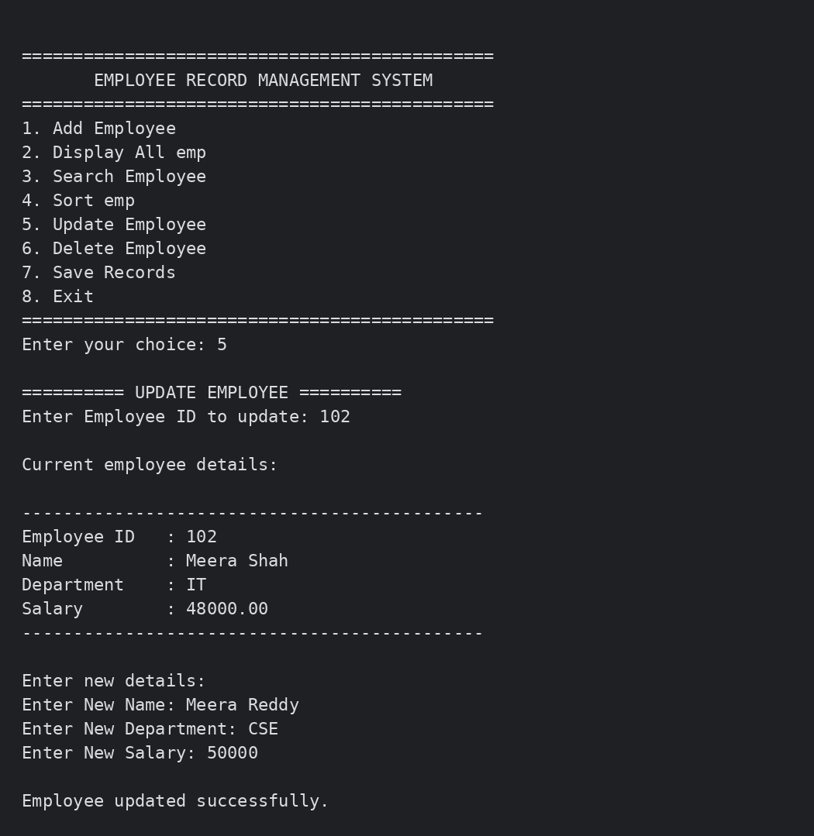
Figure 12.5: Updating the details of employee 102 (Option 5)
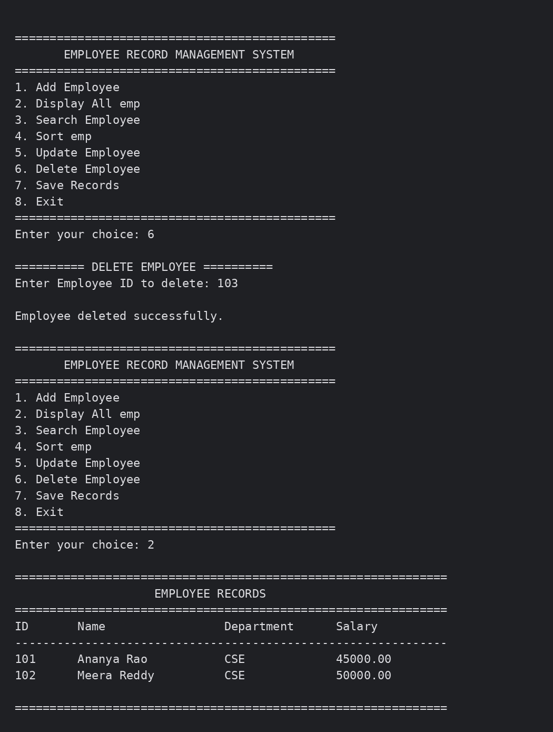
Figure 12.6: Deleting employee 103 (Option 6) and displaying the remaining records (Option 2)
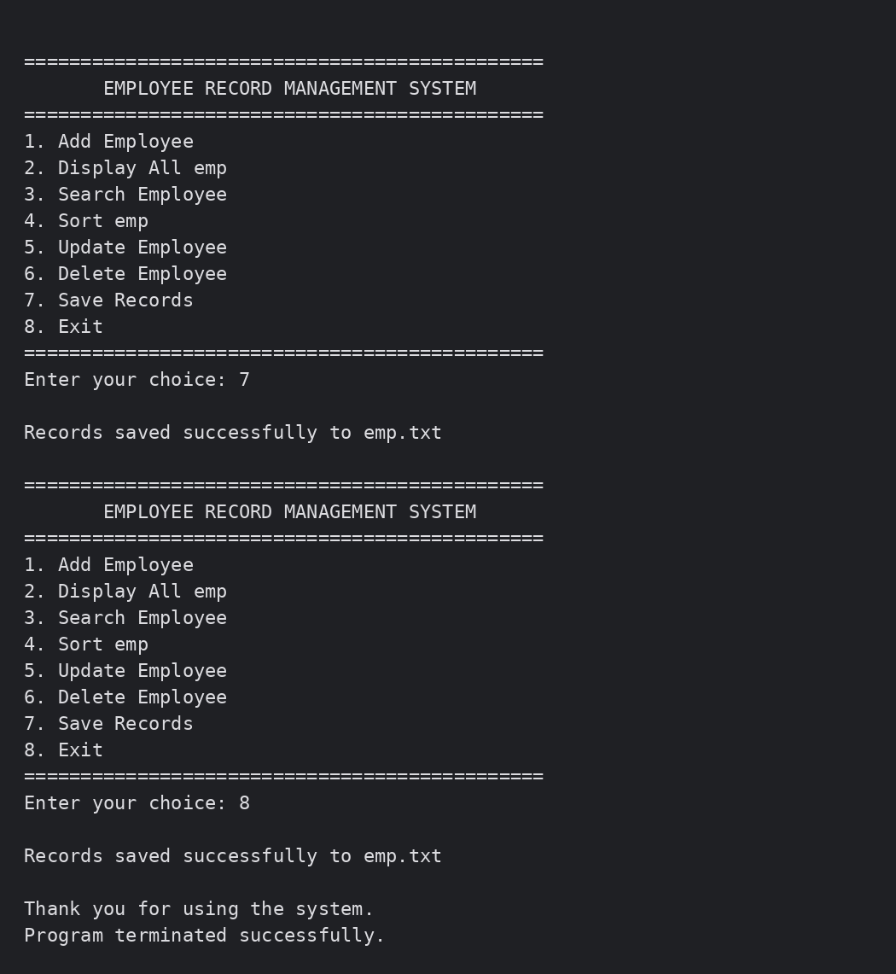
Figure 12.7: Saving the records (Option 7) and exiting the program (Option 8)

13. RESULTS AND ANALYSIS
The Employee Record Sorting and Searching System was successfully implemented in C using structures, arrays, Linear Search, Bubble Sort and file handling. The employee details are stored as records in an array, and all operations are available through a simple menu.
The system successfully performs the following operations:
- Adds employee records with ID, name, department and salary, and rejects duplicate IDs.
- Displays all employee records in a formatted table.
- Searches for an employee by ID or by name using Linear Search.
- Sorts the records by ID, name or salary using Bubble Sort.
- Updates the name, department and salary of an employee, and deletes an employee by ID.
- Saves the records to emp.txt and loads them again when the program starts.
- Shows an error message when the input or the menu choice is invalid, or when an ID is not found.
Result
In the sample run, the employees 101 (Ananya Rao, CSE, 45000), 103 (Rahul Kumar, ECE, 52000) and 102 (Meera Shah, IT, 48000) were added in this order, so the first display showed them in the order 101, 103, 102. A search for ID 103 displayed Rahul Kumar, and sorting by ID rearranged the records into the order 101, 102, 103. The employee 102 was then updated to Meera Reddy, CSE, 50000.00, and the employee 103 was deleted, leaving two records (101 and 102). Saving and exiting wrote these two records to emp.txt.
Verified Test Cases
No. | Menu option and input | Output
1 | Program start with no emp.txt | No previous employee records found.
2 | 1: Add 101, Ananya Rao, CSE, 45000 | Employee added successfully.
3 | 1: Add 103, Rahul Kumar, ECE, 52000 | Employee added successfully.
4 | 1: Add 102, Meera Shah, IT, 48000 | Employee added successfully.
5 | 2: Display all employees | Table with 101, 103, 102 in the order of entry.
6 | 3: Search by ID 103 | Employee found: Rahul Kumar, ECE, 52000.00
7 | 4: Sort by ID | emp sorted successfully.; table in the order 101, 102, 103.
8 | 5: Update ID 102 to Meera Reddy, CSE, 50000 | Employee updated successfully.
9 | 6: Delete ID 103 | Employee deleted successfully.
10 | 2: Display all employees | Only 101 Ananya Rao and 102 Meera Reddy (CSE, 50000.00) remain.
11 | 7: Save Records | Records saved successfully to emp.txt
12 | 8: Exit | Records saved; Thank you for using the system. Program terminated successfully.

Analysis
The results show that simple algorithms are effective for managing a small collection of records. Linear Search finds a record in at most n comparisons and needs no sorted data, which suits an array that changes often. Bubble Sort needs O(n²) time, but for at most 100 employees the sorting is instantaneous, and its simplicity makes it easy to understand and verify. Because whole records are swapped, the details of each employee remain consistent after sorting. The file emp.txt allows the data to survive between runs of the program.

14. APPLICATIONS
The Employee Record Sorting and Searching System can be used in various situations where a list of records has to be maintained.

14.1 Small Office and Department Records
A small office or a college department can use it to keep the ID, name, department and salary of its staff.

14.2 Quick Lookup of Employees
An employee’s details can be found quickly by ID or by name, without reading through a long list.

14.3 Ordered Lists for Reports
Sorting by ID, name or salary gives lists that can be used for attendance sheets, alphabetical lists or salary comparisons.

14.4 Maintaining Up-to-date Information
Update and delete operations keep the records correct when an employee changes department or salary, or leaves the organisation.

14.5 Educational Purpose
The project demonstrates structures, arrays, Linear Search, Bubble Sort and file handling in C, and can be used to teach and practise these topics in a Data Structures and Algorithms course.
Overall, the system shows how basic data structures and algorithms can be combined to solve a real record-management problem.

15. ADVANTAGES
- Simple Operation – a numbered menu makes the system easy to use.
- Complete Record Management – records can be added, displayed, searched, sorted, updated and deleted.
- Flexible Searching – employees can be found by ID or by name.
- Flexible Sorting – records can be sorted by ID, name or salary, and whole records are moved together.
- Persistent Data – records are saved to emp.txt and loaded automatically when the program starts.
- Input Validation – invalid numbers, empty or over-long text and duplicate IDs are rejected.
- Easy to Understand – only basic C features (structures, arrays, loops, functions and files) are used.
- Modular Design – each task is a separate function, which makes the program easy to read and extend.

16. LIMITATIONS
- Fixed Capacity – at most 100 employees can be stored (MAX = 100).
- Linear Search Is Slow for Large Data – the time grows in proportion to the number of records.
- Bubble Sort Is Slow for Large Data – it needs O(n²) time and always performs all passes.
- Exact Name Matching – a search by name is case-sensitive and the whole name must be typed.
- Limited Field Lengths – names are limited to 20 characters and departments to 15 characters.
- No Range Checks – negative or zero IDs and salaries are accepted.
- Text File Storage Only – the data is kept in a plain text file whose column layout must not be changed by hand; there is no database, password or backup.
- Console Interface – the system has no graphical interface.
- Single User – only one user works with the records at a time.

17. CONCLUSION
The Employee Record Sorting and Searching System successfully demonstrates how structures, arrays, algorithms and file handling can be combined to build a complete record-management application in C. Each employee is stored as a structure with an ID, name, department and salary, and up to 100 such structures are kept in an array. The system uses Linear Search to find employees by ID or by name and Bubble Sort to arrange the records by ID, name or salary. The menu-driven interface also supports adding, displaying, updating and deleting records, and the records are saved to and loaded from the file emp.txt.
The sample outputs show that all operations work as expected, and the project helps in understanding important concepts such as structures, arrays, searching, sorting, file handling and time complexity (O(n) for Linear Search and O(n²) for Bubble Sort).
Although the current system has limitations such as a fixed capacity, simple search and sort algorithms, exact-match name search, limited input range checks and a text-only interface, it provides a strong basic model for managing employee records. In the future, the system can be enhanced by using dynamic memory or linked lists to remove the size limit, faster algorithms such as Binary Search (on sorted data), Merge Sort or Quick Sort, partial and case-insensitive name search, a database for storage, and a graphical user interface.

