Project Plan

“The Bird Game”

Sam & Kazuru

Table of Contents
1. Introduction 3
1.1 Foreword 3
1.2 Background 3
2. Project Organization 3
2.1 Development Model 3
2.2 Project Team 4
3. Risk Analysis 5
4. Hardware and Software Requirements 5
5. Schedule and Breakdown Structure 6

1. Introduction
1.1 Foreword

The purpose of this document is to provide information about the Bird Game project. It will include the information, risks, project team, and the visual aspect of the program. This plan will:

• Provide a general product description.
• Identify required resources.
• Identify schedules and activities to be performed.

1.2 Background

The goal is to make a game using the raphael.js library. The game will begin with a start screen that will have options to view other pages such as directions, sound, and start; pressing start will begin the game loop. The game will be viewed from a side angle, with the player being at a probably fixed x position (it might move slightly at times but probably not.) The player will be “gliding” and will have a constant downward force applied to him/her. By hitting a button, an upward force will be applied to the player which will overcome the downward force, and will allow the player to attempt to maintain level flight. The force application will take some adjusting because the upward force will probably have to be removed slowly/incrementally so that the player doesn’t drop too suddenly.

Aside from flying, the player will try to dodge oncoming obstacles that will be instantiated on the right side of the screen. The objects will move left at a random speed between two fixed speeds (so that they don’t move too quickly) and will be instantiated at random y positions. The player will have to attempt to dodge these oncoming obstacles in order to stay aloft; the obstacles will be changing their x position rather than the player, which will create the illusion of player-movement. The objective will be to stay gliding as long as possible, which will cause your score to go up. If the player flies to high or low, they will also lose. After dying, the player will be returned to the start screen where they can choose to play again.

2. Project Organization

2.1 Development Model

2.2 Project Team
The table below lists the members of the XXX project team. The project Team consists of xxx

Project Team
Samuel Pesce
Kazuru Takase

3. Risk/Problem Analysis

Possible problems:

- Getting the gravity and physics to work properly
- Creating a scrolling background to create the illusion of movement

To solve both of these issues, we will have to research the standard way of implementing both of design concepts. We will first attempt to solve both on our own, but in the event that we cannot we will look at other projects (probably open source examples) with a similar effect. Physics is a big topic in game design so it probably won’t be too difficult to research it. An infinite background has been implemented before and we already have an idea of how to accomplish it.

4. Hardware and Software Requirements

We will be using the Raphael.js library, along with backbone.js for structuring. We might incorporate photoshop or another visual editor to increase game appearance.

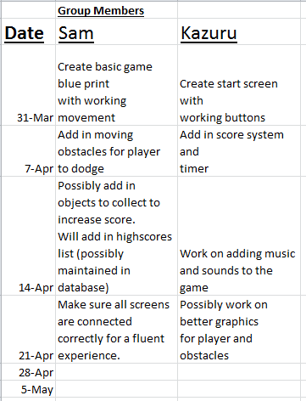
5. Schedule and Work Breakdown Structure

