Sam Plank CS 105

Investigating the Privacy of Venmo

**Abstract**

The Venmo public feed creates a serious privacy concern for a diverse set of users. Using simple web-scraping and data analysis tools, this project demonstrated that the Venmo public feed is easily stored and interpreted. The full names of individuals using Venmo for both seemingly illicit, and legitimate, but sensitive, transactions were found in the public feed. For users who wish their Venmo transactions to be private, it is recommended that simple settings be updated. Furthermore, it is concluded that the default public setting be changed to a default private setting.

**Background**

Venmo was founded in 2009 as a platform for people to easily pay one another. It allows users to link their credit cards to their Venmo account so that they can transact money through the ease of a mobile application. Venmo has grown rapidly since its launch in 2009 and was acquired by Braintree in 2012 and then by PayPal in 2013 (Venmo). In the first quarter of 2016 alone, $3.2 billion was transferred over Venmo, representing 154 percent growth over the same quarter in 2015 (Del Rey). The application allows users to link their Facebook accounts both for verification and to integrate a social network component. Information about transactions is then shared publically over the users’ networks unless the transaction is specified as private.

The public nature of Venmo transactions raises questions about its integrity as a platform for something as sensitive as transacting money. Though specific dollar amounts are not shared, metadata containing the name of the person who is paying, the name of the recipient, and a description of the transaction is shared publically. Though some users may want to publically broadcast their transactions, others may be uncomfortable with a public record of their Venmo transactions being permanently available on the platform. This would be especially true if the records could link them to activity deemed questionable by society or the law. To probe the privacy of Venmo and to determine the extent to which sensitive information is being shared over the platform, Venmo’s public feed was scraped and analyzed. These findings were tentatively interpreted to show that Venmo is likely being used for the transaction of illegal drugs, for sales falsification, and as a payment platform for legitimate business and activities.

**Methodology**

The public Venmo feed can be accessed by anyone with an account. The feed provides the full names of both users, the time of their transaction, and a description that has been provided by one of the users. The person who both initiated the transaction and who wrote the description is identified by either the word “paid” or “charged.” Additionally, a link to the users profile is provided, where one can view the profiles of all of the user’s Facebook friends who are on Venmo (if the user has linked through Facebook).

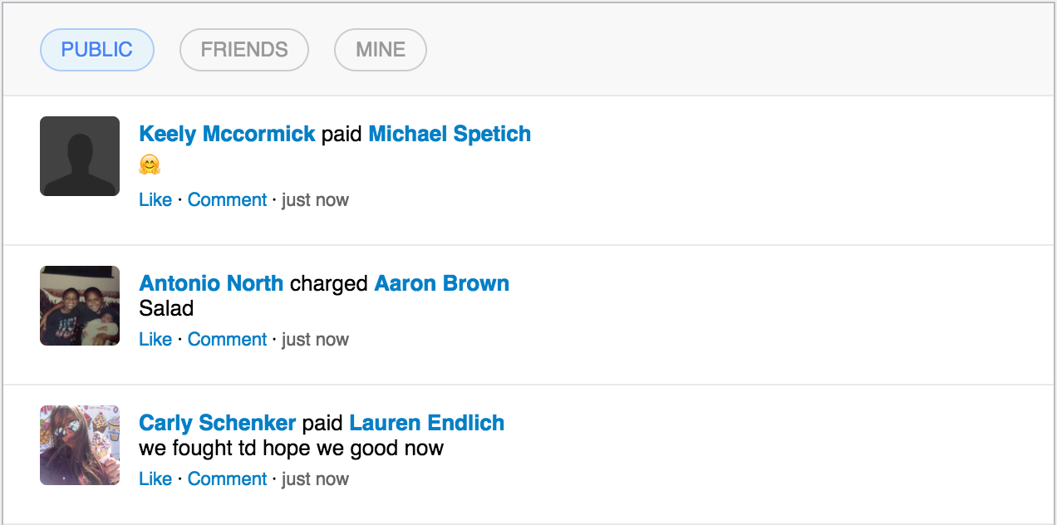

*Entries from the Venmo public feed.*

Data from the public feed was scraped using Selenium, a browser automation tool, and Beautiful Soup, an HTML parser. This process took place over the course of two weeks but was not continuous due to frequent crashes of the scraper. After processing, the data was written into a csv file. Roughly 1,000,000 unique transactions were collected and were analyzed using Python Pandas. From there, various strategies were used to look for transaction patterns that imply illegal or questionable behavior.

**Drug Transactions**

The first avenue of exploration was for Venmo users who appeared to be selling marijuana. There is anecdotal evidence for drug dealing on Venmo (Skelding), but there have been no studies of its extent. To begin searching for marijuana-related transactions in the data, a list of words and emojis relating to the substance was compiled. Though this task was not an exact science, internet resources were particularly useful in compiling the list (10 Marijuana Emojis). The results of the data were then filtered to identify users who had received at least 7 payments and who had made a transaction that contained one of the marijuana-related words or emojis.

Each identified user was further analyzed to determine what additional data could be collected. Due to the fact that the user’s transactions were first found through the public feed, in every case, the user’s personal Venmo could be accessed. This yielded all of the user’s public transaction history since they first created an account. Contextualizing the few transactions that were scraped by looking back at a user’s full history helped determine who looked likely to be using Venmo for drug transactions and who was unlikely to be doing so. Because Venmo provides the full name of a user, other social media profiles could be linked to identified accounts. For certain users, this was done successfully for both Facebook and LinkedIn (Appendix I). It should be noted that this process was highly subjective, as there was no way to prove who was actually in the business of selling marijuana. The reader may draw conclusions for themselves based on the provided patterns in the data.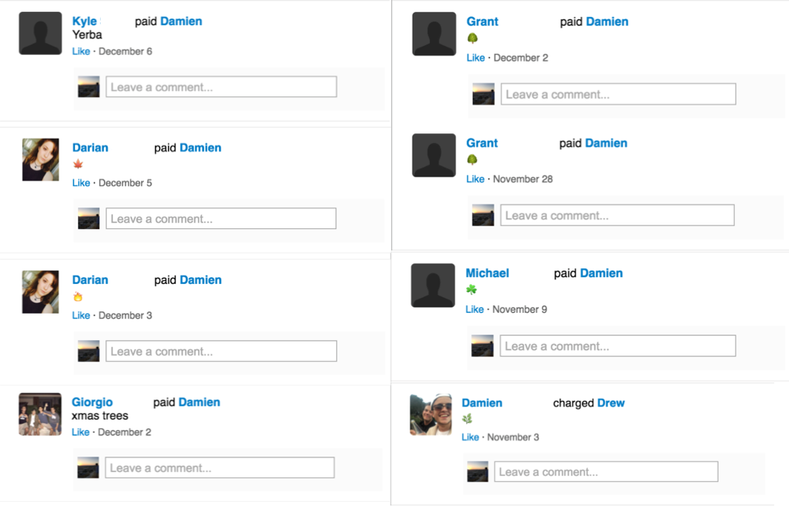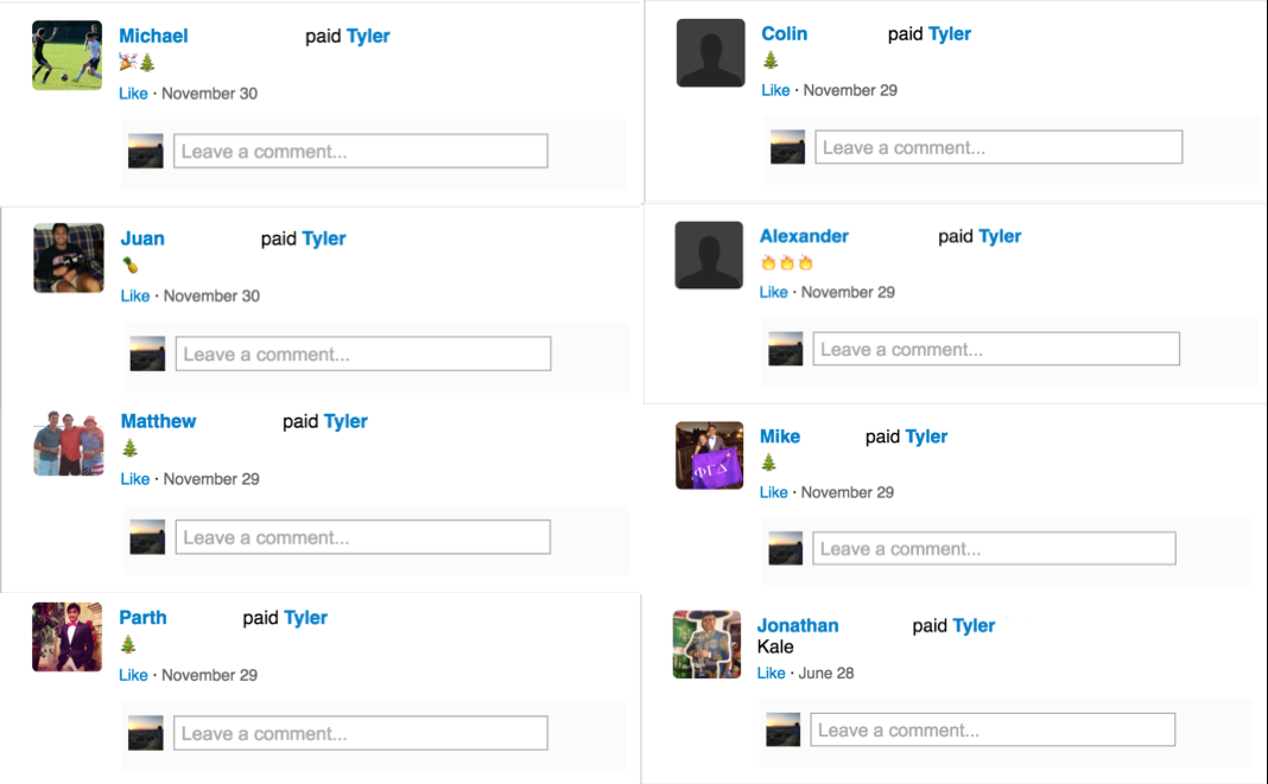*Transaction patterns that appear to be related to marijuana.*

**Greek Life**

Other patterns were looked for in the Venmo data of users who were involved in a high number of transactions. The accounts associated with the highest number of transactions were largely members of Greek life organizations who were hosting events. Many of these events were apparently charity fundraisers. Others appeared to be social mixers.

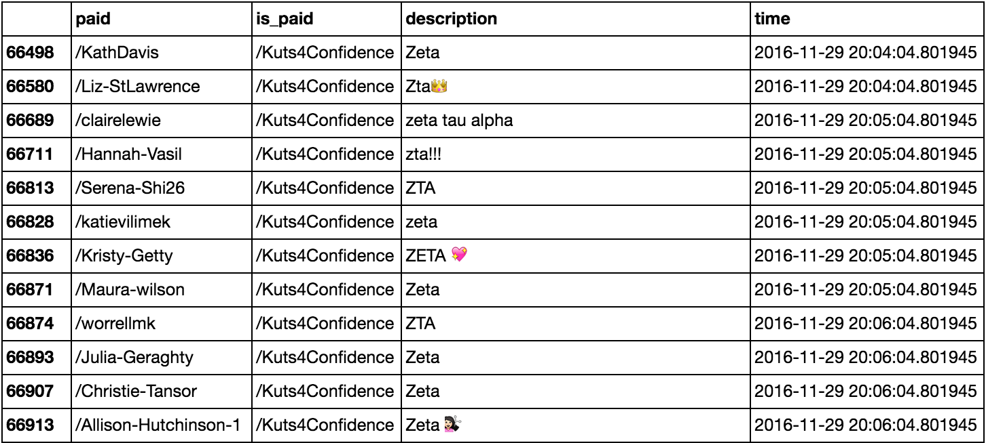*A fundraiser event for a sorority.*

Whatever the use case, the high activity of Greek life organizations on Venmo poses privacy concerns for these organizations. By creating a ledger of all transactions for group events, Venmo essentially generates a membership roster. Though “ZTA” could be a chapter of the national sorority at any university, it is not incredible difficult to pinpoint the specific chapter using the identifies of the members. The ZTA shown above was identified as the chapter of Saint Louis University (see Appendix II).

Perhaps sororities and fraternities do not place priority on membership privacy, and it is acceptable to them to have a public roster. This may be true for some groups at some universities, but it is certainly not true everywhere. Here at Harvard alone, there has been tremendous tension between single-gender groups and the university administration (Fahs). It is likely that members of social groups who are under criticism from their administration would not want their names made publically available.

**Sales Falsification**

Outside of the high numbers of sororities and fraternities amongst the top transactors on Venmo, some other interesting cases were uncovered. One user appeared to be generating false revenue and sales for Chinese companies on the online marketplace Taobao (Appendix III). Taobao was founded by in 2003 and is run by the Alibaba group. It is China’s largest mobile commerce platform and is comparable to Amazon (“Our Businesses”). The user in question was sending multiple payments per day to other users for consumer goods like iPhone screens and pens. The phrase “刷单” occurs in most of the payment descriptions, and is frequently associated with the practice of “brushing,” or faking sales, on Taobao (Chu and Burkitt).

Though some translation difficulties were encountered when examining this activity, privacy concerns were still apparent. Brushing is not allowed on Taobao, and it is a practice that Alibaba works actively to stop. Thus, being linked to the practice of selling fake goods could have serious consequences for an ecommerce business. The motivation behind using Venmo for the practice is not entirely clear, but it should noted that the mobile payment ecosystem in China is far different than it is in the United States. Alibaba’s Alipay app dominates almost half of the Chinese mobile payment market (Back). It is a significant possibility that Taobao “brushers” use Venmo to circumvent Alibaba’s payment platform.

**Legitimate Businesses**

A number of seemingly legal businesses were also found to be using Venmo to conduct transactions. Tea-Press, a Berkeley-based cafe, accepted frequent payments on Venmo for food and drinks. A user named Gaogao Li appeared to also be selling food, although it is unclear where she is located and if she is tied to a specific business. Though it may make it easier for taxing authorities to keep track of a business’ sales, there is no immediately obvious privacy concern in these transactions. It is seemingly unlikely that users who pay for tea with Venmo would worry that their payment is public.

Other businesses who use Venmo may raise more serious privacy concerns. Both SeatGeek and SurveyDollars make payments via Venmo. SeatGeek is an online marketplace for event tickets ("What's SeatGeek?"). It aggregates tickets from other ticket sites, and allows individual users to sell tickets. While tickets provided by another site are labeled with the name of that site, tickets provided by an individual user are just labeled “SeatGeek.” The whole transaction process from individual seller to buyer is mediated by SeatGeek, and the users never come in contact or know anything about each other.

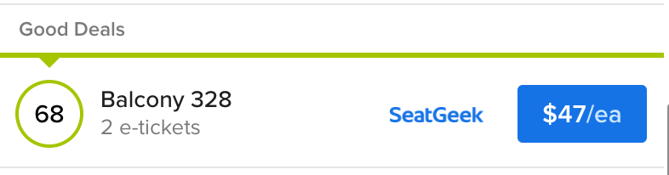

*A generic “SeatGeek” listing*

Venmo, however, upends the anonymous transaction process for SeatGeek sellers because payouts are documented on the public Venmo feed. Someone who buys a SeatGeek ticket can document when they bought their ticket and then watch SeatGeek’s Venmo payouts to see who is paid shortly thereafter. This is not a perfect process, as SeatGeek can take some time to process payments ("Frequently Asked Questions"), but it allows a buyer to create a narrow list of seller candidates. A disgruntled buyer could decide to take their grievance directly to the perceived seller instead of working through the SeatGeek customer service process.

SurveyDollars uses Venmo payouts in a similar way to SeatGeek. The website directs users towards survey platforms where they can take compensated surveys. As the middleman, SurveyDollars pays users who have completed surveys by Venmo. SurveyDollars itself has no visible privacy policy, but it directs users towards survey platforms that do have privacy policies. The foremost platform that SurveyDollars links to, GlobalTestMarket , has a privacy policy that explicitly states that personal information will only be shared with business partners (“Privacy Policy”). However, when SurveyDollars makes a payout, it shows the name of the person who is being paid, disclosing personal information about participants. The scale of this privacy violation does not seem to be great in magnitude, but it is nevertheless a concern for those who would rather it not be made public that they take online surveys for income.

**Remediation**

Fortunately for those who would like their Venmo history to remain private, there are steps that can be taken. Although Venmo makes transactions public by default, simple changes in settings can ensure that transactions are private. Venmo even includes the option to retroactively make all past transactions private.

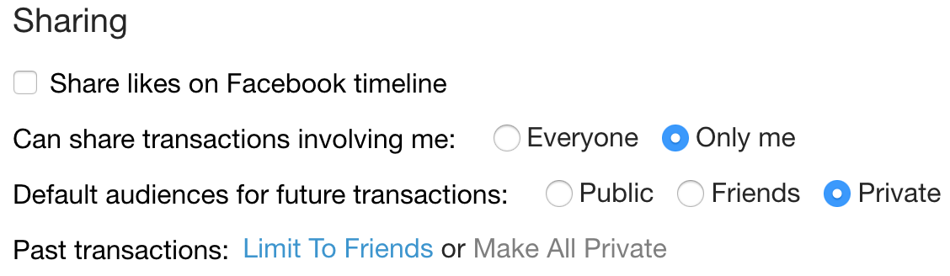

*Under “Privacy” a user may update their Venmo transactions.*

It should be noted that any Venmo transactions picked up by a scraper, such as the one built in this project, will not be retroactively removed from whatever database they have been stored to. As is (hopefully) common knowledge, it is near impossible to completely remove content from the internet.

**Conclusion**

The Venmo public feed presents a privacy problem by broadcasting every transaction that has not been made private. Users who are engaged in activity that is sensitive in some nature likely do not want this information to be publicized and very well may not be aware that it is so accessible. This paper has demonstrated concrete cases where seemingly illegal activity such as drug dealing and the falsification of sales are public. It has also shown that legitimate business activity on Venmo also can compromise privacy by disclosing the names of individuals who are engaged in supposedly private transactions.

Easy steps are provided for an individual to restrict public access to their Venmo transactions. Beyond just outlining these available setting updates however, the findings in this paper imply that perhaps a public Venmo feed is too costly a privacy concern and that the default setting for a user’s transactions should be more limited than they currently are. Though this may change the way that Venmo presents itself as a social platform, it would be a boon to the privacy of the sensitive transaction information generated on Venmo. A default private setting would ensure that users are easily able to transact in private. Those who wish to make Venmo a social experience would be able to opt-in to doing so. Such a change would greatly diminish the privacy concerns associated with the Venmo public feed and would make Venmo a much more protected place for financial transactions.

**Appendix**

I.

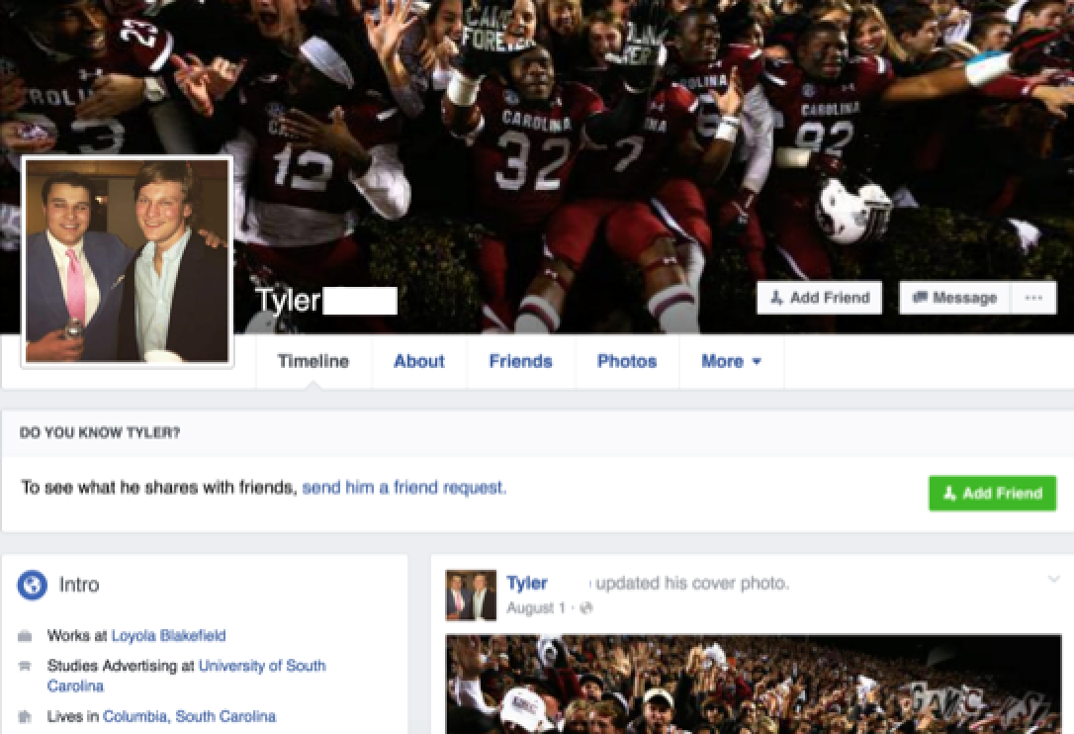

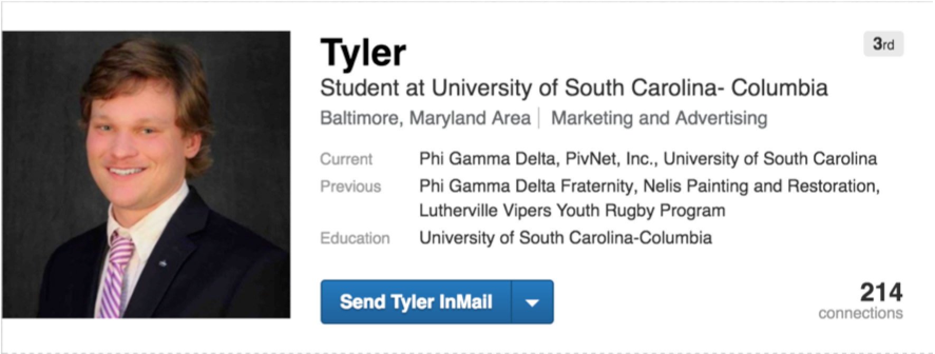

II.

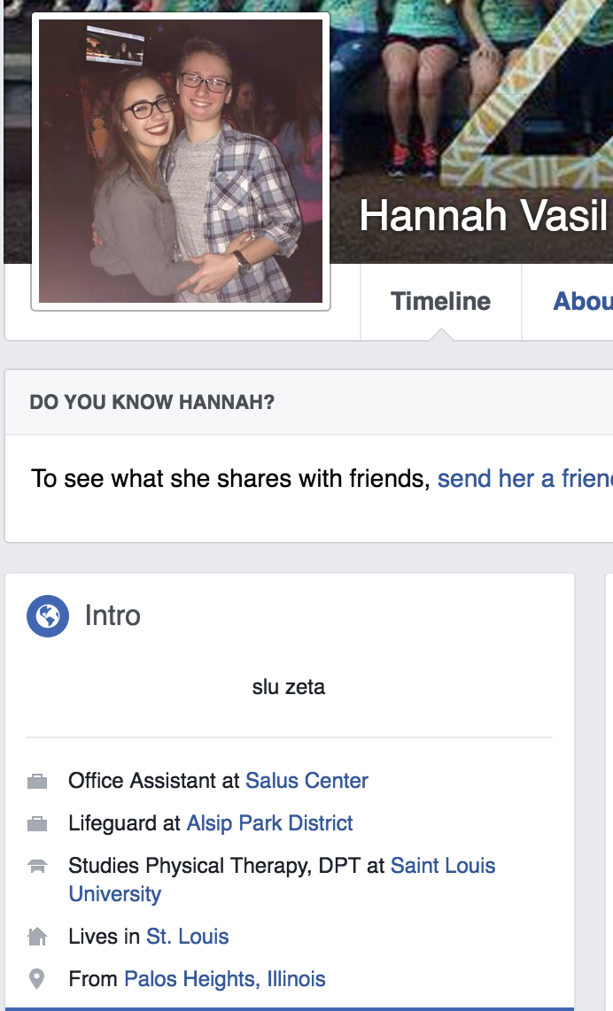

III.

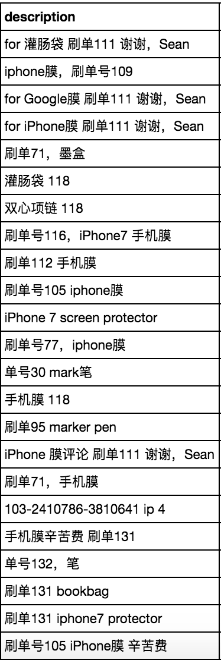

**Works Cited**

"10 Marijuana Emojis For Stealth Weed Texts - Mary Jane's Diary." Mary Janes Diary. N.p., 2015. Web. 30 Oct. 2016.

Back, Aaron. "For Apple and Venmo, China Shows What Lies Ahead." The Wall Street Journal. Dow Jones & Company, 26 Nov. 2015. Web. 13 Dec. 2016.

Chu, Kathy, and Laurie Burkitt. "Chinese Broadcaster Raps Fake Sales on Alibaba That Pump Up Shop Rankings." The Wall Street Journal. Dow Jones & Company, 16 Mar. 2016. Web. 13 Dec. 2016.

Del Rey, Jason. "Venmo Is Growing Ridiculously Fast." Recode. N.p., 27 Apr. 2016. Web. 30 Oct. 2016.

Fahs, C. Ramsey. "In Historic Move, Harvard to Penalize Final Clubs, Greek Organizations | News | The Harvard Crimson." The Harvard Crimson. N.p., 06 May 2016. Web. 13 Dec. 2016.

"Frequently Asked Questions." SeatGeek. N.p., n.d. Web. 13 Dec. 2016.

"Our Businesses." Alibaba Group. N.p., n.d. Web. 13 Dec. 2016.

“Privacy Policy.” GlobalTestMarket. N.p., n.d. Web. 13 Dec. 2016.

Skelding, Conor. "Students Fret over Venmo Payments to Alleged Drug Dealer." Politico PRO. N.p., 3 Apr. 2015. Web. 30 Oct. 2016.

"Venmo." Crunchbase. Web. 30 Oct. 2016.

"What's SeatGeek?" SeatGeek. N.p., n.d. Web. 13 Dec. 2016.