**Optimal Linac Jaw Calibration Procedure**

**Purpose:** To optimize TrueBeam jaw calibration points to minimize both:

1. Individual jaw positional errors.
2. Jaw-matching errors at clinically important junctions (4-field breast + Supraclavicular/axillary nodes)

**About:** There are three parts to this jaw calibration procedure:

1. Data Collection.
   1. Collect MV images needed to characterize the current behaviour of linac jaws and correlate jaw positions with jaw encoder values.
2. Optimization & Calibration.
   1. Run *JawCal* optimization script to determine optimal jaw calibration positions and perform the calibration.
3. Verification.
   1. Recollect MV images needed to characterize the post-calibration behaviour of linac jaws and perform necessary QA.

­­­

**Procedure – Part 1: Data Collection**

All measurements will define jaw positions relative to the mechanical isocentre in terms of MV image pixel displacements, and in the end, precise calibration positions will also be defined by their projection onto EPID pixels. Since it isn’t feasible for someone to iteratively adjust a jaws position until it projects onto a given EPID pixel, we need to correlate jaw projections onto the EPID with something we can determine more easily. This is accomplished by correlating jaw pixel projections with jaw encoder values (Method of Corns and Zhao, 20181).

The first step is to correlate jaw positions (defined by their projection onto MV image pixels) with their encoder values (accessible in service mode).

1. Start by protracting the EPID panel to a position of about 8.6. Place the 5x5 cm isocentre cube on top, and adjust the height of the panel as necessary to align the lateral sides of the cube with the room’s lasers (Fig 1). Align the anterior face of the cube with the light field crosshair.

*Note: Since there will be no gantry rotations for this step, it is sufficient to align the cube vertically using the room lasers.*

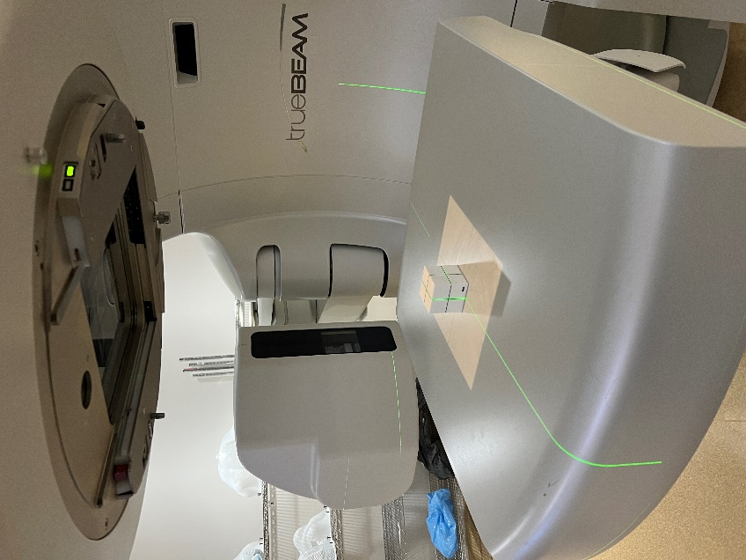

*Figure 1. When correlating jaw positional encoder values with their projection onto EPID pixels, one image marking the isocentre is required. For this we use a 5x5 cm isocentre cube.*

1. Take note of the final EPID panel position. This will be needed to scale distances properly and will later be input to the optimization script.
2. Open the jaw encoder spreadsheet template (U#_encoders_mmdd.csv) from https://github.com/samplecm/JawCal---Optimize-TrueBeam-Jaw-Calibrations/tree/main/encoder_spreadsheets.
3. Open Service Mode (Advanced) on the Unit. To fill out the spreadsheet, navigate to Utilities->Encoder Display to view the jaw encoder values (see photo). Being careful to avoid collisions when moving jaws to closed or negative positions, move each jaw to each position defined in the first column of the spreadsheet and record the encoder value in the respective cell. Save the spreadsheet according to the format: “U#_encoders_mmdd” (replace # with the unit number, mmdd with correct date).

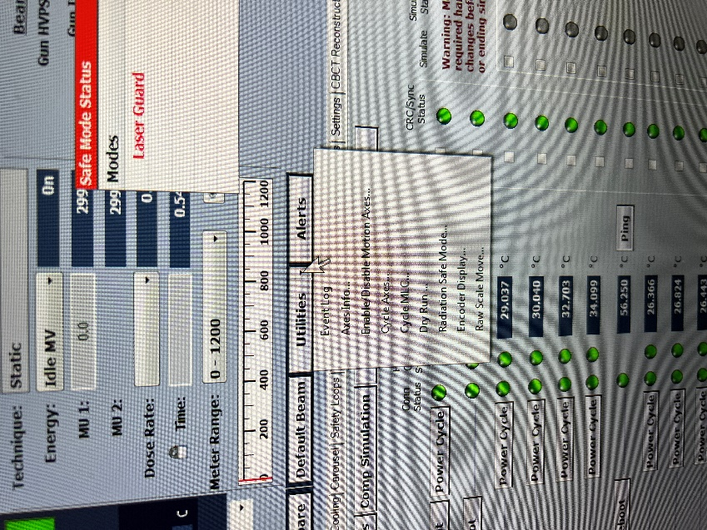

1. Acquire an MV image with each jaw at each position defined in the first column of the spreadsheet. To make sure jaw pixel positions are normalized without bias, this must be done individually for each jaw, with the 3 other jaws being set to a position of 12 cm.
2. *For example, 14 jaw positions x 4 jaws = 56 total images. Each jaw will remain at 12 cm for 42/56 images.*
3. Once finished, export the images into a folder following the naming format: “U#_encoders_MMDD.”
4. The next step is to acquire 6X LRFC images with the Standard Imaging FC-2 phantom. This is needed to ensure that the LRFC remains within tolerance following calibration. Follow the regular monthly QA procedure to acquire the 10x10 and 15x15 field images at 6X and save them as DICOM files in a folder following the name convention: “U#_lrfc_pre_mmdd.”

*Note that technically we can only really control the crosshair/radiation field alignment here, and technically this could be done without the Standard Imaging FC-2 phantom, however, it is useful to measure using the plates so that we can measure changes in all final LRFC parameters before/after calibration using the standard QA method.*

1. The next step is to acquire the closed jaw MV images used for characterizing the jaw positions. First, you must set up the 5x5 isocentre cube at the mechanical isocentre. To avoid slippage of the cube when moving the couch longitudinally, align the isocentre cube on a high friction surface such as bolus, and/or tape the cube to the couch. With the gantry at 0 and 90 degrees, use the light field crosshair to align the cube.

*Important: Record the couch VERT, LONG and LAT position (make sure pitch and roll are zero).*

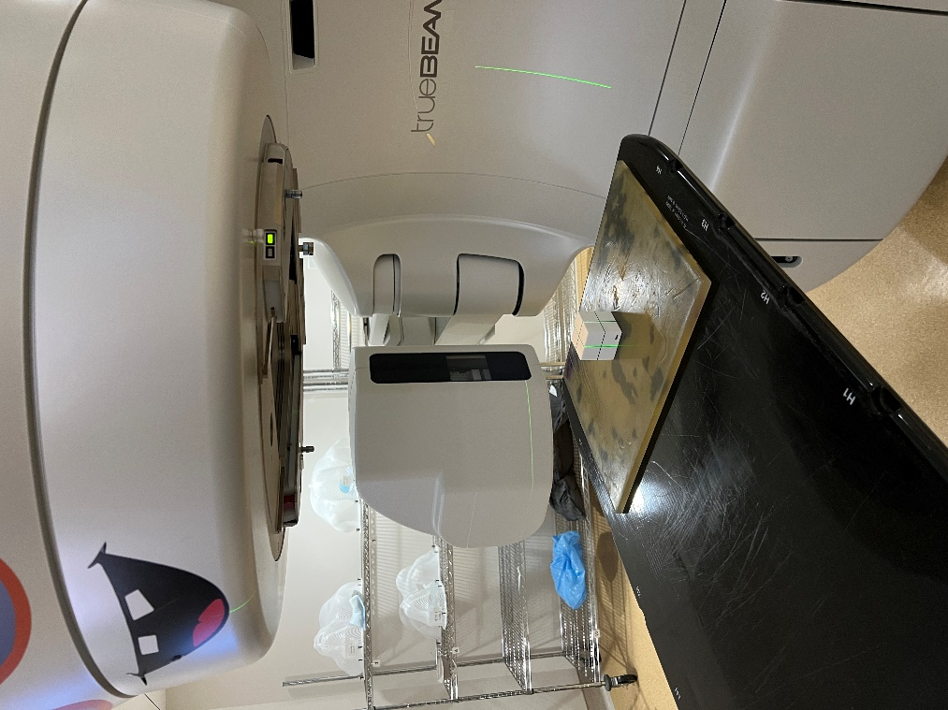

1. It is up to you which gantry/collimators you want to assess the jaw positions at. The average jaw positional error over all angles will ultimately be minimized. Any time you take an image of a closed jaw, ensure that all other jaws are set to a position of 10 cm.

*Important: For each gantry angle that images are acquired at, you must take an image of the isocentre cube aligned at the mechanical isocentre. All images of closed jaws should have the couch retracted from the image field (eg. couch LONG=20). The best way to do this is to start by taking a cube image at all gantry angles to be used, and then retract the couch and start acquiring your closed jaw images.*

* The recommended protocol is to acquire images at:

gantry=0,50,130,180,230,310 with collimator at 0, 90 (and 270 if used clinically). (4 Images at each position, one for each closed jaw).

* + Ie. 6 gantry angles x 2 collimator angles x (4 closed jaws+1 isocentre cube) = 60 images.
* The only combinations which are necessary to assess specific junctions are:

gantry=0,50,130,180,230,310 with collimator at 90. (X1 jaw closed for gantry=0,180; X2 jaw closed for other gantry angles).

1. Once all images have been acquired, save them all as DICOM files in a folder following the naming format: U#_pre_mmdd (with the correct unit number and date).
2. The final step is to acquire a quick set of jaw images (5 cm, 10 cm, 15 cm, 20 cm) with the gantry/collimator set to 0 degrees. This will be taken before/after calibration to assess individual jaw positions for QA purposes. Export these as DICOM images into a folder following the naming format: “U#_jaws_pre_mmdd,” with the correct unit number and date.

*Note: An additional isocentre cube image is not necessary. The optimization script will use the isocentre cube image acquired in the previous step for assessing jaw positions.*

­­­

**Procedure – Part 2: Optimization and Calibration.**

1. Clone the github repository: <https://github.com/samplecm/JawCal---Optimize-TrueBeam-Jaw-Calibrations>.
2. Install necessary requirement packages in requirements.txt

(ie. pip install -r requirements.txt)

1. Place all image folders collected into the “Images” folder in the program directory.
2. Execute the “jaw_cal_optimizer.py” script (eg. >> py jaw_cal_optimizer.py). Follow the prompts, entering information such as the treatment unit number, the junction priority (between 0 and 1, higher = more emphasis on jaw matching, recommended value is 0.7).
3. The program will create a folder with the format “U#_Output.” In this folder, there will be a spreadsheet containing all jaw measurements and predicted post-calibration values. If the post calibration values appear favourable, proceed with the calibration.
4. Open the “encoder_plots_cubic.png” file and save it/take a photo of it on your phone. This contains the encoder values to align the jaws to when performing the calibration. Note that in the figure, the values are listed from top to bottom for the X1, X2, Y1 and Y2 jaws. Values are listed for P1, P5, P9 and P19, corresponding to the 1 cm, 5 cm, 9 cm and 19 cm positions. (The 1 cm and 19 cm positions are used for calibration and the 5 cm and 9 cm positions are used for verification of the x/y jaw positions post-calibration.
5. The next step is to perform the calibration using the encoder values saved on your phone. Make sure the linac is set to a gantry angle and collimator angle of 0 degrees.
6. In service mode (advanced), go to the AXIS tab, and then click “System Calibrate,” starting with the X1 jaw. Follow the prompts and use the couch pendant to move the jaw to the 1 cm and then the 19 cm positions for calibration. For each position, align the jaw to the correct encoder value (shown by clicking utilities -> encoder values). This process is tedious, and requires iteratively adjusting the couch pendant wheel until you approach an encoder value (try to match to the nearest 1000th (ie third last digit).

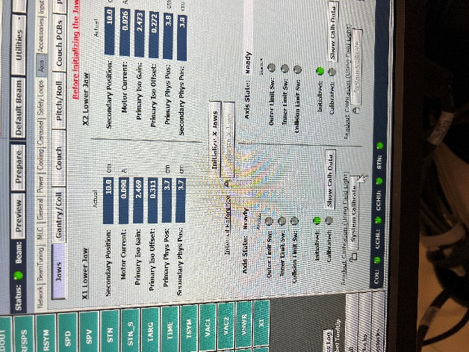

1. After the two points have been calibrated, the calibration window will prompt you to move the jaw to the mid-jaw position (5 cm for x jaws, 9 cm for y jaws). Verify that the encoder value at this position is reasonably close to the value from the script.

*Note: It won’t match perfectly, due to uncertainties inherent to this calibration procedure.*

1. Repeat this process for all jaws, and afterwards, DO NOT SAVE THE CALIBRATION YET. You first must verify that the post-calibration jaws are acceptable.

­­­

**Procedure – Part 3: Verification**

Repeat the data collection and rerun the script to verify that new jaw positions and junction errors are favourable before saving the calibration.

1. To do this, simply acquire the images as described in the “Data Collection” part of the procedure, but altering the image folder names to read “post” rather than “pre” in the name.

*Note: You don’t need the encoder correlation images again. Just acquire the main asymmetric jaw images, LRFC images, and the final 4 symmetric jaw position images for QA purposes.*

1. When these new images are exported as before and placed in the “Images” folder, rerun the optimization script and verify the results in the resultant spreadsheet.
2. If results are appropriate, save the calibration.
3. Perform any necessary additional QA (ie. Jaw alignment with graph paper, LRFC images at other energies, jaw matching QA)

**Bibliography**

1. Corns, R.A. and Zhao, Y. (2019), Calibrating TrueBeam jaws by considering collimator walkout to improve the dose uniformity at abutting field junctions. J Appl Clin Med Phys, 20: 120-126. <https://doi.org/10.1002/acm2.12586>