MILESTONE REPORT WEEK1

1. Environment details

Software Requirements:

OS: linux ubuntu 20.04 (VM or as a main OS on the machine)
Tools: docker, docker-compose, zookeeper, kafka, mongodb, spark,pyspark
Languages: python 3.8, mongo no sql.
Database: MongoDB

Hardware Requirements:

HDD Size: min 50GB
Ram: Min 4GB
Virtualization: HW should support

2. What goes in as an input

Pyspark Data Processor Service: This Service will read the data from the mongoDB using the pyspark mongodb connector. Once loaded data from the mongoDB. We feed this data along with the pre-trained model’s data into the trainer service.

Train Service: Trainer service will get the data from the Processor service as input.

3. How the input is being processed

The Processor service will preprocess the data and divide the data into train and test sets.
Currently we fit the data using the GaussianNB model from the sklearn in the trainer service.

4. What comes out as an output

The test and training data from the processor service is then passed to the training service.

We are writing the model output from the trainer service to a pickle file.

5. Challenges encountered and the way you tackled them

1. Faced issues with spark mongo connector.
2. Integrating training, processor services to the data ingestion service that we have done in the first week.
3. Running the processor utility as a spark worker thread.
4. Finding a pre trained model is a time consuming process. We found some but still struggling to finalize the one to use in our project.
5. pre-process the already trained model to fetch the features that we need for our processing.

Output screens:

FastAPI: (processr and Trainer)

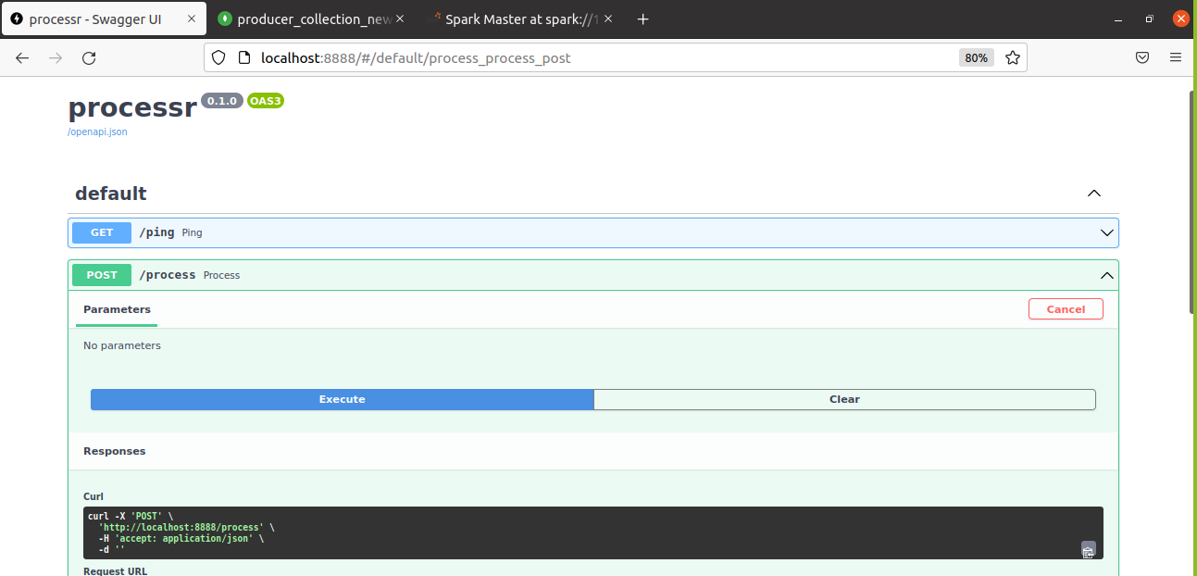

Spark Processor service:

