MILESTONE REPORT WEEK3

1. Environment details

Software Requirements:

OS: linux ubuntu 20.04 (VM or as a main OS on the machine)
Tools: docker, docker-compose, zookeeper, kafka, mongodb, spark,pyspark
Languages: python 3.8, mongo no sql, flask, fastapi
Database: MongoDB

Hardware Requirements:

HDD Size: min 50GB
Ram: Min 4GB
Virtualization: HW should support

2. What goes in as an input

The trained model from the trainer service is loaded into the predictor service. Test data was fed into the model generated to do the predictions on the test data set.
Data from the Data collector service – which is stored into the MongoDB- will be read from the mongo db using the pyspark data connector.

3. How the input is being processed

The collected data is then preprocessed to collect the required features to be fed into the training model. We appled different steps to filter the data like, removing nulls, tokenizing, lowering, removing punctuations, removing stop words etc. The processed data is then converted into vectors of token counts. This data is then transformed to extract the features. The final filtered dataset is then divided into training and testing dataset.

The training dataset is then fitted to the NaiveBayes model. This model is then tested on the test dataset for making test predictions.

4. What comes out as an output

The pyspark model is serialized using the pyspark ml save method.
The accurarcy and the error were captured from the test results.
The saved model is then loaded into the prediction service and is used for predicting the new article category.

5. Challenges encountered and the way you tackled them

1. Faced issues with spark mongo connector. We fixed it by finding the appropriate spark jar files. The org.mongodb.spark:mongo-spark-connector_2.12:3.0.1 fixed the issue for our environment.
2. Integrating training, processor services and the predictor service and passing data among the services. The training service will save the model to a pyspark model file. This has to be properly loaded into the predictor service for the prediction to work appropriately. We faced issues in mapping the local drive as a common folder between the services. Later we were able to resolve it by creating the volumes using the docker command and kept the relavant entry in the docker-compose yml file.

3. Integrating the flask UI to the prediction model.

Output screens:

FastAPI: (Tainer and Predictor)

Fast API testing, giving URL as input:

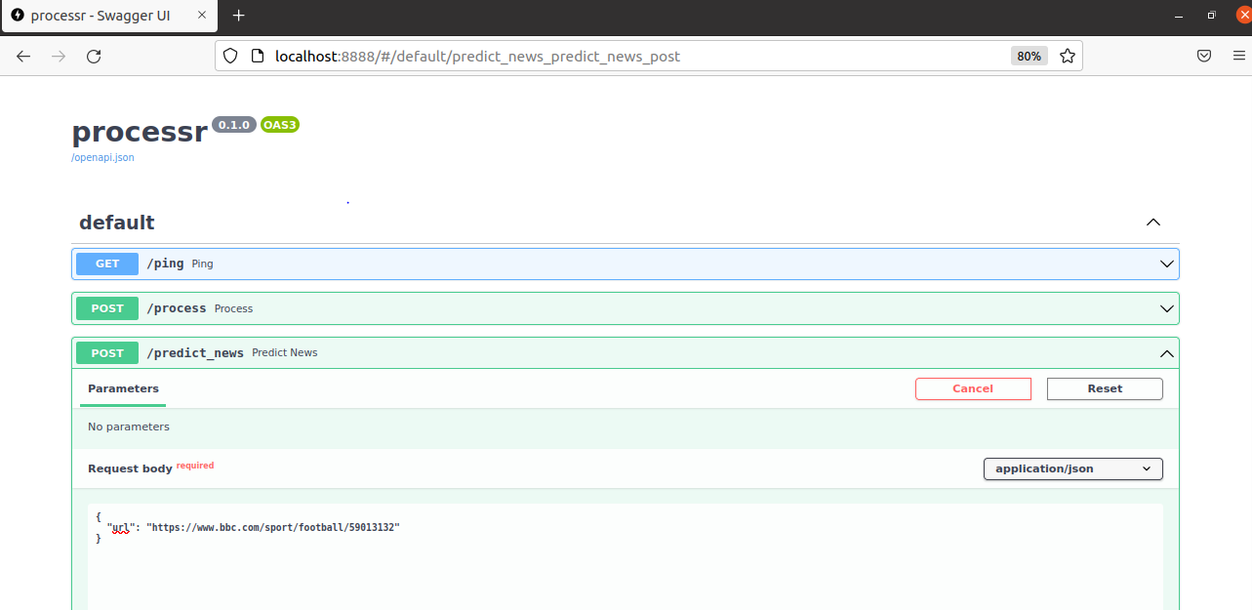

Prediction Log output:
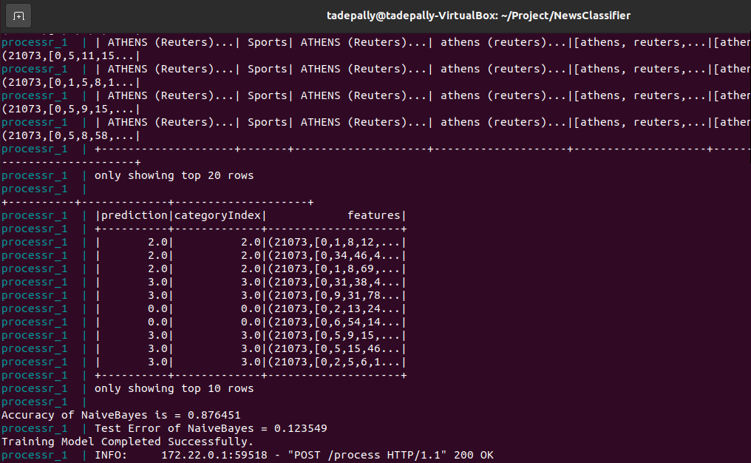

Flask UI

Final User Interface:

