Sampletalk Research:

Nature-inspired algorithm design
● in logic
● in natural language understanding
● in question answering
● in image and video understanding

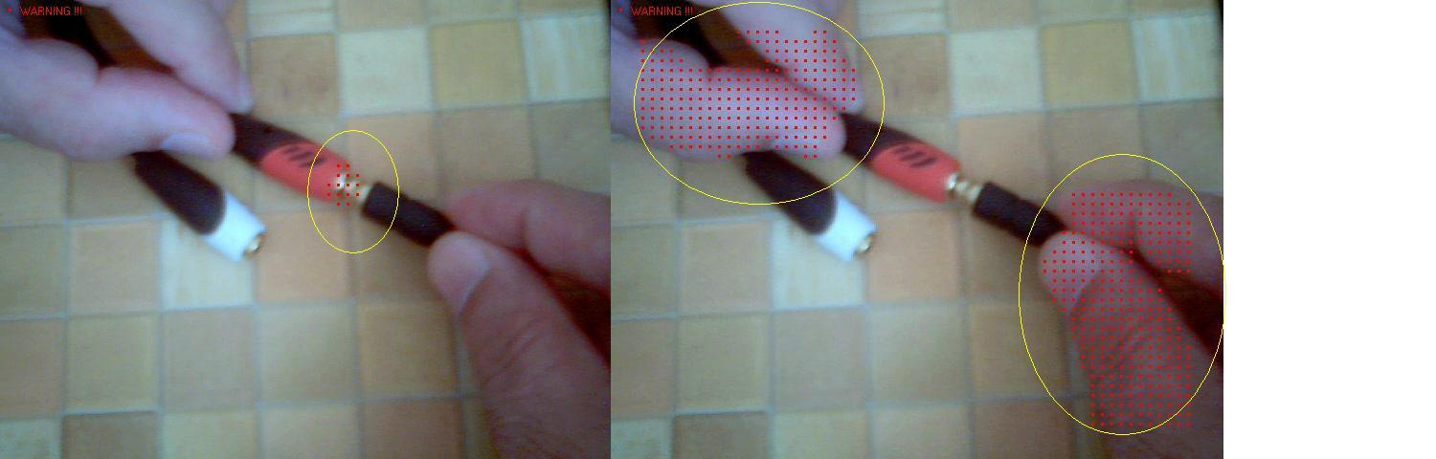
Can nature-inspired constructions replace the artificial ones, such as logical predicates, formal grammars, math formulas and equations?

NEW: Theory of Uninventing

Definition of Alternative Programming
by a metaphoric comparison with Alternative Medicine
(Slideshow)

The philosophy of programming by samples
(Slideshow)

Description of Sampletalk language and compiler
Data processing example abstraction immediately becomes
a useful program if text matching is in focus.
Program examples and experiments.

Download Sampletalk Compiler Version 3.2.1 (December 2022) for Windows

Generalization of First Order Predicate Calculus
Alternative treatment of First Order Logic:
theoretical analysis

Verbal Description Generalization:
Alternative treatment of Knowledge Representation

Automatic synthesis of Sampletalk programs
Inductive reasoning for the extraction of useful algorithms
immediately from text data

Object Recognition System Design
for finding objects in images and video sequences

Universal Classification System
for classification of multiple objects in images and video sequences

Contact us

This nature-inspired technology is also tested for video processing: it facilitates the creation of various intelligent vision systems using a single universal approach, which is based on so-called image samples. The system is trainable for detecting various objects and situations – on the road, in a production line, in a working environment etc. Signals of different nature and sources can be recognized by such a system and joined into a simple alerting language (see the red dots and the warning messages in the image above and in the videos below):

Reviews & Videos
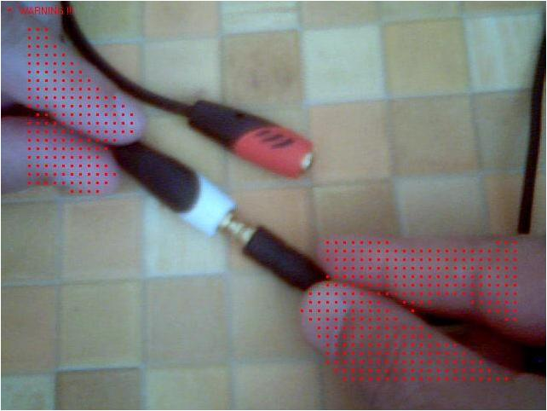  Recognizing and detecting fingers among other moving objects |   Locating vehicle identification Plates in an unstable video sequence | 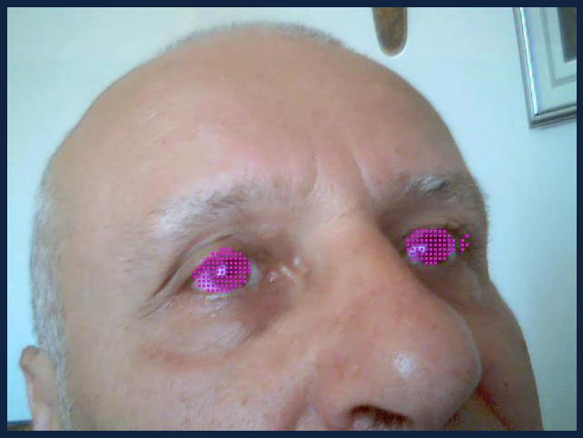  Detection, Marking, Evaluation of Human Iris, and Fatigue Detection in Ordinary Daylight
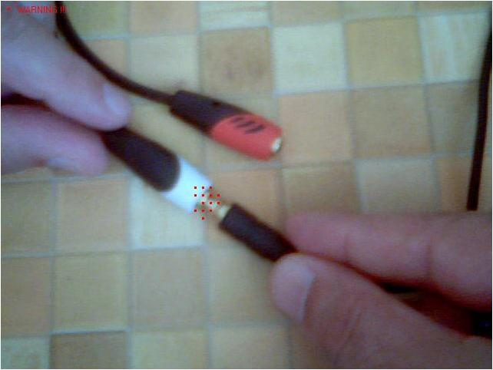  Detecting a contact situation while using electrical appliances | 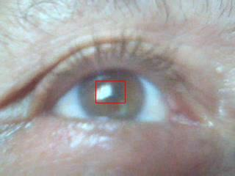  Dynamic Marking of a Human Pupil in Complex Illumination Environment |   Detecting Intrusion of a Human while Animal Ignored

